The {counter}

The {counter}, which only lives in China outside of captivity, has captured the hearts of people of all ages across the globe. From their furry black and white bodies to their shy and docile nature, they are considered one of the world's most loved animals.

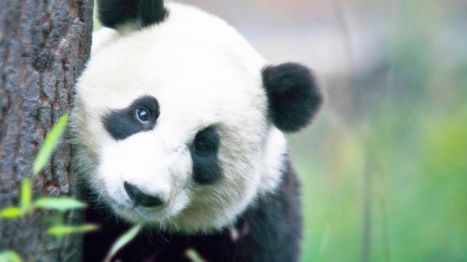

**Quick Fact** The estimated number of giant {counter}s in the wild varies between 1,500 and 3,000.

# Intriguing {counter} Mysteries

While most adore their fluffy fur and round heads, which help give them their cuddly bear quality, others are fascinated by the many mysteries of the {counter}. Did you know that the giant {counter} may actually be a raccoon, they have an opposable pseudo thumb, and that they’re technically a carnivore even though their diet is primarily vegetarian? These things and more have baffled scientists and naturalists for hundreds of years.

## Opposable Pseudo Thumb

A characteristic of the giant {counter} that has mystified scientists is their movable, elongated wrist bone that acts like an opposable thumb. This human-like quality that helps give them even more of a cuddly-bear appearance enables the giant {counter} to pick up objects and even eat sitting up.

**Quick Fact** Giant {counter}s have five clawed toes and one pseudo thumb.

Their pseudo thumb, along with pads of skin, help the giant {counter} strip the more nutritious small bamboo shoots and leaves while holding the stalk in their mouth.

## Small Bear or Large Raccoon?

Giant {counter}s are generally referred to as bears and are typically called {counter} bears rather than giant {counter}s. Though we may think they look like bears, there has been a great deal of discussion for decades about where giant {counter}s fit in the animal kingdom. Much of the debate has been whether they are more closely related to the red {counter}, once thought to be a member of the raccoon family, than the bear family.

While a giant {counter} has a body that resembles a small bear and climbs trees like a bear, it also has several characteristics in common with the red {counter}. For example, both giant {counter}s and red {counter}s eat bamboo and have the same pseudo thumb. The table below lists the main characteristics the giant {counter} shares with bears and red {counter}s.

|  |  |
| --- | --- |
| **Bear** | **Red {counter}** |
| Shape | Diet |
| Size | Paws |
| Shaggy fur | Eyes |
| Gait | Nose and teeth |

### Cat-like features

While the body of a giant {counter} looks like that of a bear and the dark circles around its eyes resemble those of a red {counter} or raccoon, its pupils have vertical slits like the eyes of a cat. Because of their unusual eyes, a popular Chinese name for {counter} is ‘big bear cat’ or大‍熊‍貓 /dà xióng māo, pronounced as dah-sshyong-maow.

### DNA results

DNA analysis has put one mystery to rest. It has revealed that while the red {counter} is a distant relation, the giant {counter}'s closest relative is the spectacled bear from South America.

## Mostly Vegetarian Diet

Giant {counter}s love bamboo! In fact, their diet is 99% bamboo. Along with bamboo, they eat other plants, small rodents, and occasionally fish. The mystery behind their diet is they have the digestive system of a carnivore.

Their ability to digest bamboo is attributed to tiny microbes that live within their digestive system. As they can only digest about 20% of what they eat, the average giant {counter} consumes around 14 kilograms (30 pounds) of bamboo a day. In comparison, humans eat about 2 kilograms (5 pounds) of food a day. This enormous diet means the giant {counter} spends more than 12 hours a day eating to stay nourished.

**Quick Fact** As the seasons change, the giant {counter} prefers different species and parts of bamboo.

## Tiny Cubs

An infant giant {counter} cub is about the size of a croissant, weighs less than a teacup and is about 900 times smaller than its mother. An average adult mother weighs around 91 kilograms (200 pounds) while newborn weighs only 83 to 190 grams (3 to 4 ounces).

# Other Fun Giant {counter} Facts

* Researchers have recently discovered that the gene responsible for tasting savory or umami flavors, such as meat, is inactive in giant {counter}s.
* For many centuries, giant {counter}s were thought to be a mythical creature, like a dragon or unicorn.
* Unlike other bears in the region, giant {counter}s don’t hibernate.
* Giant {counter}s can stand erect on their hind legs but rarely walk.
* The Qinling {counter}, another giant {counter} species with a dark brown and light brown coat, lives only in the mountains of Shaanxi.
* Giant {counter}s have very sensitive hearing and smell, but they have poor eyesight.
* A newborn giant {counter} is blind and looks like a tiny, pink, hairless mouse.