1. Place the following paragraph in screen and with proper justify alignment use Calibri font and size is 11.

We understand the challenges facing software developers and business teams. Between ensuring deadlines are met, managing project requirements, and testing and debugging your applications, time is your most important resource, and it seems like you never have enough of it. That’s where we come in.

Syncfusion offers over **1,700** components and frameworks for mobile, web, and desktop development, and we’re confident that our *ready-to-deploy* enterprise software will help get your products to market faster. With endless customization options, you can deliver an optimal user experience while saving development time and costs.

We are proud to serve a wide variety of customers, from individual developers to Fortune 500 companies. No matter your needs or your budget, we have the tools to help your team succeed.

1. Design as like following listings in HTML document

* HTML
* CSS
* C#
* Java Script

1. HTML
2. CSS
3. C#
4. Java Script
5. HTML
6. CSS
7. C#
8. Java Script
9. HTML
10. CSS
11. C#
12. Java Script
13. HTML
    1. CSS

Bootstrap

Custom css

* 1. C#

ASP.net

WPF

1. Java Script
2. Design the following table

1. Design like the following
   1. Hello World
   2. Hello World
   3. **Hello World**
   4. *Hello World*
   5. A2 + B2
   6. ~~Hello World~~
   7. Hello World
2. Design the following

* Try to place a video file and it needs to play on your screen.
* Try to place an audio file and it needs to play on your screen.
* Need to show a YouTube video on your screen.
* Place an image on your screen.
* Place and show a pdf file on your screen.
* Place a link for [www.google.com](http://www.google.com) When we click the link it needs to show [www.google.com](http://www.google.com)

1. Create a data view like below.

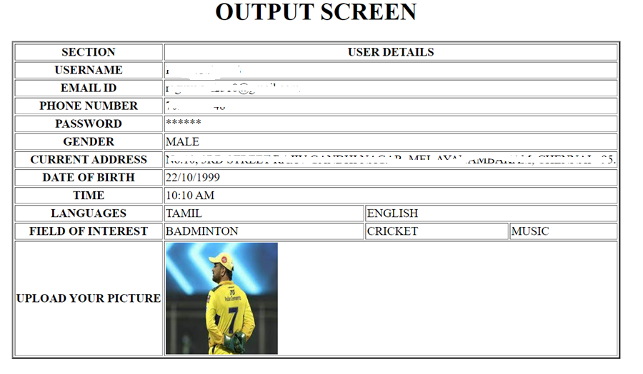

1. **Create a form as below.**

Create a table view like below.

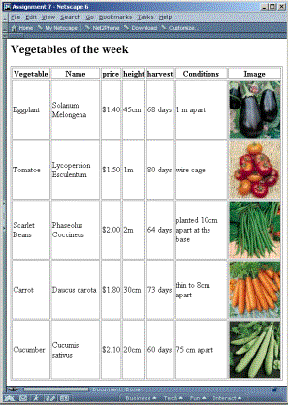

Learn from <https://www.w3schools.com/html/html_accessibility.asp>

* Tutorial
* Graphics
* Media
* Practice the examples.