
ALUMNI MANAGEMENT AND NETWORKING PORTAL
A PROJECT REPORT
Submitted by
GOPINATH K (727824TUIT048)
In partial fulfilment for the award of the degree
of
BACHELOR OF ENGINEERING
IN
INFORMATION TECHNOLOGY
SRI KRISHNA COLLEGE OF TECHNOLOGY
Autonomous Institution | Approved by AICTE | Affiliated to Anna University |
Accredited by NAAC with A++ Grade
Kovaipudur,Coimbatore – 641042.
September 2026

SUSTAINABLE DEVELOPMENT GOALS
The Sustainable Development Goals are a collection of 17 global goals designed as a blueprint to achieve a better and more sustainable future for all. The SDGs were set in 2015 by the United Nations General Assembly and are intended to be achieved by the year 2030. The Alumni Management and Networking Portal contributes to quality education, sustainable career growth, and improved institutional networking. It promotes smarter career planning while reducing administrative costs and communication gaps. It also supports safer, more reliable, and data-driven alumni engagement management.
Questions | Answer Samples
Which SDGs does the project directly address? | SDG 8, SDG 11 and SDG 12 – promoting efficient work, sustainable transportation, and responsible resource usage.
What strategies or actions are being implemented to achieve these goals? | Alumni directory search, mentorship pairing, job board referrals, event management, and campaign tracking.
How is progress measured and reported in relation to the SDGs? | By tracking active alumni registrations, mentorship connections made, job referrals, and donation contributions.
How were these goals identified as relevant to the project’s objectives? | They support career advancement, reduce communication gaps, and improve institutional networking productivity.
Are there any partnerships or collaborations in place to enhance this impact? | Collaboration with alumni associations, corporate recruiters, department faculty, and career guidance centers can enhance the system's impact.

BONAFIDE CERTIFICATE
Certified that this project report titled “ ALUMNI MANAGEMENT AND NETWORKING PORTAL ” is the Bonafide work of GOPINATH K (727824TUIT048) who carried out the project work under my supervision.
SIGNATURE | SIGNATURE
Submitted for the Project viva-voce examination held on ______________________
INTERNAL EXAMINER | EXTERNAL EXAMINER

ACKNOWLEDGEMENT
At this juncture, we take the opportunity to convey our sincere thanks and gratitude to the management of the college for providing all the facilities to us.
We wish to convey our gratitude to our college principal, Dr. K. Sundararaman for forwarding us to do our project and offering adequate duration to complete our project.
We would like to express our grateful thanks to Dr. N. Susila, Head of the Department, Department of Information Technology, for her encouragement and valuable guidance for this project.
We extend our gratitude to our beloved guide Mrs. R. S. Sree Vidhya, Assistant Professor, Department of Information Technology, for their constant support and immense help at all stages of the project.

ABSTRACT
The Alumni Management and Networking Portal is a web-based application developed to provide an integrated and efficient solution for managing alumni relations and student networking. Traditional alumni management often involves separate records and manual processes for handling profiles, mentorship requests, job referrals, events, donations, and compliance documents, which can lead to delays, errors, and increased administrative costs. The proposed system brings these activities together through a centralized platform.
The system enables authorized users to register and manage alumni profiles, maintain professional information, request mentorship, browse career vacancies, schedule institutional reunions, track donation campaigns, and manage important documents such as degree certificates and verification records. Role-based access control ensures that administrators, alumni, students, faculty, and office personnel can access functions according to their responsibilities.
The system also provides notifications for event dates and mentorship schedules, along with analytical reports for monitoring network engagement, job referral conversion, campaign goals, and mentorship performance. By providing centralized data and timely insights, the system helps reduce manual effort, improve connectivity, minimize operational expenses, and support better decision-making. Overall, the portal promotes safer, more reliable, cost-effective, and sustainable alumni operations.

TABLE OF CONTENTS
CHAPTER NO. | TITTLE | PAGE
 | ACKNOWLEDGEMENT | Iii
 | ABSTRACT | Iv
 | LIST OF TABLES | Vii
 | LIST OF FIGURES | Viii
 | LIST OF ABBREVIATIONS | Ix
1 | INTRODUCTION | 1
 | 1.1 Overview | 1
 | 1.2 Components of the System | 2
 | 1.3 Advanced Technologies | 4
 | 1.4 Global Perspectives | 5
2 | SYSTEM ANALYSIS | 7
 | 2.1 Existing System | 7
 | 2.1.1 Drawbacks | 8
 | 2.2 Problem System | 9
 | 2.3 Proposed System | 10
 | 2.3.1 Advantages | 11
3 | SYSTEM REQUIREMENTS | 12
 | 3.1 Hardware Requirements | 12
 | 3.2 Software Requirements | 12
 | 3.3 Software Description | 12
 | 3.3.1 Frontend ( React JS ) | 13
 | 3.3.2 Backend ( Java & Spring Boot) | 14
4 | SYSTEM DESIGN | 16
 | 4.1 Module Description | 16

 | 4.1.1 User & Driver Mangement | 16
 | 4.1.2 Vehicle Management | 17
 | 4.1.3 Trip & Dispatch Management | 17
 | 4.1.4 Maintenance & Fuel Management | 18
 | 4.1.5 Document , Compliance & Admin Management | 18
 | 4.2 Use Case Diagram | 19
 | 4.3 Sequence Diagram | 20
 | 4.4 Data Flow Diagram | 21
5 | TESTING | 22
 | 5.1 Unit Testing | 22
 | 5.2 Integration Testing | 22
 | 5.3 Security & Authentication | 23
 | 5.4 Test Cases | 24
 | 5.4.1 Test Case I: Driver Registration Validation | 24
 | 5.4.2 Test Case II: Trip Dispatch Scheduling | 25
6 | CONCLUSION AND FUTURE WORK | 26
 | 6.1 Conclusion | 26
 | 6.2 Future Work | 26
7 | APPENDICES | 27
 | Appendix I: Source Code | 27
 | Appendix II: System Screenshots | 29
 | REFERENCES | 36

LIST OF TABLES
TABLE NO. | TITTLE | Page No.
4.1 | User and Driver Management | 16
4.2 | Vehicle Management | 17
4.3 | Trip & Dispatch Management | 17
4.4 | Maintenance & Fuel Management | 18
4.5 | Document, Compliance & Admin Management | 19

LIST OF FIGURES
Figure No. | Tittle | Page No.
3.1 | VS Code Logo | 12
4.1 | Use Case Diagram | 20
4.2 | Sequence Diagram | 21
4.3 | Data Flow Diagram | 22
5.1 | Handling User Authentication and Role Based Redirection | 24
5.2 | Authenticating the user using bearer token | 25
5.3 | Test case I | 25
5.4 | Test case II | 26
A.2.1 | Home Page | 30
A.2.2 | Admin Login | 30
A.2.3 | Customer Management | 31
A.2.4 | Driver Management | 31
A.2.5 | Analytics Management | 32
A.2.6 | Customer Login Page | 32
A.2.7 | Customer Dashboard | 33
A.2.8 | Book a Trip | 33
A.2.9 | Assign Assets to Trip | 34
A.2.10 | Completion Status | 34
A.2.11 | Payment Method Details | 35
A.2.12 | Overall Status | 35
A.2.13 | Trip DataBase | 36

LIST OF ABBREVIATIONS
Sl.No | Abbreviation | Expansion
1. | API | Application Programming Interface
2. | DFD | Data Flow Diagram
3. | DOM | Document Object Model
4. | ERP | Enterprise Resource Planning
5. | GPS | Global Positioning System
6. | HTTP | Hypertext Transfer Protocol
7. | JDBC | Java Database Connectivity
8. | JPA | Java Persistence API
9. | JSON | JavaScript Object Notation
10. | JSX | JavaScript XML
11. | JWT | JSON Web Token
12. | OBD | On-Board Diagnostics
13. | OS | Operating System
14. | RAM | Random Access Memory
15. | REST | Representational State Transfer
16. | SQL | Structured Query Language
17. | UI | User Interface
18. | UML | Unified Modeling Language

CHAPTER 1
INTRODUCTION
1.1 OVERVIEW
The rapid growth of higher education institutions and alumni networks has increased the need for efficient and organized alumni management. Traditional alumni management methods often rely on manual records and separate processes for handling profiles, mentorship requests, job postings, donations, events, and compliance documents. These challenges can lead to operational delays, increased costs, poor network utilization, and difficulties in maintaining accurate alumni information. The Alumni Management and Networking Portal aims to address these issues by providing a centralized, user-friendly platform for managing alumni activities. The system simplifies alumni profile management, student-alumni mentorship pairing, job referral posting, event scheduling, campaign tracking, and document verification, while enabling authorized users to efficiently monitor and manage networking activities.
The platform allows alumni officers to maintain graduate records, assign mentors and job postings, monitor donation campaign usage, schedule reunion events, and track important documents such as degree certificates, verification IDs, and chapter charters. At the same time, alumni, students, and other authorized personnel can access the information and functions relevant to their assigned responsibilities. One of the key benefits of the system is its ability to reduce manual work, provide timely notifications, improve data accuracy, and support better utilization of institutional network resources. By integrating major alumni operations into a single platform, the system improves transparency and enables faster access to important information for effective decision-making.
Ultimately, the Alumni Management and Networking Portal aims to streamline alumni operations, reduce operational costs, improve networking reliability and utilization, and provide a modern and efficient approach to institutional management.

1.2 COMPONENTS OF SYSTEM
System Landing Page
The landing page serves as the entry point for users, providing an overview of the alumni management services and system features. It allows users to access login and registration and navigate to the appropriate modules based on their roles.
System Dashboard
The dashboard acts as the central hub for network operations. Alumni managers can view member availability, active mentorship requests, event status, campaign contributions, and important alerts, while other authorized users can access information related to their responsibilities.
Alumni Directory Management
This component allows authorized users to register, update, and manage alumni profile information such as graduation year, degree, current company, status, and assigned domain. It provides a centralized record of all alumni in the network.
Mentorship Management
The mentorship management component maintains mentor profiles, expertise details, assigned mentees, session schedules, and performance records. It helps alumni managers assign suitable mentors and maintain accurate mentorship information.
Job and Career Referral Management
This component enables users to create and manage job postings by assigning company details and referral contacts, defining domain tracks, and recording vacancy details. It helps organize placement activities and monitor planned and filled job openings.

Event and Reunion Management
The event component supports reunion scheduling and attendee record management. It helps identify upcoming institutional meetups and increases alumni participation through timely invitations.
Donation and Campaign Management
This component records and monitors financial contributions and related expenses for institutional development. It helps identify contribution patterns, calculate campaign efficiency, and direct funding towards priority campus projects.
Document and Compliance Management
This component manages important alumni and institutional documents such as degree certificates, accreditation records, verification IDs, and chapter charters. It provides alerts for upcoming expirations to support timely renewal and compliance.
User Behaviour Monitoring
The system records relevant user engagement information such as login frequency, mentorship responsiveness, event attendance, and contribution history. This information can be used to generate activity scores and encourage active alumni participation.
Notifications and Alerts
The notification component provides timely alerts for document expiry, scheduled events, mentorship updates, and other important network activities. This helps users take necessary actions without delay.
Analytics and Reporting
This component provides reports and insights on alumni directory growth, mentorship success rates, campaign contributions, job placements, and member engagement. It helps institutional managers make informed operational decisions.

User Profile Management
Users can manage their personal information and access role-specific features through their profiles. Role-based access ensures that users can only access the functions permitted for their responsibilities.
Security and Access Control
The system uses secure authentication and role-based access control to protect alumni and user information. Only authorized users can access sensitive data and perform management operations.
1.3 ADVANCED TECHNOLOGIES
Intelligent Network Optimization
AI-based insights help alumni managers optimize directory engagement, mentorship assignments, and event planning based on network data and usage patterns.
Predictive Engagement Analytics
Activity data can be analyzed to identify upcoming mentorship requirements and potential network drops, helping reduce lost connections and active member downtime.
Campaign Efficiency Monitoring
The system monitors donation contributions and efficiency for individual campaigns, helping identify fund distribution patterns and support institutional development.
Real-Time Notifications
Automated notifications alert users about mentorship updates, event schedules, document expirations, and other important network activities, improving timely decision-making.

Mentorship Performance Monitoring
Mentorship activities such as session completion, mentee feedback, and response times can be monitored to generate performance insights and encourage active guidance practices.
Mobile-Friendly Platform
A responsive interface allows alumni and students to access job details, profile information, notifications, and other essential functions conveniently from mobile devices.
Data Analytics for Institutional Managers
Analytical dashboards provide insights into directory engagement, campaign contributions, mentorship rates, and job placement performance, helping managers make informed decisions.
1.4 GLOBAL PERSPECTIVES
Global perspectives on alumni management systems are shaped by the growth of higher education and corporate networks, technological advancements, rising administrative costs, and the need for efficient alumni engagement.
• Growing Demand for Efficient Alumni Operations
With the expansion of educational institutions worldwide, organizations require efficient systems to manage alumni, students, mentorship, and operational resources effectively.
• Shift Toward Digital Alumni Management
Organizations are increasingly moving from manual records to digital alumni platforms. Web and mobile-based systems provide centralized access to profile information, event details, campaign records, and verification data.
• Integration of Advanced Technologies
Artificial intelligence, data analytics, and cloud technologies are being integrated into alumni management to improve mentorship planning, campaign efficiency, member performance, and directory utilization.

being integrated into alumni management to improve event planning, campaign efficiency, mentorship performance, and member utilization.
• Focus on Safety and Compliance
Modern alumni systems emphasize data safety, member verification, and timely renewal of essential documents. Automated alerts and performance monitoring help organizations maintain safer and more compliant network operations.
• Data-Driven Network Optimization
Globally, alumni management platforms are evolving to provide analytical insights into campaign funding, administrative costs, directory engagement, and mentorship performance. This helps organizations reduce operational expenses and make informed decisions.

CHAPTER – 2
SYSTEM ANALYSIS
2.1 EXISTING SYSTEM
• Many organizations currently manage alumni operations using manual records, spreadsheets, phone calls, and separate software tools for members, mentors, jobs, donations, and events. This can lead to data duplication, errors, and difficulty in accessing updated information.
• Existing digital alumni systems may provide basic profile and directory management, but often have limited integration between mentorship scheduling, job placement, campaign tracking, and compliance management.
• Event activities are frequently handled based on fixed schedules or manual reminders. This can result in delayed invitations, unexpected event cancellations, and increased organizing costs.
• Campaign contributions and mentorship performance are often recorded separately, making it difficult for alumni managers to identify low engagement, inefficient mentorship practices, or underutilized networks.
• Document management is also a challenge when degree certificates, verification IDs, chapter charters, and accreditation records are maintained manually. Missing renewal deadlines can create compliance issues.
• Overall, existing alumni management approaches may support basic operations but lack a centralized platform for monitoring network performance, reducing operational costs, improving member engagement, and supporting data-driven decision-making.

2.1.1 DRAWBACKS
While existing digital and manual alumni management methods provide basic operational support, they also face certain challenges:
Quality of Service
• Delayed Information: Manual updates can result in outdated profile, mentor, job, and event information.
• Coordination Issues: Separate processes for mentors, alumni, events, and jobs can make communication and coordination difficult.
Limited Functionality
• Lack of Integration: Some systems do not combine profile, mentorship, job, donation, and compliance management in a single platform.
• Limited Analytics: Basic systems may provide insufficient insights into campaign efficiency, directory engagement, event turnout, and mentorship performance.
Operational Issues
• Manual Errors: Repeated manual data entry can lead to incorrect records and scheduling mistakes.
• Network Downtime: Delayed event scheduling can decrease alumni participation and reduce network engagement.
Security and Privacy
• Data Security Risks: Alumni, student, and operational information requires secure authentication and controlled access.

• Unauthorized Access: Without proper role-based permissions, sensitive alumni information may be accessible to unauthorized users.
Cost Considerations
• Higher Operational Costs: Poor campaign monitoring, inefficient network engagement, and delayed event management can increase overall administrative expenses.
• Resource Wastage: Inefficient planning may result in unnecessary administrative usage, fund misallocation, and event expenditure.
2.2 PROBLEM DEFINITION
1. Manual Management Issues: Alumni information is often maintained through spreadsheets, paper records, and separate systems. This can result in data duplication, incorrect entries, difficulty in updating records, and delays in accessing important network information.
2. Limited Monitoring: Alumni managers may face difficulties in monitoring member engagement, campaign funding, event status, job referrals, and mentorship performance from a single platform. This makes it harder to identify inefficiencies and respond to operational issues quickly.
3. Event and Compliance Delays: Manual event scheduling and document tracking can lead to missed meeting dates and document expiry deadlines. Delayed events may decrease alumni involvement, while expired documents can create compliance and operational issues.
4. Poor Decision-Making: The absence of centralized data and analytical reports makes it difficult to evaluate network performance, identify unnecessary expenses, and recognize areas for improvement. Alumni managers may therefore depend on manual analysis for important operational decisions.

2.3 PROPOSED SYSTEM
• Centralized Alumni Management: The system provides a single platform to manage profiles, mentors, jobs, campaigns, events, and compliance records, reducing dependency on manual records and separate systems.
• Alumni and Student Management: Authorized users can add, update, and manage alumni and student details, including member status, mentor information, and relevant documents.
• Mentorship and Job Management: Alumni managers can create and assign mentorship sessions to suitable mentors and mentees, maintain job details, and monitor planned and completed career sessions.
• Event Scheduling: The system allows reunion and webinar schedules to be planned and maintained, helping ensure timely invitations and reducing unexpected event delays.
• Donation Management: Campaign contributions and expenses can be recorded and analyzed to monitor fund allocation and identify campaign requirements.
• Document and Compliance Tracking: The system maintains important alumni and institutional documents and provides timely alerts for upcoming document expirations and renewals.
• Mentorship Performance Monitoring: Mentor-related performance information can be maintained to identify guidance issues and support safer and more efficient alumni operations.
• Analytics and Reporting: The system provides reports on member engagement, campaign contributions, event costs, jobs, and mentorship performance to support effective decision-making.
• Notifications and Alerts: Automated notifications help users stay informed about event schedules, document expiry, session updates, and other important network activities.

2.3.1 ADVANTAGES
• Centralized Alumni Management
• Improved Network Utilization
• Reduced Manual Errors and Delays
• Better Event and Compliance Management
• Improved Campaign Efficiency and Cost Control
• Better Communication and Coordination
• Time-Saving and Cost-Effective Operations

CHAPTER – 3
SYSTEM REQUIREMENTS
The hardware and software requirements and the platform description of the Alumni Management System are explained under Sections 3.1, 3.2, and 3.3 respectively.
3.1 HARDWARE REQUIREMENTS
i. Processor Type : Intel Core i5
ii. RAM : 8 GB
iii. Hard Disk : 512 GB SSD
iv. Display : 1366 × 768 resolution or higher
v. Internet Connection : Stable broadband connection
3.2 SOFTWARE REQUIREMENTS
a. Operating System : Windows 11
b. Front End : React.js
c. Back End : Java with Spring Boot
d. Database : MySQL
e. Development Environment : Visual Studio Code
f. Web Browser : Google Chrome / Microsoft Edge
3.3 SOFTWARE DESCRIPTION
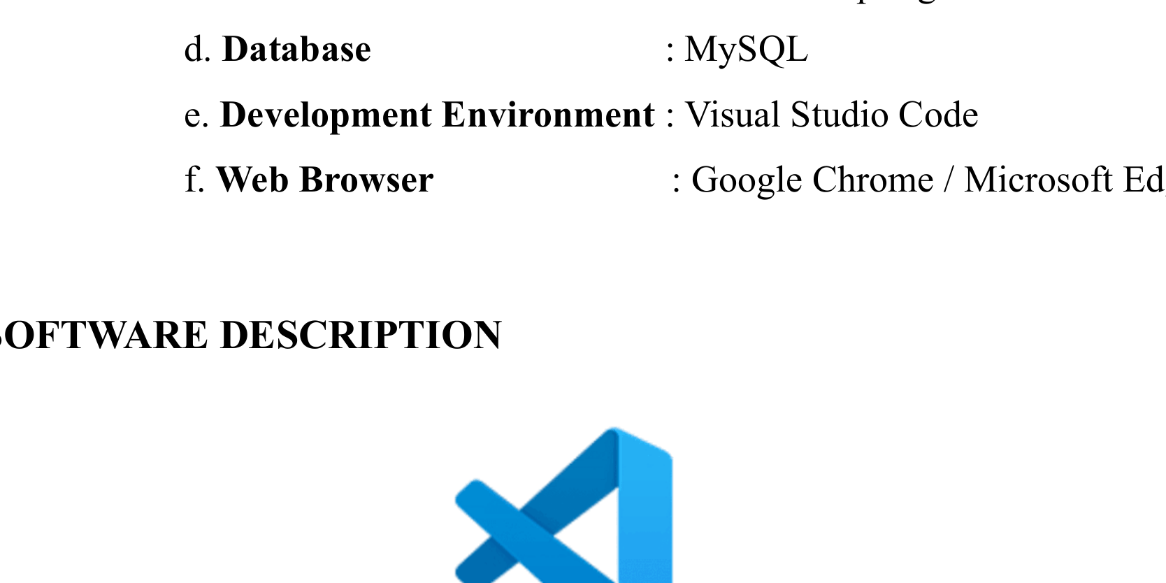
Fig . 3.1 VS Code Logo

Visual Studio Code, also commonly referred to as VS Code, is a source code editor made by Microsoft, it can be used to work with Windows, Linux and macOS. Features include support for debugging, syntax highlighting, intelligent code completion, snippets, embedded Git. Users can change the theme, keyboard shortcuts, preferences, and install extensions that add functionality.
3.3.1 FRONTEND
ReactJS
ReactJS is a JavaScript library used for developing interactive and responsive user interfaces for web applications. In the Alumni Management System, ReactJS is used to create dashboards and interfaces for managing members, mentors, jobs, events, campaigns, and compliance information. React follows a component-based architecture, allowing different parts of the application to be developed as reusable components.
React uses a Virtual DOM to efficiently update the user interface when application data changes. It also uses JSX, which allows developers to write HTML-like structures within JavaScript, making the interface easier to develop and maintain. React follows a unidirectional data flow, which provides a clear and predictable way of managing application data.
Features of ReactJS
1.Component-Based Architecture
React divides the user interface into reusable components, making the application easier to develop, maintain, and update.
2.VirtualDOM
The Virtual DOM improves application performance by updating only the required parts of the user interface.
3.JSX
JSX allows developers to write HTML-like syntax within JavaScript, making UI components easier to understand.

4.ReusableComponents
Common elements such as navigation bars, dashboards, forms, tables, and cards can be reused across different modules.
5.UnidirectionalDataFlow
Data flows in a predictable direction between components, making application state easier to manage.
6.ResponsiveInterface
React can be used to build interfaces that adapt to different screen sizes, allowing alumni personnel to access the system from desktops, tablets, and mobile devices.
7.RichEcosystem
React provides access to a large ecosystem of libraries and development tools that support application development.
3.3.2 BACKEND
Java with Spring Boot
Java is a high-level, object-oriented programming language widely used for developing secure and scalable applications. In the Alumni Management System, Java is used to implement the backend logic and business operations. Spring Boot provides a framework for developing RESTful web services and connecting the frontend with the database.
The backend manages operations such as user authentication, alumni profile management, mentorship assignment, job posting, campaign records, event tracking, and document verification. Spring Data JPA is used to simplify database operations, while Spring Security provides authentication and authorization mechanisms.
Extensions and Tools Used
1. Extension Pack for Java
Provides essential Java development features such as code navigation, debugging, and IntelliSense.

2. Spring Boot Extension Pack
Provides development support for creating and managing Spring Boot applications.
3. Lombok
Reduces repetitive Java code by automatically generating getters, setters, constructors, and other commonly required methods.
Dependencies Used
1. Spring Web
Provides the components required to create REST APIs and handle HTTP requests and responses.
2. Spring Boot DevTools
Improves development efficiency through automatic application restart and development-time features.
3. Spring Data JPA
Simplifies database access and enables interaction with database tables through JPA repositories.
4. MySQL Driver
Provides connectivity between the Spring Boot application and the MySQL database.
5. Lombok
Reduces boilerplate code and improves the readability and maintainability of Java classes.
6. Spring Security
Provides authentication and authorization features to protect the system and control access based on user roles.
7. JWT Authentication
JSON Web Tokens are used to securely authenticate users and maintain authorized access to protected backend resources.

CHAPTER – 4
SYSTEM DESIGN
4.1 MODULE DESCRIPTION
The Alumni Management System consists of the following five core modules:
1. User & Auth Management
2. Alumni Directory & Profile Management
3. Mentorship & Job Board Management
4. Donation & Campaign Management
5. Event, Chapter & Admin Management
4.1.1 USER & AUTH MANAGEMENT
The User & Auth Management module allows administrators to manage user accounts and member profiles. It stores essential personal, contact, credentials, and role-related information. Role-based access ensures that each user can access only the functions relevant to their responsibilities.
Table 4.1 User & Authentication Management
Field | Description
User ID | Unique identification number for each user
Name | Full name of the user or member
Email | Email address used for login and communication
Contact Number | Phone number of the user or member
Role | Defines the user's responsibility, such as Admin, Alumni, or Student
Password Hash | Encrypted password hash stored securely in database
Status | Current account status such as Active or Inactive

4.1.2 ALUMNI DIRECTORY & PROFILE MANAGEMENT
The Alumni Directory & Profile Management module maintains complete information about network members. It allows administrators to add, update, and monitor alumni along with their current employment status and assigned chapters. This helps in efficient member utilization and tracking.
Table 4.2 Alumni Directory & Profile Management
Field | Description
Alumni ID | Unique identification number for each alumnus
Graduation Year | Year of graduation from institution
Degree & Major | Degree qualification such as B.E. IT
Current Company | Employer organization or business
Designation | Current professional job title
Location | Current city and country of residence
Assigned Chapter | Regional alumni chapter association
Verification Status | Verification status of alumni degree record
4.1.3 MENTORSHIP & JOB BOARD MANAGEMENT
The Mentorship & Job Board Management module manages career sessions, vacancy postings, and referral assignment of alumni and students. It records opportunity details from the starting application to placement and helps alumni managers monitor ongoing and completed sessions.
Table 4.3 Mentorship & Job Board Management
Field | Description
Job / Session ID | Unique identification number for opportunity
Alumni Mentor ID | Alumnus assigned for guidance/referral
Student Mentee ID | Student requesting mentorship/job
Domain Track | Field of expertise (e.g. Software Dev)
Company Name | Hiring company for corporate vacancy

Start Date & Time | Scheduled or actual session starting time
Expected Completion | Expected completion date and time
Duration | Total planned or conducted session time
Session Status | Status such as Scheduled, Ongoing, Completed, or Cancelled
4.1.4 DONATION & CAMPAIGN MANAGEMENT
The Donation & Campaign Management module manages campus funding, development contributions, and campaign allocation. It helps schedule fundraising drives and monitor contribution expenses, improving campus development and controlling project goals.
Table 4.4 Donation & Campaign Management
Field | Description
Campaign ID | Unique identification number for campaign
Alumni ID | Alumnus associated with donation record
Contribution Type | Type of cause or project funded
Donation Date | Date on which contribution was made
Transaction Record ID | Unique transaction payment code
Amount Contributed | Financial amount donated to campaign
Campaign Goal | Target funding goal for project
Campaign Status | Current fundraising status of campaign
4.1.5 EVENT, CHAPTER & ADMIN MANAGEMENT
The Event, Chapter & Admin Management module manages important institutional and member documents and monitors their validity. It provides expiry alerts and compliance information. The admin dashboard gives a centralized view of network activities, alerts, and reports for effective decision-making.

Table 4.5 Event, Chapter & Admin Management
Field | Description
Document ID | Unique identification number for document
Member / Chapter ID | Alumnus or chapter associated with document
Document Type | Type of document such as Degree, ID, Charter, or Verification
Issue Date | Date on which document was issued
Expiry Date | Date on which document expires
Document Status | Current status such as Valid, Expired, or Pending
Alert Status | Indicates whether an expiry notification has been generated
Reports & Analytics | Provides network performance and operational reports
4.2 USE CASE DIAGRAM
A use case diagram is a visual representation in UML (Unified Modelling Language) that illustrates the interactions between actors and a system or software application.
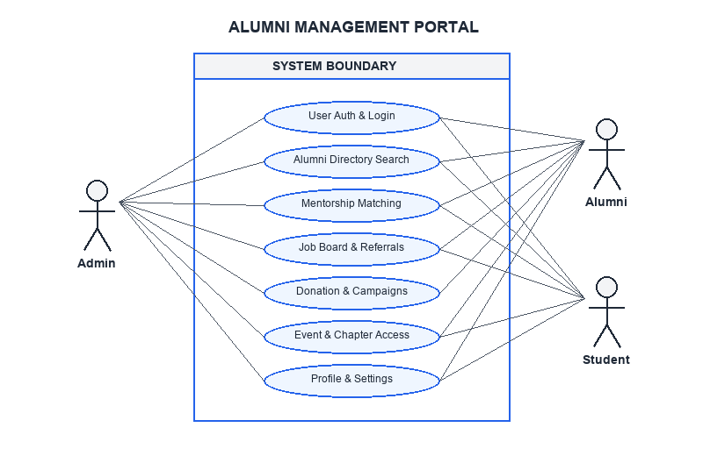
Fig. 4.1 Use Case Diagram

4.3 SEQUENCE DIAGRAM
A sequence diagram is a visual representation used in software engineering to illustrate the interactions and communication between different objects or components in a system over a specific period of time. It shows the chronological order of messages or method calls exchanged between these entities, helping to depict the dynamic behaviour of a system or a particular scenario. In essence, it provides a time-ordered view of how various parts of a system collaborate to achieve a particular task or functionality.
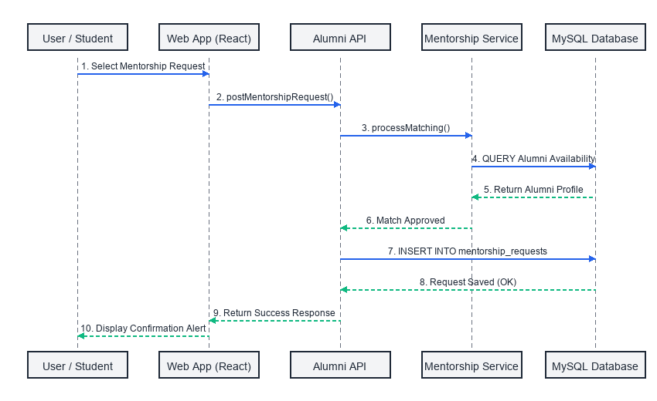
Fig. 4.2 Sequence Diagram

4.4 DATA FLOW DIAGRAM
A Data Flow Diagram (DFD) is a visual representation that illustrates the flow of data within a system or process. It uses symbols to depict processes, data stores, data flow, and external entities. DFD helps to analyse, design, and document information systems, showing how data is input, processed and output, while emphasizing the interactions between different elements in the system.
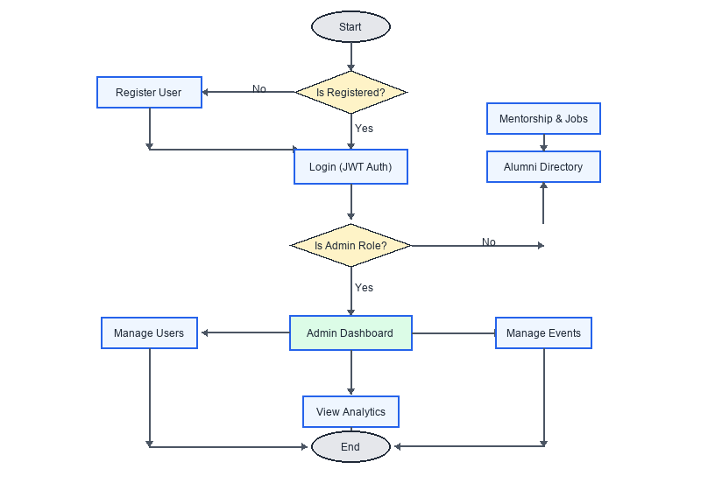
Fig. 4.3 Data Flow Diagram

CHAPTER – 5
TESTING
5.1 UNIT TESTING
Unit testing forms the foundational layer of the testing process for the Alumni Management System. It involves testing individual software components in isolation to identify and rectify issues early in the development cycle. In this context, unit testing includes examining Java classes, service methods, validation logic, and database queries individually. Unit testing, often conducted concurrently with development, focuses on validating the smallest units of the software and ensuring that each component works correctly before being integrated into the complete system.
5.2 INTEGRATION TESTING
Integration testing for the Alumni Management System focuses on ensuring seamless interaction between different components of the system. The goal is to validate that API endpoints responsible for communication between the React front-end and Java Spring Boot back-end work correctly together. This phase ensures accurate data flow between modules such as alumni directory management, mentorship management, job board management, donation management, and event management. It ultimately validates the overall functionality and coordination of the alumni management system.
5.3 SECURITY AND AUTHENTICATION
In the Alumni Management System, ensuring the security and authentication of user data is of utmost importance. JSON Web Tokens (JWTs) are used for user authentication and secure access control. During user registration, user credentials are securely stored in the database. After successful login, a JWT is generated and issued to the authenticated

user. The JWT serves as an authentication token, allowing secure access to the system's features according to the user's assigned role.
The JWT is securely signed using a secret key known only to the server, ensuring the authenticity and integrity of the token. Whenever a user interacts with the system, the JWT is included in the request. The Spring Boot backend validates the token before granting access to protected resources. Role-based authorization ensures that administrators, alumni managers, and students can access only the functions permitted for their responsibilities. To enhance security, JWTs have a finite expiration time, after which the user must authenticate again to obtain a new token.
const handleSelectDemo = (key) => {
const demo = DEMO_ACCOUNTS[key];
if (demo) {
setIdentifier(demo.email);
setPassword(demo.password);
setSelectedDemo(key);
}
};
const handleLogin = async (e) => {
e.preventDefault();
if (!identifier.trim() || !password.trim()) {
toast.warning('Please enter your identifier and password');
return;
}
setLoading(true);
try {
const authData = await login({
identifier: identifier.trim(),
email: identifier.trim(),
password
});
toast.success(`Welcome back, ${authData.fullName}!`);
if (authData.role === 'ADMIN') navigate('/admin');
else navigate('/dashboard');
} catch (err) {
toast.error('Authentication failed. Please check your credentials.');
} finally {
setLoading(false);
}
};
Fig. 5.1. Handling User Authentication and Role-Based Redirection

// Attach JWT token to all outgoing requests
api.interceptors.request.use(
(config) => {
const token = localStorage.getItem('alumni_token');
if (token) {
config.headers.Authorization = `Bearer ${token}`;
}
return config;
},
(error) => Promise.reject(error)
);
Fig. 5.2 Authenticating the User using Bearer Token
5.4 TEST CASES
Test cases are essential for evaluating the functionality of the Alumni Management System, including user authentication, profile management, mentorship scheduling, job referral assignment, and network tracking. Proper testing ensures data accuracy, secure access, smooth operation, and a seamless user experience while maintaining the overall quality, reliability, and efficiency of the system.
5.4.1 TEST CASE I
Fig. 5.3 Test Case I

EXPECTED OUTPUT:
Registration fails and an error message is displayed, prompting the user to enter the missing required credentials.
ACTUAL OUTPUT:
Registration fails, and the system indicates that all required credentials must be entered.
5.4.2 TEST CASE II
Fig. 5.4 Test Case II
EXPECTED OUTPUT:
After successfully booking a mentorship session, a confirmation message is displayed indicating that the booking was completed successfully.
ACTUAL OUTPUT:
After booking the session, the system displays a “Mentorship Request Completed successfully” message.

CHAPTER – 6
CONCLUSION AND FUTURE WORK
6.1 CONCLUSION
The Alumni Management System project is an essential solution aimed at addressing the growing need for efficient and organized alumni operations. By providing a centralized platform for managing members, mentors, jobs, campaigns, events, and compliance records, the system improves operational efficiency while reducing manual effort. Its focus on centralized data management, mentorship scheduling, donation tracking, document verification, and secure role-based access ensures a reliable and efficient alumni management experience. Overall, this project represents a significant step toward modernizing alumni operations, reducing operational errors and costs, improving member engagement, and supporting better decision-making for institutional managers.
6.2 FUTURE WORK
An alternative solution for enhancing alumni management could be to develop a mobile application that allows alumni managers, graduates, and students to manage important network activities from a single platform. The application could include features such as real-time mentorship tracking, event updates, donation reminders, campaign monitoring, student notifications, and digital document access. This approach would provide greater convenience and accessibility to users while enabling alumni operations to be monitored from anywhere.
For institutional administrators and alumni officers, an advanced online dashboard could be developed to provide real-time network monitoring and intelligent analytics. The dashboard could include features such as predictive engagement analytics, AI-based mentor matching, campaign efficiency analysis, member performance monitoring, placement forecasting, automated compliance alerts, and detailed network utilization reports. Such enhancements would provide a centralized solution for alumni operations, improving efficiency, reducing operational costs, increasing member engagement, and supporting data-driven decision-making.

CHAPTER – 7
APPENDICES
APPENDIX I SOURCE CODE
import api from './api';
export const alumniService = {
getAlumni: async (params = {}) => {
const response = await api.get('/alumni', { params });
return response.data;
},
getAlumniById: async (id) => {
const response = await api.get(`/alumni/${id}`);
return response.data;
},
requestMentorship: async (mentorshipData) => {
const response = await api.post('/mentorship', mentorshipData);
return response.data;
},
approveMentorship: async (id) => {
const response = await api.post(`/mentorship/${id}/approve`);
return response.data;
},
assignReferral: async (id, referralData) => {
const response = await api.post(`/jobs/${id}/refer`, referralData);
return response.data;
},
startSession: async (id) => {
const response = await api.post(`/mentorship/${id}/start`);
return response.data;
},
};

completeSession: async (id, data = {}) => {
const response = await api.post(`/mentorship/${id}/complete`, data);
return response.data;
},
cancelSession: async (id, reasonData = {}) => {
const response = await api.post(`/mentorship/${id}/cancel`, reasonData);
return response.data;
},
// Role-specific helpers
getAlumniMentorships: async () => {
const response = await api.get('/mentorship/alumni/my-sessions');
return response.data;
},
getAlumniActiveSessions: async () => {
const response = await api.get('/mentorship/alumni/active');
return response.data;
},
getStudentMentorships: async () => {
const response = await api.get('/mentorship/student/my-sessions');
return response.data;
},
getStudentActiveSessions: async () => {
const response = await api.get('/mentorship/student/active');
return response.data;
},
};

APPENDIX II SCREENSHOTS
<b>Fig. A.2.1 Home Page</b>
<b>Fig. A.2.2 Admin Login</b>

<b>Fig. A.2.3 Customer Management</b>
<b>Fig. A.2.4 Driver Management</b>

<b>Fig. A.2.5 Analytics</b>
<b>Fig. A.2.6 Customer Login</b>

<b>Fig. A.2.7 Customer Dashboard</b>
<b>Fig. A.2.8 Book a Trip</b>

<b>Fig. A.2.9 Assign Assets to Trip</b>
<b>Fig. A.2.10 Completion Status</b>

<b>Fig. A.2.11 Payment Method Details</b>
<b>Fig. A.2.12 Overall Status</b>

<b>Fig. A.2.13 Trip DataBase</b>

REFERENCES
WEB REFERENCES
1. React.js Documentation – Official documentation for building user interfaces.
React.js Official Documentation
2. Spring Security Documentation – Reference for authentication, authorization and application security.
Spring Security Official Documentation
3. MySQL Documentation – Official reference for MySQL database management and SQL.
MySQL Official Documentation
4. Spring Data JPA Documentation – Reference for database access using JPA and Spring.
Spring Data JPA Documentation
5. GitHub Documentation – Reference for source-code management, repositories and collaboration.
GitHub Documentation
BOOK REFERENCES
[1] John E. Dolce (2003), Fleet Manager’s Guide to Vehicle Specification and Procurement, SAE International.
[2] David A. Wilson (2021), The Ultimate Guide to Commercial Vehicle Fleet Management, DW Consultancy.
[3] Vasileios Zeimpekis, Christos D. Tarantilis, George M. Giaglis

& Ioannis Minis (2007), Dynamic Fleet Management: Concepts, Systems, Algorithms & Case Studies, Springer.
[4] Asvin Goel (2008), Fleet Telematics: Real-time Management and Planning of Commercial Vehicle Operations, Springer.
[5] Teodor Gabriel Crainic & Gilbert Laporte (Eds.) (1998), Fleet Management and Logistics, Springer.

