Build the following Computational Graphs using tensorflow:

*NOTE: 1. Use* ***floating values*** *for x and y.*

*2. For division use* ***tf.divide(****constant1, constant2****)***

*3. For square root use* ***tf.sqrt(****constant****)***

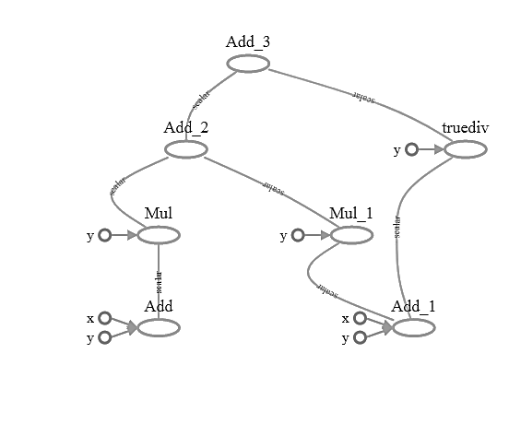1)

2)

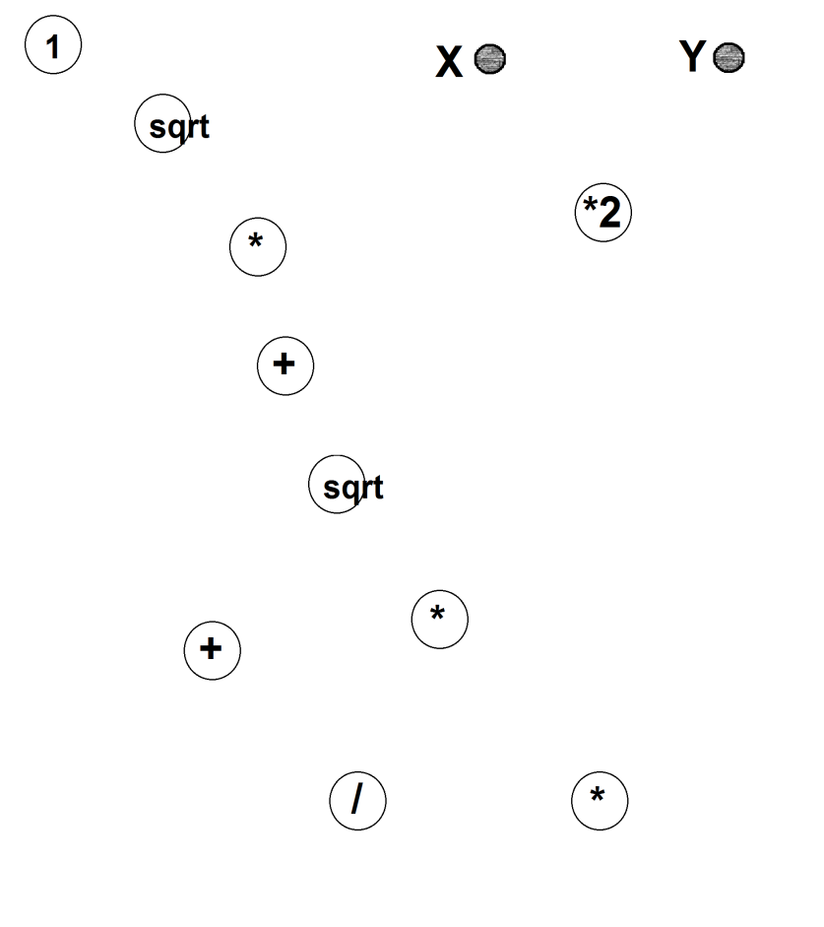

**Solutions:**

**1)**

**import** tensorflow **as** tf  
x = tf.constant(2.0,name=**'x'**)  
y = tf.constant(3.0,name=**'y'**)  
  
add = tf.add(x,y)  
add1 = tf.add(x,y)  
mul = tf.multiply(add,y)  
mul1 = tf.multiply(add1,y)  
add2 = tf.add(mul,mul1)  
div = tf.divide(add1,y)  
mul3 = tf.add(add2,div)  
  
**with** tf.Session() **as** sess:  
 writer = tf.summary.FileWriter(**'graph_assgn1'**,sess.graph)  
 print(sess.run(mul3))  
writer.close()

**2)**

**import** tensorflow **as** tf  
  
x = tf.constant(2.0,name=**"x"**)  
y = tf.constant(3.0,name=**"y"**)  
  
const1 = tf.constant(2.0,name=**'2'**)  
const2 = tf.constant(1.0,name=**'1'**)  
  
a = tf.multiply(x,const1)  
b = tf.multiply(a,y)  
c = tf.sqrt(const2)  
d = tf.multiply(c,a)  
e = tf.add(const2,d)  
f = tf.sqrt(e)  
g = tf.multiply(f,a)  
h = tf.add(e,g)  
i = tf.div(h,y)  
  
**with** tf.Session() **as** sess:  
 writer = tf.summary.FileWriter(**'graph_assgn2'**,sess.graph)  
writer.close()