**Notes for using the Overleaf Template:**

1. The complier should be set to XeLaTex or else it won't compile.

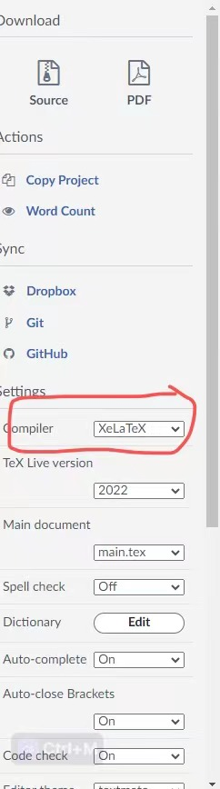

1. The cover page was done in a Word document (**coverpage_Gordon**.docx) and called from Overleaf.

**NB: This overleaf version of the Dissertation template conforms to the Dissertation Writing Standards of UESTC as of March 2023. You can compare it with the Word version provided by the University.**