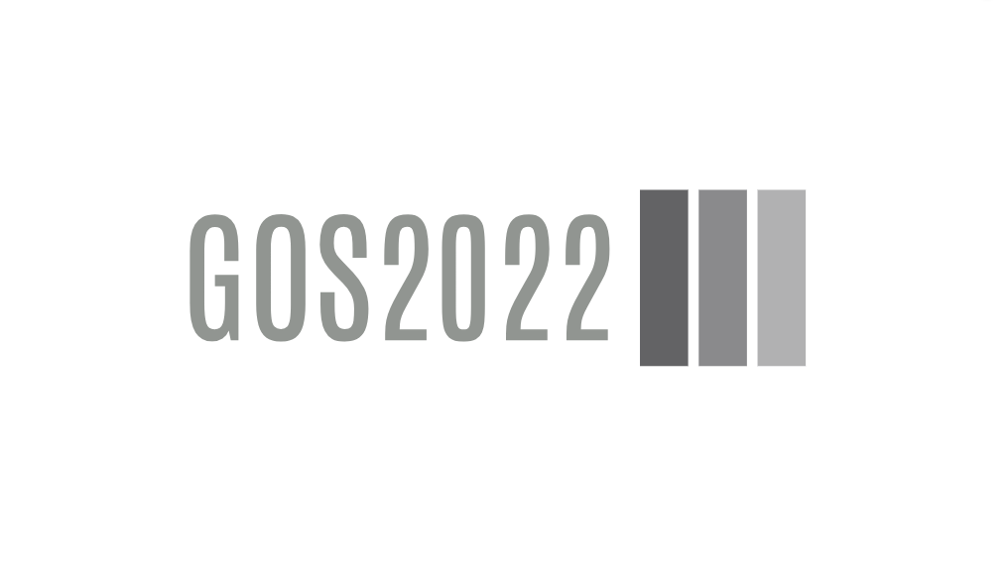

MB02A1 Hardware Requirements Specification

**GOS2022**

MB02A1 Hardware Requirements Specification

**Main Board Version 02, Revision A1**

© Ahmed Gazar, 2024

|  |  |  |  |  |
| --- | --- | --- | --- | --- |
| Version history | | | | |
| Version | Date | Author | Change | Released |
| 1.0 | 2024-07-25 | Ahmed Gazar | Initial version of document. | 2024-07-25 |
|  |  |  |  |  |
|  |  |  |  |  |
|  |  |  |  |  |

# **Content**

Content 5

Chapter 1 Introduction 6

1. Purpose 7

Chapter 2 Requirements 8

HWREQ.0001 9

HWREQ.0002 9

HWREQ.0003 9

HWREQ.0004 9

HWREQ.0005 9

HWREQ.0006 9

HWREQ.0007 10

HWREQ.0008 10

HWREQ.0009 10

HWREQ.0010 10

HWREQ.0011 10

HWREQ.0012 10

HWREQ.0013 11

HWREQ.0014 11

HWREQ.0015 11

HWREQ.0016 11

HWREQ.0017 11

HWREQ.0018 11

HWREQ.0019 11

HWREQ.0020 12

HWREQ.0021 12

HWREQ.0022 12

Table Of Figures 13

# **Chapter 1** Introduction

## Purpose

The purpose of the development of Main Board 02 is to

* fix the known issues of MB01A1
* remove components that proved unnecessary to reduce cost and size
* add new features to the existing design
* improve already existing design

MB01A1 is obsolete (was a first prototype), therefore compatibility is not required. Components can be added and removed without restriction, however, re-use of already existing parts is highly recommended to save development time and effort, as well as to reduce the risk of design failures.

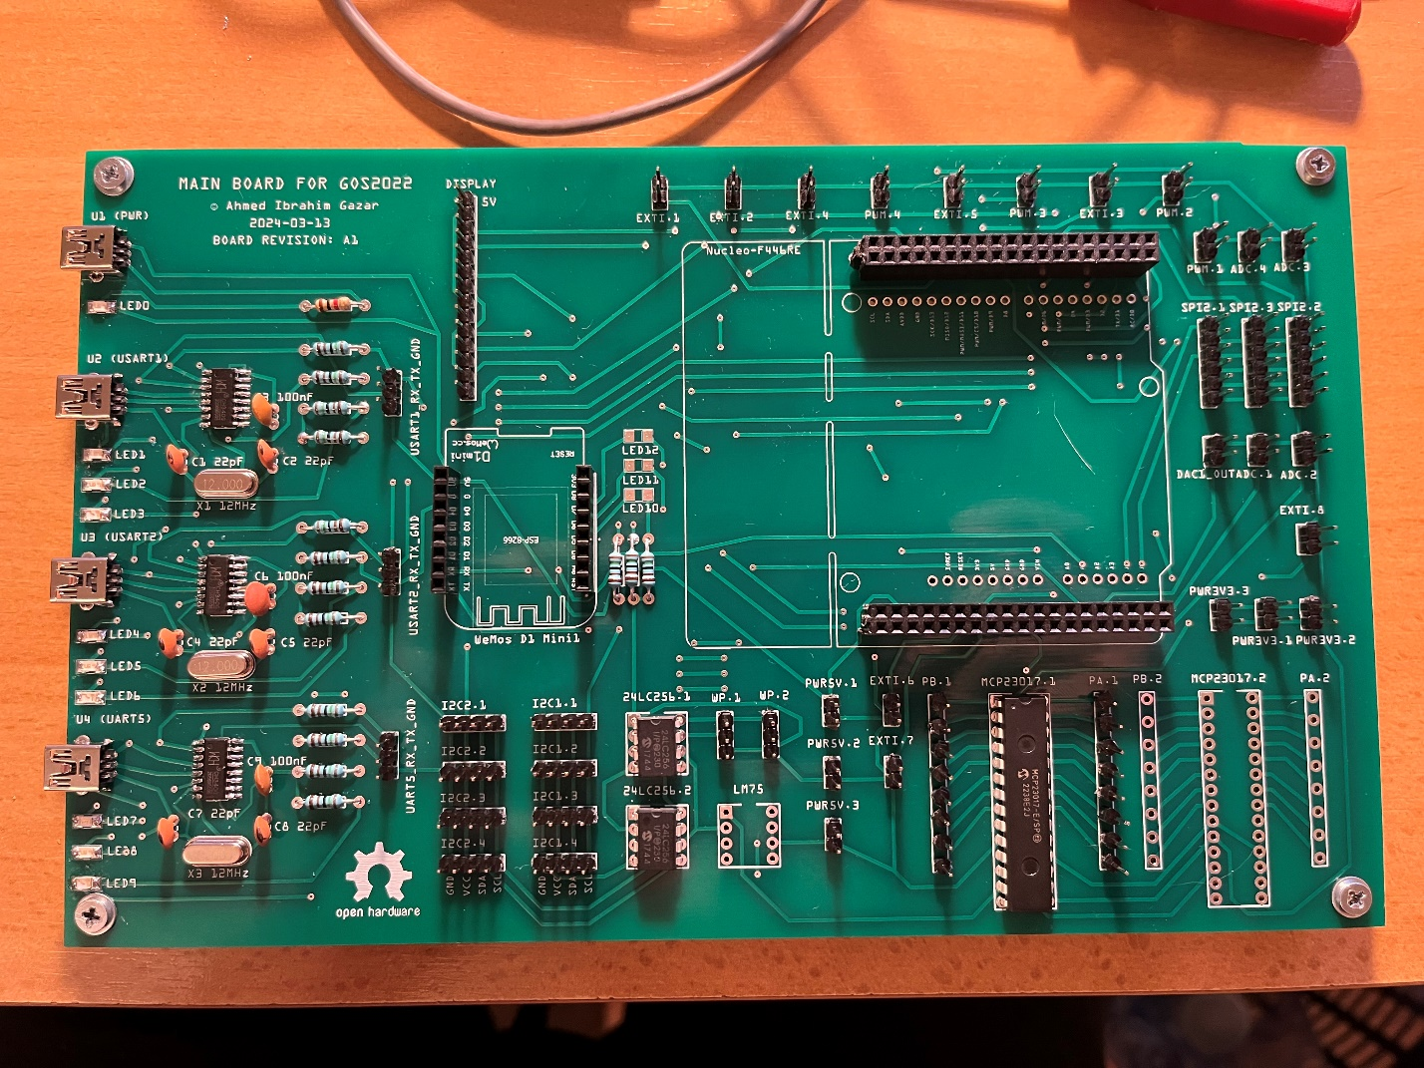

Figure 1: Half-assembled MB01A1 board

# **Chapter 2** Requirements

|  |  |
| --- | --- |
| HWREQ.0001 | Compatibility with Nucleo-64 boards |
| MB02A1 shall offer a Nucleo-64 compatible pin header connection for a processor board. | |

|  |  |
| --- | --- |
| HWREQ.0002 | Compatibility with WeMos D1 mini |
| MB02A1 shall offer a WeMos D1 mini compatible pin header connection for a WiFi board. | |

|  |  |
| --- | --- |
| HWREQ.0003 | Power supply |
| MB02A1 shall have a separate USB connector to have an external +5V (nominal) power input. | |

|  |  |
| --- | --- |
| HWREQ.0004 | Over-voltage protection |
| MB02A1 shall have an on-board over-voltage protection circuit that is activated at around +5.3V and shuts down the power line in case of over-voltage. | |

|  |  |
| --- | --- |
| HWREQ.0005 | Short-circuit protection |
| MB02A1 shall have a short-circuit protection on the power line that is activated at around 1A. | |

|  |  |
| --- | --- |
| HWREQ.0006 | Feedback LEDs |
| MB02A1 shall feature 3 LEDs:   * One green LED that indicates that the board is powered without any problems * One red LED that indicates an over-voltage error * One red LED that indicates a short-circuit error | |

|  |  |
| --- | --- |
| HWREQ.0007 | On-board UART-USB converters |
| MB02A1 shall feature 3 on-board UART-USB converter circuits that are connected to certain UART lines of the processor board. The USB lines shall be available via USB connectors on the board. | |

|  |  |
| --- | --- |
| HWREQ.0008 | On-board I/O extender |
| MB02A1 shall feature 2 on-board I/O extender circuits. One shall be for internal use of the board, and one shall be user-accessible (via pin headers). | |

|  |  |
| --- | --- |
| HWREQ.0009 | On-board EEPROM |
| MB02A1 shall have an on-board EEPROM memory chip with at least 32KB storage. | |

|  |  |
| --- | --- |
| HWREQ.0010 | On-board I2C bus connection |
| MB02A1 shall have 4-4 pin headers for two separate I2C lines to allow for user-connection.  (VCC, GND, SCL, SDA). | |

|  |  |
| --- | --- |
| HWREQ.0011 | On-board SPI bus connection |
| MB02A1 shall have 3 pin headers for one SPI line to allow for user-connection.  (VCC, GND, CS, MOSI, MISO, SCK). | |

|  |  |
| --- | --- |
| HWREQ.0012 | On-board EXTI connection |
| MB02A1 shall have 4 pin headers for external interrupts (EXTI, GND). | |

|  |  |
| --- | --- |
| HWREQ.0013 | On-board ADC connection |
| MB02A1 shall have 4 pin headers for analogue input connection (ADC, GND). | |

|  |  |
| --- | --- |
| HWREQ.0014 | On-board PWM connection |
| MB02A1 shall have 4 pin headers for PWM output connections (PWM, GND). | |

|  |  |
| --- | --- |
| HWREQ.0015 | On-board DAC connection |
| MB02A1 shall have 1 pin header for DAC output connection (DAC, GND). | |

|  |  |
| --- | --- |
| HWREQ.0016 | On-board +5V connection |
| MB02A1 shall have 2 pin headers for +5V output connection (5V, GND). | |

|  |  |
| --- | --- |
| HWREQ.0017 | On-board +3.3V connection |
| MB02A1 shall have 2 pin headers for +3.3V output connection (3V3, GND). | |

|  |  |
| --- | --- |
| HWREQ.0018 | On-board display connection |
| MB02A1 shall have 1 pin header to allow for TFT display connection (VCC, GND, SPI_CS, DISPL_RST, DISPL_DC, SPI_MOSI, SPI_SCK, DISPL_BLIGHT, DISPL_TCS, DISPL_IRQ). | |

|  |  |
| --- | --- |
| HWREQ.0019 | Connection between processor board and WiFi board |
| The processor board and the WiFi board shall be connected via USB. | |

|  |  |
| --- | --- |
| HWREQ.0020 | Periphery power line control |
| The power line shall be controllable (on/off) by the processor board through switch circuits for the following peripheries:   * On-board I/O extender via an MCU I/O pin directly (1) * Each I2C connector pin header via the I/O extender (8) * Each SPI connector pin header via the I/O extender (3) * WiFi board via the I/O extender (1) * Display connector pin header via the I/O extender (1) * Both +5V power outputs (2) * One of the +3V3 power outputs (1)   Note: Therefore, the total number of controlled power lines is 17 out of which 1 is controlled directly by the MCU and 16 are controlled through the I/O extender chip. | |

|  |  |
| --- | --- |
| HWREQ.0021 | Use of SMD components |
| Except for connectors, all components shall be surface mounted (except if the given part only has a through-hole variant). | |

|  |  |
| --- | --- |
| HWREQ.0022 | Labels on the PCB |
| The final PCB shall contain meaningful labels for each LED and connector pin. Labels for integrated circuits can be hidden under the parts (only to help assembling) or left out.  The PCB shall display the following information:   * Name of the board (MB02A1) * Names of designers (including everyone that participated from requirement level to PCB design at any stage) * Date of PCB design (date when the final gerber files are generated in yyyy-MM-dd format) * Open hardware logo | |

# **Table Of Figures**

Figure 1: Half-assembled MB01A1 board 7