

MB02A1 Hardware Design Specification

**GOS2022**

MB02A1 Hardware Design Specification

**Main Board Version 02, Revision A1**

© Ahmed Gazar, 2024

|  |  |  |  |  |
| --- | --- | --- | --- | --- |
| Version history | | | | |
| Version | Date | Author | Change | Released |
| 1.0 | 2024-07-25 | Ahmed Gazar | Initial version of document. |  |
|  |  |  |  |  |
|  |  |  |  |  |
|  |  |  |  |  |

# **Content**

Content 5

Chapter 1 Introduction 6

1. Purpose 7

Chapter 2 Design Description 8

1. Power Circuit Design 9

ID.0001 9

ID.0002 9

ID.0003 10

ID.000X 11

2. UART-USB Converter Design 11

ID.000X 11

ID.000X 11

3. On-board Connectors and ICs 12

ID.000X 12

ID.000X 12

4. MCU Pin Assignments 13

ID.000X 13

ID.000X 14

Table Of Figures 15

# **Chapter 1** Introduction

## Purpose

The purpose of this document is to <TODO>

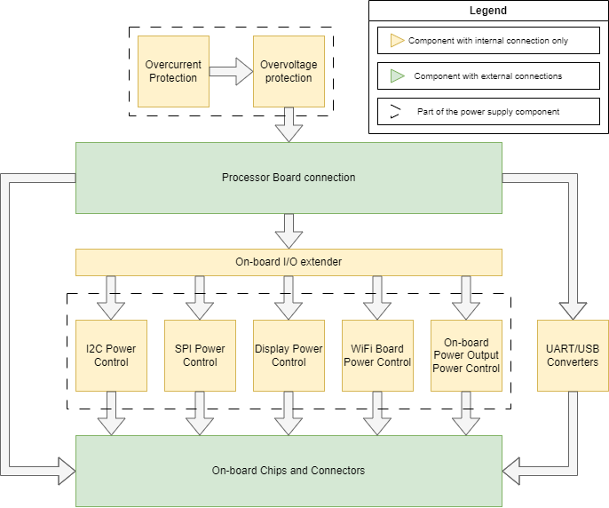

Figure 1: Hardware Component Diagram

# **Chapter 2** Design Description

## Power Circuit Design

|  |  |  |
| --- | --- | --- |
| ID.0001 | USB Connection for Power Supply | |
| USB Connection for Power Supply  An USB connector is used for power supply the board. Only the VDD and GND pins are used. GND is directly connected to the rest of the circuit, making it the common ground. VDD is connected to the *U5V* network, which is then connected to the protection circuits. | | |
| Satisfied HWREQ item(s) | | HWREQ.0003 |

|  |  |  |
| --- | --- | --- |
| ID.0002 | Overcurrent Protection | |
| Overcurrent Protection  Overcurrent protection circuit features a PTC fuse with $I_{hold}=500mA$ and $I_{trip}=1A$ values.  The input of the circuit is marked as *U5V*, while the output is marked as *U5V_FUSED*.  When an overcurrent occurs, the resistance of the PTC will increase significantly, and the voltage of the connection point between *U5V_FUSED* and PTC pin number will be nearly zero. Therefore, the voltage of the PTC will be nearly equal to the voltage of *U5V*. This voltage will activate *LED1* that indicates the overcurrent state. | | |
| Satisfied HWREQ item(s) | | HWREQ.0005, HWREQ.0006 |

|  |  |  |
| --- | --- | --- |
| ID.0003 | Overvoltage Protection | |
| Overvoltage Protection  The main pass element in the protection circuit is the PNP transistor Q2. Care should be taken in selecting this part, as any power-supply voltage drops will be determined by the characteristics of this transistor. This transistor shall exhibit very low VCE saturation voltage values. This minimizes the voltage drop induced by the presence of the protection circuit. The transistor Q1 acts as the control element for Q2 and will turn on (turning Q2 off) when the voltage at the power-supply input is equal to the sum of the zener voltage, due to diode D1 and Q2's own VBE voltage at a collector current of about 650uA. Q2 and D1 together produce a typical trip voltage of 5.85V at 25°C. Approximately 0.53V of this is due to the VBE voltage of Q1. The remaining 5.32V is produced across D2. Note that the zener diode D2, although a nominal 5.6V device, is being operated at a very low reverse current, about 200uA as defined by the VBE of Q1 together with R2. At this current, the zener voltage is below the characteristic "knee" and is therefore less than the rated value. R5 connected to the base of Q2 provides the current necessary to keep Q1 turned on under normal circumstances.  The circuit operates to disconnect the load during overvoltage conditions. That is to say that Q2 switches off when an overvoltage condition is detected, removing power from the load. Q2 will turn on again when the overvoltage condition is removed. One of the attractions of this type of circuit is in its response speed. The circuit does not use feedback, so there are no high-order damping effects or slew-rate limitations to overcome. The full speed of the constituent parts is available to prevent transient power-supply events from reaching the load.  Q1 has been chosen, for convenience, to be the same type as that chosen for Q2, although there are no special requirements of this device and almost any PNP device could be substituted.  *(Reference:* [*https://www.electronics-notes.com/articles/analogue_circuits/power-supply-electronics/current-limiter-circuit.php*](https://www.electronics-notes.com/articles/analogue_circuits/power-supply-electronics/current-limiter-circuit.php) *)* | | |
| Satisfied HWREQ item(s) | | HWREQ.0004, HWREQ.0006 |

|  |  |  |
| --- | --- | --- |
| ID.000X | Power Switch Circuit | |
| TODO | | |
| Satisfied HWREQ item(s) | | HWREQ.0020 |

## UART-USB Converter Design

|  |  |  |
| --- | --- | --- |
| ID.000X | UART-USB Converter Circuit | |
| TODO | | |
| Satisfied HWREQ item(s) | | HWREQ.0007 |

|  |  |  |
| --- | --- | --- |
| ID.000X |  | |
|  | | |
| Satisfied HWREQ item(s) | |  |

## On-board Connectors and ICs

|  |  |  |
| --- | --- | --- |
| ID.000X | On-board I/O Extender Circuit for Power Control | |
|  | | |
| Satisfied HWREQ item(s) | | HWREQ.0008 |

|  |  |  |
| --- | --- | --- |
| ID.000X | On-board I/O Extender Circuit for User Connection | |
|  | | |
| Satisfied HWREQ item(s) | | HWREQ.0008 |

|  |  |  |
| --- | --- | --- |
| ID.000X | USB Connectors | |
|  | | |
| Satisfied HWREQ item(s) | |  |

|  |  |  |
| --- | --- | --- |
| ID.000X |  | |
|  | | |
| Satisfied HWREQ item(s) | |  |

## MCU Pin Assignments

|  |  |  |
| --- | --- | --- |
| ID.000X | Nucleo-64 Compatible Connections | |
|  | | |
| Satisfied HWREQ item(s) | | HWREQ.0001 |

|  |  |  |
| --- | --- | --- |
| ID.000X | MCU Pinout Map | |
| |  |  |  | | --- | --- | --- | | **Pin** | **Function** | **Notes** | | PA0 | UART4_TX | MB02A1 | | PA1 | UART4_RX | MB02A1 | | PA2 | **FREE** | - | | PA3 | **FREE** | - | | PA4 | DAC_OUT | MB02A1 | | PA5 | EXTI1 | MB02A1 | | PA6 | EXTI2 | MB02A1 | | PA7 | EXTI3 | MB02A1 | | PA8 | PWM1 | MB02A1 | | PA9 | USART1_TX | MB02A1 | | PA10 | USART1_RX | MB02A1 | | PA11 | PWM2 | MB02A1 | | PA12 | MCP_PWR_EN | MB02A1 | | PA13 | SWDIO | PB01A1 | | PA14 | SWCLK | PB01A1 | | PA15 | DISPL_BNESS | MB02A1 | |  |  |  | | PB0 | SPI2_CS1 | MB02A1 | | PB1 | SPI2_CS2 | MB02A1 | | PB2 | PWM4 | MB02A1 | | PB3 | I2C2_SDA | MB02A1 | | PB4 | DISPL_RST | MB02A1 | | PB5 | SPI3_MOSI | MB02A1 | | PB6 | I2C1_SCL | MB02A1 | | PB7 | I2C1_SDA | MB02A1 | | PB8 | DISPL_TCH | MB02A1 | | PB9 | DISPL_TIRQ | MB02A1 | | PB10 | I2C2_SCL | MB02A1 | | ~~PB11~~ | NC | - | | PB12 | SPI3_CS | MB02A1 | | PB13 | SPI2_SCK | MB02A1 | | PB14 | SPI2_CS3 | MB02A1 | | PB15 | DISPL_DC | MB02A1 | |  |  |  | | PC0 | ADC1 | MB02A1 | | PC1 | SPI2_MOSI | MB02A1 | | PC2 | SPI2_MISO | MB02A1 | | PC3 | ADC2 | MB02A1 | | PC4 | ADC3 | MB02A1 | | PC5 | ADC4 | MB02A1 | | PC6 | UART6_TX | MB02A1 | | PC7 | UART6_RX | MB02A1 | | PC8 | EXTI4 | MB02A1 | | PC9 | PWM3 | MB02A1 | | PC10 | SPI3_SCK | MB02A1 | | PC11 | SPI3_MISO | MB02A1 | | PC12 | UART5_TX | MB02A1 | | PC13 | LED_GREEN | PB01A1 | | PC14 | LED_YELLOW1 | PB01A1 | | PC15 | LED_YELLOW2 | PB01A1 | |  |  |  | | PD2 | UART5_RX | MB02A1 | |  |  |  | | PH0 | **FREE** | - | | PH1 | **FREE** | - | | | |
| Satisfied HWREQ item(s) | | HWREQ.0001 |

# **Table Of Figures**

Figure 1: Hardware Component Diagram 7