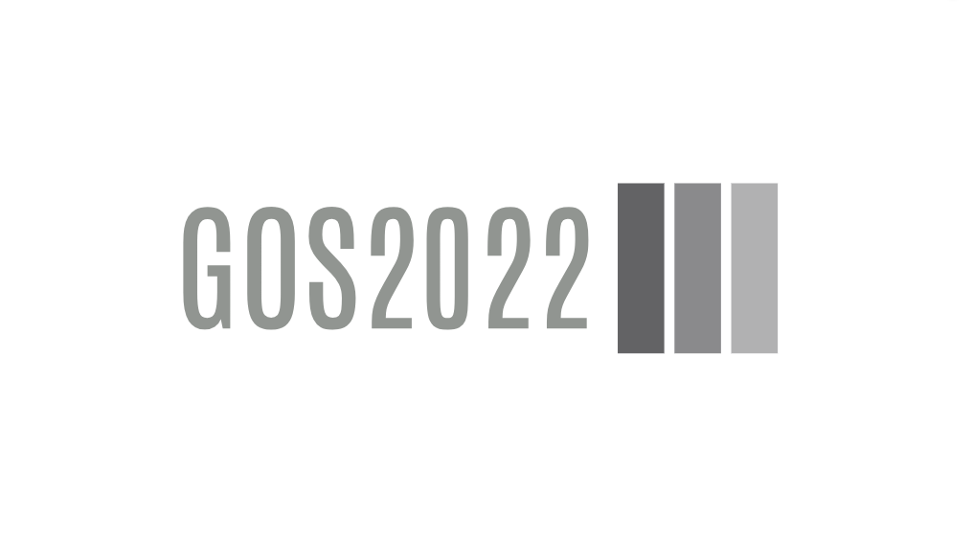

PB01A1 Hardware Requirements Specification

**GOS2022**

PB01A1 Hardware Requirements Specification

**Processor Board Version 01, Revision A1**

© Ahmed Gazar, 2024

|  |  |  |  |  |
| --- | --- | --- | --- | --- |
| Version history | | | | |
| Version | Date | Author | Change | Released |
| 1.0 | 2024-07-23 | Ahmed Gazar | Initial version of document. |  |
|  |  |  |  |  |
|  |  |  |  |  |
|  |  |  |  |  |

# **Content**

Content 5

Chapter 1 Introduction 6

1. Purpose 7

Chapter 2 Requirements 8

HWREQ.0001 9

HWREQ.0002 9

HWREQ.0003 9

HWREQ.0004 9

HWREQ.0005 9

HWREQ.0006 9

HWREQ.0007 10

HWREQ.0008 10

Table Of Figures 11

# **Chapter 1** Introduction

## Purpose

The purpose of the development of Processor Board 01 is to have a custom, MB-compatible (Main Board) processor card that is replaceable and matches the modular development concept.

PB01 shall be interchangeable with the STM32F446 development board on the Main Board, and shall be based on the STM32F446RE MCU,

Figure 1: STM32F446RE LQFP64 Pinout

# **Chapter 2** Requirements

|  |  |
| --- | --- |
| HWREQ.0001 | Compatibility with MB01 and MB02 |
| PB01A1 shall be pin compatible with MB01 and MB02 which also means that it shall be Nucleo-64 compatible. | |

|  |  |
| --- | --- |
| HWREQ.0002 | Debugger Connection |
| PB01A1 shall provide a 10-pin ICD connector to allow for debugger connection (Nucleo ST-Link/V2). | |

|  |  |
| --- | --- |
| HWREQ.0003 | Feedback LEDs |
| PB01A1 shall feature 4 LEDs:   * One green LED that is hard-wired to the power line * Two yellow LEDs for customisable feedback * One red LED for error feedback | |

|  |  |
| --- | --- |
| HWREQ.0004 | LED GPIO assignment |
| The pin assignment of the feedback LEDs shall be in a way that only such pins are used that are unassigned by the Main Board. | |

|  |  |
| --- | --- |
| HWREQ.0005 | Use of SMD components |
| Except for connectors, all components shall be surface mounted. | |

|  |  |
| --- | --- |
| HWREQ.0006 | MCU Type |
| PB01A1 shall feature an STM32F446RE MCU with external oscillator. | |

|  |  |
| --- | --- |
| HWREQ.0007 | Power Regulator |
| PB01A1 shall have an on-board power regulator circuit. | |

|  |  |
| --- | --- |
| HWREQ.0008 | Reset button |
| PB01A1 shall have a reset button that is connected to the reset pin of the MCU. | |

# **Table Of Figures**

Figure 1: STM32F446RE LQFP64 Pinout 7