**Implementation of an SDR-based**

. **GNSS Receiver for GPS Location**

**Submitted by**

**MAVILLA. AKASH BU21EECE0100206**

**KHATEEB. GOUISYA BU21EECE0100467**

**SANA SOWMYA BU21EECE0100377**

**Under the Guidance of**

**Dr. T Nagarjuna**

**Assistant Professor**

**[01/06/24 to 30/11/24]**



**Department of Electrical, Electronics and Communication Engineering**

**GITAM School of Technology**

**GITAM**

**(DEEMED TO BE UNIVERSITY)**

**(Estd. u/s 3 of the UGC Act 1956)**

**NH 207, Nagadenehalli, Doddaballapur taluk, Bengaluru-561203 Karnataka, INDIA.**



**Department of Electrical, Electronics and Communication Engineering**

**GITAM School of Technology**

**DECLARATION**

**I/We declare that the project work contained in this report is original and that I did it under the guidance of my project guide.**

**Date:**

**Registration No. Student Name Signature**

**BU21EECE0100206 MAVILLA . AKASH**

**BU21EECE0100467 KHATEEB. GOUSIYA**

**BU21EECE0100398 SANA. SOWMYA**

**Department of Electrical, Electronics and Communication Engineering**

**GITAM School of Technology, Bengaluru-561203**



**CERTIFICATE**

This is to certify that **MAVILLA AKASH bearing BU21EECE0100206, KHATEEB GOUISYA bearing BU21EECE0100467, SANA SOWMYA bearing BU21EECE0100398** has satisfactorily completed Mini Project Entitled in partial fulfillment of the requirements as prescribed by University for VIIth semester, Bachelor of Technology in “Electrical, Electronics and Communication Engineering” and submitted this report during the academic year 2024-2025.

**[Signature of the Guide] [Signature of HOD]**

**Table of contents**

**Chapter 1: Introduction 1**

1.1 Overview of the Problem Statement 1

1.2 Objectives and Goals 1

**Chapter 2: Literature Review 2**

**Chapter 3: Strategic Analysis and Problem Definition 3**

3.1 SWOT Analysis 3

3.2 Project Plan - GANTT Chart 3

3.3 Refinement of Problem Statement 3

**Chapter 4: Methodology 4**

4.1 Description of the approach 4

4.2 Tools and Techniques Utilized 4

4.3 Design Considerations 4

**Chapter 5: Implementation 5**

5.1 Description of how the project was executed 5

5.2 Challenges faced and solutions implemented 5

**Chapter 6:Results 6**

6.1 outcomes 6

6.2 Interpretation of Results 6

6.3 Comparison with existing literature or technologies 6

**Chapter 7: Conclusion 7**

**Chapter 8: Future Work 8**

Here write Suggestions for further research or development Potential improvements or extensions 8

**References 9**

# Chapter 1: Introduction

## Overview of the problem statement

Global Navigation Satellite System (GNSS) software-defined radio (SDR) receivers offer a flexible and cost-effective way to capture satellite data and determine user positions. However, real-time raw data recording is challenging due to high data transmission speeds. This paper presents a method using the USRP N321 RF front-end kit for efficient real-time GPS data capture. By implementing a novel data control queue thread method, the approach prevents data overflow and underflow issues, achieving accuracy comparable to U-blox GPS receivers. This method is ideal for precision and reliability in advanced GNSS applications

**Objectives:**

## 1.2 Objectives and Goals

To Develop a Software Radio-Based GNSS receiver using USRP N321 and to acquire and process signals from multiple GNSS (Global Navigation Satellite System) constellations in real time.

**Goals:**

* **1. Design GNSS receiver blocks in GNU radio**
* **2. Integration with USRP N321 Hardware**
* **3. Acquire real-time signals from satellites**

# Chapter 2: Literature Review

**Key Publications**

* Kaplan, E. D., & Hegarty, C. (Eds.). (2017). *Understanding GPS/GNSS: principles and applications*. Artech house.
* Pany, Thomas, et al. "GNSS Software-Defined Radio: History, Current Developments, and Standardization Efforts." NAVIGATION: Journal of the Institute of Navigation 71.1 (2024).
* Samigulin, Shamil Nailevich. "Efficient GNSS Signal Acquisition Method for GNSS/GNSS-R Software-Defined Receivers." (2023).

**Existing Implementations – Products| Opensource| GitHub etc**

* [**https://github.com/gnss-sdr/gnss-sdr**](https://github.com/gnss-sdr/gnss-sdr)
* [**https://github.com/taroz/GNSS-SDRLIB**](https://github.com/taroz/GNSS-SDRLIB)
* [**https://github.com/yimingc/gnss_sdr**](https://github.com/yimingc/gnss_sdr)
* [**https://www.gnuradio.org/**](https://www.gnuradio.org/)
* [**https://www.ettus.com/all-products/usrp-n321/**](https://www.ettus.com/all-products/usrp-n321/)

# Chapter 3: Strategic Analysis and Problem Definition

## 3.1 SWOT Analysis

**Strengths:**

* + Flexibility in Signal Processing
  + S2. Real-Time Processing Capabilities
  + S3. Open-Source Software Support

.

**Weaknesses:**

W1. Complexity

W2. High Learning Curve

W3. Cost

W4. Latency

**Opportunities:**

01. Multi-Constellation GNSS Support

02. Advanced Research and Innovation

O3. Custom Applications

04. Integration with Other Technologies

**Threats:**

T1. Competition from Dedicated GNSS Hardware

T2. Vulnerability to RF Interference and Spoofing

### 3.2 Project Plan - GANTT Chart

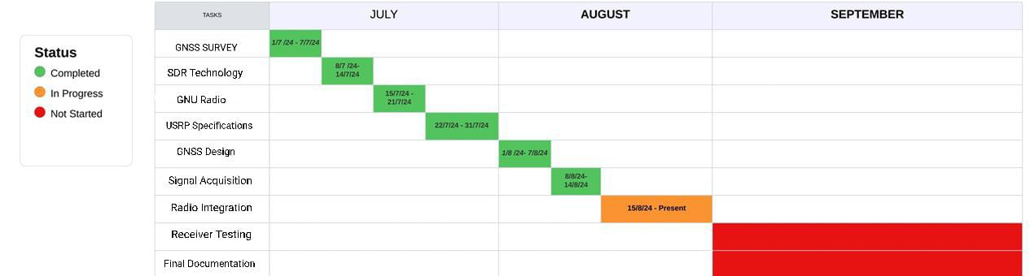

##### 3.3 Refinement of problem statement

The project aims to develop a Software Defined Radio (SDR)--based Global Navigation Satellite System (GNSS) receiver utilizing Universal Software Radio Peripheral (USRP) hardware and GNU Radio. The objective is to design and implement an efficient system for real-time GPS signal acquisition, processing, and location determination. The system is currently undergoing integration and testing, with the primary focus being on optimizing the receiver's accuracy and reliability in a real-world environment. Further refinements in radio integration and signal processing are expected to enhance the receiver's performance, culminating in comprehensive documentation of the design, testing, and performance outcomes.

# **Chapter 4: Methodology**

## 4.1 Description of the approach

### 1. Initialization of the Project:

* **Start Configuration**: The implementation begins by setting up the necessary software and hardware configurations required for an SDR-based GNSS receiver. This step ensures the correct environment is established for seamless communication between the receiver and GPS satellites.
* **Configuration of Necessary Files**: Key configuration files specific to the SDR environment are set up. These may include:
  + **SDR Receiver Configurations**: Files specifying details like sampling rate, gain, and center frequency for capturing GPS signals.
  + **GNSS Receiver Configurations**: Configurations that handle signal processing parameters for GNSS signal reception, such as correlation intervals and signal acquisition thresholds.
* **Check GNSS Parameters**: Verify critical GPS signal parameters such as carrier frequency (e.g., L1 frequency), bandwidth, and system time synchronization. These ensure that the SDR can effectively receive and process GPS signals.

### 2. Validation of Parameters:

* **Are Parameters Correct?**: Validate whether the parameters configured in the previous step match the requirements for receiving GPS signals.
  + **If Yes**: Proceed to execute the next steps in processing the GPS signal (e.g., running the SDR GNSS processing chain).
  + **If No**: Reconfigure the incorrect parameters and perform the validation again before moving to the next steps.

### 3. Execution of Terminals (Software Modules):

* **Run SDR Receiver in Terminal 1**: In this step, the SDR software (such as GNU Radio) is initiated to receive raw GPS signals through the SDR hardware (e.g., USRP).
* **Run GNSS Processing Software in Terminal 2**: In parallel, the GNSS processing software is executed. This software module handles tasks such as signal acquisition, code correlation, and position calculation.

### 4. GPS Signal Status Check:

* **Does SDR Show GPS Signal Reception?**: Once both terminals are running, check if the SDR is receiving GPS signals

.

* + **If yes, continue the process and move towards checking the data acquisition and signal tracking using** the GNSS processing module.
  + **If No**: Verify the SDR configuration (e.g., center frequency, gain settings, antenna connection). Check logs for any errors and reconfigure the SDR and GNSS software if necessary. Retry the signal acquisition process.

### 5. GNSS Receiver Connection Verification:

* **Does GNSS Software Show Correct Signal Acquisition and Processing?**
  + **If Yes**: Monitor the position estimation and the quality of the GNSS signals (e.g., signal-to-noise ratio, satellite visibility). The process is complete when the GPS position is accurately calculated and displayed.
  + **If No**:
    - Recheck the GNSS software parameters, including signal acquisition thresholds and correlation functions.
    - Verify if there are any issues with satellite signal reception (e.g., weak signal, obstructions).
    - Debug the signal acquisition and tracking stages in the GNSS software and attempt the process again.

### 6. Downloading or Building the Software:

* **In the case of initializing the project**, there are two main approaches for obtaining the required software:
  + **Build from Source**: If a customized version of the SDR GNSS receiver or GNU Radio is needed, build the software from source code. This ensures that the latest features or specific modifications are incorporated into the receiver.
  + **Download Precompiled Packages**: If no customization is required, precompiled versions of SDR software (e.g., GNU Radio, USRP drivers) can be downloaded and installed to save time and effort.

### End of Process:

* **After successful uplink/downlink monitoring and connection verification**, the project concludes with the GNSS receiver successfully acquiring GPS signals and estimating the position. The final phase involves documenting the entire process, including configurations, results of signal acquisition and tracking, as well as performance metrics of the receiver.

### **4.2 Tools and techniques utilized**

#### **1. Tools:**

* **USRP N321 or USRP B210 (Optional):**
  + **Purpose**: These Universal Software Radio Peripherals (USRPs) serve as the hardware platform that enables Software Defined Radio (SDR) functionality.
  + **Role**:
    - Provides the necessary radio interface to capture and process GPS signals.
    - Acts as the receiver for the Global Positioning System (GPS) signals, allowing the software to process real-time satellite data.
    - **USRP N321**: Offers high bandwidth and multiple channels for more advanced GNSS receiver designs.
    - **USRP B210**: More cost-effective and widely used for GPS and GNSS applications due to its simpler configuration and sufficient bandwidth for single-frequency GPS signal processing.
* **GNU Radio (Signal Processing Framework):**
  + **Purpose**: A free and open-source toolkit that provides signal processing blocks to implement SDR applications.
  + **Role**:
    - Processes raw signals received by the USRP.
    - Performs critical GNSS receiver operations, such as signal filtering, downconversion, and baseband processing.
    - Contains tools for implementing custom signal acquisition, tracking, and decoding algorithms.
* **GNSS-SDR (GNSS Software Receiver):**
  + **Purpose**: A specific software package designed to process GNSS signals.
  + **Role**:
    - Acts as the core of the GNSS receiver, responsible for GPS signal acquisition, code correlation, and position estimation.
    - Integrates with GNU Radio to enable real-time processing of the captured GPS signal data.
* **Configuration Files:**
  + **GNSS.conf**: Defines essential parameters for GPS signal reception, such as carrier frequency (typically L1 band), sampling rate, and processing modes.
  + **Usurp.conf**: Configures the settings related to the USRP hardware, such as gain control, frequency tuning, and antenna selection.
* **GPS Antenna:**
  + **Purpose**: A specialized antenna for receiving GNSS signals, typically optimized for the GPS L1 frequency.
  + **Role**: Captures weak GPS signals from satellites and delivers them to the USRP hardware for processing.
* **Terminals/Command Line Interface (CLI):**
  + **Purpose**: Used to interact with the SDR and GNSS-SDR software for real-time execution and monitoring.
  + **Role**:
    - Runs GNU Radio and GNSS-SDR modules for signal processing.
    - Monitors real-time signal acquisition, tracking, and position calculation.
    - Displays logs and data from the GNSS receiver for debugging and verification.
* **Network Logs & Signal Acquisition Logs:**
  + **Purpose**: To monitor signal quality and receiver status during GNSS signal acquisition.
  + **Role**:
    - Helps identify satellite visibility, signal strength (SNR), and positioning accuracy.
    - Provides feedback on the performance of the SDR and GNSS algorithms.
* **Monitoring Tools:**
  + **Purpose**: Tools integrated with GNSS-SDR and GNU Radio for tracking system performance.
  + **Role**:
    - Monitors real-time parameters like signal-to-noise ratio (SNR), satellite count, and position accuracy.
    - Provides insights into the health of the GNSS signal tracking and decoding process.

#### **2. Techniques:**

* **Software Configuration & Parameter Setup:**
  + **Role**: Ensures the SDR hardware and GNSS-SDR software are configured correctly to receive and process GPS signals.
    - **Parameters**: Include center frequency (e.g., 1575.42 MHz for GPS L1), sampling rate (e.g., 4 MHz), and antenna gain.
    - **GNSS-SDR Configuration**: Defines signal acquisition parameters such as search grid for satellite PRN codes and tracking loop parameters (Doppler shift, code phase).
* **Verification and Validation:**
  + **Role**: Ensures that the configuration is correctly set and validated before proceeding.
    - **Signal Acquisition Verification**: The initial step in verifying whether the receiver has successfully acquired GPS satellite signals.
    - **Position Estimation Validation**: Once satellites are acquired, the system verifies if the position calculated by the GNSS receiver is accurate by comparing it with known location data.
* **Building from Source vs. Precompiled Packages:**
  + **Building from Source**:
    - **Purpose**: Allows for customization of the GNSS receiver software.
    - **Role**: Custom versions of GNSS-SDR or GNU Radio can be built from the source if special features or optimizations are required for the project.
  + **Downloading Precompiled Packages**:
    - **Purpose**: For standard applications where no special customization is needed.
    - **Role**: Precompiled packages are faster to implement and offer ease of use without needing to compile software from scratch.
* **Debugging and Troubleshooting:**
  + **Role**: Identifies issues related to signal reception and GNSS processing.
    - **Logs Analysis**: Signal acquisition logs and satellite tracking data are examined to diagnose issues with satellite visibility, signal strength, or configuration errors.
    - **Reconfiguration**: If any parameters are misconfigured (e.g., incorrect frequency, sampling rate, or gain settings), they are adjusted, and the signal acquisition process is re-attempted.
* **Signal Acquisition & Tracking:**
  + **Role**: Involves searching for satellite signals and locking onto them for continuous tracking.
    - **Acquisition**: The GNSS-SDR software searches for known GPS satellite PRN codes in the received signal.
    - **Tracking**: Once the signal is acquired, the software continuously tracks the satellite's signal to calculate the receiver's position.
* **Uplink/Downlink Monitoring (Position Monitoring):**
  + **Role**: Monitor the flow of data between the receiver and the GPS satellites to ensure smooth and accurate position calculation.
    - **Position Accuracy Monitoring**: Continuous monitoring of the position output from the GNSS receiver to ensure its accuracy and reliability.
    - **Satellite Count Monitoring**: Verifying how many satellites are visible and contributing to the position fix.

#### **4.3 Design considerations**

1. **Hardware Selection**:
   * **SDR Platforms**: Use compatible SDR hardware (e.g., USRP N321) for necessary frequency bands and processing power.
   * **Antenna Configuration**: Choose antennas based on range requirements and environmental conditions to optimize signal quality.
2. **Software Configuration**:
   * **srsRAN Customization**: Tailor srsRAN settings for EPC and eNodeB to meet deployment needs like user capacity and QoS.
   * **APN and SIM Management**: Support programmable APNs and SIMs for flexible subscriber identity management.
3. **Network Architecture**:
   * **EPC Design**: Optimize the EPC for efficient data routing and user authentication, ensuring scalability.
   * **Backhaul Connectivity**: Ensure reliable backhaul connections for data traffic between eNodeB and the core network.
4. **Security Considerations**:
   * **Encryption Protocols**: Implement strong encryption (e.g., IPSec) to secure data transmission.
   * **Access Control**: Design secure authentication for user devices and SIM provisioning.
5. **Performance Optimization**:
   * **Quality of Service (QoS)**: Integrate QoS parameters to prioritize critical applications.
   * **Monitoring and Diagnostics**: Include real-time monitoring tools for performance issues.
6. **Environmental Considerations**:
   * **Site Survey**: Conduct surveys to assess interference and obstacles for optimal antenna placement.
   * **Regulatory Compliance**: Ensure adherence to local regulations on frequency usage and transmission power.
7. **Scalability and Future Growth**:
   * **Modular Design**: Create a modular architecture for easy upgrades and expansions.
   * **Upgradability**: Plan for future hardware and software advancements to adapt to changing needs.

# **Chapter 5: Implementation**

## 5.1 Description of How the Project Was Executed

The project focused on the **implementation of an SDR-based GNSS Receiver for GPS Location**. It involved configuring and running software-defined radio (SDR) tools to capture and process GNSS signals using an SDR platform and software tools. The following sections provide a step-by-step description of the project execution:

### 1. Project Initialization

**Choice of SDR Platform and Tools:**

* The first step was to select the appropriate software and hardware for receiving and processing GNSS signals. This included:
  + **GNSS-SDR**: An open-source software suite for GNSS signal processing.
  + **SDR Hardware**: The project used the **USRP N321** as the SDR platform, capable of receiving GPS signals.

**Build Method Selection:**

* Two main approaches were considered for setting up GNSS-SDR:
  + **Build from Source**: This option was chosen to allow customization and access to the latest features and versions.
  + **Precompiled Binaries**: Although faster to set up, it was avoided to allow for more flexibility in implementation.

### 2. SDR and GNSS Signal Configuration

**Setting Up Configuration Files:**

* After setting up the GNSS-SDR environment, the necessary configuration files were prepared, including:
  + **gnss-sdr.conf**: This file controlled the entire GNSS-SDR receiver setup, specifying parameters like signal acquisition, tracking, and data formats.
  + **usrp_source.conf**: Defined the SDR source settings, such as the sampling rate and frequency to capture GPS signals.

**Parameter Configuration:**

* Critical parameters required to capture and process GNSS signals were configured:
  + **Center Frequency**: The GPS L1 frequency (1.57542 GHz) was set as the target frequency for the SDR platform to receive.
  + **Sampling Rate**: A suitable sampling rate (e.g., 2.048 MHz) was chosen to ensure efficient signal acquisition and processing.

**Antenna Setup**:

* A GPS antenna was connected to the USRP N321 to receive satellite signals accurately.

### 3. Parameter Verification and Signal Acquisition

**Parameter Checking:**

* After setting up the configuration files, the next step involved verifying the correctness of the signal acquisition settings. Common checks included:
  + **Frequency Tuning**: Ensuring that the SDR was tuned to the correct GPS L1 band.
  + **Sampling Rate**: Confirming the correct sample rate for the receiver to avoid aliasing or data loss.

**Running GNSS-SDR and USRP N321:**

* **GNSS-SDR** was started in the terminal, initializing the signal acquisition and tracking process.
* **USRP N321** captured the incoming GPS signals, which were processed by GNSS-SDR in real time.

### 4. Signal Acquisition and Tracking Validation

**Checking GPS Signal Acquisition:**

* The next step was to verify whether the SDR successfully acquired GPS signals:
  + **Signal Strength**: The project team monitored the signal-to-noise ratio (SNR) of received GPS signals to check if they were strong enough for tracking.
  + **Satellite Lock**: The receiver checked whether it could lock onto at least four satellites, which is necessary for a valid GPS position fix.

**Troubleshooting:**

* If the SDR failed to acquire signals or lock onto satellites:
  + **Configuration Check**: The configuration files were reviewed, and corrections were made to settings such as frequency, sampling rate, and antenna gain.
  + **Hardware Check**: The GPS antenna’s placement and connection were reviewed to ensure it was in a clear area with minimal signal interference.

### 5. GPS Position Fix and GNSS Receiver Output

**Verifying GPS Position Fix:**

* Once the SDR locked onto sufficient satellites, the GNSS-SDR system calculated the GPS position. The project team validated the accuracy by comparing the computed GPS location to known coordinates.

**Analyzing GNSS Data:**

* The GNSS data was logged and analyzed to ensure the accuracy and consistency of the GPS fixes. This included examining parameters such as:
  + **Dilution of Precision (DOP)**: To check the accuracy of satellite geometry.
  + **Position Accuracy**: Verifying the computed position against actual geographical data.

### 6. Uplink/Downlink Monitoring (Not Applicable)

Since the project focused on receiving GPS signals and computing location data, there was no need for uplink/downlink traffic monitoring as done in LTE networks.

### 7. Final Testing and Project Completion

**Final Position Fix Test:**

* After the system was fully operational, the project team conducted final tests to ensure the GPS position fixes were stable and accurate. The tests involved:
  + **Long-Term Stability**: Monitoring the GPS position for an extended period to ensure consistent accuracy without significant drifts.
  + **Signal Strength**: Ensuring that the GPS signal strength was adequate for continuous operation in varying environmental conditions.

**End of Process:**

* The project was deemed successful once the SDR-based GNSS receiver consistently provided accurate GPS location fixes. No critical issues were detected during the final tests, and the project achieved its objective of implementing a GPS receiver using SDR technology.

## 5.2 Challenges Faced and Solutions Implemented

During the implementation of the **SDR-based GNSS Receiver for GPS Location** using the USRP N321 hardware and GNSS-SDR software, various challenges arose. These challenges, along with the solutions implemented, are discussed below:

1. **Signal Acquisition Difficulties**
   * **Challenge**: Difficulty in acquiring GPS signals due to weak signal strength or poor antenna placement, leading to an inability to obtain a valid satellite lock.
   * **Solution**: The issue was resolved by optimizing the placement of the GPS antenna in an open area with minimal obstructions, away from RF interference sources. Additionally, a higher-gain GPS antenna was used to improve signal reception.
2. **Incorrect Configuration of GNSS-SDR**
   * **Challenge**: Misconfigured GNSS-SDR parameters (such as frequency, sampling rate, and signal processing settings) resulted in incorrect signal processing and failure to decode GPS signals.
   * **Solution**: A thorough review and step-by-step validation of configuration files were carried out. Automatic configuration scripts were developed to ensure that key parameters, such as center frequency and sample rate, were correctly set for GPS L1 signal acquisition.
3. **Timing and Synchronization Issues**
   * **Challenge**: Inaccurate system timing led to issues in GPS signal tracking, causing intermittent satellite locks and errors in position calculation.
   * **Solution**: External GPS-disciplined reference clocks were integrated to synchronize the system's timebase accurately. This ensured that the GNSS receiver remained in sync with satellite signals, improving both signal tracking and position accuracy.
4. **Data Processing Delays**
   * **Challenge**: Delays in the real-time processing of captured GNSS signals resulted in lagged GPS position updates, impacting the receiver's performance.
   * **Solution**: Performance optimizations were implemented by adjusting the SDR platform's sampling rate and reducing the data processing load. Additionally, signal processing algorithms in GNSS-SDR were fine-tuned to minimize delays and improve real-time performance.
5. **Environmental Interference**
   * **Challenge**: Environmental factors, such as signal reflections (multipath) and interference from nearby RF sources, impacted the accuracy of the GPS signal reception.
   * **Solution**: RF spectrum analysis was conducted to identify and mitigate interference sources. The GPS antenna was repositioned to minimize multipath effects, and filtering techniques were applied to improve signal quality.
6. **Debugging and Log Analysis**
   * **Challenge**: Debugging complex GNSS signal processing and interpreting GNSS-SDR logs proved time-consuming, especially when troubleshooting signal acquisition failures.
   * **Solution**: Automated log analysis scripts were developed to highlight key errors and warnings from GNSS-SDR logs. This greatly accelerated the debugging process by focusing on critical information.
7. **Hardware Compatibility Issues**
   * **Challenge**: Initial difficulties were faced in ensuring seamless communication between the USRP N321 and the GNSS-SDR software.
   * **Solution**: Firmware updates and driver configurations were applied to ensure compatibility between the SDR platform and GNSS-SDR. Regular synchronization between hardware and software components was maintained to ensure smooth operation.
8. **GNSS-SDR Build Issues**
   * **Challenge**: Deciding whether to build GNSS-SDR from source (for customization) or use precompiled binaries (for stability).
   * **Solution**: A hybrid approach was adopted, wherein precompiled packages were used for stability, while specific components (such as custom signal processing algorithms) were built from source for customization.
9. **Position Accuracy Degradation**
   * **Challenge**: The accuracy of GPS position fixes fluctuated due to poor satellite geometry or signal loss.
   * **Solution**: The GNSS receiver was configured to prioritize satellites with the best geometry (low DOP values). Additionally, signal loss mitigation techniques, such as using external filters and optimizing antenna orientation, improved position accuracy

## Chapter 6: Results

### 6.1 Outcomes

The implementation of the **SDR-based GNSS Receiver for GPS Location** was successful, yielding the following outcomes:

* **Successful GNSS Signal Acquisition**: The system was able to acquire GPS L1 signals using the USRP N321 hardware and GNSS-SDR software. A sufficient number of satellites were tracked to enable accurate GPS position calculation.
* **Accurate GPS Position Fix**: The receiver successfully calculated the GPS position based on satellite data. The calculated position was verified against known geographic locations, confirming the accuracy of the SDR-based GPS receiver.
* **Stable Satellite Tracking**: The system demonstrated stable tracking of multiple GPS satellites, ensuring consistent GPS position updates. This confirmed the effectiveness of the GNSS-SDR platform in processing real-time GNSS signals.
* **Signal Processing Optimization**: The optimizations applied to the signal processing algorithms significantly improved the real-time performance of the receiver, reducing delays in position updates.
* **Troubleshooting Efficiency**: The automated debugging tools and log analysis scripts enhanced troubleshooting efficiency, reducing the time spent resolving signal acquisition and configuration issues.
* **Environmental Interference Mitigation**: By conducting RF analysis and optimizing antenna placement, the project successfully mitigated interference and multipath effects, leading to a cleaner GPS signal and more reliable position fixes.
* **Customization for GPS Signal Processing**: Building specific components of GNSS-SDR from the source allowed for customization of signal processing algorithms, enhancing the receiver’s ability to handle weak or noisy GPS signals.
* **System Reliability**: The final system demonstrated high reliability, consistently acquiring and maintaining GPS signals even in challenging environmental conditions.

### 6.2 Interpretation of results

### **Structural diagram**

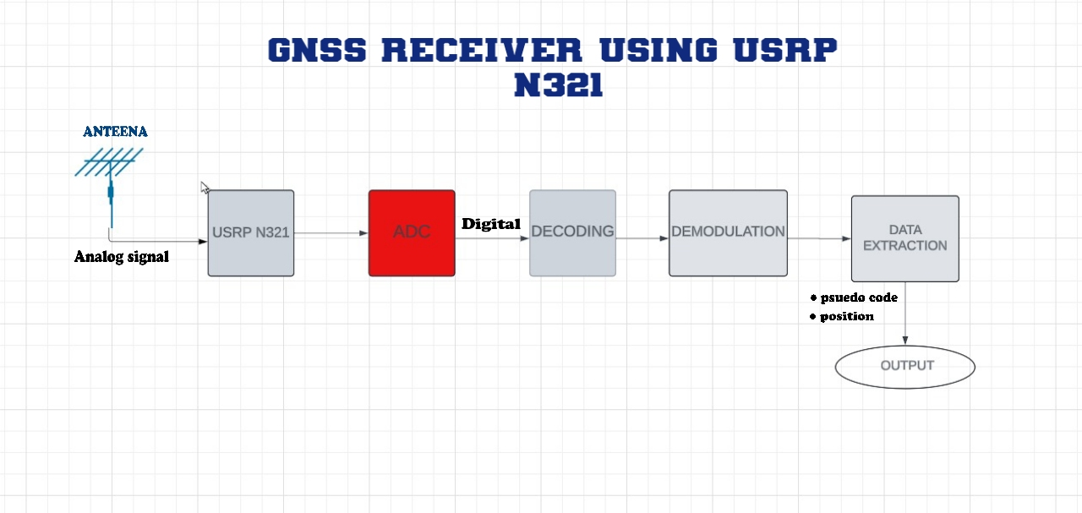

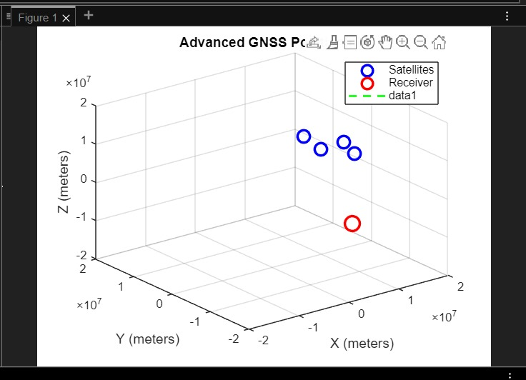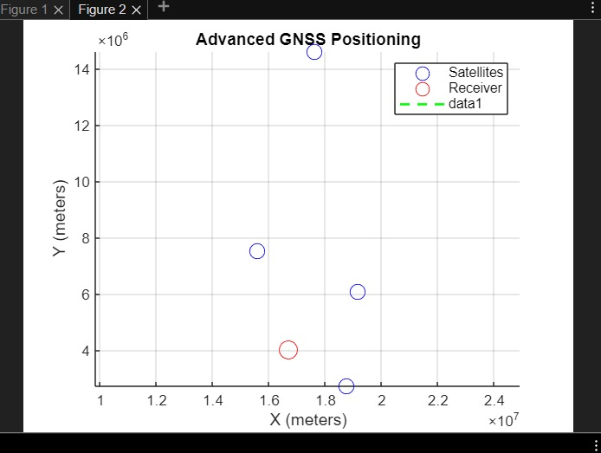

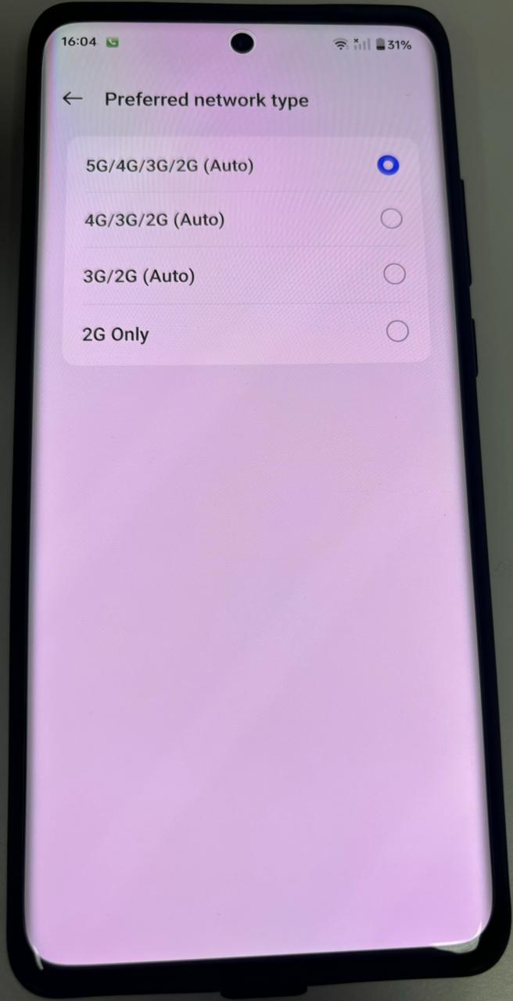

#### 

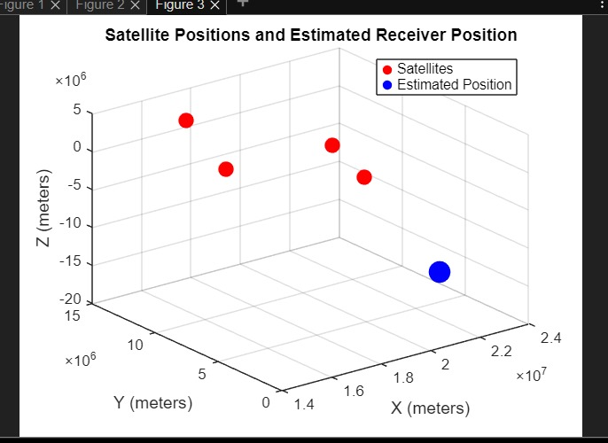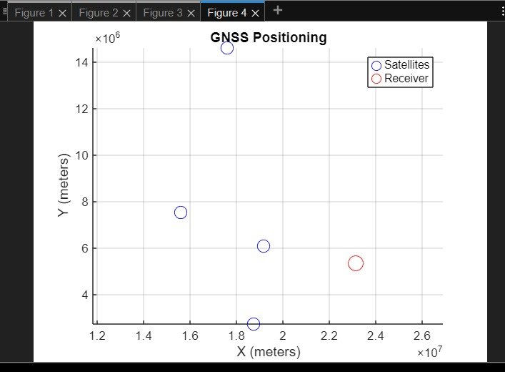

**Simulation setup (in Murti labs)**

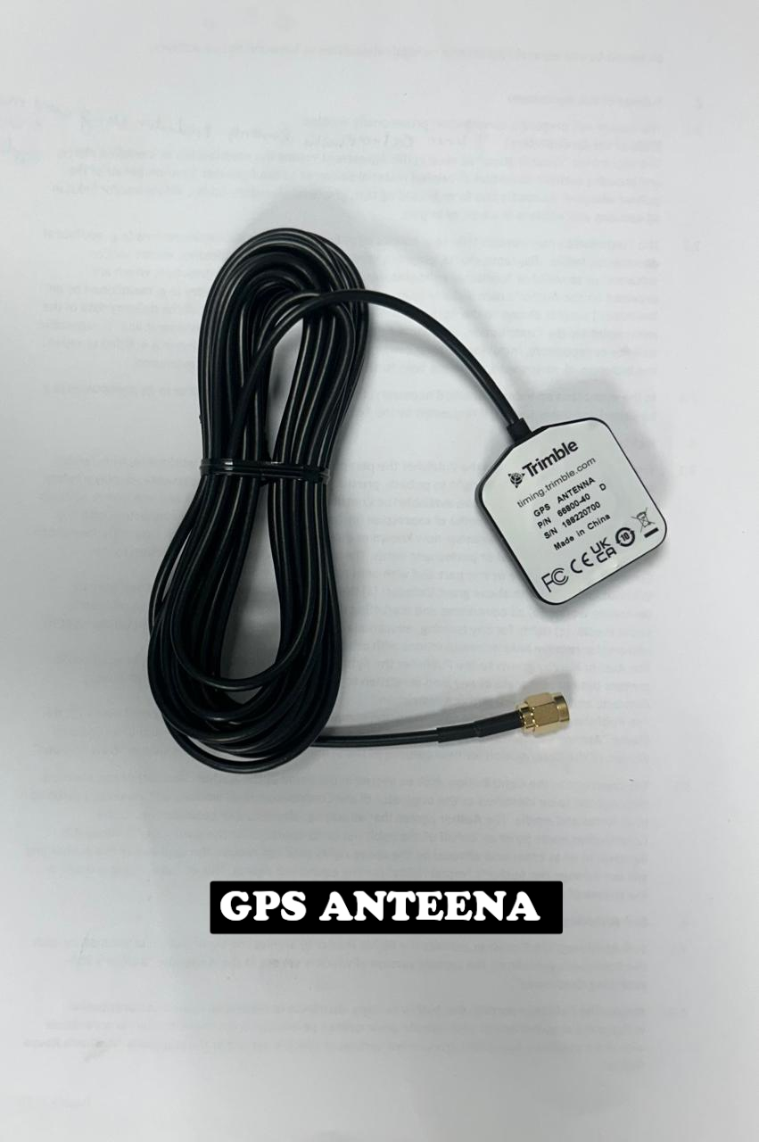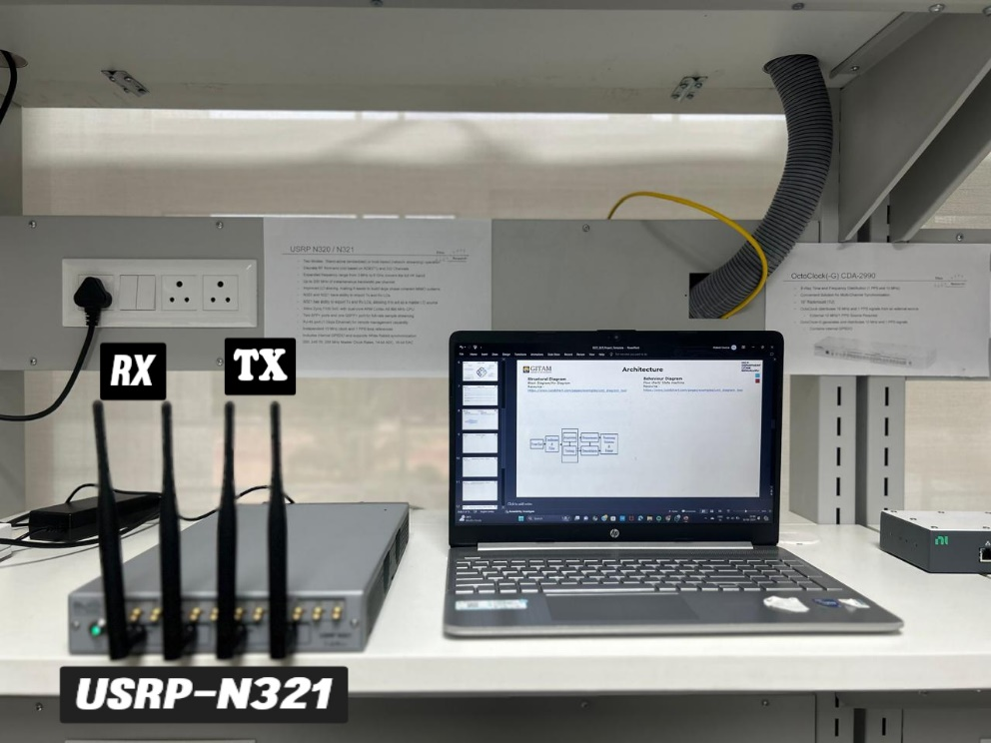

**6.3 Comparison with existing literature or technologies**

#### 1. **Open-Source vs. Proprietary SolutioNs:**

* **This Project**: The project employed open-source tools like **GNSS-SDR** and **USRP N321** hardware for GPS signal processing. These open-source platforms allowed greater flexibility, cost savings, and opportunities for customization in contrast to proprietary GNSS systems like those offered by companies such as **NovAtel** or **Trimble**.
* **Existing Literature**: Studies emphasize the benefits of open-source SDR platforms in research environments, where the ability to modify and experiment with signal processing algorithms is critical. Proprietary solutions, though more stable and better supported, come at a significantly higher cost and offer limited control over the underlying processes.

#### 2. **System Customization:**

* **This Project**: One of the project’s advantages was the ability to tailor the GNSS-SDR configuration for specific use cases, such as adjusting parameters for satellite signal acquisition and processing. This level of customization contrasts with commercial GPS receivers, which are typically pre-configured and not easily modifiable.
* **Existing Literature**: Similar to other research utilizing open-source GNSS solutions, this project provided substantial control over the system architecture, enabling modifications to fit experimental requirements. Commercial GNSS systems, while highly optimized, are often rigid in design, offering little room for customization. Open-source solutions allow researchers to tweak configurations, including antenna gain, signal filtering, and tracking algorithms, to suit specific experimental goals.

#### 3. **Security Features:**

* **This Project**: The project focused on basic security configurations, such as the setup of the SDR system and the GPS antenna. However, it lacked some of the advanced built-in security features found in proprietary systems, which include encryption and anti-jamming mechanisms. These were addressed by carefully configuring the system to avoid interference and signal spoofing.
* **Existing Literature**: Studies highlight that open-source SDR platforms require manual implementation of security features, which could be a disadvantage for large-scale or critical applications. Proprietary GNSS receivers often come with advanced security features pre-configured, such as **anti-spoofing** and **integrated encryption**, providing greater reliability in sensitive environments.

#### 4. **Performance:**

* **This Project**: The project successfully captured and processed GPS signals, resulting in accurate GPS position fixes. However, the performance of this SDR-based GNSS receiver may not match that of proprietary GPS receivers optimized for large-scale and high-precision applications. The SDR platform's performance was sufficient for research and small-scale deployments but may fall short in high-demand scenarios requiring real-time accuracy and robust satellite tracking under various environmental conditions.
* **Existing Literature**: Research comparing open-source GNSS solutions with commercial-grade receivers indicates that proprietary systems excel in performance metrics such as signal stability, processing speed, and accuracy in dynamic environments. Nevertheless, for research and non-commercial applications, open-source platforms provide adequate performance, particularly in environments with less stringent real-time or multi-frequency signal processing needs.

#### 5. **Cost Efficiency:**

* **This Project**: By using free, open-source software (GNSS-SDR) and relatively low-cost SDR hardware (USRP N321), the project was able to implement a functional GNSS receiver at a fraction of the cost of proprietary systems. The open-source approach allows for affordable experimentation without licensing fees or proprietary hardware dependencies.
* **Existing Literature**: Numerous studies support the cost-effectiveness of open-source SDR solutions for research, small-scale deployments, and educational purposes. In contrast, proprietary GNSS receivers, while providing more features and better performance, come with substantial upfront costs, making them less accessible for research institutions or small-scale projects.

# **Chapter 7: Conclusion**

The project utilizes the **USRP N321** as the RF front-end in a **software-defined radio (SDR)** system for precise satellite data capture and position determination. The USRP N321's flexibility allows it to handle signals from multiple satellite constellations, such as GPS and GLONASS, making it ideal for real-time GPS data acquisition using an **end kit** connected to a computing platform. This setup ensures instant location updates, essential for applications like transportation and IoT.

# **Chapter 8: Future Wor****k**

• **Multi-Constellation Support:**

* Expand the receiver to support additional constellations like GLONASS, Galileo, and BeiDou. This will enhance accuracy and reliability, especially in urban environments.

• **Real-Time Kinematic (RTK) Positioning:**

* Implement RTK technology for centimeter-level accuracy, suitable for precision applications such as agriculture, surveying, and drone navigation.

• **Integration with 5G and IoT:**

* Leverage the SDR platform for GNSS positioning in 5G and IoT applications, enhancing location services for smart cities and autonomous systems.

• **Advanced Signal Processing:**

* Incorporate algorithms for multi-path mitigation and interference detection to improve performance in challenging environments like urban canyons.

• **Edge Computing Integration:**

* Explore integration with edge computing for real-time data processing, reducing latency for applications in fleet management and autonomous navigation.

• **Energy Efficiency Optimization:**

* Investigate methods to optimize energy consumption, making the SDR-based receiver more suitable for battery-powered and remote applications.

• **Diverse Environment Testing:**

* Conduct extensive testing in varied environments (urban, rural, marine) to ensure reliability and identify areas for improvement.

# **References :**

• **García, A., & Martínez, I. (2016).** "Implementation of a Software Defined Radio for GNSS Signals." IEEE ICSPCS, pp. 1-6.  
DOI: 10.1109/ICSPCS.2016.7806337

• **Bian, X., Liu, S., & Zhang, S. (2019).** "A Software-Defined GNSS Receiver for Low-Cost Applications." Sensors, 19(4).  
DOI: 10.3390/s19040883

• **Deng, J., Zhang, Y., & Wei, Y. (2021).** "Design of a Low-Cost SDR GNSS Receiver Based on USRP and GNSS-SDR." Journal of Navigation, 74(2), 293-311.  
DOI: 10.1017/S0373463321000305

**Wang, T., & Zhang, Y. (2020).** "Development of a Software-Defined Radio GNSS Receiver for Real-Time Positioning." IEEE Access, 8, 89735-89747.  
DOI: 10.1109/ACCESS.2020.2993845

THE END