BluTrain Tensor Parallelism — Implementation Report
124M GPT-2 · Custom C++/CUDA TP Stack · Dual RTX 5070

1. Overview
To reduce the overhead imposed by high-level frameworks, BluTrain implements a tensor-parallel training stack in C++ and CUDA. The core abstraction separates a tensor’s global shape from its physical allocation across a multi-GPU device mesh, allowing individual layers to be written without awareness of their distributed context. Collective communications are determined at layer boundaries and inserted into the backward graph automatically. Row and column parallelism follow the Megatron-LM scheme, extended to work jointly with vocabulary parallelism.
This report covers the 124M-parameter GPT-2 configuration. It documents the base TP scheme (single-GPU baseline versus TP=2), a throughput comparison of BluTrain TP=2 against a Megatron-LM reference at the same parallel degree, and the dual-stream AsyncTP AllReduce-overlap variant evaluated at two and four token sub-chunks. All runs use full FP32 precision.

2. Model Configuration
Parameter | Value
vocab_size | 50304
context_length | 1024
n_embd | 768
n_heads | 12
n_layers | 12
head_dim | 64
B × T | 4 × 1024
global_batch | 524288
grad_accum_steps | 128
Weight Tying | ENABLED
Parameters (1 GPU) | 124,475,904
Parameters / GPU (TP=2) | 62,659,584
Precision | FP32

3. BluTrain Base Tensor Parallelism

3.1 How It Works
In the base configuration, each GPU holds a vertical shard of the weight matrix. For a column-parallel layer, every rank computes a partial output independently. For a row-parallel layer, each rank holds a horizontal shard and produces a partial sum that must be reduced across all ranks. The synchronization step is a blocking AllReduce — the compute stream stalls until the collective completes and the fully reduced tensor is available to the next operation.

3.2 Algorithm
--- Column-parallel forward ---
Y_partial = X @ W_local # each rank computes its own output shard
# no collective needed; output is partitioned

--- Row-parallel forward ---
Y_partial = X_local @ W # partial sum on each rank
AllReduce(Y_partial) -> Y # BLOCKING: all ranks stall until reduction done
# downstream op reads Y only after AR completes

--- Column-parallel backward ---
grad_X = grad_Y @ W_local^T # partial grad on each rank
AllReduce(grad_X) # BLOCKING: stalls until grad is fully reduced
grad_W = X_local^T @ grad_Y # weight grad (local, no collective needed)
The cost is that every row-parallel layer adds one full collective latency to the forward pass, and each column-parallel backward adds one to the backward pass. On PCIe hardware this collective is bandwidth-bound and serializes compute across all transformer blocks.

4. Results — BluTrain Base TP

4.1 Single-GPU vs TP=2: Memory and Throughput
The base scheme was first evaluated on a single GPU and then with tensor-parallel degree two (TP=2). Sharding the parameter and activation states across two devices both relieves per-device memory pressure and raises throughput. Reported throughput figures are steady-state averages, excluding the first warmup/compilation step.
Metric | 1 GPU | TP=2 | Improvement
Avg. throughput (tok/sec) | 25,108 | 33,961 | +35.3%
Step time (ms) | 20,881 | 15,438 | -26.1%
Peak memory / device (MiB) | 8,966 | 5,762 | -35.7%
Parameters / device | 124.48M | 62.66M | -49.7%
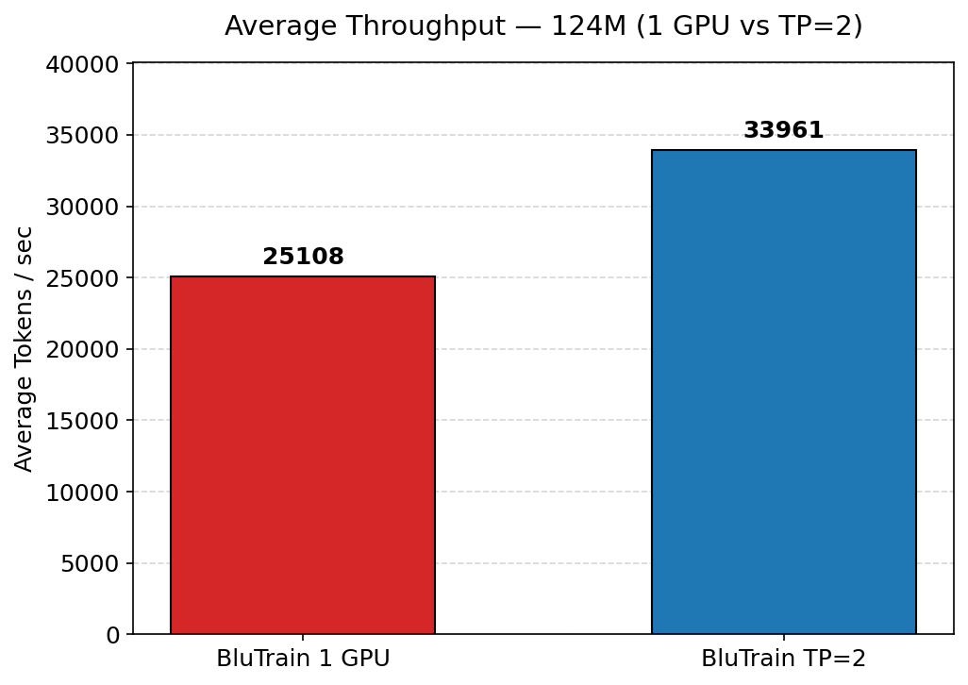
Figure 1. Average throughput, 124M base TP — 1 GPU vs TP=2.
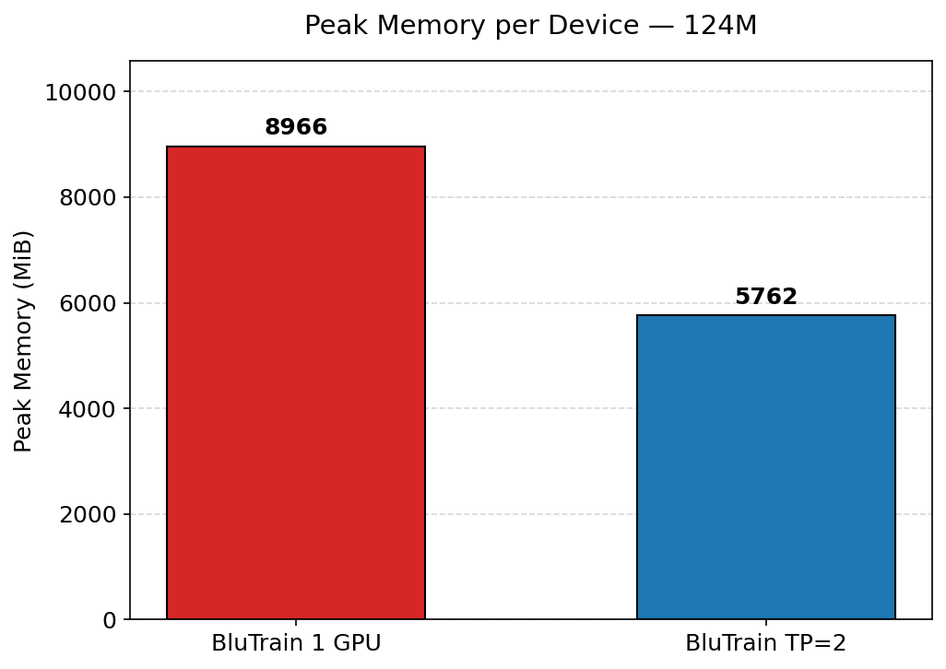
Figure 2. Peak memory per device, 124M base TP — 1 GPU vs TP=2.
At TP=2, BluTrain reaches a mean throughput of 33,961 tokens/sec, a 35.3% gain over the single-GPU baseline of 25,108 tokens/sec, while peak memory per device drops from 8,966 MiB to 5,762 MiB (a 35.7% reduction). The memory saving is what makes the configuration practical: the 124M model at this batch size sits close to the single-device capacity ceiling, and TP=2 sharding restores comfortable headroom.

5. Comparison with Megatron-LM

5.1 Throughput — BluTrain TP=2 vs Megatron TP=2
To validate the multi-device architecture, the BluTrain TP=2 runtime was benchmarked against a PyTorch-based Megatron-LM reference on the same dual-GPU testbed, at identical model configuration, global batch size, and FP32 precision. Both systems use tensor-parallel degree two.
System (124M, TP=2) | Avg. throughput (tok/sec) | Step time (ms)
Megatron-LM | 28,374 | 18,478
BluTrain | 33,961 | 15,438
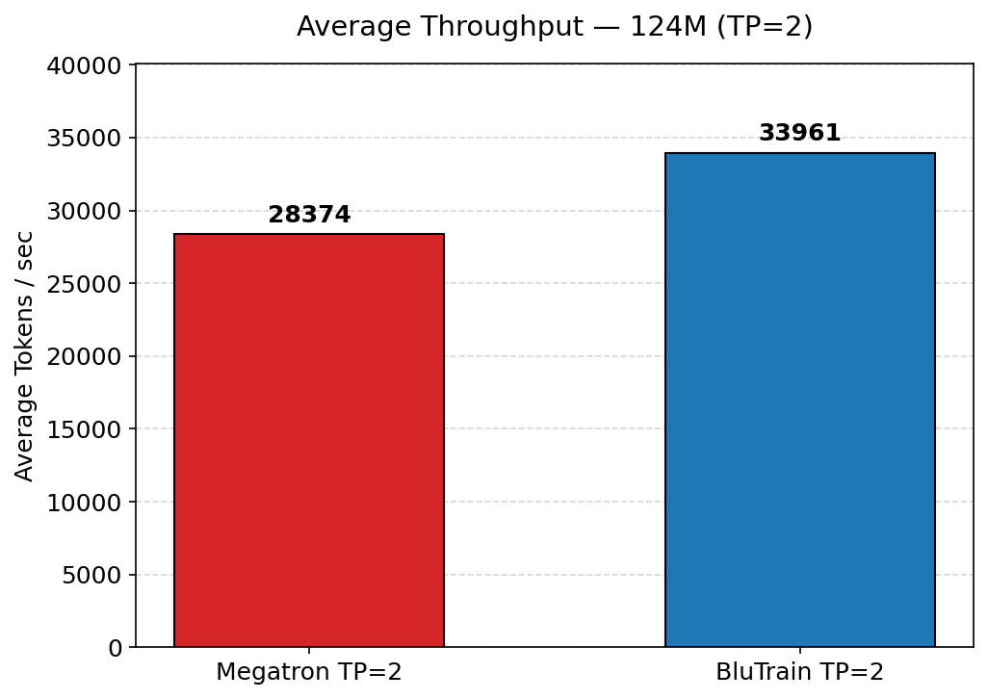
Figure 3. Average throughput at TP=2, 124M — Megatron-LM vs BluTrain.
At TP=2 BluTrain sustains 33,961 tokens/sec against the Megatron-LM baseline of 28,374 tokens/sec, a 19.7% advantage, with per-step time falling from 18,478 ms to 15,438 ms. The gap is attributable to reduced framework dispatch overhead rather than any change to the model architecture; both systems train the same 124M configuration to matching loss trajectories.

6. BluTrain AsyncTP — AllReduce Overlap

6.1 Motivation
The base scheme places every AllReduce on the critical path. Between the time a layer finishes its GEMM and the time the next layer can begin, the GPU sits idle waiting for the collective to propagate across devices. The goal of AsyncTP is to eliminate this idle time by running the AllReduce concurrently with the next available compute operation, so communication and computation proceed in parallel rather than in sequence.

6.2 Design
The overlap is implemented using two CUDA streams: a compute stream for cuBLAS GEMMs and a separate non-blocking NCCL stream for collectives. CUDA events bridge the two streams, ensuring each chunk’s AllReduce only begins once that chunk’s GEMM has written its output. The token dimension is split into N equal sub-chunks; AllReduce(chunk i) fires on the NCCL stream while GEMM(chunk i+1) runs on the compute stream, so the collective hides behind the matmul that produced it rather than serializing after it. With N=1 the path degenerates to the base blocking case, which serves as a correctness anchor. The hidden fraction is (N-1)/N of the total AllReduce volume, bounded by how much compute exists to hide behind.

6.3 Algorithm
# Backward (column-parallel) - chunked AR on grad_X
nc = num_chunks
for i in 0..nc-1:
grad_X[i] = grad_Y[i] @ W^T # compute stream
record event[i] # signal chunk i GEMM done
grad_W = X^T @ grad_Y # enqueued before any AR; runs during pipeline
for i in 0..nc-1:
nccl_stream waits event[i]
AllReduce(grad_X[i]) # NCCL stream; overlaps GEMM[i+1] + grad_W
compute_stream waits ev_ar_done # sync before downstream reads grad_X

6.4 Results — Base TP vs AsyncTP (N=2, N=4)
AsyncTP was evaluated on the same 124M TP=2 configuration at two and four token sub-chunks, against the base blocking TP run. Throughput figures are steady-state averages; per-stage timings are averaged forward, backward, and MLP times per step.
Configuration | Throughput (tok/sec) | Forward (ms) | Backward (ms) | MLP (ms)
Base TP (blocking) | 33,961 | 5,304 | 9,781 | 2,273
AsyncTP N=2 | 36,562 | 5,325 | 8,661 | 2,287
AsyncTP N=4 | 36,658 | 5,219 | 8,729 | 2,201
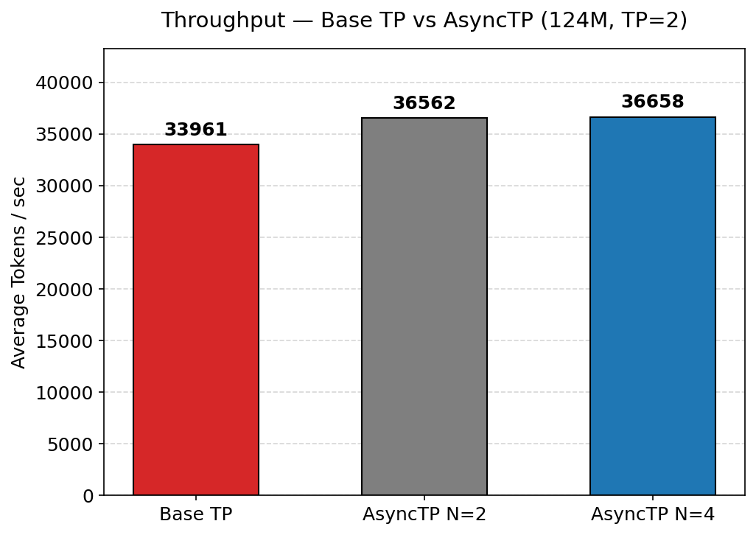
Figure 4. Throughput — base TP vs AsyncTP (124M, TP=2).
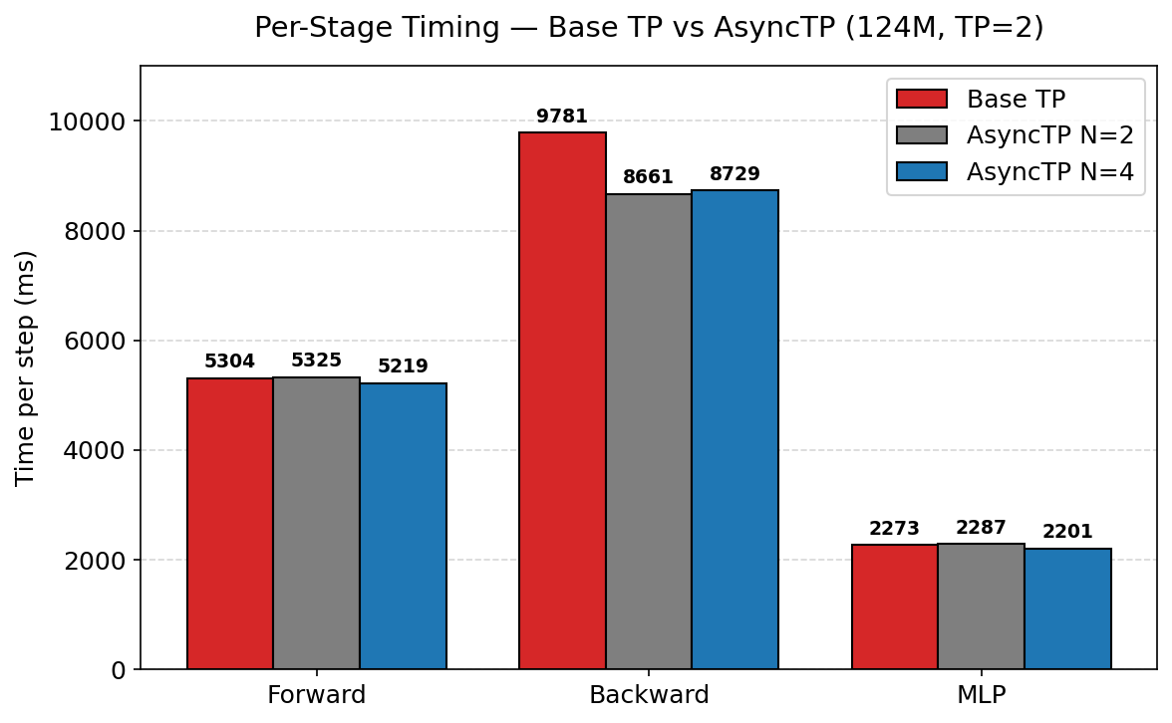
Figure 5. Per-stage timing — base TP vs AsyncTP (124M, TP=2).
Overlapping the collective lifts throughput from 33,961 tokens/sec (base) to 36,562 tokens/sec at N=2 (+7.7%) and 36,658 tokens/sec at N=4 (+7.9%). The gain comes almost entirely from the backward pass, where the AllReduce on grad_X dominates: backward time drops from 9,781 ms to 8,661 ms (N=2) and 8,729 ms (N=4), recovering roughly 1.1 s per step. Forward and MLP times are essentially unchanged, as expected for a backward-side optimization. The marginal difference between N=2 and N=4 indicates that two sub-chunks already expose enough compute to hide most of the collective; finer chunking yields diminishing returns at this model size.

6.5 Summary of Deltas
Comparison (124M, TP=2) | Metric | Delta
AsyncTP N=2 vs Base | Throughput | +7.7%
AsyncTP N=2 vs Base | Backward time | -1,119 ms
AsyncTP N=4 vs Base | Throughput | +7.9%
AsyncTP N=4 vs Base | Backward time | -1,052 ms
AsyncTP N=4 vs N=2 | Throughput | +0.3%

