LINUX PROGRAMMING LAB – 3

NAME: GOVIND RAHUL KANTHETI
REG NO: 16MIS1058

1. Write a shell scrpit to search for a string a file

rahul.sh
echo "Enter your String:"
read string1
if grep -qF "$String1" rahul.txt; then
echo "Found it"
else
echo "Sorry"
fi
exit 0

rahul.txt
This is a test

Output:
This is a test
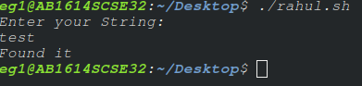

2. loop--> while+grep

rahul.sh:
while read line
do
grep -c "line"
done < rahul.txt

rahul.txt:
first line
second line

Output:

3.Write a script that will check log file every hour to check for errors. If errors found,display the error message.

rahul.sh
echo grep base-passwd dpkg.log

4.Write a shell script to perform the following
- Measure the performance of a background process(P1)
- Display every 5 min, the CPU utilization(%) and Memory utilization(%) of P1 into a file called P1measure

rahul.sh
ps -aux | grep -i firefox
top -p 3845

Output:

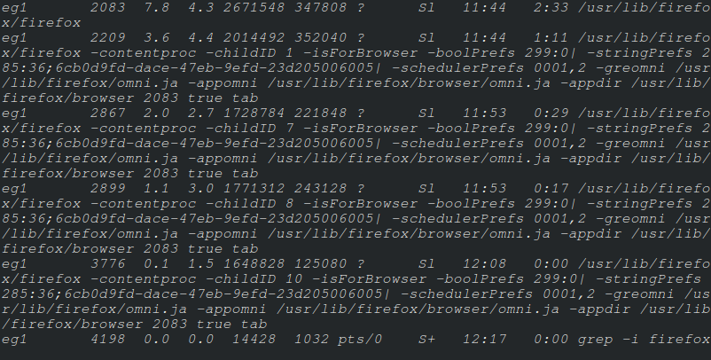

(or)
$ ps -p 3845 -o %cpu,%mem,cmd

%CPU %MEM CMD
11.1 3.7 /usr/lib/firefox/firefox

