LINUX PROGRAMMING LAB 6

NAME: GOVIND RAHUL KANTHETI
REG NO: 16MIS1058

(1)

CODE:

#include<stdio.h>
#include<fcntl.h>
#include<errno.h>
extern int errno;
int main()
{
int fd=open("good.txt",O_RDONLY);
printf("fd=%d\n",fd);
if(fd==-1)
{
printf("erreor%d",errno);
perror("Program");
}
return 0;
}

OUTPUT:

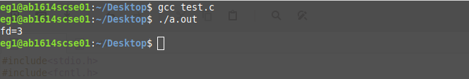

(2)

CODE:

#include<stdio.h>
#include<string.h>
#include<errno.h>
#include<unistd.h>
#include <fcntl.h>
int main()
{
int fd=open("good.txt",O_RDONLY);

printf("fd=%d\n",fd);
if(fd==-1)
{
printf("erreor%d",errno);
perror("Program");
}
char word[50];
read(fd,word,sizeof(word));
const char *buf="ok great";
ssize_t nr;
nr=write(fd,buf,strlen(buf));
}

OUTPUT:

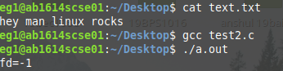

(3)

CODE:

#include<stdio.h>
#include<fcntl.h>
#include<errno.h>
#include<stdlib.h>
#include<string.h>
int main()
{
int fd = open("good.txt", O_RDONLY,0777);
int sz;
const char *buf="read in one file and written to another file";
ssize_t nr;
nr=write(fd,buf,strlen(buf));
if (nr==-1 && errno != EINTR)
{
perror("Read"); exit(EXIT_FAILURE);

}
return 0;
}

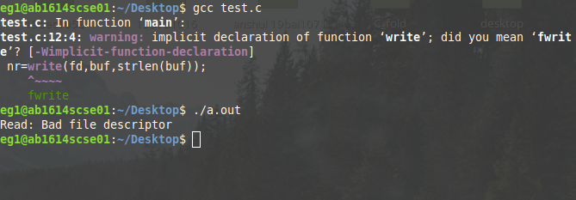

(4)

CODE:

fac

