LINUX PROGRAMMING VIRTUAL LAB

NAME: GOVIND RAHUL KANTHETI
REG NO: 16MIS1058

(1)
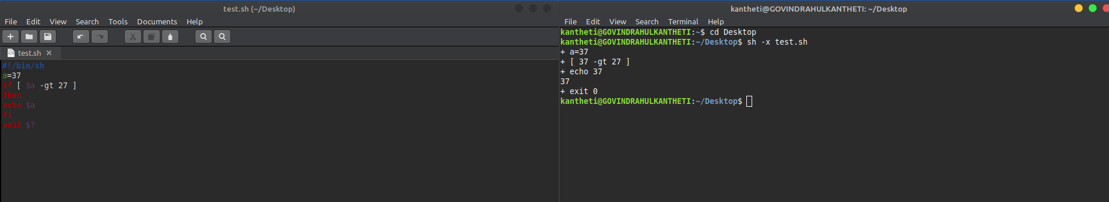

(2)

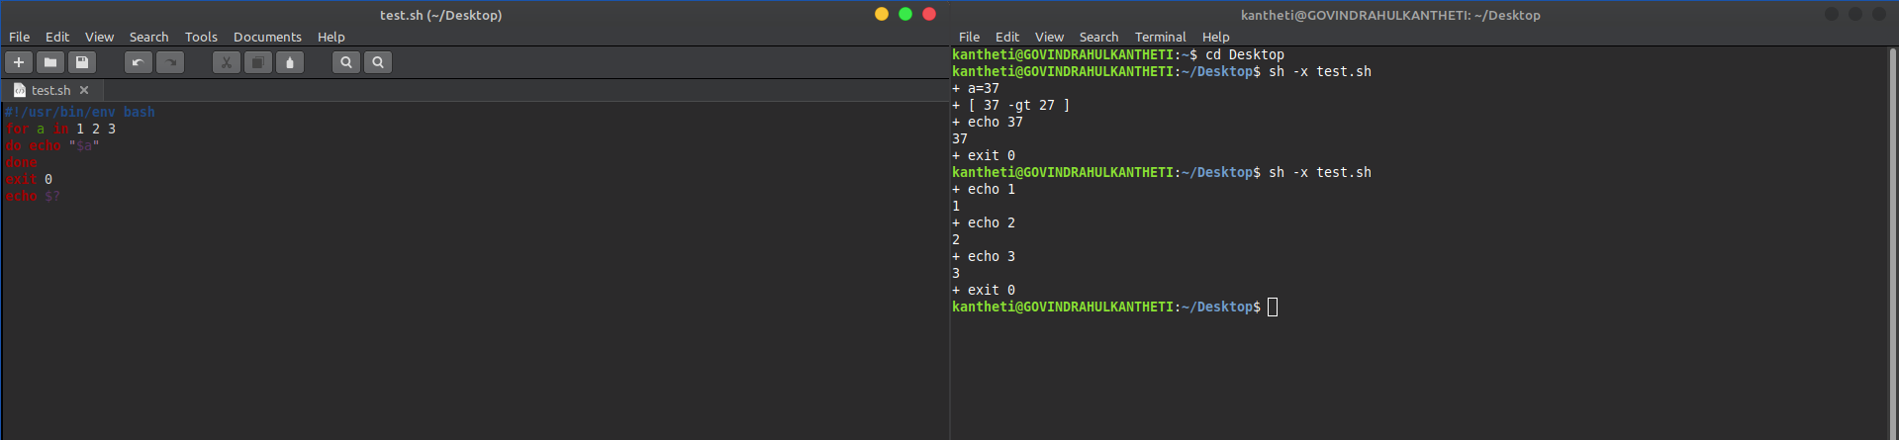

(3)

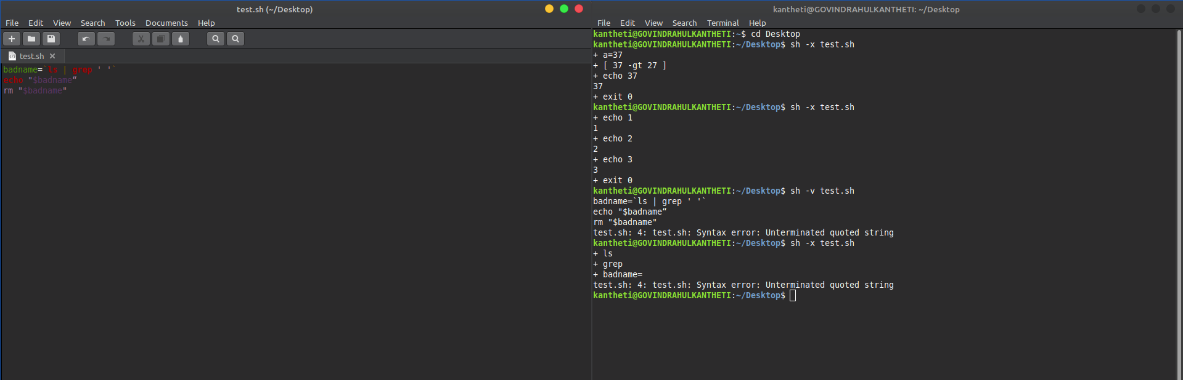

(4)

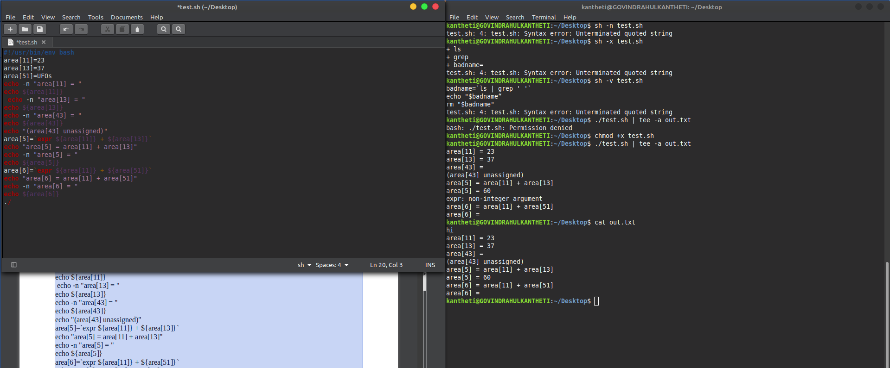

(5.1)

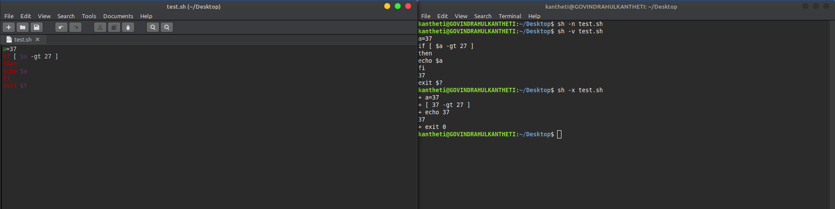

(5.2)

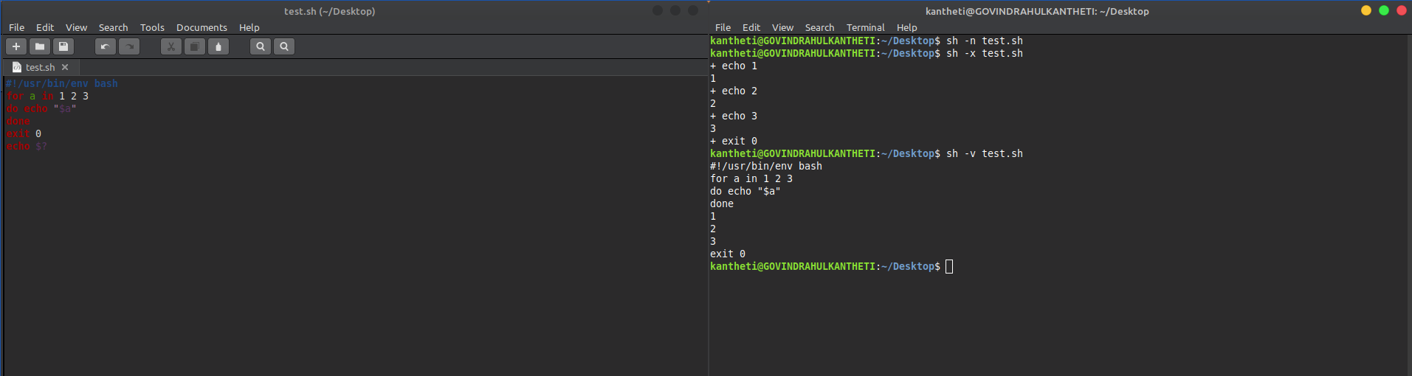

(5.3)

