DEFECT REPORT — FINAL

Tichi Web Application
https://tichi-app-webapp-stage.web.app

Prepared By | Gowtham C
Role | QA Intern
Testing Type | Exploratory Testing
Application | Tichi Web Application
Environment | Stage
Browser | Google Chrome
OS | Windows 11
Testing Tool | Playwright v1.x with Chromium
Date | 2 July 2026
Report Version | Final v1.0

1. Defect Summary
This report documents the defects identified during exploratory testing of the Tichi Web Application on the Stage environment. All defects have been verified as reproducible and are supported by API response evidence and screenshot captures.

Total Defects | Critical | High | Medium | Low
4 | 0 | 1 | 2 | 1

Bug Status Legend
Status | Meaning
Confirmed | Reproducible; verified by screenshot and/or API response logs
Not Reproducible | Could not be reproduced in repeated attempts
False Positive | Initial analysis was incorrect; behaviour is by design

2. Confirmed Defects

BUG_001
BUG_001 [HIGH] — Duplicate Account Registration Fails Silently — No UI Error Shown

Bug ID | BUG_001
Module | Signup
Severity | High
Priority | High
Status | Confirmed
Environment | Stage
Browser | Chrome
OS | Windows 11
Reported By | Gowtham C
Reported Date | 2 July 2026

Description
When a user attempts to register using a phone number that is already associated with an existing account, the backend API returns HTTP 400 Bad Request with the message 'User Already Exists'. However, the Signup UI does not surface this error to the user — no toast notification, no inline field error, and no page redirect occurs. The form remains in its filled state with no indication of why registration has failed.

Steps to Reproduce
- Navigate to https://tichi-app-webapp-stage.web.app/sign-up
- Fill First Name, Last Name with any valid values
- In the Mobile Number field, enter a phone number already registered (e.g. 9876543210 with +91 prefix)
- Enter a unique, unregistered email address
- Fill in a valid password and confirm password (e.g. Abcdef12#)
- Check the Terms and Conditions checkbox
- Click Sign Up
- Observe: the page stays unchanged with no error message

Expected Result
A clear, user-facing error message is displayed: "An account with this phone number already exists. Please log in or use a different number."

Actual Result
The API returns 400 Bad Request with body: {"message":"User Already Exists","error":"Bad Request","statusCode":400}. The UI shows no error — the signup form remains unchanged. The user has no indication of why registration failed.

API Evidence
POST /api/auth/register
Response: 400 Bad Request
Body: {"message":"User Already Exists","error":"Bad Request","statusCode":400}

Screenshot Evidence
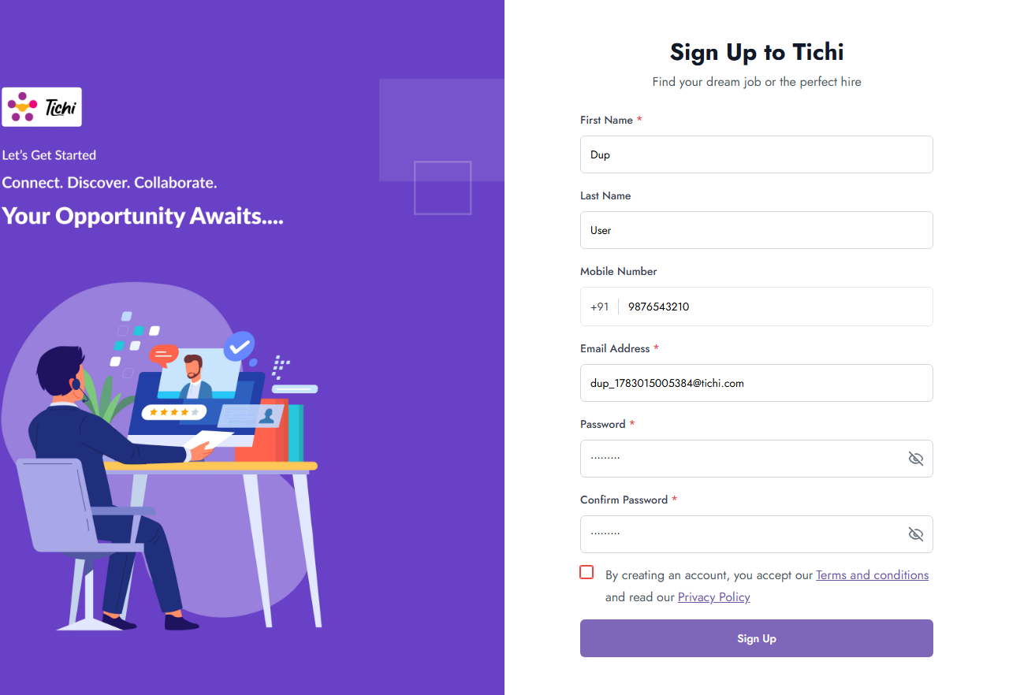
Figure: BUG_001 — Signup form unchanged after 400 User Already Exists response

Impact
Users attempting to register with an existing phone number are left confused with no actionable feedback. They may re-submit multiple times, creating duplicate API calls. New users cannot distinguish between a network failure and a duplicate account error, potentially causing them to abandon registration entirely.

Recommendation
- Intercept the 400 'User Already Exists' API response in the Signup component
- Display a toast notification: 'A Tichi account already exists with this phone number. Please login instead.'
- Highlight the Mobile Number field with a red border and inline validation message
- Include a clickable link redirecting the user to the login page

BUG_002
BUG_002 [MEDIUM] — Password Mismatch Validation Uses Grammatically Incorrect Error Message

Bug ID | BUG_002
Module | Signup
Severity | Medium
Priority | Medium
Status | Confirmed
Environment | Stage
Browser | Chrome
OS | Windows 11
Reported By | Gowtham C
Reported Date | 2 July 2026

Description
When a user enters mismatched values in the Password and Confirm Password fields on the Signup page and then blurs the Confirm Password field, a browser-native validation tooltip appears with the text: 'Confirm password must be match with password'. This message is grammatically incorrect ('must be match with' should be 'must match'). Additionally, the validation uses a transient browser-level tooltip via setCustomValidity() rather than a persistent, styled inline error below the Confirm Password field — which is the industry-standard UX pattern for form validation.

Steps to Reproduce
- Navigate to https://tichi-app-webapp-stage.web.app/sign-up
- In the Password field, enter: Abcdef12#
- In the Confirm Password field, enter a different value: Xyzabc99!
- Click on any other field (e.g. First Name) to trigger the blur event on Confirm Password
- Observe the validation tooltip that appears near the Confirm Password field

Expected Result
A persistent, styled inline error appears immediately below the Confirm Password field: "Passwords do not match". The error must be grammatically correct and visible in real-time.

Actual Result
A browser-native popup tooltip appears reading: 'Confirm password must be match with password'. The grammar is incorrect ('must be match' is not valid English). The tooltip is transient and disappears when the user interacts with any other element. The Sign Up button remains enabled despite the password mismatch.

Screenshot Evidence
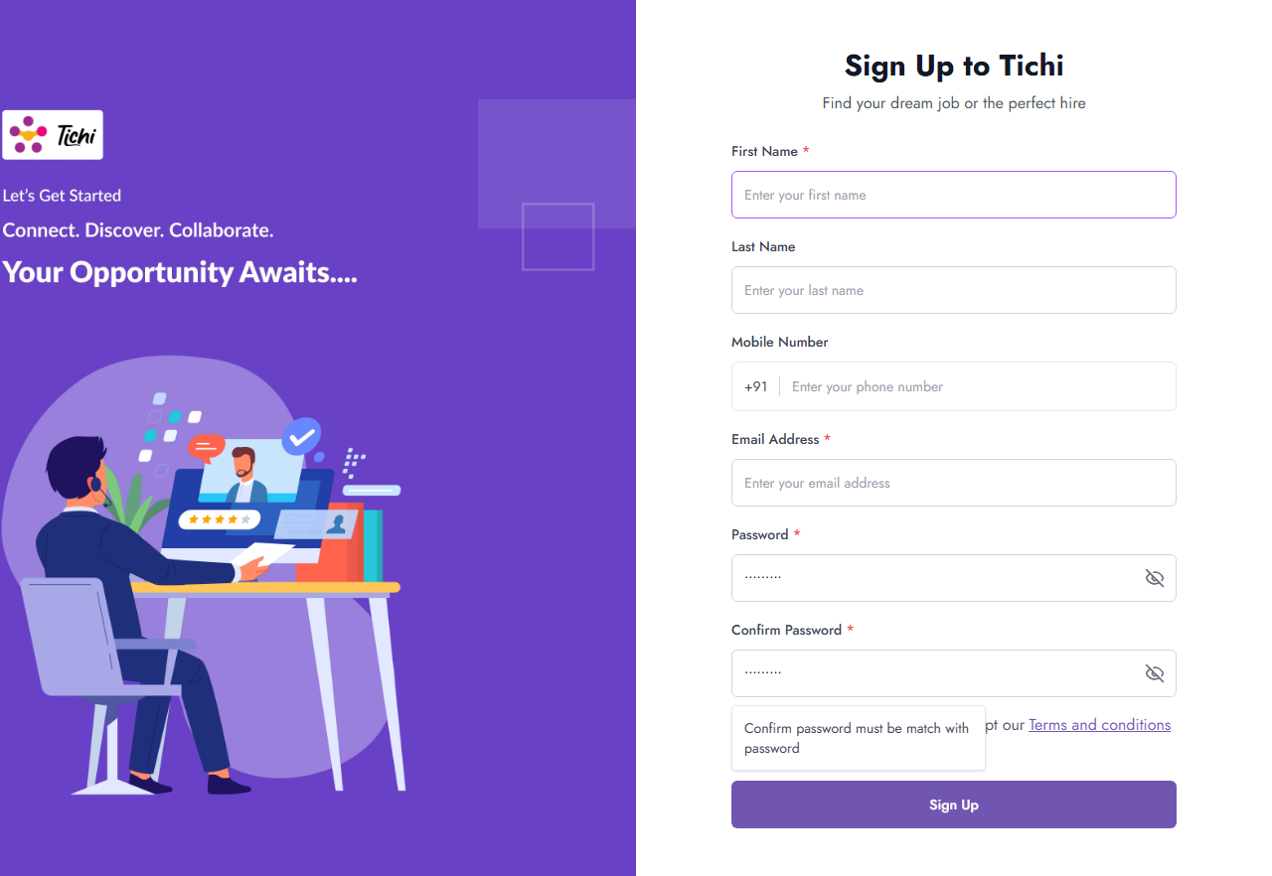
Figure: BUG_002 — Browser tooltip displaying grammatically incorrect password mismatch error

Impact
Users who type mismatched passwords but miss the transient tooltip will not be aware of the error until form submission fails. The grammatically incorrect message reduces product quality perception. Non-native English speakers will find the error particularly confusing.

Recommendation
- Replace setCustomValidity() with a React-state-based inline error below the Confirm Password field
- Implement real-time onChange comparison between Password and Confirm Password fields
- Display 'Passwords do not match' immediately when the two values differ
- Disable the Sign Up button until the passwords match
- Correct the error text to: 'Passwords do not match'

BUG_003
BUG_003 [MEDIUM] — No 'Resend Verification Email' Option After Login Fails with 'Email not verified'

Bug ID | BUG_003
Module | Login / Session / Post-Signup Flow
Severity | Medium
Priority | High
Status | Confirmed
Environment | Stage
Browser | Chrome
OS | Windows 11
Reported By | Gowtham C
Reported Date | 2 July 2026

Description
After a user successfully creates an account on the Signup page, they are required to verify their email before logging in. When login is attempted with valid credentials before email verification, the application correctly shows the error 'Email not verified'. However, the login page provides no mechanism to resend the verification email — no button, no link, and no actionable next-step guidance is shown. The user is left with an error message and no self-service recovery path.

Steps to Reproduce
- Register a new account at https://tichi-app-webapp-stage.web.app/sign-up with a unique email and phone
- Do NOT click the email verification link in the registration confirmation email
- Navigate to https://tichi-app-webapp-stage.web.app/login
- Enter the registered email address and click Continue
- On Step 2, enter the correct password and click Login
- Observe: 'Email not verified' error is shown with no resend option

Expected Result
Upon receiving the 401 'Email not verified' response, the application displays: 'Your email address has not been verified. Please check your inbox for the verification link.' alongside a visible [Resend Verification Email] button.

Actual Result
The error message 'Email not verified' is displayed in red above the email field on login Step 2. No resend link or button is visible. No redirect to a verification page occurs. No instructions are shown on what the user should do next. The user has no self-service recovery path from the login page.

API Evidence
POST /api/auth/login
Response: 401 Unauthorized
Body: {"message":"Email not verified","error":"Unauthorized","statusCode":401}

Screenshot Evidence
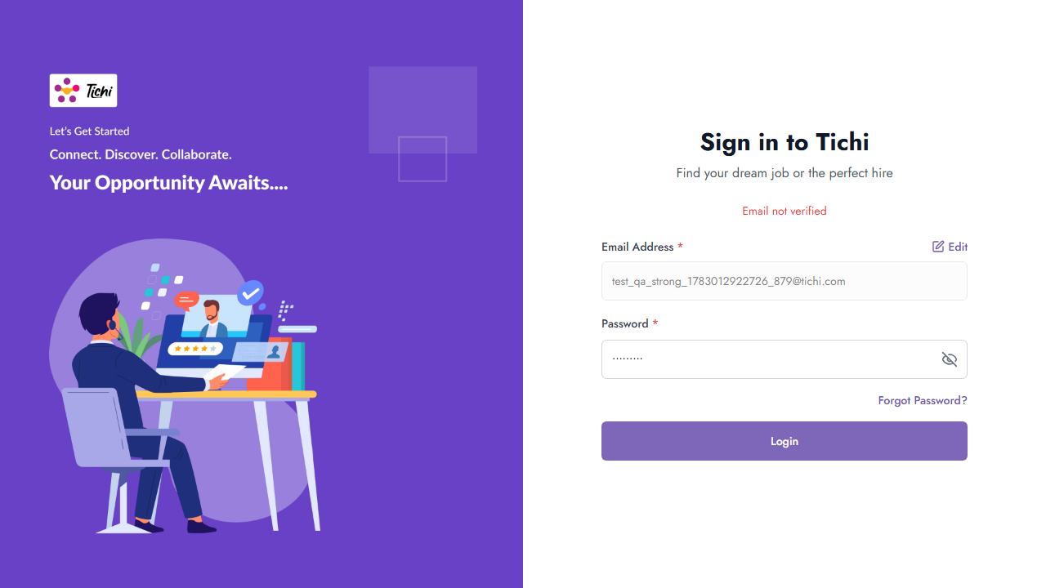
Figure: BUG_003 — Login page showing 'Email not verified' error with no resend option or guidance

Impact
Users who miss or accidentally delete the verification email have no self-service recovery path. They must contact customer support to verify their account, creating unnecessary friction and increasing support overhead. This directly impacts user activation rates and first-time login success.

Recommendation
- When the API returns 401 'Email not verified', display a 'Resend Verification Email' button
- Implement a POST /api/auth/resend-verification endpoint and wire it to the button
- Show a success toast: 'Verification email sent! Please check your inbox.' after resend
- Consider redirecting to a dedicated 'Verify Your Email' page immediately after successful signup

BUG_004
BUG_004 [LOW] — Signup: Name Input Fields Have No Maximum Character Length Constraint

Bug ID | BUG_004
Module | Signup / Input Validation
Severity | Low
Priority | Low
Status | Confirmed
Environment | Stage
Browser | Chrome
OS | Windows 11
Reported By | Gowtham C
Reported Date | 2 July 2026

Description
The First Name and Last Name input fields on the Signup page do not enforce any maximum character length constraint. A user can type or paste an arbitrarily long string (tested up to 500+ characters) without any validation error, character counter, or truncation. No maxlength HTML attribute exists on these fields.

Steps to Reproduce
- Navigate to https://tichi-app-webapp-stage.web.app/sign-up
- Click on the First Name input field
- Paste a string of 500+ characters (e.g. 500 repetitions of the letter A)
- Observe that all characters are accepted without any validation error

Expected Result
The First Name and Last Name fields enforce a maximum of 50 characters. An inline error appears if exceeded: 'Maximum 50 characters allowed'. The maxlength='50' HTML attribute prevents typing beyond the limit.

Actual Result
All 500 characters are accepted and stored in the field. The text visually overflows the input box boundary. No error message, character counter, or maxlength constraint is present.

Screenshot Evidence
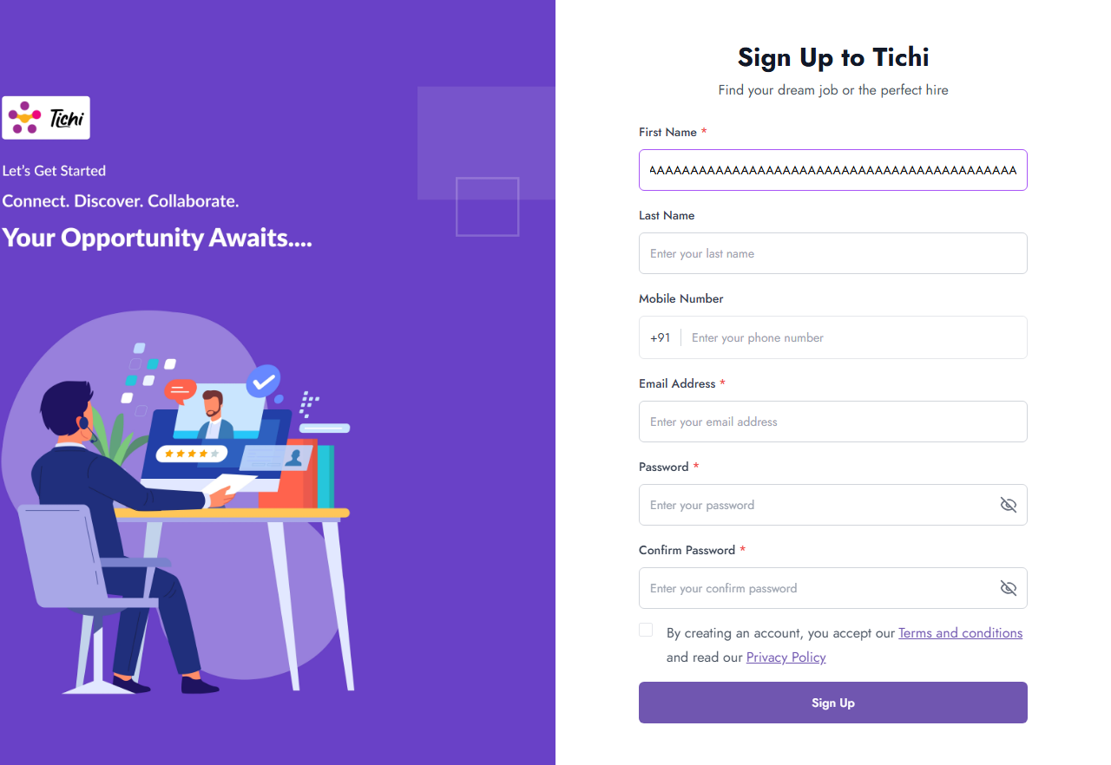
Figure: BUG_004 — First Name field accepting 500+ characters with visible text overflow beyond the input boundary

Impact
Database: Backend may encounter column-length overflow errors if the schema has a VARCHAR limit. UI Rendering: Extremely long names could break profile page layouts, navigation bars, and email templates. Security: Excessively long inputs could be used for denial-of-service or buffer overflow probing.

Recommendation
- Add maxlength='50' to the First Name and Last Name <input> elements
- Display a live character counter below the field (e.g. 0/50 updating in real-time)
- Show an inline error when the limit is reached: 'Name cannot exceed 50 characters.'
- Validate the field length on the backend as a defense-in-depth measure

3. Previously Reported Bugs — Reclassified
The following bugs were originally reported in Defect_Report.docx and have been audited and reclassified following live verification testing.

Bug ID | Original Title | Reclassified Status | Reason
BUG_001 (Original) | Login accepts invalid email format | False Positive | Login form validates email format correctly. HTML5 input validation + custom inline error 'Please enter a valid email address.' is correctly displayed on Step 1.
BUG_002 (Original) | Signup accepts weak passwords | False Positive | Signup enforces 8-character minimum with alphanumeric requirement. Weak passwords (e.g. abcdef12) are rejected by the API: 400 'Password must be alphanumeric'.
BUG_003 (Original) | Logout does not invalidate session token | Architectural Risk — Not a Code Defect | App uses stateless JWT tokens. Token expiry is configured at issuance (TTL). Client-side logout correctly clears the stored token. This is by architectural design.

4. Defect Traceability Matrix

Bug ID | Test Case(s) | Module | Severity | Status | Screenshot
BUG_001 | TC_SGN_019 (Duplicate Phone) | Signup | High | Confirmed | B_signup_duplicate_silent.png
BUG_002 | TC_SGN_006, TC_SGN_007 | Signup | Medium | Confirmed | D_password_mismatch.png
BUG_003 | TC_LGN_010 (Verification) | Login | Medium | Confirmed | E_login_unverified_no_feedback.png
BUG_004 | TC_SGN_004 (Input Validation) | Signup | Low | Confirmed | F_large_input.png

5. Test Environment Details
Application | Tichi Web Application
URL | https://tichi-app-webapp-stage.web.app
Environment | Stage
Platform | Firebase Hosting + Node.js Backend
Auth | JWT (stateless)
Testing Tool | Playwright v1.x with Chromium
OS | Windows 11
Browser | Google Chrome
Testing Date | 2 July 2026
Prepared By | Gowtham C — QA Intern

Prepared by: Gowtham C | QA Intern | Tichi Application QA Assignment | Final Submission

