MINI PROJECT

DATA ANALYSIS AND VISUALIZATION USING PYTHON, POWER BI, AND TABLEAU

Framework for Data Visual Analytics

GOWTHAM P
2116241501060
AIML/ RAJALAKSHMI ENGINEERING COLLEGE

ABSTRACT
This mini project, carried out for the subject Fundamentals of Data Visualization and Analytics (FDVA), analyses a T20 International (T20I) cricket match dataset using Python, Microsoft Power BI and Tableau. The dataset, stored in the file t20i_Matches_Data.csv, contains 2,411 match records and 33 columns covering match details, series, teams, captains, runs scored, wickets fallen, extras, venue (stadium, city and country), umpires, toss details, match winner and player of the match. The project focuses on understanding scoring patterns, team performance, toss decisions and the growth of T20 international cricket over time.
Python (Pandas, NumPy, Matplotlib, Seaborn and Scikit-learn) was used to inspect, clean, normalise and export the dataset, and to create a histogram, bar chart, line chart, pie chart, box plot, scatter plot and correlation heatmap. The cleaned dataset (cleaned_cricket_data.csv) was then used to build interactive dashboards in Power BI and Tableau containing KPI cards, team-wise wins, toss decision charts, yearly match trends, venue-wise match counts and a comparison of the runs scored by the two teams. The analysis shows that the average first-innings score is about 147.7 runs against 126.5 runs for the second team, that teams choosing to bowl first after winning the toss (about 52%) slightly outnumber those choosing to bat, that India and Pakistan have recorded the most wins, and that the number of T20I matches played per year has risen sharply since 2019. The project demonstrates how data preparation, visualization and interactive dashboards can turn raw match records into meaningful insights.

Data Preprocessing
The dataset (t20i_Matches_Data.csv) contains 2,411 T20I match records and 33 columns. Python with Pandas, NumPy and Scikit-learn was used to inspect and prepare the data before it was visualised in Python, Power BI and Tableau. The steps followed in the notebook are described below.

Importing libraries and loading the data
import pandas as pd import numpy as np
import matplotlib.pyplot as plt

df = pd.read_csv("t20i_Matches_Data.csv") display(df.head())

The required libraries were imported and the dataset was loaded into a Pandas DataFrame. The first few records were displayed to confirm that the file had loaded correctly.

Inspecting the dataset
print("Dataset shape:", df.shape) print(df.columns.tolist()) print(df.dtypes)
df.info() display(df.describe(include="all").T)

The dataset has 2,411 rows and 33 columns. The data covers 103 distinct teams in the Team 1 column, 503 series, 212 stadiums, 161 cities and 64 venue countries. Numerical columns such as Team1 Runs Scored, Team1 Wickets Fell and Team2 Runs Scored were stored as float values, while columns such as Match Name, Team Names, Venue and Toss Winner Choice were stored as text (object) values. Match Date was initially stored as text and required conversion.

Checking missing values and duplicates
print(df.isnull().sum())
print("Duplicate rows:", df.duplicated().sum()) print((df.isnull().mean() * 100).round(2))

No duplicate rows were found. Missing values were present in several columns, as summarised in Table 1.

Column | Missing values
Match Date | 11
Team1 Runs Scored / Wickets Fell / Extras Rec | 13 each
Team2 Runs Scored / Wickets Fell / Extras Rec | 46 each
Umpire 1 / Umpire 2 | 2 each

Column | Missing values
Match Referee | 441
Toss Winner | 1
Toss Winner Choice | 10
Match Winner | 91
MOM Player | 297
Table 1: Columns with missing values

Cleaning the dataset
df = df.drop_duplicates() df = df.dropna(how="all")
df = df.dropna(axis=1, how="all")

for col in df.columns:
if pd.api.types.is_numeric_dtype(df[col]): df[col] = df[col].fillna(df[col].median())
else:
df[col] = df[col].fillna("Unknown")

Duplicate rows and completely empty rows or columns were removed. Missing numerical values were replaced with the column median, which is less affected by outliers than the mean, and missing text values were replaced with the label "Unknown". After cleaning, the dataset still contained 2,411 rows and 33 columns. As a result, matches with no recorded winner appear under the category "Unknown" in the dashboards.

Converting date columns
for col in df.columns:
if "date" in col.lower():
converted = pd.to_datetime(df[col], errors="coerce") if converted.notna().mean() >= 0.5:
df[col] = converted

The Match Date column was converted from text to the datetime format so that matches could be grouped by year and filtered by date range in the dashboards. Entries that could not be converted as dates (the 11 records whose date was originally missing) remain as missing date values, which is why the final verification reports 11 remaining missing values.

Normalising numerical data
from sklearn.preprocessing import MinMaxScaler

numeric_cols = df.select_dtypes(include=np.number).columns scaled_df = df.copy()
scaler = MinMaxScaler()
scaled_df[numeric_cols] = scaler.fit_transform(df[numeric_cols])

Min-Max normalisation was applied to all numerical columns to rescale their values to the range 0 to 1. The scaled copy (scaled_df) was used to demonstrate normalisation, while the

original cleaned values were retained for the charts and dashboards so that runs and wickets keep their real meaning.

Exporting the cleaned dataset
df.to_csv("cleaned_cricket_data.csv", index=False)

The cleaned dataset was exported as cleaned_cricket_data.csv and used as the data source for both the Power BI and Tableau dashboards. The final verification confirmed 2,411 rows, 33 columns and no duplicate records.

Data Visualization Using Python
The cleaned dataset was explored using Matplotlib and Seaborn. The following figures show the distribution of scores, team performance, trends over time, toss decisions and relationships between numerical variables.
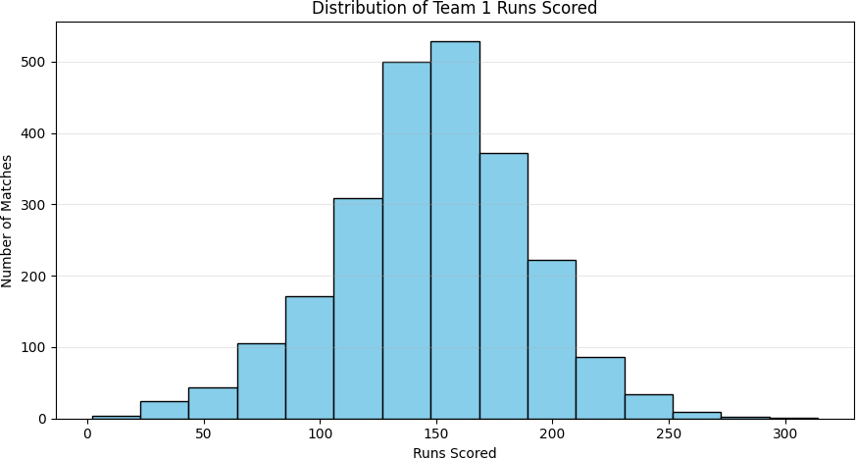
Figure 2.1: Distribution of Team 1 Runs Scored
Result: The scores of the team batting first follow an approximately bell-shaped distribution. Most innings fall between 110 and 190 runs, with the highest frequency in the 130–170 run range. Scores above 250 are very rare.
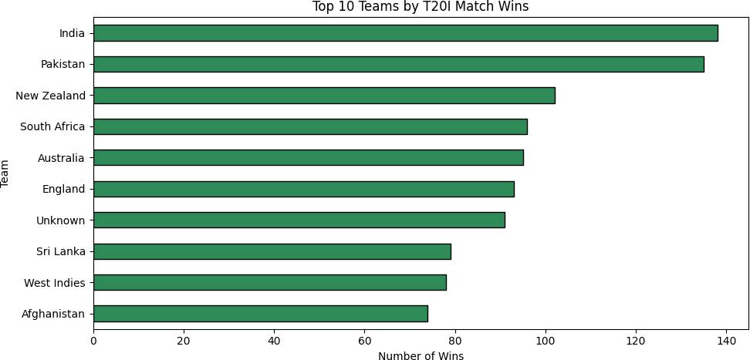
Figure 2.2: Top 10 Teams by T20I Match Wins
Result: India (about 138 wins) and Pakistan (about 135 wins) have won the most T20I matches, followed by New Zealand (about 102), South Africa (96), Australia (95) and England (93). The "Unknown" bar (91) represents matches with no recorded winner, such as ties or no-results.

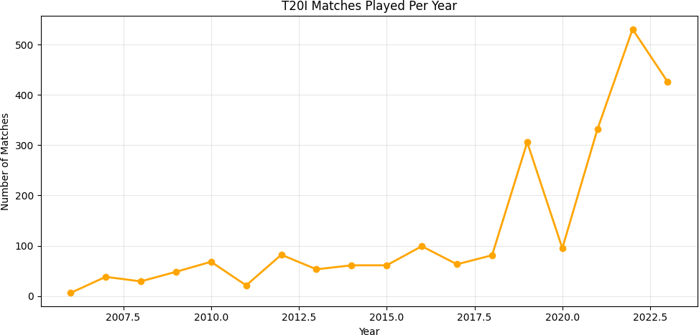
Figure 2.3: T20I Matches Played Per Year
Result: The number of T20I matches stayed below about 100 per year until 2018, rose to about 305 in 2019, fell to about 95 in 2020 and then climbed to a peak of about 530 matches in 2022. The 2020 dip coincides with the COVID-19 pandemic, and the rapid growth afterwards reflects the increase in matches played by associate nations.
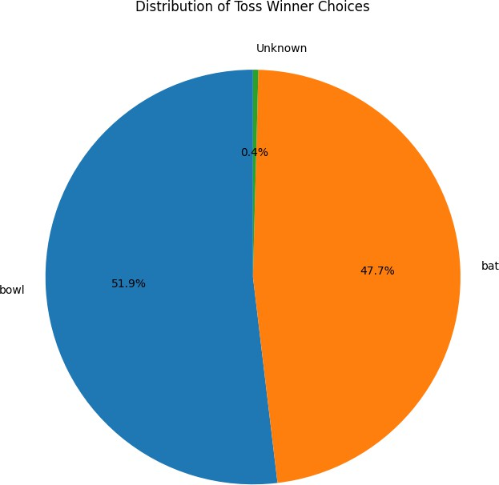

Figure 2.4: Distribution of Toss Winner Choices
Result: Teams winning the toss chose to bowl first in 51.9% of matches and to bat first in 47.7% of matches. The remaining 0.4% of matches have an unknown decision. Fielding first is therefore marginally more popular.

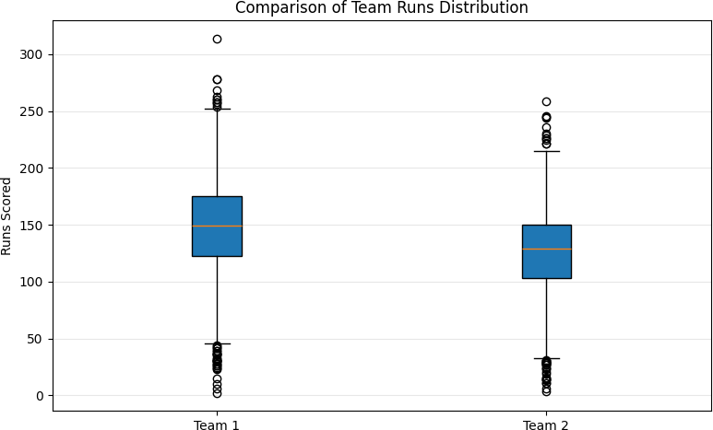
Figure 2.5: Comparison of Team Runs Distribution (Box Plot)
Result: The median score of Team 1 (about 150 runs) is higher than that of Team 2 (about 128 runs). Both teams show outliers at the low end (very short innings, often in rain-affected or collapsed innings) and at the high end, with the highest Team 1 total exceeding 300 runs.
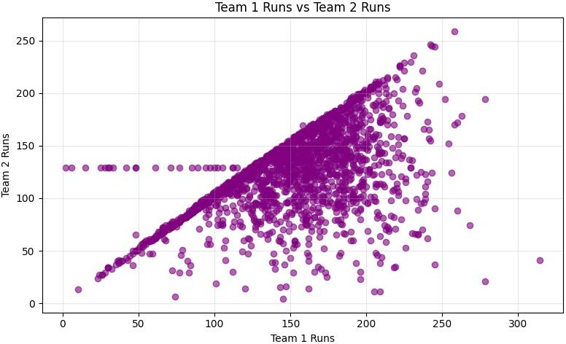
Figure 2.6: Team 1 Runs vs Team 2 Runs (Scatter Plot)
Result: Team 2 scores increase with Team 1 scores and are densely packed just below the diagonal, which shows that chasing teams tend to finish close to, or just short of, the target. The horizontal line of points at about 129 runs is not real match data; it is caused by the median imputation of missing Team 2 scores during cleaning.

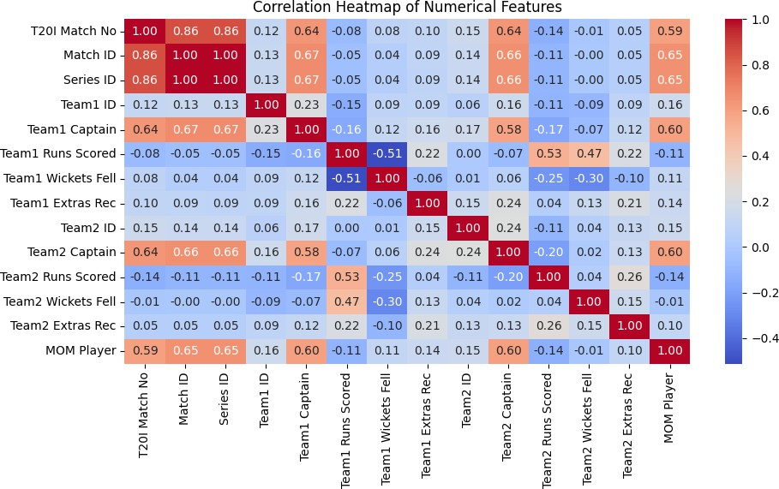
Figure 2.7: Correlation Heatmap of Numerical Features
Result: Match ID and Series ID are almost perfectly correlated (1.00), and both correlate strongly with the T20I match number, because they are sequential identifiers. These ID-based correlations carry no analytical meaning. Among the meaningful variables, Team 1 runs have a moderate negative correlation with Team 1 wickets fallen (−0.51) and a moderate positive correlation with Team 2 runs (0.53), while most other features have weak correlations.

Power BI Dashboard
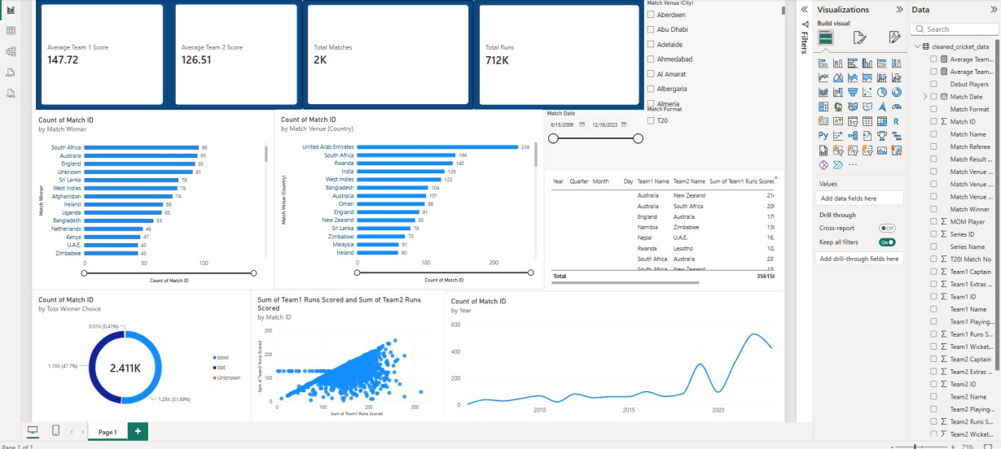
Figure 3.1: T20I Cricket Dashboard in Power BI
- KPI cards: Average Team 1 Score (147.72), Average Team 2 Score (126.51) and Total Matches (2K, i.e. 2,411 matches).
- Charts: Number of matches by match winner, matches by venue country, toss winner choice donut chart, Team 1 versus Team 2 runs scatter plot, matches per year line chart and a detail table of Team 1 and Team 2 names with runs scored.
- Interactive filters: A match date slider (15 June 2006 to 18 December 2023) and slicers for Match Venue (City) and Match Format (T20) allow users to explore the data for any period, city or format.
- Insights: Matches with no recorded winner ("Unknown") total 91. The United Arab Emirates has hosted the most matches (236), followed by South Africa (144), Rwanda (140), India (128) and the West Indies (123). Teams that won the toss chose to bowl in 51.89% of matches and to bat in 47.7%. The matches-per-year line rises steeply after 2019, with a dip in 2020 and a peak around 2022.
- Note: The dashboard provides an interactive view of team performance, venue distribution and toss behaviour, and the filters update every visual together.

Tableau Dashboard
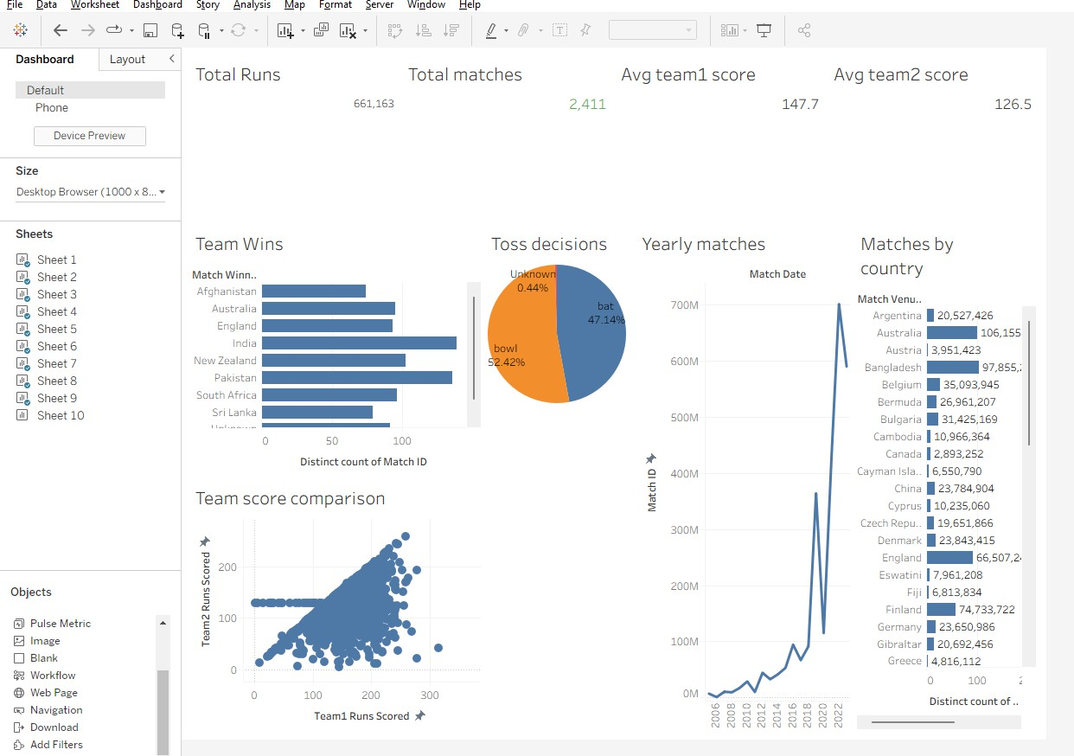
Figure 4.1: T20I Cricket Dashboard in Tableau
- KPIs: Total Runs 661,163, Total Matches 2,411, Average Team 1 Score 147.7 and Average Team 2 Score 126.5.
- Charts: Team wins (bar chart), toss decisions (pie chart), yearly matches (line chart), matches by country (bar chart) and a team score comparison (scatter plot of Team 1 runs against Team 2 runs).
- Insights: India and Pakistan have the highest number of match wins. Toss winners chose to bowl in 52.42% of matches and to bat in 47.14%, with 0.44% unknown. The yearly trend shows a sharp rise in matches from 2019 onwards with a dip in 2020. The scatter plot shows that Team 2 scores generally stay below or close to Team 1 scores.
- Note: The Tableau dashboard presents the same dataset as the Power BI dashboard and confirms the key findings from different visual formats.

Conclusion
This project analysed 2,411 T20 International cricket matches using Python, Power BI and Tableau. Data preprocessing handled missing values, converted dates, normalised numerical data and produced a clean dataset that was shared across all three tools. The main findings are summarised below.
- The average score of the team batting first (147.7 runs) is higher than that of the team batting second (126.5 runs).
- Most first-innings totals lie between 110 and 190 runs, and totals above 250 runs are rare.
- India and Pakistan have won the most T20I matches in the dataset.
- Slightly more toss winners choose to field first (about 52%) than to bat first (about 48%).
- T20I cricket has grown rapidly since 2019, with a temporary fall in 2020 and a peak of roughly 530 matches in 2022.
- The United Arab Emirates has hosted the largest number of matches in the dataset.

Limitations
Missing run values were replaced with the median, which creates an artificial cluster of Team 2 scores at about 129 runs in the scatter plots, and matches without a recorded winner are grouped as "Unknown". Future work could remove or flag such matches instead of imputing them, and could add batting and bowling statistics to compare players as well as teams.

Tools Used
Python (Pandas, NumPy, Matplotlib, Seaborn, Scikit-learn), Microsoft Power BI, Tableau and Jupyter Notebook.

