ASSIGNMENT-02
Name: R. Gowthami
Reg. No.: 23BEC7355
Design and implement a smart environmental monitoring system using Node-RED, MQTT, and ESP32. The system should monitor temperature and humidity using a DHT22 sensor, display real-time readings on dashboard gauges and charts, and automatically control a fan and an LED based on predefined threshold conditions.
Output - A functional IoT dashboard that supports real-time monitoring, automatic control, manual device operation, alerts, and data logging.
Submission - Node-RED flow export (JSON), dashboard screenshots, flowchart of the proposed system, and a brief explanation of the working principle.
Flowchart of the Proposed System:
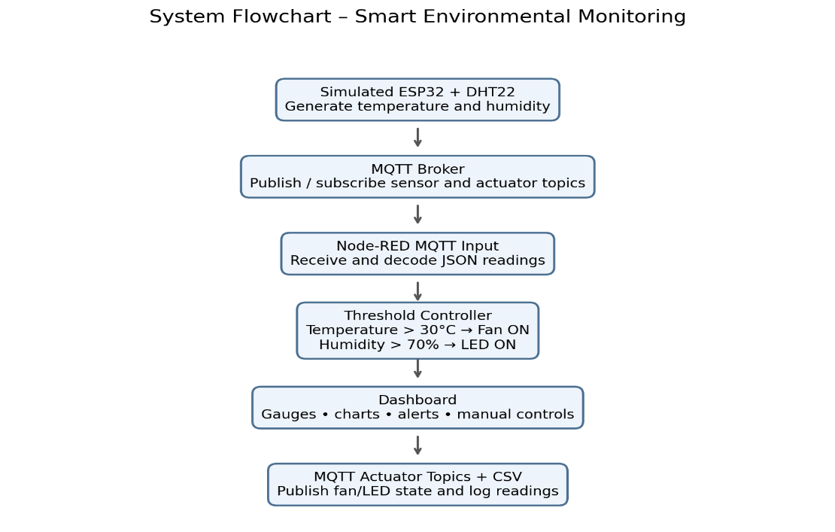

Working Principle:
The Smart Environmental Monitoring System is designed to monitor temperature and humidity in real time using Node-RED, MQTT, and an ESP32-based IoT architecture. In this project, the system is implemented through simulation, where software-generated sensor readings represent the data from a DHT22 temperature and humidity sensor.
The simulated sensor continuously generates temperature and humidity values and publishes them to the MQTT broker. MQTT acts as the communication medium, allowing Node-RED to receive and process the sensor data. Node-RED then displays the live readings on a dashboard using gauges, charts, and status indicators.
The system also provides automatic and manual device control. In automatic mode, Node-RED compares the received readings against predefined threshold values. If the temperature exceeds 30°C, the fan is automatically switched ON. If the humidity exceeds 70%, the LED is switched ON. When the readings fall below these thresholds, the respective devices are switched OFF. In manual mode, users can operate the fan and LED directly through dashboard switches.
Additionally, the system generates alerts when the environmental parameters cross the defined thresholds and stores sensor readings in a log file for future reference and analysis. Thus, the project demonstrates real-time environmental monitoring, automated device control, remote operation, alert generation, and data logging through an IoT-based monitoring platform.
Note: The current implementation uses simulated sensor readings and device responses. The same architecture can be extended to physical ESP32, DHT22, fan, and LED hardware.

Automatic control logic
Read temperature and humidity
|
Is temperature > 30°C?
/ \
YES NO
| |
Fan ON Fan OFF
|
Is humidity > 70%?
/ \
YES NO
| |
LED ON LED OFF
Alert Normal

Node-RED Flow:
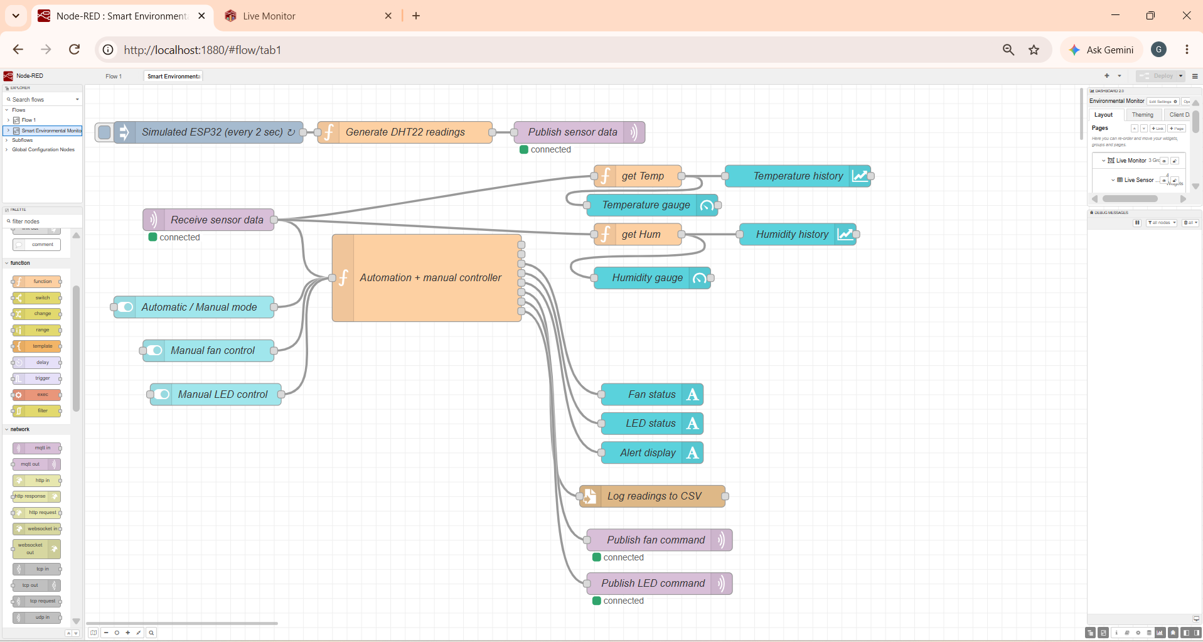
Dashboard Screenshots:
- Conditions Normal
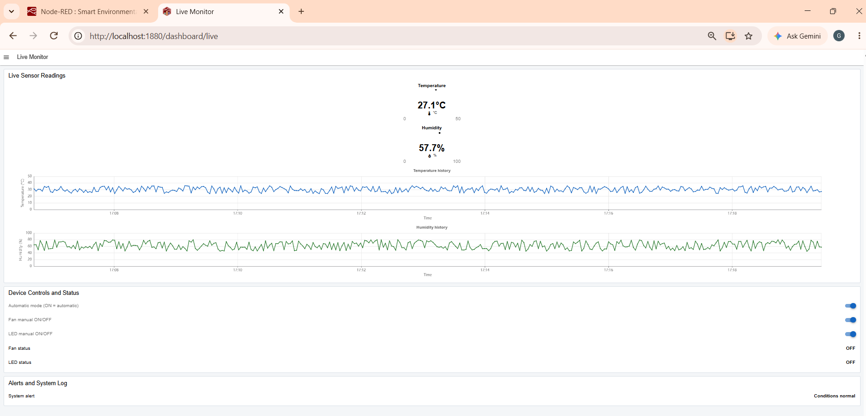

- High Temperature
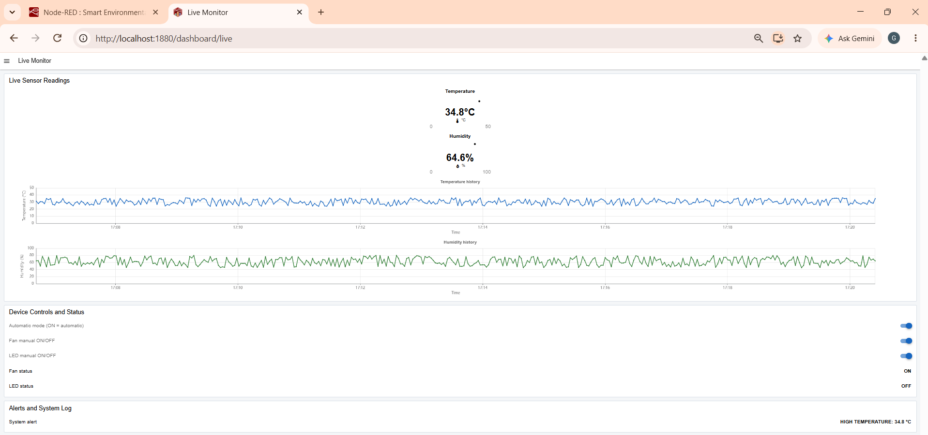

- High Temperature, High Humidity
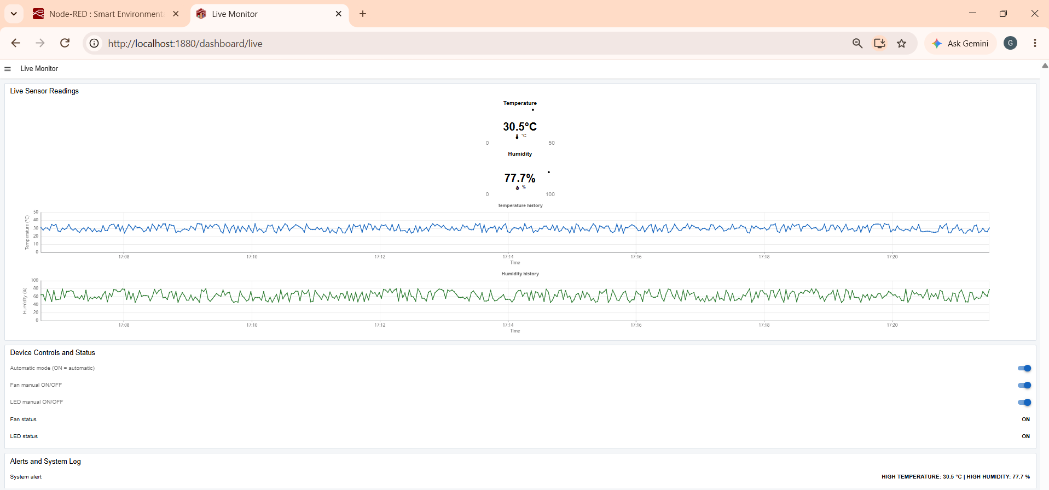

Node-RED flow export (JSON):
[
{
"id": "tab1",
"type": "tab",
"label": "Smart Environmental Monitoring",
"disabled": false,
"info": "Simulated ESP32/DHT22 environmental monitoring using MQTT and FlowFuse Dashboard 2.0."
},
{
"id": "broker1",
"type": "mqtt-broker",
"name": "Local Mosquitto",
"broker": "127.0.0.1",
"port": "1883",
"clientid": "nodered-env-monitor",
"autoConnect": true,
"usetls": false,
"protocolVersion": "4",
"keepalive": "60",
"cleansession": true,
"autoUnsubscribe": true,
"birthTopic": "",
"birthQos": "0",
"birthPayload": "",
"birthMsg": {},
"closeTopic": "",
"closeQos": "0",
"closePayload": "",
"closeMsg": {},
"willTopic": "",
"willQos": "0",
"willPayload": "",
"willMsg": {},
"userProps": "",
"sessionExpiry": ""
},
{
"id": "base1",
"type": "ui-base",
"name": "Environmental Monitor",
"path": "/dashboard",
"includeClientData": true,
"acceptsClientConfig": [
"ui-notification",
"ui-control"
],
"showPathInSidebar": false,
"navigationStyle": "default",
"title": "Environmental Monitoring",
"showThemeToggle": true,
"\u8272": "#0094CE"
},
{
"id": "theme1",
"type": "ui-theme",
"name": "Default Theme",
"colors": {
"surface": "#ffffff",
"primary": "#1565c0",
"bgPage": "#f4f6f8",
"groupBg": "#ffffff",
"groupOutline": "#d9e0e7"
},
"sizes": {
"density": "comfortable",
"pagePadding": "12px",
"groupGap": "12px",
"groupBorderRadius": "4px",
"widgetGap": "12px"
}
},
{
"id": "page1",
"type": "ui-page",
"name": "Live Monitor",
"ui": "base1",
"path": "/live",
"icon": "dashboard",
"layout": "grid",
"theme": "theme1",
"breakpoints": [
{
"name": "Default",
"px": "0",
"cols": "3"
}
],
"order": 1,
"className": "",
"visible": "true",
"disabled": "false"
},
{
"id": "group1",
"type": "ui-group",
"name": "Live Sensor Readings",
"page": "page1",
"width": "6",
"height": "1",
"order": 1,
"showTitle": true,
"className": ""
},
{
"id": "group2",
"type": "ui-group",
"name": "Device Controls and Status",
"page": "page1",
"width": "6",
"height": "1",
"order": 2,
"showTitle": true,
"className": ""
},
{
"id": "group3",
"type": "ui-group",
"name": "Alerts and System Log",
"page": "page1",
"width": "6",
"height": "1",
"order": 3,
"showTitle": true,
"className": ""
},
{
"id": "inject1",
"type": "inject",
"z": "tab1",
"name": "Simulated ESP32 (every 2 sec)",
"props": [
{
"p": "payload"
}
],
"repeat": "2",
"crontab": "",
"once": true,
"onceDelay": "1",
"topic": "",
"payload": "",
"payloadType": "date",
"x": 170,
"y": 100,
"wires": [
[
"sim1"
]
]
},
{
"id": "sim1",
"type": "function",
"z": "tab1",
"name": "Generate DHT22 readings",
"func": "// Simulated DHT22 readings, representing an ESP32 publishing sensor data.\\nlet t = 24 + Math.random()*12;\\nlet h = 45 + Math.random()*35;\\nmsg.topic = 'environment/sensor';\\nmsg.payload = JSON.stringify({temperature:Number(t.toFixed(1)), humidity:Number(h.toFixed(1)), timestamp:new Date().toISOString(), source:'SIMULATED_ESP32_DHT22'});\\nreturn msg;",
"outputs": 1,
"timeout": 0,
"noerr": 0,
"initialize": "",
"finalize": "",
"libs": [],
"x": 420,
"y": 100,
"wires": [
[
"mqtt_sensor_out"
]
]
},
{
"id": "mqtt_sensor_out",
"type": "mqtt out",
"z": "tab1",
"name": "Publish sensor data",
"topic": "environment/sensor",
"qos": "0",
"retain": "false",
"respTopic": "",
"contentType": "",
"userProps": "",
"correl": "",
"expiry": "",
"broker": "broker1",
"x": 680,
"y": 100,
"wires": []
},
{
"id": "mqtt_sensor_in",
"type": "mqtt in",
"z": "tab1",
"name": "Receive sensor data",
"topic": "environment/sensor",
"qos": "0",
"datatype": "auto-detect",
"broker": "broker1",
"nl": false,
"rap": true,
"rh": 0,
"inputs": 0,
"x": 170,
"y": 220,
"wires": [
[
"controller1"
]
]
},
{
"id": "mode_switch",
"type": "ui-switch",
"z": "tab1",
"name": "Automatic / Manual mode",
"label": "Automatic mode (ON = automatic)",
"group": "group2",
"order": 1,
"width": "6",
"height": "1",
"passthru": true,
"decouple": "false",
"topic": "mode",
"topicType": "str",
"style": "",
"className": "",
"layout": "row-spread",
"clickableArea": "switch",
"onvalue": "true",
"onvalueType": "bool",
"offvalue": "false",
"offvalueType": "bool",
"x": 190,
"y": 340,
"wires": [
[
"controller1"
]
]
},
{
"id": "fan_switch",
"type": "ui-switch",
"z": "tab1",
"name": "Manual fan control",
"label": "Fan manual ON/OFF",
"group": "group2",
"order": 2,
"width": "3",
"height": "1",
"passthru": true,
"decouple": "false",
"topic": "fan_manual",
"topicType": "str",
"style": "",
"className": "",
"layout": "row-spread",
"clickableArea": "switch",
"onvalue": "true",
"onvalueType": "bool",
"offvalue": "false",
"offvalueType": "bool",
"x": 180,
"y": 400,
"wires": [
[
"controller1"
]
]
},
{
"id": "led_switch",
"type": "ui-switch",
"z": "tab1",
"name": "Manual LED control",
"label": "LED manual ON/OFF",
"group": "group2",
"order": 3,
"width": "3",
"height": "1",
"passthru": true,
"decouple": "false",
"topic": "led_manual",
"topicType": "str",
"style": "",
"className": "",
"layout": "row-spread",
"clickableArea": "switch",
"onvalue": "true",
"onvalueType": "bool",
"offvalue": "false",
"offvalueType": "bool",
"x": 180,
"y": 460,
"wires": [
[
"controller1"
]
]
},
{
"id": "controller1",
"type": "function",
"z": "tab1",
"name": "Automation + manual controller",
"func": "// Input topics: environment/sensor, mode, fan_manual, led_manual\\nlet s = flow.get('sensor') || {temperature:25,humidity:50};\\nlet mode = flow.get('autoMode');\\nif (mode === undefined) mode = true;\\nlet fan = flow.get('fanState') || false;\\nlet led = flow.get('ledState') || false;\\nlet alert = 'Conditions normal';\\nif (msg.topic === 'environment/sensor') {\\n let d = msg.payload; if (typeof d === 'string') { try { d=JSON.parse(d); } catch(e) { return null; } }\\n s = d; flow.set('sensor',s);\\n} else if (msg.topic === 'mode') { mode = (msg.payload === true || msg.payload === 'true'); flow.set('autoMode',mode); }\\nelse if (msg.topic === 'fan_manual' && !mode) { fan = !!msg.payload; }\\nelse if (msg.topic === 'led_manual' && !mode) { led = !!msg.payload; }\\nif (mode) { fan = Number(s.temperature) > 30; led = Number(s.humidity) > 70; }\\nflow.set('fanState',fan); flow.set('ledState',led);\\nif (Number(s.temperature)>30) alert='HIGH TEMPERATURE: '+s.temperature+' \u00b0C';\\nif (Number(s.humidity)>70) alert += (alert==='Conditions normal'?'':' | ')+'HIGH HUMIDITY: '+s.humidity+' %';\\nif (alert==='Conditions normal') alert='Conditions normal';\\nlet a=[]; a[0]={payload:Number(s.temperature),timestamp:Date.now()}; a[1]={payload:Number(s.humidity),timestamp:Date.now()}; a[2]={payload:fan?'ON':'OFF'}; a[3]={payload:led?'ON':'OFF'}; a[4]={payload:alert};\\nif (msg.topic==='environment/sensor') a[5]={payload:new Date().toISOString()+','+s.temperature+','+s.humidity+','+(fan?'ON':'OFF')+','+(led?'ON':'OFF')+'\\\\n'};\\na[6]={topic:'environment/fan',payload:fan?'ON':'OFF'}; a[7]={topic:'environment/led',payload:led?'ON':'OFF'};\\nreturn a;",
"outputs": 8,
"timeout": 0,
"noerr": 0,
"initialize": "flow.set('autoMode',true);",
"finalize": "",
"libs": [],
"x": 470,
"y": 300,
"wires": [
[
"temp_gauge",
"temp_chart"
],
[
"hum_gauge",
"hum_chart"
],
[
"fan_status"
],
[
"led_status"
],
[
"alert_text"
],
[
"csv_file"
],
[
"mqtt_fan_out"
],
[
"mqtt_led_out"
]
]
},
{
"id": "temp_gauge",
"type": "ui-gauge",
"z": "tab1",
"name": "Temperature gauge",
"group": "group1",
"order": 1,
"width": "3",
"height": "3",
"gtype": "gauge-half",
"gstyle": "needle",
"title": "Temperature",
"units": "\u00b0C",
"icon": "thermometer",
"prefix": "",
"suffix": "\u00b0C",
"segments": [
{
"from": "0",
"color": "#2196f3"
},
{
"from": "30",
"color": "#ff9800"
},
{
"from": "35",
"color": "#f44336"
}
],
"min": 0,
"max": "50",
"size": "6",
"className": "",
"x": 780,
"y": 200,
"wires": []
},
{
"id": "hum_gauge",
"type": "ui-gauge",
"z": "tab1",
"name": "Humidity gauge",
"group": "group1",
"order": 2,
"width": "3",
"height": "3",
"gtype": "gauge-half",
"gstyle": "needle",
"title": "Humidity",
"units": "%",
"icon": "water-percent",
"prefix": "",
"suffix": "%",
"segments": [
{
"from": "0",
"color": "#2196f3"
},
{
"from": "70",
"color": "#ff9800"
},
{
"from": "85",
"color": "#f44336"
}
],
"min": 0,
"max": "100",
"size": "6",
"className": "",
"x": 780,
"y": 260,
"wires": []
},
{
"id": "temp_chart",
"type": "ui-chart",
"z": "tab1",
"name": "Temperature history",
"group": "group1",
"order": 3,
"width": "6",
"height": "4",
"label": "Temperature history",
"chartType": "line",
"category": "topic",
"categoryType": "msg",
"xAxisLabel": "Time",
"xAxisProperty": "timestamp",
"xAxisPropertyType": "msg",
"xAxisType": "time",
"yAxisLabel": "Temperature (\u00b0C)",
"yAxisProperty": "payload",
"yAxisPropertyType": "msg",
"ymin": "0",
"ymax": "50",
"action": "append",
"stackSeries": false,
"pointShape": "circle",
"pointRadius": 3,
"showLegend": false,
"removeOlder": "1",
"removeOlderUnit": "3600",
"removeOlderPoints": "",
"colors": [
"#1565c0"
],
"textColor": [
"#666666"
],
"x": 790,
"y": 340,
"wires": [
[]
]
},
{
"id": "hum_chart",
"type": "ui-chart",
"z": "tab1",
"name": "Humidity history",
"group": "group1",
"order": 4,
"width": "6",
"height": "4",
"label": "Humidity history",
"chartType": "line",
"category": "topic",
"categoryType": "msg",
"xAxisLabel": "Time",
"xAxisProperty": "timestamp",
"xAxisPropertyType": "msg",
"xAxisType": "time",
"yAxisLabel": "Humidity (%)",
"yAxisProperty": "payload",
"yAxisPropertyType": "msg",
"ymin": "0",
"ymax": "100",
"action": "append",
"stackSeries": false,
"pointShape": "circle",
"pointRadius": 3,
"showLegend": false,
"removeOlder": "1",
"removeOlderUnit": "3600",
"removeOlderPoints": "",
"colors": [
"#2e7d32"
],
"textColor": [
"#666666"
],
"x": 790,
"y": 400,
"wires": [
[]
]
},
{
"id": "fan_status",
"type": "ui-text",
"z": "tab1",
"group": "group2",
"order": 4,
"width": "3",
"height": "1",
"name": "Fan status",
"label": "Fan status",
"format": "{{msg.payload}}",
"layout": "row-spread",
"style": false,
"font": "",
"fontSize": 16,
"color": "",
"className": "",
"x": 780,
"y": 460,
"wires": []
},
{
"id": "led_status",
"type": "ui-text",
"z": "tab1",
"group": "group2",
"order": 5,
"width": "3",
"height": "1",
"name": "LED status",
"label": "LED status",
"format": "{{msg.payload}}",
"layout": "row-spread",
"style": false,
"font": "",
"fontSize": 16,
"color": "",
"className": "",
"x": 780,
"y": 500,
"wires": []
},
{
"id": "alert_text",
"type": "ui-text",
"z": "tab1",
"group": "group3",
"order": 1,
"width": "6",
"height": "1",
"name": "Alert display",
"label": "System alert",
"format": "{{msg.payload}}",
"layout": "row-spread",
"style": false,
"font": "",
"fontSize": 16,
"color": "",
"className": "",
"x": 780,
"y": 540,
"wires": []
},
{
"id": "csv_file",
"type": "file",
"z": "tab1",
"name": "Log readings to CSV",
"filename": "environment_log.csv",
"filenameType": "str",
"appendNewline": false,
"createDir": true,
"overwriteFile": "false",
"encoding": "utf8",
"x": 780,
"y": 600,
"wires": [
[]
]
},
{
"id": "mqtt_fan_out",
"type": "mqtt out",
"z": "tab1",
"name": "Publish fan command",
"topic": "",
"qos": "0",
"retain": "false",
"respTopic": "",
"contentType": "",
"userProps": "",
"correl": "",
"expiry": "",
"broker": "broker1",
"x": 790,
"y": 660,
"wires": []
},
{
"id": "mqtt_led_out",
"type": "mqtt out",
"z": "tab1",
"name": "Publish LED command",
"topic": "",
"qos": "0",
"retain": "false",
"respTopic": "",
"contentType": "",
"userProps": "",
"correl": "",
"expiry": "",
"broker": "broker1",
"x": 790,
"y": 720,
"wires": []
}
]

