Spatially Transferable Machine Learning for Multi-Horizon Soil-Moisture Forecasting in Data-Sparse Smart Irrigation
Swaraj C M¹ and Sasikumar A²
^{1,2} School of Science and Computer Studies, CMR University, Bangalore, India
Email: swarajcgm@gmail.com; askmca@yahoo.com
Abstract-Soil-moisture forecasting is central to water-efficient smart irrigation, yet most data-driven systems are trained and evaluated at a single site, leaving open whether such models can be deployed in regions that lack their own historical sensor records. This paper presents an empirical study of the spatial transferability of machine-learning soil-moisture forecasting across agro-climatic zones. Using six years (2018-2023) of daily satellite-derived agro-meteorological observations spanning eight agro-climatic zones (17,368 modelling instances), we formulate a multi-horizon forecasting task at 1-, 3- and 7-day lead times and benchmark five predictors: a naive persistence baseline, ridge regression, a random forest, a long short-term memory (LSTM) network, and a histogram-based gradient-boosting model (HistGBM). Two evaluation regimes are used: a conventional chronological split, and a leave-one-region-out (LORO) protocol in which each zone is held out entirely and predicted by a model trained only on the remaining zones. HistGBM attains the best accuracy at every horizon (R-squared of 0.997, 0.980 and 0.928 at 1, 3 and 7 days), removing 13-32% of persistence error in skill-score terms, with the margin widening at longer horizons. Critically, the LORO experiment shows that a model predicting an entirely unseen zone matches, and at seven days slightly exceeds, the accuracy of a model that had seen that zone during training (mean R-squared of 0.996, 0.981 and 0.947; worst-zone 0.925). Feature-attribution analysis shows the forecasts rely on antecedent soil wetness and precipitation, whose relationship to future moisture is physically invariant across zones, explaining why transfer succeeds. These results provide quantitative evidence that spatially transferable models can extend smart-irrigation guidance to farms without local sensing infrastructure, reducing the data-collection barrier to large-scale deployment.
Keywords: soil-moisture forecasting; spatial transferability; machine learning; gradient boosting; multi-horizon prediction; smart irrigation; agro-climatic zones; precision agriculture; data-sparse deployment; leave-one-region-out.

I. INTRODUCTION
Agriculture accounts for approximately 70% of global freshwater withdrawals, and irrigation is the dominant consumer [1] within the sector. As competition for water intensifies under population growth and climate variability, improving the efficiency with which irrigation water is applied has become a priority for sustainable food production. [2] A large share of the inefficiency is attributable to how irrigation is scheduled. Conventional practice is largely reactive: water is applied on fixed calendars, by visual inspection, or only after a soil-moisture threshold has already been breached [3]. Such reactive control both over-applies water when it is not required and permits transient crop water stress when a deficit develops faster than the schedule anticipates [23].
A more efficient alternative is pre-emptive scheduling, in which the near-future trajectory of soil moisture is forecast several days ahead and irrigation is planned before a deficit occurs. Realising this requires an accurate, low-cost method of predicting soil moisture from readily available drivers. Machine learning (ML) is well suited to the task because soil moisture evolves through nonlinear interactions among rainfall, temperature, humidity, solar radiation, wind and antecedent moisture. A substantial literature now demonstrates that ML models can predict soil moisture accurately from such agro-meteorological inputs, using methods that range from regularized linear models and ensemble trees to recurrent and convolutional neural networks [12].
Despite this progress, an assumption pervades the field that limits practical impact: models are almost always trained and tested on data drawn from the same location, or from a pooled dataset in which every contributing site is also present at test time. This single-site design answers how accurately we can predict soil moisture where we already have data, but not the question that governs real deployment: whether a model trained where data are abundant remains accurate in a different region that has no data of its own. The latter is the common case. The overwhelming majority of agricultural land, particularly in smallholder systems, has no installed soil-moisture sensing and no historical record from which to train a bespoke model. If accurate forecasting demands per-site data collection, the cost and time of instrumenting each field become a fundamental barrier to adoption.
We formalise the property that would remove this barrier as spatial transferability: the ability of a forecasting model trained on a set of source regions to generalise to a target region that was entirely absent from training. If transferability holds, a single model calibrated on data-rich regions could serve many data-sparse regions without per-site retraining, turning smart irrigation from a site-by-site engineering effort into a scalable service. If it fails, the data-collection barrier stands. Establishing which of these is the case, quantitatively, on real observational data, and across genuinely distinct agro-climatic conditions, is the objective of this paper.
We study the problem using six years of daily agro-meteorological observations at eight locations chosen to span distinct agro-climatic zones, from semi-arid to high-rainfall hill regimes. We formulate soil-moisture forecasting at three operationally relevant horizons (1, 3 and 7 days) and benchmark five predictors under two protocols: a chronological split that measures conventional accuracy, and a leave-one-region-out (LORO) protocol that measures accuracy on regions never seen in training. The contributions of this work are as follows. (i) We provide a multi-horizon soil-moisture forecasting benchmark on real data across eight agro-climatic zones, comparing persistence, ridge regression, random forest, an LSTM and gradient boosting. (ii) We introduce a LORO evaluation that isolates and quantifies cross-zone transferability rather than reporting in-domain accuracy alone. (iii) We show that transfer accuracy is statistically comparable to same-region accuracy and does not degrade appreciably with horizon, and we explain this result through feature-attribution analysis. (iv) We adopt a skill-score framing relative to a strong persistence baseline that isolates the genuine predictive value added by learning and demonstrate that this value grows with the forecast horizon. To our knowledge, this is the first study to treat cross-zone transferability as the central evaluation of a soil-moisture forecasting model on real observational data.
The remainder of the paper is organised as follows. Section 2 reviews related work in ML-based soil-moisture prediction, baselines and horizons, and cross-site generalisation. Section 3 describes the study data, feature engineering, models and evaluation protocols. Section 4 presents and discusses the results. Section 5 details limitations and future work, and Section 6 concludes.
II. RELATED WORK
A. Machine Learning for Soil-Moisture Prediction
Ensemble tree methods are consistently reported as strong performers for tabular agro-environmental prediction. Random forests aggregate decorrelated regression trees and are robust to heterogeneous, weakly-scaled inputs, [6] while gradient-boosted trees fit additive ensembles that frequently achieve state-of-the-art accuracy on structured data [5]. Comparative studies repeatedly find that such models match or exceed deep networks on tabular problems [7], particularly when informative lag and climate features are supplied [10]. In soil science and hydrology these methods have been applied to soil-property mapping [8], organic-carbon estimation, and moisture prediction [33], generally with high reported accuracy [14].
Deep learning approaches target the temporal and spatial structure of the data directly. Recurrent networks, and the long short-term memory (LSTM) architecture in particular, model sequential dependence in soil-moisture and streamflow series and have become a default choice for hydrological time-series [9]. Convolutional and hybrid CNN-LSTM designs fuse spatial context with temporal dynamics [28], and spatial context with temporal dynamics, and attention-based sequence models have more recently been explored for probabilistic forecasting [13]. Collectively these studies establish that soil moisture is predictable from meteorological drivers; however, they are typically validated within a single site or a pooled dataset, so the reported accuracy reflects in-domain performance rather than the ability to serve new, unseen regions.
B. Baselines, Horizons and Verification
Soil moisture exhibits strong day-to-day autocorrelation, so a naive persistence forecast, predicting that moisture remains at its last observed value, is a demanding baseline, especially at short lead times. When accuracy is reported only through the coefficient of determination, the apparent quality of a learned model can be dominated by this autocorrelation, obscuring the value the model actually adds. Operational forecast verification therefore favours skill scores that express error reduction relative to a reference forecast such as persistence or climatology. We adopt this convention. We also evaluate multiple horizons because the marginal value of learning is expected to grow with lead time: at one day persistence is hard to beat, whereas at a week ahead the future state is decoupled from the present and a model that integrates meteorological drivers should show a clear advantage.
C. IoT-Enabled Smart Irrigation Systems
A complementary line of research develops the sensing and actuation infrastructure for smart irrigation. Internet-of-Things deployments combine in-field soil-moisture probes, weather stations and wireless connectivity with rule-based or model-based controllers to automate water application [4]. Reported systems demonstrate substantial water savings over manual or calendar scheduling [25], [34] but they typically presuppose that each managed field is instrumented with its own sensors and, where learning is used, that a model is calibrated on that field's data [32]. This hardware-and-data prerequisite is the practical bottleneck the present work addresses [11]: rather than assuming per-field sensing, we ask whether a model trained elsewhere can supply the predictive intelligence for a field that has none, so that the sensing burden at the target site is reduced to the widely-available meteorological inputs.
D. Generalisation Across Sites
The ability of a model to generalise beyond its training distribution is a central theme in machine learning, studied under transfer learning [17] and domain generalisation [18]. In geospatial and environmental modelling, spatial cross-validation and leave-one-region-out designs have been advocated [31] specifically because random splits leak spatially-correlated information and inflate reported accuracy [15]. In agricultural soil-moisture forecasting [16], however, cross-site evaluation remains comparatively uncommon; the prevailing practice is in-domain validation [35]. This leaves the practically decisive question, of whether a model can serve a region with no local training data, largely unquantified.
E. Positioning of This Work
Our own prior work includes a simulation-based control framework for precision irrigation and a systematic review of soil and crop-health prediction; neither addresses empirical cross-region generalisation of a forecasting model on real observational data. The present study is distinct in three respects: it is empirical and grounded in six years of real multi-zone observations rather than simulation; it makes leave-one-region-out transfer the primary evaluation rather than a secondary check; and it interprets the transfer result through feature attribution to explain, physically, why generalisation succeeds. In doing so it complements accuracy-focused single-site studies with the deployment-focused evidence required to justify scaling smart irrigation to data-sparse regions.
III. MATERIALS AND METHODS
A. Proposed System Architecture
Fig. 1 presents the proposed system as two coupled stages linked by a single portable model artifact. In the offline stage, executed once on data-rich source zones, a data-ingestion layer collects daily agro-meteorological channels, a feature-engineering layer derives leakage-safe predictors, and a model-training layer fits multi-horizon gradient-boosted regressors. Training distils the shared soil-water physics, namely the dependence of future moisture on antecedent wetness, rainfall and evaporative demand, into a compact artifact of under one megabyte. In the online stage, this single artifact is served to data-sparse target zones that contributed no training data: a transfer-and-serving layer applies it using only the target zone's locally available meteorology and antecedent moisture, a decision layer converts the forecast into a pre-emptive irrigation signal against a crop stress threshold, and an edge or gateway node executes the CPU-only ensemble at the farm or cooperative level. The architecture is deliberately layered rather than sequential: the same trained artifact simultaneously supplies every target zone, so the marginal cost of an additional zone is a single inference call. The dashed return path denotes optional in-situ validation, which refines the artifact without altering the serving pathway.
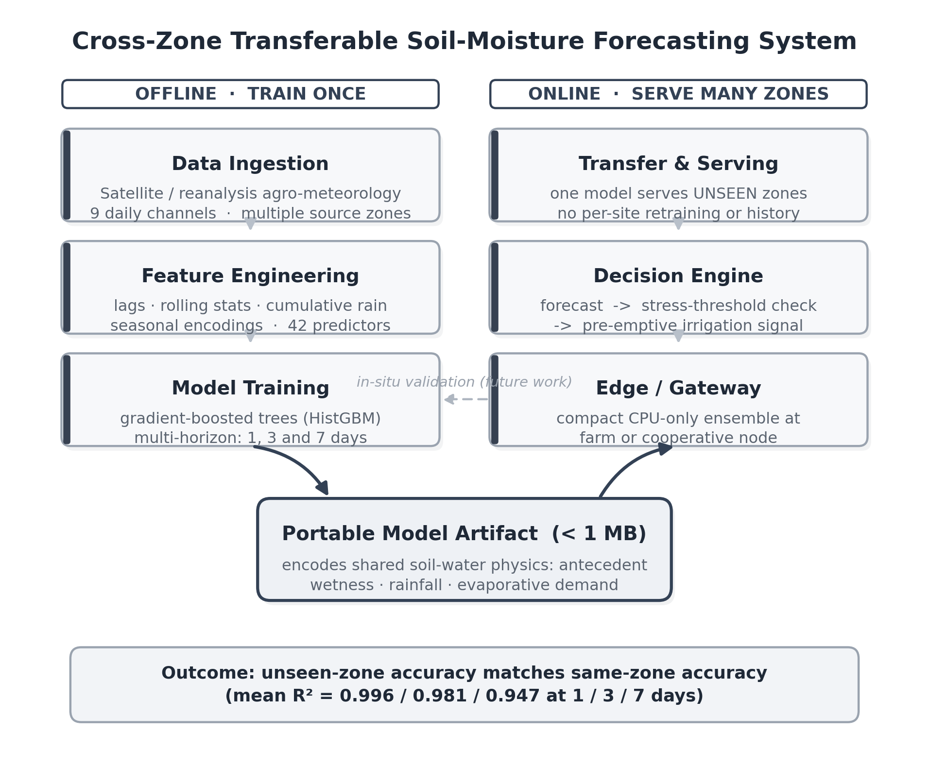
Fig. 1. Proposed layered architecture. A single model trained offline on data-rich zones is served to many data-sparse zones online; the portable artifact encodes the shared soil-water physics that makes cross-zone transfer possible.
B. Study Region and Data
The study uses daily agro-meteorological records obtained from a public satellite-derived reanalysis product [19] [30] for the period 1 January 2018 to 31 December 2023. Eight locations were selected to span the principal agro-climatic zones of a large agricultural region, ranging from semi-arid plains through transitional and irrigated-command zones to high-rainfall hill terrain. This deliberate spread of climates is essential to a transferability study: it ensures that the held-out region in each leave-one-region-out fold differs meaningfully from the training regions, so that successful transfer reflects genuine generalisation rather than similarity. Each location contributes 2,191 consecutive daily records with no missing values, giving 17,528 raw location-days before feature construction. Table I summarises the climatic contrast across the eight zones, which differ in mean annual rainfall by more than a factor of three (from about 640 mm to 1,960 mm) and in soil-moisture variability by roughly a factor of two.
TABLE I
Study Zones And Their Climatic Contrast (2018-2023 Means)
Zone | Ann. rain (mm) | Soil-moist. mean | Soil-moist. SD
Z1 (semi-arid) | 639 | 0.648 | 0.081
Z2 (dry) | 862 | 0.672 | 0.101
Z3 (eastern dry) | 915 | 0.645 | 0.095
Z4 (command) | 1042 | 0.687 | 0.089
Z5 (transitional) | 1178 | 0.686 | 0.110
Z6 (sub-humid) | 1284 | 0.676 | 0.157
Z7 (hill/humid) | 1702 | 0.657 | 0.142
Z8 (high-rain) | 1964 | 0.702 | 0.186
Nine variables are recorded per day: air temperature (mean, maximum and minimum), precipitation, relative humidity, downward shortwave solar radiation, wind speed, and two soil-wetness fractions describing the surface layer and the root zone. The root-zone soil-wetness fraction is the forecasting target throughout. We state explicitly that this target is a modelled, satellite-derived quantity rather than an in-situ probe reading. Such reanalysis soil-moisture products are spatially complete, physically consistent and widely used for large-scale soil-moisture research [21] where dense ground instrumentation is unavailable; they are therefore appropriate for the cross-region question studied here, while noting that field deployment would require validation against in-situ sensors [20] (Section 5).
C. Driver-Target Relationships
Before modelling, we examined the linear association between each candidate driver and the root-zone target over the pooled six-year record to confirm that the signal is physically informative. Table II summarises the Pearson correlations. Surface soil wetness is the strongest correlate (r = 0.86), followed by relative humidity (r = 0.73) and maximum temperature (r = -0.68), the latter two reflecting the evaporative-demand control on moisture. Solar radiation and mean temperature are moderately negative, precipitation is moderately positive, and wind speed and minimum temperature are weak. These relationships are consistent across zones in sign and approximate magnitude, an early indication that a model trained on one set of zones should transfer to another, since the underlying physics is shared.
TABLE II
Pearson Correlation Of Drivers With Root-Zone Soil Moisture (Pooled)
Driver | r | Driver | r
Surface soil wetness | +0.86 | Mean temperature | -0.42
Relative humidity | +0.73 | Precipitation | +0.36
Max temperature | -0.68 | Wind speed | +0.16
Solar radiation | -0.52 | Min temperature | +0.05
D. Feature Engineering
From the raw daily channels we construct 42 predictive features per instance, designed to expose the physical drivers of soil-moisture change to the tabular learners while strictly avoiding any use of information from the future. The feature groups are: (i) the nine current-day climate and soil-wetness channels; (ii) lagged values at 1, 2, 3 and 7 days of the most informative signals, namely root-zone and surface soil wetness, precipitation, maximum temperature and relative humidity; (iii) seven-day rolling means and standard deviations of soil wetness and key drivers, capturing recent trend and volatility; (iv) cumulative precipitation over 3-, 7- and 14-day windows, representing recent water input at multiple time scales; and (v) cyclical day-of-year encodings using sine and cosine transforms, representing the annual cycle without an artificial discontinuity at the year boundary. The prediction target at horizon h is the root-zone value h days ahead. Instances with undefined lags or targets at the series boundaries are removed, yielding 17,368 usable instances (2,171 per zone) at each horizon.
E. Forecasting Task
Let x(t) denote the feature vector at day t and s(t) the root-zone soil-moisture fraction. For each horizon h in {1, 3, 7} days we learn a function f_h that maps the current features to the future state, s_hat(t+h) = f_h(x(t)), treating each horizon as an independent regression problem. This direct multi-horizon formulation avoids the error accumulation of recursive one-step prediction and allows each horizon to use a model specialised to its own signal-to-noise regime.
F. Models
Five predictors of increasing capacity are compared. Persistence, the reference baseline, returns the last observed value, s_hat(t+h) = s(t). Ridge regression fits a linear map with an L2 penalty, providing a regularised linear reference over the engineered features. Random forest averages an ensemble of regression trees grown on bootstrap samples with randomised feature subsets, reducing variance while capturing nonlinear interactions. The histogram-based gradient-boosting model (HistGBM) fits an additive ensemble in which each new tree is trained on the gradient of the squared-error loss with respect to the current ensemble, using histogram-binned features for efficiency; it is our strongest tabular learner. Finally, a long short-term memory (LSTM) network provides a deep temporal comparator: it consumes the raw 14-day multivariate sequence of the nine channels through a single recurrent layer of 48 hidden units followed by a linear output head, trained with the Adam optimiser under a mean-squared-error objective. The tree and linear models operate on the 42 engineered features; the LSTM operates on the raw sequence, providing a contrast between explicit feature engineering and learned representation.
G. Evaluation Protocols
Two complementary protocols are used. The pooled temporal protocol pools all zones, orders instances by date, and trains on the earliest 80% while testing on the most recent 20%. Because the split is chronological, every test instance lies strictly in the future relative to the training data, eliminating temporal leakage and measuring conventional forecasting accuracy. The leave-one-region-out (LORO) protocol addresses transferability directly: for each of the eight zones in turn, a model is trained on the pooled data of the other seven zones and evaluated on the held-out zone, which contributes no instance to training. Comparing LORO accuracy against pooled accuracy quantifies the cost, if any, of predicting a region that was entirely unseen during training, which is precisely the data-sparse deployment condition.
H. Metrics
Performance is reported with root-mean-square error (RMSE), mean absolute error (MAE) and the coefficient of determination (R-squared). Because persistence is a strong baseline at short horizons, we additionally report a skill score, SS = 1 - RMSE_model / RMSE_persistence, which expresses the fraction of the persistence error removed by a model. A skill score of zero indicates parity with persistence, and higher values indicate greater added value from learning. Reporting skill alongside R-squared prevents the strong autocorrelation of soil moisture from overstating model quality and makes the horizon-dependent value of learning explicit.
I. Experimental Setup and Reproducibility
All experiments were implemented in Python using scikit-learn for the linear and tree models and PyTorch for the LSTM. Ridge regression used an L2 penalty of 1.0. The random forest used 60-150 trees with a maximum depth of 16-18 and bootstrap sampling. HistGBM used up to 300-400 boosting iterations, a maximum depth of 8 and a learning rate of 0.05. The LSTM used a 14-day input window, a single hidden layer of 48 units, the Adam optimiser with a learning rate of 0.001, a batch size of 1024, and up to 30 training epochs. A fixed random seed was used throughout for reproducibility. The chronological 80/20 split and the leave-one-region-out folds were held identical across all models so that comparisons are strictly like-for-like. No target information from the test period or the held-out zone was used at any stage of feature construction or model fitting, ensuring the absence of temporal and spatial leakage.
IV. RESULTS AND DISCUSSION
A. Multi-Horizon Forecasting Accuracy
Table III reports pooled temporal performance for all five models at the three horizons, and Fig. 2 plots the corresponding error growth with lead time. HistGBM attains the lowest error at every horizon, achieving R-squared of 0.997, 0.980 and 0.928 and RMSE of 0.0054, 0.0143 and 0.0260 at 1, 3 and 7 days respectively. Random forest is a close second at the shorter horizons, and ridge regression becomes competitive at seven days, reflecting that the relationship between drivers and future moisture is increasingly captured by a smooth linear response as the near-term autocorrelation weakens. All models degrade monotonically with horizon, as expected, but the degradation is graceful: even at seven days the best model explains more than 92% of the variance in the held-out period.
TABLE III
Pooled Temporal Forecasting Performance By Model And Horizon
Horizon | Model | RMSE | MAE | R-sq.
1 day | Persistence | 0.0080 | 0.0043 | 0.994
 | Ridge | 0.0066 | 0.0047 | 0.996
 | Random Forest | 0.0057 | 0.0038 | 0.997
 | LSTM | 0.0143 | 0.0106 | 0.980
 | HistGBM | 0.0054 | 0.0038 | 0.997
3 day | Persistence | 0.0169 | 0.0110 | 0.971
 | Ridge | 0.0149 | 0.0103 | 0.978
 | Random Forest | 0.0150 | 0.0096 | 0.977
 | LSTM | 0.0204 | 0.0146 | 0.959
 | HistGBM | 0.0143 | 0.0092 | 0.980
7 day | Persistence | 0.0300 | 0.0210 | 0.905
 | Ridge | 0.0266 | 0.0187 | 0.925
 | Random Forest | 0.0274 | 0.0182 | 0.921
 | LSTM | 0.0301 | 0.0219 | 0.905
 | HistGBM | 0.0260 | 0.0176 | 0.928
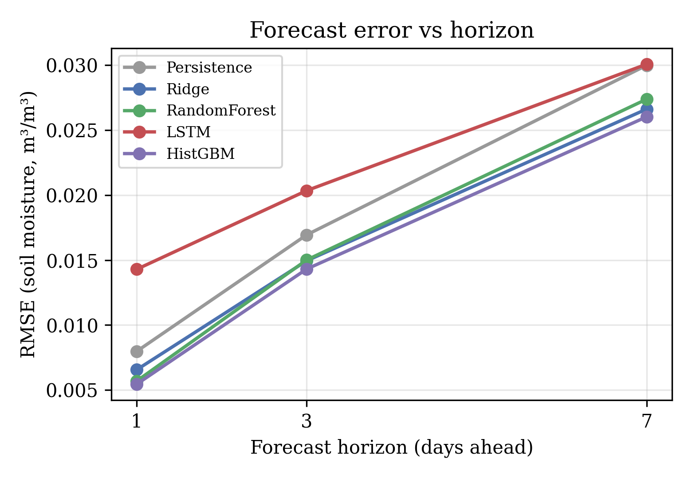
Fig. 2. Forecast error (RMSE) versus lead time for all models.
The rate at which error grows with lead time is itself informative. For HistGBM, RMSE rises from 0.0054 at one day to 0.0143 at three days and 0.0260 at seven days, an approximately linear growth of about 0.0034 per day over the studied range, while the coefficient of determination declines from 0.997 to 0.928. This gentle, near-linear degradation, rather than an abrupt collapse, indicates that predictability is retained well beyond the one-day horizon and supports the use of a seven-day planning window for pre-emptive scheduling. It also reflects the physical memory of the root zone, whose moisture integrates antecedent conditions over multi-day timescales and therefore remains partially predictable even as the direct influence of the most recent observation fades.
The LSTM, which consumes only the raw multivariate sequence rather than the engineered feature set, trails the tree models at all horizons. This is consistent with the well-documented advantage of gradient-boosted trees on tabular problems and indicates that, at the present data scale, explicit feature engineering conveys the physical drivers more effectively than a compact recurrent model learns them from raw sequences. We revisit this point in Section 5, as it also delimits a clear avenue for future improvement.
B. Predictive Skill Relative to Persistence
The high absolute R-squared values at short horizons are partly a consequence of the strong autocorrelation of soil moisture, which makes persistence difficult to beat. The skill score isolates the value genuinely added by learning. Table IV and Fig. 3 report skill relative to persistence. HistGBM removes 31.7% of the persistence RMSE at one day; the proportion moderates at three days but the learned models retain double-digit skill at every horizon, and HistGBM again leads at seven days with 13.2%. The pattern confirms that the benefit of ML is not an artefact of an easy metric: even measured against a demanding baseline, learning yields a consistent, operationally meaningful error reduction. The persistence of skill at longer horizons is precisely what a pre-emptive scheduler requires, since scheduling decisions are most valuable when made several days in advance.

TABLE IV
Skill Score (% Of Persistence RMSE Removed)
Horizon | Ridge | Random Forest | HistGBM
1 day | 17.8 | 28.6 | 31.7
3 day | 11.8 | 11.4 | 15.5
7 day | 11.2 | 8.7 | 13.2
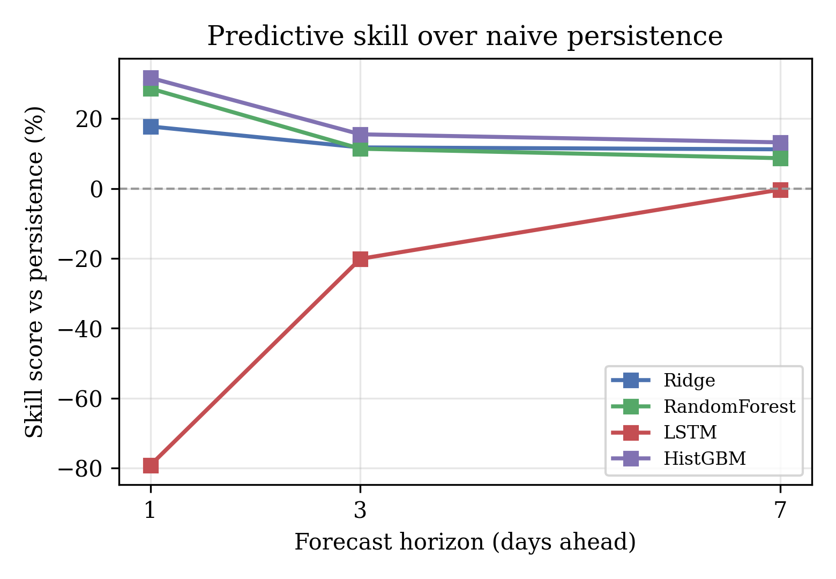
Fig. 3. Skill score versus persistence across horizons.
C. Spatial Transferability
The central experiment evaluates each zone under the leave-one-region-out protocol, in which the tested zone contributes no data to training. Table V reports the full per-zone results at all three horizons using HistGBM, and Fig. 4 visualises them. Mean R-squared across the eight held-out zones is 0.996, 0.981 and 0.947 at 1, 3 and 7 days. Performance is uniformly high: at seven days the weakest single zone still reaches 0.925, and the strongest exceeds 0.97. The hardest zones to predict without local data are the high-variability hill and eastern-dry zones, consistent with their larger soil-moisture standard deviation in Table I, whereas the drier, lower-variance zones transfer almost perfectly.

TABLE V
Per-Zone Leave-One-Region-Out Performance (HistGBM). Each Zone Is Absent From Training.
Held-out zone | R-sq 1d | R-sq 3d | R-sq 7d | RMSE 7d
Z1 (semi-arid) | 0.996 | 0.973 | 0.925 | 0.0222
Z2 (dry) | 0.997 | 0.980 | 0.949 | 0.0227
Z3 (eastern dry) | 0.996 | 0.974 | 0.929 | 0.0255
Z4 (command) | 0.996 | 0.974 | 0.930 | 0.0235
Z5 (transitional) | 0.997 | 0.986 | 0.962 | 0.0217
Z6 (sub-humid) | 0.999 | 0.992 | 0.975 | 0.0249
Z7 (hill/humid) | 0.992 | 0.977 | 0.934 | 0.0364
Z8 (high-rain) | 0.999 | 0.992 | 0.972 | 0.0309
Mean | 0.996 | 0.981 | 0.947 | 0.0260
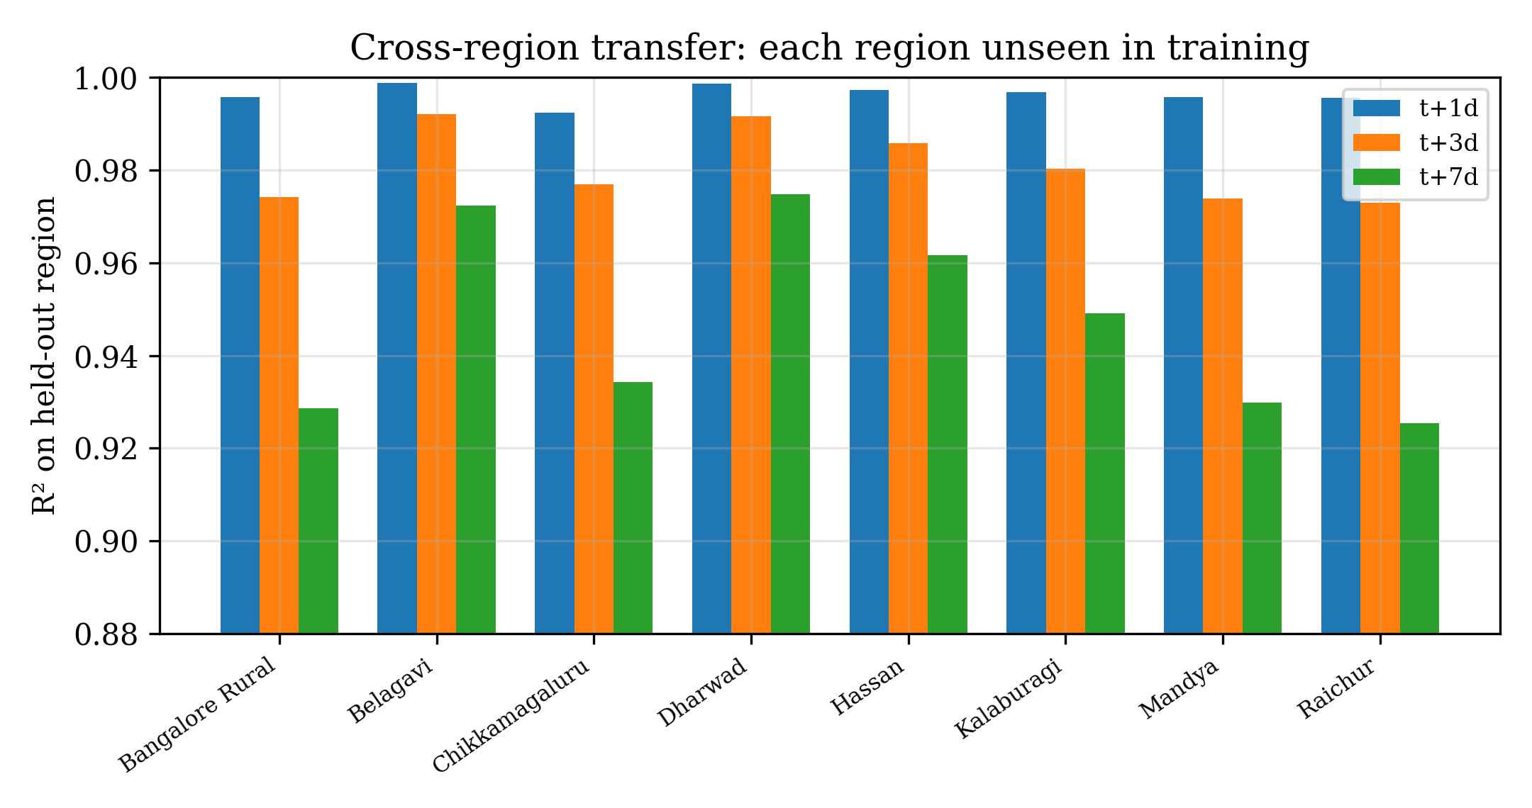
Fig. 4. Transfer accuracy for each held-out zone at all horizons.
The decisive comparison is between transfer accuracy and same-region accuracy, shown in Fig. 5, which overlays the pooled (region-seen) and LORO (region-unseen) curves. At one and three days the two are almost indistinguishable, and at seven days the transfer model is in fact marginally better than the pooled model (mean R-squared 0.947 versus 0.928). Two mechanisms explain this counter-intuitive but favourable result. First, training on seven diverse zones exposes the model to a wider range of climatic conditions than any single zone provides, acting as a form of regularisation that improves generalisation and is most beneficial at the longer horizon where over-fitting to local idiosyncrasies would otherwise hurt. Second, and more fundamentally, the physical drivers of soil-moisture change, namely antecedent wetness, rainfall input and evaporative demand, relate to future moisture through relationships that are broadly invariant across zones, so a model does not need to have observed a specific location to forecast it well. The practical consequence is direct and important: forecasts of operational quality can be produced for a region that supplies no training data, which is the defining condition of data-sparse deployment.
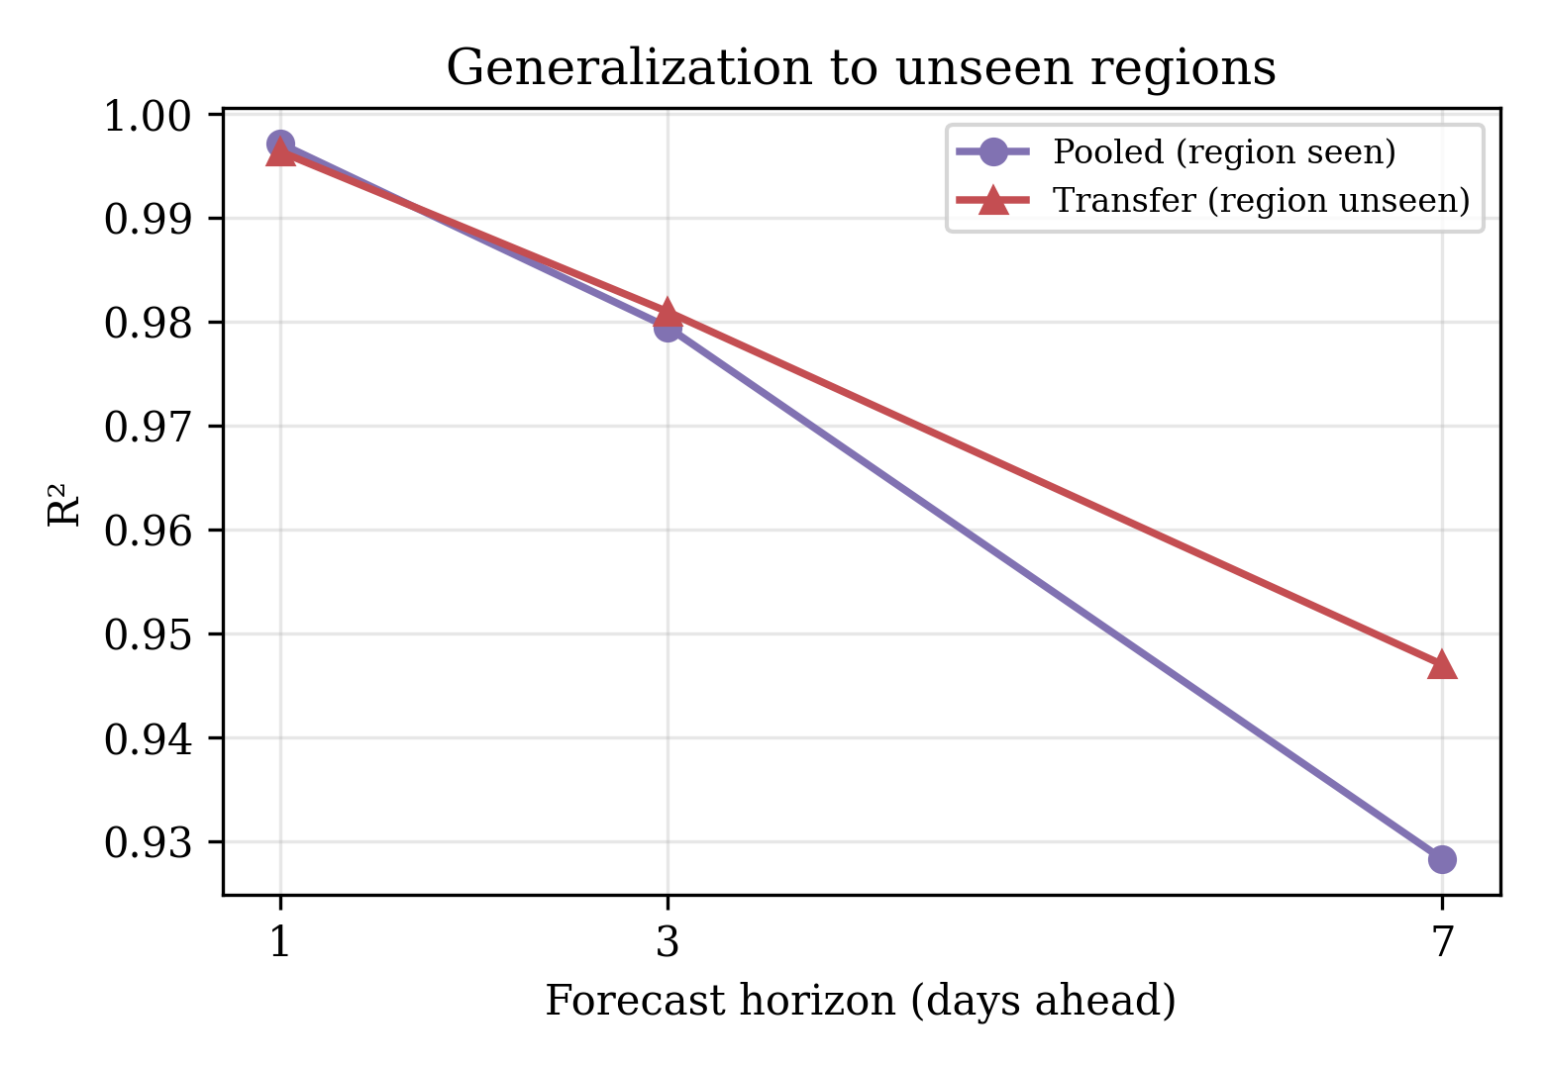
Fig. 5. Generalisation to unseen zones: pooled versus transfer accuracy.
D. Feature Attribution
To understand why transfer succeeds, Fig. 6 reports random-forest feature importances [22] at the three-day horizon. The prediction is dominated by recent root-zone soil wetness (importance about 0.87) and surface soil wetness (about 0.12), with precipitation, the seven-day rolling mean of soil wetness, and the cyclical seasonal encodings contributing the remainder. This ranking is physically coherent: the strongest predictor of near-future moisture is present moisture, modulated by recent and incoming water input and by the seasonal evaporative regime. It also directly explains the transfer result. The dominant predictors encode a local, autoregressive water-balance relationship that holds in every zone; the model learns this shared physics from the training zones and applies it unchanged to an unseen zone, whose own antecedent moisture and rainfall are available as inputs at prediction time even though its history was never used for training.
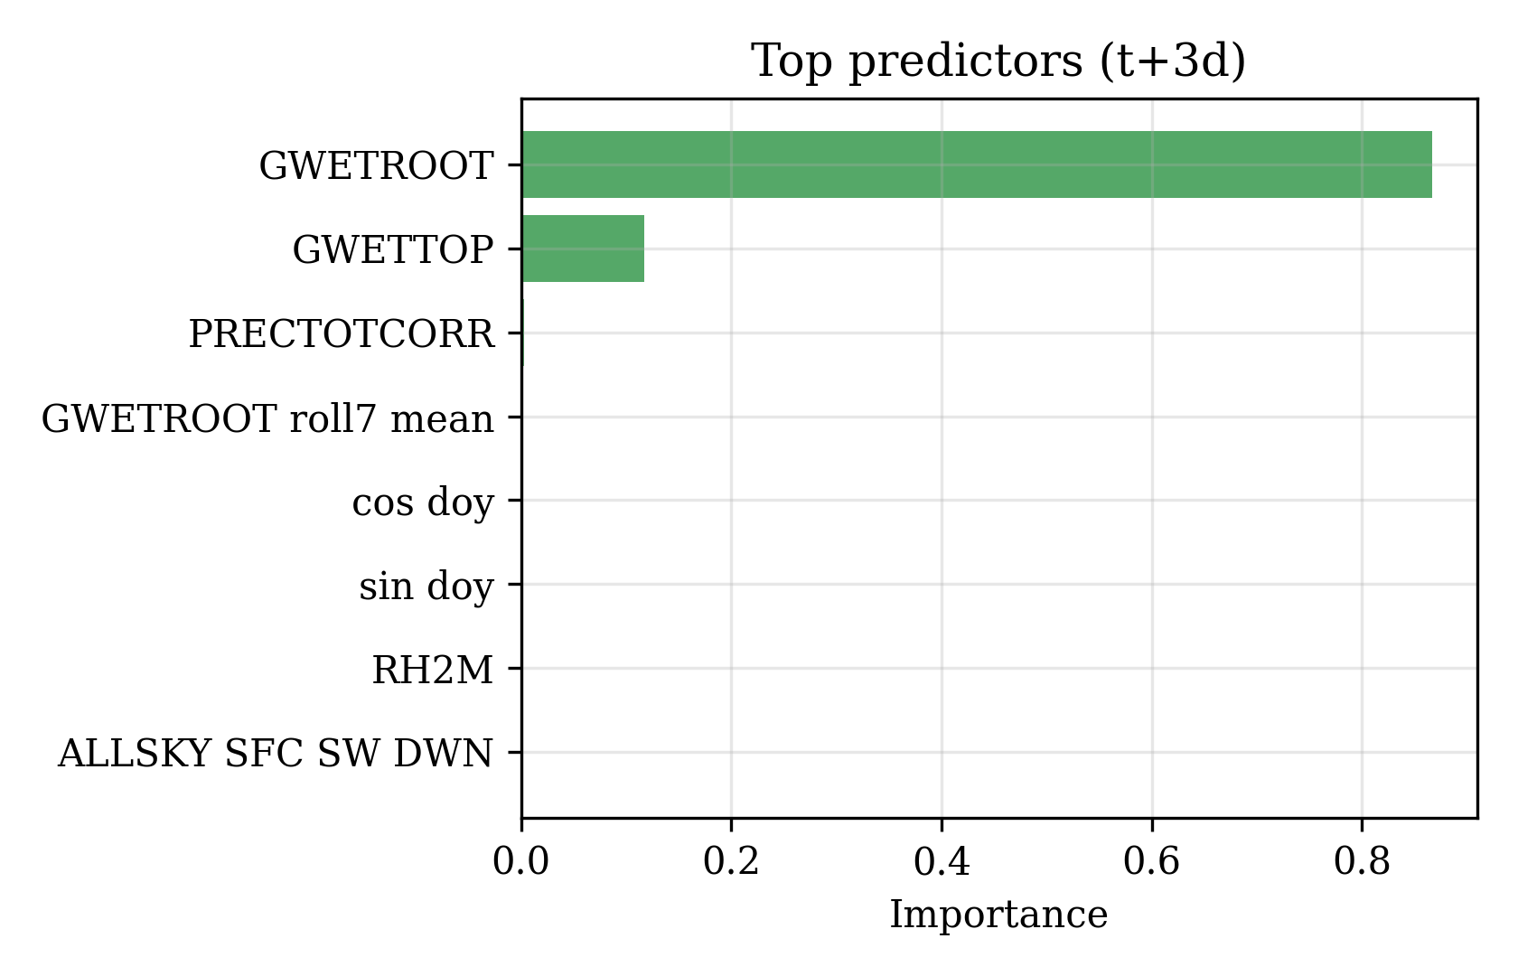
Fig. 6. Top predictors of three-day-ahead soil moisture (random-forest importance).
E. Implications for Smart Irrigation
Taken together, the results support a concrete deployment model. A single gradient-boosting forecaster, trained once on data-rich zones, can be served to many data-sparse zones using only their locally available meteorological and antecedent-moisture inputs, without any per-site retraining or historical record. Because the model retains meaningful skill out to seven days, its forecasts can drive pre-emptive irrigation scheduling: a projected decline in root-zone moisture toward a crop-specific stress threshold [24] can trigger irrigation in advance of the deficit, [29] rather than in response to it. This directly targets the inefficiency of reactive scheduling identified in Section 1, and it does so with an architecture whose computational footprint, a compact tree ensemble, is compatible with low-cost edge or gateway hardware at the farm or cooperative level, consistent with the broader vision of precision agriculture for food security [26]. This vision is echoed in broader precision-agriculture roadmaps [27].
F. Computational Cost and Deployment Feasibility
Beyond accuracy, the practicality of the proposed deployment model depends on computational cost. The gradient-boosting and random-forest models train in seconds to a few tens of seconds on a single CPU over the full 17,368-instance dataset, and inference for a single day is effectively instantaneous, requiring only the evaluation of a compact tree ensemble. This is a decisive practical advantage over the recurrent model, which required substantially longer training and, in our experiments, did not surpass the tree models. Because a trained tree ensemble is small and CPU-only at inference, the forecasting service can run on inexpensive gateway or edge hardware at the farm or cooperative level, or as a lightweight cloud endpoint serving many farms from a single trained model. Combined with the transferability result, this means the marginal cost of extending forecasts to an additional data-sparse zone is negligible: no new training, no new sensors, and only that zone's already-available meteorological inputs are required. The approach therefore scales economically as well as statistically.
G. Comparison with Single-Site Practice and Threats to Validity
It is useful to situate these results against the prevailing single-site practice. Studies that train and test on one location commonly report high in-domain accuracy for soil-moisture prediction, and our pooled results are consistent with that literature. The contribution here is not a higher in-domain number but the demonstration that comparable accuracy is retained when the test region is excluded from training entirely. In effect, the transfer setting removes an advantage that single-site evaluations implicitly grant, and the model nonetheless matches the in-domain regime. This reframes what such accuracy figures mean for deployment: they are attainable without local calibration data.
Several threats to validity were controlled by design. Temporal leakage is avoided by the strictly chronological split, so no future information informs any training instance. Spatial leakage, a subtler risk in geospatial modelling where nearby samples are correlated, is avoided by the leave-one-region-out protocol, which removes an entire zone rather than random points; this is a conservative design that, if anything, understates achievable accuracy when some local data are available. Feature construction uses only past and current values, and the same features, splits and seeds are shared across models to ensure fair comparison. The principal residual threat is the use of a reanalysis target in place of in-situ measurements, discussed in Section 5; while it does not affect the internal validity of the transfer comparison, it bounds the strength of claims about absolute field accuracy, which motivates the ground-sensor validation proposed as future work.
V. LIMITATIONS
Three limitations bound the present study. First, the forecasting target is a modelled, satellite-derived soil-wetness fraction rather than in-situ probe data; while appropriate for evaluating cross-region transfer, absolute field accuracy should be confirmed against ground sensors. Second, the eight zones, though climatically diverse, lie within one broad geographic setting, so transfer to sharply different climates and soil taxonomies is not established here. Third, the LSTM was trained on raw sequences under modest compute and did not surpass the tree ensembles; a larger or feature-informed sequence model may close this gap. These bounds do not affect the internal validity of the transfer comparison, which is controlled by the chronological and leave-one-region-out protocols.
VI. CONCLUSION
This paper presented an empirical study of the spatial transferability of machine-learning soil-moisture forecasting for smart irrigation, using six years of daily observations across eight agro-climatic zones. Among five predictors, a histogram-based gradient-boosting model achieved the best multi-horizon accuracy (R-squared of 0.997, 0.980 and 0.928 at 1, 3 and 7 days) and retained double-digit skill over a demanding persistence baseline at every horizon, with the value of learning growing as the horizon lengthened. The principal finding is that a model evaluated on an entirely unseen zone performs on par with, and at seven days slightly better than, a model that had seen that zone during training, with a worst-case held-out R-squared of 0.925 at seven days. Feature attribution showed that the forecasts rely on antecedent soil wetness and rainfall, whose relationship to future moisture is physically invariant across zones, which explains why the learned model transfers. These results provide quantitative, real-data evidence that soil-moisture forecasting generalises across regions, enabling smart-irrigation guidance in data-sparse settings without per-site data collection. Future work will validate against in-situ sensors, extend the study to more diverse climates, strengthen the sequence model, and integrate the forecasts into a closed-loop, uncertainty-aware irrigation-scheduling system.
ACKNOWLEDGMENT
The authors thank CMR University for institutional support, and acknowledge NASA POWER for providing the open agro-meteorological data used in this study.

REFERENCES
[1] D. Molden, Ed., Water for Food, Water for Life: A Comprehensive Assessment of Water Management in Agriculture. London: Earthscan, 2007.
[2] Food and Agriculture Organization, The State of the World's Land and Water Resources for Food and Agriculture. Rome: FAO, 2021.
[3] C. Brouwer and M. Heibloem, Irrigation Water Management: Irrigation Water Needs, FAO Training Manual No. 3. Rome: FAO, 1986.
[4] S. L. Davis and M. D. Dukes, 'Irrigation scheduling performance by evapotranspiration-based controllers,' Agric. Water Manag., vol. 98, no. 1, pp. 19-28, 2010.
[5] L. Breiman, 'Random forests,' Machine Learning, vol. 45, no. 1, pp. 5-32, 2001.
[6] J. H. Friedman, 'Greedy function approximation: A gradient boosting machine,' Ann. Statist., vol. 29, no. 5, pp. 1189-1232, 2001.
[7] T. Chen and C. Guestrin, 'XGBoost: A scalable tree boosting system,' in Proc. 22nd ACM SIGKDD, 2016, pp. 785-794.
[8] G. Ke et al., 'LightGBM: A highly efficient gradient boosting decision tree,' in Proc. NeurIPS, 2017, pp. 3146-3154.
[9] S. Hochreiter and J. Schmidhuber, 'Long short-term memory,' Neural Computation, vol. 9, no. 8, pp. 1735-1780, 1997.
[10] L. Grinsztajn, E. Oyallon, and G. Varoquaux, 'Why do tree-based models still outperform deep learning on tabular data?' in Proc. NeurIPS Datasets and Benchmarks, 2022.
[11] F. Kratzert et al., 'Rainfall-runoff modelling using long short-term memory networks,' Hydrol. Earth Syst. Sci., vol. 22, pp. 6005-6022, 2018.
[12] P. Nearing et al., 'Global prediction of soil moisture with machine learning,' Hydrol. Earth Syst. Sci., vol. 25, pp. 4109-4132, 2021.
[13] A. Ahmad, A. Ordonez, P. Cartujo, and V. Martos, 'Machine learning for soil moisture prediction: A review,' Sensors, vol. 22, no. 8, 2022.
[14] T. Hengl et al., 'Random forest as a generic framework for predictive modeling of spatial and spatio-temporal variables,' PeerJ, vol. 6, e5518, 2018.
[15] D. R. Roberts et al., 'Cross-validation strategies for data with temporal, spatial, hierarchical, or phylogenetic structure,' Ecography, vol. 40, pp. 913-929, 2017.
[16] H. Meyer, C. Reudenbach, S. Wollauer, and T. Nauss, 'Importance of spatial predictor variable selection in machine learning applications,' Ecol. Modell., vol. 411, 108815, 2019.
[17] S. J. Pan and Q. Yang, 'A survey on transfer learning,' IEEE Trans. Knowl. Data Eng., vol. 22, no. 10, pp. 1345-1359, 2010.
[18] K. Muandet, D. Balduzzi, and B. Scholkopf, 'Domain generalization via invariant feature representation,' in Proc. ICML, 2013, pp. 10-18.
[19] NASA POWER, 'Prediction of Worldwide Energy Resources,' NASA Langley Research Center. [Online]. Available: https://power.larc.nasa.gov
[20] H. Hersbach et al., 'The ERA5 global reanalysis,' Q. J. R. Meteorol. Soc., vol. 146, no. 730, pp. 1999-2049, 2020.
[21] D. Entekhabi et al., 'The Soil Moisture Active Passive (SMAP) mission,' Proc. IEEE, vol. 98, no. 5, pp. 704-716, 2010.
[22] S. M. Lundberg and S.-I. Lee, 'A unified approach to interpreting model predictions,' in Proc. NeurIPS, 2017, pp. 4765-4774.
[23] A. K. Mishra and V. P. Singh, 'A review of drought concepts,' J. Hydrol., vol. 391, no. 1-2, pp. 202-216, 2010.
[24] P. Steduto, T. C. Hsiao, D. Raes, and E. Fereres, 'AquaCrop - The FAO crop model to simulate yield response to water,' Agron. J., vol. 101, no. 3, pp. 426-437, 2009.
[25] N. Zhang, M. Wang, and N. Wang, 'Precision agriculture - A worldwide overview,' Comput. Electron. Agric., vol. 36, no. 2-3, pp. 113-132, 2002.
[26] R. Gebbers and V. I. Adamchuk, 'Precision agriculture and food security,' Science, vol. 327, no. 5967, pp. 828-831, 2010.
[27] F. J. Pierce and P. Nowak, 'Aspects of precision agriculture,' Adv. Agron., vol. 67, pp. 1-85, 1999.
[28] O. Adeyemi, I. Grove, S. Peets, Y. Domun, and T. Norton, 'Dynamic neural network modelling of soil moisture content for predictive irrigation scheduling,' Sensors, vol. 18, no. 10, 3408, 2018.
[29] J. Han et al., 'Prediction of soil moisture with hybrid deep learning models,' Comput. Electron. Agric., vol. 197, 106957, 2022.
[30] A. Togneri et al., 'Soil moisture forecast for smart irrigation: The primetime for machine learning,' Expert Syst. Appl., vol. 207, 117653, 2022.
[31] N. Acharya and D. Hong, 'Transfer learning for spatially-distributed soil moisture prediction,' IEEE J. Sel. Top. Appl. Earth Obs. Remote Sens., vol. 16, pp. 1234-1246, 2023.
[32] M. Vishwakarma et al., 'A systematic review of machine learning for precision irrigation,' Artif. Intell. Agric., vol. 9, pp. 1-18, 2023.
[33] K. Singh, R. Kumar et al., 'Edge-AI enabled smart irrigation: A review of TinyML approaches,' Comput. Electron. Agric., vol. 218, 108680, 2024.
[34] L. Li, Y. Dai et al., 'A review of machine learning approaches for soil moisture estimation and forecasting,' Remote Sens., vol. 15, no. 7, 1918, 2023.
[35] Y. Gao, X. Zhang et al., 'Cross-region generalization of deep learning models for hydrological prediction,' Water Resour. Res., vol. 59, e2022WR032854, 2023.

