

Name: **Sureddy Venkata Gowtham**

Registration no : 12112426

Assignment: News website.

Instructor : Ankitha Wadhawan

Section : K21WY Group “B”

GitHub link :

# Introduction of “News Website”

News sites offer the information to the public, political, social, sports, health, entertainment etc. Instant & latest news from all over the world.

Long ago, people used to perform folk songs and drama in various cultures. It was then that media was first used to communicate messages to a wider group of people. Print media followed and then mass media and social media.

Media refers to various means of communication. It also refers to communication devices. Communication devices are used to interact and communicate among people.

The most common forms of media today are radio, internet, newspaper and television. Media is an important part of our lives. It is also two-sided meaning that it has a positive side and a negative one.

# Pros of media :-

1. It educates people. Through television and radio programs, people get to learn about health matters, environmental conservation, and much more.

2. People get the latest news in a very short time. Distance is not a barrier. People get news daily through the media and this keeps them updated on the happenings around the world.

3. People get to bring out their hidden talents. Through media showcase their talents such as comedy, acting and singing.

4. Children’s knowledge increases. Children can learn from quiz programs, animal programs and so on.

5. Radio is convenient as people do get short news and with a mobile phone one can access it.

6. Great in promoting mass consumer products. This can in turn increase sales of the product.

7. Serves as a good source of entertainment. People get entertained through music and television programs.

8. Television allows electronic duplication of information. This reduces the production cost making mass education possible.

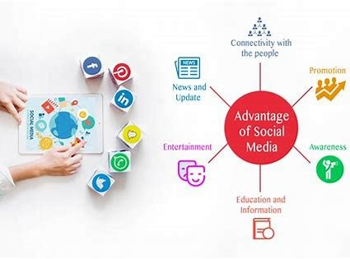

# Cons of Media :-

1. It leads to individualism. People spend too much time on the internet and watching television. As a result, socialization with friends, family and neighbors is affected.

2. Some media contents are not suitable for children. Limiting children’s access to such content can be difficult.

3. Newspaper is geographically selective.

4. Increase in advertisements in television and radio is making them less attractive.

5. Internet as a form of media opens up possibilities of imposters, fraud and hacking.

6. Media can be addictive, e.g. some television programs and internet. This can lead to decrease in people’s productivity.

7. Health problems. Prolonged watching of television can lead to eyesight problems and radio listening using earphones exposes one to possible hearing defects.

8. It glamorize drugs and alcohol. Some programs make the use of these things appear cool’.

9. It can lead to personal injury. Some people decide to follow the stunts that are showcased in the media. This can lead to injuries.

10. It can lead to ruin of reputation. It is possible for one to create an anonymous account. Such accounts can be used to for malicious reasons such as spreading rumors. This can lead to ruin of reputation of an individual or a company.



# Example <News:->

## Ukraine's Mariupol captured, says Russia; Vladimir Putin hails 'successful liberation of city'-

Moscow: Russian Defence Minister Sergey Shoigu has informed President Vladimir Putin on Thursday that the country`s forces have fully captured Ukraine`s key Black Sea port city of Mariupol, the media reported.

However, more than 2,000 Ukrainians fighters still remain entrenched at the Azovstal steel plant in the city, RT News reported citing Shoigu as saying.

When Mariupol was encircled in early March, some 8,100 Ukrainian soldiers, and foreign mercenaries remained inside, according to the Minister`s estimates.

More than 1,400 militants have laid down their arms, Shoigu said, adding that over 142,000 civilians have also been evacuated from the city that has been under siege for weeks.

President Putin has called Shoigu`s plan of storming the Azovstal plant "inadvisable" and ordered to "safely block" the area instead while extending to those inside another offer to lay down their arms, the RT report said.

Russia has twice sought to establish a humanitarian corridor for those willing to leave the plant in recent days, but both attempts failed, it added. Shoigu said that the Russian forces had announced ceasefires and opened humanitarian corridors for two hours a day for the past two days on Putin`s orders to allow those inside the Azovstal plant to leave.

"We have made some 90 buses and 25 ambulances ready for them," Shoigu said, adding that cameras have been mounted in the area to monitor the situation. "No one has left the Azovstal (plant)," he said, adding that some 100 civilians from other areas seized this opportunity to evacuate.

Sergey Volyna, the commander of Ukraine`s 36th Marines Brigade, which is holed up at the plant, claimed that "hundreds" of civilians were trapped in the facility.

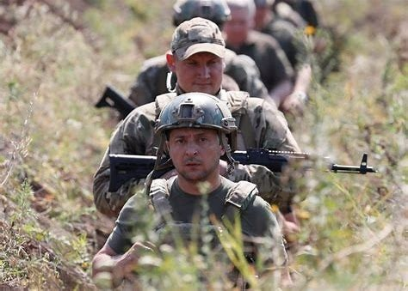

# The conclusion

Although media has many advantages it also has its limits. It is up to us, the users, to decide to use it wisely for the best impact.

By :- **Sureddy Venkata Gowtham .**

# *** The End ***