

|  |  |
| --- | --- |
| Operating Systems 1 Project | |
|  |  |
| By: عبدالله محمد عبدالناصر الزبداني –علا طلال أبو كرم  محمد عثمان بسام دياربكرلي – ربى خالد حمد Date: 20-12 |  |

**UI:**

We created one script called UI.sh that runs the whole other scripts. It contains a display for the options that the user will choose from and depending on the option that the user uses it’ll run either a function from another script or a whole other script, also it contains a function for the crontab for auto-monitoring for the system.

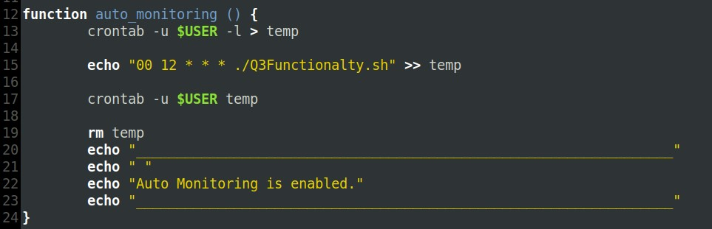

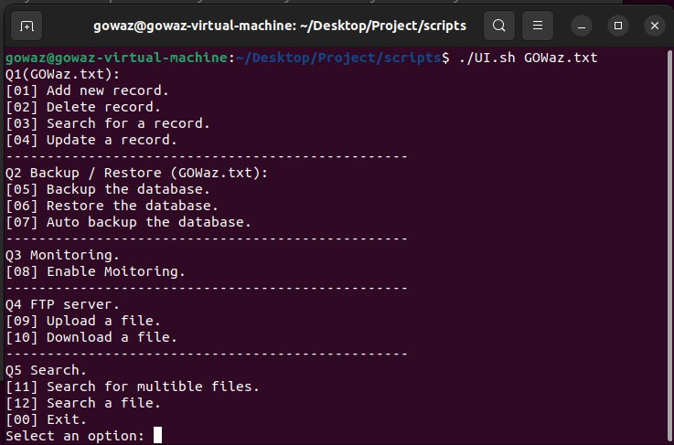

**Q1:**

What we did here is we created one script called Q1Functionalty.sh it contains four functions each function does one of the requirements for question 1:

1. Insert new record:

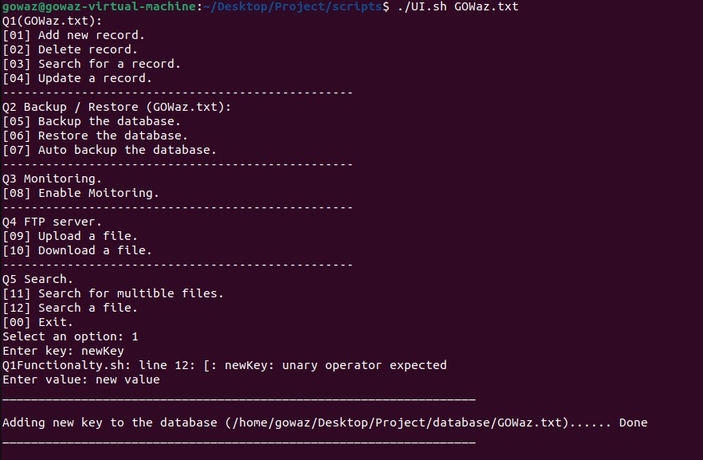First, the function asks the user to enter the key of the new record, then the function checks if the key is already in the database or not, if it’s already there it displays a message “already exists.” Because the key must be unique, if it doesn’t exist it asks the user for the value, then it encodes the value and inserts both the key and the value in the database along with the version of the record and the user.

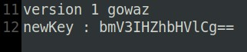

1. Delete record:

First, the function asks the user to enter the key, the function then goes and searches the database if the key matches any key from there, if it matches the key, it brings up the number of the line that the key was placed in, then it sends a command to delete both lines of the record and its version, and if it doesn’t exist it displays “doesn’t exist.”.

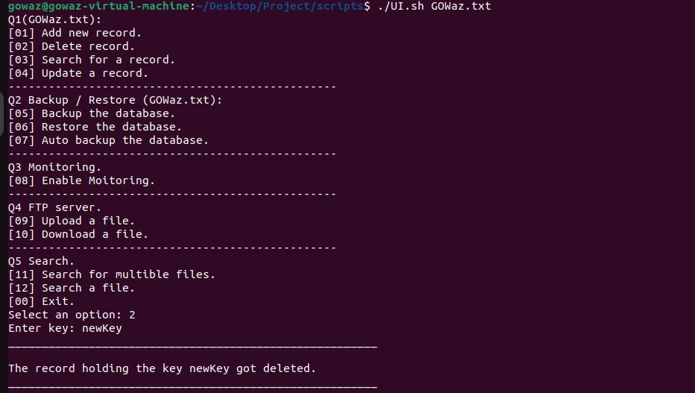

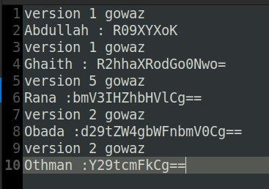

1. Search record.

First, the function asks the user to enter the key, then it searches the database for any key that matches the entered key, if it matches a key, the function brings that record from the database, decodes the value, and displays the key with its decoded value for the user, and if it doesn’t exist it displays “doesn’t exist.”.

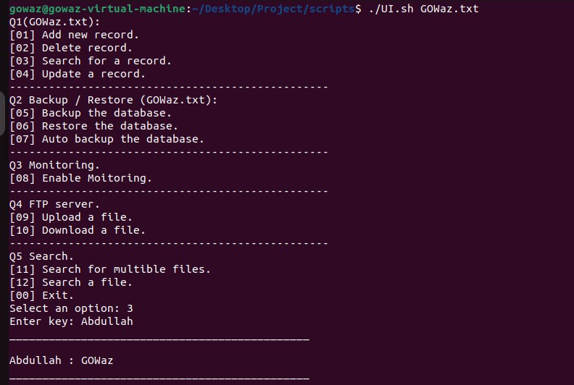



1. Edit record:

First, the function asks the user to enter the key, then it searches the database for the key that matches the entered key, and it brings the record with its value and what line in the database it’s in, then it asks the user for the new value, after that it sends the new value and it updates the version number, of course, we send the number of the line we want to edit, so if there are to keys holding the same value, we don’t change the unwanted key.

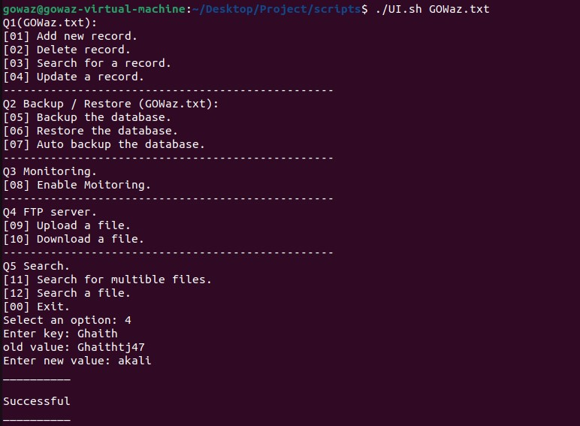

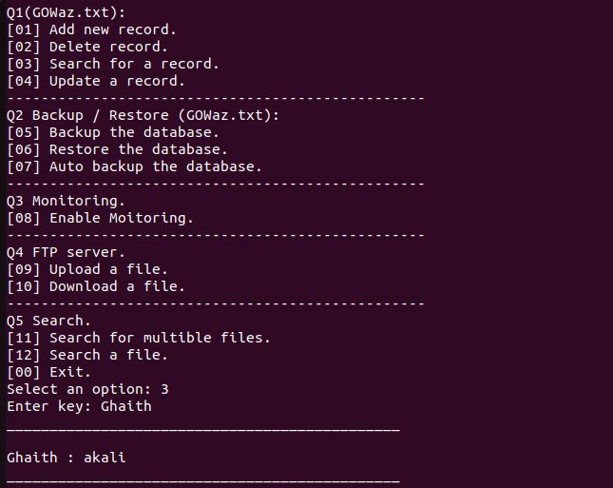

**Before**

** After**

**Q2:**

We created one script it has three functions:

1. Backup database:

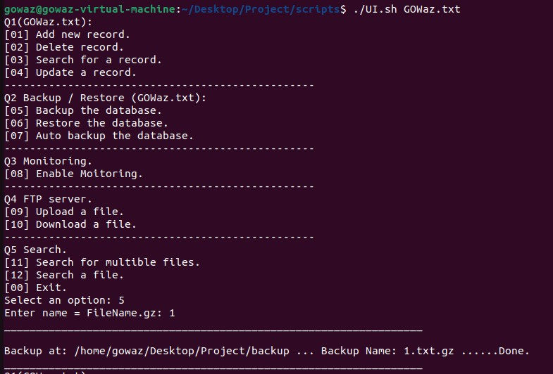It asks the user to input the backup name, and it backs the database to the backup folder without deleting the original file.

1. Restore database:

It asks the user to input the name of the backup name he wants to restore, then it restores it and puts it in the database folder.

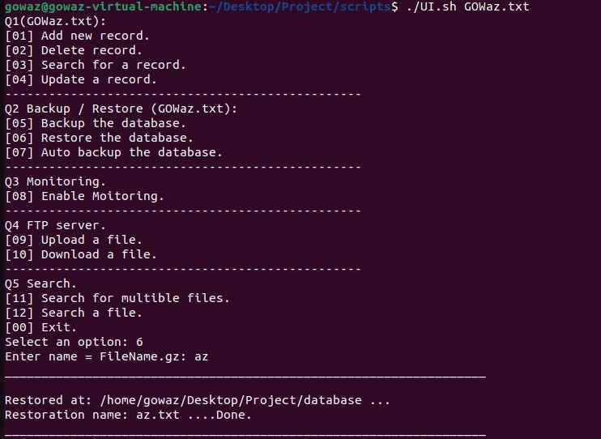

1. Auto backup for the database:

The function asks the user to input the maximum number of backups he wants, then it checks that it’s not equal to zero, then it asks the user to input the schedule Daily, Weekly, or Monthly, and depending on the choice it’ll run another script using crontab the other script it’ll checks the number of files in the backup folder if it’s bigger than max it’ll delete the oldest backups and create new backup holding the:

date of the machine_database name.txt.gz, and if it’s less than max then it creates a new backup same as before.

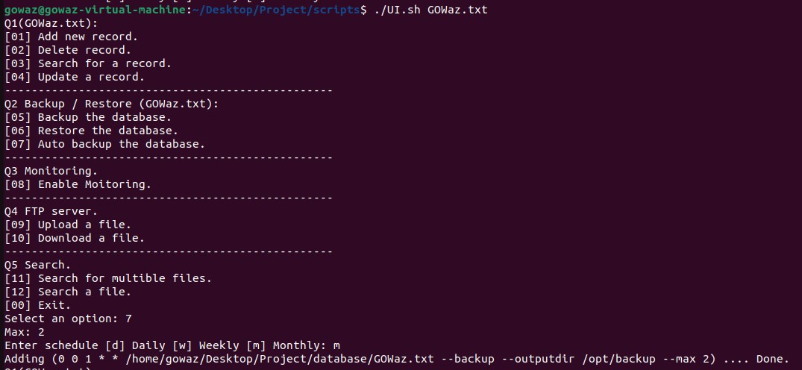

**Q3:**

We created one script that contains four functions, each function calls a status command RAM, CPU, HARD, and a function that calls the other three, and create a file with the date that the script runs at and put the result in that file.

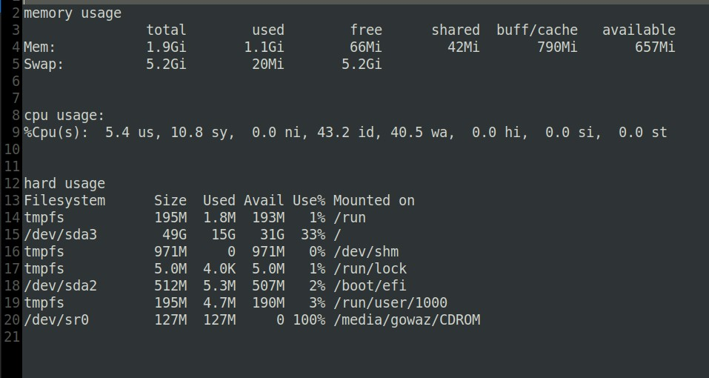

**Q4:**

1- To set up the FTP server we used the vsftpd server which is widely regarded as the fastest and most secure FTP server for UNIX-like systems.

First, we need a new machine to be the FTP server so we installed Ubuntu then we installed vsftpd and ufw, and FTP through this instruction.

sudo apt install vsftpd ufw ftp -y

In our case the default configuration of vsftpd is fine, but we still need to make sure FTP traffic is allowed, so we executed these instructions:

sudo ufw allow 20/tcp

sudo ufw allow 21/tcp

sudo ufw allow 990/tcp

sudo ufw allow 40000:50000/tcp

then we created a user who is going to use the FTP access.

2-In order to upload files from company pcs to our FTP server we need first to open a connection between them and use FTP user information (user name and password) to access the server,

then the employee has to enter his file’s location and name, so we create the following script to do this thing:

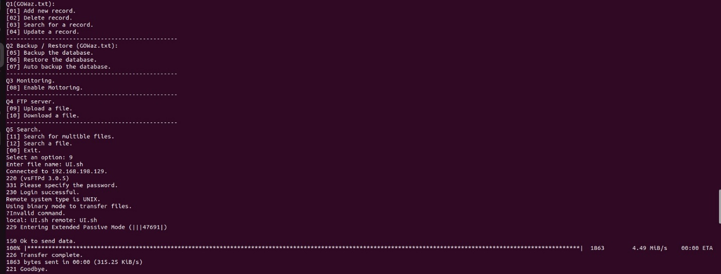

3-In order to download files from the FTP server we have to do the same previous connection process but here the employee should enter the location and names of the files he wants, so we create the following script to do these things:

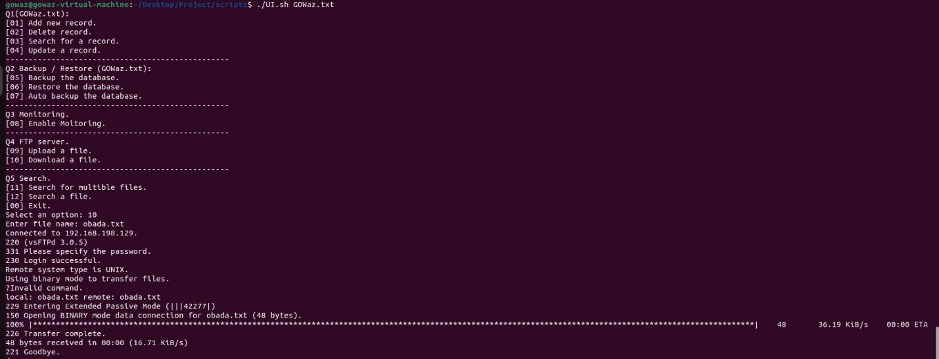

**Q5:**

We created one script with two functions, one for searching multiple files and displaying the path of the searched files, and also saves the search result so if the user searched for the same file again the search will be faster it displays the result right away, and one to search for file info and displays the first three columns.

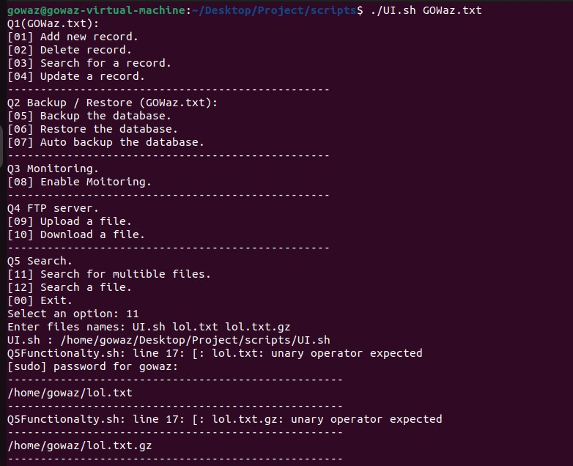Here the script takes time to search for these files:

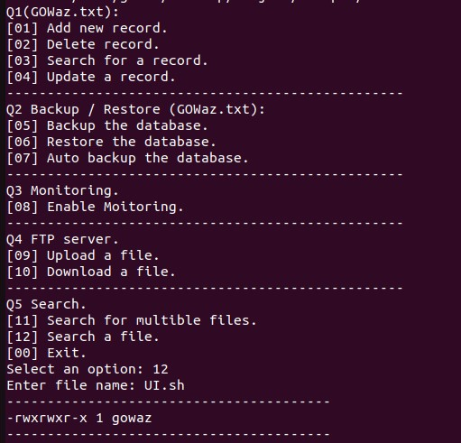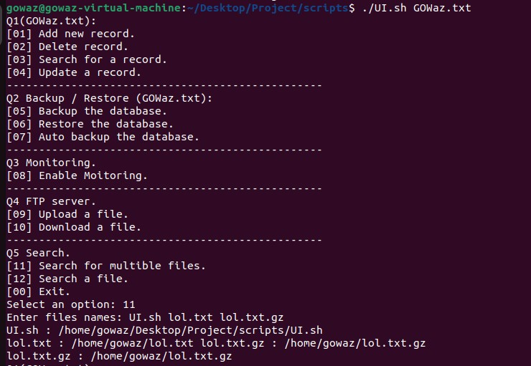Here the script instantly displays the result because of the previous search.