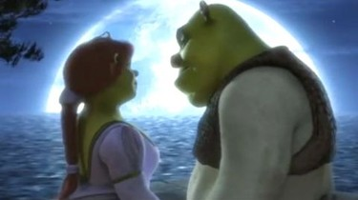
March 24, 2024
Glory Onyeugbo, Amelia Green
IST 718: Big Data Analytics
Spring 2024
Cinematic Insights
Predicting and Comparing MPAA Ratings for "Shrek 2"
Table of Contents
SUMMARY 2
Recommendation 2
Introduction 3
Problem Statement 3
Data Questions 3
Hypothesis 3
About the Data 3
Data Exploration (Observations) 4
Data Analysis 9
Decision Tree Model 9
Random Forest Models 10
Model 1 10
Model 2 10
Model 3 11
Model Summaries 12
Recommendations 12
References 13
Appendices 14

SUMMARY
We aim to assist Dreamworks, a prominent movie producer, in evaluating the accuracy of their parental guidance ratings for each movie they produce, with a specific focus on 'Shrek 2,' which received a PG-13 rating from the Motion Picture Association of America (MPAA). Leveraging data collected from IMDb.com and MovieLens.com, we developed decision tree and Random Forest models. These models utilized features such as sex, violence, profanity, drugs, and intensity, identified through observational analysis, to assess the correctness of assigned ratings. Following the creation of test and training sets from the dataset, both models achieved an accuracy rate of 76% and correctly predicted that 'Shrek 2' should be rated PG-13.

Recommendation
We recommend that Dreamworks continue assigning parental guidance ratings to movies in their current manner, as it appears to be effective. However, for potentially improved accuracy, we suggest two approaches. Firstly, we recommend breaking down the data by decades to investigate whether societal changes over time have influenced rating trends, potentially leading to more conservative or stricter ratings. Secondly, we propose considering a k-nearest neighbor (knn) model with a fixed number of clusters, corresponding to the five MPAA ratings. This approach may provide additional insights into the classification of movies based on their content.

Introduction
In the ever-evolving landscape of the film industry, understanding the factors influencing movie ratings is paramount for filmmakers, distributors, and audiences alike. The Motion Picture Association of America (MPAA) rating system provides crucial guidance to viewers regarding the suitability of movies for different age groups. However, predicting these ratings accurately can be a challenging task, given the myriad of factors involved.

Problem Statement
For our analysis, we aim to investigate the key features that significantly influence MPAA ratings, such as G, PG, PG-13, R, and NC-17. Our primary objective is to develop a predictive model capable of accurately forecasting MPAA ratings for movies. A particular emphasis will be placed on predicting the MPAA rating for Dreamworks animated film "Shrek 2." Through this endeavor, we seek to unravel the understated factors that contribute to movie ratings and pave the way for more informed decision-making processes within the film industry.

Data Questions
In our analysis, we aim to address the following questions:
- What features significantly influence the MPAA rating for "Shrek 2" and potentially all movies?
- To what extent can we achieve accuracy in predicting the MPAA rating for "Shrek 2"?

Hypothesis
We hypothesize that the parental guide fields, such as sex, violence, profanity, drugs, and intensity, hold substantial influence over a movie's rating.

About the Data
We’ve obtained two datasets to conduct our analysis with. We have already obtained both the IMDB Parental Guide and Movie Lens datasets. These datasets collectively provide a rich source of information, covering user preferences, movie details, and content appropriateness.
- IMDB Parental Guide Dataset: Supplementary dataset obtained from Kaggle, sourced from IMDB, providing parental guide information. IMDB Parental Guide
- Rows: 53,228
- Columns: 22
- MovieLens Dataset: A comprehensive dataset obtained from MovieLens, including user ratings and associated movie details. MovieLens Datasets
- Rows: 45,466
- Columns: 24

Data Exploration (Observations)
Our data exploration revealed intriguing insights into the movie landscape, notably in the realm of genres. Drama emerged as the dominant genre, boasting a staggering count of over 14,000 movies in our dataset. This finding was visually represented through a bar chart, vividly showcasing the prevalence of drama compared to other genres.
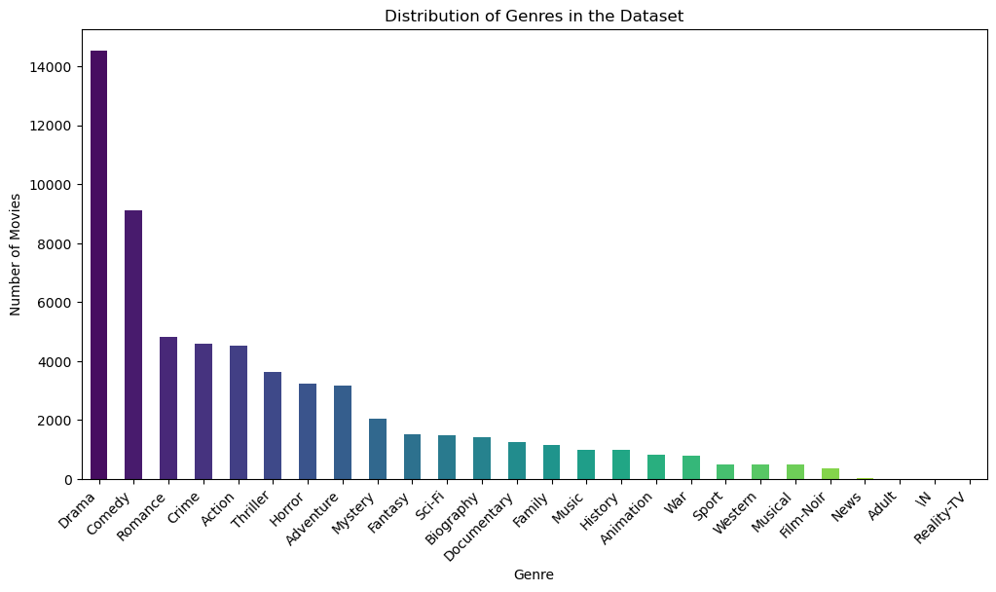
Following closely behind were comedy and romance, with approximately 9,000 and 5,000 movies, respectively. This distribution sheds light on the diverse thematic interests of filmmakers and the viewing preferences of audiences. Such observations serve as valuable groundwork for understanding trends in movie production and consumption, guiding future analyses and decision-making processes.

Another notable observation pertained to the distribution of MPAA ratings among the movies in our dataset. It's crucial to acknowledge that a substantial portion, more than 50%, of the movies were missing any assigned ratings. Thus, our initial analysis focused solely on movies with available ratings. Among these, the most prevalent MPAA rating was PG, attributed to approximately 8,000 movies. Following PG were the ratings R, G, PG-13, and NC-17, with respective counts of around 7,000, 5,000, 3,000, and 1,000. This distribution highlights the prevalence of family-friendly content, as evidenced by the dominance of PG-rated movies, while also showcasing the diversity of content across different rating categories.

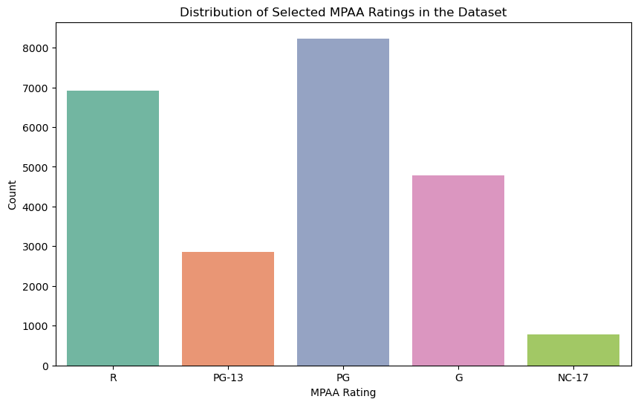

Furthermore, we conducted an analysis by generating word clouds based on the overviews of each movie. This visualization technique allowed us to identify words that appeared with the highest frequency across the dataset. In the aggregated word cloud encompassing all movies, prominent terms included "life," "find," "love," and "one." Subsequently, we segmented the word clouds based on the assigned MPAA ratings to discern any notable patterns. One noteworthy observation was the varying frequency of the term "family" across different rating categories. Interestingly, the size or frequency of the word "family" decreased as the MPAA rating increased, indicating a potential shift in thematic emphasis towards more mature or adult-oriented content. However, this trend was not consistent across all ratings, as the size of "family" increased for movies rated R, particularly in the PG-13 and R categories, suggesting a unique narrative focus within these classifications.

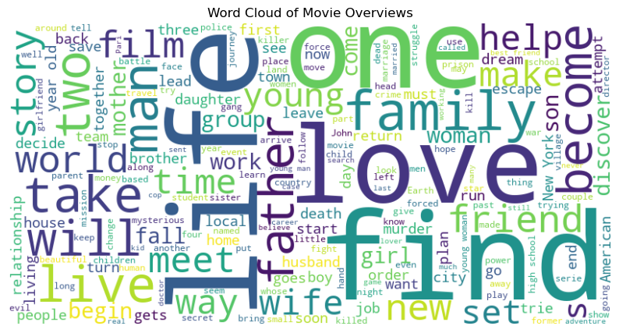

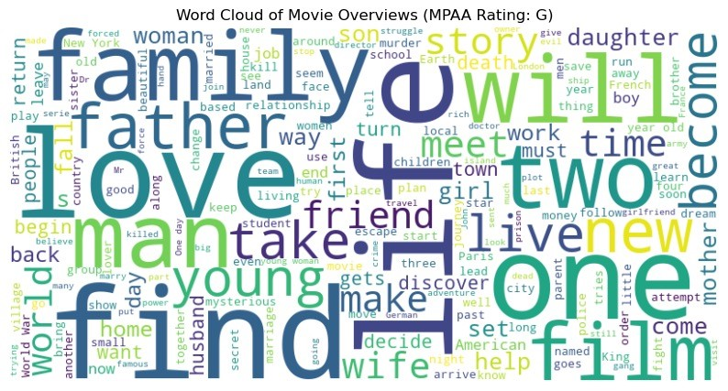
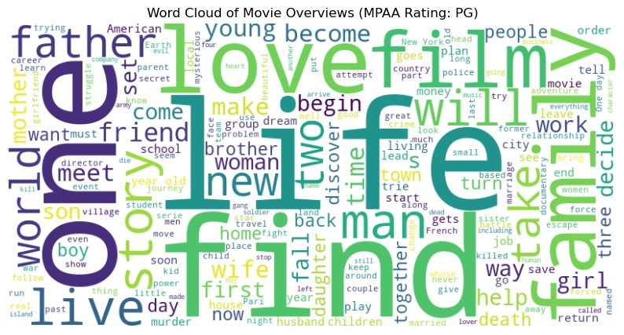
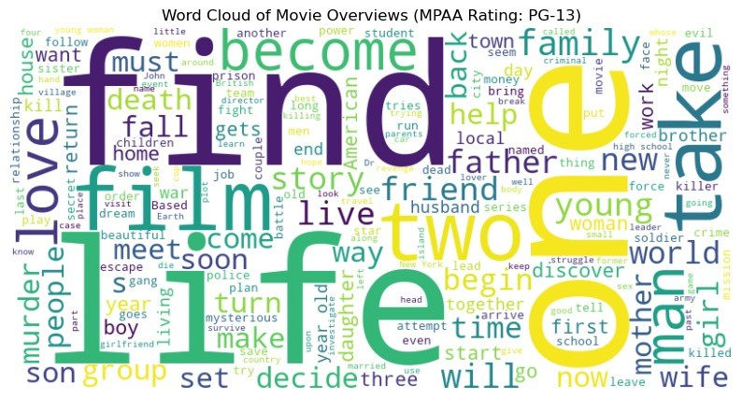
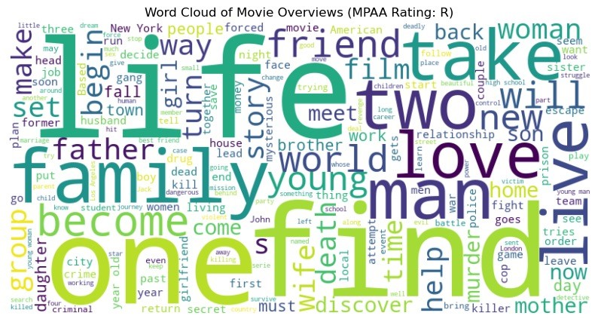
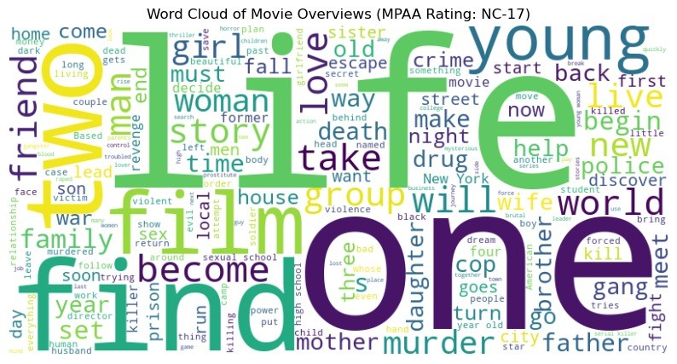
In our final observation, we analyzed the relationship between movie genres and their corresponding MPAA ratings using a heatmap visualization. Specifically, we focused on the distribution of MPAA ratings across different genres to identify any prevalent patterns. For the most common genre, drama, we observed that the predominant MPAA rating assigned was PG, totaling approximately 2,000 movies. Additionally, we found that comedy emerged as the genre with the highest number of MPAA ratings, with around 2,500 movies falling under this category. Delving deeper into the genres associated with "Shrek 2," namely adventure, animation, and comedy, we noted that the most common MPAA rating assigned across all three genres was PG, suggesting a consistent trend in rating classification across these genres. This analysis provides valuable insights into the relationship between movie genres and MPAA ratings, highlighting potential trends and preferences within the film industry.

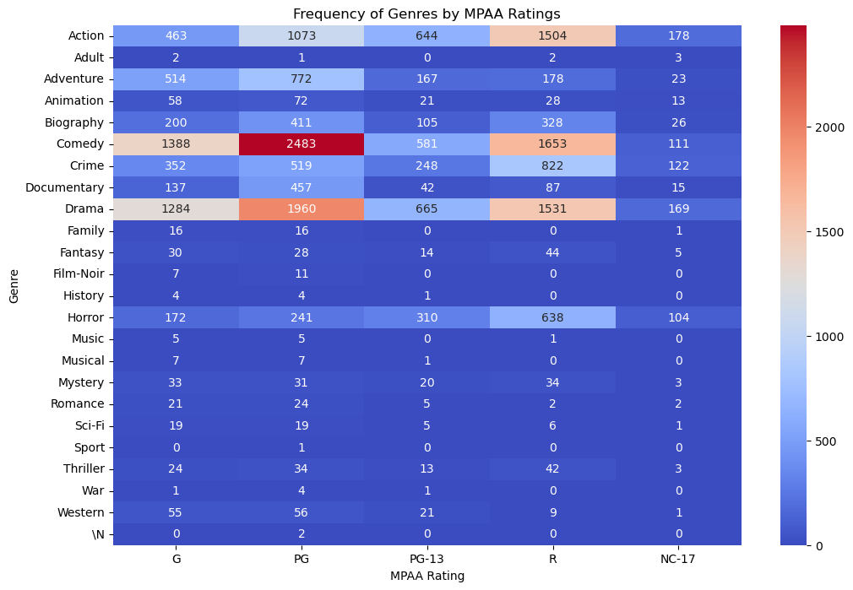

Data Analysis
In our data analysis phase, we elected to construct predictive models for MPAA ratings. Initially, we employed Decision Trees, followed by Random Forest. These models were selected due to the classification nature of our task, aiming to effectively classify MPAA ratings for movies.

Decision Tree Model
In the data analysis phase of our project, our initial approach involved building a decision tree model. We opted to utilize the parental guidance fields—specifically, features related to sex, violence, profanity, drugs, and intensity—as the primary predictors for the model. These features were chosen based on our hypothesis that they would have a significant impact on predicting MPAA ratings.
We began by splitting the dataset into training and testing subsets, allocating 80% of the data for training the model and reserving the remaining 20% for validation purposes. Upon training, the decision tree model exhibited a commendable accuracy rate of 76%. Subsequently, we tested the model on the 'Shrek 2' dataset, where it accurately predicted the MPAA rating as PG, consistent with the actual rating.

Random Forest Models

Model 1
Similar to our decision tree model, we chose to construct our first random forest model using the explicit fields, including sex, violence, profanity, drugs, and intensity.
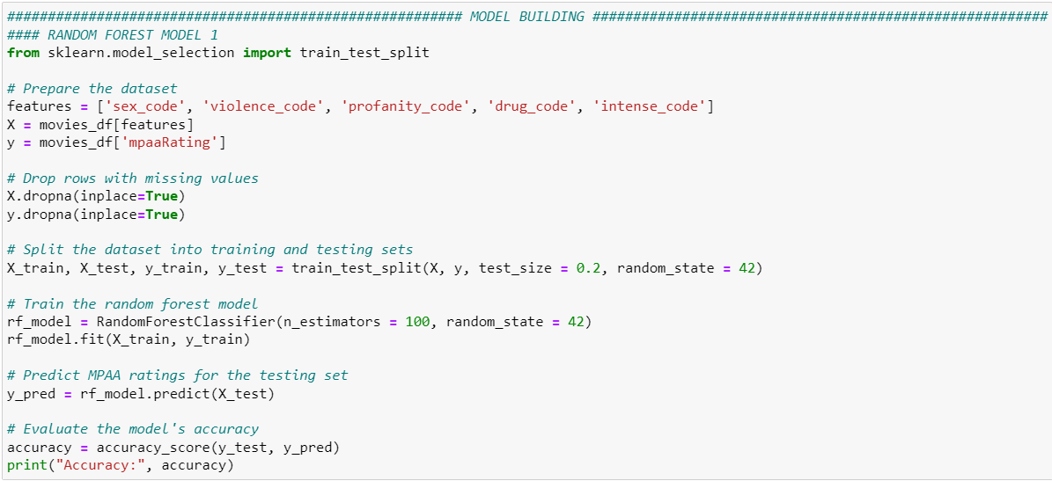
After partitioning the dataset into training and testing sets, we proceeded to construct and train our initial model using 80% of the data. Subsequently, we evaluated the model's performance on the remaining 20% and achieved an accuracy exceeding 73.6%.
Following the model's validation, we employed it to predict the MPAA rating for the movie "Shrek 2" by substituting its features with corresponding values. The model accurately predicted a PG rating for the movie, demonstrating its effectiveness in MPAA rating prediction.
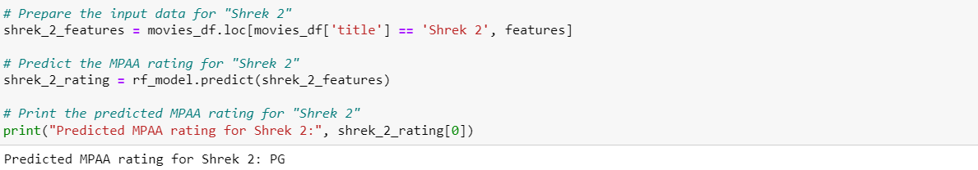

Model 2
To further enhance the predictive capability of our model, we opted to construct a second random forest model by integrating genre information alongside the original features.
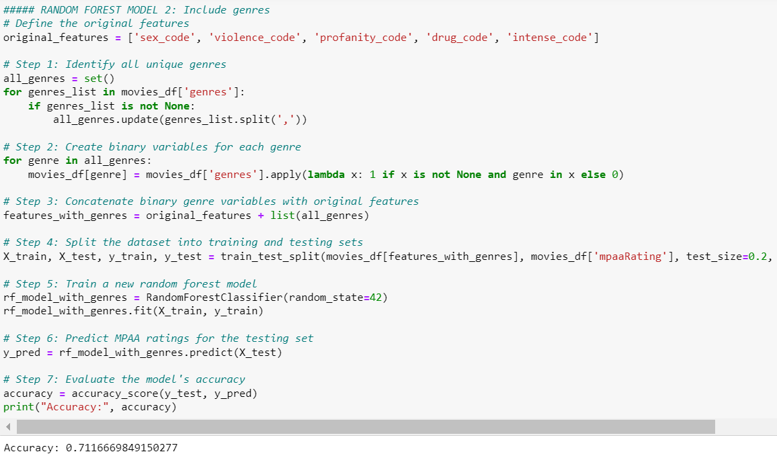
Despite our expectation of improving accuracy, the inclusion of genres led to a slight decrease in model accuracy to approximately 71.67%.
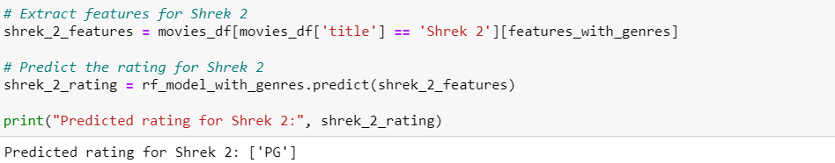
Despite this reduction, the model remained effective in predicting the MPAA rating for "Shrek 2", yielding a PG rating, albeit with a slightly diminished accuracy compared to the initial model.

Model 3
In an effort to improve model accuracy, we opted to construct a third random forest model, augmenting the features of the second model with the inclusion of runtime. Our objective was to investigate whether a movie's duration correlates with its MPAA rating. We hypothesized that longer films might tend to receive PG-13 and higher ratings, while shorter ones might lean towards PG and below, potentially targeting a younger audience. However, after training and testing the model, we observed a decline in accuracy to 70%. This outcome suggests that variables other than explicit content, such as runtime, may not significantly influence a movie's rating.
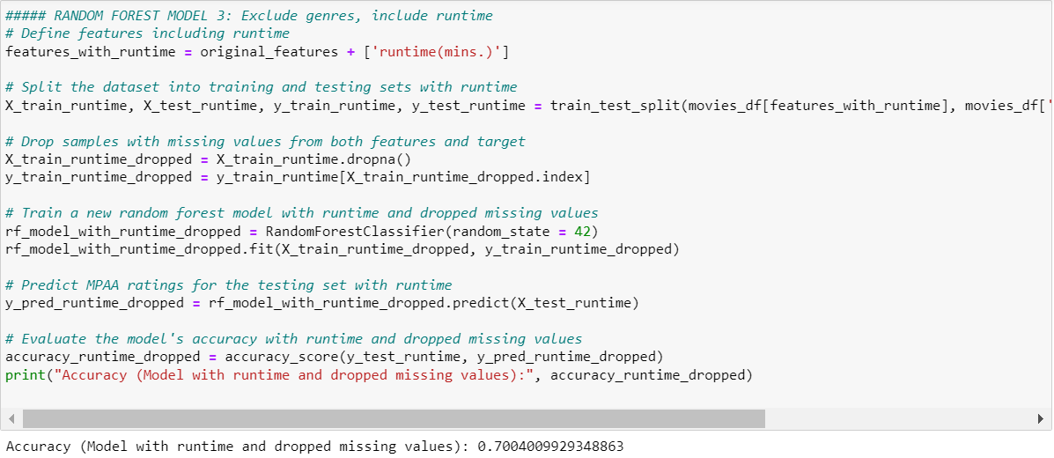

Model Summaries
Models | Accuracy | Prediction
Decision Tree | ~ 76 | PG
Random Forest 1 | ~ 73.65% | PG
Random Forest 2 | ~ 71.17% | PG
Random Forest 3 | ~ 70% | PG

Recommendations
Given more time and resources, we suggest exploring variables beyond parental guidance and genres to enhance the predictive power of our model. These could include factors such as directorial style, production budget, or audience demographics, which may provide deeper insights into MPAA rating determinants. While this may involve collecting new data, we must acknowledge the significant influence of the parental guide fields on our model's accuracy. Therefore, we recommend content creators to continue documenting these fields to better understand their impact on the final MPAA rating. We also recommend exploring alternative classification models, such as K-Nearest Neighbors (KNN) or Naïve Bayes, to evaluate their efficacy in producing accurate results.
To gain a deeper understanding of how the rating system has evolved over time, we also recommend focusing on movies released in specific years, such as 2004 in the case of "Shrek 2". By analyzing historical trends in MPAA ratings and identifying any changes in rating criteria, we can better understand the dynamics of the rating system and its flexibility over time.
Investigating the changes in the rating system over time will provide valuable insights into societal attitudes, cultural shifts, and regulatory influences on content classification. By examining historical data and comparing it to contemporary standards, we can assess whether the rating system has become more (or less) flexible and adaptive to the evolving social norms and values.

References
https://grouplens.org/datasets/movielens/
https://www.kaggle.com/datasets/barryhaworth/imdb-parental-guide

Appendices
