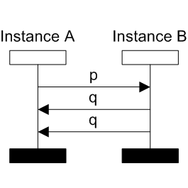
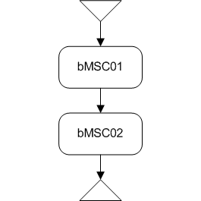
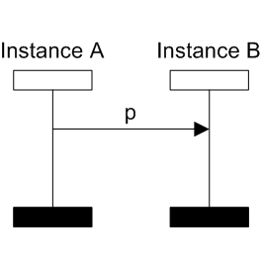
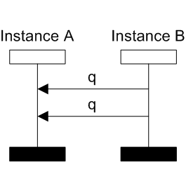
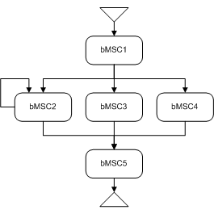
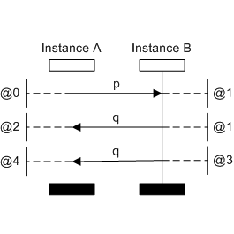
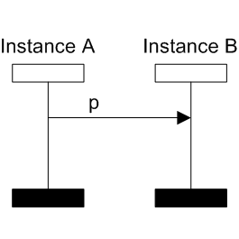
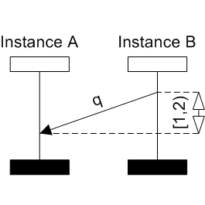
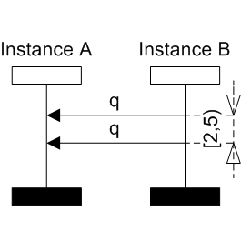
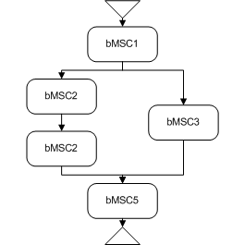
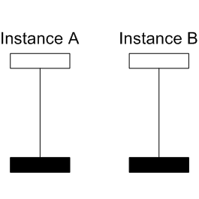
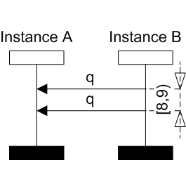
Membership

The problematic of membership is deciding whether given bMSC is contained in given HMSC. It is possible to check both untimed and timed cases of bMSCs and HMSCs.

Example 1:

Input bMSC Input HMSC
bMSC01 bMSC02

In the figure above we have specified input to the membership problem. Every path from initial node to terminal node in a HMSC represents a bMSC. There is only one path in the input HMSC. The bMSC specified by the path is formed from nodes (bMSCs) on the path by sequential composition (putting the bMSCs one after the other and gluing the matching process lines). It is easy to see that the input bMSC is exactly the same bMSC represented by the only path in the HMSC. The result of procedure solving membership problem should be every successful path i.e. input HMSC.

More formal specification of a procedure:
Input:
- bMSC with timing assignment
- HMSC with timers and time interval constraints (both HMSC constraints and bMSC constraints)

Output: graph of nodes and edges between initial and terminal vertex in the input HMSC representing the possible paths in the HMSC. The paths, after sequential composition, form a set of bMSCs with time constraints. The input bMSC satisfies all the time constraints in every one of the bMSCs formed by paths from the initial to the terminal vertex.

Example 2:
Input bMSC Input HMSC
bMSC2 bMSC3 bMSC3
bMSC4 bMSC5 result

In the result there are only two paths through input HMSC because only these two paths form bMSCs, which are satisfied by input bMSC. The path through bMSC4 forms bMSC which is not satisfied by input bMSC. This is because the difference between send times of messages with label q is 2, what is not included in time interval [8,9). Also there are only two iterations of cycle through bMSC2 possible, because there are only two messages with label q in the input bMSC.

