|  |
| --- |
| **PROJECT PLAN** |
|  |
|  |
| **GP Genie** |
|  |
| **SEIS 610 SatB PROF. CHIH LAI** |
| **10/26/2013** |

# Problem Description

* **Problem Title:**
  + SEIS 610 – Generic Programming (GP) Project
* **Problem Summary**:
  + Generating a function that is equivalent to the target function
* Detailed description:

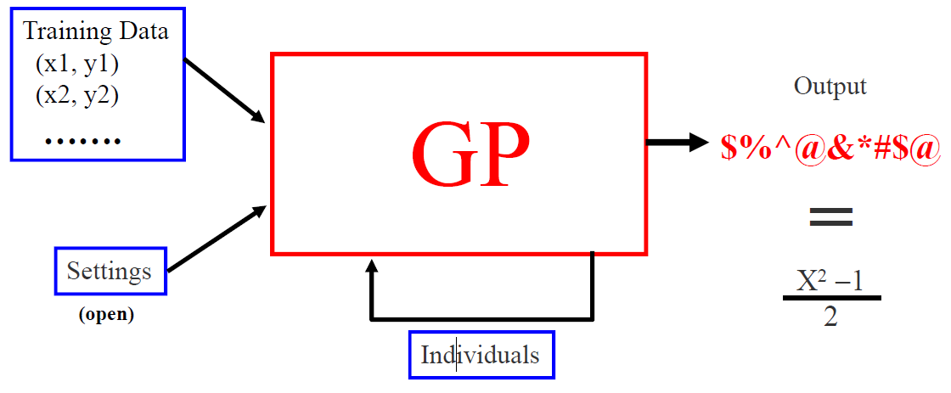

* + Generate a set of training set to evaluate the fitness. A set of random input (x) will be generated. Evaluate the input using the target function, to provide the training set.
  + Generate a set of initial inputs of random compositions of the function of the problem.
  + Execute each program in the population and assign it a fitness value according to how well it solves the problem. The fitness can be calculated as the delta (sum of error) of the function and the target function. Higher delta leads to a lower fitness.
  + If there is a function that meets the termination condition (delta =0), program stops.
  + If termination condition does not meet, the following steps will be executed
    - **Natural Selection**: The solutions with good fitness value survive to the next generation with high probability. Solutions will lower fitness value perish with high probability.
    - **Crossover**: Two solutions chosen with natural selection to generate new solutions
    - **Mutation**: replacing part of the solution with random generated new solution to reproduce new solutions
    - Repeat the fitness and selection step until termination condition meets, or time is over
* **Approach**
  + The project will follow the “V-module” during the software development.

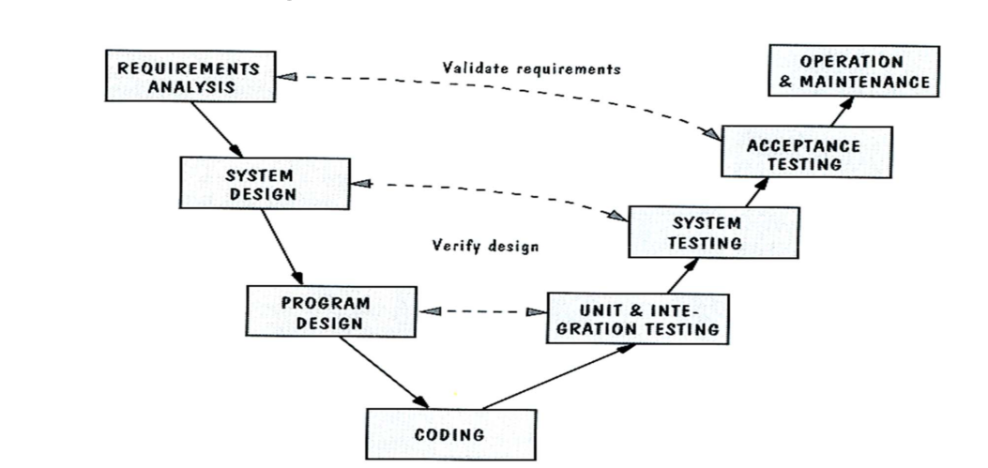

* + The client requirement should be documented and captured during the development

# Requirements Analysis and Preliminary System Design

The team created an Software Requirements Specification (SRS) document to capture requirements, requirements analysis in model diagrams and a data dictionary, and the preliminary design in a class diagram. A hard copy of this SRS document “SRS GP Genie.docx“ is attached and submitted with this Project Plan.

# Weekly SCM files and folders for traceability

TBD

# Work Plan

**Roles & Responsibilities**

The following is a list of roles and who is responsible for each role.

|  |  |
| --- | --- |
| **Roles** | **Name** |
| Project Management & Communications Liaison | Ujin Han |
| Process Leader | Ujin Han  Justin Florkiah |
| Development Leader | Li Wang |
| Technical Leader | Roger Peterson  Felista Mpanga |
| Measurement Leader | Susan Mairs  Ujin Han |
| Capture Requirements | Susan Mairs |
| Coding | Li Wang  Roger Peterson |
| Code Review | Susan Mairs |
| Testing | Felista Mpanga |

For the roles with multiple team members listed, they will share the responsibilities of that particular section of the project. As the project goes on and more responsibilities come up, those roles will be added. During the project, if a certain team member is struggling with the given task, others with knowledge and availability will assist in its completion.

**Milestones & Schedule**

To complete the project with changes in requirements by December 14th, the team has following milestones and dates set.

|  |  |
| --- | --- |
| **Milestone** | **Due Date** |
| Requirements & preliminary system design finalized; Project Plan completed and submitted | October 26, 2013 |
| All complements needed for program design finalized | October 29, 2013 |
| Working software | November 19, 2013 |
| Testing software | November 26, 2013 |
| Revised working software with new requirements | December 7, 2013 |
| PowerPoint presentation completed | December 12, 2013 |
| Project completion and deliverables submitted | December 14, 2013 |

The team has a weekly meeting on Tuesday evenings at 6 pm until the end of the semester to check-in and discusses the progress of the project. These meetings will last from an hour to two hours depending on the subject of the meeting at the time. Additional meetings will be scheduled as the team sees fit.