[] Dicon Texture Atlas Generator

> Created by Jintaek Seo on 15th November, 2013

> Modified by Jintaek Seo on 10th June, 2017

Copyright: We referred to the following source

3d_io-TexAtlasGen_original.mcr

This tool is public, just as the original license is public although it has been modified so much.

# [] What is this?

* The toolset which generates a texture atlas for 3dsMax 2015.

# [] How to install.

* You must run 3dsMax with administrator privilege to install plugins. Click right mouse button on the 3dsMax icon, and select 'Run as Administrator' menu item.

[Figure] Run 3dsMax 2015 as Administrator privilege.

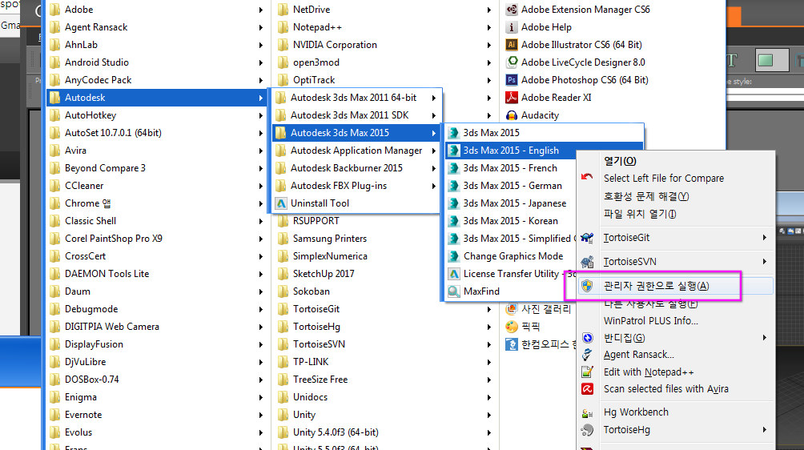

* Check following 7 files

* FreeImage.dll
* FreeImageNET.dll
* DsuInvalidFaceBreaker.mcr
* DsuTextureAtlasGenerator.mcr
* DsuTextureAtlasGenerator_install.ms
* DsuTextureAtlasGenerator_startup.ms
* DsuAtlasTextureLocator.exe

[Figure] Atlas Tools are composed with 7 files.

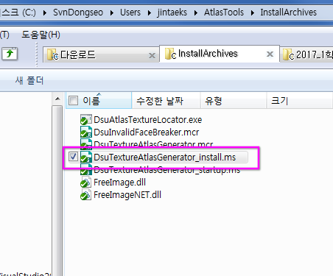

* Select 'MAXScript Editor…' menu item in 3dsMax.

[Figure] To install plugin tool set, run MaxScript editor by selecting 'MAXScript Editor…' menu item.

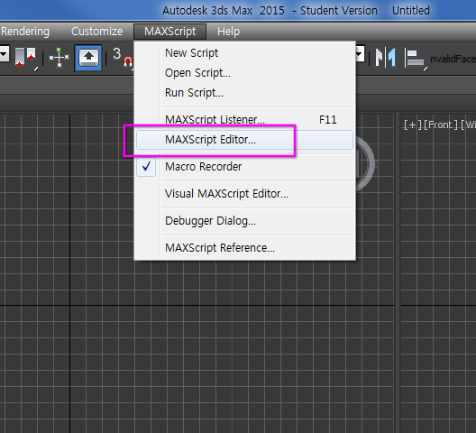

* Open 'DsuTextureAtlasGenerator_install.ms' file and evaluate.

- This file will copy required files to proper locatoin.

[Figure] Open 'DsuTextureAtlasGenerator_install.ms' in MaxScript editor.

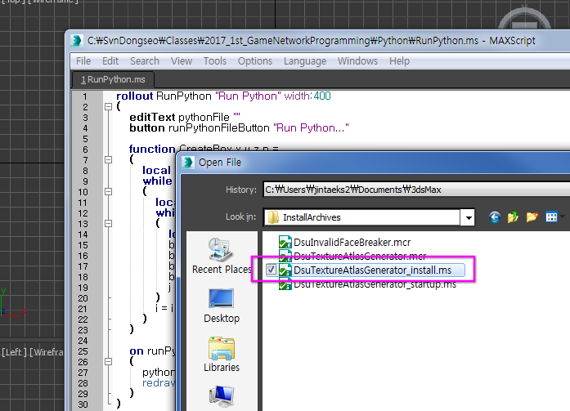

[Figure] Select 'Evaluate All' to run script.

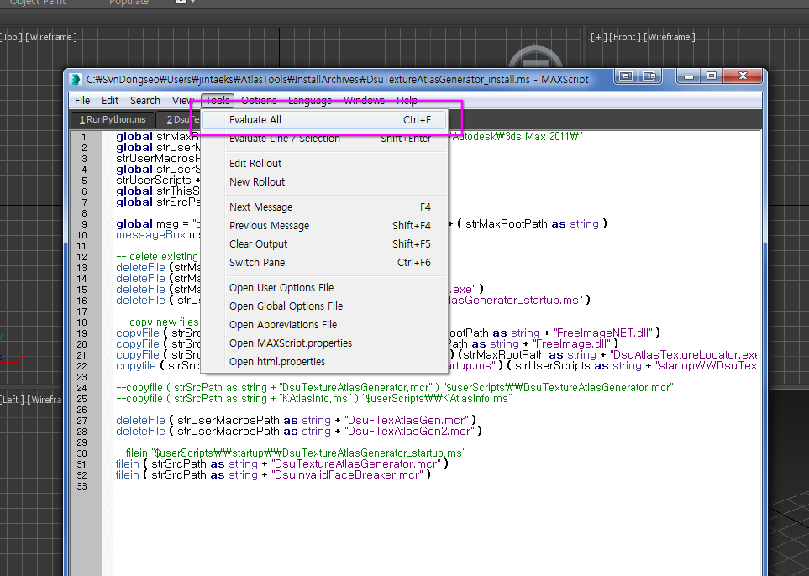

* The dialog will be opened and displays the destination path for file copying.

* The default installation path is **C:\Program Files\Autodesk\3ds Max 2015\**. The program will automatically copy the following three files to the appropriate path(If the Atlas tools doesn't work properly, check the path for the following files).

* FreeImage.dll
* FreeImageNET.dll
* DsuAtlasTextureLocator.exe

* Next, installation script will run following macro scripts.

* DsuInvalidFaceBreaker.mcr
* DsuTextureAtlasGenerator.mcr

* ' **DsuInvalidFaceBreaker.mcr**' is a tool for face arranging.

* ' **DsuInvalidFaceBreaker.mcr**' is a tool for generating atlas textures.

* Once you evaluate a .mcr file, it will be registered in 3dsMax environment. So you don't need to manage these files after installation.

[Figure] The macro script will be copied to special folders managed by 3dsMax.

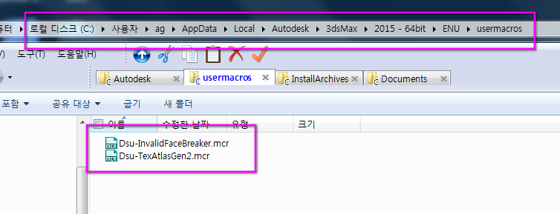

[Figure] This dialog displays the source and destination paths for file copying.

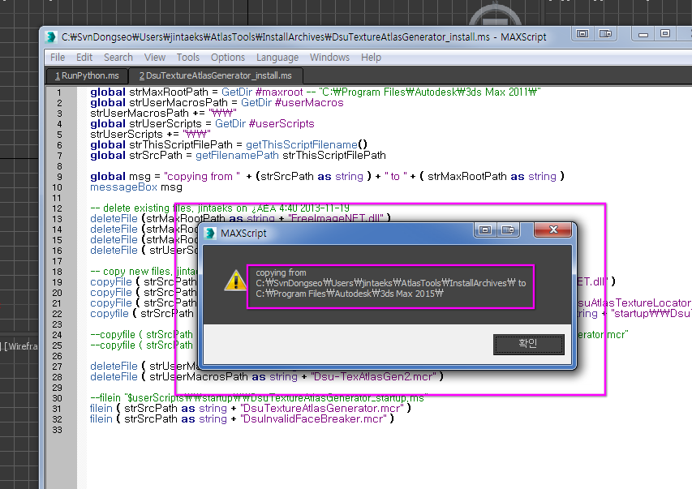

## [] Register Tool UI Icons.

* Register the Atlas tool and the Face breaker tool as the icons in the main toolbar.

* (1) To register Atlas tool, select [Customize 🡪 Customize…] menu item.

[Figure] Select [Customize 🡪 Customize…] menu item to customize main toolbar.

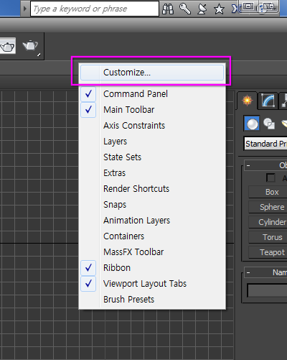

* Press right mouse button on the main toolbar.

* Select 'Dsu' in category dropdown list box, it displays tool items in the list.

[Figure] Select [Category 🡪 Dsu]

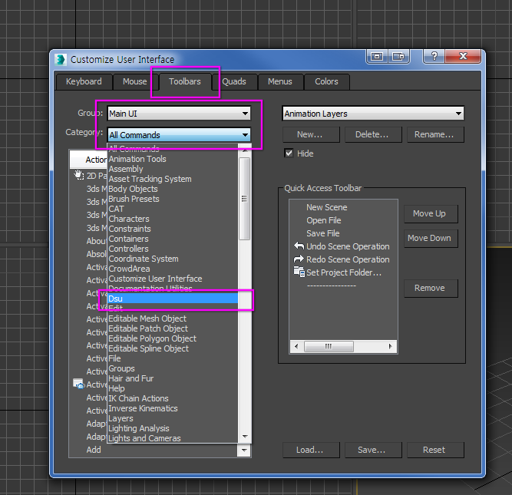

* Locate [TexAtlasGen2] item in appropriate place in the main toolbar by drag & drop.

* Locate [Invalid Face Breaker] item in the same way.

[Figure] Locate macro script item in the appropriate place in the main toolbar.

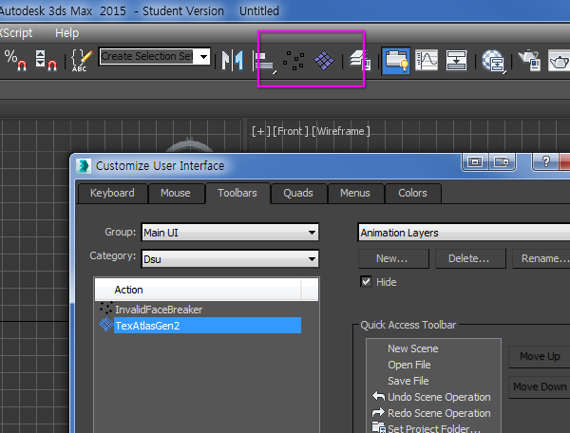

# [] Generating Atlas Textures

* Select an object you want to generate atlas texture for it.

* Press [Generate Texture Atlas] button.

* (1) If you select 'Auto set to file path' button, you can set destination folder for atlas textures.

* (2) Run the texture locator tool by selecting 'Edit Texture Position' button. With this tool you can edit texture positions.

* (3) Generate textures by selecting 'Generate Texture Atlas' button.

[Figure] Atlas generator dialog box.

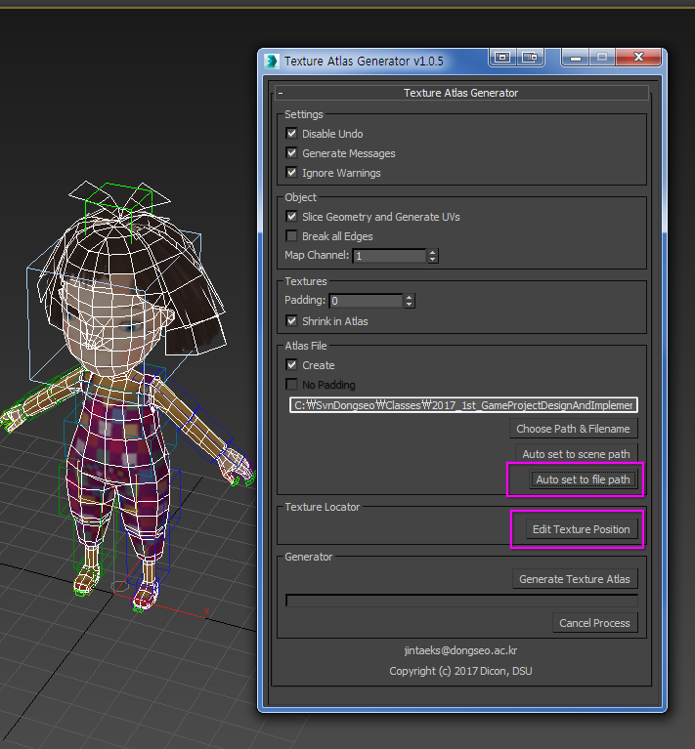

## [] Editing texture locations that make up the Atlas

* Texture locator tool was written in C#, and texture layout information is transferred to 3dsMax via Windows clipboard..

* (1) At first, textures are placed automatically. The user can adjust the position and size of the texture.

* (2) If the material contains bump, specular and glossiness, you can see all the textures.

- All layout information which is not diffuse uses same information with diffuse.

- If the texture is empty, that place is filled with a black color.

* (3) Can adjust the width and height of the current texture.

* (4) Select the check box icon, when you finished the texture placement.

- This action will copy texture placement information to the clipboard.

- This value is used when the 'Generate Texture Atlas' button in the Atlas dialog pressed.

[Figure] Texture Locator tool

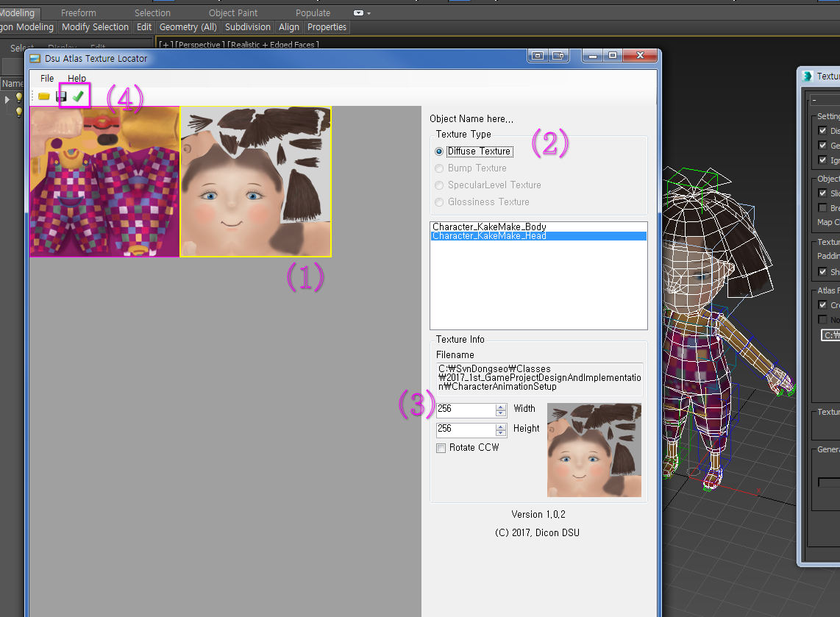

## [] Generating Atlas Textures

* Starts the Atlas texture generation.

* (1) Uvw modifier appears on the screen. And you can see current face breaking actions.

- Internally it create a copy of current object and place it in the origin of the World.

* (2) It displays the current progress in the progress bar.

[Figure] Atlas generator displays the progress of the generation.

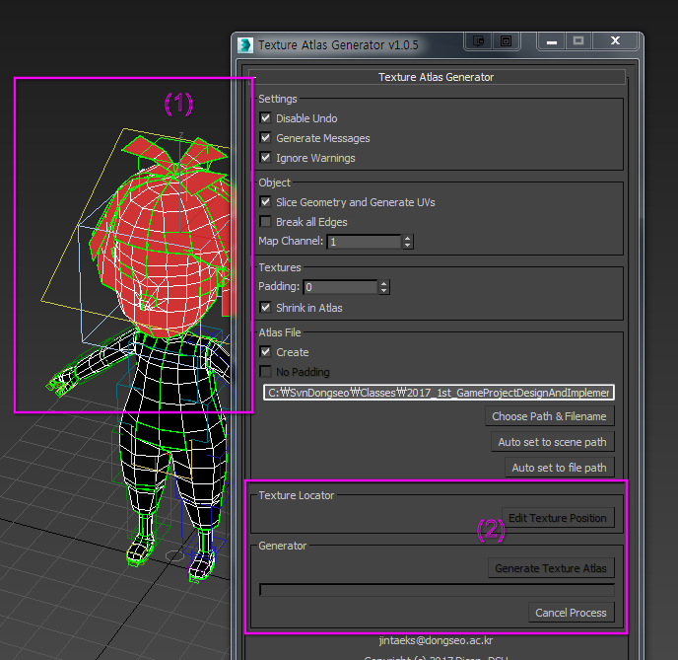

* If it succeeded, you can see 'Atlas generated!' dialog box.

[Figure] If the atlas texture generation is succeeded, it displays 'Atlas generated!'.

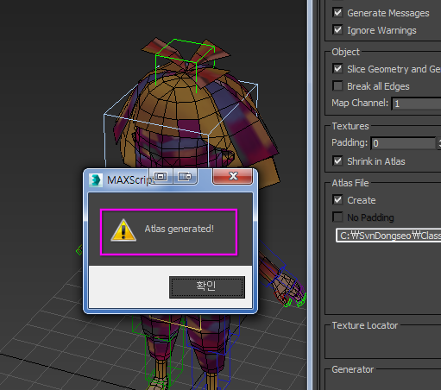

* When the atlas task is completed successfully, it shows the generated Atlas textures.

* (1) It displays the diffuse texture of the Atlas texture.

* If the material contains bump map, it displays the normal map atlas texture also.

[Figure] It displays the generated atlas textures.

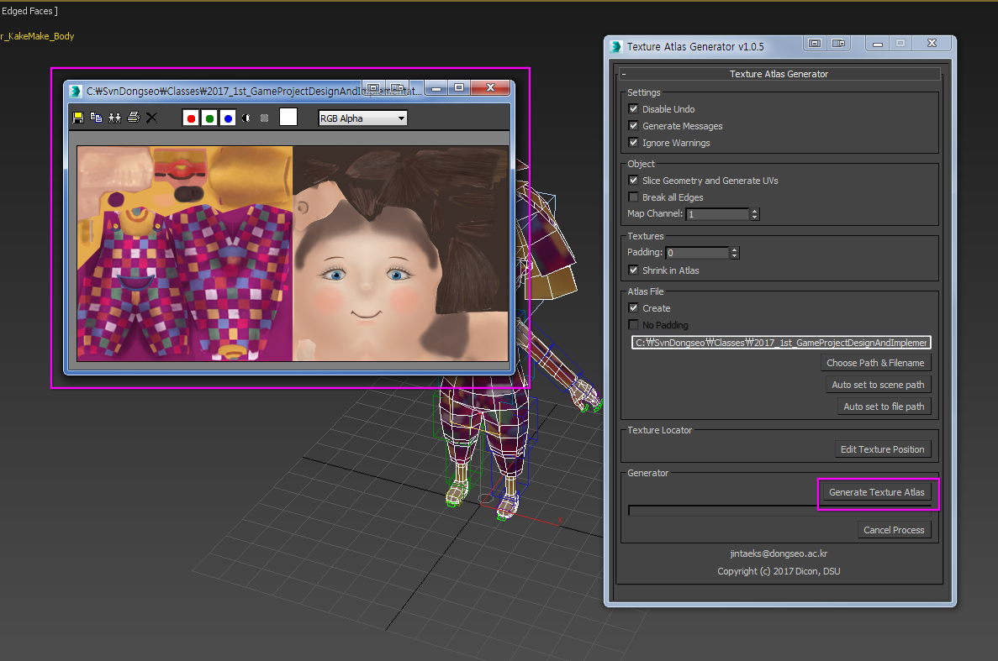

## [] Applying a atlas texture material for the Object

* The current version of the tool doesn't automatically apply the generated atlas texture to the object.

- Therefore, after creating the atlas texture, you must create the 'Standard' material and apply the material to the object manually.

[Figure] Create a standard material and assign the generated atlas texture to the bitmap.

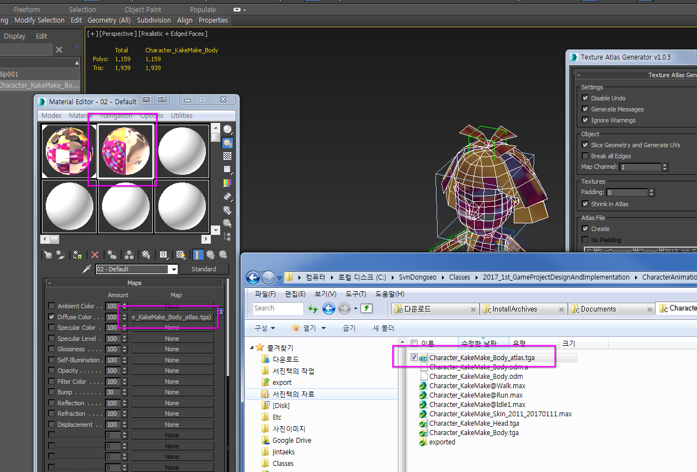

[Figure] You can see the atlas applied object by applying the standard material to the object.

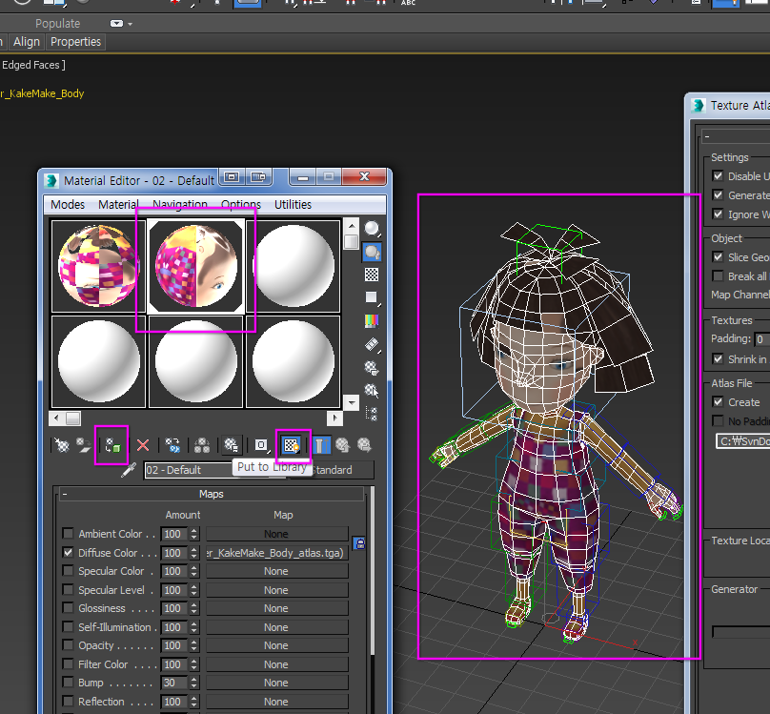

# [] Face arranging tool: Invalid Face Breaker

* Atlas creation may fail for a variety of reasons.

* Invalid Face Breaker is the tool for fixing invalid UVW faces.

- With Invalid Face Breaker tool, you can fix various type of problems.

* [Break 0 Area Uvw Faces] tool for breaking area 0 faces.

* [Select Slicer Uvw Faces] tool for selecting big size UVW faces due to uninitialization.

* [Flatten wrong side Uvw Faces] tool for flattening flipped faces.

* [Break Shared Uvw Faces] tool for breaking faces by invalid welding.

- These faces are multiple faces of an object, but are recognized as a face in UVW Unwrap.

* [Break Mismatching Poly,Uvw Faces] tool for breaking faces when the Object face and the UVW face mismatch.

- When different faces share the same UVW.

- If there are partially shared edges.

[Figure] Invalid Face Breaker is tool for breaking invalid UVW faces.

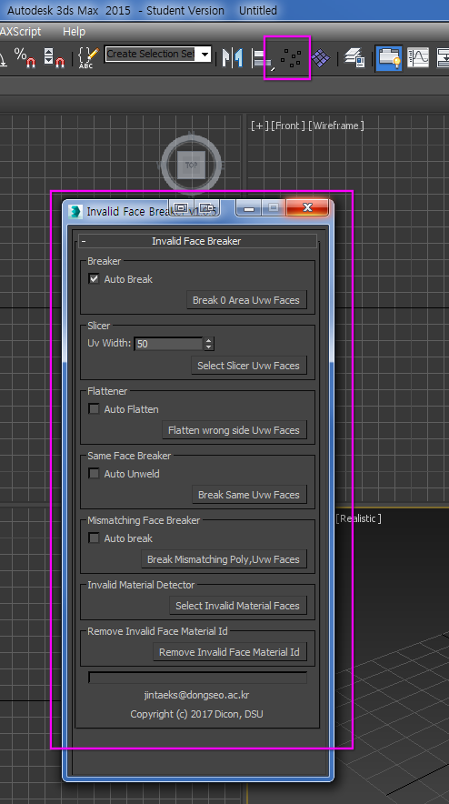

@End of Document