# <https://www.geeksforgeeks.org/mid-point-circle-drawing-algorithm/>

# Mid-Point Circle Drawing Algorithm

• [Read](javascript:void(0))

• [Discuss](javascript:void(0))

• [Courses](javascript:void(0))

• [Practice](javascript:void(0))

• [Video](javascript:void(0))

The **mid-point** circle drawing algorithm is an algorithm used to determine the points needed for rasterizing a circle. 

We use the **mid-point** algorithm to calculate all the perimeter points of the circle in the **first octant** and then print them along with their mirror points in the other octants. This will work because a circle is symmetric about its centre.

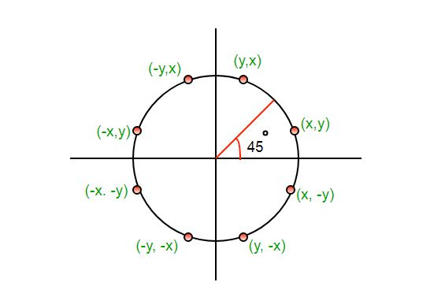

The algorithm is very similar to the [Mid-Point Line Generation Algorithm](https://www.geeksforgeeks.org/mid-point-line-generation-algorithm/). Here, only the boundary condition is different.

For any given pixel (x, y), the next pixel to be plotted is either **(x, y+1)** or **(x-1, y+1)**. This can be decided by following the steps below.

1. Find the mid-point **p** of the two possible pixels i.e (x-0.5, y+1)
2. If **p** lies inside or on the circle perimeter, we plot the pixel (x, y+1), otherwise if it’s outside we plot the pixel (x-1, y+1)

**Boundary Condition :** Whether the mid-point lies inside or outside the circle can be decided by using the formula:- 

*Given a circle centered at (0,0) and radius r and a point p(x,y)****F(p) = x2 + y2 – r2*** *if F(p)<0, the point is inside the circle  
F(p)=0, the point is on the perimeter  
F(p)>0, the point is outside the circle*

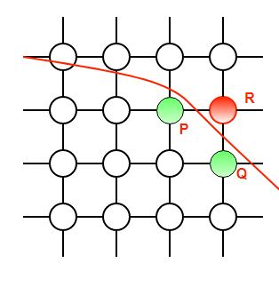

In our program, we denote F(p) with P. The value of P is calculated at the mid-point of the two contending pixels i.e. (x-0.5, y+1). Each pixel is described with a subscript k.

***Pk = (Xk — 0.5)2 + (yk + 1)2 – r2*** *Now,   
xk+1 = xk or xk-1 , yk+1= yk +1  
∴ Pk+1 = (xk+1 – 0.5)2 + (yk+1 +1)2 – r2   
= (xk+1 – 0.5)2 + [(yk +1) + 1]2 – r2   
= (xk+1 – 0.5)2 + (yk +1)2 + 2(yk + 1) + 1 – r2   
= (xk+1 – 0.5)2 + [ – (xk – 0.5)2 +(xk – 0.5)2 ] + (yk + 1)2 – r2 + 2(yk + 1) + 1  
= Pk + (xk+1 – 0.5)2 – (xk – 0.5)2 + 2(yk + 1) + 1   
= Pk + (x2k+1 – x2k) – (xk+1– xk) + 2(yk + 1) + 1****= Pk + 2(yk +1) + 1, when Pk <=0 i.e the midpoint is inside the circle******(xk+1 = xk)******Pk + 2(yk +1) – 2(xk – 1) + 1, when Pk>0 I.e the mid point is outside the circle(xk+1 = xk-1)***

The first point to be plotted is (r, 0) on the x-axis. The initial value of P is calculated as follows:-

*P1 = (r – 0.5)2 + (0+1)2 – r2   
= 1.25 – r   
= 1 -r (When rounded off)*

**Examples:** 

**Input :** Centre -> (0, 0), Radius -> 3

**Output :** (3, 0) (3, 0) (0, 3) (0, 3)

(3, 1) (-3, 1) (3, -1) (-3, -1)

(1, 3) (-1, 3) (1, -3) (-1, -3)

(2, 2) (-2, 2) (2, -2) (-2, -2)

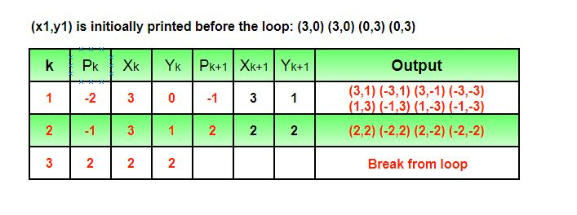

 void KVectorUtil::MidpointCircle(HDC hdc, int x_centre, int y_centre, int r, Gdiplus::Color color)

{

int x = r;

int y = 0;

Gdiplus::Color color2 = color;

#ifdef _DEBUG

//color2 = Gdiplus::Color::Red; // for debug

#endif

// Printing the initial point on the axes

// after translation

PutPixel(hdc, x + x_centre, y + y_centre, color);

// When radius is zero only a single

// point will be printed

if (r > 0)

{

PutPixel(hdc, -x + x_centre, y + y_centre, color2);

PutPixel(hdc, y + x_centre, x + y_centre, color);

PutPixel(hdc, -y + x_centre, -x + y_centre, color2);

}

// Initialising the value of P

int P = 1 - r;

int dbgCnt = 0;

while (x > y)

{

y++;

// Mid-point is inside or on the perimeter

if (P <= 0)

P = P + 2 * y + 1;

// Mid-point is outside the perimeter

else

{

x--;

P = P + 2 * y - 2 * x + 1;

}

// All the perimeter points have already been printed

if (x < y)

break;

#ifdef _DEBUG

//if (dbgCnt == g_idebug)

// break;

//dbgCnt += 1;

#endif

// Printing the generated point and its reflection

// in the other octants after translation

PutPixel(hdc, x + x_centre, y + y_centre, color);

PutPixel(hdc, -x + x_centre, y + y_centre, color2);

PutPixel(hdc, x + x_centre, -y + y_centre, color);

PutPixel(hdc, -x + x_centre, -y + y_centre, color2);

// If the generated point is on the line x = y then

// the perimeter points have already been printed

if (x != y)

{

PutPixel(hdc, y + x_centre, x + y_centre, color);

PutPixel(hdc, -y + x_centre, x + y_centre, color2);

PutPixel(hdc, y + x_centre, -x + y_centre, color);

PutPixel(hdc, -y + x_centre, -x + y_centre, color2);

}

}

}