Name of Students:

Gauri Arun Mulik (197036)

Amruta Narayan Gore (197019)

Branch: Information Technology

Project Name: Guessing Game

College Name : Government Polytechnic, Abad

Python Miniproject

# Guessing Game

This is GUI-based guessing game in Python using Tkinter — which is a Python library for creating GUI widgets (buttons, labels, images, text area etc). This game will definitely provide fun to player and also it is a logical game so playing this game create an adventurous atmosphere for player.

A **number guessing game** is a simple **guessing game** where a user is supposed to **guess** a **number** between 0 and N in a maximum of 3 attempts. The **game** will end after 3 attempts and if the player failed to **guess** the **number**, and then he loses the **game**.

Brief description

About miniprojet.

Here is a brief information about game. How the main screen will look alike, and how to play this game. So let’s dive in to the Information

# **• In following figure, two widgets (Lables) showing on the Main Window**

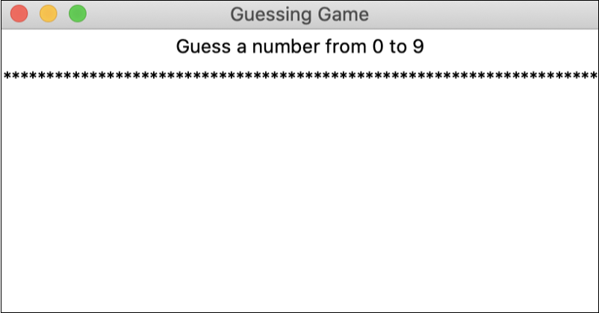

## **• Main window with all widgets added**

## 

## • **Game window before the start button is clicked. The “Guess buttons” are disabled**

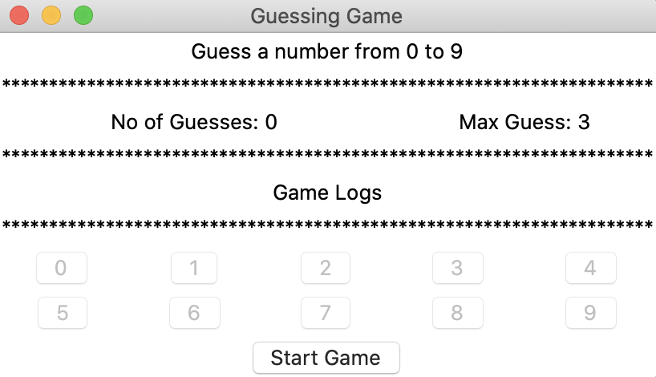

## **• The start button is clicked and the “Guess buttons” are enabled**

**Here is the secret number is 7.**

## **• First player guess is wrong. Player is notified.**

## **• Second guess is equally not the secret number**

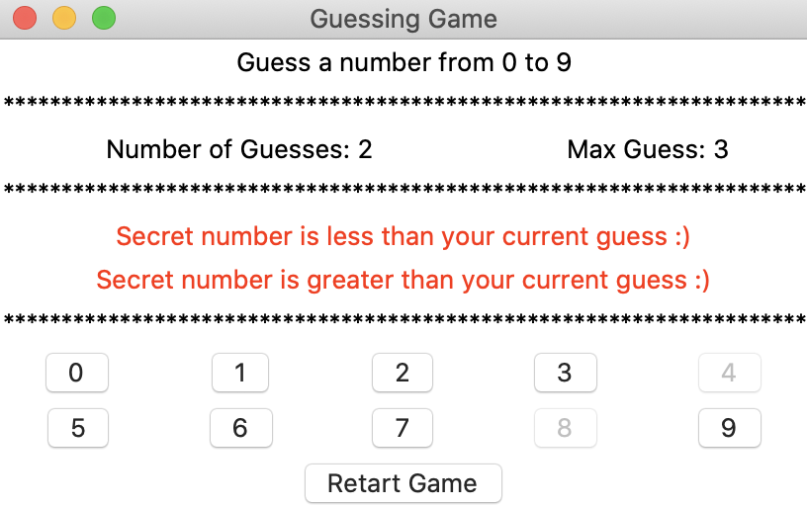

## **• victor at last ☺ The “Guess buttons (0-9) are disabled and the game is ended . Player can restart the game.**

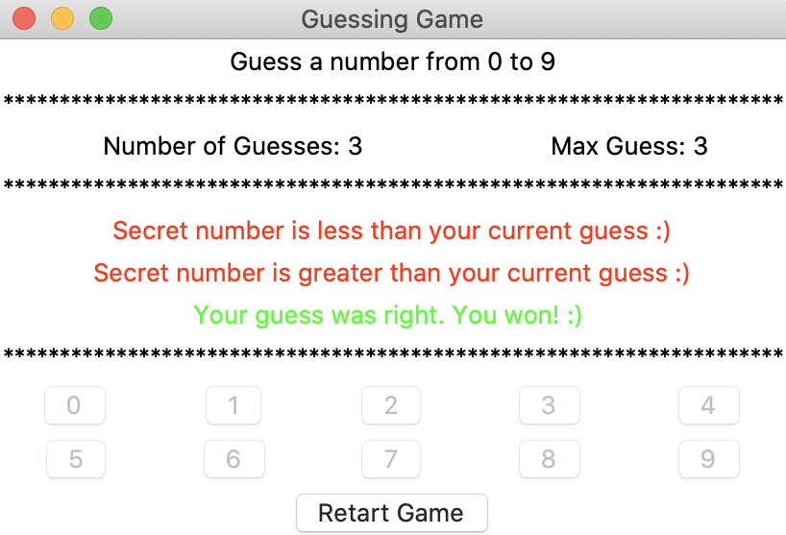

This is a description of how to play this game.

============================°°°°°°°°°========================

Conclusion:

We have built a program for simple guessing game using Python and Tkinter library. It clear our all concepts of Python such as variables, datatypes, comments, functions, if/else statement, loops, lists,and the Tkinter library for implementing GUI.

_Thank you_