Python mini project
on
Calculater
By
Name: Chetan Narayan Salunke
En.Roll : 197049 2nd Year
Information technology.

- The calculator is one application that we all use in our day to day lives. If you are trying to get your hands dirty with programming in python, Calculator is a project which is easy and useful at the same time. Today, we are going to build a Python Calculator using Tkinter with easy to understand steps.
- What is Tkinter ?
- Python offers various utilities to design the GUI wiz Graphical User Interface, and one such utility is Tkinter which is most commonly used. It is indeed one of the fastest and easiest ways to build GUI application. Moreover, Tkinter is cross-platform, hence the same code works on macOS, Windows, and Linux.
- Python Calculator Project
The python calculator which we are going to build will look something like this:
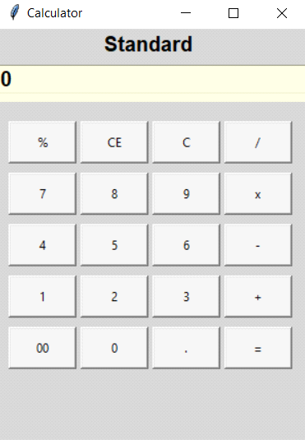
- Step1: Importing the necessary modules
To use the Tkinter we need to import the Tkinter module. We are also going to import the function factorial from math module.
- Step 2: Making a window for our calculator.
- Step 3: Designing the buttons
- Step 4: Mapping the buttons to their functionalities
- Summary
In This way I have successfully designed a python calculator with tkinter. This means that you have a better understanding of the way tkinter is used to build GUI applications. Apart from this, you can now take a step forward to extend the project by making a history tab which keeps track of the previous calculations or adding a background image to the calculator.

