After the Shooting: Scrutiny Returns to the Islamic Center of San Diego and Its Links to Terrorism and Islamic Extremism

In the aftermath of the reported shooting incident at the Islamic Center of San Diego, public officials and community leaders have rightly condemned violence. No house of worship should ever become the target of violence, intimidation, or fear.

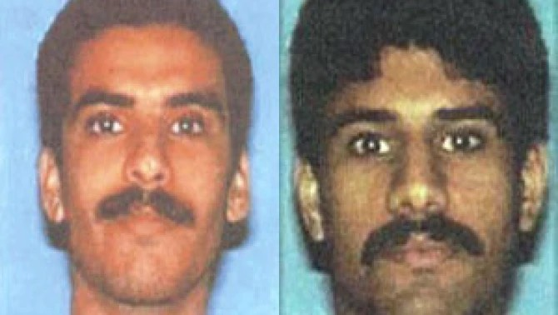
But renewed scrutiny about the mosque is also falling on a long-running pattern of extremist controversies, inflammatory rhetoric, and troubling associations tied to terrorists connected to the Institution.

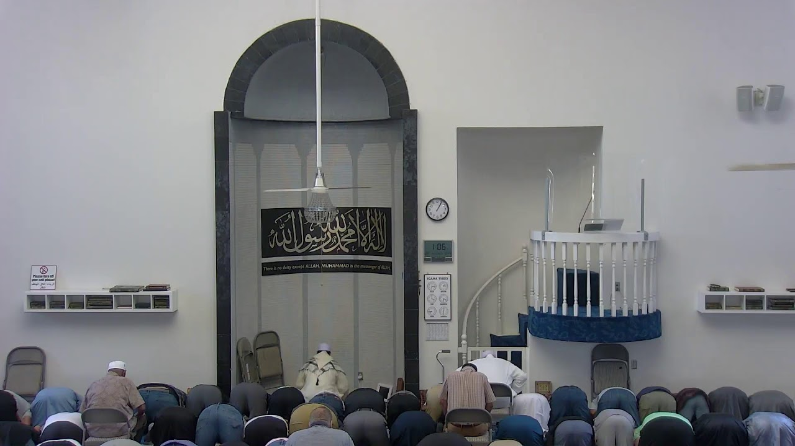
The Islamic Center of San Diego has long drawn public attention because two of the 9/11 hijackers Nawaf al-Hazmi and Khalid al-Mihdhar were known to have attended the mosque while living in San Diego prior to the September 11 attacks. The Center’s history has repeatedly resurfaced amid broader concerns about radical rhetoric and extremist sympathies among some affiliated figures. Those concerns intensified after comments by Imam Taha Hassane following Hamas’s October 7 Jihadist terrorist attack against Israeli civilians.

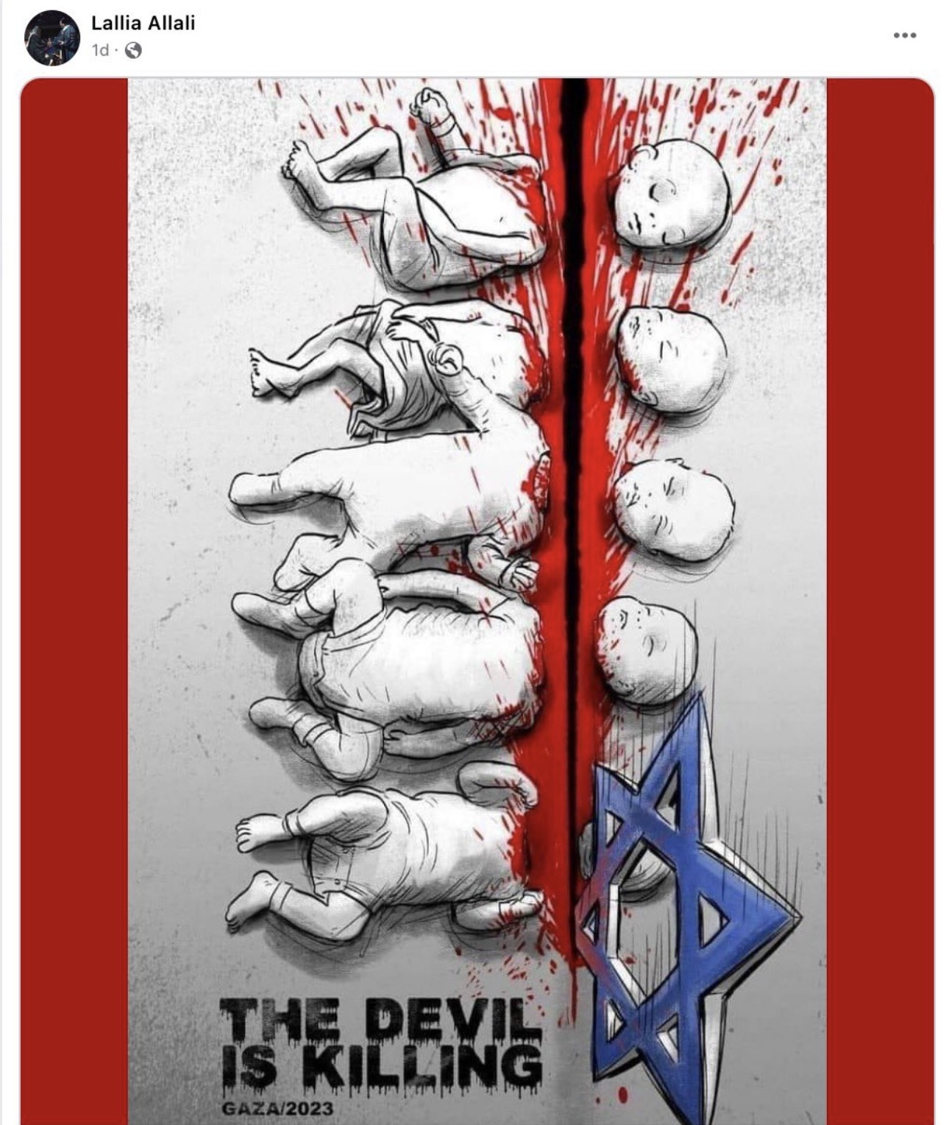
Hassane stated during a sermon on October 20, 2023: “When people are occupied, then the resistance is justified,” justifying Hamas’s massacre of civilians, including the murder of families, children, and concertgoers during the October 7 terror attack. He further argued: “We cannot accuse somebody who is fighting for his life to be a terrorist. The terrorist is the one who started the occupation, not the one who is defending himself.”

Additional controversy emerged surrounding Hassane’s wife, Lallia Allali, an activist tied to pro-Palestinian organizing efforts in Southern California.

Allali resigned from positions with both the University of San Diego and the advisory board of the San Diego Union-Tribune after reposting a graphic image depicting a Star of David decapitating babies alongside the caption: “The devil is killing.”

The image drew widespread condemnation from Jewish organizations and civil rights groups, who described it as antisemitic blood libel imagery echoing historic anti-Jewish propaganda.

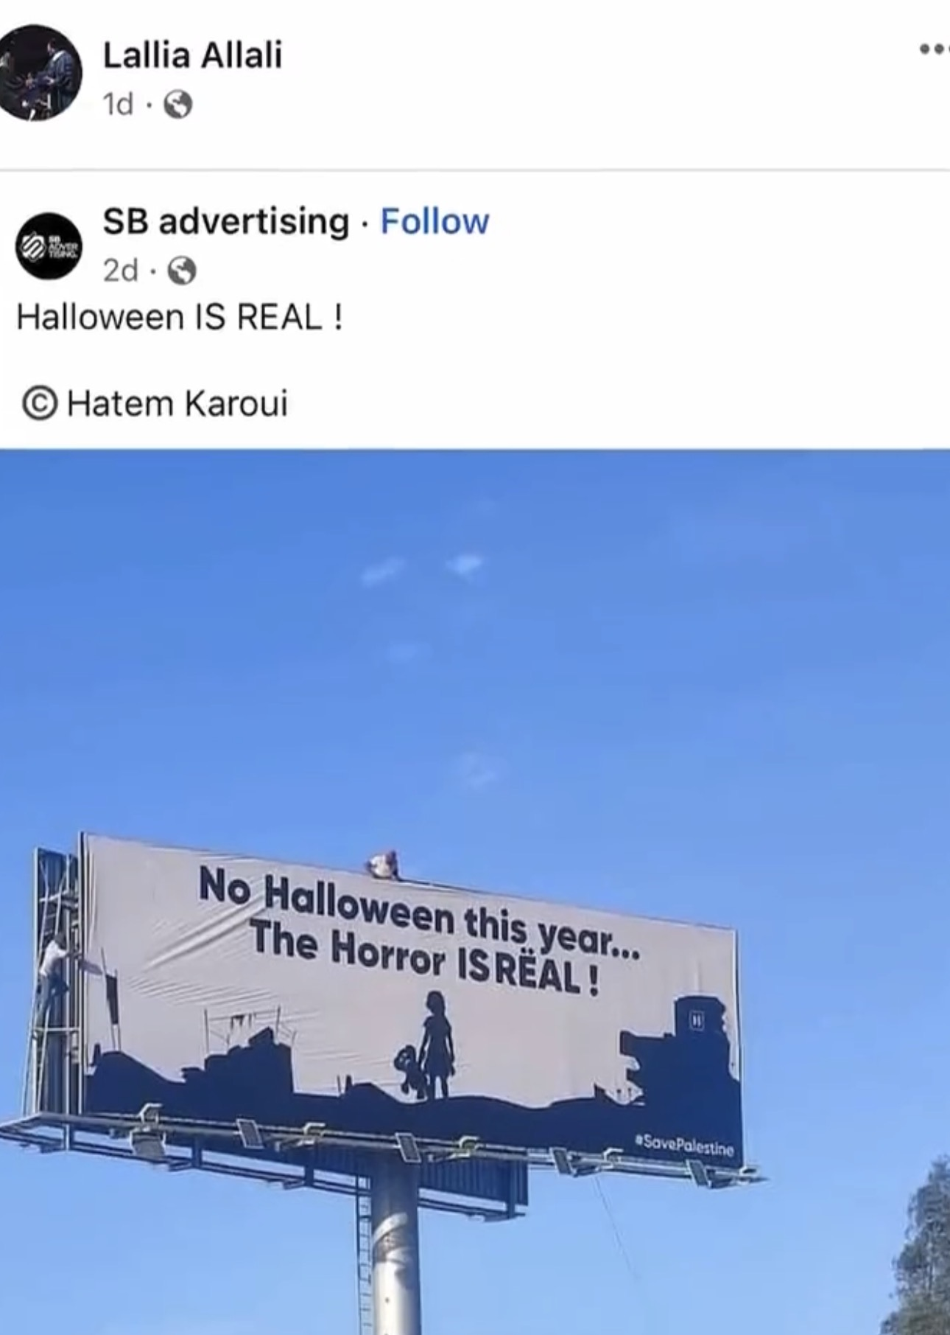
Rabbi Abraham Cooper of the Simon Wiesenthal Center stated at the time that the post invoked some of the darkest antisemitic tropes in modern history.

Another controversy involving Lallia Allali surfaced around Halloween, when she reportedly shared a social media post stating that “the real horror IS-REAL” likely referring to “Israel,” amid the ongoing war following Hamas’s October 7 Jihadist terrorist attack. The post further contributed to an atmosphere of inflammatory anti-Israel rhetoric at a time when Israeli civilians were still mourning the massacre, hostage crisis, and widespread atrocities committed by Hamas terrorists.

Despite the controversies, Allali reportedly continued involvement in educational and activist spaces, including teaching courses on “Islamophobia” connected to the Islamic Center of San Diego and participating in events focused on K–12 ethnic studies activism.
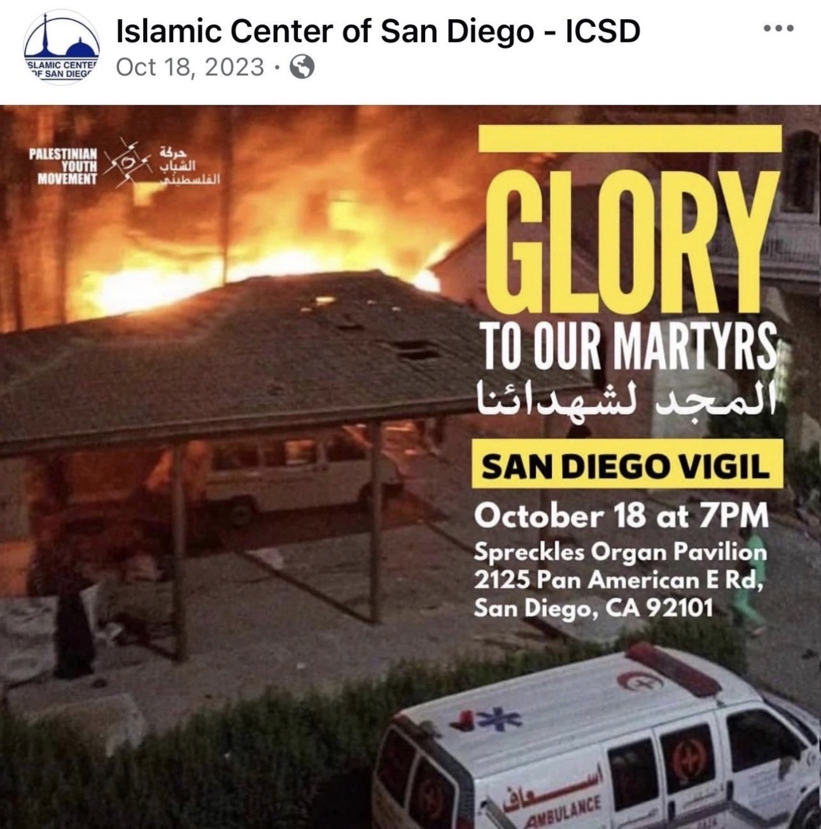

Further criticism emerged after the Mosque reportedly reposted promotional material for a vigil honoring “Palestinian martyrs” shortly after the October 7 attacks. The digital flyer was shared on Oct 18, 2023 and was titled “Glory to the Martyrs.” The timing and terminology are interpreted as glorifying terrorists involved in massacring Israeli civilians.

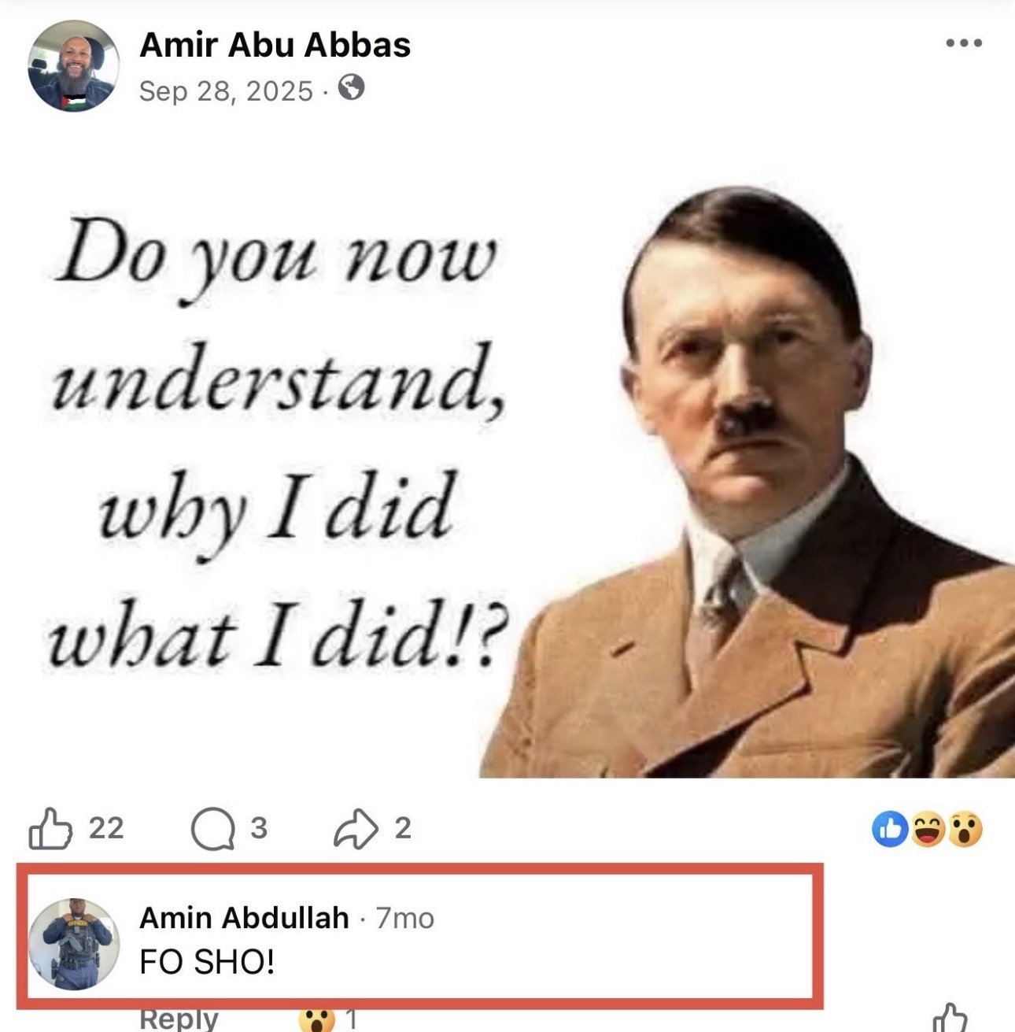
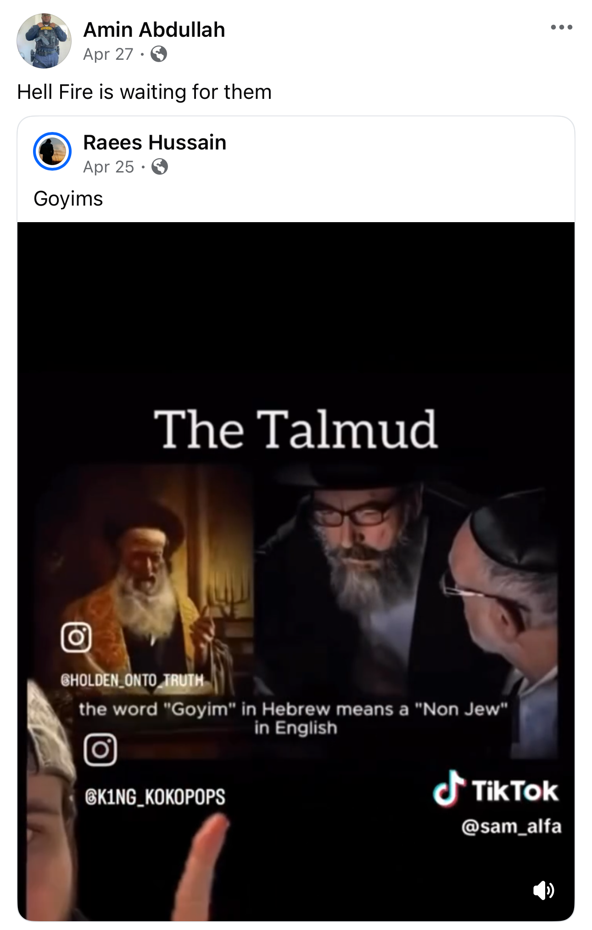
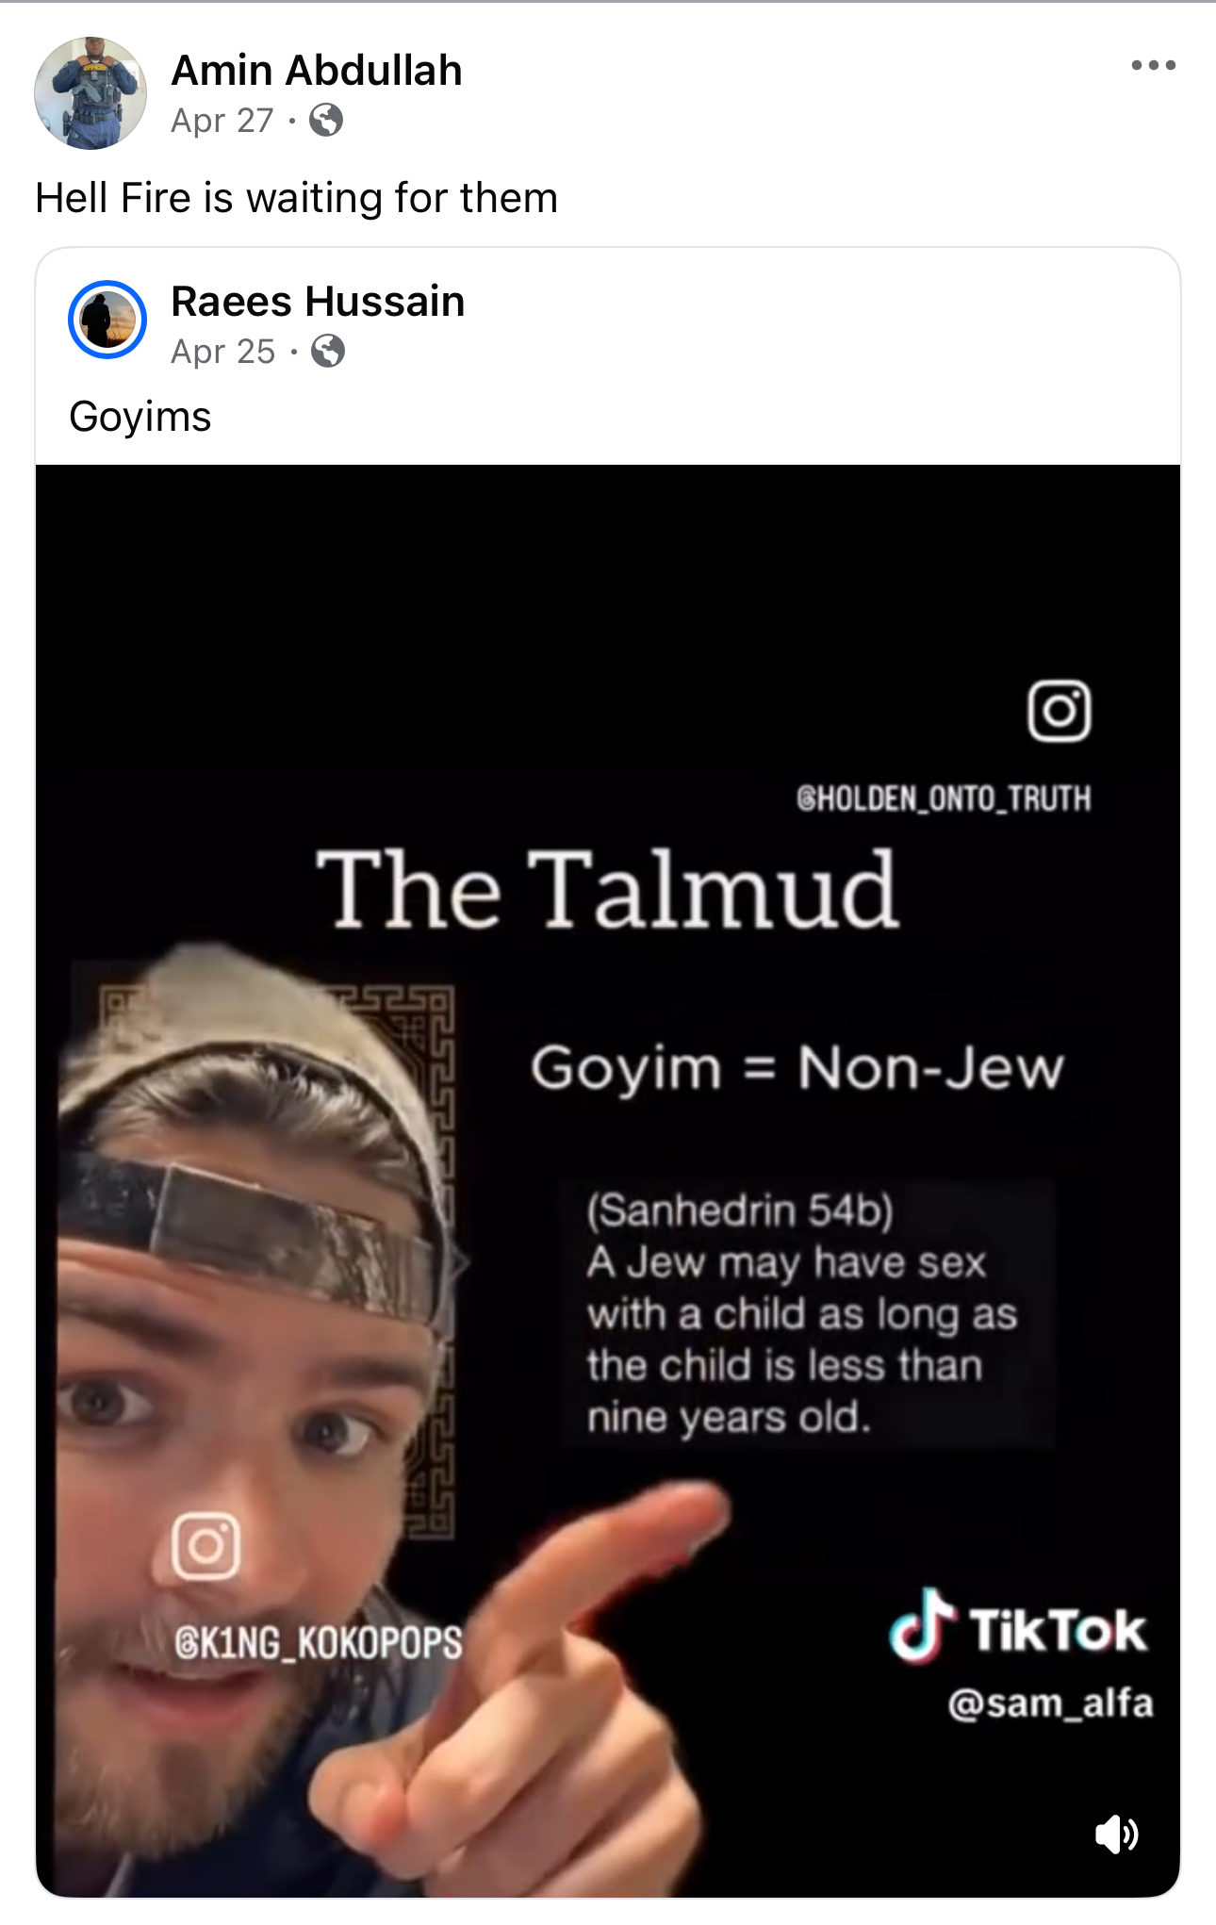
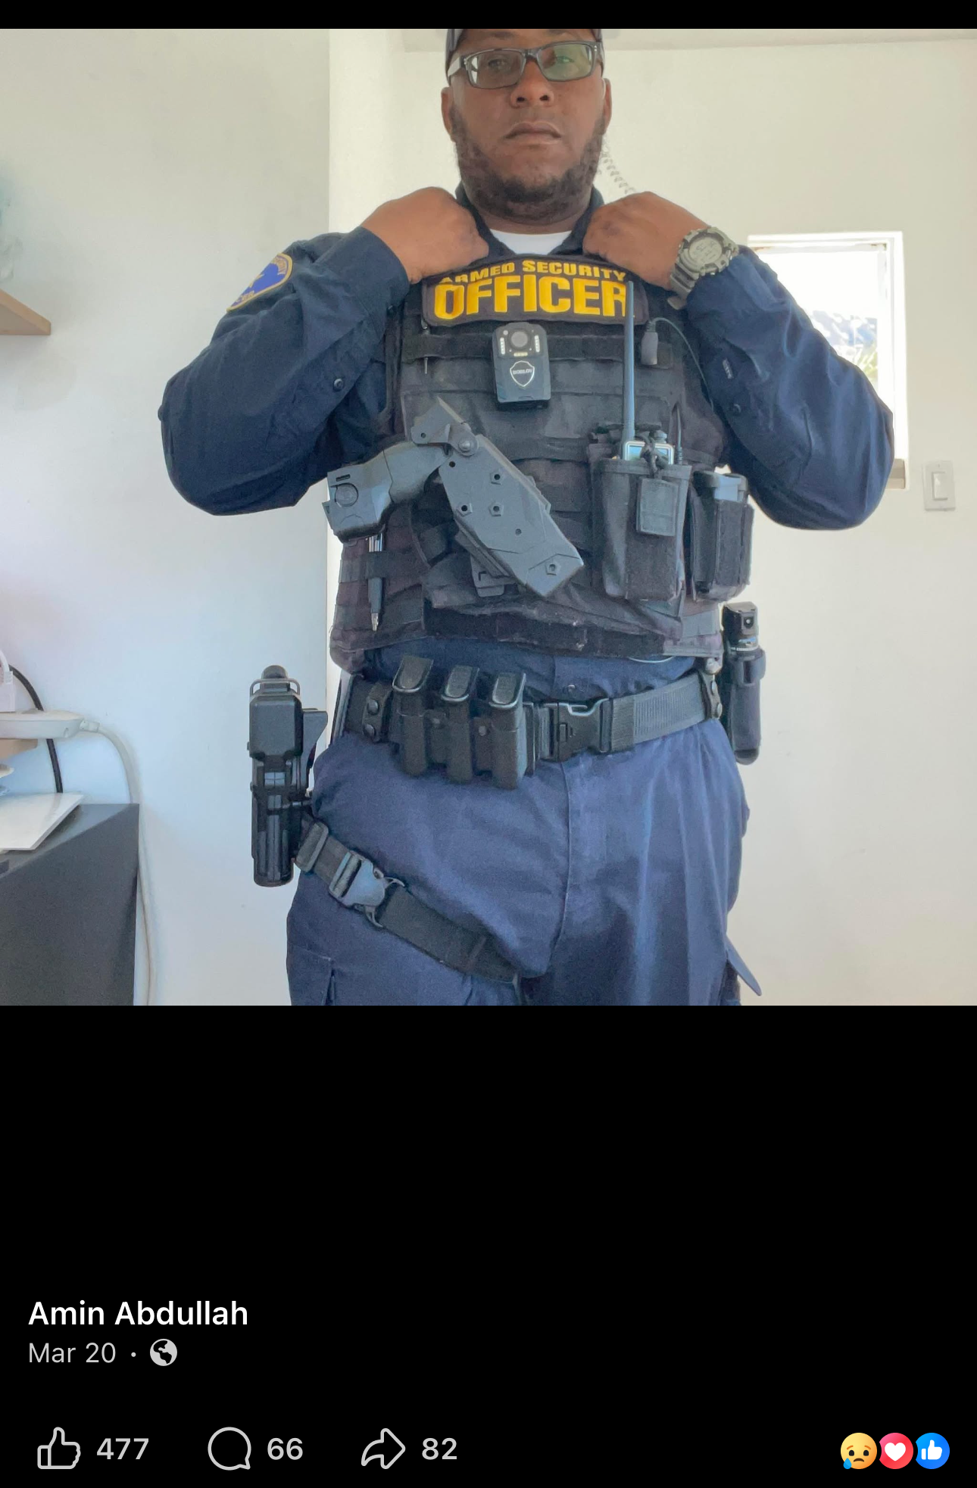
The renewed attention has also extended to social media activity tied to individuals associated with the Mosque. Amin Abdullah, identified by some outlets and social media users as a security guard connected to the Center and reportedly among the victims of the shooting incident, had previously shared antisemitic conspiracy content online, including reposting a video containing inflammatory claims about Jews and the Talmud, including false allegations portraying Jews as pedophiles or inherently immoral. Screenshots taken from what appears to be Abdullah’s Facebook account also appear to show him reposting the video with the caption, “Hell Fire is waiting for them.”

More concerning, however, are allegations that Amin Abdullah openly expressed support for Adolf Hitler in what appears to be a comment posted under a now-deleted image of Hitler alongside the caption, “Do you now understand why I did what I did?” Screenshots of the exchange, which are now circulating on social media, appear to show Abdullah responding, “FO SHO!” seemingly expressing agreement with the statement.

Further social media activity, including posts, comments, and interactions allegedly linked to Amin Abdullah and documented through screenshots collected by Global Peace for Israel, appears to show repeated engagement with antisemitic propaganda, anti-Israel incitement, Islamic extremist rhetoric, and inflammatory content directed not only toward Jews and Israel, but toward America and the West more broadly.

Among the more disturbing examples was an alleged comment appearing beneath a post stating, “May Allah destroy Israel and her allies and grant the Muslims victory over the disbelieving people Allahuma Ameen,” to which Abdullah allegedly responded twice: “Ameen 🤲.”
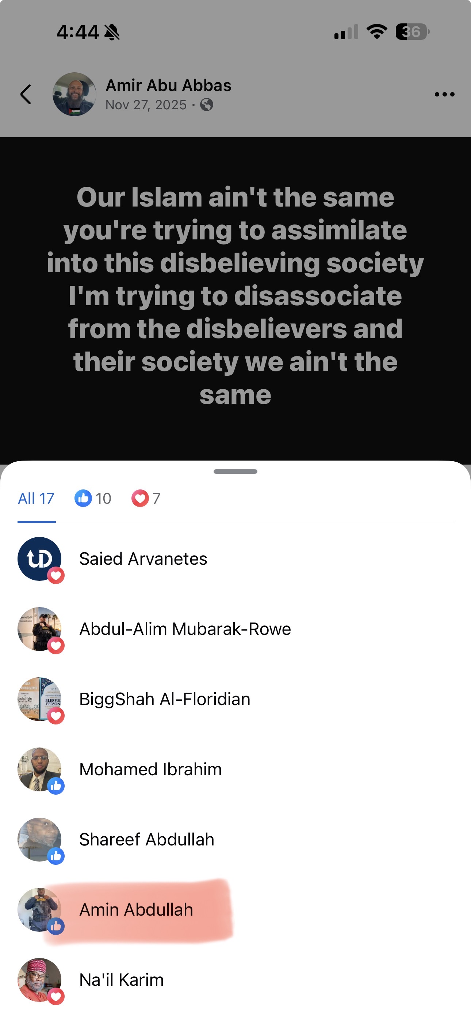
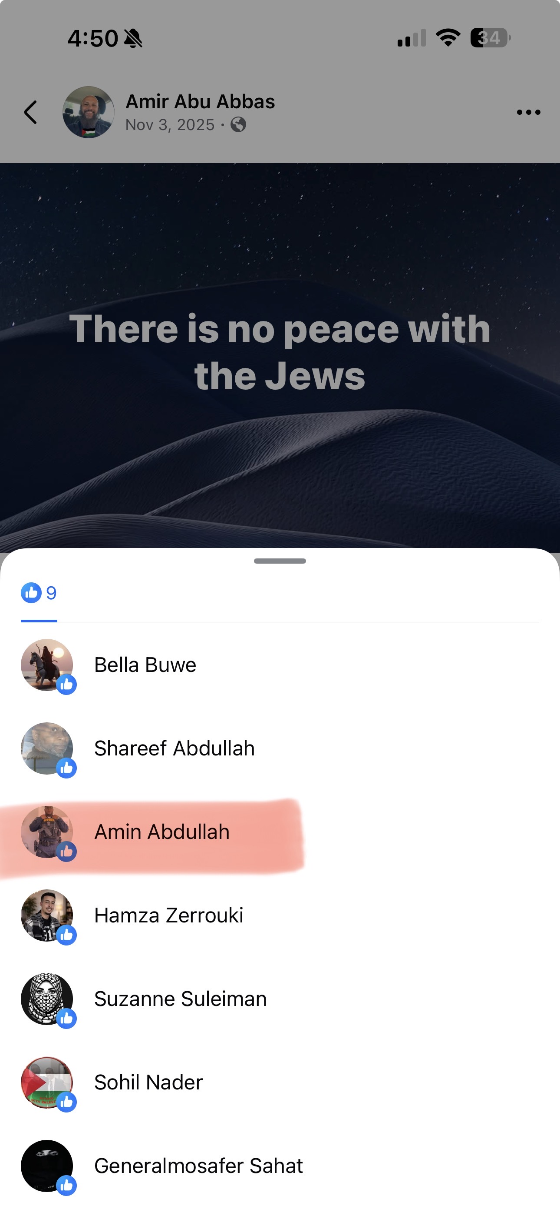
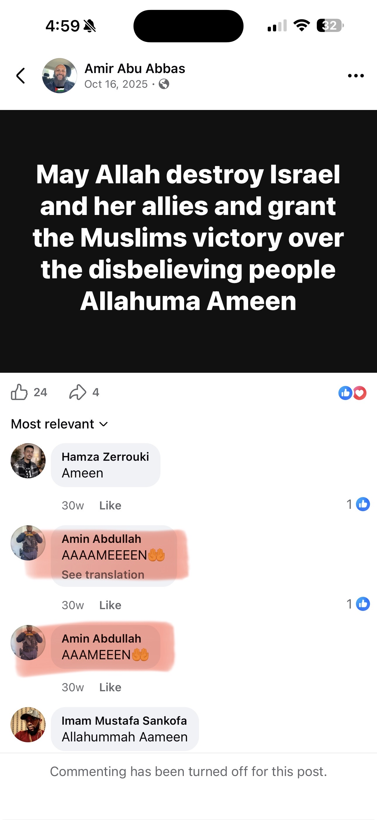
Additional posts allegedly liked by Abdullah included statements such as “Israel is a cancer that needs to be removed,” “There is no peace with the Jews,” and another declaring, “Our Islam ain’t the same — you’re trying to assimilate into this disbelieving society,” before continuing, “I’m trying to disassociate from the disbelievers and their society, we ain’t the same.”
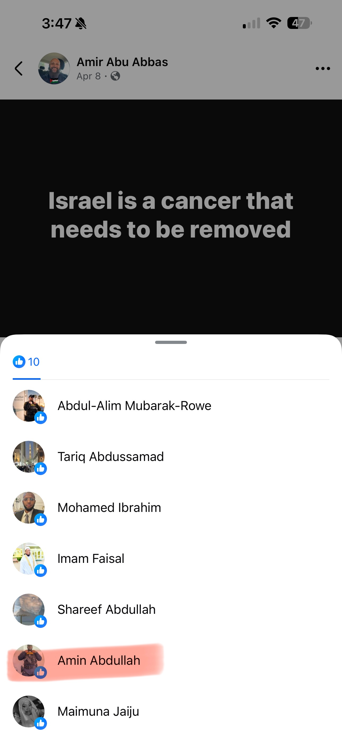
Screenshots reviewed by Global Peace for Israel appear to show the same account allegedly belonging to Abdullah engaging with and liking each of the posts. The repeated pattern of interaction with antisemitic, sectarian, and extremist rhetoric raises serious concerns that extend far beyond ordinary political discourse or criticism of Israel.
Additional screenshots reviewed by Global Peace for Israel allegedly show repeated engagement with antisemitic incitement and Islamic extremist rhetoric. In one example, a post stated, “I knew the Israelis weren’t going to fulfill their oath. They are the enemies of humanity. May Allah wipe them off the face of the earth, allahuma ameen ameen,” to which Abdullah allegedly responded, “Aaameen 🤲.”
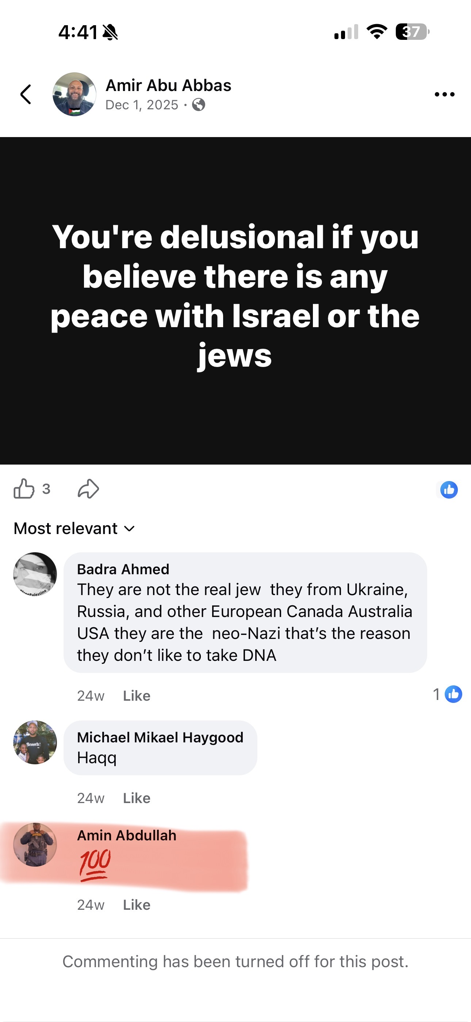
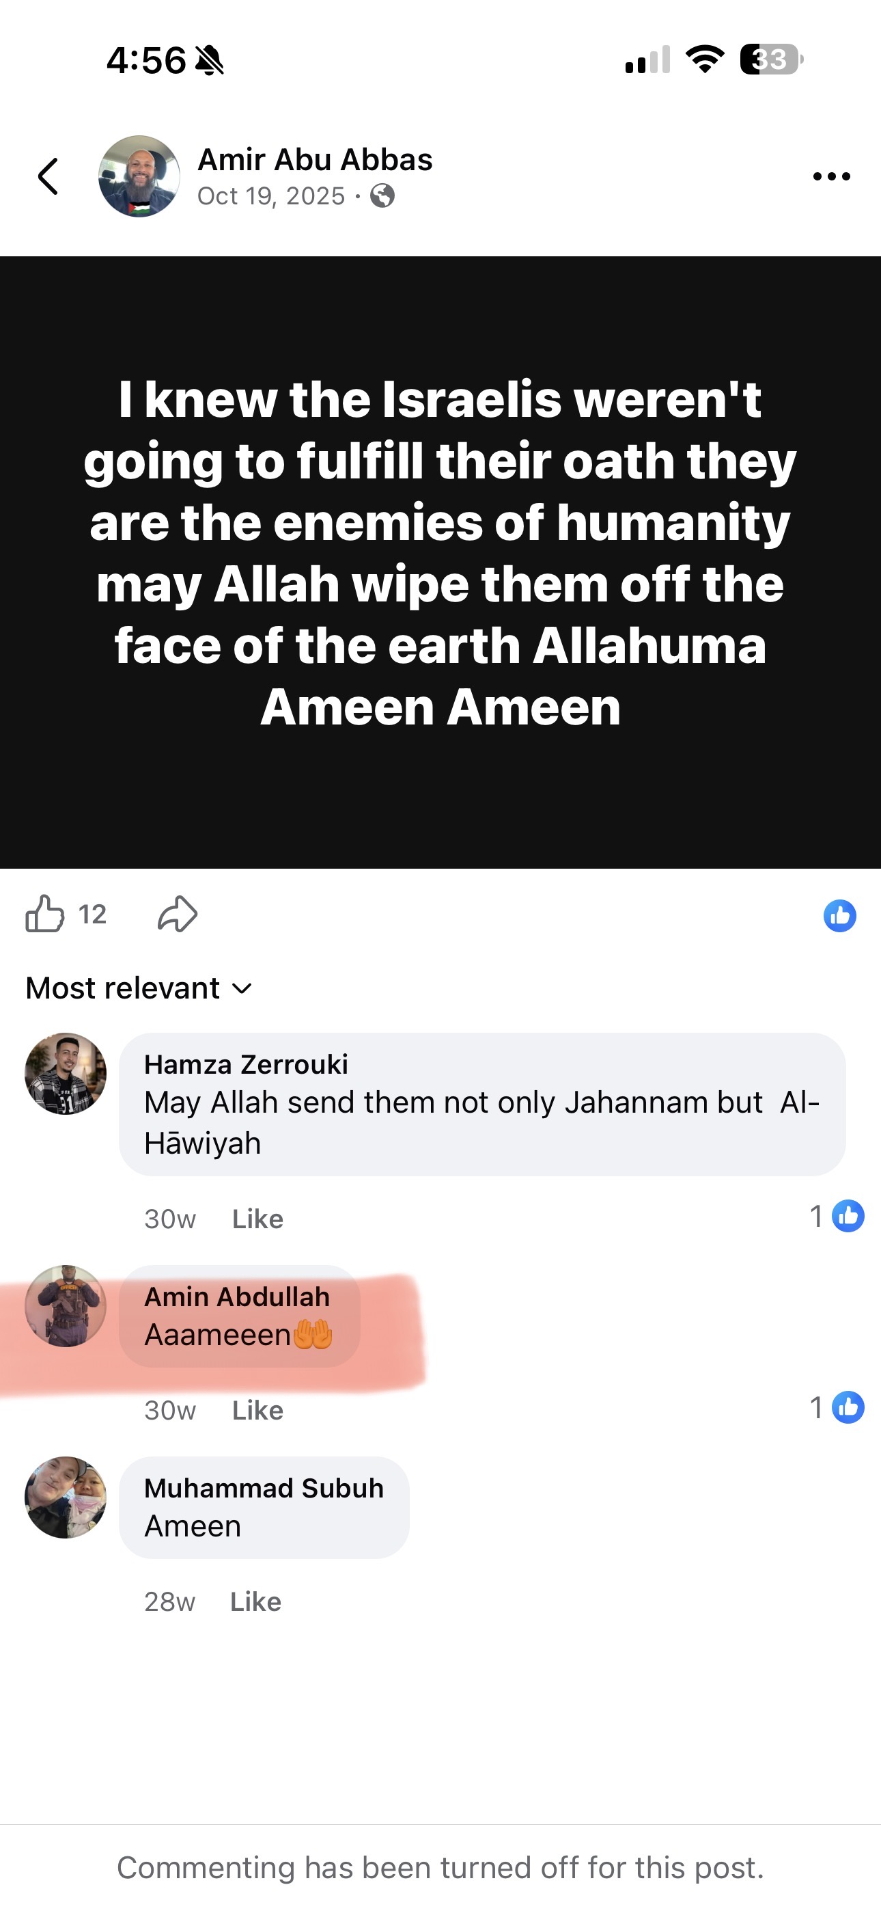
Another post stated, “You’re delusional if you believe there is any peace with Israel or the Jews,” to which Abdullah allegedly replied with “💯,” appearing to express agreement with the statement.
In another example, a post read, “The filthiest animal on the planet is not the pig. It’s the Israeli,” to which Abdullah allegedly responded, “💯💯 The pig worships Allah.” This repeated pattern of interaction with violent, antisemitic, and dehumanizing rhetoric raises serious concerns about ideological extremism and hatred toward Jews and Israel.
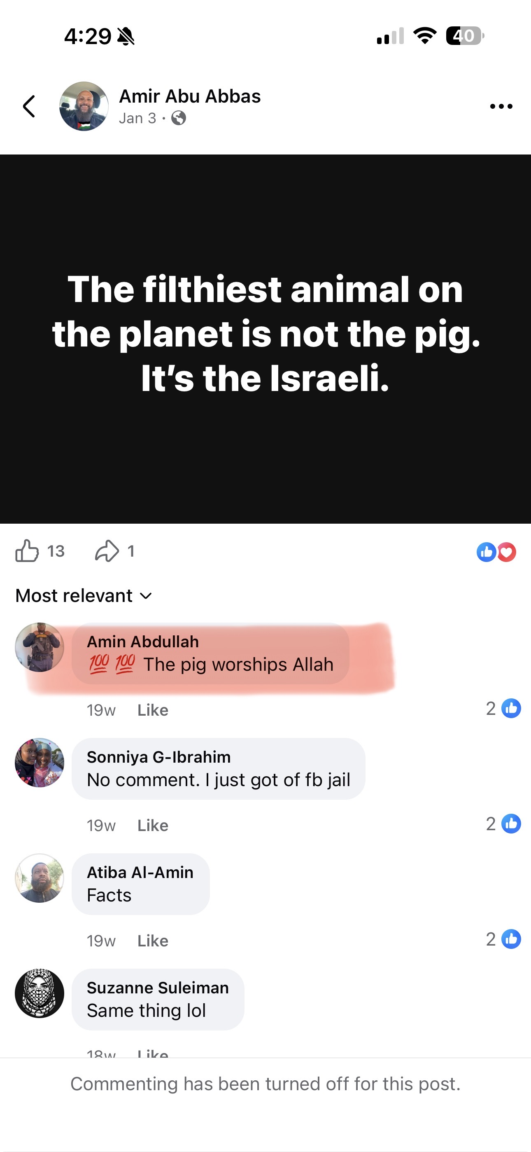

The broader issue now facing San Diego officials and American leaders nationwide is whether institutions receiving community influence and in some cases government support, are doing enough to clearly reject Islamic extremism. Where credible evidence of support for terrorism, incitement, or Islamic extremist ideology exists, authorities and the public alike will inevitably question what level of accountability, oversight, legal scrutiny, and national security concern is warranted.

Democratic societies must unequivocally condemn attacks on any houses of worship, while also refusing to ignore concerns about institutions or individuals accused of promoting Islamic extremism, glorifying terrorism, or spreading hateful ideology within Western society.

