МІНІСТЕРСТВО ОСВІТИ І НАУКИ УКРАЇНИ
Національний аерокосмічний університет ім. М.Є. Жуковського
“Харківський авіаційний інститут”

Кафедра комп’ютерних систем та мереж

Лабораторна робота № 1

“Разработка и исследование линейных программ ”(Калькулятор)

По дисциплине “Технологии программирования”

ХАІ.503.525В.123. 1705067.180

Виконав студент гр. 525В Пеналоза Г.
(№ групи) (П.І.Б.)
03-02-19
(підпис, дата)
Перевірив ст. викладач каф. 503
(науковий ступінь, вчене звання, посада)

(підпис, дата) (П.І.Б.)

2018

Тема работы: “Разработка и исследование линейных программ ”(Калькулятор)

Задание: разработать на C# проект, реализующий калькулятор.
Запретить ввод в окно редактирования: - символов отличных от (0 1 2 3 4 5 6 7 8 9 + - ,), - двух символов (+ - ,), - символов (+ -) не в начале числа.
Калькулятор должен содержать одно окно для ввода слагаемых и вывода результата.
Разработать модульные тесты (unit-тесты) для методов класса калькулятора.

Вариант 20

Задание

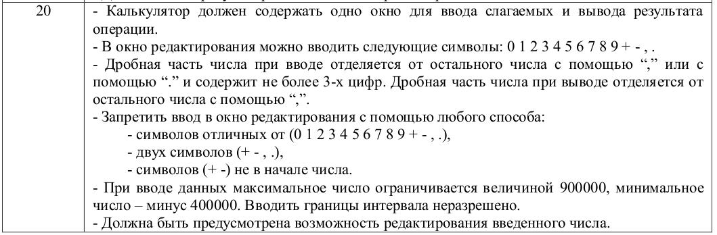

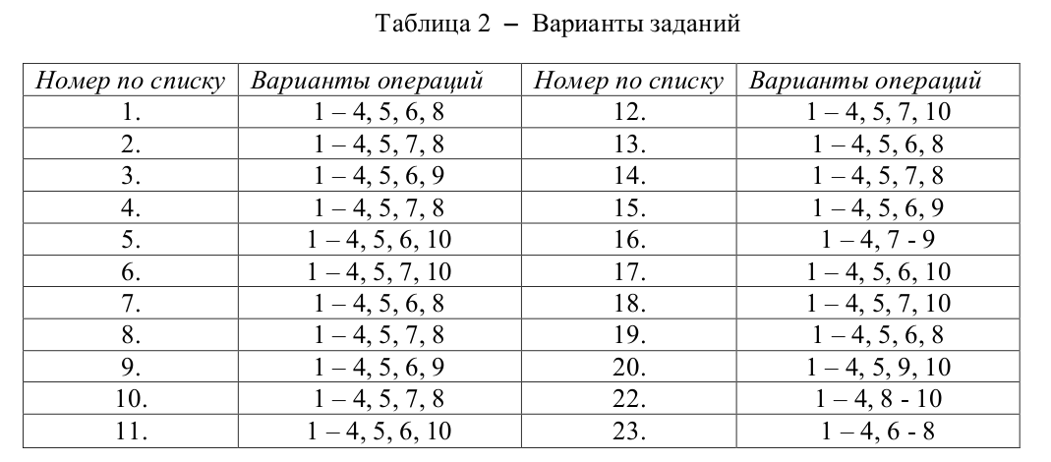

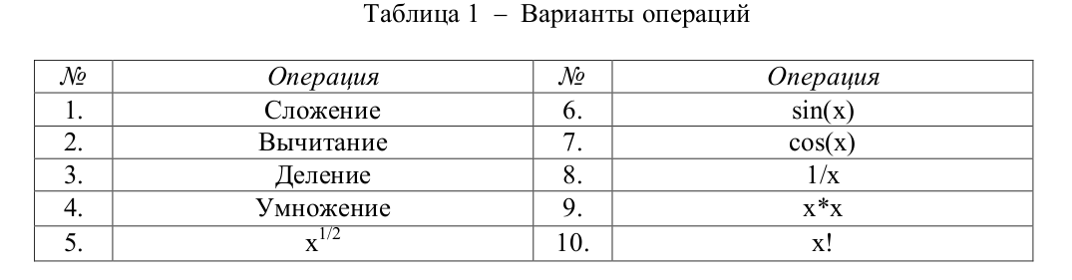
Диаграмму классов

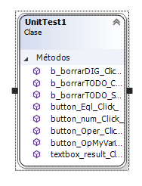
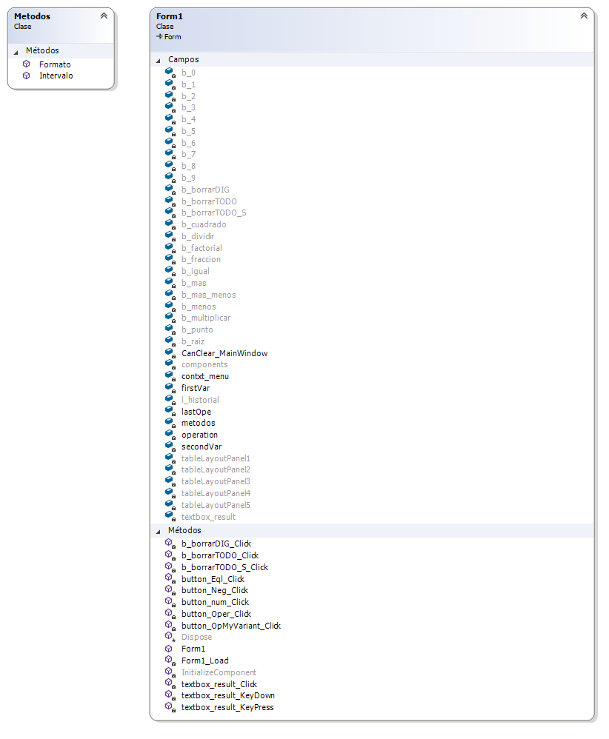

Текст программы

Form.cs

using System;
using System.Collections.Generic;
using System.ComponentModel;
using System.Data;
using System.Drawing;
using System.Globalization;
using System.Linq;
using System.Text;
using System.Threading;
using System.Threading.Tasks;
using System.Windows.Forms;

namespace CalculadoraCompleta
{
public partial class Form1 : Form
{
private ContextMenu contxt_menu = new ContextMenu(); //Create an empty context menu object
private string operation = ""; //Actual Operation
private double lastOpe; //Last operations
private double firstVar; //Number entered
private double secondVar; //Var to add
private bool CanClear_MainWindow;
Metodos metodos = new Metodos();

public Form1()
{
InitializeComponent();
}

private void textbox_result_Click(object sender, EventArgs e) //Set cursor in textbox
{
if (!(textbox_result.Text == "0"))
return;
textbox_result.Text = "";
}

private void textbox_result_KeyPress(object sender, KeyPressEventArgs e) //Detect key entered according to the variant.
{
Thread.CurrentThread.CurrentCulture = new CultureInfo("es-EC"); //Gets or sets the current culture used by the Resource Manager to look up culture-specific resources at run time.
if (!char.IsDigit(e.KeyChar) && e.KeyChar != ',' && (e.KeyChar != '.' && e.KeyChar != '-') && (e.KeyChar != '\b' && e.KeyChar != '.'))
{
e.KeyChar = char.MinValue;
}
else
{
if (l_historial.Text == "unknown format!" || l_historial.Text == "too big value!" || (l_historial.Text == "less than zero!" || l_historial.Text == "div by zero!"))
l_historial.Text = "";
else if (l_historial.Text.Contains("unknown format!") || l_historial.Text.Contains("too big value!") || (l_historial.Text.Contains("less than zero!") || l_historial.Text.Contains("div by zero!")))
l_historial.Text = string.Format("{0} {1} ", (object)firstVar, (object)operation);
if (e.KeyChar == ',' || e.KeyChar == '.')
{
if (e.KeyChar == '.')
e.KeyChar = ',';
if (textbox_result.Text.IndexOf(',') != -1)
{
e.KeyChar = char.MinValue;
}
}
else if (e.KeyChar == '-')
{
if (textbox_result.Text.Length == 0)
return;
e.KeyChar = char.MinValue;
}
else
{
if (!char.IsDigit(e.KeyChar))
return;
if (!metodos.Intervalo(Convert.ToDouble(textbox_result.Text + e.KeyChar.ToString(), (IFormatProvider)Thread.CurrentThread.CurrentCulture.NumberFormat)))
{
if (l_historial.Text == "")
l_historial.Text = "too big value!";
else if (l_historial.Text != "" && l_historial.Text.IndexOf(string.Format(" {0} ", (object)operation)) == l_historial.Text.Length - 3)
l_historial.Text = string.Format("{0} {1} too big value!", (object)firstVar, (object)operation);
else if (l_historial.Text != "" && l_historial.Text.IndexOf(string.Format(" {0} ", (object)operation)) != l_historial.Text.Length - 3)
l_historial.Text = string.Format("{0} {1} too big value!", (object)lastOpe, (object)operation);
e.KeyChar = char.MinValue;
}
else
{
string text = textbox_result.Text;
int num = text.IndexOf(',');
if (num == -1 || text.Length - 1 - num <= 2)
return;
e.KeyChar = char.MinValue;
}
}
}
}

private void b_borrarTODO_Click(object sender, EventArgs e)//Clean all
{
l_historial.Text = "";
textbox_result.Text = "0";
operation = "";
}

private void textbox_result_KeyDown(object sender, KeyEventArgs e)//Event when press control + c or control + v to copy and paste
{
if (e.Control && (e.KeyCode == Keys.V))
{
string n = Clipboard.GetText();
if (n.Length > 11)
e.Handled = false;
string str = metodos.Formato(n);
if (!(str == "dec"))
{
e.Handled = true;
}
else
{
if (n.Contains("."))
n = n.Replace('.', ',');
if (!metodos.Intervalo(Convert.ToDouble(n, (IFormatProvider)Thread.CurrentThread.CurrentCulture.NumberFormat)))
e.Handled = true;
else
textbox_result.Text = n;
}
}
else
{
if (!e.Control || e.KeyValue != 67)
return;
Clipboard.SetText(textbox_result.Text);
Help.ShowPopup(textbox_result, "text copied!", new Point(textbox_result.Right, textbox_result.Left));
}
}

private void b_borrarDIG_Click(object sender, EventArgs e)//Delete one by one digit
{
if (textbox_result.Text.Length <= 1)
{
textbox_result.Text = "0";
}
else
{
if (l_historial.Text == "unknown format!" || l_historial.Text == "too big value!" || (l_historial.Text == "less than zero!" || l_historial.Text == "div by zero!"))
l_historial.Text = "";
else if (l_historial.Text.Contains("unknown format!") || l_historial.Text.Contains("too big value!") || (l_historial.Text.Contains("less than zero!") || l_historial.Text.Contains("div by zero!")))
l_historial.Text = string.Format("{0} {1} ", (object)firstVar, (object)operation);
else if (l_historial.Text.Contains("sqrt") || l_historial.Text.Contains("1/") || l_historial.Text.Contains("^2")||l_historial.Text.Contains("!"))
l_historial.Text = "";
else if (l_historial.Text != "" && l_historial.Text.IndexOf(string.Format(" {0} ", (object)operation)) != l_historial.Text.Length - 3)
l_historial.Text = "";
textbox_result.Text = textbox_result.Text.Remove(textbox_result.Text.Length - 1, 1);
}
}

private void Form1_Load(object sender, EventArgs e)
{
textbox_result.ContextMenu = this.contxt_menu; //Set an empty context menu object
}

private void button_num_Click(object sender, EventArgs e) //Enter all digits 0-9
{
Thread.CurrentThread.CurrentCulture = new CultureInfo("es-EC");
if (CanClear_MainWindow)//Limpia los digitos actuales del texbox, para poder ingresar un nuevos luego de una operacion.
{
textbox_result.Text = "";
CanClear_MainWindow = false;
}
Button button = (Button)sender;//Estable el boton presionado
if (l_historial.Text == "unknown format!" || l_historial.Text == "too big value!" || (l_historial.Text == "less than zero!" || l_historial.Text == "div by zero!"))//Limpia el historial si hubo error
l_historial.Text = "";
else if (l_historial.Text.Contains("unknown format!") || l_historial.Text.Contains("too big value!") || (l_historial.Text.Contains("less than zero!") || l_historial.Text.Contains("div by zero!")))//Limpia el mensaje de error si se ingresa una coma
l_historial.Text = string.Format("{0} {1} ", (object)firstVar, (object)operation);
if (textbox_result.Text == "0")
textbox_result.Text = "";
if (button.Text == ",")
{
if (textbox_result.Text == "")
{
textbox_result.Text = "0" + button.Text;
}
else
{
if (!(metodos.Formato(textbox_result.Text) == "dec") || textbox_result.Text.Contains(","))//Verifica si ya existe una coma.
return;
textbox_result.Text += button.Text;
}
}
else
{
if (!char.IsDigit(Convert.ToChar(button.Text)))
return;
if (!metodos.Intervalo(Convert.ToDouble(textbox_result.Text + button.Text, (IFormatProvider)Thread.CurrentThread.CurrentCulture.NumberFormat)))
{
if (l_historial.Text == "")
l_historial.Text = "too big value!";
else if (l_historial.Text != "" && l_historial.Text.IndexOf(string.Format(" {0} ", (object)operation)) == l_historial.Text.Length - 3)
{
l_historial.Text = string.Format("{0} {1} too big value!", (object)firstVar, (object)operation);
}
else
{
if (!(l_historial.Text != "") || l_historial.Text.IndexOf(string.Format(" {0} ", (object)operation)) == l_historial.Text.Length - 3)//Luego de una operacion e ingreso de un numero erroneo, se visualiza en el historial el resultado de la anterior mas mensaje de error
return;
l_historial.Text = string.Format("{0} {1} too big value!", (object)lastOpe, (object)operation);
}
}
else
{
string str = textbox_result.Text + button.Text;
int num = str.IndexOf(',');
if (num != -1)//Verificar el numero de decimales
{
if (str.Length - 1 - num > 3)
return;
textbox_result.Text = str;
}
else
textbox_result.Text = str;
}
}
}

private void button_Oper_Click(object sender, EventArgs e)//Basic operations
{
Thread.CurrentThread.CurrentCulture = new CultureInfo("es-EC");
Button button = (Button)sender;
string text = textbox_result.Text;
string str = metodos.Formato(textbox_result.Text);
if (!(str == "dec"))
{
if (str == "nul")
{
if (textbox_result.Text == "")
{
textbox_result.Text = "0";
return;
}
if (this.l_historial.Text == "")
this.l_historial.Text = "unknown format!";
else if (this.l_historial.Text == "unknown format!" || this.l_historial.Text == "too big value!" || (this.l_historial.Text == "less than zero!" || this.l_historial.Text == "div by zero!"))
this.l_historial.Text = "unknown format!";
else if (this.l_historial.Text != "" && this.l_historial.Text.IndexOf(string.Format(" {0} ", (object)button.Text)) == this.l_historial.Text.Length - 3)
this.l_historial.Text = string.Format("{0} {1} unknown format!", (object)this.firstVar, (object)button.Text);
else if (this.l_historial.Text.Contains("unknown format!") || this.l_historial.Text.Contains("too big value!") || (this.l_historial.Text.Contains("less than zero!") || this.l_historial.Text.Contains("div by zero!")))
this.l_historial.Text = string.Format("{0} {1} unknown format!", (object)this.firstVar, (object)button.Text);
else if (this.l_historial.Text != "" && this.l_historial.Text.IndexOf(string.Format(" {0} ", (object)button.Text)) != this.l_historial.Text.Length - 3)
this.l_historial.Text = "unknown format!";
}
}
else
{
double n = double.Parse(this.textbox_result.Text, (IFormatProvider)Thread.CurrentThread.CurrentCulture.NumberFormat);
bool interval = metodos.Intervalo(n);
if (interval)
{
if (this.l_historial.Text == "unknown format!" || this.l_historial.Text == "too big value!" || (this.l_historial.Text == "less than zero!" || this.l_historial.Text == "div by zero!"))
this.l_historial.Text = "";
else if (this.l_historial.Text.Contains("unknown format!") || this.l_historial.Text.Contains("too big value!") || (this.l_historial.Text.Contains("less than zero!") || this.l_historial.Text.Contains("div by zero!")))
this.l_historial.Text = string.Format("{0} {1} ", (object)this.firstVar, (object)button.Text);
if (this.l_historial.Text == "")
{
this.firstVar = n;
this.l_historial.Text = string.Format("{0} {1} ", (object)text, (object)button.Text);
}
else if (this.l_historial.Text != "" && this.l_historial.Text.IndexOf(string.Format(" {0} ", (object)button.Text)) == this.l_historial.Text.Length - 3)
{
if (this.operation == "÷")
{
this.secondVar = n;
if (this.secondVar != 0.0)
{
this.operation = string.Format("{0}", (object)button.Text);
this.b_igual.PerformClick();//LLama al boton = para realizar la division anterior y dividir nuevamente.
this.l_historial.Text = string.Format("{0} {1} ({2})", (object)this.firstVar, (object)button.Text, (object)text);
}
else if (this.l_historial.Text == "")
this.l_historial.Text = "div by zero!";
else if (this.l_historial.Text != "" && this.l_historial.Text.IndexOf(string.Format(" {0} ", (object)this.operation)) == this.l_historial.Text.Length - 3)
this.l_historial.Text = "div by zero!";
}
else
{
this.secondVar = n;
this.operation = string.Format("{0}", (object)button.Text);
this.b_igual.PerformClick();
if (this.l_historial.Text != "too big value!")
this.l_historial.Text = string.Format("{0} {1} ({2})", (object)this.firstVar, (object)button.Text, (object)text);
}
}
else if (this.l_historial.Text != "" && this.l_historial.Text.IndexOf(string.Format(" {0} ", (object)button.Text)) != this.l_historial.Text.Length - 3)
{
this.firstVar = n;
this.l_historial.Text = string.Format("{0} {1} ", (object)this.firstVar, (object)button.Text);
}
}
else if (this.l_historial.Text == "")
this.l_historial.Text = "too big value!";
else if (this.l_historial.Text == "unknown format!" || this.l_historial.Text == "too big value!" || (this.l_historial.Text == "less than zero!" || this.l_historial.Text == "div by zero!"))
this.l_historial.Text = "too big value!";
else if (this.l_historial.Text != "" && this.l_historial.Text.IndexOf(string.Format(" {0} ", (object)button.Text)) == this.l_historial.Text.Length - 3)
this.l_historial.Text = string.Format("{0} {1} too big value!", (object)this.firstVar, (object)button.Text);
else if (this.l_historial.Text.Contains("unknown format!") || this.l_historial.Text.Contains("too big value!") || (this.l_historial.Text.Contains("less than zero!") || this.l_historial.Text.Contains("div by zero!")))
this.l_historial.Text = string.Format("{0} {1} too big value!", (object)this.firstVar, (object)button.Text);
else if (this.l_historial.Text != "" && this.l_historial.Text.IndexOf(string.Format(" {0} ", (object)button.Text)) != this.l_historial.Text.Length - 3)
this.l_historial.Text = "too big value!";
}
this.operation = string.Format("{0}", (object)button.Text);
this.CanClear_MainWindow = true;
}

private void button_Eql_Click(object sender, EventArgs e)//Button =
{
Thread.CurrentThread.CurrentCulture = new CultureInfo("es-EC");
string text = this.textbox_result.Text;
string str = metodos.Formato(this.textbox_result.Text);
if (!(str == "dec"))
{
if (this.textbox_result.Text == "")
{
this.textbox_result.Text = "0";
return;
}
if (this.l_historial.Text == "")
this.l_historial.Text = "unknown format!";
else if (this.l_historial.Text == "unknown format!" || this.l_historial.Text == "too big value!" || (this.l_historial.Text == "less than zero!" || this.l_historial.Text == "div by zero!"))
this.l_historial.Text = "unknown format!";
else if (this.l_historial.Text != "" && this.l_historial.Text.IndexOf(string.Format(" {0} ", (object)this.operation)) == this.l_historial.Text.Length - 3)
this.l_historial.Text = string.Format("{0} {1} unknown format!", (object)this.firstVar, (object)this.operation);
else if (this.l_historial.Text != "" && this.l_historial.Text.IndexOf(string.Format(" {0} ", (object)this.operation)) != this.l_historial.Text.Length - 3)
this.l_historial.Text = "unknown format!";
else if (this.l_historial.Text.Contains("unknown format!") || this.l_historial.Text.Contains("too big value!") || (this.l_historial.Text.Contains("less than zero!") || this.l_historial.Text.Contains("div by zero!")))
this.l_historial.Text = string.Format("{0} {1} unknown format!", (object)this.firstVar, (object)this.operation);
}
else
{
double n = double.Parse(textbox_result.Text, (IFormatProvider)Thread.CurrentThread.CurrentCulture.NumberFormat);
bool interval = metodos.Intervalo(n);
if (interval)
{
this.secondVar = n;
string operation = this.operation;
if (!(operation == "+"))
{
if (!(operation == "-"))
{
if (!(operation == "×"))
{
if (operation == "÷")
{
if (secondVar != 0.0)
{
this.lastOpe = this.firstVar / this.secondVar;
this.l_historial.Text = string.Format("{0} {1} ({2})", (object)this.firstVar, (object)this.operation, (object)this.secondVar);
this.lastOpe = Math.Round(this.lastOpe, 3);
if (!metodos.Intervalo(this.lastOpe))
this.l_historial.Text = "too big value!";
else
this.textbox_result.Text = Convert.ToString(this.lastOpe);
}
else if (this.l_historial.Text == "")
this.l_historial.Text = "div by zero!";
else if (this.l_historial.Text != "" && this.l_historial.Text.IndexOf(string.Format(" {0} ", (object)this.operation)) == this.l_historial.Text.Length - 3)
this.l_historial.Text = "div by zero!";
}
}
else
{
this.lastOpe = this.firstVar * this.secondVar;
this.l_historial.Text = string.Format("{0} {1} ({2})", (object)this.firstVar, (object)this.operation, (object)this.secondVar);
this.lastOpe = Math.Round(this.lastOpe, 3);
if (!metodos.Intervalo(this.lastOpe))
this.l_historial.Text = "too big value!";
else
this.textbox_result.Text = Convert.ToString(this.lastOpe);
}
}
else
{
this.lastOpe = this.firstVar - this.secondVar;
this.l_historial.Text = string.Format("{0} {1} ({2})", (object)this.firstVar, (object)this.operation, (object)this.secondVar);
this.lastOpe = Math.Round(this.lastOpe, 3);
if (!metodos.Intervalo(this.lastOpe))
this.l_historial.Text = "too big value!";
else
this.textbox_result.Text = Convert.ToString(this.lastOpe);
}
}
else
{
this.lastOpe = this.firstVar + this.secondVar;
this.l_historial.Text = string.Format("{0} {1} ({2})", (object)this.firstVar, (object)this.operation, (object)this.secondVar);
this.lastOpe = Math.Round(this.lastOpe, 3);
if (!metodos.Intervalo(this.lastOpe))
this.l_historial.Text = "too big value!";
else
this.textbox_result.Text = Convert.ToString(this.lastOpe);
}
}
else if (this.l_historial.Text == "")
this.l_historial.Text = "too big value!";
else if (this.l_historial.Text == "unknown format!" || this.l_historial.Text == "too big value!" || (this.l_historial.Text == "less than zero!" || this.l_historial.Text == "div by zero!"))
this.l_historial.Text = "too big value!";
else if (this.l_historial.Text.Contains("unknown format!") || this.l_historial.Text.Contains("too big value!") || (this.l_historial.Text.Contains("less than zero!") || this.l_historial.Text.Contains("div by zero!")))
this.l_historial.Text = string.Format("{0} {1} too big value!", (object)this.firstVar, (object)this.operation);
else if (this.l_historial.Text != "" && this.l_historial.Text.IndexOf(string.Format(" {0} ", (object)this.operation)) == this.l_historial.Text.Length - 3)
this.l_historial.Text = string.Format("{0} {1} too big value!", (object)this.firstVar, (object)this.operation);
else if (this.l_historial.Text != "" && this.l_historial.Text.IndexOf(string.Format(" {0} ", (object)this.operation)) != this.l_historial.Text.Length - 3)
this.l_historial.Text = "too big value!";
}
this.CanClear_MainWindow = true;
}

private void b_borrarTODO_S_Click(object sender, EventArgs e)//clean the number entered
{
if (!(this.l_historial.Text=="")&&!(this.textbox_result.Text==""))
{
if (this.l_historial.Text.Contains('('))
{
b_borrarTODO.PerformClick();
}
else
{
this.textbox_result.Text = "";
}
}
else if ((this.l_historial.Text=="")&&!(this.textbox_result.Text==""))
{
textbox_result.Text = "";
}
}

private void button_Neg_Click(object sender, EventArgs e)//Put positve or negative in from the number
{
Thread.CurrentThread.CurrentCulture = new CultureInfo("es-EC");
string str = metodos.Formato(this.textbox_result.Text);
if (!(str == "dec"))
{
if (!(str == "nul"))
return;
if (this.textbox_result.Text == "")
this.textbox_result.Text = "0";
else if (this.l_historial.Text == "")
this.l_historial.Text = "unknown format!";
else if (this.l_historial.Text == "unknown format!" || this.l_historial.Text == "too big value!" || (this.l_historial.Text == "less than zero!" || this.l_historial.Text == "div by zero!"))
this.l_historial.Text = "unknown format!";
else if (this.l_historial.Text != "" && this.l_historial.Text.IndexOf(string.Format(" {0} ", (object)this.operation)) == this.l_historial.Text.Length - 3)//Si se inserta un solo signo menos
this.l_historial.Text = string.Format("{0} {1} unknown format!", (object)this.firstVar, (object)this.operation);
else if (this.l_historial.Text.Contains("unknown format!") || this.l_historial.Text.Contains("too big value!") || (this.l_historial.Text.Contains("less than zero!") || this.l_historial.Text.Contains("div by zero!")))
{
this.l_historial.Text = string.Format("{0} {1} unknown format!", (object)this.firstVar, (object)this.operation);
}
else
{
if (!(this.l_historial.Text != "") || this.l_historial.Text.IndexOf(string.Format(" {0} ", (object)this.operation)) == this.l_historial.Text.Length - 3)
return;
this.l_historial.Text = string.Format("{0} {1} unknown format!", (object)this.lastOpe, (object)this.operation);
}
}
else
{
double n = double.Parse(this.textbox_result.Text, (IFormatProvider)Thread.CurrentThread.CurrentCulture.NumberFormat);
bool interval = metodos.Intervalo(n);
if (interval)
{
if (!interval)
return;
if (this.l_historial.Text == "unknown format!" || this.l_historial.Text == "too big value!" || (this.l_historial.Text == "less than zero!" || this.l_historial.Text == "div by zero!"))
this.l_historial.Text = "";
else if (this.l_historial.Text.Contains("unknown format!") || this.l_historial.Text.Contains("too big value!") || (this.l_historial.Text.Contains("less than zero!") || this.l_historial.Text.Contains("div by zero!")))
this.l_historial.Text = string.Format("{0} {1} ", (object)this.firstVar, (object)this.operation);
if (this.l_historial.Text == "")
this.l_historial.Text = "";
else if (this.l_historial.Text != "" && this.l_historial.Text.IndexOf(string.Format(" {0} ", (object)this.operation)) != this.l_historial.Text.Length - 3)
this.l_historial.Text = "";
if (n == 0.0)
return;
if (this.textbox_result.Text[0] == '-')
this.textbox_result.Text = this.textbox_result.Text.Remove(0, 1);
else if (metodos.Intervalo(Convert.ToDouble("-" + this.textbox_result.Text, (IFormatProvider)Thread.CurrentThread.CurrentCulture.NumberFormat)))
{
this.textbox_result.Text = "-" + this.textbox_result.Text;
}
else
{
if (this.l_historial.Text == "")
this.l_historial.Text = "too big value!";
if (this.l_historial.Text != "" && this.l_historial.Text.IndexOf(string.Format(" {0} ", (object)this.operation)) == this.l_historial.Text.Length - 3)
{
this.l_historial.Text = string.Format("{0} {1} too big value!", (object)this.firstVar, (object)this.operation);
}
else
{
if (!(this.l_historial.Text != "") || this.l_historial.Text.IndexOf(string.Format(" {0} ", (object)this.operation)) == this.l_historial.Text.Length - 3)
return;
this.l_historial.Text = "too big value!";
}
}
}
else if (this.l_historial.Text == "")
this.l_historial.Text = "too big value!";
else if (this.l_historial.Text == "unknown format!" || this.l_historial.Text == "too big value!" || (this.l_historial.Text == "less than zero!" || this.l_historial.Text == "div by zero!"))
this.l_historial.Text = "too big value!";
else if (this.l_historial.Text != "" && this.l_historial.Text.IndexOf(string.Format(" {0} ", (object)this.operation)) == this.l_historial.Text.Length - 3)
this.l_historial.Text = string.Format("{0} {1} too big value!", (object)this.firstVar, (object)this.operation);
else if (this.l_historial.Text.Contains("unknown format!") || this.l_historial.Text.Contains("too big value!") || (this.l_historial.Text.Contains("less than zero!") || this.l_historial.Text.Contains("div by zero!")))
{
this.l_historial.Text = string.Format("{0} {1} too big value!", (object)this.firstVar, (object)this.operation);
}
else
{
if (!(this.l_historial.Text != "") || this.l_historial.Text.IndexOf(string.Format(" {0} ", (object)this.operation)) == this.l_historial.Text.Length - 3)
return;
this.l_historial.Text = "too big value!";
}
}
}

private void button_OpMyVariant_Click(object sender, EventArgs e)//Operations accouding my variant
{
Thread.CurrentThread.CurrentCulture = new CultureInfo("es-EC");
Button button = (Button)sender;
string text1 = this.textbox_result.Text;
string str = metodos.Formato(this.textbox_result.Text);
if (!(str == "dec"))
{
if (!(str == "nul"))
return;
if (this.textbox_result.Text == "")
this.textbox_result.Text = "0";
else if (this.l_historial.Text == "" || this.l_historial.Text != "" && this.l_historial.Text.IndexOf(string.Format(" {0} ", (object)this.operation)) != this.l_historial.Text.Length - 3)
{
this.l_historial.Text = "unknown format!";
}
else
{
if (!(this.l_historial.Text != "") || this.l_historial.Text.IndexOf(string.Format(" {0} ", (object)this.operation)) != this.l_historial.Text.Length - 3)
return;
this.l_historial.Text = string.Format("{0} {1} unknown format!", (object)this.firstVar, (object)button.Text);
}
}
else
{
double num = double.Parse(this.textbox_result.Text, (IFormatProvider)Thread.CurrentThread.CurrentCulture.NumberFormat);
bool interval = metodos.Intervalo(num);
if (interval)
{
if (!interval)
return;
if (this.l_historial.Text == "" || this.l_historial.Text != "" && this.l_historial.Text.IndexOf(string.Format(" {0} ", (object)this.operation)) != this.l_historial.Text.Length - 3)
{
string text2 = button.Text;
if (!(text2 == "sqrt"))
{
if (!(text2 == "1/x"))
{
if (!(text2 == "x^2"))
{
if (text2=="x!")
{
if (((decimal)num - Decimal.Truncate((decimal)num)) != 0)
{
this.secondVar = Math.Pow(num / Math.E, num) * Math.Sqrt(Math.PI*(2*(num)+1/3.0));//https://www.quora.com/How-do-I-calculate-decimal-factorials-like-1-7
this.l_historial.Text = string.Format("({0})!", (object)text1);
}
else
{
this.secondVar = MathNet.Numerics.SpecialFunctions.Factorial((int)num);
this.l_historial.Text = string.Format("({0})!", (object)text1);
}
}
}
else
{
this.secondVar = Math.Pow(num,2);
this.l_historial.Text = string.Format("({0})^2", (object)text1);
}
}
else if (num != 0.0)
{
this.secondVar = 1.0 / num;
this.l_historial.Text = string.Format("1/({0})", (object)text1);
}
else
{
this.l_historial.Text = "div by zero!";
return;
}
}
else if (num >= 0.0)
{
this.secondVar = Math.Sqrt(num);
this.l_historial.Text = string.Format("sqrt({0})", (object)text1);
}
else
{
this.l_historial.Text = "less than zero!";
return;
}
this.secondVar = Math.Round(this.secondVar, 3);
if (!metodos.Intervalo(this.secondVar))
{
this.l_historial.Text = "too big value!";
}
else
{
this.textbox_result.Text = Convert.ToString(this.secondVar);
this.lastOpe = this.secondVar;
}
}
else
{
if (!(this.l_historial.Text != "") || this.l_historial.Text.IndexOf(string.Format(" {0} ", (object)this.operation)) != this.l_historial.Text.Length - 3)
return;
string text2 = button.Text;
if (!(text2 == "sqrt"))
{
if (!(text2 == "1/x"))
{

if (!(text2=="x^2"))
{

if (!(text2 == "x!"))
return;

if (((decimal)num - Decimal.Truncate((decimal)num)) != 0)
{
if (!metodos.Intervalo(this.secondVar))
{
this.l_historial.Text = "too big value!";
}
else
{
this.secondVar = Math.Pow(num / Math.E, num) * Math.Sqrt(Math.PI * (2 * (num) + 1 / 3.0));//https://www.quora.com/How-do-I-calculate-decimal-factorials-like-1-7
this.textbox_result.Text = Convert.ToString(this.secondVar);
this.l_historial.Text = string.Format("{0} {1} ", (object)this.firstVar, (object)this.operation);
}
}
else
{
if (!metodos.Intervalo(this.secondVar))
{
this.l_historial.Text = "too big value!";
}
else
{
this.secondVar = MathNet.Numerics.SpecialFunctions.Factorial((int)num);
this.textbox_result.Text = Convert.ToString(this.secondVar);
this.l_historial.Text = string.Format("{0} {1} ", (object)this.firstVar, (object)this.operation);
}
}
}
else
{
this.secondVar = Math.Pow(num, 2);
if (!metodos.Intervalo(this.secondVar))
{
this.l_historial.Text = "too big value!";
}
else
{
this.textbox_result.Text = Convert.ToString(this.secondVar);
this.l_historial.Text = string.Format("{0} {1} ", (object)this.firstVar, (object)this.operation);
}
}
}
else if (num != 0.0)
{
this.secondVar = 1.0 / num;
this.secondVar = Math.Round(this.secondVar, 3);
if (!metodos.Intervalo(this.secondVar))
{
this.l_historial.Text = "too big value!";
}
else
{
this.textbox_result.Text = Convert.ToString(this.secondVar);
this.l_historial.Text = string.Format("{0} {1} ", (object)this.firstVar, (object)this.operation);
}
}
else
this.l_historial.Text = "div by zero!";
}
else if (num >= 0.0)
{
this.secondVar = Math.Sqrt(num);
this.secondVar = Math.Round(this.secondVar, 3);
if (!metodos.Intervalo(this.secondVar))
{
this.l_historial.Text = "too big value!";
}
else
{
this.textbox_result.Text = Convert.ToString(this.secondVar);
this.l_historial.Text = string.Format("{0} {1} ", (object)this.firstVar, (object)this.operation);
}
}
else
this.l_historial.Text = "less than zero!";
}
}
else if (this.l_historial.Text == "" || this.l_historial.Text != "" && this.l_historial.Text.IndexOf(string.Format(" {0} ", (object)this.operation)) != this.l_historial.Text.Length - 3)
{
this.l_historial.Text = "too big value!";
}
else
{
if (!(this.l_historial.Text != "") || this.l_historial.Text.IndexOf(string.Format(" {0} ", (object)this.operation)) != this.l_historial.Text.Length - 3)
return;
this.l_historial.Text = string.Format("{0} {1} too big value!", (object)this.firstVar, (object)button.Text);
}
}
}
}
}

Metodos.cs

using System;
using System.Collections.Generic;
using System.Linq;
using System.Text;
using System.Threading.Tasks;
using System.Text.RegularExpressions;
using System.Threading;
using System.Globalization;

namespace CalculadoraCompleta
{
public class Metodos
{
public bool Intervalo(double n)//Interval of numbers
{
return n >= -400000.000 && n <= 900000.000;
}
public string Formato(string n)//Check the formart
{
Regex reg_dec_nul = new Regex("^(-)?[0-9]+([.,][0-9]{1,3})?$");
string input = n;
return reg_dec_nul.IsMatch(n) ? "dec" : "nul";
}
}
}

Unit-тестов.

using System;
using Microsoft.VisualStudio.TestTools.UnitTesting;
using CalculadoraCompleta;
using System.Windows.Forms;

namespace PruebasUnitarias
{
[TestClass]
public class UnitTest1
{
[TestMethod]
public void b_borrarDIG_Click_()
{
var valorTextbox = "543";
var newvalorTextbox = "54";
Form1 main = new Form1();
Button button = main.b_borrarDIG;
TextBox tb = main.textbox_result;
tb.Text = valorTextbox;
main.b_borrarDIG_Click(button, new EventArgs());
Assert.AreEqual(newvalorTextbox, tb.Text);
}
[TestMethod]
public void b_borrarTODO_Click_()
{
var valorTextbox = "543";
var newvalorTextbox = "";
var valorLabel = "3+(4)";
var newvalorLabel = "";
Form1 main = new Form1();
Button button = main.b_borrarTODO;
TextBox tb = main.textbox_result;
Label lb = main.l_historial;
tb.Text = valorTextbox;
lb.Text = valorLabel;
main.b_borrarTODO_Click(lb, new EventArgs());
Assert.AreEqual(newvalorLabel, lb.Text, newvalorTextbox, tb.Text);
}
[TestMethod]
public void b_borrarTODO_S_Click_()
{
var valorTextbox = "543";
var newvalorTextbox = "";
Form1 main = new Form1();
Button button = main.b_borrarTODO_S;
TextBox tb = main.textbox_result;
tb.Text = valorTextbox;
main.b_borrarTODO_S_Click(button, new EventArgs());
Assert.AreEqual(newvalorTextbox, tb.Text);
}
[TestMethod]
public void button_Eql_Click_()
{
var num1 = 15.5;
var num2 = 75.5;
var result = num1 + num2; //Add
Form1 main = new Form1();
Button button = main.b_igual;
main.firstVar = num1;
TextBox tb = main.textbox_result;
tb.Text = num2.ToString();
main.operation = "+";
main.button_Eql_Click(button, new EventArgs());
Assert.AreEqual(result.ToString(), tb.Text);
}
[TestMethod]
public void button_num_Click_()
{
var previoVAL = "-22";
var newVAL = "4";
var result = previoVAL + newVAL;
Form1 main = new Form1();
Button button = main.b_4;
TextBox tb = main.textbox_result;
tb.Text = previoVAL.ToString();
main.button_num_Click(button,new EventArgs());
Assert.AreEqual(result,tb.Text);
}
[TestMethod]
public void button_Oper_Click_()
{
var firstVAL = "";
var secondVAL = "34";
var esp = secondVAL + " ÷ ";
Form1 main = new Form1();
Button button = main.b_dividir;
Label his = main.l_historial;
his.Text = firstVAL.ToString();
TextBox tb = main.textbox_result;
tb.Text = secondVAL;
main.button_Oper_Click(button,new EventArgs());
Assert.AreEqual(esp,his.Text);
}
[TestMethod]
public void button_OpMyVariant_Click_()
{
var value = "5";
var espVALTEXBOX = "120";
var espVALLABEL = "(5)!";
Form1 main = new Form1();
main.textbox_result.Text = value;
main.l_historial.Text = "";
main.b_factorial.Text = "x!";
main.b_igual.Text = "=";
main.button_OpMyVariant_Click(main.b_factorial,new EventArgs());
Assert.AreEqual(espVALLABEL,main.l_historial.Text,espVALTEXBOX,main.textbox_result);

}
[TestMethod]
public void textbox_result_Click_()
{
Form1 main = new Form1();
TextBox tb = main.textbox_result;
var prevVAL = "0";
var espVAL = "";
tb.Text = prevVAL;
main.textbox_result_Click(new object(),new EventArgs());
Assert.AreEqual(espVAL,tb.Text);
}
}
}

Скриншоты
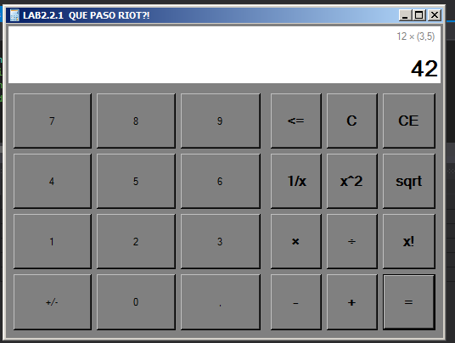
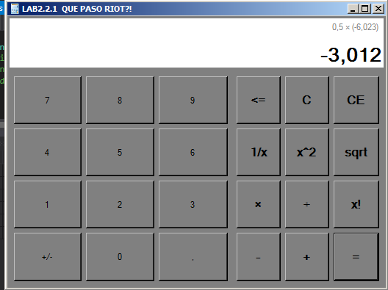

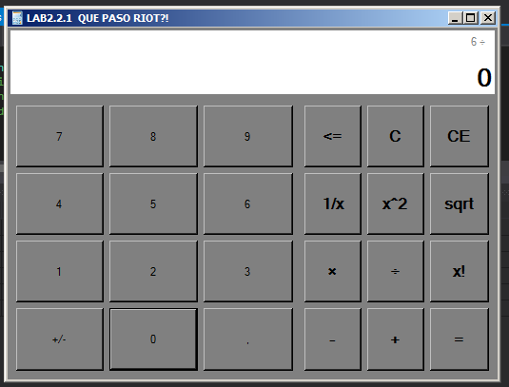
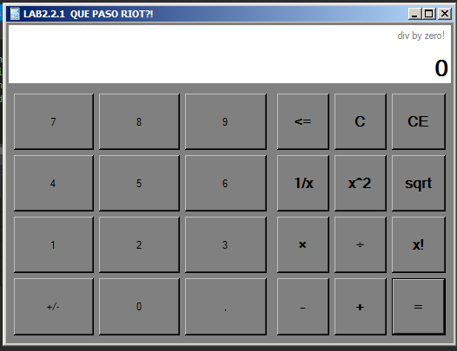

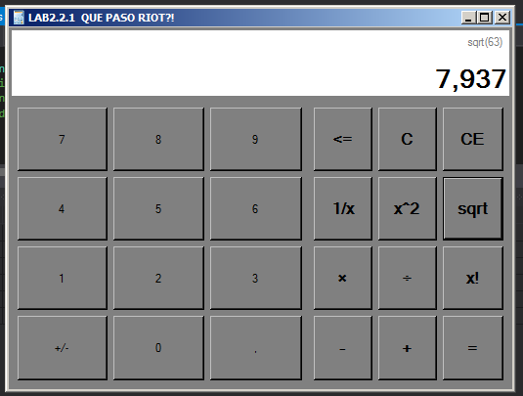
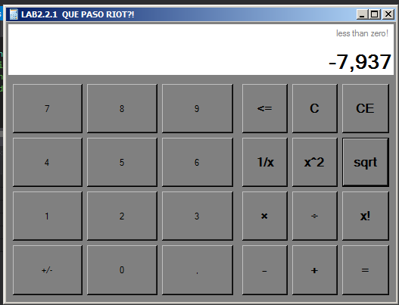

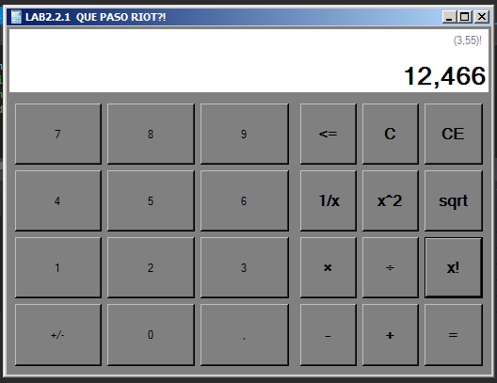
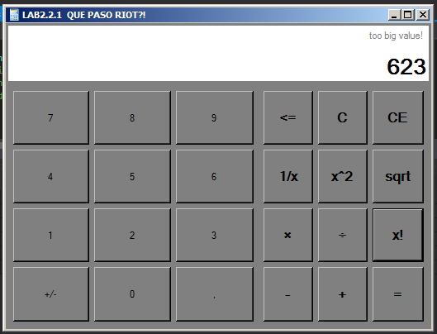

Таблица 1  Поля и методы класса А и их назначение (Пример)

N° | Поле | Назначение
1 | b_0 | Button 0
2 | b_1 | Button 1
3 | b_2 | Button 2
4 | b_3 | Button 3
5 | b_4 | Button 4
6 | b_5 | Button 5
7 | b_6 | Button 6
8 | b_7 | Button 7
9 | b_8 | Button 8
10 | b_9 | Button 9
11 | b_borrarDIG | Remove one digit
12 | b_borrarTODO | Clean all
13 | b_borrarTODO_S | Clean only the textbox
14 | b_cuadrado | Square of a number.
15 | b_dividir | Divide
16 | b_factorial | Factorial
17 | b_fraccion | Fraction
18 | b_igual | Equal
19 | b_mas | Add two numbers
20 | b_mas_menos | Set positive or negative
21 | b_menos | Subtract
22 | b_multiplicar | Multiply
23 | b_punto | Set point
24 | b_raiz | Square root
25 | CanClear_MainWindow | Clean or not the textbox
26 | components | Components
27 | contxt_menu | Set null context menu
28 | firstVar | First number entered
29 | l_historial | Label with the history of the operations
30 | lastOpe | Last operation entered
31 | metodos | Instance of methods
32 | operation | Current operation
33 | secondVar | Last number entered
34 | textbox_result | Textbox to entered numbers
35 | tableLayoutPanel1 | Layouts to show better elements
36 | tableLayoutPanel2 | Layouts to show better elements
37 | tableLayoutPanel3 | Layouts to show better elements
38 | tableLayoutPanel4 | Layouts to show better elements
39 | tableLayoutPanel5 | Layouts to show better elements
40 | Метод | Назначение
41 | Formato | Indentify the correct format of the numbers entered.
42 | Intervalo | Identify if the numbers belong to interval.

Таблица 2  Обработчики событий проекта и их назначение (Пример)

N° | Обработчик события | Назначение
1 | b_borrarDIG_Click | Remove one digit
2 | b_borrarTODO_Click | Clean all
3 | b_borrarTODO_S_Click | Clean only the textbox
4 | button_Eql_Click | Set the result
5 | button_num_Click | Set the differents 0-9 with . , -
6 | button_Oper_Click | Basic operations
7 | button_OpMyVariant_Click | Operations of my variant
8 | Form1_Load | Set null context menu to textbox
9 | textbox_result_Click | Set 0 when press in the textbox
10 | textbox_result_KeyDown | Copy and Paste with key combination
11 | textbox_result_KeyPress | Identify the correct digits

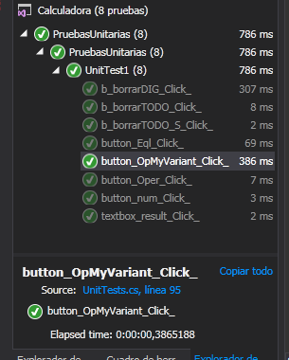

Unit Tests

Выводы

После первой лабораторной практики стало возможным понять, как работает базовый калькулятор по моему варианту.
При выполнении калькулятора были установлены параметры для правильного ввода и вывода чисел, это помогло лучше вычислить операции.
Калькулятор может быть улучшен с точки зрения проектирования с использованием WTF, а с точки зрения функциональности может быть предусмотрен метод, который позволяет копировать составные выражения в текстовом поле и выполнять их. Можно также сохранить историю в общей структуре данных и, дважды щелкнув по метке, содержащей предыдущую операцию, показать все выполненные операции.

Использованные источники

- https://docs.microsoft.com/es-es/dotnet/

