МІНІСТЕРСТВО ОСВІТИ І НАУКИ УКРАЇНИ
Національний аерокосмічний університет ім. М.Є. Жуковського
“Харківський авіаційний інститут”

Кафедра комп’ютерних систем та мереж

Лабораторна робота № 3

“Разработка и исследование программы обработки массивов.”

По дисциплине “Технологии программирования”

ХАІ.503.525В.123. 1705067.180

Виконав студент гр. 525В Пеналоза Г.
(№ групи) (П.І.Б.)
4-03-19
(підпис, дата)
Перевірив ст. викладач каф. 503
(науковий ступінь, вчене звання, посада)

(підпис, дата) (П.І.Б.)

2018

Задание: разработать на Visual C# проект, использующий библиотеку Windows Forms и реализующий генерацию массива, ввод (вывод) массива из файла, обработку массива и сохранение результатов обработки массива в файле в соответствии с вариантом из таблицы 1. Разработать модульные тесты (unit-тесты) для методов класса операций над одномерным массивом. UML диаграмма вариантов использования проекта приведена на рисунке 1.

Вариант 20

Задание

4. Вычислить минимальный, максимальный элементы массива и медиану массива (вычисления проводить без использования встроенных функций C#).

5. Отсортировать элементы массива по возрастанию.

15. Определить сумму и количество элементов массива ai ,
у которых число, составленное из двух первых цифр числа ai, четное.

18. Определить количество простых чисел массива методом пробных делителей.

Диаграмму классов
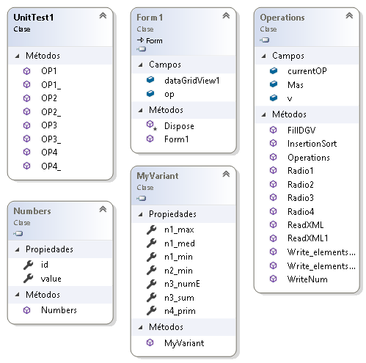

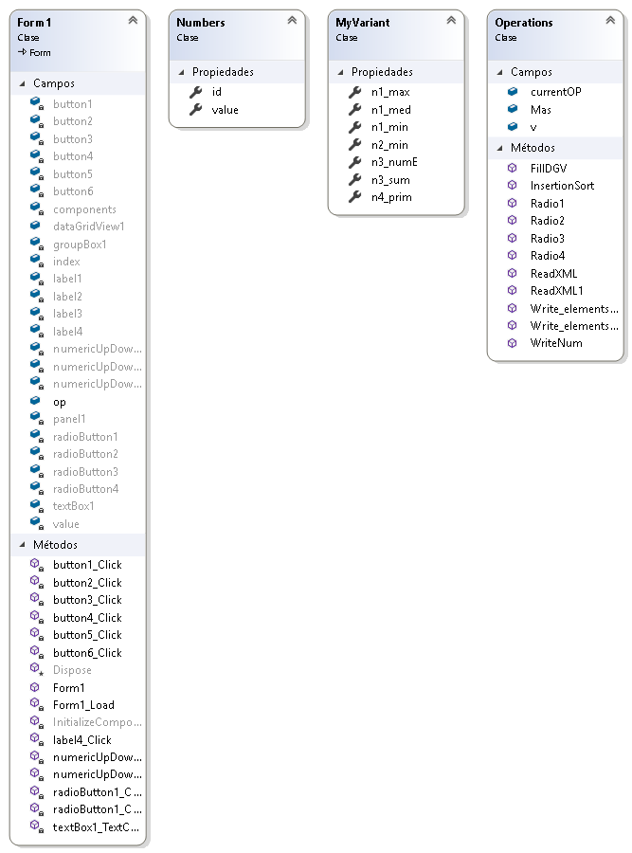

Текст программы

Form.cs

using System;
using System.Collections.Generic;
using System.ComponentModel;
using System.Data;
using System.Drawing;
using System.IO;
using System.Linq;
using System.Text;
using System.Threading.Tasks;
using System.Windows.Forms;
using System.Xml;

namespace Lab2._2._3
{
public partial class Form1 : Form
{
public Form1()
{
InitializeComponent();
}

public Operations op = new Operations();

// Set correct interval
private void numericUpDown2_ValueChanged(object sender, EventArgs e)
{
if (numericUpDown2.Value>numericUpDown3.Value&&numericUpDown2.Value!=0&&numericUpDown3.Value!=0)
{
MessageBox.Show("This number can be less than B!");
numericUpDown2.Value -= 1;
}
else
{
if (numericUpDown3.Value==0||numericUpDown3.Value<=numericUpDown2.Value)
{
numericUpDown3.Value = numericUpDown2.Value + 1;
}
}
}
// Set correct interval
private void numericUpDown3_ValueChanged(object sender, EventArgs e)
{
if (numericUpDown3.Value <= numericUpDown2.Value || numericUpDown3.Value == 0)
{
MessageBox.Show("This number can be higher than A!");
numericUpDown3.Value = numericUpDown2.Value + 1;
}
}
//Close App
private void button6_Click(object sender, EventArgs e)
{
this.Close();
}
//Generate array random
private void button1_Click(object sender, EventArgs e)
{
radioButton1.Checked = false;
radioButton2.Checked = false;
radioButton3.Checked = false;
radioButton4.Checked = false;
textBox1.Text = "";
if (numericUpDown1.Value>0&&numericUpDown2.Value>=0&&numericUpDown3.Value!=0) {
dataGridView1.RowCount = (int)numericUpDown1.Value;

dataGridView1 = op.FillDGV(numericUpDown1,numericUpDown2,numericUpDown3,dataGridView1);

button2.Enabled = true;
}
else
{
MessageBox.Show("Parameters to generate the array are incorrect!");
}
}
//Write array
private void button2_Click(object sender, EventArgs e)
{
Stream myStream;
SaveFileDialog saveFileDialog1 = new SaveFileDialog();
saveFileDialog1.Filter = "Xml files (*.xml)|*.xml|All files (*.*)|*.*";
saveFileDialog1.FilterIndex = 1;
saveFileDialog1.RestoreDirectory = true;
if (saveFileDialog1.ShowDialog() == DialogResult.OK)
{
if ((myStream = saveFileDialog1.OpenFile()) != null)
{
myStream.Close();
op.Write_elements_f1(saveFileDialog1,op.Mas);
}
}
}
//Read array
private void button4_Click(object sender, EventArgs e)
{
dataGridView1=op.ReadXML(dataGridView1);
numericUpDown1.Value = dataGridView1.RowCount;
}
//Set actions to radiobuttons of the variant
private void radioButton1_Click(object sender, EventArgs e)
{
RadioButton rd = (RadioButton)sender;
if (dataGridView1.RowCount > 1)
button3.Enabled = true;
else
{
rd.Checked = false;
MessageBox.Show("There are not elements to operate!");
return;
}
if (rd == radioButton1)
{
textBox1.Text=op.Radio1(textBox1.Text);
}
else if (rd == radioButton2)
{
textBox1.Text = op.Radio2(textBox1.Text);
return;
}
else if (rd == radioButton3)
{
textBox1.Text = op.Radio3(textBox1.Text);
return;
}
else
{
textBox1.Text = op.Radio4(textBox1.Text);
return;
}
}

private void radioButton1_CheckedChanged(object sender, EventArgs e)
{

}
//Read file 2 with opetations
private void button5_Click(object sender, EventArgs e)
{
textBox1.Text = op.ReadXML1();
}
//Write XML file 2 with operations
private void button3_Click(object sender, EventArgs e)
{
if (op.v.n1_med != 0 && op.v.n2_min != "" && op.v.n3_sum != 0 && op.v.n4_prim!=null)
op.Write_elements_f2(op.Mas);
else
MessageBox.Show("Do all the operations to save!");
}

private void Form1_Load(object sender, EventArgs e)
{
if (!File.Exists("Operations.xml")) {
XmlTextWriter writer = new XmlTextWriter("Operations.xml", System.Text.Encoding.UTF8);
writer.WriteStartDocument();
writer.WriteStartElement("MyVariant");
writer.WriteEndElement();
writer.Close();
}
}

private void textBox1_TextChanged(object sender, EventArgs e)
{

}

private void label4_Click(object sender, EventArgs e)
{

}
}
//Class to use in the array Mas
public class Numbers
{
public int id { get; set; }
public int value { get; set; }
}
//values to be calculated of my variant
public class MyVariant
{
public int n1_min { get; set; }
public int n1_max { get; set; }
public double n1_med { get; set; }
public string n2_min { get; set; }
public int n3_sum { get; set; }
public int n3_numE { get; set; }
public string n4_prim { get; set; }
}
//Class with the operations to Read, Write and generate array Mas
public class Operations
{
//Algorith to sort the Mas
public List<Numbers> InsertionSort(List<Numbers> inputArray)
{
for (int i = 0; i < inputArray.Count - 1; i++)
{
for (int j = i + 1; j > 0; j--)
{
if (inputArray[j - 1].value > inputArray[j].value)
{
int temp = inputArray[j - 1].value;
inputArray[j - 1].value = inputArray[j].value;
inputArray[j].value = temp;
}
}
}
return inputArray;
}
//Current operation of radiobutton
public int currentOP;
//Instance of my variant class
public MyVariant v = new MyVariant();
//Operation 1
public string Radio1(string current)
{
string rTextBox = current;
List<Numbers> sMas = InsertionSort(Mas);
v.n1_max = sMas[sMas.Count-1].value;
v.n1_min = sMas[0].value;
if (sMas.Count%2==0)
{
v.n1_med = (sMas[sMas.Count / 2].value + sMas[(sMas.Count / 2) - 1].value) / 2.0;
}
else
{
v.n1_med = sMas[sMas.Count / 2].value;
}
rTextBox += "Max:" + v.n1_max + " Min:" + v.n1_min + " Med:" + v.n1_med+"\r\n";
currentOP = 1;
return rTextBox;
}
//Operation 2
public string Radio2(string current)
{
v.n2_min = "";
string rTextBox = current;
List<Numbers> sMas = InsertionSort(Mas);
for (int c=0;c<sMas.Count;c++)
{
v.n2_min += sMas[c].value + " ";
}
rTextBox += v.n2_min;
currentOP = 2;
return rTextBox+"\r\n";
}
//Operation 3
public string Radio3(string current)
{
v.n3_numE = 0;
v.n3_sum = 0;
string rTextBox = current;
for (int c=0;c<Mas.Count;c++)
{
string num;
if (Mas[c].value>99)
{
num = Mas[c].value.ToString().Substring(0, 2);
}
else
{
num = Mas[c].value.ToString();
}
if (Int32.Parse(num)%2==0)
{
v.n3_numE = v.n3_numE + 1;
v.n3_sum += Mas[c].value;
}
}
rTextBox += "Sum:" + v.n3_sum + " Elements:" + v.n3_numE;
currentOP = 3;
return rTextBox+"\r\n";
}
//Operation 4
public string Radio4(string current)
{
int nPri = 0;
bool cmp;
string rTextBox = current;
for (int c=0;c<Mas.Count;c++)
{
cmp = true;
for (int i=2;i<Mas[c].value;i++)
{
if (Mas[c].value%i==0)
{
cmp = false;
break;
}
}
if (cmp&&Mas[c].value>1)
{
nPri = nPri + 1;
}
}
rTextBox += "Prim Numbers: " + nPri;
v.n4_prim = nPri.ToString();
currentOP = 4;
return rTextBox+"\r\n";
}
//Funtions to write elements in f1 chosen
public void Write_elements_f1(SaveFileDialog sv, List<Numbers>Mas)
{
XmlTextWriter writer = new XmlTextWriter(sv.FileName, System.Text.Encoding.UTF8);
writer.WriteStartDocument();
writer.WriteStartElement("Массив_Mas");
writer.WriteEndElement();
writer.Close();
for (int c=0;c<Mas.Count;c++)
{
Numbers n = new Numbers { id=Mas[c].id,value=Mas[c].value };
WriteNum(n.id.ToString(),n.value.ToString(),sv);
}
}
//Funtions to write elements in f2 chosen
public void Write_elements_f2(List<Numbers> Mas)
{
XmlDocument doc = new XmlDocument();
doc.Load("Operations.xml");

XmlElement root = doc.DocumentElement;

XmlElement numberOP1 = doc.CreateElement("op1");
XmlElement numberOP2 = doc.CreateElement("op2");
XmlElement numberOP3 = doc.CreateElement("op3");
XmlElement numberOP4 = doc.CreateElement("op4");

//XmlAttribute idV1 = doc.CreateAttribute("id");
//XmlAttribute idV2 = doc.CreateAttribute("id");
//XmlAttribute idV3 = doc.CreateAttribute("id");
//XmlAttribute idV4 = doc.CreateAttribute("id");

XmlElement valueO1_1 = doc.CreateElement("max");
XmlElement valueO1_2 = doc.CreateElement("min");
XmlElement valueO1_3 = doc.CreateElement("med");

XmlElement valueO2_1 = doc.CreateElement("sort_array");

XmlElement valueO3_1 = doc.CreateElement("Sum");
XmlElement valueO3_2 = doc.CreateElement("Element_numbers");

XmlElement valueO4_1 = doc.CreateElement("Prim_numbers");

//XmlText idText1 = doc.CreateTextNode("0");
//XmlText idText2 = doc.CreateTextNode("1");
//XmlText idText3 = doc.CreateTextNode("2");
//XmlText idText4 = doc.CreateTextNode("3");

XmlText valueTextO1_1 = doc.CreateTextNode(v.n1_max.ToString());
XmlText valueTextO1_2 = doc.CreateTextNode(v.n1_min.ToString());
XmlText valueTextO1_3 = doc.CreateTextNode(v.n1_med.ToString());

XmlText valueTextO2_1 = doc.CreateTextNode(v.n2_min.ToString());

XmlText valueTextO3_1 = doc.CreateTextNode(v.n3_sum.ToString());
XmlText valueTextO3_2 = doc.CreateTextNode(v.n3_numE.ToString());

XmlText valueTextO4_1 = doc.CreateTextNode(v.n4_prim.ToString());

//idV1.AppendChild(idText1);
//idV2.AppendChild(idText2);
//idV3.AppendChild(idText3);
//idV4.AppendChild(idText4);

valueO1_1.AppendChild(valueTextO1_1);
valueO1_2.AppendChild(valueTextO1_2);
valueO1_3.AppendChild(valueTextO1_3);

valueO2_1.AppendChild(valueTextO2_1);

valueO3_1.AppendChild(valueTextO3_1);
valueO3_2.AppendChild(valueTextO3_2);

valueO4_1.AppendChild(valueTextO4_1);

//numberOP1.Attributes.Append(idV1);
//numberOP2.Attributes.Append(idV2);
//numberOP3.Attributes.Append(idV3);
//numberOP4.Attributes.Append(idV4);

numberOP1.AppendChild(valueO1_1);
numberOP1.AppendChild(valueO1_2);
numberOP1.AppendChild(valueO1_3);

numberOP2.AppendChild(valueO2_1);

numberOP3.AppendChild(valueO3_1);
numberOP3.AppendChild(valueO3_2);

numberOP4.AppendChild(valueO4_1);

root.AppendChild(numberOP1);
root.AppendChild(numberOP2);
root.AppendChild(numberOP3);
root.AppendChild(numberOP4);
doc.Save("Operations.xml");
v = new MyVariant();

}
//Funcion aux to write f1 file
public void WriteNum(string pID, string value, SaveFileDialog sv)
{
XmlDocument doc = new XmlDocument();
doc.Load(sv.FileName);
XmlElement root = doc.DocumentElement;
XmlElement number = doc.CreateElement("number");
XmlAttribute idV = doc.CreateAttribute("id");
XmlElement valueV = doc.CreateElement("value");
XmlText idText = doc.CreateTextNode(pID);
XmlText valueText = doc.CreateTextNode(value);
idV.AppendChild(idText);
valueV.AppendChild(valueText);
number.Attributes.Append(idV);
number.AppendChild(valueV);
root.AppendChild(number);
doc.Save(sv.FileName);
}
//List of values Numbers
public List<Numbers> Mas=new List<Numbers>();
//Funtion to fill DataGridVied
public DataGridView FillDGV(NumericUpDown n1, NumericUpDown n2, NumericUpDown n3,DataGridView dgv)
{
Mas = new List<Numbers>((int)(n1.Value));
Random rn = new Random();
for (int c = 0; c < (int)n1.Value; c++)
{
Numbers n = new Numbers { id = c, value = rn.Next((int)(n2.Value), (int)(n3.Value)) };
Mas.Add(n);
dgv[0, c].Value = Mas[c].id;
dgv[1, c].Value = Mas[c].value;
}
return dgv;
}
//Read XML file of f2 file
public string ReadXML1()
{
string result = "";
try
{
using (OpenFileDialog openFileDialog = new OpenFileDialog())
{
openFileDialog.InitialDirectory = "c:\\";
openFileDialog.Filter = "Xml files (*.xml)|*.xml|All files (*.*)|*.*";
openFileDialog.FilterIndex = 2;
openFileDialog.RestoreDirectory = true;
if (openFileDialog.ShowDialog() == DialogResult.OK)
{
XmlDocument xDoc = new XmlDocument();
xDoc.Load(openFileDialog.FileName);
XmlElement xRoot = xDoc.DocumentElement;
foreach (XmlNode xnode in xRoot)
{
switch (xnode.Name)
{
case "op1":
v.n1_max = int.Parse(xnode["max"].InnerText);
v.n1_min = int.Parse(xnode["min"].InnerText);
v.n1_med = double.Parse(xnode["med"].InnerText);
result += "Max:" + v.n1_max + " Min:" + v.n1_min + " Med:" + v.n1_med+"\r\n";
break;
case "op2":
v.n2_min = xnode["sort_array"].InnerText;
result += v.n2_min+"\r\n";
break;
case "op3":
v.n3_sum = int.Parse(xnode["Sum"].InnerText);
v.n3_numE = int.Parse(xnode["Element_numbers"].InnerText);
result += "Sum:" + v.n3_sum + " Elements:" + v.n3_numE+"\r\n";
break;
case "op4":
v.n4_prim = (xnode["Prim_numbers"].InnerText);
result += "Prim Numbers: " + v.n4_prim+"\r\n";
break;
}
}
}
}
}
catch { MessageBox.Show("Problems to read the XML file format!"); }
return result;
}
//Read XML file of f1 file
public DataGridView ReadXML(DataGridView dgv)
{
try
{
using (OpenFileDialog openFileDialog = new OpenFileDialog())
{
openFileDialog.InitialDirectory = "c:\\";
openFileDialog.Filter = "Xml files (*.xml)|*.xml|All files (*.*)|*.*";
openFileDialog.FilterIndex = 2;
openFileDialog.RestoreDirectory = true;
if (openFileDialog.ShowDialog() == DialogResult.OK)
{
Mas.Clear();
XmlDocument xDoc = new XmlDocument();
xDoc.Load(openFileDialog.FileName);
XmlElement xRoot = xDoc.DocumentElement;
foreach (XmlNode xnode in xRoot)
{
Numbers num = new Numbers();
num.id = int.Parse(xnode.Attributes[0].Value);
num.value = int.Parse(xnode["value"].InnerText);
Mas.Add(num);
}

}
}
dgv.RowCount = Mas.Count();
for (int c = 0; c < Mas.Count; c++)
{
dgv[0, c].Value = Mas[c].id;
dgv[1, c].Value = Mas[c].value;
}
}
catch { MessageBox.Show("Problems to read the XML file format!"); }
return dgv;
}
}
}

UnitTest1

using System;
using Microsoft.VisualStudio.TestTools.UnitTesting;
using Lab2._2._3;
using System.Collections.Generic;

namespace UnitTest
{
[TestClass]
public class UnitTest1
{
[TestMethod]
public void OP1()
{
//5,2,12,5,9,10,1 => 1,2,5,5,9,10,12
var min_e="1";
var max_e="12";
var med_e="5";
Operations op = new Operations();
op.Mas = new List<Numbers> { new Numbers() { id = 0, value = 5 }, new Numbers() { id = 1, value = 2 }, new Numbers() { id = 2, value = 12 }, new Numbers() { id = 3, value = 5 }, new Numbers() { id = 4, value = 9 }, new Numbers() { id = 5, value = 10 }, new Numbers() { id = 6, value = 1 } };
op.Radio1("");
Assert.AreEqual(min_e,op.v.n1_min.ToString(),max_e,op.v.n1_max.ToString(),med_e,op.v.n1_med.ToString());
}
[TestMethod]
public void OP1_()
{
//5,2,12,6,9,10,1,3 => 1,2,3,6,5,9,10,12 => 11/2=5.5
var min_e = "1";
var max_e = "12";
var med_e = "5.5";
Operations op = new Operations();
op.Mas = new List<Numbers> { new Numbers() { id = 0, value = 5 }, new Numbers() { id = 1, value = 2 }, new Numbers() { id = 2, value = 12 }, new Numbers() { id = 3, value = 6 }, new Numbers() { id = 4, value = 9 }, new Numbers() { id = 5, value = 10 }, new Numbers() { id = 6, value = 1 }, new Numbers() { id=7,value=3} };
op.Radio1("");
Assert.AreEqual(min_e, op.v.n1_min.ToString(), max_e, op.v.n1_max.ToString(), med_e, op.v.n1_med.ToString());
}
[TestMethod]
public void OP2()
{
//5,2,12,5,9,10,1 => 1,2,5,5,9,10,12
var array_e = "1 2 5 5 9 10 12 ";
Operations op = new Operations();
op.Mas = new List<Numbers> { new Numbers() { id = 0, value = 5 }, new Numbers() { id = 1, value = 2 }, new Numbers() { id = 2, value = 12 }, new Numbers() { id = 3, value = 5 }, new Numbers() { id = 4, value = 9 }, new Numbers() { id = 5, value = 10 }, new Numbers() { id = 6, value = 1 } };
op.Radio2("");
Assert.AreEqual(array_e,op.v.n2_min);
}
[TestMethod]
public void OP2_()
{
//5,2,12,5,9,10,11 => 2,5,5,9,10,11,12
var array_e = "2 5 5 9 10 11 12 ";
Operations op = new Operations();
op.Mas = new List<Numbers> { new Numbers() { id = 0, value = 5 }, new Numbers() { id = 1, value = 2 }, new Numbers() { id = 2, value = 12 }, new Numbers() { id = 3, value = 5 }, new Numbers() { id = 4, value = 9 }, new Numbers() { id = 5, value = 10 }, new Numbers() { id = 6, value = 11 } };
op.Radio2("");
Assert.AreEqual(array_e, op.v.n2_min);
}
[TestMethod]
public void OP3()
{
//53 427 242 211 126 227 8
var numE_e = "5";
var sum_e = "1030";
Operations op = new Operations();
op.Mas = new List<Numbers> { new Numbers() { id = 0, value = 53 }, new Numbers() { id = 1, value = 427 }, new Numbers() { id = 2, value = 242 }, new Numbers() { id = 3, value = 211 }, new Numbers() { id = 4, value = 126 }, new Numbers() { id = 5, value = 127 }, new Numbers() { id = 6, value = 8 } };
op.Radio3("");
Assert.AreEqual(numE_e, op.v.n3_numE.ToString(), sum_e, op.v.n3_sum.ToString());
}
[TestMethod]
public void OP3_()
{
//296 214 125 502 385 480 245
var sum_e = "1737";
var numE_e = "5";
Operations op = new Operations();
op.Mas = new List<Numbers> { new Numbers() { id = 0, value = 296 }, new Numbers() { id = 1, value = 214 }, new Numbers() { id = 2, value = 125 }, new Numbers() { id = 3, value = 502 }, new Numbers() { id = 4, value = 385 }, new Numbers() { id = 5, value = 480 }, new Numbers() { id = 6, value = 245 } };
op.Radio3("");
Assert.AreEqual(numE_e, op.v.n3_numE.ToString(), sum_e, op.v.n3_sum.ToString());
}
[TestMethod]
public void OP4()
{
//65 2 119 96 115 84 101
var pri_e = "2";
Operations op = new Operations();
op.Mas = new List<Numbers> { new Numbers() { id = 0, value = 65 }, new Numbers() { id = 1, value = 2 }, new Numbers() { id = 2, value = 119 }, new Numbers() { id = 3, value = 96 }, new Numbers() { id = 4, value = 115 }, new Numbers() { id = 5, value = 84 }, new Numbers() { id = 6, value = 101 } };
op.Radio4("");
Assert.AreEqual(pri_e, op.v.n4_prim);
}
[TestMethod]
public void OP4_()
{
//46 57 39 98 47 6 42
var pri_e = "1";
Operations op = new Operations();
op.Mas = new List<Numbers> { new Numbers() { id = 0, value = 46 }, new Numbers() { id = 1, value = 57 }, new Numbers() { id = 2, value = 39 }, new Numbers() { id = 3, value = 98 }, new Numbers() { id = 4, value = 47 }, new Numbers() { id = 5, value = 6 }, new Numbers() { id = 6, value = 42 } };
op.Radio4("");
Assert.AreEqual(pri_e, op.v.n4_prim);
}
}
}

Скриншоты

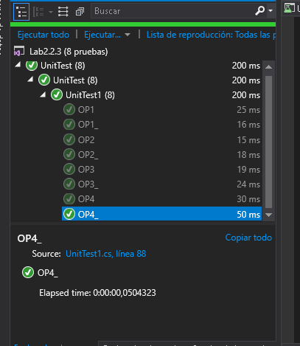

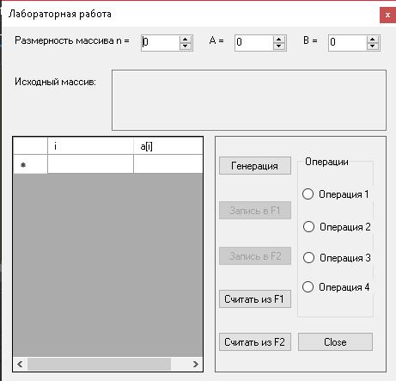

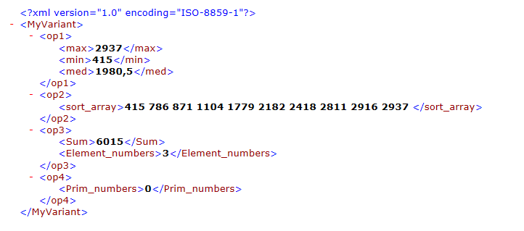

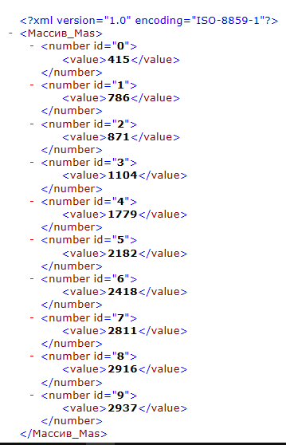

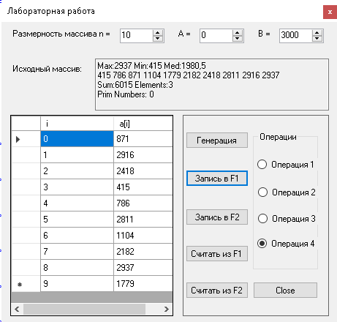

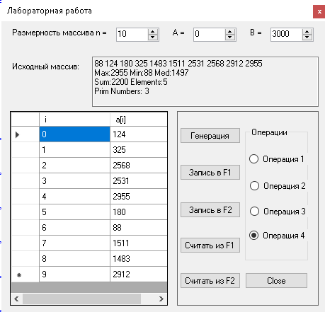

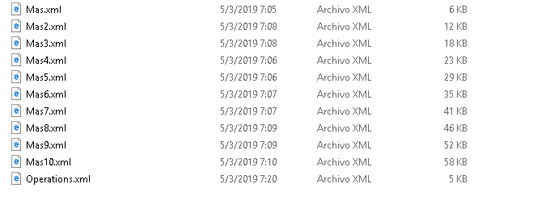

Таблица 1 - Результаты работы проекта

N | 100 | 200 | 300 | 400 | 500 | 600 | 700 | 800 | 900 | 1000
Объем памяти файла с массивом | 6 | 12 | 18 | 23 | 29 | 35 | 41 | 46 | 52 | 58
Объем памяти файла с результатами  обработки массива | 1 | 2 | 2 | 3 | 3 | 4 | 4 | 4 | 5 | 6

Таблица 1 - Поля и методы класса А и их назначение (Пример)

N° | Поле | Назначение
1 | button1 | Generate Mas
2 | button2 | Write F1 file
3 | button3 | Write F2 file
4 | button4 | Read F1 file
5 | button5 | Read F2 file
6 | button6 | Close
7 | dataGridView1 | DataGridView to store the values
8 | label1 | Titles of elements
9 | label2 | Titles of elements
10 | label3 | Titles of elements
11 | label4 | Titles of elements
12 | numericUpDown1 | Size of Mas
13 | numericUpDown2 | Inteval x
14 | numericUpDown3 | Interval y
15 | op | Instance of operations
16 | textBox1 | Textbox to put results
17 | radioButton1 | Options of the variant (1)
18 | radioButton2 | Options of the variant (2)
19 | radioButton3 | Options of the variant (3)
20 | radioButton4 | Options of the variant (4)
21 | id | Id of number
22 | clave | Value of the Mas
23 | n1_max | Properties of the results (max)
24 | n1_min | Properties of the results
25 | n1_med | Properties of the results
26 | n2_min | Properties of the results
27 | n3_numE | Properties of the results
28 | n3_Sum | Properties of the results
29 | n4_prim | Properties of the results
30 | Mas | Array
31 | v | Instance of variant properties
32 | currentOP | Current operation
33 | Метод | Назначение
34 | FIllDGV | Fill dataGridView1
35 | InsertionSort | Sort method
36 | Radio1 | Funtion of the 1 variant
37 | Radio2 | Funtion of the 2 variant
38 | Radio3 | Funtion of the 3 variant
39 | Radio4 | Funtion of the 4 variant
40 | ReadXML1 | Read XML f2
41 | ReadXML | Read XML f1
42 | WriteNum | Aux method to write xml file f1
43 | Write_elements_f2 | Funtion to write elements f2
44 | Write_elements_f1 | Funtion to write elements f1

Таблица 2 - Обработчики событий проекта и их назначение (Пример)

N° | Обработчик события | Назначение
1 | button1_Click | Event to execute funtion to generate Mas
2 | button2_Click | – funtion to write f1
3 | button3_Click | – function to write f2
4 | button4_Click | – function to read f1
5 | button5_Click | – function to read f2
6 | button6_Click | – fuction to close app
7 | Form1_load | Verify if xml file f2 exist or create new
8 | radioButton1_Click | General event to control radioButtons
9 | numericUpDown1_Click | General event to control numericUpDowns

Выводы

В ходе лабораторной практики мы изучили больше компонентов Windows Forms (radiobutton, dataGridview и т. Д.) И управление файлами (txt, json, xml).
В соответствии с моим вариантом мне пришлось использовать XML-файлы для хранения данных. Кроме того, для выполнения некоторых операций с массивом, созданным с использованием OPP.
Было сложно понять, как сохранить полученные данные.
Улучшения для реализации:
* Лучше организовать данные, используя json.

Использованные источники

- https://docs.microsoft.com/es-es/dotnet/
- https://es.wikipedia.org/wiki/Divisi%C3%B3n_por_tentativa

