МІНІСТЕРСТВО ОСВІТИ І НАУКИ УКРАЇНИ
Національний аерокосмічний університет ім. М.Є. Жуковського
“Харківський авіаційний інститут”

Кафедра комп’ютерних систем та мереж

Лабораторна робота № 5

“Разработка и исследование программы построения графиков”

По дисциплине “Технологии программирования”

ХАІ.503.525В.123. 1705067.180

Виконав студент гр. 525В Пеналоза Г.
(№ групи) (П.І.Б.)
15-03-19
(підпис, дата)
Перевірив ст. викладач каф. 503
(науковий ступінь, вчене звання, посада)

(підпис, дата) (П.І.Б.)

2019

Задание:

Pазработать программу для построения на форме:

* гистограммы (столбиковой вертикальной и горизонтальной диаграмм);
* круговой диаграммы.

Диаграммы нарисовать с помощью примитивов в соответствии с вариантом для N значений (N=1..15).

Проект должен содержать три формы:

* 1-я форма – для задания и редактирования значений и параметров диаграммы и выбора вида диаграммы,

* 2-я форма – для визуализации диаграммы (в работающем приложении 2-я форма должна быть развернута на весь экран),

* 3-я форма – для сведений об авторе проекта (модальная форма, которая может вызываться из первых двух форм).

Разработать модульные тесты (unit-тесты) для методов класса.
UML диаграмма вариантов использования проекта приведена на рисунке 1.

Вариант 20

Текст программы

Form.cs

using System;
using System.Collections.Generic;
using System.ComponentModel;
using System.Data;
using System.Drawing;
using System.Linq;
using System.Text;
using System.Threading.Tasks;
using System.Windows.Forms;

namespace Lab2._2._5
{
public partial class Form1 : Form
{
public Form1()
{
InitializeComponent();
}

public Diagrama diagrama = new Diagrama();//Instance of Graph window

private void button3_Click(object sender, EventArgs e)//Show about autor
{
About about = new About();
about.ShowDialog();
}

private void button2_Click(object sender, EventArgs e)//Show Graphs
{
diagrama.Refresh();
diagrama.Show();
diagrama.Focus();
}

private void numericUpDown2_ValueChanged(object sender, EventArgs e)//Check min
{
if (numericUpDown2.Value > numericUpDown3.Value)
{
MessageBox.Show("This number can be higher than Max!");
numericUpDown2.Value = numericUpDown3.Value - 1;
}
else
{
if (numericUpDown3.Value == 0 || numericUpDown3.Value <= numericUpDown2.Value)
{
numericUpDown3.Value = numericUpDown2.Value + 1;
}
}
}

private void numericUpDown3_ValueChanged(object sender, EventArgs e)//Check max
{
if (numericUpDown3.Value <= numericUpDown2.Value)
{
MessageBox.Show("This number can be less than Min!");
numericUpDown3.Value = numericUpDown2.Value + 1;
}
}

private void button1_Click(object sender, EventArgs e)//Generate random numbers according to the type of graph.
{
Metodos.GenerarArrayNumeros((int)numericUpDown1.Value, (int)numericUpDown3.Value, (int)numericUpDown2.Value);
FillData();
button2.Enabled = true;
button4.Enabled = true;
}

public void FillData()//Fill the values into the dataview
{
dataGridView1.Rows.Clear();
dataGridView1.Columns.Clear();
switch (Metodos.diagrama)
{
case 0:
case 1:
case 2:
dataGridView1.Columns.Add("Значение", "Значение");
for (int c = 0; c < (int)numericUpDown1.Value; c++)
{
dataGridView1.Rows.Add();
dataGridView1.Rows[c].Cells[0].Value = Metodos._arrayNumbers012[c];
}
break;
case 3:
dataGridView1.Columns.Add("Значение Graph 1", "Значение Graph 1");
dataGridView1.Columns.Add("Значение Graph 2", "Значение Graph 2");
for (int c = 0; c < (int)numericUpDown1.Value; c++)
{
dataGridView1.Rows.Add();
dataGridView1.Rows[c].Cells[0].Value = Metodos._arrayNumbers3[c, 0];
dataGridView1.Rows[c].Cells[1].Value = Metodos._arrayNumbers3[c, 1];
}
break;
case 4:
dataGridView1.Columns.Add("Значение Graph 1 - serie 1", "Значение Graph 1 - serie 1");
dataGridView1.Columns.Add("Значение Graph 1 - serie 2", "Значение Graph 1 - serie 2");
dataGridView1.Columns.Add("Значение Graph 2 - serie 1", "Значение Graph 2 - serie 1");
dataGridView1.Columns.Add("Значение Graph 2 - serie 2", "Значение Graph 2 - serie 2");
for (int c = 0; c < (int)numericUpDown1.Value; c++)
{
dataGridView1.Rows.Add();
dataGridView1.Rows[c].Cells[0].Value = Metodos._arrayNumbers4[c, 0];
dataGridView1.Rows[c].Cells[1].Value = Metodos._arrayNumbers4[c, 1];
dataGridView1.Rows[c].Cells[2].Value = Metodos._arrayNumbers4[c, 2];
dataGridView1.Rows[c].Cells[3].Value = Metodos._arrayNumbers4[c, 3];
}
break;
}
}

private void Form1_Load(object sender, EventArgs e)//Load the necessary values when the program start
{
dataGridView1.AutoSizeColumnsMode = DataGridViewAutoSizeColumnsMode.Fill;
dataGridView1.Rows.Clear();
Metodos.color = Color.Black;
comboBox1.SelectedIndex = 2;
button5.ForeColor = Color.Black;
Metodos.diagrama = 2;
}

private void checkBox1_CheckedChanged(object sender, EventArgs e)//Select the color for the graph
{

}

private void button4_Click(object sender, EventArgs e)//Button to sort
{
try
{
Metodos.Sort();
FillData();
}
catch { MessageBox.Show("Error while sorting the array, try to generate again!"); return; }
}

private void comboBox1_SelectedIndexChanged(object sender, EventArgs e)//Select the graph type
{
Metodos.diagrama = comboBox1.SelectedIndex;
button1_Click(sender,e);//Call to the generate numbers button
}

private void button5_Click(object sender, EventArgs e)//Select the color for the graph
{
if (colorDialog1.ShowDialog() == DialogResult.OK)
{
button5.ForeColor = colorDialog1.Color;Metodos.color = colorDialog1.Color;
}
}

private void numericUpDown1_ValueChanged(object sender, EventArgs e)
{
button1_Click(sender, e);
}
}
}

About.cs

using System;
using System.Collections.Generic;
using System.ComponentModel;
using System.Data;
using System.Drawing;
using System.Linq;
using System.Text;
using System.Threading.Tasks;
using System.Windows.Forms;

namespace Lab2._2._5
{
public partial class About : Form
{
public About()
{
InitializeComponent();
}

private void button1_Click(object sender, EventArgs e)
{
this.Close();
}
}
}

Diagrama.cs

using System;
using System.Collections.Generic;
using System.ComponentModel;
using System.Data;
using System.Drawing;
using System.Drawing.Drawing2D;
using System.Linq;
using System.Text;
using System.Threading.Tasks;
using System.Windows.Forms;
using System.Windows.Forms.DataVisualization.Charting;

namespace Lab2._2._5
{
public partial class Diagrama : Form
{
public Diagrama()
{
InitializeComponent();
}

private void Diagrama_Load(object sender, EventArgs e)
{
if (Metodos.diagrama==0||Metodos.diagrama==1)
{
FillArrayPrimitive();
}
}

private Panel panel=new Panel();//Graph
private Panel title=new Panel();//Title
private string m_name="";//Title for the primitives
public Graphics gr;//Graphs primitives
private Metodos.Item[] arr;//Array with values of the primitive chart

private void Gtitle(object sender, System.Windows.Forms.PaintEventArgs e)//Draw tittle 0-1
{
Graphics gtitle = e.Graphics;
gtitle.SmoothingMode = SmoothingMode.HighQuality;
Font font = new Font("Times New Roman", 15f);
SizeF sizeF = gtitle.MeasureString(m_name, font);
gtitle.DrawString(m_name, font, Brushes.Blue, title.Location.X, title.Location.Y);
}

private void Ggraphs(object sender, System.Windows.Forms.PaintEventArgs e)//Draw Graphs
{
FillArrayPrimitive();
gr = e.Graphics;
switch (Metodos.diagrama)
{
case 0:
Description(true);
Circle();
break;
case 1:
Description(false);
HorizontalScale();
BuildHorizontalChart();
break;
}

}

public void FillArrayPrimitive()//Fill the array with primitive chart
{
arr = new Metodos.Item[Metodos._arrayNumbers012.Length];
for (int i = 0; i < arr.Length; i++)
{
arr[i].value = Metodos._arrayNumbers012[i];
arr[i].color = Metodos.GetColor(i);
arr[i].name = "Val ";
arr[i].name += (i + 1).ToString() + " = " + Metodos._arrayNumbers012[i].ToString();
}
}

private void Diagrama_Activated(object sender, EventArgs e)//Draw with chart or primitive
{
chart1.BackGradientStyle = GradientStyle.DiagonalLeft;
switch (Metodos.diagrama)
{
case 0:

//FillArrayPrimitive();
this.Refresh();

chart1.Visible = false;
label1.Visible = false;

//Draw the круговая
panel.Dock = DockStyle.Fill;
panel.BackColor = Color.LightGray;
panel.Paint += new PaintEventHandler(this.Ggraphs);
tableLayoutPanel1.Controls.Add(panel,0,0);

//Write the tittle
m_name = "круговая - примитивов Visual C#";
title.Dock = DockStyle.Fill;
title.BackColor = Color.LightGray;
title.Paint += new PaintEventHandler(this.Gtitle);
tableLayoutPanel2.Controls.Add(title, 0, 0);
break;
case 1:
//FillArrayPrimitive();
this.Refresh();
chart1.Visible = false;
label1.Visible = false;

//Draw the линейная BAR
panel.Dock = DockStyle.Fill;
panel.BackColor = Color.LightGray;
panel.Paint += new PaintEventHandler(this.Ggraphs);
tableLayoutPanel1.Controls.Add(panel, 0, 0);

//Write the tittle
m_name = "линейная - примитивов Visual C#";
title.Dock = DockStyle.Fill;
title.BackColor = Color.LightGray;
title.Paint += new PaintEventHandler(this.Gtitle);
tableLayoutPanel2.Controls.Add(title, 0, 0);
break;
case 2:
if (tableLayoutPanel1.Controls.Count==3)
{
tableLayoutPanel1.Controls.Remove(panel);
tableLayoutPanel2.Controls.Remove(title);
}
chart1.Visible = true;
label1.Visible = true;
chart1.ChartAreas.Clear();
chart1.ChartAreas.Add("Горизонтальная линейная - TChart");
chart1.ChartAreas[0].AxisX.Title = "Ось X";
chart1.ChartAreas[0].AxisY.Title = "Ось Y";
chart1.Series.Clear();
chart1.Series.Add("Горизонтальная линейная - TChart");
chart1.Series[0].ChartType = SeriesChartType.Bar;
label1.Text = "Горизонтальная линейная - TChart";
chart1.Series[0].Color = Metodos.color;
foreach (var t in Metodos._arrayNumbers012)
chart1.Series[0].Points.Add(t);
break;
case 3:
if (tableLayoutPanel1.Controls.Count == 3)
{
tableLayoutPanel1.Controls.Remove(panel);
tableLayoutPanel2.Controls.Remove(title);
}
chart1.Visible = true;
label1.Visible = true;
chart1.ChartAreas.Clear();
chart1.ChartAreas.Add("2 горизонтальная линейная - TChart");
chart1.ChartAreas[0].AxisX.Title = "Ось X";
chart1.ChartAreas[0].AxisY.Title = "Ось Y";
chart1.Series.Clear();
chart1.Series.Add("1 горизонтальная линейная - TChart");
chart1.Series.Add("2 горизонтальная линейная - TChart");
chart1.Series[0].ChartType= SeriesChartType.Bar;
chart1.Series[0].Color = Metodos.color;
chart1.Series[1].ChartType = SeriesChartType.Bar;
label1.Text = "2 горизонтальная линейная - TChart";
for (int c=0;c<Metodos._arrayNumbers3.GetLength(0);c++)
{
chart1.Series[0].Points.Add(Metodos._arrayNumbers3[c,0]);
chart1.Series[1].Points.Add(Metodos._arrayNumbers3[c,1]);
}
break;
case 4:
if (tableLayoutPanel1.Controls.Count == 3)
{
tableLayoutPanel1.Controls.Remove(panel);
tableLayoutPanel2.Controls.Remove(title);
}
chart1.Visible = true;
label1.Visible = true;
chart1.ChartAreas.Clear();
chart1.Series.Clear();
chart1.ChartAreas.Add("Chart_Area_1");
chart1.ChartAreas.Add("Chart_Area_2");
chart1.ChartAreas[0].AxisX.Title = "Ось X";
chart1.ChartAreas[0].AxisY.Title = "Ось Y";
chart1.ChartAreas[1].AxisX.Title = "Ось X";
chart1.ChartAreas[1].AxisY.Title = "Ось Y";

chart1.Series.Add("1 горизонтальная линейная - 1 TChart"); chart1.Series[0].ChartType = SeriesChartType.Bar; chart1.Series[0].ChartArea = "Chart_Area_1";
chart1.Series.Add("2 горизонтальная линейная - 1 TChart"); chart1.Series[1].ChartType = SeriesChartType.Bar; chart1.Series[1].ChartArea = "Chart_Area_1";
chart1.Series.Add("1 горизонтальная линейная - 2 TChart"); chart1.Series[2].ChartType = SeriesChartType.Bar; chart1.Series[2].ChartArea = "Chart_Area_2";
chart1.Series.Add("2 горизонтальная линейная - 2 TChart"); chart1.Series[3].ChartType = SeriesChartType.Bar; chart1.Series[3].ChartArea = "Chart_Area_2";

for (int i=0;i<Metodos._arrayNumbers4.GetLength(0);i++)
{
chart1.Series[0].Points.Add(Metodos._arrayNumbers4[i, 0]);
chart1.Series[1].Points.Add(Metodos._arrayNumbers4[i, 1]);
chart1.Series[2].Points.Add(Metodos._arrayNumbers4[i, 2]);
chart1.Series[3].Points.Add(Metodos._arrayNumbers4[i, 3]);
}

label1.Text = "2 горизонтальная линейная и две графы - TChart";
break;
}
}

private void button1_Click(object sender, EventArgs e)
{
this.Visible = false;
}

private void HorizontalScale()//Draw scale for the horizontal bars
{
int max = Metodos.MaxVal();
Pen pen = new Pen(Color.Black, 2);
float y = 60;
float x1 = 20, x2 = panel.Width - 200;
gr.DrawLine(pen, new PointF(x1, y), new PointF(x2, y));
float interval = (x2 - x1) / 10;
Font font = new Font("Arial", 12);
SolidBrush brush = new SolidBrush(Color.Black);
for (int i = 0; i < 11; i++)
{
float tmpX = x2 - i * interval;
gr.DrawLine(pen, new PointF(tmpX, y - 5), new PointF(tmpX, y + 5));
string str = ((double)(max * (10 - i)) / 10).ToString();
gr.DrawString(str, font, brush, new PointF(tmpX - 10, 37));
}
}
private void BuildHorizontalChart()//Draw horizontal bars
{
int startY = 70;
int finishY = panel.Height - 20;
int addY = (finishY - startY) / (int)Metodos._arrayNumbers012.Length;
int leftX = 20;
int rightX = panel.Width - 200;
int maxW = (rightX - leftX);
int curH = addY * 3 / 4;
int curW;
Pen pen = new Pen(Color.Black, 3);
for (int i = 0; i < Metodos._arrayNumbers012.Length; i++)
{
curW = maxW * arr[i].value / Metodos.MaxVal();
Rectangle rect = new Rectangle(new Point(leftX, startY + i * addY),
new Size(curW, curH));
gr.FillRectangle(new SolidBrush(arr[i].color), rect);
gr.DrawRectangle(pen, rect);
}
gr.DrawLine(pen, new Point(leftX, startY), new Point(leftX, finishY - addY));
}
private void Circle()//Draw Pie diagram
{
Pen pen = new Pen(Color.Red, 1);
int y = 100;
int a = panel.Height - 50 - y;
int x = (panel.Width - a) / 2 - 100;
Point pt = new Point(x, y);
Size sz = new Size(a, a);
Rectangle rect = new Rectangle(pt, sz);
float curAngle = 0;
for (int i = 0; i < Metodos._arrayNumbers012.Length; i++)
{
float swAngle = 360.0F * arr[i].value / Metodos.SumTotal();
gr.FillPie(new SolidBrush(arr[i].color), rect, curAngle, swAngle);
gr.DrawPie(pen, rect, curAngle, swAngle);
curAngle += swAngle;
}
}
public void Description(bool isRound)//Show the description of graphs
{

int x = Width - 175;
int curY = 50;
Pen pen = new Pen(Color.Black, 1);
Font font = new Font("Times New Roman", 12);
string str;
for (int i = 0; i < Metodos._arrayNumbers012.Length; i++)
{
Rectangle rect = new Rectangle(x, curY, 10, 10);
SolidBrush brush = new SolidBrush(arr[i].color);
gr.FillRectangle(brush, rect);
gr.DrawRectangle(pen, rect);
str = arr[i].name;
float perCent = 0;
if (isRound)
{
perCent = (arr[i].value * 360 )/ Metodos.SumTotal();
if (perCent == 0)
perCent = 1;
str += " (" + perCent.ToString() + "°)";

}
gr.DrawString(str, font, brush, new PointF(x + 20, curY - 4));
curY += 40;
}
}

private void Diagrama_Resize(object sender, EventArgs e)//Re draw
{
this.Refresh();
}

private void Diagrama_Enter(object sender, EventArgs e)
{
if (Metodos.diagrama == 0 || Metodos.diagrama == 1)
{
FillArrayPrimitive();
}
}

private void Diagrama_Paint(object sender, PaintEventArgs e)
{
if (Metodos.diagrama == 0 || Metodos.diagrama == 1)
{
FillArrayPrimitive();
}
}

private void Diagrama_VisibleChanged(object sender, EventArgs e)
{
if (Metodos.diagrama == 0 || Metodos.diagrama == 1)
{
FillArrayPrimitive();
}
}
}
}

Metodos.cs

using System;
using System.Collections.Generic;
using System.Linq;
using System.Text;
using System.Threading.Tasks;
using System.Drawing;

namespace Lab2._2._5
{
public class Metodos
{
public static float[] gradosN;//Unit test grades
public static float[] pixelbars;//Unit test pixels
public static int [] _arrayNumbers012;//Array to 0,1,2 graph one-dimensional
public static int[,] _arrayNumbers3;//Array to 3 graph two-dimensional
public static int[,] _arrayNumbers4;//Array to 4 graph 4-dimensional
public static int diagrama = 0;//Type of the graph
public static Color color;//Color for the graphs
public struct Item//The structure that stores the properties of the chart element
{
public int value;
public Color color;
public string name;
}
public static Color GetColor(int n)//Get color to chart
{
switch (n)
{
case 0: return Color.DarkRed;
case 1: return Color.Green;
case 2: return Color.Blue;
case 3: return Color.Orange;
case 4: return Color.Cyan;
case 5: return Color.Magenta;
case 6: return color;
case 7: return Color.Thistle;
case 8: return Color.SteelBlue;
case 9: return Color.DarkKhaki;
case 10: return Color.DarkRed;
case 11: return Color.Yellow;
case 12: return Color.Purple;
case 13: return Color.DarkBlue;
case 14: return Color.Red;
}
return color;
}
public static void Sort()//Sort the array according the graph to show
{
switch (diagrama)
{
case 0:
case 1:
case 2:
for (int i=0;i<_arrayNumbers012.Length-1;i++)
{
for (int j=i+1;j>0;j--)
{
if (_arrayNumbers012[j-1]>_arrayNumbers012[j])
{
int temp = _arrayNumbers012[j - 1];
_arrayNumbers012[j - 1] = _arrayNumbers012[j];
_arrayNumbers012[j] = temp;
}
}
}
break;
case 3:
for (int i = 0; i < _arrayNumbers3.GetLength(0) - 1; i++)
{
for (int j = i + 1; j > 0; j--)
{
if (_arrayNumbers3[j - 1,0] > _arrayNumbers3[j,0])
{
int temp = _arrayNumbers3[j - 1,0];
_arrayNumbers3[j - 1,0] = _arrayNumbers3[j,0];
_arrayNumbers3[j,0] = temp;
}
if (_arrayNumbers3[j - 1, 1] > _arrayNumbers3[j, 1])
{
int temp = _arrayNumbers3[j - 1, 1];
_arrayNumbers3[j - 1, 1] = _arrayNumbers3[j, 1];
_arrayNumbers3[j, 1] = temp;
}
}
}
break;
case 4:
for (int i = 0; i < _arrayNumbers4.GetLength(0) - 1; i++)
{
for (int j = i + 1; j > 0; j--)
{
if (_arrayNumbers4[j - 1, 0] > _arrayNumbers4[j, 0])
{
int temp = _arrayNumbers4[j - 1, 0];
_arrayNumbers4[j - 1, 0] = _arrayNumbers4[j, 0];
_arrayNumbers4[j, 0] = temp;
}
if (_arrayNumbers4[j - 1, 1] > _arrayNumbers4[j, 1])
{
int temp = _arrayNumbers4[j - 1, 1];
_arrayNumbers4[j - 1, 1] = _arrayNumbers4[j, 1];
_arrayNumbers4[j, 1] = temp;
}
if (_arrayNumbers4[j - 1, 2] > _arrayNumbers4[j, 2])
{
int temp = _arrayNumbers4[j - 1, 2];
_arrayNumbers4[j - 1, 2] = _arrayNumbers4[j, 2];
_arrayNumbers4[j, 2] = temp;
}
if (_arrayNumbers4[j - 1, 3] > _arrayNumbers4[j, 3])
{
int temp = _arrayNumbers4[j - 1, 3];
_arrayNumbers4[j - 1, 3] = _arrayNumbers4[j, 3];
_arrayNumbers4[j, 3] = temp;
}
}
}
break;
}
}
public static void GenerarArrayNumeros(int _n, int max, int min)//Fill array according the graph
{
if (diagrama==0|| diagrama == 1|| diagrama == 2)
{
_arrayNumbers012 = new int[_n];
Random rm = new Random();
for (int c = 0; c < _n; c++)
{
_arrayNumbers012[c] = rm.Next(min, max);
}
}
else if (diagrama==3)
{
_arrayNumbers3 = new int[_n,2];
Random rm = new Random();
for (int c = 0; c < _n; c++)
{
_arrayNumbers3[c, 0] = rm.Next(min, max);
_arrayNumbers3[c, 1] = rm.Next(min, max);
}
}
else
{
_arrayNumbers4 = new int[_n, 4];
Random rm = new Random();
for (int c = 0; c < _n; c++)
{
_arrayNumbers4[c, 0] = rm.Next(min, max);
_arrayNumbers4[c, 1] = rm.Next(min, max);
_arrayNumbers4[c, 2] = rm.Next(min, max);
_arrayNumbers4[c, 3] = rm.Next(min, max);
}
}
}
public static void UnitTestPie()//Logic Pie
{
gradosN = new float[_arrayNumbers012.Length];
for (int i = 0; i < Metodos._arrayNumbers012.Length; i++)
{
gradosN[i] = (360 * _arrayNumbers012[i]) / SumTotal();
}
}
public static void UnitTestBar()//Logit Bars
{
int x = 691, y = 404;
int startY = 70;
int finishY = y - 20;
int addY = (finishY - startY) / (int)Metodos._arrayNumbers012.Length;
int leftX = 20;
int rightX = x- 200;
int maxW = (rightX - leftX);
int curH = addY * 3 / 4;
int curW;
pixelbars = new float[_arrayNumbers012.Length];
for (int i=0;i<_arrayNumbers012.Length;i++)
{
curW = maxW * _arrayNumbers012[i] / MaxVal();
pixelbars[i] = curH * curW;
}
}
public static int SumTotal()//Get sum of the array values
{
int sum = 0;
for (int i = 0; i < _arrayNumbers012.Length; i++)
sum += _arrayNumbers012[i];
return sum;
}
public static int MaxVal()//Get max val of the array
{
int max = 0;
for (int i = 0; i < _arrayNumbers012.Length; i++)
{
if (_arrayNumbers012[i] > max)
{
max = _arrayNumbers012[i];
}
}
return max;
}
}
}

Диаграмму классов

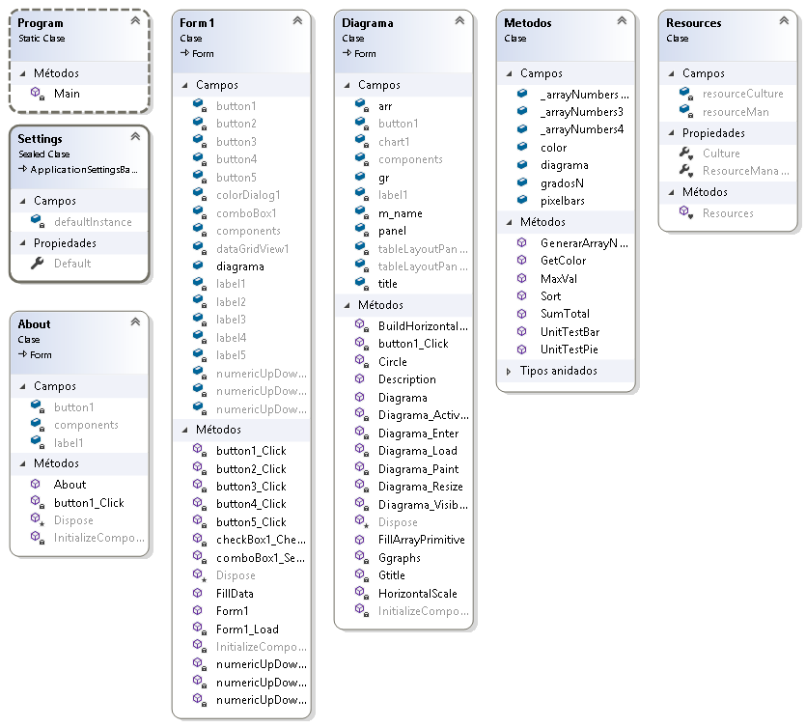

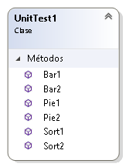

UnitTests

using System;
using Microsoft.VisualStudio.TestTools.UnitTesting;
using Lab2._2._5;
using System.Drawing;
using System.Drawing.Drawing2D;
using System.Windows.Forms;

namespace UnitTest
{
[TestClass]
public class UnitTest1
{
[TestMethod]
public void Sort1()
{
int[] arr = new int[] {1,3,2,7,5 };
int[] arrEX = new int[] {1,2,3,5,7 };
Metodos._arrayNumbers012 = (int[])arr.Clone();
Metodos.Sort();
CollectionAssert.AreEqual(arrEX,Metodos._arrayNumbers012);
}
[TestMethod]
public void Sort2()
{
int[] arr = new int[] { 5, 11, 2, 0, 5 };
int[] arrEX = new int[] { 0,2,5,5,11 };
Metodos._arrayNumbers012 = (int[])arr.Clone();
Metodos.Sort();
CollectionAssert.AreEqual(arrEX, Metodos._arrayNumbers012);
}

[TestMethod]
public void Bar1()
{
int[] arr = new int[] { 20, 30, 40, 10 };
float[] arrGRADOSE = new float[] { 13630,20474,27318,6786 };
Metodos._arrayNumbers012 = (int[])arr.Clone();
Metodos.UnitTestBar();
CollectionAssert.AreEqual(arrGRADOSE, Metodos.pixelbars);
}
[TestMethod]
public void Bar2()
{
int[] arr = new int[] { 2, 3, 4, 10 };
float[] arrGRADOSE = new float[] { 5452, 8178, 10904, 27318 };
Metodos._arrayNumbers012 = (int[])arr.Clone();
Metodos.UnitTestBar();
CollectionAssert.AreEqual(arrGRADOSE, Metodos.pixelbars);
}

[TestMethod]
public void Pie1()
{
int[] arr = new int[] { 20, 30, 40, 10 };
float[] arrGRADOSE = new float[] {72,108,144,36 };
Metodos._arrayNumbers012= (int[])arr.Clone();
Metodos.UnitTestPie();
CollectionAssert.AreEqual(arrGRADOSE, Metodos.gradosN);
}
[TestMethod]
public void Pie2()
{
int[] arr = new int[] { 208, 90, 140, 10 };
float[] arrGRADOSE = new float[] { 167,72,112,8 };
Metodos._arrayNumbers012 = (int[])arr.Clone();
Metodos.UnitTestPie();
CollectionAssert.AreEqual(arrGRADOSE, Metodos.gradosN);
}
}
}

Скриншоты

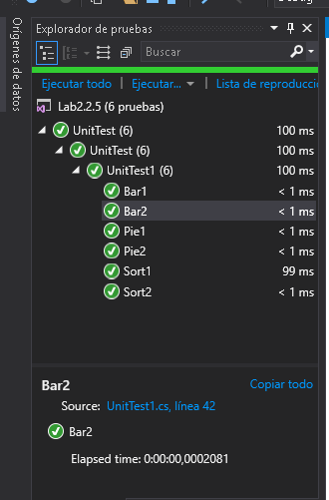

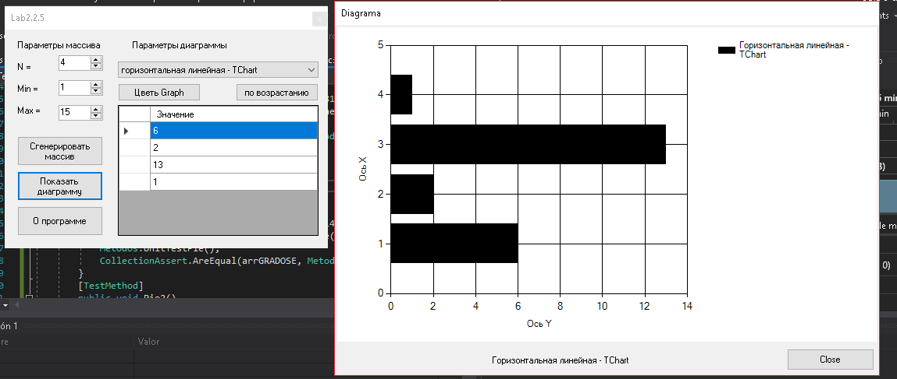

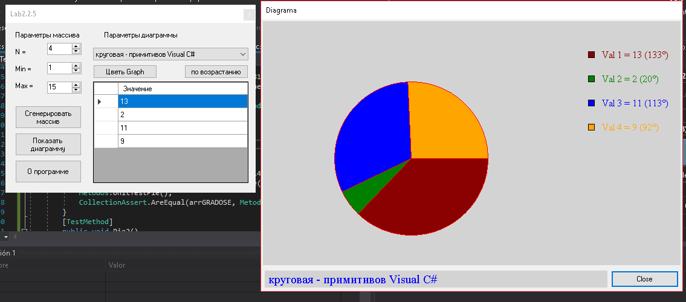

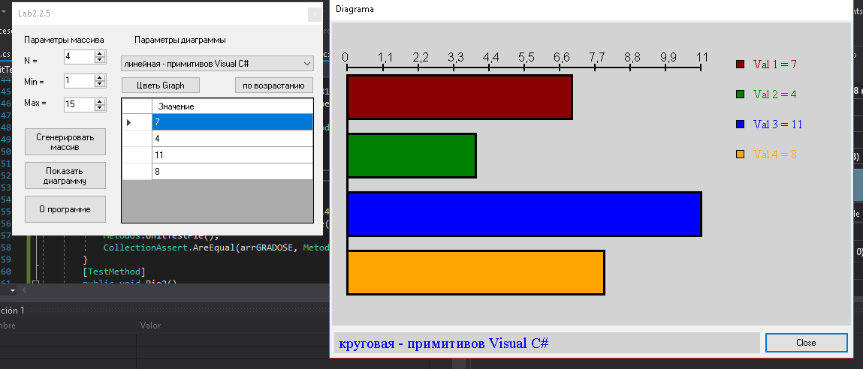

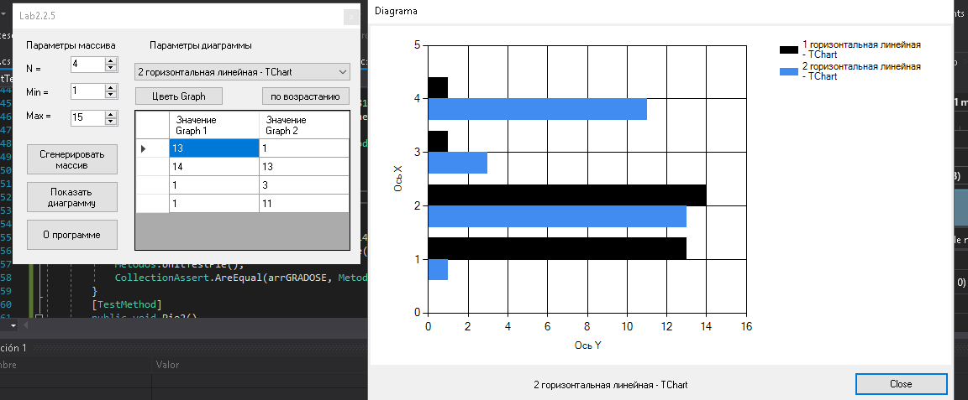

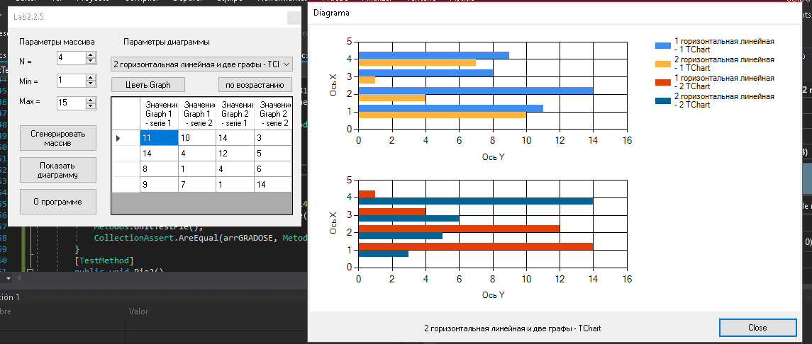

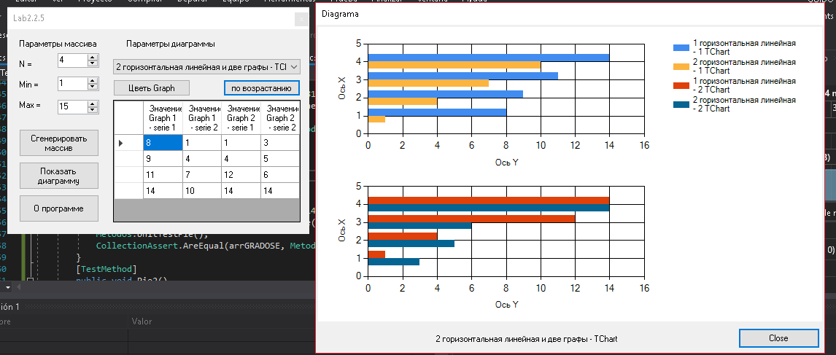

Таблица 1 - Поля и методы класса А и их назначение

N° | Поле | Назначение
1 | button1 | Generate array
2 | button2 | Show graphs
3 | button3 | About program
4 | button4 | Sort
5 | button5 | Color grahs
6 | comboBox1 | Diagrams
7 | colorDialog1 | Color diagrams
8 | dataGridView1 | Show array
9 | numericUpDown1 | Array size
10 | numericUpDown2 | min
11 | numericUpDown3 | max
12 | arr | Array with values of the primitive chart
13 | button1 | Exit
14 | chart1 | 2-4 charts
15 | gr | 0-1 primitives
16 | label1 | Title for the charts
17 | m_name | Title fot the primitives
18 | panel | Panel to draw primitives
19 | title | Panel to draw title pirmitive
20 | _arrayNumber012 | Array for 0,1,2 graphs
21 | _arrayNumers3 | Array for 3 graphs
22 | _arrayNumbers4 | Array for 4 graphs
23 | color | Color graphs
24 | diagrama | Type graphs
25 | gradosN | Array pie unit test
26 | pixelbars | Array bars unit test
 | Метод | Назначение
27 | FillData | Fill the values into dataview
28 | Description | Show the description of graphs
29 | HorizontalScale | Draw scale for the horizontal bars
30 | BuildHorizontalChart | Draw horizontal bars
31 | FillArrayPrimitive | Fill the array with primitive chart
32 | GetColor | Get color to chart
33 | Sort | Sort the array according the graph to show
34 | GenerarArrayNumeros | Fill array according the graph
35 | UnitTestPie | Logic Pie
36 | UnitTestBar | Logit Bars
37 | SumTotal | Get sum of the array values
38 | MaxVal | Get max val of the array

Таблица 2 - Обработчики событий проекта и их назначение

N° | Обработчик события | Назначение
1 | button3_Click | Show about autor
2 | button2_Click | Show Graphs
3 | numericUpDown2_ValueChanged | Check min
4 | numericUpDown3_ValueChanged | Check max
5 | button1_Click | Generate random numbers according to the type of graph
6 | Form1_Load | Load the necessary values when the program star
7 | checkBox1_CheckedChanged | Select the color for the graph
8 | button4_Click | Button to sort
9 | comboBox1_SelectedIndexChanged | Select the graph type
10 | button5_Click | Select the color for the graph
11 | Gtitle | Draw tittle 0-1
12 | Ggraphs | /Draw Graphs
13 | Diagrama_Resize | Re draw

Выводы

В лабораторной практике изучалось "Разработка и исследование программы построения графиков”.
Данные были представлены в статистических графиках с использованием графических примитивов C # и функции «Диаграмма». Панель использовалась для рисования примитивов в макете.
Как улучшение: Реализуйте больше статистических характеристик для представленных данных.

Использованные источники

- https://docs.microsoft.com/es-es/dotnet/

