МІНІСТЕРСТВО ОСВІТИ І НАУКИ УКРАЇНИ
Національний аерокосмічний університет ім. М.Є. Жуковського
“Харківський авіаційний інститут”

Кафедра комп’ютерних систем та мереж

Лабораторна робота № 6

“Разработка и исследование программы построения часов”

По дисциплине “Технологии программирования”

ХАІ.503.525В.123. 1705067.180

Виконав студент гр. 525В Пеналоза Г.
(№ групи) (П.І.Б.)
15-04-19
(підпис, дата)
Перевірив ст. викладач каф. 503
(науковий ступінь, вчене звання, посада)

(підпис, дата) (П.І.Б.)

2019

Задание:

Постановка задачи: разработать программу для построения на форме часов.
Часы должны:
- содержать три стрелки – часовую, минутную и секундную,
- показывать время (часы, минуты и секунды) в цифровом формате.
Проект должен содержать три формы:
o 1-я форма – часы с цифрами 3, 6, 9, 12 на циферблате и штрихами для
остальных часов,
o 2-я форма – для задания параметров часов (форма, которая вызывается из
контекстного меню формы с часами),
o 3-я форма – для сведений об авторе проекта (форма, которая вызывается из
контекстного меню формы с часами).
Разработать модульные тесты (unit-тесты) для методов класса.

Вариант 20

Текст программы

Form.cs

using System;
using System.Collections.Generic;
using System.ComponentModel;
using System.Data;
using System.Drawing;
using System.Linq;
using System.Text;
using System.Threading.Tasks;
using System.Windows.Forms;

namespace Lab2._2._6
{
public partial class Form1 : Form
{
public Form1()
{
InitializeComponent();
}
///Instance of the configuration form
Configurations conf = new Configurations();
///Point to help move
private Point pos = new Point();
/// <summary>
/// Variables for the center
/// </summary>
private int xc, yc;
/// <summary>
/// Size of the min, sec, hor
/// </summary>
private int min, sec, hor;
/// <summary>
/// Radio size
/// </summary>
private int radio;
/// <summary>
/// Clock
/// </summary>
private Graphics g_clock;

private void Form1_Paint(object sender, PaintEventArgs e)
{
}

private void Form1_Click(object sender, EventArgs e)
{

}

private void menuContextual_Opening(object sender, CancelEventArgs e)
{

}

private void exitToolStripMenuItem_Click(object sender, EventArgs e)
{
Application.Exit();
}

/// <summary>
/// Move the Clock
/// </summary>
/// <param name="sender"></param>
/// <param name="e"></param>
private void Form1_MouseDown(object sender, MouseEventArgs e)
{
switch (MouseButtons)
{
case MouseButtons.Left:
break;
case MouseButtons.Right:
menuContextual.Show(this,e.Location);
break;
}
this.pos.X = e.X;
this.pos.Y = e.Y;
}

/// <summary>
/// Show information about autor
/// </summary>
/// <param name="sender"></param>
/// <param name="e"></param>
private void aboutToolStripMenuItem_Click(object sender, EventArgs e)
{
About about = new About();
about.ShowDialog();
}

/// <summary>
/// Open configurations
/// </summary>
/// <param name="sender"></param>
/// <param name="e"></param>
private void configurationsToolStripMenuItem_Click(object sender, EventArgs e)
{
conf.Refresh();
conf.Show();
conf.Focus();
}

/// <summary>
/// Move Clock
/// </summary>
/// <param name="sender"></param>
/// <param name="e"></param>
private void Form1_MouseMove(object sender, MouseEventArgs e)
{
if (e.Button != MouseButtons.Left)
return;
this.Left = Control.MousePosition.X - this.pos.X;
this.Top = Control.MousePosition.Y - this.pos.Y;
}

/// <summary>
/// Timer to draw the clock with the parameters
/// </summary>
/// <param name="sender"></param>
/// <param name="e"></param>
private void timer1_Tick(object sender, EventArgs e)
{
g_clock = this.CreateGraphics();
g_clock.Clear(BackColor);
int[] finalPoint = new int[2];
this.Opacity = Clock.opacity;
if (Clock.digitalClock)//Show digital clock
{
string digitalClock = DateTime.Now.ToString("h:m:s");
g_clock.DrawString(digitalClock, new Font("Arial", 15), new SolidBrush(Color.Violet), new PointF(xc-30, yc+30));
}
if (Clock.small)//Size clock
{
radio = Width / 4 - 15;
hor = radio - 20*4;
min = radio - 10*3;
sec = radio - 5*2;
}
else
{
radio = Width / 2 - 15;
hor = radio - 20*4;
min = radio - 10*3;
sec = radio - 5*2;
}

//Get and set the time
Clock.time[0] = DateTime.Now.Hour;
Clock.time[1] = DateTime.Now.Minute;
Clock.time[2] = DateTime.Now.Second;

//Draw the circle
Pen circle = new Pen(Clock.colors[0]);
circle.Width = 8.0F;
circle.LineJoin = System.Drawing.Drawing2D.LineJoin.Bevel;
Methods.DrawCircle(g_clock, circle, xc, yc, radio);
circle.Dispose();

//Draw numbers in the clock
g_clock.DrawString("12", new Font("Arial", 12), new SolidBrush(Clock.colors[0]), new PointF(xc-10, yc-radio+5));
g_clock.DrawString("3", new Font("Arial", 12), new SolidBrush(Clock.colors[0]), new PointF(xc+radio-20, yc-5));
g_clock.DrawString("6", new Font("Arial", 12), new SolidBrush(Clock.colors[0]), new PointF(xc-6, yc+radio-20));
g_clock.DrawString("9", new Font("Arial", 12), new SolidBrush(Clock.colors[0]), new PointF(xc-radio+8, yc-5));

//Draw sec
finalPoint = Methods.msCoord(Clock.time[2], sec,xc,yc);
g_clock.DrawLine(new Pen(Clock.colors[3], 1f), new Point(xc, yc), new Point(finalPoint[0], finalPoint[1]));

//Draw min
finalPoint = Methods.msCoord(Clock.time[1], min,xc,yc);
g_clock.DrawLine(new Pen(Clock.colors[2], 2f), new Point(xc, yc), new Point(finalPoint[0], finalPoint[1]));

//Draw hor
finalPoint = Methods.hCoord(Clock.time[0] % 12, Clock.time[1], hor,xc,yc);
g_clock.DrawLine(new Pen(Clock.colors[1], 3f), new Point(xc, yc), new Point(finalPoint[0], finalPoint[1]));

g_clock.Dispose();
}

/// <summary>
/// Load information
/// </summary>
/// <param name="sender"></param>
/// <param name="e"></param>
private void Form1_Load(object sender, EventArgs e)
{
timer1.Start();
this.xc = this.Width / 2;
this.yc = this.Height / 2;
Clock.Start();
}
}
}

About.cs

using System;
using System.Collections.Generic;
using System.ComponentModel;
using System.Data;
using System.Drawing;
using System.Linq;
using System.Text;
using System.Threading.Tasks;
using System.Windows.Forms;

namespace Lab2._2._6
{
public partial class About : Form
{
public About()
{
InitializeComponent();
}

private void button1_Click(object sender, EventArgs e)
{
this.Close();
}
}
}

Configurations.cs

using System;
using System.Linq;
using System.Windows.Forms;
using System.IO;
using Newtonsoft.Json;
using Newtonsoft.Json.Linq;
using System.Reflection;
using System.Collections.Generic;
using System.ComponentModel;
using System.Data;
using System.Drawing;
using System.Text;
using System.Threading.Tasks;
using System.Runtime.Serialization.Json;
using Newtonsoft.Json.Converters;
using Newtonsoft.Json.Serialization;

namespace Lab2._2._6
{
public partial class Configurations : Form
{
public Configurations()
{
InitializeComponent();
}

private void label3_Click(object sender, EventArgs e)
{

}

private void button1_Click(object sender, EventArgs e)
{
this.Visible = false;
}
/// <summary>
/// Show digital clock
/// </summary>
/// <param name="sender"></param>
/// <param name="e"></param>
private void checkBox1_CheckedChanged(object sender, EventArgs e)
{
if (checkBox1.Checked)
{
Clock.digitalClock = true;
}
else
{
Clock.digitalClock = false;
}
}
/// <summary>
/// Show small or large
/// </summary>
/// <param name="sender"></param>
/// <param name="e"></param>
private void comboBox3_SelectedIndexChanged(object sender, EventArgs e)
{
if (comboBox3.SelectedIndex==0)
{
Clock.small = true;
}
else
{
Clock.small = false;
}
}

/// <summary>
/// Set opacity
/// </summary>
/// <param name="sender"></param>
/// <param name="e"></param>
private void comboBox2_SelectedIndexChanged(object sender, EventArgs e)
{
Clock.opacity = Int32.Parse(comboBox2.Text.Substring(0,2));
}

/// <summary>
/// Set default values
/// </summary>
/// <param name="sender"></param>
/// <param name="e"></param>
private void Configurations_Load(object sender, EventArgs e)
{
comboBox3.SelectedIndex = 0;
checkBox1.Checked = true;
comboBox2.SelectedIndex = 0;
}
/// <summary>
/// Set color to clock elements
/// </summary>
/// <param name="sender"></param>
/// <param name="e"></param>
private void comboBox1_SelectedIndexChanged(object sender, EventArgs e)
{
ColorDialog cd = new ColorDialog();
switch (comboBox1.SelectedIndex)
{
case 0:
if (cd.ShowDialog() == DialogResult.OK)
Clock.colors[0] = cd.Color;
break;
case 1:
if (cd.ShowDialog() == DialogResult.OK)
Clock.colors[1] = cd.Color;
break;
case 2:
if (cd.ShowDialog() == DialogResult.OK)
Clock.colors[2] = cd.Color;
break;
case 3:
if (cd.ShowDialog() == DialogResult.OK)
Clock.colors[3] = cd.Color;
break;
}
}
/// <summary>
/// Write conf.
/// </summary>
/// <param name="sender"></param>
/// <param name="e"></param>
private void button3_Click(object sender, EventArgs e)
{
Clock.ToARGB();
SaveFileDialog sfd = new SaveFileDialog { Filter = @"JSON files (*.json)|*.json" };
if (sfd.ShowDialog() == DialogResult.OK)
{
var w_conf = new Clock();
var json = JsonConvert.SerializeObject(w_conf);
File.WriteAllText(sfd.FileName, json);
MessageBox.Show("The configuration was saved!");
}
}
/// <summary>
/// Read conf.
/// </summary>
/// <param name="sender"></param>
/// <param name="e"></param>
private void button2_Click(object sender, EventArgs e)
{
Clock.ToARGB();
OpenFileDialog sfd = new OpenFileDialog { Filter = @"JSON files (*.json)|*.json" };
if (sfd.ShowDialog() == DialogResult.OK)
{
var source = JsonConvert.DeserializeObject<JToken>(File.ReadAllText(sfd.FileName));
MapJTokenToStaticClass(source);
}
this.checkBox1.Checked = Clock.digitalClock;
comboBox2.SelectedItem = Clock.opacity.ToString() + "%";
if (Clock.small)
comboBox3.SelectedIndex = 0;
else
comboBox3.SelectedIndex = 1;

}
public void MapJTokenToStaticClass(JToken source)
{
var destinationProperties = typeof(Clock)
.GetProperties(BindingFlags.Public | BindingFlags.Static);
int c = 0;
foreach (JProperty prop in source)
{
var destinationProp = destinationProperties
.SingleOrDefault(p => p.Name.Equals(prop.Name, StringComparison.OrdinalIgnoreCase));
if (c<3) {
var value = ((JValue)prop.Value).Value;
destinationProp.SetValue(null, Convert.ChangeType(value, destinationProp.PropertyType));
c++;
}
else
{
var value = ((JArray)prop.Value).ToArray();
Clock.argb_Colors[0] = (Int32)value[0];
Clock.argb_Colors[1] = (Int32)value[1];
Clock.argb_Colors[2] = (Int32)value[2];
Clock.argb_Colors[3] = (Int32)value[3];
Clock.FromARGB();
}
}
}

private void label2_Click(object sender, EventArgs e)
{
}
}
}

Methods.cs

using System;
using System.Collections.Generic;
using System.Linq;
using System.Text;
using System.Threading.Tasks;
using System.Drawing;
using System.Drawing.Drawing2D;
using System.Runtime.Serialization;
using System.Windows.Forms;
using System.Runtime.Serialization.Json;
using Newtonsoft.Json;

namespace Lab2._2._6
{
public class Clock
{
[JsonProperty]
public static bool digitalClock { get; set; }
[JsonProperty]
public static bool small { get; set; }
[JsonProperty]
public static int opacity { get; set; }
[JsonProperty]
public static int[] argb_Colors { get; set; }
public static int[] time { get; set; }
public static Color[] colors { get; set; }

public Clock()
{
}
//Default values
public static void Start()
{
time = new int[3];
colors = new Color[4];
colors[0] = Color.Black;
colors[1] = Color.Red;
colors[2] = Color.Green;
colors[3] = Color.Blue;
digitalClock = true;
small = true;
opacity = 20;
}
//Convert to ARGB colors
public static void ToARGB()
{
argb_Colors = new int[4];
for (int i = 0; i < colors.Length; i++)
argb_Colors[i] = colors[i].ToArgb();
}
//Convert from ARGB colors
public static void FromARGB()
{
colors = new Color[4];
for (int i = 0; i < colors.Length; i++)
colors[i] = Color.FromArgb(argb_Colors[i]);
}
}
public class Methods
{
//Draw circle
public static void DrawCircle(Graphics g, Pen pen, float centerX, float centerY, float radius)
{
g.DrawEllipse(pen, centerX - radius, centerY - radius, radius + radius, radius + radius);
}
//Get coordenate for min and sec
public static int[] msCoord(int val, int hlen,int cx,int cy)
{
int[] coord = new int[2];
val *= 6;

if (val >= 0 && val <= 180)
{
coord[0] = cx + (int)(hlen * Math.Sin(Math.PI * val / 180));
coord[1] = cy - (int)(hlen * Math.Cos(Math.PI * val / 180));
}
else
{
coord[0] = cx - (int)(hlen * -Math.Sin(Math.PI * val / 180));
coord[1] = cy - (int)(hlen * Math.Cos(Math.PI * val / 180));
}
return coord;
}
//Get coordenate for hr
public static int[] hCoord(int hval, int mval, int hlen,int cx,int cy)
{
int[] coord = new int[2];

int val = (int)((hval * 30) + (mval * 0.5));

if (val >= 0 && val <= 180)
{
coord[0] = cx + (int)(hlen * Math.Sin(Math.PI * val / 180));
coord[1] = cy - (int)(hlen * Math.Cos(Math.PI * val / 180));
}
else
{
coord[0] = cx - (int)(hlen * -Math.Sin(Math.PI * val / 180));
coord[1] = cy - (int)(hlen * Math.Cos(Math.PI * val / 180));
}
return coord;
}

}
}

Диаграмму классов

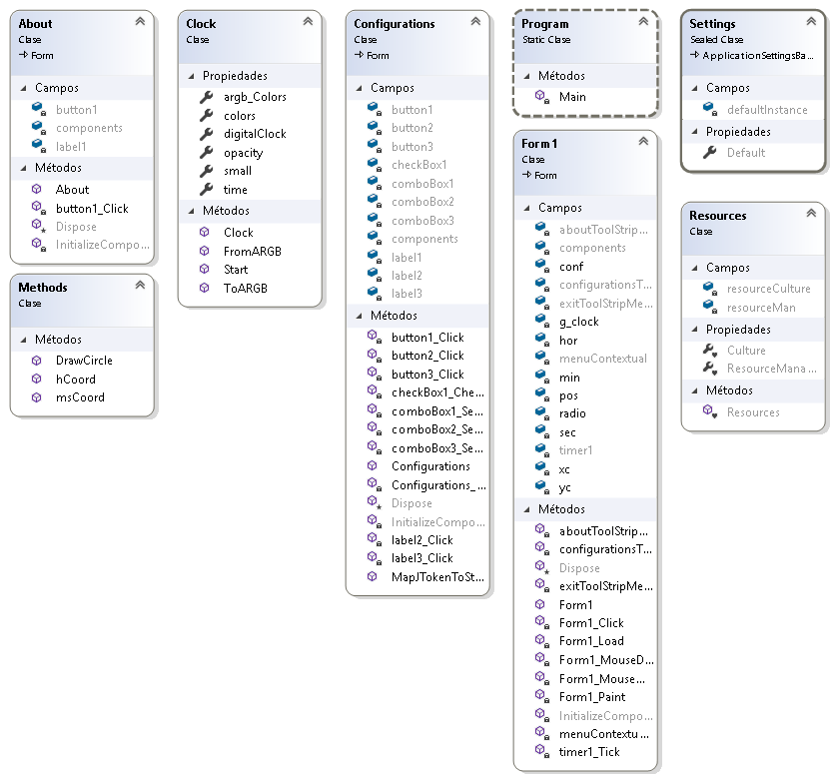

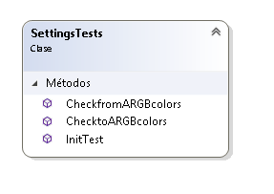

UnitTests

using System;
using Microsoft.VisualStudio.TestTools.UnitTesting;
using System.Drawing;
using Lab2._2._6;

namespace UnitTest
{
[TestClass()]
public class SettingsTests
{
[TestMethod()]
//-16777216,-65536,-16744448,-16776961
public void ChecktoARGBcolors()
{
Clock.Start();
Clock.ToARGB();
Assert.AreEqual(-16777216, Clock.argb_Colors[0]);
Assert.AreEqual(-65536, Clock.argb_Colors[1]);
Assert.AreEqual(-16744448, Clock.argb_Colors[2]);
Assert.AreEqual(-16776961, Clock.argb_Colors[3]);
}

[TestMethod()]
public void CheckfromARGBcolors()
{
Clock.Start();
Clock.ToARGB();
Clock.FromARGB();
Assert.AreEqual(Color.Black.ToArgb(), Clock.colors[0].ToArgb());
Assert.AreEqual(Color.Red.ToArgb(), Clock.colors[1].ToArgb());
Assert.AreEqual(Color.Green.ToArgb(), Clock.colors[2].ToArgb());
Assert.AreEqual(Color.Blue.ToArgb(), Clock.colors[3].ToArgb());
}

[TestMethod()]
public void InitTest()
{
Clock.Start();
Assert.AreEqual(3, Clock.time.Length);
Assert.AreEqual(4, Clock.colors.Length);
Assert.AreEqual(Color.Black, Clock.colors[0]);
Assert.AreEqual(Color.Red, Clock.colors[1]);
Assert.AreEqual(Color.Green, Clock.colors[2]);
Assert.AreEqual(Color.Blue, Clock.colors[3]);
}
}
}

Скриншоты

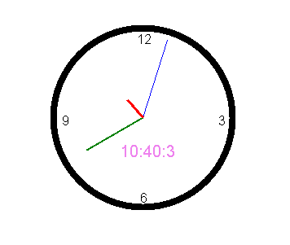

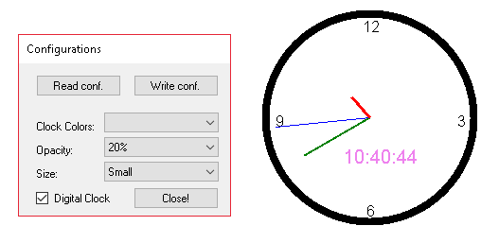

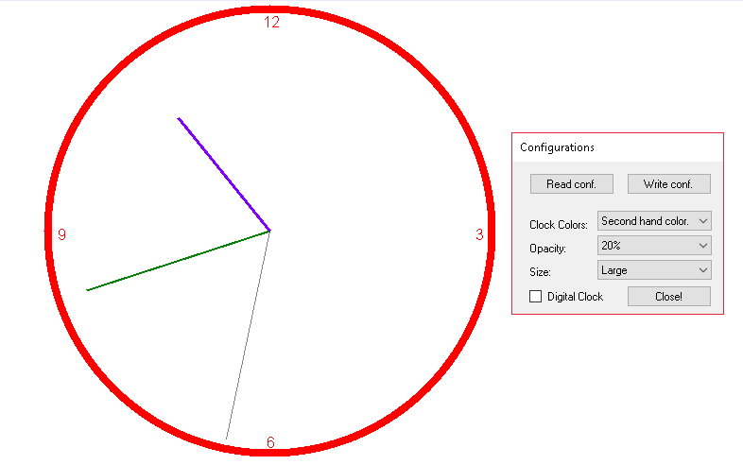

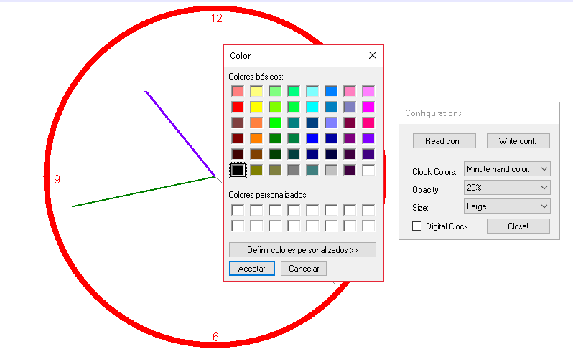

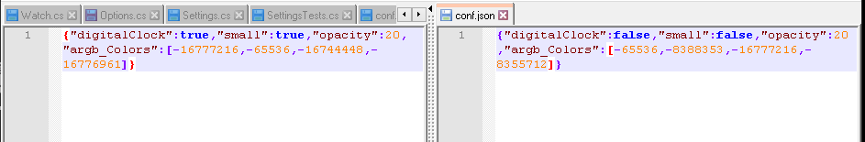

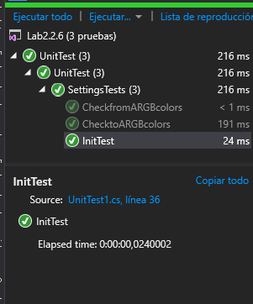

Таблица 1 - Поля и методы класса А и их назначение

N° | Поле | Назначение
1 | g_clock | Clock
2 | min | Size min
3 | hor | Size hr
4 | pos | Temp move
5 | radio | Size radio
6 | sec | Size sec
7 | xc | Center x
8 | yc | Center y
9 | button1 | Close conf
10 | button2 | Read conf
11 | button3 | Write conf
12 | checkBox1 | Show digital
13 | comboBox1 | Colors elements
14 | comboBox2 | Opacity
15 | comboBox3 | Size Clock
16 | label1 | Labels conf
17 | label2 | Labels conf
18 | label3 | Labels conf
19 | argb_Colors | ARGB colors
20 | colors | Colors of the elements
21 | digitalClock | Show digital
22 | opacity | Opacity
23 | small | Size clock
24 | time | Time
25 | button1 | Exit about
26 | label1 | Text of credits
 | Метод | Назначение
27 | Clock | Empty contructor
28 | FromARGB | Convert from ARGB colors
29 | Start | Start default values
30 | ToARGB | Convert to ARGB colors
31 | DrawCircle | Draw circle
32 | hCoord | Get coordenate hr
33 | msCoord | Get coordenate min and seg
34 | MapJTokenToStaticClass | Read Json file to static class elements

Таблица 2 - Обработчики событий проекта и их назначение

N° | Обработчик события | Назначение
1 | button2_Click | Read json conf
2 | button3_Click | Write json conf
3 | button1_Click | Close conf
4 | checkBox1_CheckedChanged | Show digital clock
5 | comboBox1_SelectedIndexChanged | Set color to clock elements
6 | comboBox2_SelectedIndexChanged | Set opacity
7 | comboBox3_SelectedIndexChanged | Show small or large
8 | Configurations_Load | Set default values

Выводы

В лабораторной практике изучалось "Разработка и исследование программы построения часов”.
Разработанные часы сохраняют конфигурацию в файл json. Были проблемы с чтением статических свойств классов конфигурации.
Как улучшение: Реализуйте больше функций для настройки часов.

Использованные источники

- https://docs.microsoft.com/es-es/dotnet/

