How Key recovery is performed using the PAT tool
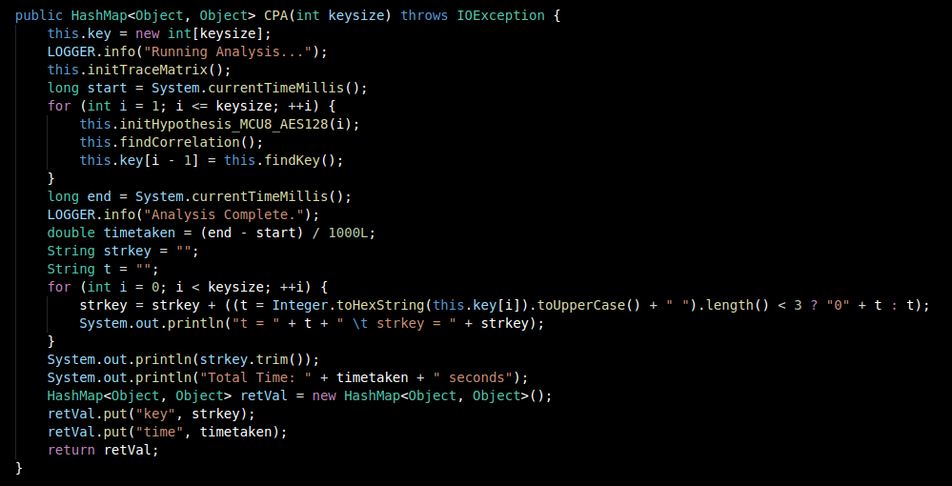

InitTraceMatrix();

Initializes a matrix based on Trace count and Number of Trace Points,
Obtains Plaintext and Ciphertext.
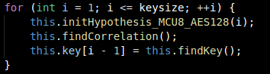

Iterate through all the keys based on number of keys (keysize), run the following functions:

//Gather Hypothesis
initHypothesis_MCU8_AES128();

// Find Correlation between actual power trace curve and estimated curve
this.findCorrelation();

// Find Best guess Key and assign to array
this.key[i - 1] = this.findKey();
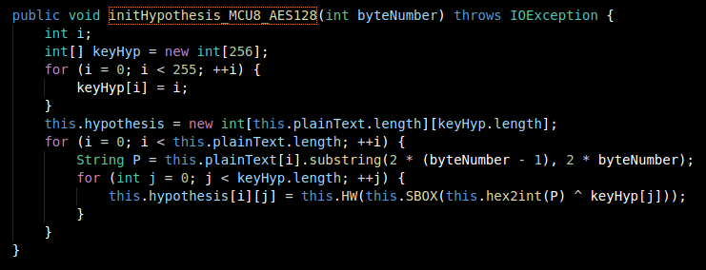

Generate Hypothesis by using the formulae:

this.HW(this.SBOX(this.hex2int(P) ^ keyHyp[j]));

with this.HW returning Integer.bitCount(n);

with this.SBOX returning the SBOX’ value;

based on the XOR-ed value of (hypothesized key which is between 0 to 255 and Plaintext)

by doing so, this.HW generates the estimated power trace level.

findCorrelation: Compares hypothesized trace level with actual trace level implemented with the help
with Correlation function
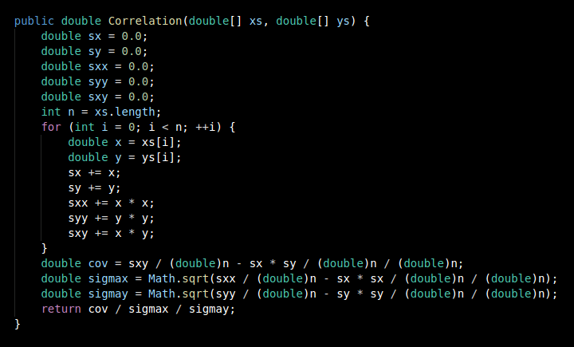

findKey: Basically compares the data point with the highest correlation

