- 宾利。慕尚
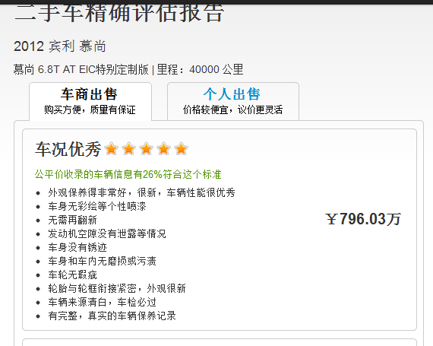
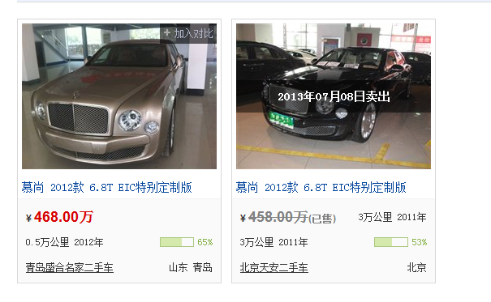
http://www.che168.com/china/binli/mushang/s11405/

