捷豹

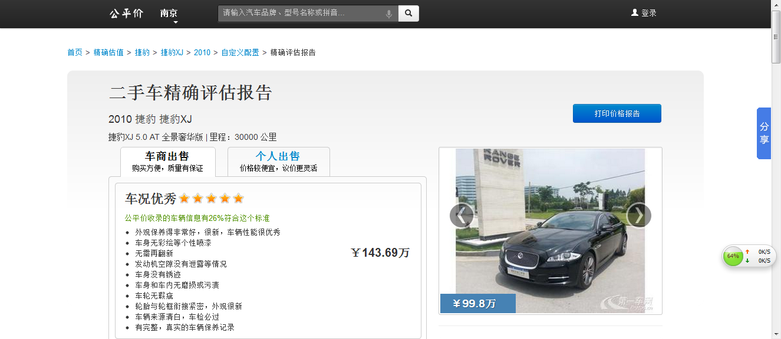

图片源于公平价:

http://www.gongpingjia.com/cars/kbb/jiebao/jiebao-xj/model_25434/2010/0/53%7C53%7C0%7C0/

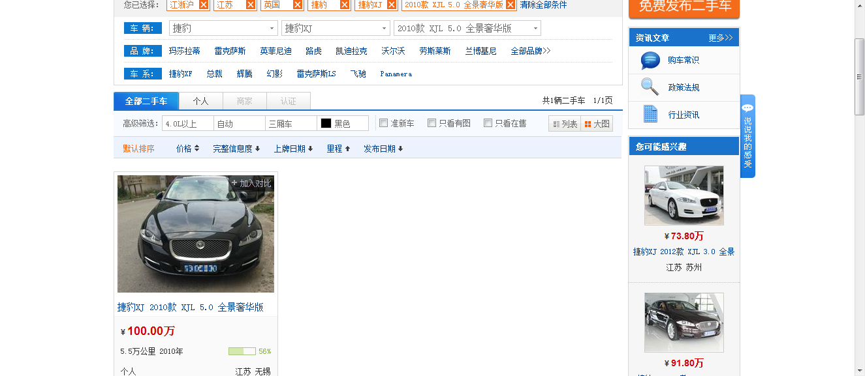

图片源于二手车之家:

<http://www.che168.com/jiangsu/jiebao/jiebaoxj/s5650/>