

Tribhuvan University
Faculty of Humanities and Social Sciences

“Learning Management System”

A PROJECT REPORT

Submitted to
Department of Computer Application
G.P. Koirala Memorial College
Sifal, Kathmandu

In partial fulfillment of the requirements for the Bachelor’s in Computer Application

Submitted by
Prerana Koirala
6-2-703-13-2020

Biplov Karki
6-2-703-6-2020

Abstract
In response to the growing need for digitized academic processes in Nepalese educational institutions, this project proposes the development of a web-based Learning Management System (LMS) named GPKMC eCampus. Built using the MERN stack (MongoDB, Express.js, React.js, and Node.js) and styled with Tailwind CSS, the system aims to provide a unified platform for managing academic and administrative activities. It addresses the inefficiencies of traditional and scattered digital tools by offering centralized features such as attendance tracking, class scheduling, study material sharing, assignment submission with plagiarism detection, and real-time notifications.
The LMS is designed for three main user roles—admin, teacher, and student—each having access to a customized dashboard and feature set. Advanced features include Google OAuth login, dynamic timetable generation, content search via Elasticsearch, and intelligent algorithms for attendance analysis and course recommendations. The system prioritizes usability, security, scalability, and operational efficiency, making it ideal for institutions seeking an affordable, user-friendly, and locally relevant solution.
Through this platform, GPKMC eCampus seeks to improve academic integrity, enhance collaboration, and minimize manual workload, thereby fostering a smarter and more connected educational environment.

Keywords: LMS, eCampus, MERN Stack, Academic Management, Attendance, Assignments, Plagiarism Detection, Role-Based Access, Nepal, Google OAuth

List of abbreviations
AI | Artificial Intelligence
API | Application Programming Interface
CDN | Content Delivery Network
CRUD | Create, Read, Update, Delete
CSP | Constraint Satisfaction Problem
CSS | Cascading Style Sheets
DB | Database
GPKMC | Girija Prasad Koirala Memorial College
HTML | HyperText Markup Language
IDE | Integrated Development Environment
JS | JavaScript
JSON | JavaScript Object Notation
JWT | JSON Web Token
LMS | Learning Management System
MERN | MongoDB, Express.js, React.js, Node.js
NLP | Natural Language Processing
OAuth | Open Authorization
QA | Quality Assurance
REST | Representational State Transfer
SEO | Search Engine Optimization
SMTP | Simple Mail Transfer Protocol
TU | Tribhuvan University
UI | User Interface
UI/UX | User Interface / User Experience
UX | User Experience

List of Figures
Figure 1: Use case diagram of Learning Management System 7
Figure 2: Agile Software development 9
Figure 3: System Flowchart of Learning Management System 10
Figure 4: Gantt Chart of Learning Management System 12

Table of Contents
Abstract ii
List of abbreviations iii
List of Figures iv
Table of Contents v
1. Introduction 1
2. Problem Statement 1
3. Objective 2
4. Methodology 2
4.1 Requirement Identification 2
4.2 Study of Existing System 2
4.3 Literature Review 3
4.4 Requirement Analysis 4
4.5 Feasibility Study 8
4.5.1. Technical Feasibility 8
4.5.2. Operational Feasibility 8
4.5.3. Economic Feasibility 8
4.5.4. High Level Design of System 8
4.5.5. Methodology of Proposed System 8
4.5.6. System Flowchart 9
4.5.7. Description of algorithms 11
6. Gantt Chart 12
7. Expected Outcomes 12
Reference

1. Introduction
Educational institutions often rely on multiple disconnected systems or manual processes to manage academic activities such as student records, faculty assignments, course scheduling, and communication. This fragmentation leads to inefficiencies, delays, and errors that affect students, teachers, and administrators alike. Students may struggle to access timely information, submit assignments, or track academic progress, while faculty and staff face challenges in organizing courses, managing batches, and communicating effectively.
Additionally, the lack of a unified digital platform results in poor coordination, increased administrative overhead, and limited transparency in academic workflows. With the increasing demand for flexible and remote learning, these challenges become even more pronounced.
The project aims to address these issues by developing a comprehensive and user-friendly Learning Management System (LMS) that centralizes academic management. This system will streamline administrative tasks, facilitate communication, support real-time updates, and empower users with easy access to educational resources and tools, thus enhancing the overall learning experience and operational efficiency.

2. Problem Statement
Educational institutions often rely on multiple disconnected systems or manual processes to manage academic activities such as student records, faculty assignments, course scheduling, and communication. This fragmentation leads to inefficiencies, delays, and errors that affect students, teachers, and administrators alike. Students may struggle to access timely information, submit assignments, or track academic progress, while faculty and staff face challenges in organizing courses, managing batches, and communicating effectively.
Additionally, the lack of a unified digital platform results in poor coordination, increased administrative overhead, and limited transparency in academic workflows. With the increasing demand for flexible and remote learning, these challenges become even more pronounced.
The project aims to address these issues by developing a comprehensive and user-friendly Learning Management System (LMS) that centralizes academic management. This system will streamline administrative tasks, facilitate communication, support real-time updates, and empower users with easy access to educational resources and tools, thus enhancing the overall learning experience and operational efficiency.

3. Objective
The objective of this project is to
- To develop a unified digital platform for managing academic and administrative tasks.
- To enhance student learning through accessible course materials and real-time updates.
- To improve institutional efficiency and reduce operational costs with streamlined processes.

4. Methodology

4.1 Requirement Identification

4.2 Study of Existing System
Digital transformation in education has led many institutions worldwide to adopt Learning Management Systems (LMS) and college automation tools [1]. These systems aim to simplify academic operations, improve communication, and provide better learning experiences. In Nepal, however, many colleges still rely on manual processes or scattered digital tools, leading to inefficiencies, miscommunication, and lack of data centralization. Analyzing existing systems, both local and global, helps identify key features, gaps, and opportunities to build a more efficient, accessible, and affordable platform tailored for institutions like ours.
- TU Exam Portal (Nepal)
Tribhuvan University provides a basic online exam routine and result publication system. While useful for checking notices and results, it lacks real-time interaction, notifications, student tracking, or academic resource management. It reflects the minimal digital infrastructure most Nepali colleges currently rely on.
- Google Classroom
Google Classroom is widely used in Nepal, especially after the COVID-19 pandemic. It offers assignment submissions, announcements, and basic communication [2]. However, it lacks features like attendance tracking, structured scheduling, exam handling, or backend admin control. It also depends heavily on Google accounts and internet stability.
- Moodle (International)
Moodle is a popular open-source LMS used by many global institutions. It offers extensive features including quizzes, grade books, attendance, and forums [3]. However, it requires technical knowledge to set up and maintain. For smaller colleges in Nepal, Moodle can be overwhelming due to its complex interface and infrastructure needs.
- SLCM – Student Lifecycle Management (India)
Universities in India use SLCM platforms to handle admissions, student records, attendance, assessments, and fee management. These systems are robust and centralized, but often expensive, require customization, and are difficult for local colleges in Nepal to adopt due to cost and regional context.
- myCampus by Ellucian (International)
Ellucian’s myCampus is a comprehensive campus management suite used in the US and other countries. It provides academic planning, scheduling, student services, and communication tools. However, it is enterprise-grade that means it is suitable for large institutions but not affordable or practical for smaller or government-funded colleges in Nepal.
- C4mpus4.0
C4mpus4.0 is a comprehensive campus management solution widely used by colleges in Nepal. It effectively manages core administrative functions such as student enrollment, attendance tracking, timetable scheduling, examination management, and fee processing. The platform supports both web and mobile interfaces, allowing easy access for students, faculty, and administrators [4]. However, its primary focus is on administrative efficiency rather than providing rich interactive learning experiences. The user interface is functional but somewhat dated, offering limited customization options. While C4mpus4.0 helps colleges digitize their operations and improve data management, it does not fully address modern educational needs like collaborative learning, online assessments, or advanced analytics, which present opportunities for more integrated learning management systems.

4.3 Literature Review
In recent years, educational technology has transformed academic institutions by enhancing both teaching and administrative processes. Globally, Learning Management Systems (LMS) and College Management Systems (CMS) such as Moodle, Google Classroom, and Blackboard have become essential tools that improve course delivery, student engagement, and administrative efficiency. These platforms provide digital environments that support accessibility, communication, and collaboration among students, faculty, and administrators.
Locally, several colleges in Nepal have started adopting digital solutions to streamline academic workflows, including attendance tracking, timetable management, notifications, and exam scheduling [5]. Systems like C4mpus4.0, which are used by some Nepalese colleges, focus mainly on administrative automation but often lack comprehensive learning tools or customization suited to the specific needs of Nepalese institutions. Moreover, many of the existing platforms are either costly or too complex, limiting their accessibility for smaller or resource-constrained colleges.
International LMS platforms are known for their usability, scalability, and integration capabilities, with open-source solutions offering high flexibility and cloud-based platforms providing ease of deployment [6]. However, challenges remain in terms of affordability, ease of use, and alignment with local academic requirements, particularly in developing countries like Nepal.
Research indicates that effective LMS and CMS solutions can improve communication between students and educators, reduce administrative workload, and foster interactive and collaborative learning environments [7]. Despite these advantages, many existing systems fail to provide a fully integrated, user-friendly platform tailored to the unique academic context of Nepalese colleges.
The GPKMC eCampus system is designed to address these gaps by providing a unified platform that focuses on core academic and administrative functions such as attendance management, scheduling, notifications, study notes, assignments, and plagiarism detection. Emphasizing simplicity, cost-effectiveness, and local relevance, this system aims to enhance educational delivery and operational efficiency for institutions in Nepal.

4.4 Requirement Analysis
Requirement analysis is the initial task to be performed while developing the system. It was
performed to identify the requirements needed for the system.
- Functional Requirements
The system will consist of three actors: teacher, student and admin for interaction with the system. As shown in the figure below, all the three actors will have their own interaction features with the proposed system.
- User Authentication and Role Management
  - Users can register/login using email/password or Google OAuth.
  - Admin manages user’s roles include Student, Teacher, Admin, and Super Admin.
  - Each role has access control to specific features.
- Dashboard Access
  - Users see role-based dashboards (e.g., students see schedule/notes; teachers see attendance/assignments).
- Attendance Management
  - Teachers can mark student attendance for their assigned subjects.
  - Option to mark attendance manually or via QR scan.
  - Students can view their attendance records.
- Class Schedule Management
  - Admins can create/update class timetables.
  - Students and teachers can view daily/weekly schedules.
  - Dynamic filtering based on faculty, batch, and semester.
- Study Materials and Notes
  - Teachers can upload notes and study materials (PDF, docs, links, ppts, videos, images).
  - Students can download or preview shared notes.
  - Notes are organized by subject and semester.
- Assignment Upload and Submission
  - Teachers can create assignments with deadlines and instructions.
  - Students can upload assignment files.
  - Teachers can review, download, and give feedback.
- Plagiarism Detection (FastAPI Integration)
  - Uploaded assignments are checked for plagiarism.
  - Students and teachers can view plagiarism reports.
  - Alerts or warnings if plagiarism exceeds threshold.
- Notification System
  - Admins/teachers can send real-time or scheduled announcements.
  - Notifications categorized (general, academic, urgent).
  - Students receive them on dashboard and via email if needed.
- Batch, Faculty, and Semester Management
  - Admin can add/update batches, faculties, and semester/year records.
  - System auto-generates semester name and slug based on rules.
  - Prevents duplicate or overlapping semester data.
- Course and Subject Allocation
  - Courses/subjects are assigned to specific faculties, batches, and semesters.
  - Teachers are assigned to subjects per semester.
- Search and Filter
  - Users can filter attendance, assignments, notes, and schedules by semester, faculty, or subject.
  - Admins can search students, batches, and users easily.
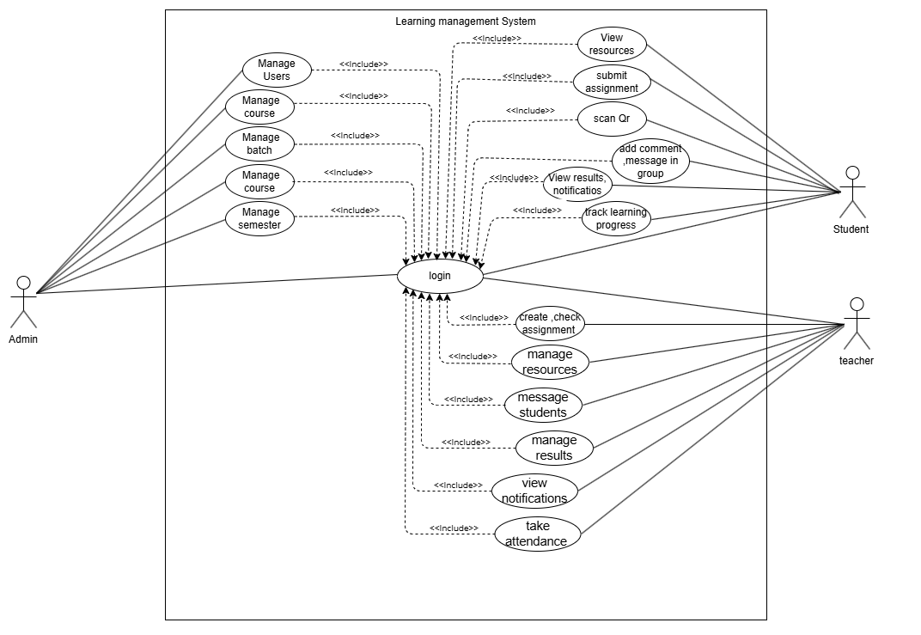
Figure 1: Use case diagram of Learning Management System
- Non-Functional Requirements
Non-functional requirements are an important aspect of a system which describes how the system should perform and operate, beyond its basic functionality. Below are some non-functional requirements that should be considered when designing the system:

1. Usability: The LMS will provide a clean, intuitive, and user-friendly interface tailored to each user role (student, teacher, admin). Features will be easily accessible, with clear navigation, reducing the learning curve and improving user satisfaction.

2. Performance: The system will be optimized for high performance to ensure fast response times, quick page loads, seamless transitions, and smooth handling of multimedia content like videos and documents, even under concurrent user activity.

3. Security: The system will implement strong security practices, including secure user authentication (email/password and Google OAuth), role-based access control, data encryption, and protection against unauthorized access or data breaches.

- Flexibility: The GPKMC eCampus system will be designed with modular architecture and scalable components, allowing future integration of new features or third-party services with minimal changes to the core system. It will support role-specific customization and adapt easily to changing institutional needs, such as curriculum updates or evolving administrative processes.
- Software Requirements
1. Backend
- Node.js: JavaScript runtime for server-side logic.
- Express.js: Framework for building RESTful APIs and managing server routes.
2. Frontend
- React.js: Library for building user interfaces with components.
- Redux (optional): For state management if needed.
3. Database
- MongoDB: NoSQL database for storing data of this system
4. Development Tools
- IDE/Code Editor: Visual Studio Code or any preferred code editor.
- Version Control: Git for source code management.
- software management tool: Trello
5. Third-party Services.
- Notification Services: Email (e.g., SendGrid) and SMS (e.g., Twilio).

4.5 Feasibility Study

4.5.1. Technical Feasibility
The project utilizes the MERN stack (MongoDB, Express.js, React.js, Node.js), a widely adopted and well-supported web development technology. With the addition of Tailwind CSS for styling and FastAPI for plagiarism detection, the system architecture is both modern and efficient. All required tools and frameworks are open-source and well-documented, ensuring ease of development, maintenance, and future scalability.

4.5.2. Operational Feasibility
The platform is designed to streamline everyday academic and administrative tasks such as attendance, assignments, and study material sharing. Since users (students, teachers, and admins) are already familiar with basic web and mobile tools, the learning curve will be minimal. The role-based dashboards and user-friendly interface ensure operational smoothness for all stakeholders.

4.5.3. Economic Feasibility
As the system leverages free and open-source technologies, the initial development cost is significantly minimized. The deployment can be done on cost-effective cloud platforms, ensuring long-term affordability. The system is designed to reduce paper-based tasks, manual errors, and redundant workload that leads to long-term cost savings in academic operations.

4.5.4. High Level Design of System

4.5.5. Methodology of Proposed System
For the development of the LMS platform, the Agile Methodology will be adopted as the primary software development approach. This methodology is ideal for the project due to its iterative and flexible nature, emphasizing collaboration, continuous feedback, and incremental improvements. The main objective of using Agile is to ensure that the platform adapts effectively to user needs and feedback, enabling the rapid rollout of new features and enhancements.
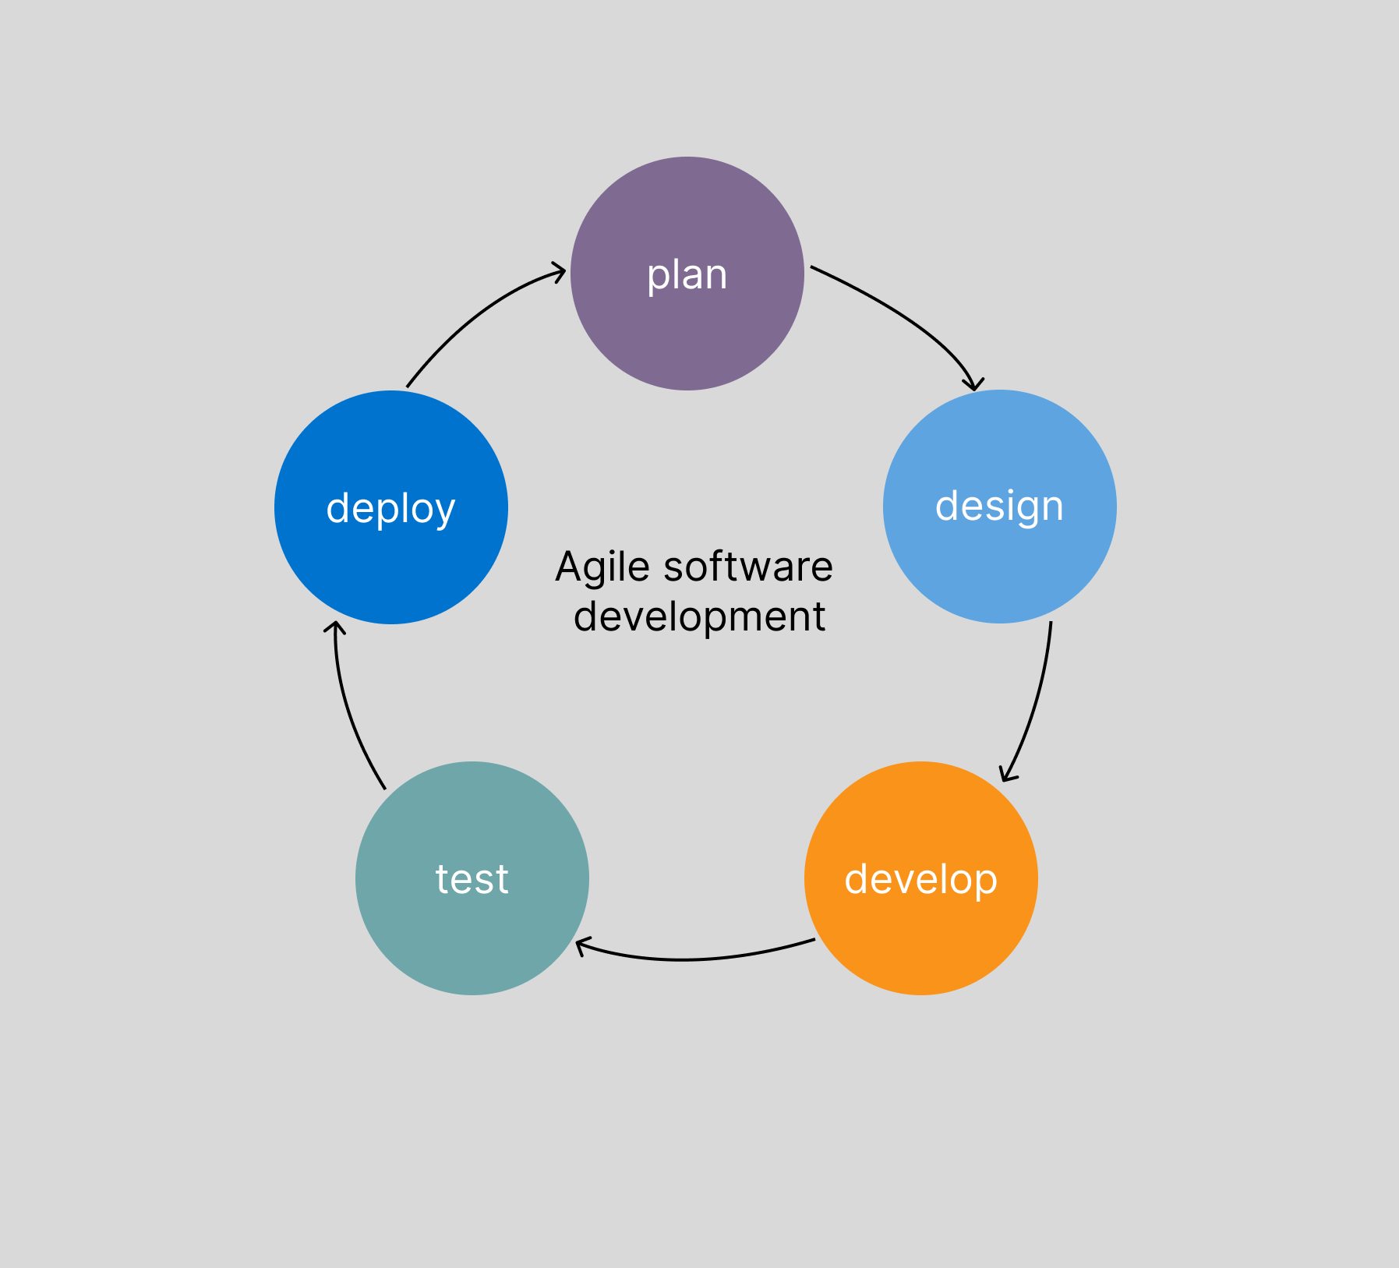
Figure 2: Agile Software development

4.5.6. System Flowchart
In the LMS platform, users visit the website, and they are already registered, they can log in with their credentials to access the system based on their roles such as teacher can access teacher dashboard while admin can access admin dashboard and student can access their own dashboard, and each user can access all features based on their roles.
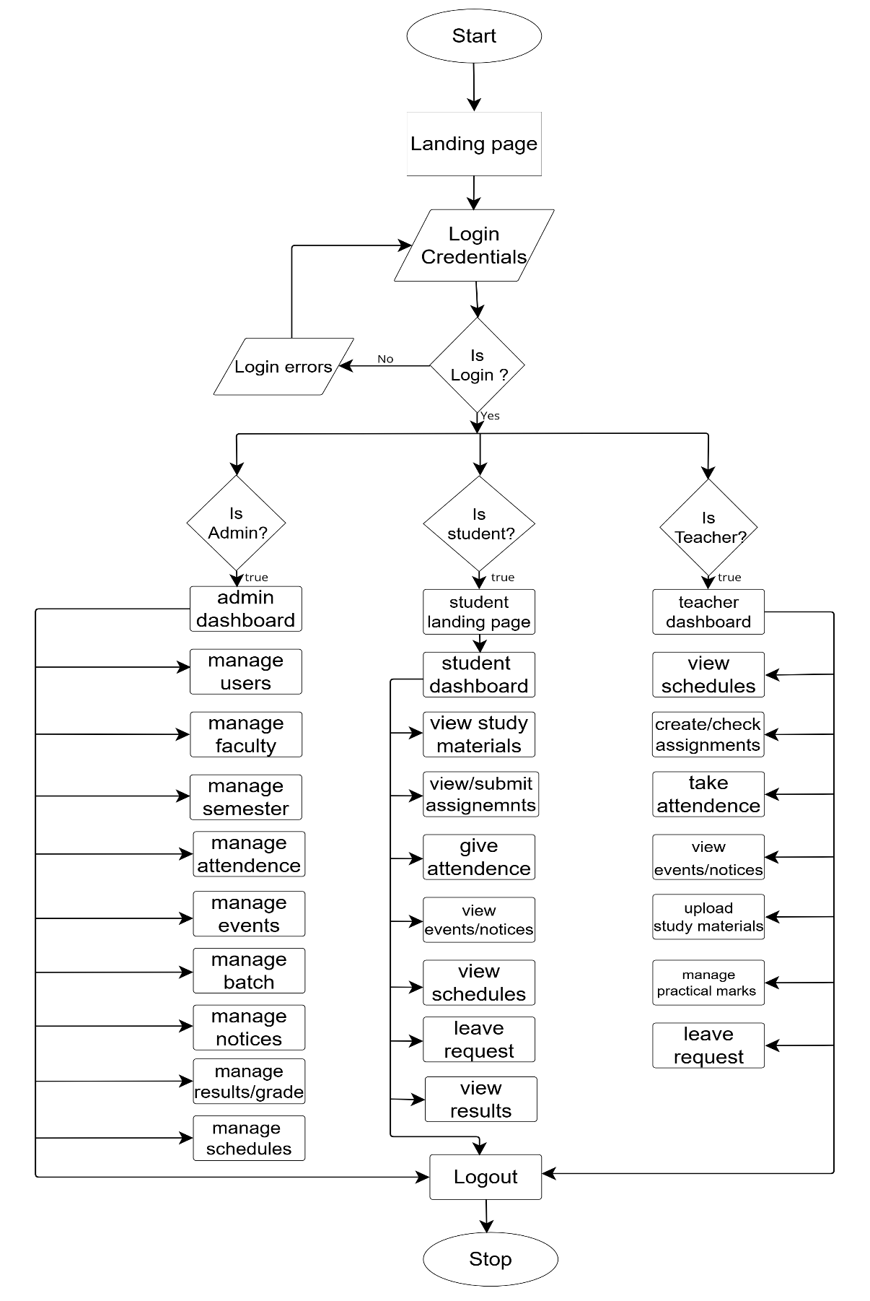
Figure 3: System Flowchart of Learning Management System
The GPKMC eCampus system begins with a secure login process, directing users to different dashboards based on their roles—Admin, Teacher, or Student. Admins have access to comprehensive controls that allow them to manage users, faculties, semesters, attendance records, events, notices, academic results, and class schedules. Teachers are provided with tools to take attendance, create and review assignments, upload study materials, check class schedules, and process student leave requests. On the other hand, students can access study materials, view and submit assignments, check their schedules and academic results, mark their attendance, and submit leave applications. Each role-specific dashboard is designed to facilitate seamless interaction with the LMS platform, enhancing the learning and management experience for all users. The entire system flow ensures smooth operation, secure access, and a user-friendly experience for every stakeholder.

4.5.7. Description of algorithms
1. Plagiarism Detection: BERT Embeddings + Cosine Similarity Used to detect similarity in student assignments by understanding the meaning behind the text, not just exact words. BERT creates a detailed representation of the text’s meaning, and cosine similarity measures how close two pieces of text are semantically, helping catch paraphrased or rewritten plagiarism.

2. Attendance Analysis: Time-Series Analysis with Pandas + MongoDB Aggregation
Used to track attendance trends over time. MongoDB aggregation can quickly group and summarize attendance data, while Pandas (Python library) helps analyze patterns like absences by week or month, detect anomalies, and predict future attendance behavior.

3. Timetable Scheduling: Constraint Satisfaction Problem (CSP) Solvers like Google OR-Tools Used to automatically generate conflict-free class schedules by considering many rules like no overlapping classes for a teacher or room, preferred times, and faculty availability, ensuring the timetable meets all constraints efficiently.

4. Query Classification / Smart Chat: DistilBERT + Text Classification Used to understand and classify user questions or requests in the system (like help queries), enabling smarter search or chatbot features by accurately interpreting what the user means, better than basic keyword matching.

5. Notes & Content Search: Elasticsearch Used to provide fast, powerful search for notes and study materials. It supports typo tolerance, filtering, and ranking results by relevance, making it easier for students and teachers to quickly find the resources they need.

6. Course Recommendations: Collaborative Filtering with Matrix Factorization
Used to suggest relevant courses or materials to students based on their and peers’ behavior (like what others viewed or downloaded), offering personalized learning paths instead of generic recommendations.

- Progress Tracking: – State Machines + Event Sourcing Used to track each student’s progress in courses or lessons step-by-step, capturing each action (like completing a lesson or quiz) to give detailed progress reports and enable features like resuming where they left off or showing completion status clearly.

6. Gantt Chart
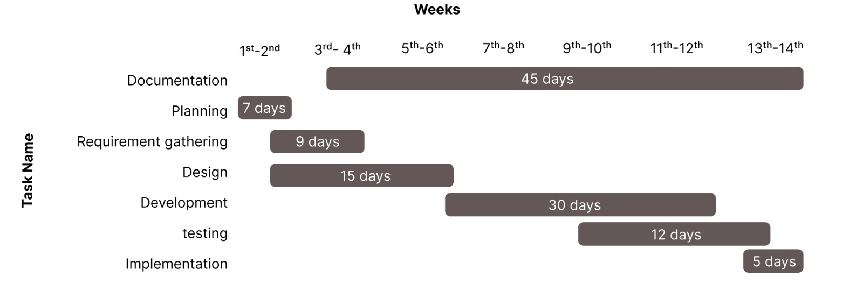

Figure 4: Gantt Chart of Learning Management System
A Gantt Chart is a widely used tool in project management for visualizing project schedules. It displays activities or tasks along a timeline, making it easy to understand the sequence and duration of each task. On the left side of the chart, a list of project activities is presented. Across the top, a time scale (such as days, weeks, or months) is shown. Each activity is represented by a horizontal bar. The position of the bar indicates the start date, while its length reflects the duration of the task, ending at the expected completion date.

7. Expected Outcomes
GPKMC eCampus will improve academic efficiency by offering a centralized platform for managing key tasks. It will enhance collaboration, ensure academic integrity, and support personalized learning while reducing manual work and operational costs.
- To provide a unified and user-friendly platform that streamlines attendance, scheduling, assignments, and communication, improving overall academic efficiency.
- To enhance collaboration and academic integrity through plagiarism detection, while supporting personalized learning and minimizing manual workload and costs.

Reference
[1] | UNESCO, "Education and Technology: Global Report on Digital Learning," UNESCO, Paris, France, 2021.
[2] | Google Classroom, ""Google Classroom Help," google, 2023. [Online]. Available: https://support.google.com/edu/classroom. [Accessed 04 july 2025].
[3] | Moodle, "Moodle - Open-source learning platform," moodle, 2022. [Online]. Available: https://moodle.org/. [Accessed 04 july 2025].
[4] | Softwarica College, "C4mpus4.0 College Management System," Softwarica College, [Online]. Available: https://c4mpus4.com/. [Accessed 04 july 2025].
[5] | S. K. Shrestha, "Digital Transformation of Higher Education in Nepal: Challenges and Opportunities," Nepalese Journal of Education Technology, vol. 5, no. 1, pp. 34-42, 2021.
[6] | M. A.-S. R. Abbas, "A Review of Learning Management Systems: Moodle, Blackboard, and Google Classroom,," International Journal of Educational Technology, vol. 7, no. 02, pp. 15-26, 2020.
[7] | K. alraimi, A. Ciganek and H. Zo, "Understanding the MOOCs Continuance: The Role of Open Educational Resources," Computers & Education, vol. 80, pp. 28-38, 2015.

