
Tribhuvan University
Faculty of Humanities and Social Sciences
A PROJECT REPORT
On
LEARNING AND MANAGEMENT SYSTEM
Submitted to:
Department of Information Technology
G.P. Koirala Memorial College

In partial fulfillment of the requirement for the Bachelors in Computer Application
Submitted by:
Biplov Karki
6-2-703-6-2020
Prerana Koirala
6-2-703-13-2020

November, 2025

Under the supervision of
Mr. Sujan Koirala

Tribhuvan University
Faculty of Humanities and Social Sciences
G.P. Koirala Memorial College
Sifal, Kathmandu
Bachelor of Computer Applications (BCA)

SUPERVISOR’SRECOMMENDATION

I hereby recommend that this project prepared under my supervision by BIPLOV KARKI and PRERANA KOIRALA entitled “LEARNING AND MANAGEMENT SYSTEM” in the Partial Fulfillment of requirement for the degree of Bachelor’s in Computer Application is recommended for that final evaluation.

…………………………….
Mr. Sujan Shrestha
Supervisor/Co-Ordinator
Department of Information Technology
G.P. Koirala Memorial College


Tribhuvan University
Faculty of Humanities and Social Sciences
G.P. Koirala Memorial College

LETTER OF APPROVAL
This is to certify that this project prepared by BIPLOV KARKI and PRERANA KOIRALA entitled “LEARNING AND MANAGEMENT SYSTEM” in partial fulfillment of the requirements for the degree of Bachelor of Computer Application has been well studied. In our opinion it is satisfactory in scope and quality as a project for the required degree.

……………………………………  Sujan Shrestha  Supervisor  GPKMC | …………………………………………..  [External Examiner]  Academic Designation  FOHSS, Tribhuvan University
……………………………………  Sujan Shrestha  Program Coordinator  GPKMC | …………………………………………..  Shiva prasad Adhikari  Campus Chief  GPKMC

ACKNOWLEDGEMENT
We would like to express our special thanks of gratitude to our supervisor and BCA Program Coordinator Mr. Sujan Shrestha who gave us the golden opportunity to do this wonderful project on the topic of LEARNING AND MANAGEMENT SYSTEM (LMS), which also helped us in doing a lot of research and we came to know about so many new tools and technologies. We would like to express my special gratitude and thanks Mr. Sujan Shrestha for his support and help for our personnel development and mainly for the completion of this Project. We would like to express our special thanks of gratitude to our Campus Chief Mr. Shiva Prasad Adhikari who gave us permission to do this Project. I am highly indebted to GP Koirala Memorial College for their guidance and constant supervision as well as for providing necessary information regarding the Project and support in the completion. We would also like to express my gratitude towards library and member of GP Koirala Memorial College for their kind co-operation and encouragement which help me in completion of this Project. We would also like to thank our parents and friends who helped us a lot in finalizing this project within the limited time frame. In the end, we would also like to thank Tribhuvan University forgiving us this opportunity via the course of Computer Application to help us understand the project ethics at this early stage and helped us to evaluate my knowledge and expand it a little more.

Prerana Koirala
Roll No: 70302014

Biplov Karki
Roll No: 70302005

Date: 2082/06/22

ABSTRACT
In response to the growing need for digitized academic processes in Nepalese educational institutions, this project proposes the development of a web-based LEARNING AND MANAGEMENT SYSTEM (LMS) named GPKMC eCampus. Built using the MERN stack (MongoDB, Express.js, React.js, and Node.js) and styled with Tailwind CSS, the system aims to provide a unified platform for managing academic and administrative activities. It addresses the inefficiencies of traditional and scattered digital tools by offering centralized features such as attendance tracking, class scheduling, study material sharing, assignment submission with plagiarism detection, and real-time notifications.
The LMS is designed for three main user roles like admin, teacher, and student. each having access to a customized dashboard and feature set. Advanced features include Google OAuth login, dynamic timetable generation, content search via Elasticsearch, and intelligent algorithms for attendance analysis and course recommendations. The system prioritizes usability, security, scalability, and operational efficiency, making it ideal for institutions seeking an affordable, user-friendly, and locally relevant solution.
Through this platform, GPKMC eCampus seeks to improve academic integrity, enhance collaboration, and minimize manual workload, thereby fostering a smarter and more connected educational environment.
Keywords: LMS, eCampus, MERN Stack, Academic Management, Attendance, Assignments, Plagiarism Detection, Role-Based Access, Nepal, Google OAuth

TABLE OF CONTENT
SUPERVISOR’SRECOMMENDATION 2
LETTER OF APPROVAL 3
ACKNOWLEDGEMENT 4
ABSTRACT 5
TABLE OF CONTENT 6
LIST OF ABBREVIATIONS 8
LIST OF FIGURES 9
LIST OF TABLES 10
CHAPTER 1: INTRODUCTION 11
1.1 Introduction 11
1.2 Problem Statement 11
1.3 Objectives 12
1.4 Scope and Limitation 12
1.4.1Scope 12
1.4.2Limitations 13
1.5 Development Methodology 13
1.6 Report Organization 13
CHAPTER 2: BACKGROUND STUDY AND LITERATURE REVIEW 15
2.1 BackgroundStudy 15
2.2 Literature Review 16
CHAPTER 3: SYSTEM ANALYSIS AND DESIGN 19
1.1 System Analysis 19
1.1.1 Requirement Analysis 19
1.1.2 Feasibility Analysis 21
1.1.3 Object Modelling using Class and Object Diagrams 22
1.1.4 Dynamic Modelling using State and Sequence Diagrams 23
1.1.5 Process Modeling using Activity Diagrams 25
1.2 System Design 29
1.2.1 Component Diagrams 31
1.2.2 Deployment Diagrams 32
1.3 Algorithm Details 32
1.3.1 Assignment submissions with plagiarism detection 32
1.3.2 Timetable Generation Algorithm (Backtracking + Forward-Checking) 34
CHAPTER 4: IMPLEMENTATION AND TESTING 37
4.1. Implementation 37
1.3.3 Tools Used (CASE tools, Programming languages, Database platforms) 37
1.3.4 ImplementationDetailsofModules 38
4.2. Testing 41
4.2.1. Testing Objectives 41
4.2.2. Unit Test Cases 41
4.2.3. System Test cases for LMS 44
4.2.4. Testing Tools 45
4.3. Result Analysis 45
CHAPTER 5: CONCLUSION AND FUTURE RECOMMENDATIONS 47
5.1. Conclusion 47
5.2. Limitations of the System 48
5.3. Future Recommendation 48
REFERENCES 50

LIST OF ABBREVIATIONS
API | Application Programming Interface
CRUD | Create, Read, Update, Delete
CSS | Cascading Style Sheets
DFD | Data Flow Diagram
ER | Entity–Relationship
GUI | Graphical User Interface
HMS | Hospital Management System
HTML | HyperText Markup Language
HTTP | HyperText Transfer Protocol
HTTPS | HyperText Transfer Protocol Secure
IDE | Integrated Development Environment
IP | Internet Protocol
JS | JavaScript
JWT | JSON Web Token
LMS | Learning and Management System
MERN | MongoDB, Express.js, React (Next.js), Node.js
MySQL | My Structured Query Language (or MySQL database)
OCR | Optical Character Recognition
QA | Quality Assurance
REST | Representational State Transfer
SRS | Software Requirements Specification
SDLC | Software Development Life Cycle
SQL | Structured Query Language
UI | User Interface
UX | User Experience
WCAG | Web Content Accessibility Guidelines
WS | Web Service

LIST OF FIGURES

Figure 1: Gantt Chart of LMS 22
Figure 2: Class Diagram of LMS 23
Figure 3: Object Diagram of Learning and Management System 23
Figure 4: State Diagram of Assignment Submission with Plagiarism Control 24
Figure 5: Sequence Diagram for Admin Master Data Management 25
Figure 6:Activity Diagram for Assignment Submission with Plagiarism Check 26
Figure 7: Activity Diagram for Teacher Grading Assignment Submissions 27
Figure 8: Overall System Flowchart of LMS 28
Figure 9: Level-0 DFD of Learning and Management System 29
Figure 10: Entity–Relationship (ER) Diagram of LMS 30
Figure 11: Architecture Diagram of LMS 31
Figure 12: Component Diagram of LMS 31
Figure 13: Deployment Diagram of LMS 32

LIST OF TABLES
Table 3.1: Gantt chart Table for Learning and Management System 22
Table 4.1: Test cases for Login of LMS 42
Table 4.2: Test cases for Assignment Submission with Plagiarism Control 42
Table 4.3: Test cases for QR-based Attendance 43
Table 4.4: Test cases for Schedule Management 44
Table 4.5: System Test Cases for LMS 44

CHAPTER 1: INTRODUCTION

Introduction
In the digital age, managing academic workflows through traditional paper-based or disjointed systems can lead to inefficiencies, miscommunication, and limited access to essential academic services. Students, teachers, and administrators often struggle with manual processes, scattered information, and lack of real-time updates which hinder effective learning and campus management.
eCampus is a modern, web-based Learning And Management System (LMS) designed to simplify and enhance the academic experience for educational institutions. Built using the MERN stack (MongoDB, Express.js, React.js, and Node.js) and styled with Tailwind CSS, the platform offers a responsive and intuitive interface accessible across devices.
The system centralizes core academic activities including user management, faculty and batch coordination, semester/year management, class schedules, notes, announcements, and assignment submissions. Students can track their academic progress, view resources, receive notifications, and submit assignments, while teachers can manage classes, share materials, mark attendance, and evaluate students. Secure Google login integration ensures seamless and safe access using institutional email accounts.
With features like real-time updates, plagiarism detection, and role-based access control, eCampus fosters a collaborative, transparent, and efficient academic environment. It bridges the gap between students, faculty, and administration help them to enabling smarter, faster, and more connected campus operations.

Problem Statement
Educational institutions often rely on multiple disconnected systems or manual processes to manage academic activities such as student records, faculty assignments, course scheduling, and communication. This fragmentation leads to inefficiencies, delays, and errors that affect students, teachers, and administrators alike. Students may struggle to access timely information, submit assignments, or track academic progress, while faculty and staff face challenges in organizing courses, managing batches, and communicating effectively.
Additionally, the lack of a unified digital platform results in poor coordination, increased administrative overhead, and limited transparency in academic workflows. With the increasing demand for flexible and remote learning, these challenges become even more pronounced.
The project aims to address these issues by developing a comprehensive and user-friendly Learning and Management System (LMS) that centralizes academic management. This system will streamline administrative tasks, facilitate communication, support real-time updates, and empower users with easy access to educational resources and tools, thus enhancing the overall learning experience and operational efficiency.

Objectives
The objective of this project is to
- To develop a unified digital platform for managing academic and administrative tasks.
- To enhance student learning through accessible course materials and real-time updates.
- To improve institutional efficiency and reduce operational costs with streamlined processes.

Scope and Limitation

1.4.1 Scope
This project focuses on building a web-based Learning and Management System (LMS) called GPKMC eCampus, designed to improve the management of academic and administrative activities within educational institutions. The system targets three main user roles and they are: - Admin, Teacher, and Student and offers role-based features to simplify daily tasks and improve communication. It will be developed using the MERN stack and styled with Tailwind CSS, ensuring scalability, usability, and relevance for institutions in Nepal.
The system will cover:
- Role-based dashboards for Admin, Teacher, and Student
- Attendance management (manual and QR-based)
- Class scheduling and timetable management
- Assignment upload, feedback, and plagiarism detection
- Study material sharing (PDFs, links, videos, etc.)
- Real-time notifications for announcements and updates
- Secure login using email/password and Google OAuth

1.4.2Limitations
- Financial management features (such as fee collection, payroll, or expense tracking) are not included in the current LMS
- Integration with external tools (e.g., Google OAuth, plagiarism detection) depends on third-party service availability and policies
- Initial data migration from existing manual records to the LMS can be time-consuming and prone to errors

Development Methodology
The Learning and Management System was developed using the Agile methodology, ensuring iterative and flexible progress. The process began with requirement analysis, where functional and non-functional requirements were identified. Based on these requirements, the system design was created, followed by development in iterative cycles (sprints), focusing on implementing key features step by step.
Each sprint included testing to identify and resolve issues early, ensuring the functionality of the system. After implementing all the core features, the system underwent integration and final testing. Any issues found were resolved, ensuring the system was fully functional and ready for deployment
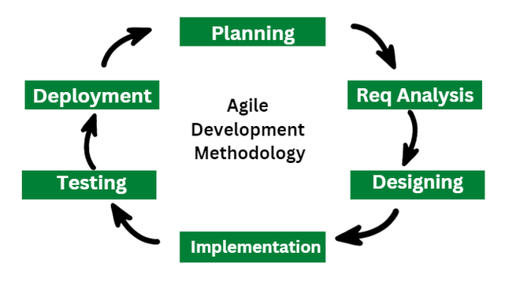

Report Organization
Chapter 1: Introduction
This chapter deals with the introduction of the system with its objectives and limitations along with there as on why the system is made.

Chapter 2: Background Study and Literature Review
Thischaptersummarizestheworkthathasbeencarriedoutinthefieldofdataminingandalso describes the features about some existing applications related to the Learning And Management System.

Chapter 3: SystemAnalysisand Design
Thischapterfocusesonthedifferentrequirementofthesystem,whichdescribesaboutthefunctional,non-functional,feasibilityanalysis,EntityRelationaldiagram,DataFlowDiagram, design of the system with system architecture, database schema, and interfacedesign.

Chapter 4: ImplementationandTesting
This chapter emphasizes tools used in system development, implementing details andresultof test performed.

Chapter 5: ConclusionandFuture Recommendation
This chapter highlights brief summary oflesson learnt, outcome and conclusion of thewholeprojectand explain what have been done and what further improvements could bedone.

CHAPTER 2: BACKGROUND STUDY AND LITERATURE REVIEW

Background Study
This project builds a web-based Learning and Management System (LMS) for GPKMC to bring teaching and learning into one organized place. An LMS helps institutions deliver materials, run assessments, track progress, and communicate with students in a structured way that supports teaching quality and accountability [1]. In Nepal, the shift toward online and blended learning highlighted both the promise of digital platforms and the persistent gaps in connectivity, devices, and user readiness, especially outside major cities [2][3].

The platform follows well-established LMS principles: clear organization of learning activities, reliable records of teaching/assessment, and timely feedback to students[4]. To support fair evaluation, the system can check text submissions for similarity using modern sentence-embedding approaches (e.g., Sentence-BERT) that compare texts with cosine similarity and surface likely overlaps for teacher review rather than making automatic judgments [5]. For scanned or image-based work, Optical Character Recognition (OCR) is used to extract text so it can be searched and compared; OCR quality and evaluation metrics are important to ensure usable results [6]. The interface aims to be readable and navigable across devices by drawing on widely used web accessibility guidance (e.g., WCAG 2.x) so more learners can participate effectively[7].

A course is the subject (e.g., Operations Research), while a course instance is the actual offering tied to a batch, teacher, and time window. Batch and semester/year reflect the local academic structure used for enrollment and scheduling. Teachers post materials (files/links) and create assignments and quizzes; students submit work that appears in the gradebook after marking. Timetables are modeled as recurring events (for example, weekly lectures at fixed times). Attendance tokens are short-lived QR codes shown in class so students can check in quickly while reducing sharing. For integrity checks, similarity analysis highlights matched passages and sources for teacher review, and OCR refers to converting scanned pages or images into searchable text [8].
Overall, the LMS focuses on clear organization (courses vs. course instances), dependable scheduling and attendance, fair and reviewable evaluation, and an interface that works on common devices. Evidence from LMS research and from Nepal’s recent experience with online learning suggests that these foundations can improve access and day-to-day teaching, provided institutions continue to invest in connectivity, user support, and practical design choices that keep the system simple and reliable [9].

Literature Review
Digital transformation in education has encouraged institutions worldwide to adopt Learning and Management Systems (LMS) and campus/college automation tools to streamline both teaching and administrative work. In their most common form, these platforms centralize course materials, announcements, assignments, grades, and records so that teachers and students interact in a shared digital space with clearer expectations and faster feedback cycles. Meta-reviews report consistent gains in course organization, communication efficiency, and learner satisfaction when teaching activities are coordinated through an LMS rather than fragmented channels[10]. Yet, this global momentum contrasts with the situation in Nepal, where many colleges still depend on manual procedures or scattered digital tools. The result is duplicated effort, slower decision-making, and weak data visibility across offices and departments, especially when attendance, timetables, and assessments are tracked independently rather than in one place[11]. Knowing the current state of affairs, both domestically and globally, makes it easier to determine which aspects are most important, where current systems fall short, and how to create a workable, cost-effective solution for organizations like ours.

Examining representative systems reveals obvious trade-offs. Exam notifications and results are a crucial public service that TU's Exam Portal offers, but it is not designed to oversee daily instruction or student involvement. It also lacks real-time interaction, notifications, and resource management, which reflects the scant digital infrastructure that the majority of Nepali colleges currently rely on. Because it is easy to use and requires minimal training, Google Classroom became popular during and after the COVID-19 pandemic, allowing teachers to quickly distribute materials, collect submissions, and share announcements. However, it significantly relies on Google accounts and reliable internet, and it lacks deeper back-office controls (such department-level views or multi-program coordination), as well as built-in attendance tracking, structured scheduling, exam handling, and other features frequently mentioned in developing contexts[12].
In contrast, Moodle is a full-featured open-source LMS with quizzes, gradebooks, forums, and even attendance plugins, backed by a large plugin ecosystem and strong community documentation. Its power, though, comes with overhead: installation, customization, hosting, and maintenance require technical capacity, and the interface can feel complex for smaller, resource-constrained colleges in Nepal[13]. Beyond these, Student Lifecycle Management (SLCM) platforms used by universities in India and enterprise suites such as Ellucian myCampus deliver robust, centralized administration and admissions, records, fees, and academic planning but are costly, require significant customization, and are typically sized for large institutions rather than public or semi-public colleges operating under tighter budgets and localized academic structures. Closer to home, C4mpus4.0 is widely used in Nepal and excels at administrative workflows such as enrollment, attendance, timetables, examinations, fee processing, and multi-role access via web and mobile [14]. While effective for digitizing operations, it emphasizes administration over pedagogy: interactive learning features, flexible assessment workflows, and analytics that support day-to-day teaching are comparatively limited, and customization options are narrower than in open platforms.

The Nepal-specific literature emphasizes constraints that shape adoption and real-world outcomes. Studies consistently point to bandwidth variability, device access, and uneven digital skills among faculty and students as primary barriers to sustained LMS use, particularly outside major urban centers [7]. In such settings, lightweight, mobile-friendly interfaces and clear, simple workflows are repeatedly recommended over heavyweight feature sets, because reliability and ease of use determine whether teachers actually move beyond messaging apps and shared drives to structured, trackable teaching workflows. International reviews add that usability alone is not enough: the platforms that improve learning outcomes integrate assessment and feedback tightly (e.g., clear due dates, rubric-based grading, timely notifications) and provide basic analytics that help instructors identify disengagement early rather than merely digitizing paperwork [10]. At the same time, several functions important to academic integrity and fairness, such as text similarity checking for plagiarism support and OCR for scanned submissions are most effective when presented as decision support for educators rather than as automated verdicts, aligning with good assessment practice and avoiding false positives that can erode trust. Affordability, institutional capacity for setup/maintenance, and the need to align tooling to local academic structures (batch/semester flows, internal/practical marks, departmental oversight) remain decisive factors for Nepali colleges.

Synthesizing across these strands reveals a practical gap: institutions in Nepal are often forced to choose between easy-to-start teaching tools that remain shallow on administration and analytics, feature-rich open-source LMSs that are powerful but difficult to host and customize, and enterprise suites that are robust yet financially and operationally out of reach. Few options combine everyday administration (attendance, schedules, notices) with lightweight learning workflows (notes, assignments, quizzes, basic similarity checks) in a single, locally adapted, affordable system that works reliably on typical devices and networks. The GPKMC eCampus is designed to address this gap by unifying core academic and administrative functions like attendance management, scheduling, notifications, study notes, assignments, and plagiarism-similarity are support behind a simple interface that prioritizes clarity, cost-effectiveness, and local relevance. By aligning with attributes associated with impact in resource-constrained contexts: clean organization, fast feedback, low friction, and actionable analytics.The approach intends to improve day-to-day teaching quality and minimize administrative workload while remaining affordable for Nepali colleges to implement and maintain.

CHAPTER 3: SYSTEM ANALYSIS AND DESIGN

System Analysis
System analysis is a crucial step in the development of a Learning and Management System (LMS) It involves understanding the academic processes, user needs of admins, teachers and students, and the technical requirements that shape the design and functionality of the system. This section provides a brief analysis of the existing manual/semimanual processes, the functional and non-functional requirements, and the potential challenges in implementing a centralized LMS that handles schedules, QR-based attendance, assignments with plagiarism control, quizzes and announcements for GPKMC.

Requirement Analysis
Requirement analysis identifies what the system should do. The requirements are divided into functional and non-functional requirements. Functional requirements are further illustrated using use case diagrams and descriptions.

Functional Requirement
Different functional requirement of the system has been identified and are listed as below:
For Administration:
- The system allows the admin to log in to the admin dashboard using valid credentials.
- The system allows the admin to manage users (create, delete and update) expect password.
- The system allows the admin to manage Batches, Courses, Faculty, Course Instance, Batch Periods and Semesters.
- The system allows the admin to manage announcements.
- The system allows the admin to manage exam results.
- The system allows the admin to manage class schedules, view timetables, and track schedule changes
- The system allows admin to view leave requests and manage it.
For Teacher:
- The system allows the teacher to log in to the teacher dashboard using valid credentials.
- The system allows the teacher to create, edit, publish/unpublish, and delete assignments and study materials.
- The system allows the teacher to take attendance and generate attendance reports for selected courses.
- The system allows the teacher to view submissions and assign/edit grades with feedback.
- The system allows the teacher to record internal/practical marks and generate exportable exam result sheets.
- The system allows the teacher to securely change their own password after verifying the current password.
- The system allows the teacher to send leave requests.

For student:
- The system allows the student to log in to the student dashboard using valid credentials.
- The system allows the student to securely change their own password after verifying the current password.
- The system allows the student to view study materials and make comments.
- The system allows the student to submit assignments and view it’ s grades.
- The system allows the student to view class schedules.
- The system allows the teacher to send leave requests.

Non-Functional Requirement
Different non-functional requirement has been studied and identified and are listed as below:
- Security: The system ensures data security by securely storing user information and employing encryption techniques for passwords.
- Usability and User Experience: The system offers an intuitive and user-friendly interface, ensuring ease of use for both registered users and administrators.
- Performance: The system delivers fast and accurate performance due to the use of a normalized database structure, ensuring quick data retrieval and efficient operations.
- Response Time: The system provides quick response times for all user interactions, ensuring a seamless experience when searching routes, viewing stops, or calculating fares.
- Scalability: The system is designed to scale effectively, accommodating future growth in terms of users, routes, bus stops, and fare structures without compromising performance.

Feasibility Analysis
The feasibility study concluded that the project is able to be implemented to success as it was carefully planned.

TechnicalFeasibilityStudy
All required hardware and software were available and sufficient for this project. Development was done in Visual Studio Code, MongoDB was used for data storage, and Postman was used for API testing. These tools were enough to build, run and test the system smoothly, so the project was technically feasible.

OperationalFeasibilityStudy
The system has a simple and user-friendly interface that users with basic computer and internet skills can operate easily. Most tasks can be performed with clear menus and forms, so only minimal training is required. Because it fits the normal working process of the users, the system can be adopted in daily use without major operational problems.

EconomicFeasibilityStudy
The project uses mainly open-source tools and free tiers of online services, so development costs are very low. No special hardware or paid software is required beyond what is already available. As a result, the system is cost-effective to develop, deploy and maintain, making it economically feasible for the campus.

ScheduleFeasibilityStudy
The system is completed within scheduled time and do not exceed the scheduled time.

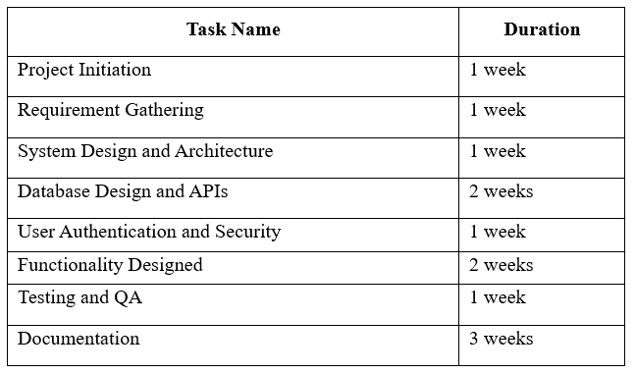
Table 3.1: Gantt chart Table for Learning and Management System

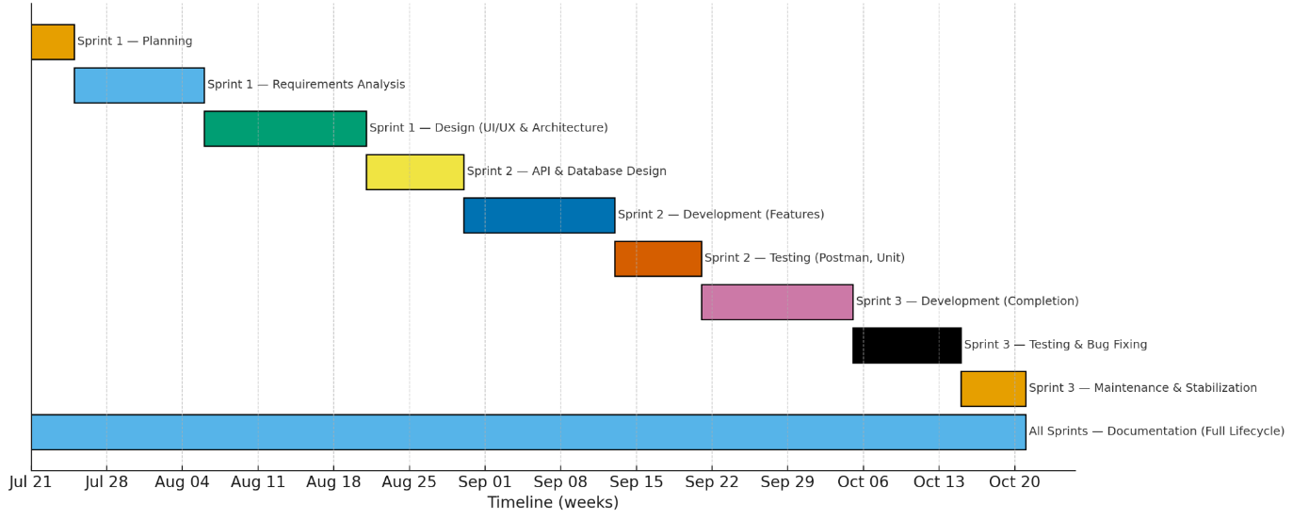
Figure 1: Gantt chart of LMS

Object Modelling using Class and Object Diagrams
Object modelling is used to represent real-world entities and their relationships in a software system. It helps visualize how data and operations are grouped into classes andhow these classes interact.
- Class Diagram
The class diagram of the Learning and Management System involves Users. The central Users class stores common attributes such as username, email, password, role, facultyId and batchId. According to the value of role, a user behaves as student, teacher or **admin`, each with its own operations such as submitting assignments, managing materials and managing academic data.
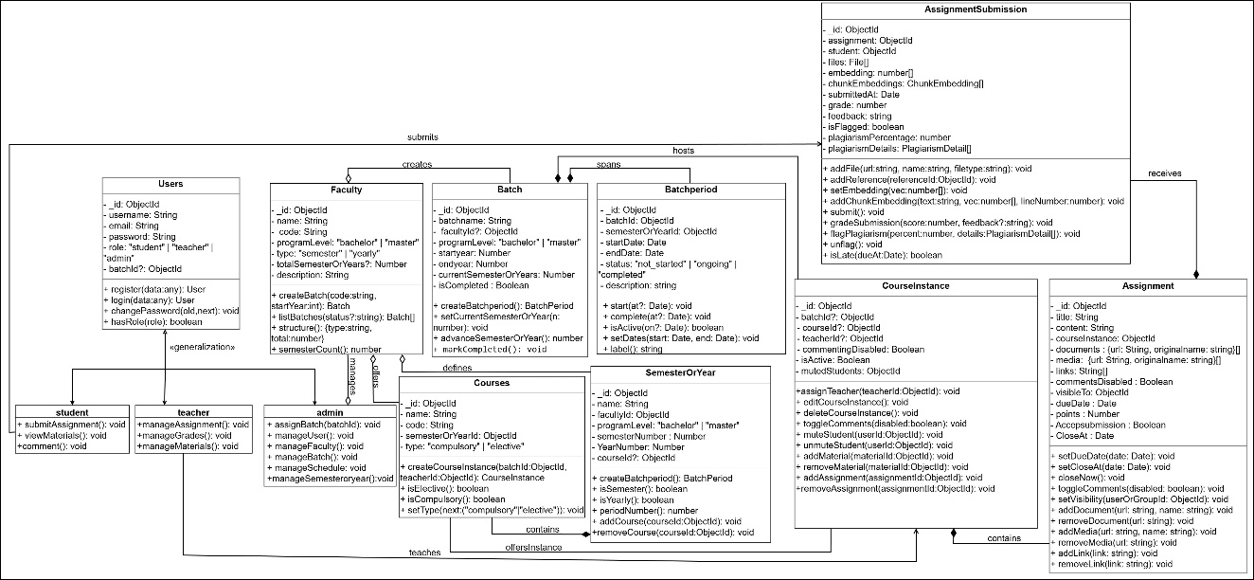
Figure 2: Class Diagram of LMS

- Object Diagram
Object diagram illustrates a snapshot of the running system, showing how specific admin, teacher, student, faculty, batch, course, assignment and submission objects are related to each other in the LMS.
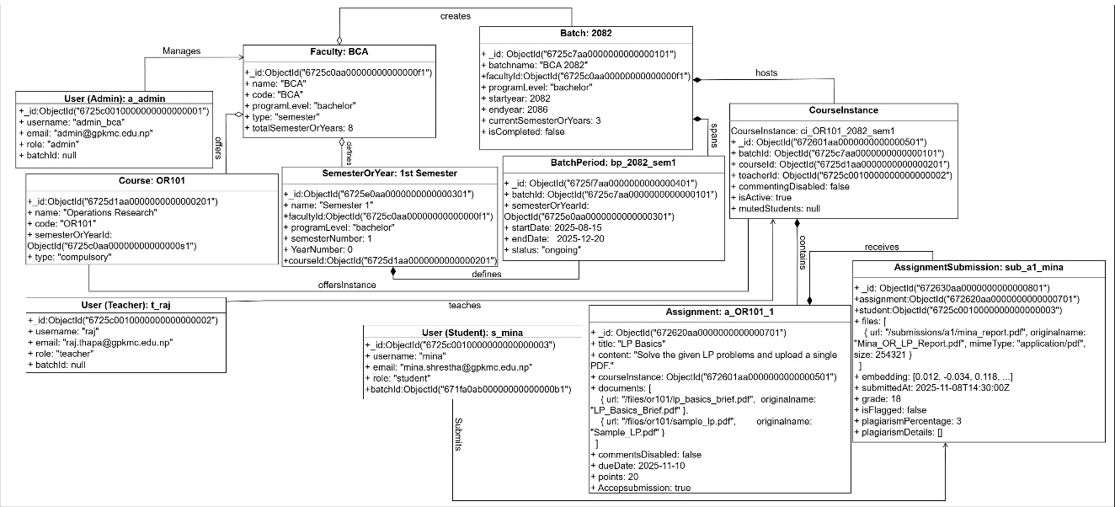
Figure 3: Object Diagram of Learning and Management System

Dynamic Modelling using State and Sequence Diagrams
Dynamic modelling describes how the system behaves over time and how various components interact during specific operations. It helps to understand the flow of activities, changes in system states, and object communication.Two key tools used for dynamic modeling are the State Diagram and Sequence Diagram.
- State Diagram
The state diagram shows the lifecycle of an assignment submission in the LMS. When a student opens an assignment, the submission is in the open for submission state. After the student uploads the file, it moves to the Uploaded state, where the system automatically runs the plagiarism check. If the plagiarism percentage is greater than 30%, the submission transitions to the Rejected state and are not stored as a valid submission. If the plagiarism percentage is less than or equal to 30%, it moves to the Submitted state. When the teacher opens the submission, it enters the Viewed by Teacher state, and after the teacher assigns marks and feedback, the submission finally reaches the Graded state, where the process ends.
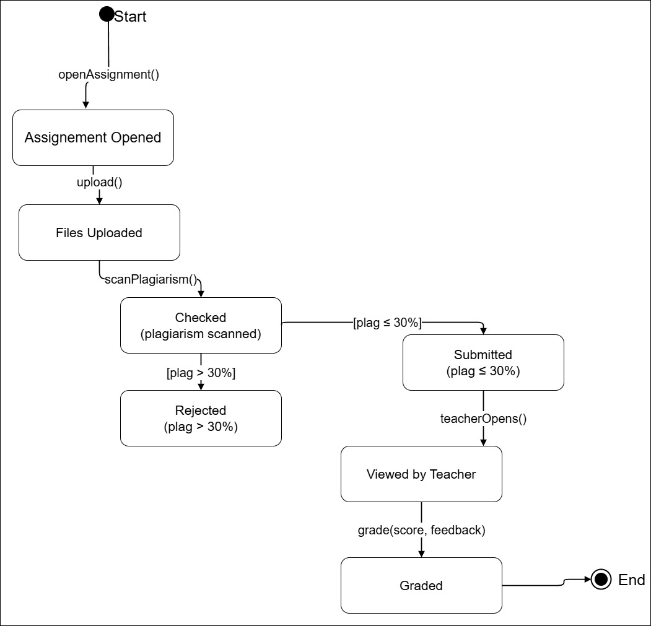
Figure 4: State Diagram of Assignment Submission with Plagiarism Control

- Sequence Diagram
The sequence diagram shows how the Admin, after logging in through the Auth Service, sequentially uses different services (User, Faculty, Semester/Year, Batch, BatchPeriod, Course, CourseInstance, Schedule and Leave) to create, edit and delete users and academic master data, thereby configuring the entire LMS for the campus.
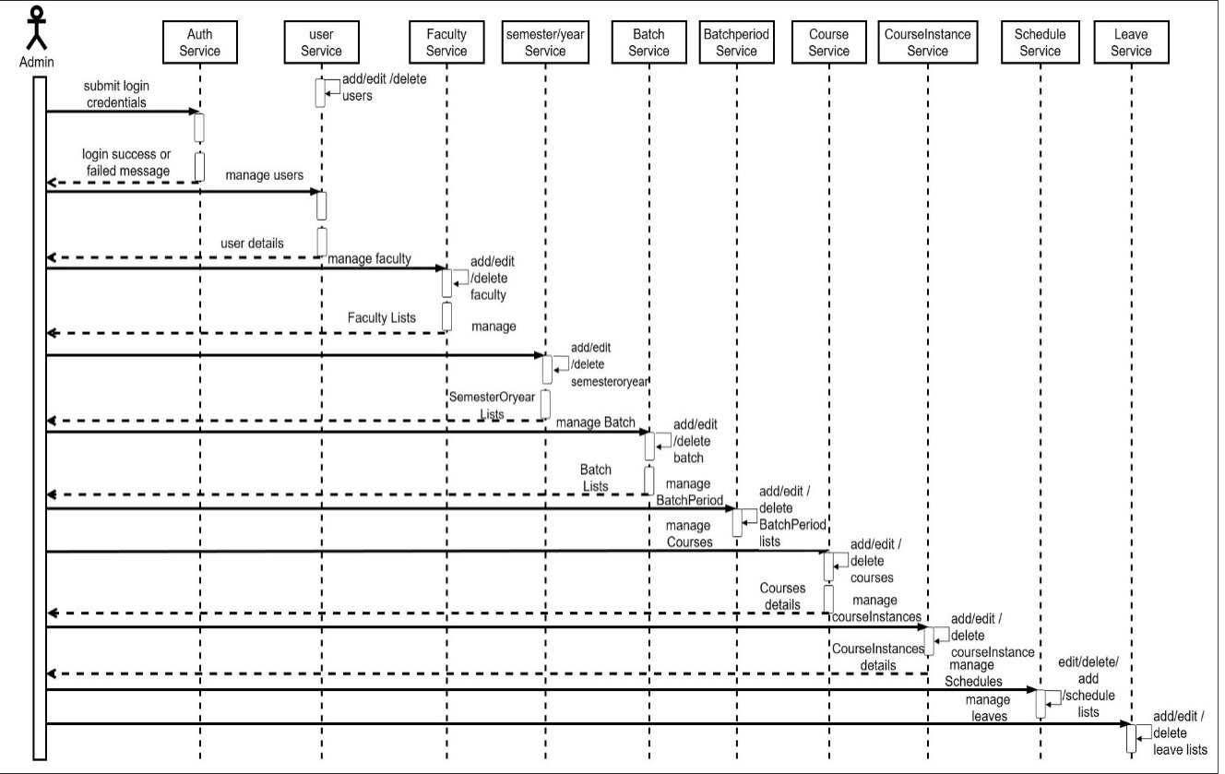
Figure 5: Sequence Diagram for Admin Master Data Management

Process Modeling using Activity Diagrams
Process modeling helps in visualizing how different tasks are carried out step-by-step in the system. It shows the flow of control and decision points involved in a particular use case or process. For this project, the following models are used:
- Activity Diagram
This activity diagram shows how a student submits an assignment in the LMS. The student logs into the system, opens the course and assignment, and uploads the assignment files. The system then scans the files for plagiarism. If the plagiarism percentage is ≤ 30%, the activity flows to Submission accepted (Submitted). If it is >30%, the system shows a warning and the flow returns to Upload assignment files so the student can re-upload a revised solution before ending.
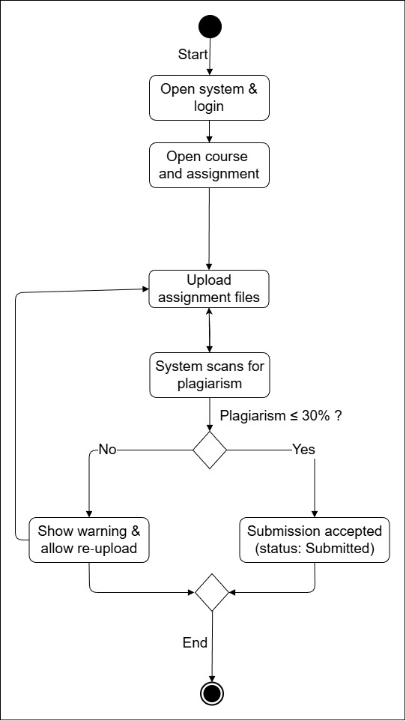
Figure 6: Activity Diagram for Assignment Submission with Plagiarism Check

This activity diagram shows how a teacher reviews and grades assignment submissions in the LMS. After logging in, the teacher opens the course and assignment, then views the list of submissions. If there are ungraded submissions, the teacher selects one and reviews the files together with the plagiarism report. When any serious plagiarism or issue is found, the submission is marked as flagged and the teacher can request resubmission. Otherwise, the teacher enters marks and feedback and saves the grade. The process is repeated until all submissions are handled, after which the teacher logs out and the activity ends.
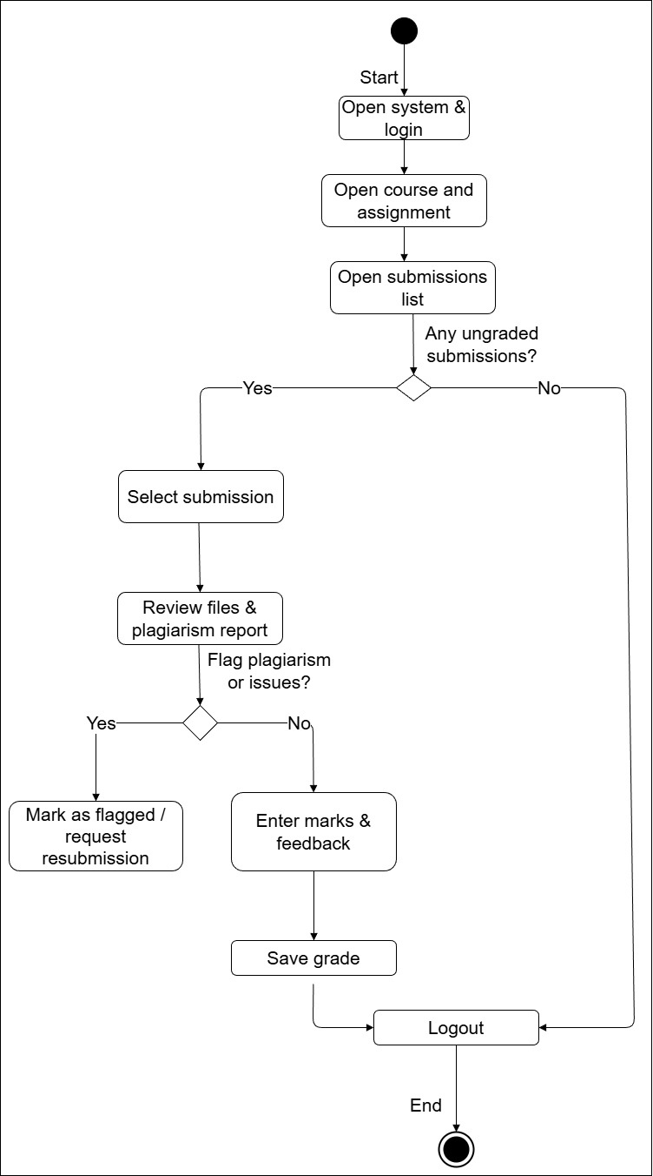
Figure 7: Activity Diagram for Teacher Grading Assignment Submissions

- Flowchart
A Flowchart is used to show a broader logical sequence of actions in the system.
This flowchart shows the main flow of the LMS from the Home Page. After registration or successful login, the user is routed to Admin, Teacher or Student dashboard. Admin can manage users, faculties, batches, semesters, course instances, timetables, announcements, leave requests and reports. Teachers create materials, assignments and quizzes, manage attendance sessions and record internal marks. Students view schedules and materials, submit assignments and quizzes, join attendance sessions, request leave and view grades. All users finally log out, ending the session.
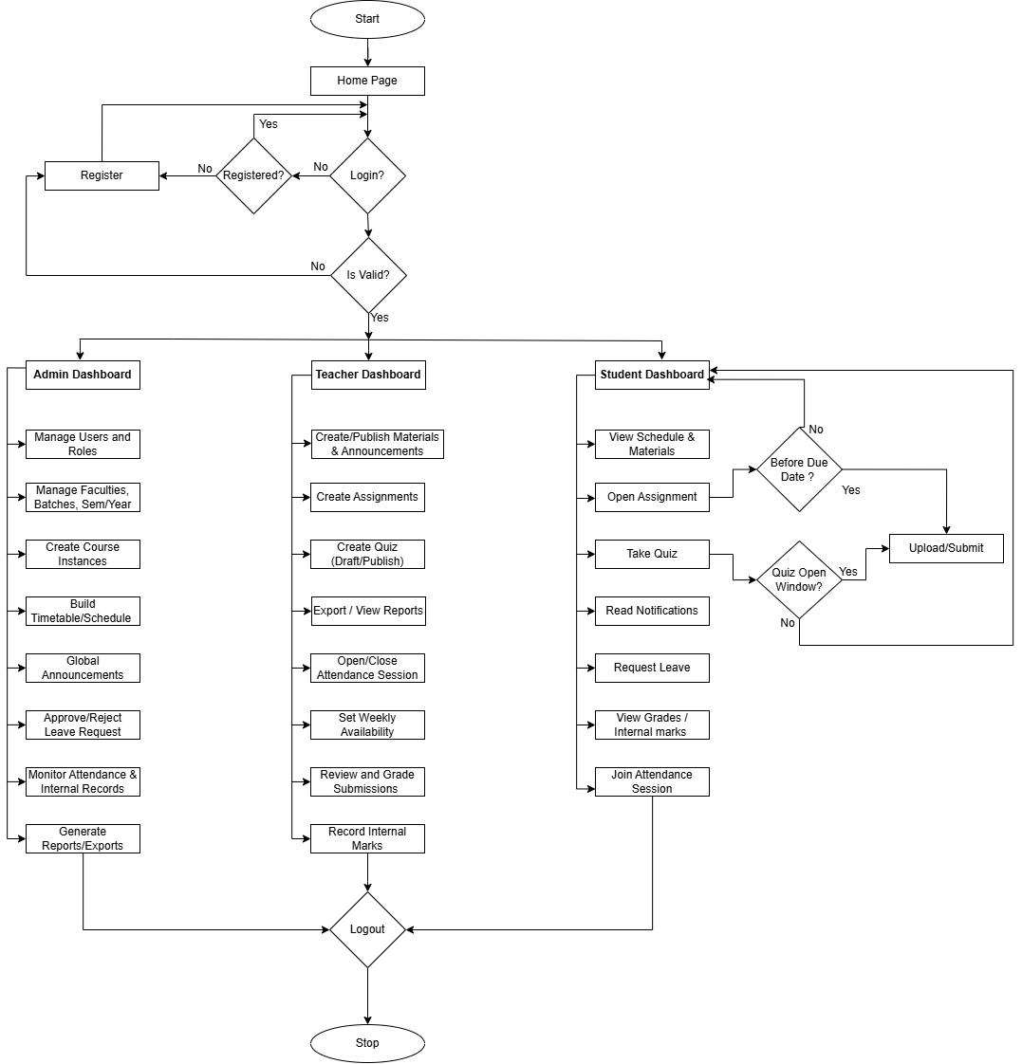
Figure 8: Overall System Flowchart of LMS

- DFD (Data Flow Diagram)
DFD Level 0 (Context Diagram)
This diagram shows the LMS as a single central process and its interactions with the three external entities: Admin, Teacher and Student. Admin sends login requests and management requests (users, courses, batches, faculties, schedules) and receives confirmations, details and reports. Teachers log in, create materials, assignments, quizzes and attendance, and receive submission lists, notifications and comments. Students log in, request materials, submit assignments and view grades, and the system responds with materials, grades, schedules and notifications.
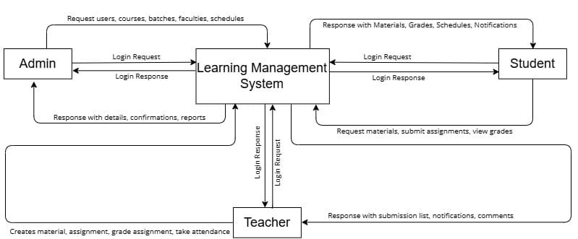
Figure 9: Level-0 DFD of Learning and Management System

System Design
To realize the different functional requirement of the system in graphical form, different design diagram of the system has been prepared which are as follows:
- ER Diagram
This ER diagram shows the main data entities and their relationships in the LMS. The core user entity (admin, teacher, student) is linked to faculties, batchesand semesterOrYear through courses and courseInstance, which represent a specific subject taught to a specific batch and semester. Around this, supporting entities handle academic operations: assignments and assignmentSubmissions, quizQuestion and quizSubmissions, materials, schedule, teacherAvailability, attendanceSessions and attendanceRecords, as well as internalRecords for marks. Administrative features are modeled through announcements and leaveRequests. The cardinalities in the diagram show how one faculty can have many batches and courses, one course can have many course instances, and each course instance can have many materials, assignments, quizzes, attendance sessions and submissions, forming a complete data model for the LMS.
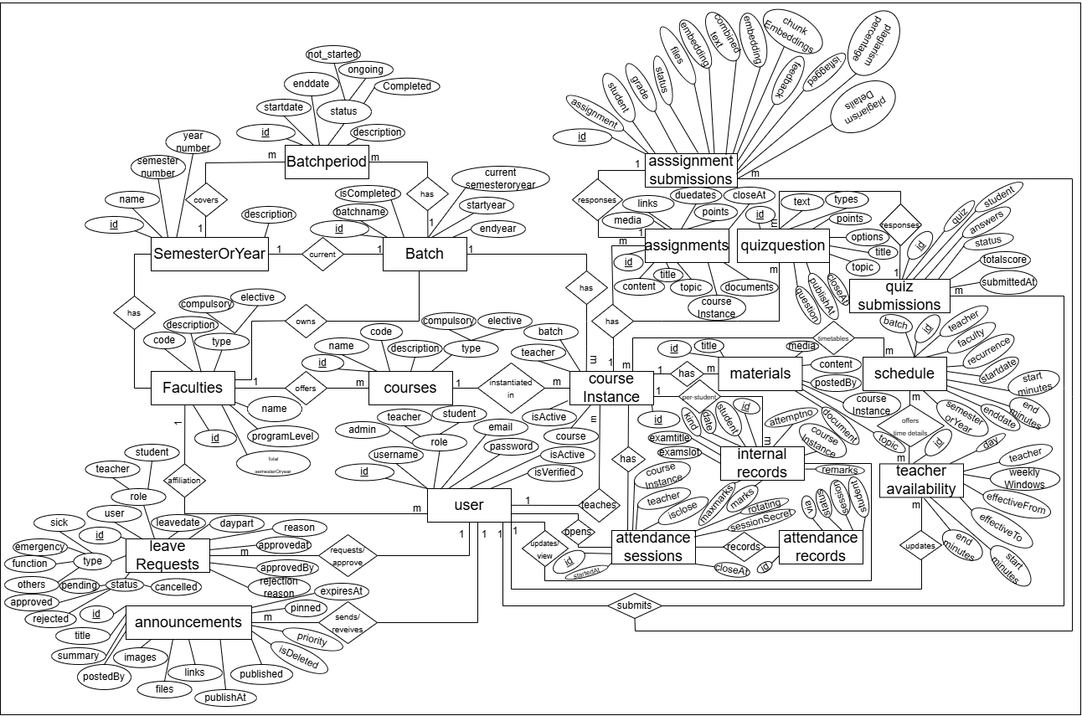
Figure 10: Entity–Relationship (ER) Diagram of LMS

- Architectural Design
This architecture diagram shows how the LMS is structured. Student, teacher and admin browsers access the Next.js frontend (hosted on Vercel) over HTTPS, which communicates with the Node.js/Express backend API via REST/WebSocket. The backend reads and writes data in MongoDB Atlas, stores uploaded files in file storage, sends plagiarism jobs to a separate Plagiarism Worker Service, and uses Google OAuth and other external services for authentication and integrations.

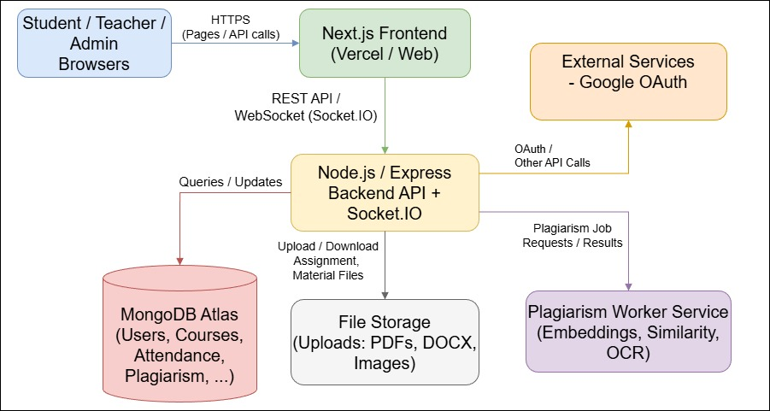
Figure 11: Architecture Diagram of LMS

Component Diagrams
This component diagram shows the main parts of the LMS and how they interact. The LMS Frontend (Next.js) talks to the Backend API (Node.js/Express), which is divided into modules for Auth & User Management, Teaching & Learning, Academic Master Data, Attendance and Schedule. The backend reads/writes data in MongoDB Atlas, stores files in the File Storage component, and communicates with external components such as Google OAuth for login, the Plagiarism Worker Service for similarity checks and a Scheduling Algorithm component for timetable generation.
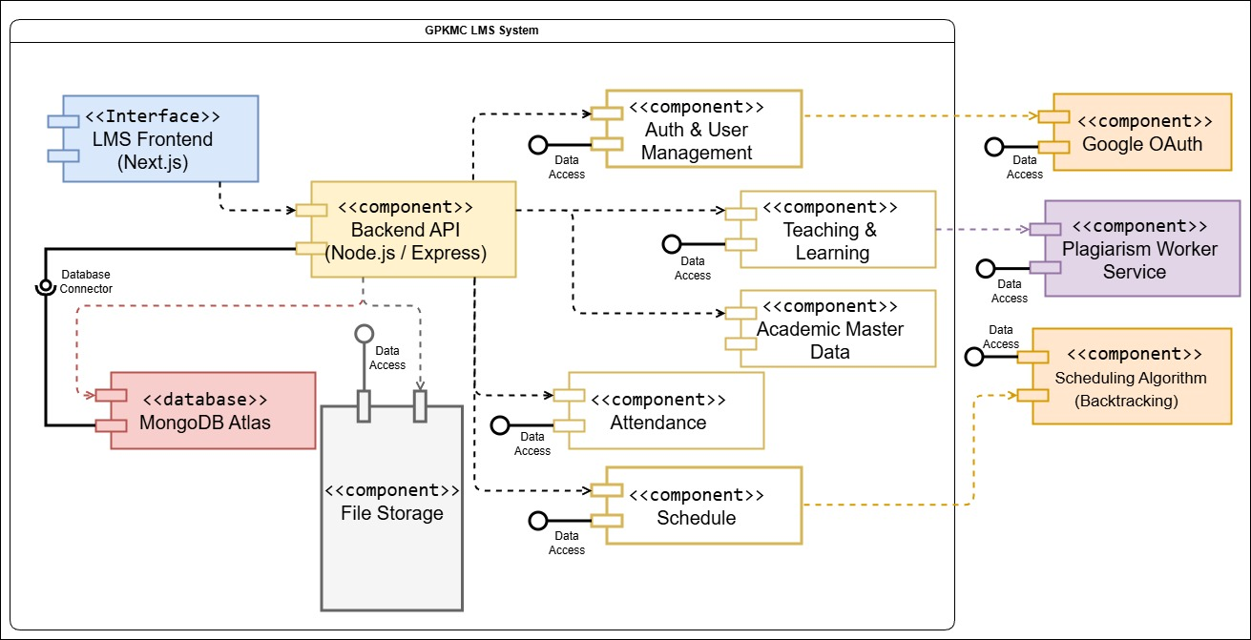
Figure 12: Component Diagram of LMS

Deployment Diagrams
This deployment diagram shows how the LMS is deployed in the real environment. Users access the system from a client web browser over HTTPS, connecting to the GPKMC LMS web server running Node.js and Express. The web server communicates with the MongoDB Atlas database server for data storage, the Gmail SMTP email server for sending notifications, the external Google OAuth provider for authentication, and an external Embeddings/Plagiarism API (e.g., Hugging Face) for similarity checking via HTTPS API calls.
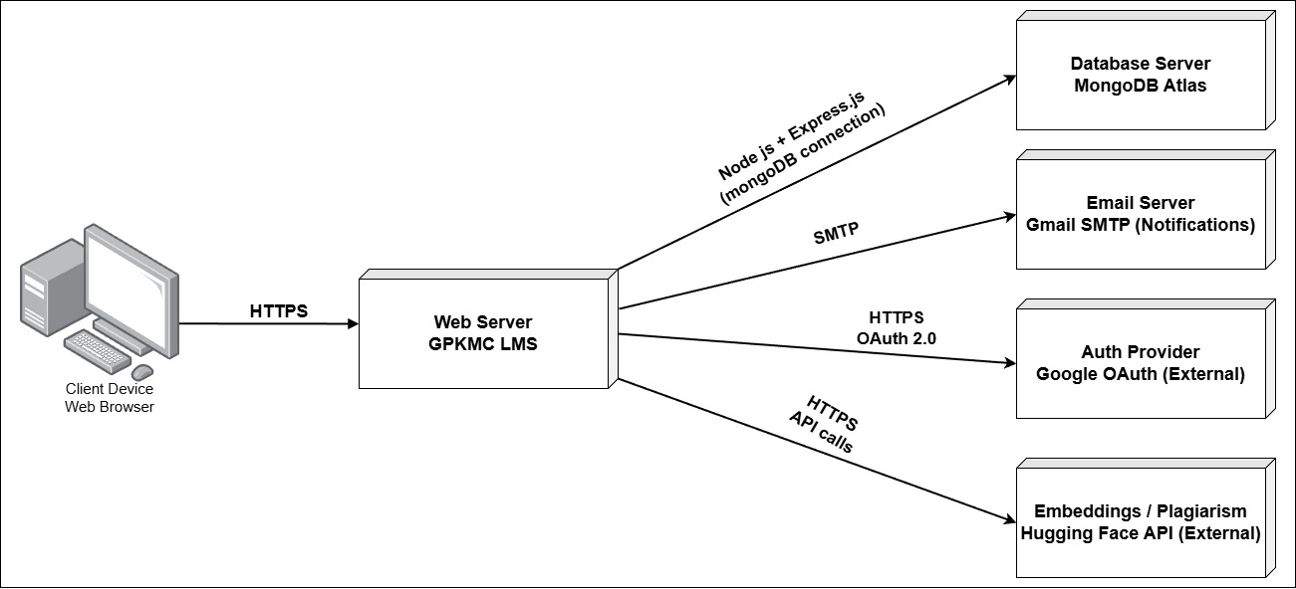
Figure 13: Deployment Diagram of LMS

Algorithm Details
This project mainly uses two custom algorithms:
- a plagiarism detection algorithm based on sentence embeddings and cosine similarity, and
- a class schedule generation algorithm based on backtracking to avoid clashes.

Assignment submissions with plagiarism detection
The plagiarism checker converts assignment text into numeric vectors and compares them with existing submissions and reference materials to find semantic similarity, not only exact word match.
Steps of the algorithm
- Text Extraction
  - When a student uploads files (PDF/DOCX/…), the system extracts plain text from each file and concatenates it.
- Chunking
  - The combined text is split into small overlapping chunks of fixed length (e.g. 20 words per chunk).
  - Each chunk is treated as one “unit” to compare.
- Embedding Generation (Hugging Face / BERT)
  - For every chunk, the system calls hf.featureExtraction() using the model
sentence-transformers/all-MiniLM-L6-v2.
  - Hugging Face tokenizes the chunk, passes it through Transformer layers and returns a sentence embedding vector.
  - The vector is L2-normalized so that cosine similarity can be used.
- Similarity Comparison
  - The embedding of each student chunk is compared (cosine similarity) with embeddings from:
    - previous assignment submissions
    - group submissions
    - question submissions
    - reference documents
  - If cosine similarity is above a threshold (e.g. 0.75–0.85), that chunk is treated as a match.
- Coverage and Percentage Calculation
  - Let totalChunks = number of chunks in the student’s text.
  - Let matchedChunks = number of chunks that had at least one similar match.
  - Plagiarism percentage is calculated as:
plagiarismPercentage=matchedChunkstotalChunks×100plagiarismPercentage = \frac{matchedChunks}{totalChunks} \times 100plagiarismPercentage=totalChunksmatchedChunks​×100
- Decision Rule (30% threshold)
  - If plagiarismPercentage ≥ 30, the submission is rejected and the student is asked to revise and resubmit.
  - If plagiarismPercentage< 30, the submission is accepted and stored with its plagiarism score.
Pseudo-code
Input: uploadedFiles, referenceEmbeddings
Extract text from uploadedFiles → combinedText
chunks ← split combinedText into word chunks

for each chunk in chunks:
emb ← embedding(chunk) // Hugging Face featureExtraction
store emb in chunkEmbeddings

matchedChunks ← 0
for each emb in chunkEmbeddings:
if exists refEmb in referenceEmbeddings
such that cosineSimilarity(emb, refEmb) ≥ threshold:
matchedChunks++

plagiarismPercentage ← (matchedChunks / |chunks|) * 100

if plagiarismPercentage ≥ 30:
status ← "PLAGIARIZED" // reject
else:
status ← "ACCEPTED" // save submission

Timetable Generation Algorithm (Backtracking + Forward-Checking)
The timetable module automatically generates weekly schedules for course instances using backtracking and forward-checking, while ensuring:
- no teacher has two classes at the same time,
- no batch has two classes at the same time, and
- the same course instance is not scheduled more than once on the same day (one “Math OR101 – BCA 2082” class per day is allowed, but it can appear again on other days of the week).
Main steps
- Candidate slot generation
  - For each task (course instance + sessions per week + duration), the system looks at the teacher’s availability and generates all possible day/time slots in 30-minute steps (candidates).
- Units and ordering
  - Each required session per week becomes a unit.
  - Units are sorted by increasing number of candidates (most constrained first).
- Existing busy map
  - All existing weekly ScheduleEvents in the date range are loaded into a busy map per weekday to represent already occupied times.
- Backtracking search
  - The algorithm recursively assigns a candidate slot to each unit:
    - it checks for clashes with placed units and with the busy map
(teacher conflict, batch conflict, or same course instance already scheduled that day);
    - if a clash occurs, it tries the next candidate;
    - if no candidate works, it backtracks to the previous unit and chooses a different slot there.
- Forward-checking
  - After tentatively placing a unit, a forward check verifies that every remaining unit still has at least one non-clashing candidate left.
  - If any future unit has zero possible slots, the current choice is abandoned immediately, pruning dead-end branches early.
- Transactional persistence
  - When a complete, clash-free timetable is found, all generated ScheduleEvent records are saved inside a single database transaction.
  - If any save fails, the transaction is rolled back so the timetable is never partially stored.
Simplified pseudo-code
units ← expandTasksIntoUnits(tasks) // each session to schedule
sort units by candidates.length ascending
busy ← loadExistingEvents()

function backtrack(i):
if i = units.length: return true // all scheduled

for each slot in units[i].candidates:
if not clashes(slot, placed, busy):
placed.push(slot)
if forwardCheck(units, i, placed, busy) and backtrack(i+1):
return true
placed.pop()
return false

if backtrack(0) = true:
begin transaction
save placed slots as ScheduleEvents
commit
else
report "No feasible timetable"

CHAPTER 4: IMPLEMENTATION AND TESTING

Implementation
In this phase, theoretical design is turned into practice i.e., working system. The most crucial stage in achieving a new successful system and in giving confidence on the new system for the users that it will work efficiently and effectively.
The system can be implemented only after thorough testing is done and if it is found to work according to the specification

Tools Used (CASE tools, Programming languages, Database platforms)
- Programming Languages and Frameworks
  - JavaScript / TypeScript – main programming language for both frontend and backend.
  - Next.js (React) – used to implement the frontend user interface, routing and pages for admin, teacher and student dashboards.
  - Node.js with Express.js – used to implement the backend REST API, request handling, middleware and business logic.
- Database Platform
  - MongoDB Atlas – cloud-based NoSQL database used to store all persistent data such as users, faculties, batches, courses, course instances, assignments, submissions, schedules, attendance sessions and records, and announcements.
  - Mongoose – Object Data Modelling (ODM) library used to define schemas, validate data and interact with MongoDB from the Node.js backend.
- CASE / Design and Documentation Tools
  - draw.io / Visual Paradigm – used for drawing UML diagrams (use case, class, activity, sequence) and DFDs.
  - Microsoft Word / Google Docs – used for preparing the project report and documentation.
  - Microsoft Excel / Google Sheets – used for preparing Gantt charts and requirement lists.
- Testing and Development Tools
  - Visual Studio Code – source code editor used for writing and debugging code.
  - Postman – used to test REST APIs.
  - Google Chrome / Microsoft Edge – used to test and run the web application.
  - Git and GitHub – used for version control and team collaboration.
- Deployment Platforms
  - Vercel – used for deploying the Next.js frontend.
  - Render – used for deploying the Node.js / Express backend as a web service.
  - MongoDB Atlas – used as the remote database linked with the backend.

ImplementationDetailsofModules
The implementation of various modules in the LEARNING AND MANAGEMENT SYSTEM is carried outmeticulously to ensure the system's effectiveness and seamless functionality. The system is organized into several modules. Each module is implemented using Express routes, controller functions and Mongoose models on the backend, and React components and pages on the frontend.
- Authentication and Authorization Module
- Classes / Collections:User
- Main Fields:username, email, passwordHash, role (admin / teacher / student), facultyId, batchId, status.
- Procedures / Functions:
  - POST /auth/login – verifies email and password, and on success generates a JSON Web Token (JWT) containing user ID and role.
  - authMiddleware – Express middleware that verifies JWT, attaches user information to the request and blocks unauthenticated access.
  - roleMiddleware(role) – checks whether the current user has the required role (admin, teacher or student) before accessing protected routes.
- Logic:
  - Passwords are hashed using a secure hashing algorithm.
  - After successful login, the frontend stores the JWT and uses it for subsequent API calls.
  - Based on the role, the frontend redirects the user to the corresponding Admin, Teacher or Student dashboard.
- User, Faculty, Batch and Course Management Module
- Classes / Collections:User, Faculty, Batch, SemesterOrYear, Course, CourseInstance.
- Key Functions:
  - POST /users (admin only) – create new teacher or student users with assigned faculty and batch.
  - PUT /users/:id – update user details or role, or deactivate a user.
  - POST /faculties, POST /batches, POST /semesters – manage academic structure.
  - POST /courses – create new course with code, title and credit hours.
  - POST /course-instances – link a course with a particular faculty, batch and semester/year and assign a responsible teacher.
- Logic:
  - Validation prevents duplicate user emails and duplicate course instances for the same course, batch, semester and teacher.
  - Course instances are used as the central link for assignments, quizzes, schedules, attendance and announcements.
- Schedule Management Module
- Classes / Collections:ScheduleEvent.
- Key Fields:courseInstanceId, dayOfWeek, startTime, endTime, optional room.
- Key Functions:
  - POST /schedule – create a schedule event for a course instance.
  - GET /schedule/teacher/:id – fetch schedule for a particular teacher.
  - GET /schedule/student/:id – fetch schedule for a particular student based on enrolled course instances.
- Logic / Algorithm:
  - Before saving a new schedule event, the system checks for time clashes for the same teacher.
  - The frontend displays schedule in list or calendar view for teachers and students.
- Assignment, Quiz and Plagiarism-Controlled Submission Module
- Classes / Collections:Assignment, Quiz, Submission.
- Assignment Creation:
  - Teacher selects a course instance and fills in title, description and deadline.
  - Files can be attached; data is stored in the assignments collection.
- Student Submission Procedure:
  - Student uploads assignment file or answer.
  - Backend extracts text and sends it to the plagiarism checking component.
  - Component compares content with reference documents and other submissions and returns a plagiarism percentage.
  - The backend applies the following rule:
    - If plagiarismPercentage< 30% → submission is accepted and stored in submissions with status = "Submitted".
    - If plagiarismPercentage ≥ 30% → submission is rejected, and the student receives a message to revise and resubmit. It is not shown to the teacher as a normal submission.
- Quiz Implementation:
  - Teachers create quizzes with objective questions.
  - When students submit answers, the system compares selected options with the correct options and automatically stores marks.
- QR-Based Attendance Module
- Classes / Collections:AttendanceSession, AttendanceRecord.
- Key Fields:
  - AttendanceSession: courseInstanceId, date, startTime, endTime, token, status.
  - AttendanceRecord: sessionId, studentId, timestamp, deviceInfo, isPresent.
- Main Procedures:
  - POST /attendance/sessions – teacher creates an attendance session; backend generates a unique token/QR code with start and end time.
  - POST /attendance/mark – student scans QR or enters token; backend validates token and session status and records attendance.
  - GET /attendance/report/:courseInstanceId – teacher retrieves attendance summary for a course.
- Algorithm:
  - Attendance is accepted only during the active session time.
  - Duplicate attendance for the same student and session is prevented.
  - Reports calculate total classes and attendance percentage.
- Announcement and Notification Module
- Classes / Collections:Announcement (or Notification).
- Key Fields:title, message, createdBy, targetFaculty, targetBatch, targetCourseInstance, createdAt.
- Procedures:
  - Admins and teachers create announcements by selecting target faculty/batch/course instance.
  - Frontend retrieves announcements filtered by the logged-in user’s faculty, batch and enrolled courses.
- Logic:
  - Only relevant users (students and teachers belonging to the target group) can see a particular announcement, ensuring focused communication.

Testing
Testing is an essential phase of software development that ensures the developed system functions correctly, efficiently, and reliably. The main objective of testing is to identify errors, verify that the system meets the specified requirements, and validate that it performs as expected under various conditions. In this project, testing was carried out for the Learning and Management System (LMS), which involves three main users: Admin, Teacher, and Student.

Testing Objectives
The objectives of testing this system are:
- To verify that all modules perform according to functional requirements.
- To identify and correct defects before deployment.
- To ensure that integrated components work together seamlessly.
- To validate that user interactions (Admin, Teacher, Student) produce the expected results

Unit Test Cases
Unit testing focuses on individual functions such as login, assignment submission with plagiarism check, QR attendance and schedule creation

Table 4.1: Test cases for Login of LMS
S.No. | Test Name | Input | Expected Output | Actual Output | Test Result
1. | Admin Login Failure | Email: wrongadmin@gpkmc.edu.np / Password: wrongpass | Message “Invalid email or password” should display. | As expected. | Pass
2. | Admin Login Success | Email: admin@gpkmc.edu.np / Password: correctpass | Admin dashboard should open successfully. | As expected. | Pass
3. | Teacher Login Success | Email: teacher1@gpkmc.edu.np / Password: correctpass | Teacher dashboard should open successfully. | As expected. | Pass
4. | Student Login Success | Email: student1@gpkmc.edu.np / Password: correctpass | Student dashboard should open successfully. | As expected. | Pass

Table 4.2: Test cases for Assignment Submission with Plagiarism Control

S.No. | Test Name | Input | Expected Output | Actual Output | Test Result
1. | Submission below plagiarism threshold | Student uploads assignment. Plagiarism result = 22%. | Assignment should be accepted, saved in database and shown in teacher’s submission list. | As expected. | Pass
2. | Submission exactly at plagiarism threshold | Student uploads assignment. Plagiarism result = 30%. | Assignment should be rejected with message “Plagiarism too high, please revise and resubmit.” | As expected. | Pass
3. | Submission above plagiarism threshold | Student uploads assignment. Plagiarism result = 75%. | Assignment should be rejected and not forwarded to the teacher as a normal submission. | As expected. | Pass
4. | Plagiarism service failure | Student submits assignment but plagiarism engine is temporarily unavailable. | System should show error “Unable to check plagiarism now, please try again” and should not accept the submission. | As expected. | Pass

Table 4.3: Test cases for QR-based Attendance
S.No. | Test Name | Input | Expected Output | Actual Output | Test Result
1. | Create QR attendance session | Teacher selects course instance and clicks Start Attendance for today’s class. | New attendance session created with unique token/QR and status Active. | As expected. | Pass
2. | Mark attendance within time | Student scans QR code during active session. | Attendance record should be stored with student ID and marked Present. | As expected. | Pass
3. | Prevent duplicate attendance | Same student scans QR code twice for the same session. | Only first record should be stored; second attempt should show message “Attendance already recorded”. | As expected. | Pass
4. | Attendance after session expiry | Student tries to scan QR after session time is over. | System should not accept attendance and should display message “Attendance session has expired”. | As expected. | Pass

Table 4.4: Test cases for Schedule Management
S.No. | Test Name | Input | Expected Output | Actual Output | Test Result
1. | Create valid schedule entry | Admin assigns BCA 3rd sem OOP class on Sunday 7:00–8:00 for Teacher A. | Schedule should be saved and visible in Teacher A and related students’ schedules. | As expected. | Pass
2. | Prevent overlapping schedule for same teacher | Admin tries to assign another class to Teacher A on Sunday 7:00–8:00. | System should show message “Schedule conflict for this teacher and time” and should not save the new entry. | As expected. | Pass

System Test cases for LMS
System testing checks complete flows involving multiple modules and roles (Admin, Teacher, Student).
Table 4.5: System Test Cases for LMS
S.No. | Test Name | Input / Scenario | Expected Output | Actual Output | Test Result
1. | Student academic flow | Student logs in → views enrolled courses and schedule → downloads materials → submits assignment (plagiarism < 30%) → attempts quiz → checks attendance. | Student should complete all actions without error; assignment accepted; quiz marks stored; attendance records and percentages displayed correctly in student dashboard. | As expected. | Pass
2. | Teacher teaching flow | Teacher logs in → views assigned course instances → creates schedule → creates assignment → starts QR attendance → checks submissions and gives marks. | All created schedules and assignments should be visible; QR attendance should record present students; valid submissions with plagiarism < 30% should appear for marking and result entry. | As expected. | Pass
3. | Admin setup and management flow | Admin logs in → creates faculty and batch → adds courses → creates course instances and assigns teachers → views overall reports and posts an announcement. | Faculty, batch and courses should be stored; course instances should appear on teacher and student dashboards; reports should show correct data; announcement visible to targeted users. | As expected. | Pass
4. | Role-based access control | Student tries to open admin URL directly and teacher tries to access user management page. | Both should be blocked and see “Access denied” or redirected to their own dashboard; only admin should access admin-only pages. | As expected. | Pass

Testing Tools
- Postman – for API and backend testing
- MongoDB Compass – for database validation
- Browser Developer Tools – for frontend debugging

Result Analysis
Based on the unit and system testing carried out:
- Functional Correctness:
Most test cases for authentication, user and course management, schedule, QR attendance, assignments, plagiarism checking and announcements passed successfully. The system meets the functional requirements specified during analysis.
- Plagiarism Control:
The 30% plagiarism threshold is correctly enforced. Submissions below the threshold are accepted and forwarded to teachers, while highly plagiarized submissions are blocked at the time of upload, helping to maintain academic integrity.
- Reliability of QR Attendance:
QR-based attendance sessions correctly accept only valid tokens within the active time period and prevent duplicate entries. Attendance summaries and percentages match manual calculations for sample data.
- Usability and Performance:
During testing, users were able to complete their typical tasks (logging in, seeing schedules, managing assignments, marking attendance) without major difficulties. Response time was acceptable for normal use.
The implementation and testing activities demonstrate that the developed Campus Learning and Management System is functionally sound, technically feasible and suitable for use in GPKMC. Any minor issues discovered during testing were fixed, and the system is ready for deployment and further enhancement.

CHAPTER 5: CONCLUSION AND FUTURE RECOMMENDATIONS

Conclusion
The main goal of this project was to design and develop a Campus Learning and Management System (LMS) that supports the daily academic activities of admins, teachers and students in a single integrated platform.
The existing practices of managing classes, assignments, attendance and notices through paper, spreadsheets and social media groups were time-consuming and error-prone. To address these problems, the proposed system was implemented using the MERN stack with a clear separation of frontend (Next.js), backend API (Node.js/Express) and database (MongoDB Atlas).
The system successfully provides:
- Secure authentication and role-based access for admins, teachers and students.
- Management of faculties, batches, semesters/years, courses and course instances, so that each subject is clearly linked with the correct batch and teacher.
- A schedule module that allows teachers and students to view upcoming classes and helps the campus avoid basic timetable conflicts.
- An assignment and quiz module, where teachers can create tasks and quizzes, and students can submit their work online.
- A plagiarism-controlled submission process, where each assignment is checked automatically. Submissions with similarity less than 30% are accepted and forwarded to the teacher, while highly plagiarized work is rejected at the time of upload, supporting academic integrity.
- A QR-based attendance module, where teachers generate attendance sessions and students mark their presence by scanning a QR code within a valid time window. Duplicate and late entries are automatically handled.
- An announcement feature that delivers notices to the relevant faculties, batches and courses instead of broadcasting everything to everyone.
Testing of individual modules and complete workflows (admin setup, teacher teaching flow, student learning flow) showed that the system works as expected and fulfills the major objectives stated in Chapter 1. Although this project is a prototype and not yet used as a full campus-wide product, it demonstrates that a web-based LMS tailored to GPKMC can significantly reduce manual work, centralize information and improve communication among admins, teachers and students.

Limitations of the System
While the system meets its core objectives, some limitations still remain:
- Web application only:
The system is designed mainly for desktop and mobile browsers. There is no separate Android or iOS mobile app at present.
- Internet dependency:
Users must have a stable internet connection to access the system, submit assignments or mark attendance. Offline usage is not supported.
- Limited integration:
The current version is focused on academic management. It does not fully integrate with other campus systems such as financial accounting, library system, TU exam portal or biometric devices.
- Basic timetable conflict checking:
Schedule conflict validation is limited mainly to detecting overlapping classes for the same teacher. More complex constraints (room capacity, parallel sections, etc.) are not handled.
- Plagiarism data source:
The plagiarism checking component mainly compares submissions within the system and with a limited reference set. It does not use a very large external database like commercial plagiarism tools.
- Single-language interface:
The interface is primarily in English. Full bilingual support (English/Nepali) is not yet implemented.
These limitations provide clear directions for future improvement and can be addressed in later versions of the system.

Future Recommendation
Based on the experience gained during development and testing, the following enhancements are recommended for future versions of the LMS:
- Mobile Application Development
  - Develop dedicated Android and iOS apps for students and teachers.
  - Provide features such as push notifications, offline viewing of materials and quick attendance scanning directly from the mobile app.
- Offline and Hybrid Support
  - Allow temporary offline access to downloaded lecture notes and assignments.
  - Synchronize attendance and submissions automatically when the device reconnects to the internet.
- Deeper Integration with Campus Systems
  - Integrate the LMS with finance, library and TU exam systems, so that a single platform can manage fees, book issues/returns, and official exam forms.
  - Provide APIs for exchanging data with other institutional software if needed.
- Enhanced Plagiarism Checking
  - Connect to larger plagiarism databases or external APIs to improve accuracy.
  - Generate more detailed reports for teachers, including highlighted matching segments and similarity sources.
- Extended Notification System
  - Integrate SMS gateway, email service and in-app notifications so that important announcements, deadlines and attendance alerts reach users through multiple channels.
- Security and Performance Improvements
  - Conduct periodic security audits and load testing.
  - Optimize database queries and caching mechanisms to support a larger number of concurrent users as the system grows.
In conclusion, the developed Campus Learning and Management System for GPKMC has successfully demonstrated how a customized LMS can streamline academic activities and improve coordination among admins, teachers and students. With further refinement and the incorporation of the above recommendations, the system has strong potential to evolve into a complete, production-ready solution for the campus and similar academic institutions.

REFERENCES

[1] | D. Turnbull, "LEARNING AND MANAGEMENT SYSTEMs: An Overview," in Encyclopedia of Education and Information Technologies, 2020, p. 213.
[2] | A. Acharya, "Digital Learning Initiatives, Challenges and Achievement in Nepal," media.neliti.com, 2021 . [Online]. Available: https://www.neliti.com/. [Accessed 8 2025].
[3] | NepJOL,"Nepal higher-education studies on online/blended learning adoption (bandwidth, devices, skills)," 2021–2025.
[4] | Moodle HQ, "Moodle LMS features: quizzes, gradebook, forums, attendance (plugin ecosystem),"official documentation [Online]. [Accessed 2025].
[5] | N. Reimers and I. Gurevych, "Sentence-BERT: Sentence Embeddings using Siamese BERT-Networks," arXiv, texas, 2019.
[6] | C. Neudecker, "A Survey of OCR Evaluation Tools and Metrics," in Proc. ACM DocEng, Chicago, 2021.
[7] | B. R. Duwal, "Factors Affecting the Online Learning Outcomes of Higher Education Students in Nepal," NepJOL, 2023. [Online]. [Accessed 2025].
[8] | R. Sethi, "Syntheses on LMS impact: organization, communication, assessment/feedback integration, and outcomes,," Multiple publishers, 2020–2024.
[9] | B. Jordan, "Reviews comparing open-source vs. cloud LMS trade-offs (usability, scalability, cost of ownership),," 2020–2025.
[10] | D. jonson, "An Overview of the Common Elements of LEARNING AND MANAGEMENT SYSTEMs Policies,” Education Sciences," Education Sciences (Educ. Sci.), vol. 5, no. 21, 2022.
[11] | W3C, Writer, “Web Content Accessibility Guidelines (WCAG) 2.1,” 2025.
[12] | google.Inc, "Get started with Google Classroom: assignments and communication product/help documentation and field reports, accessed 2025," Google . [Online]. [Accessed 2025.].
[13] | L. Sufean, "Challenges of Online Learning in the Post Covid-19 Era," ELTP Journal, vol. 2, no. 12, p. 101, 2023.
[14] | softwarica college, "C4mpus4.0 overview: enrollment, attendance, timetable, examinations, fee processing; web and mobile access," Softwarica college, Nepal, 2025.

APPENDIX
Frontend Overview
- Login Page (Student)
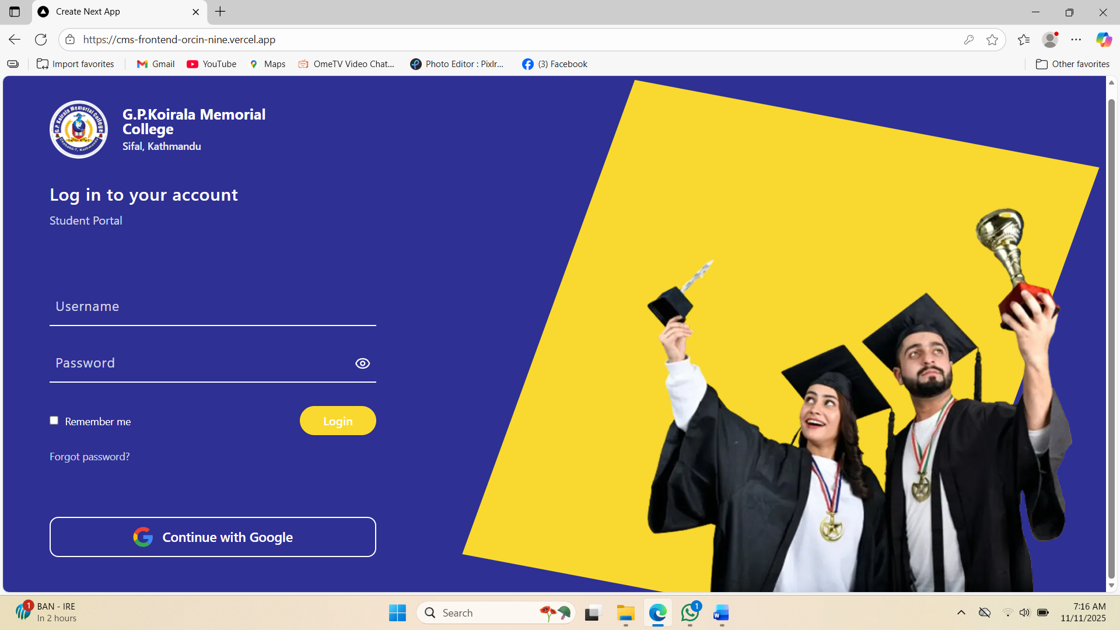

- Home Page (Student)
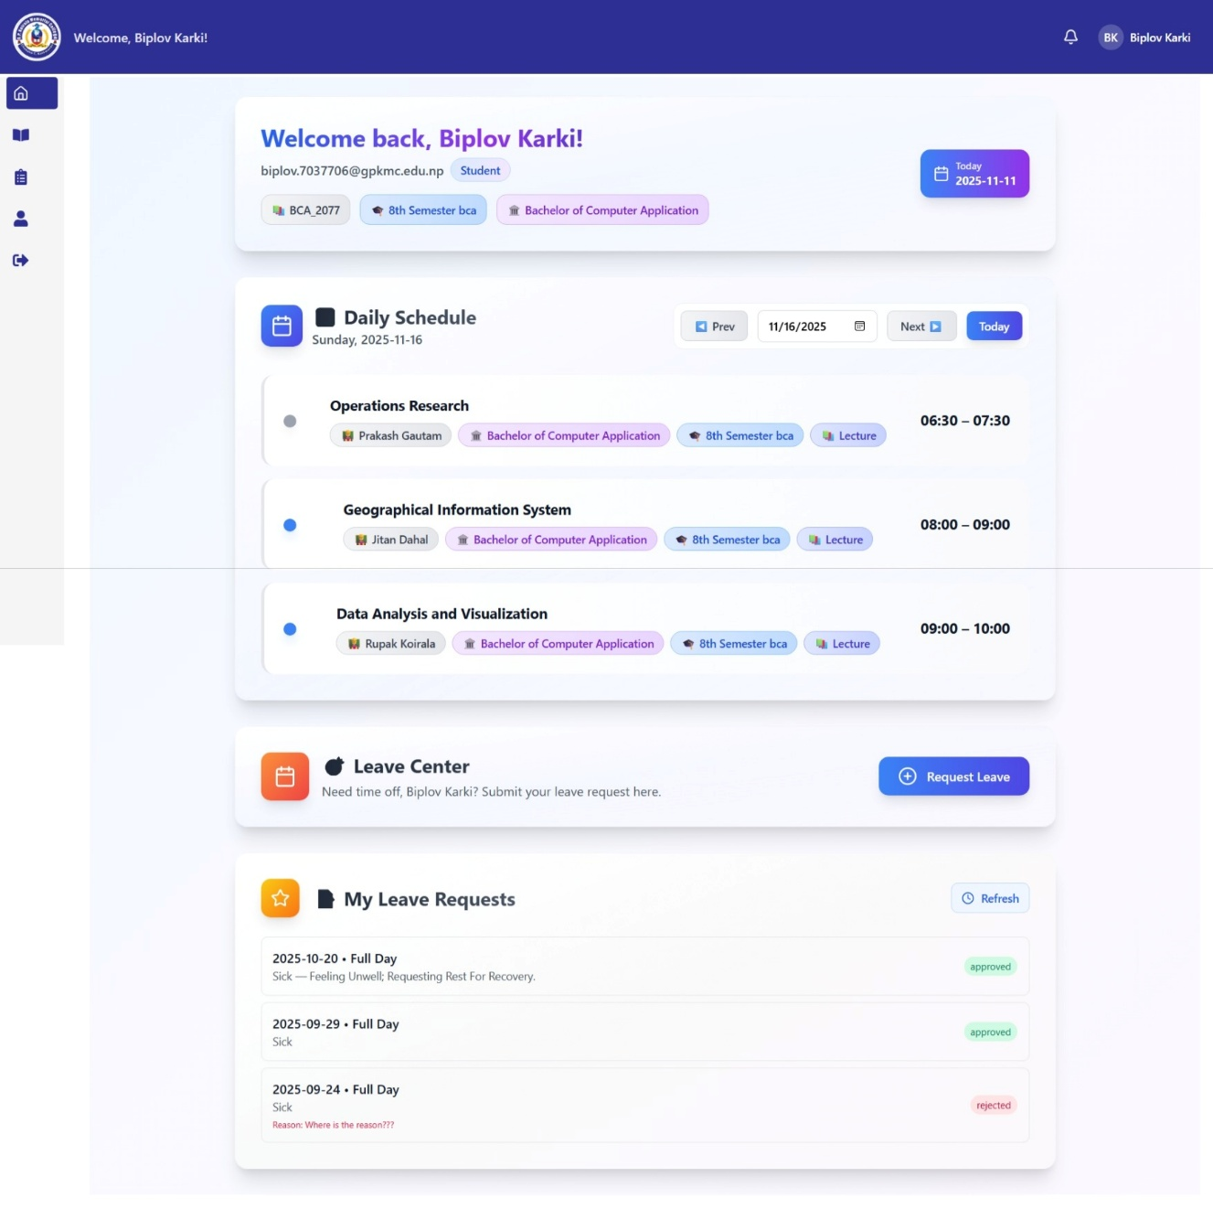

- Classroom Overview Page (Student)
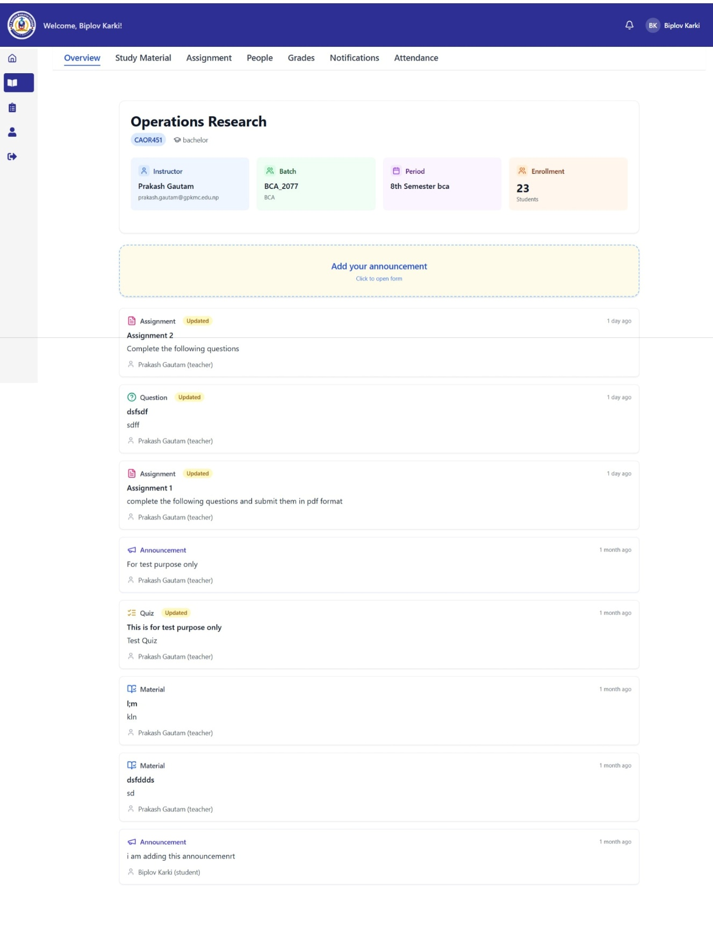

- Assignment page
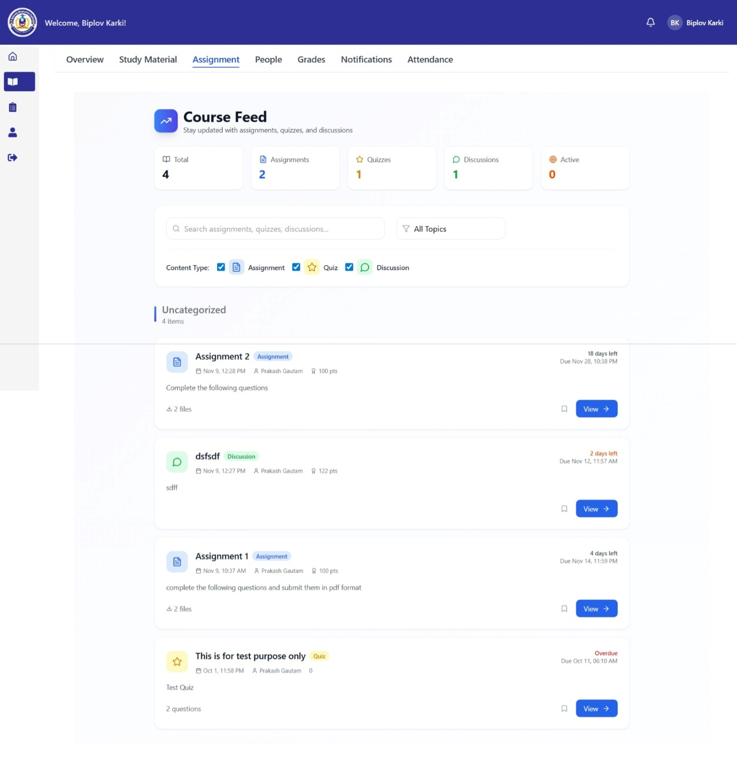

- Profile page
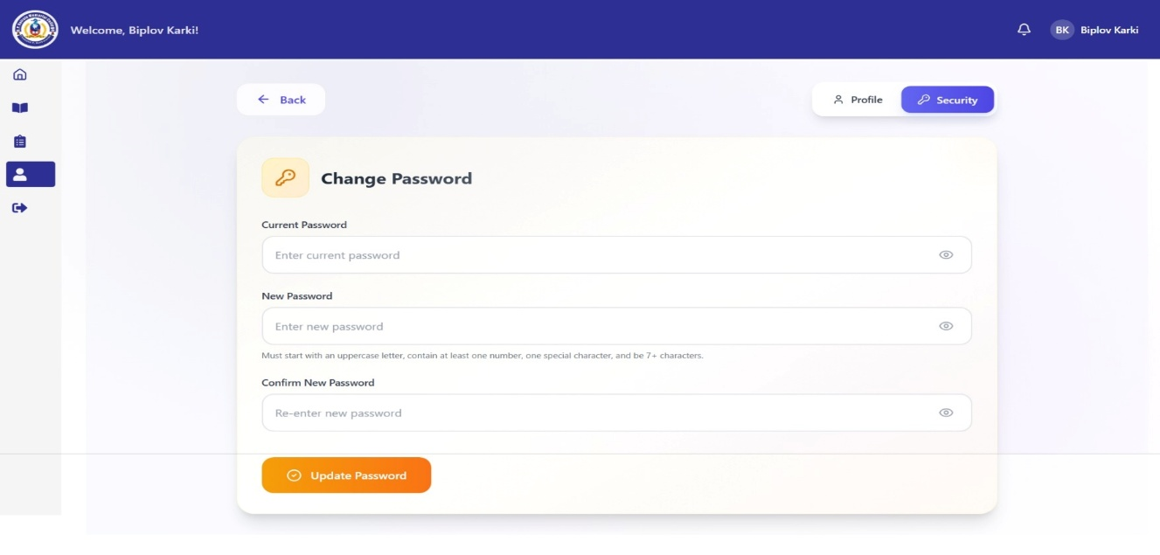
- Login Page (Teacher)
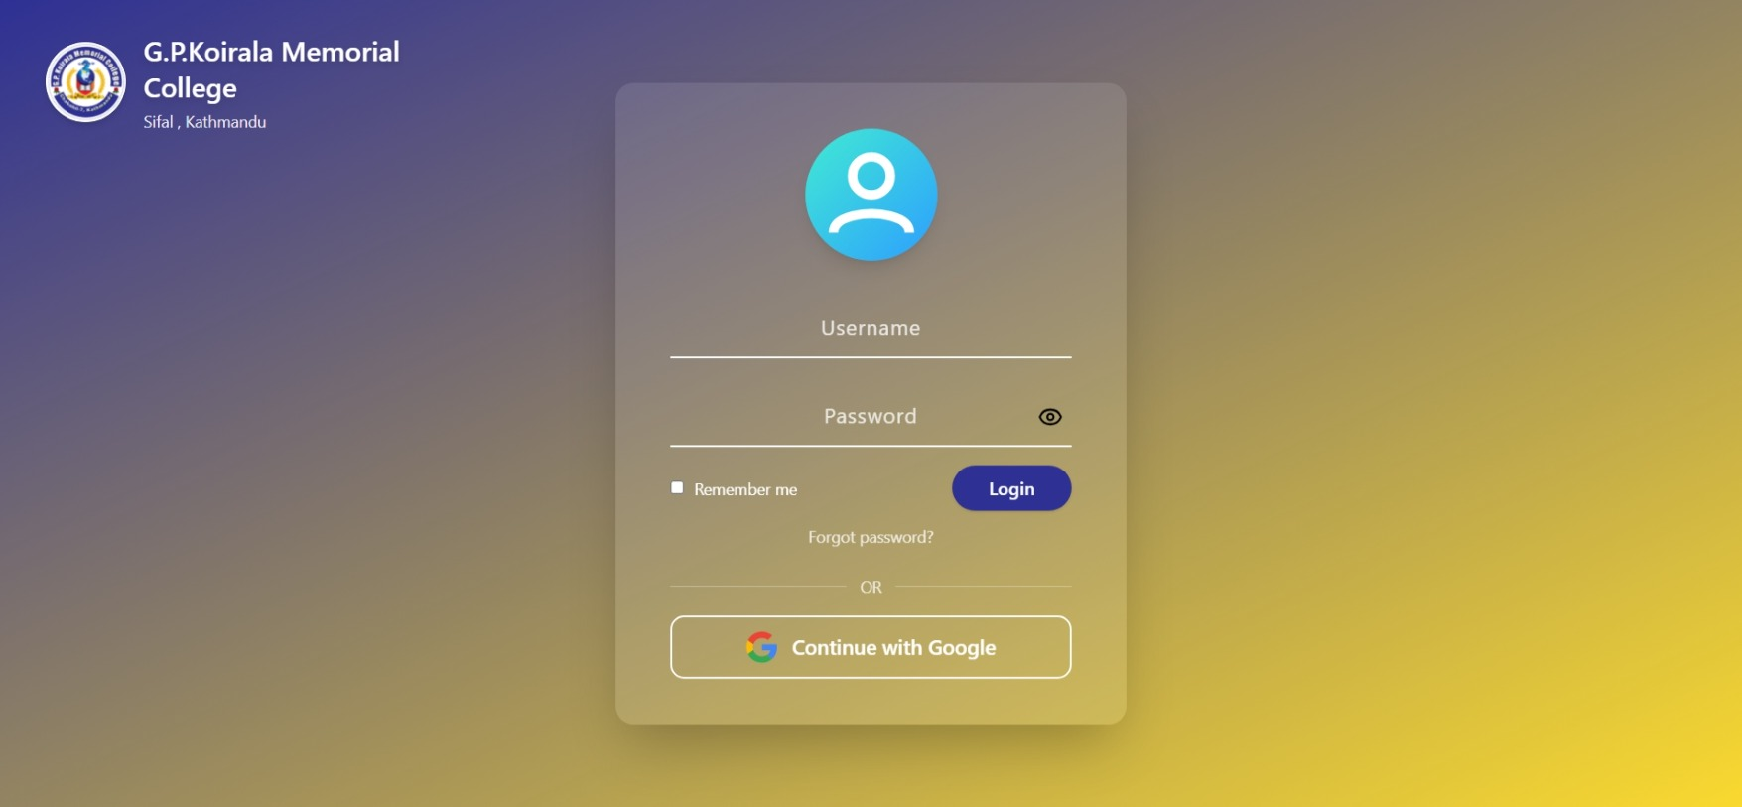
- Home page (Teacher)
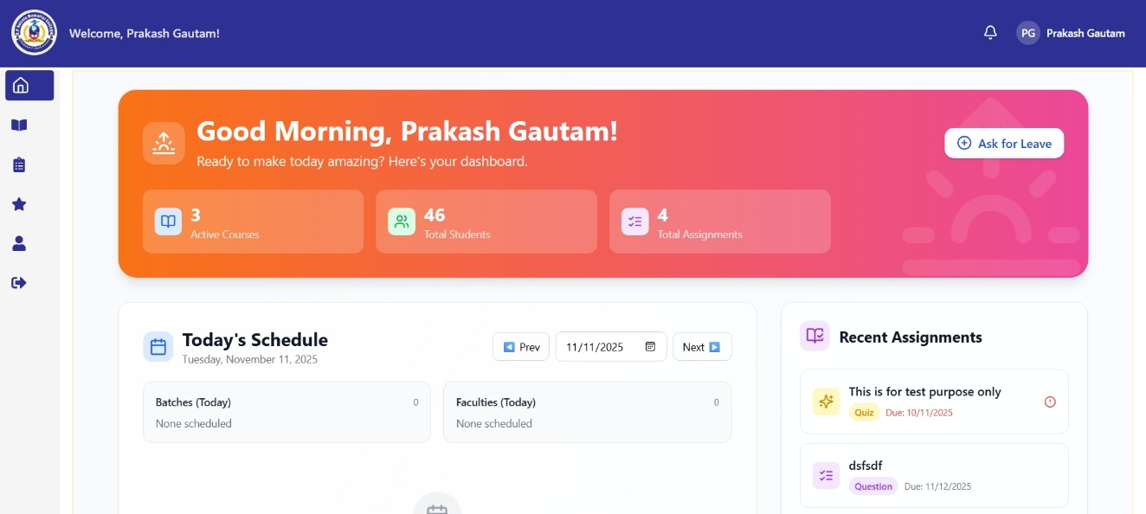
- Class list page (Teacher)
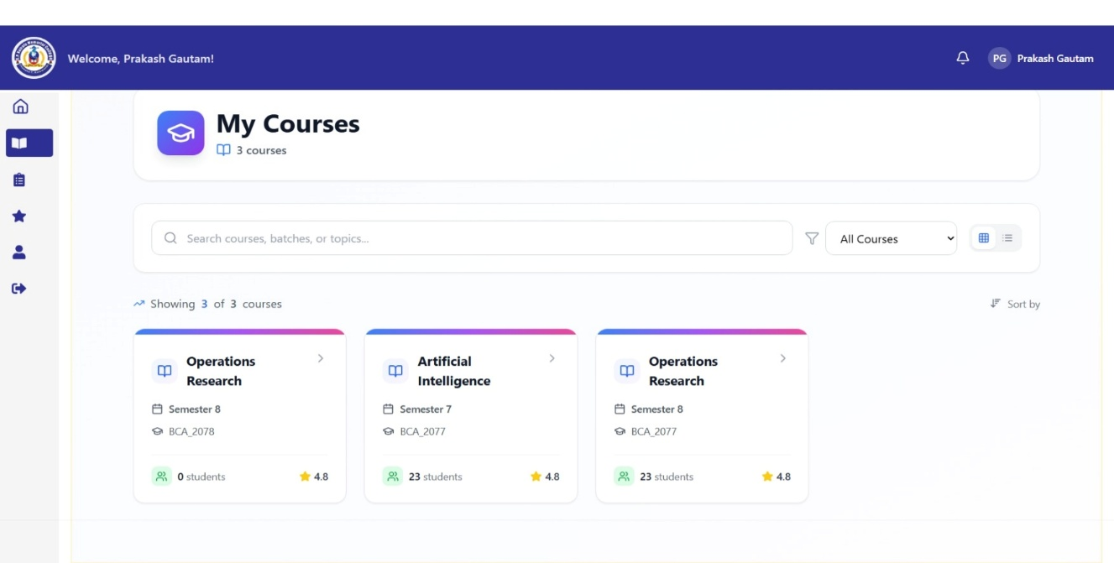
- Workspace page (Teacher)
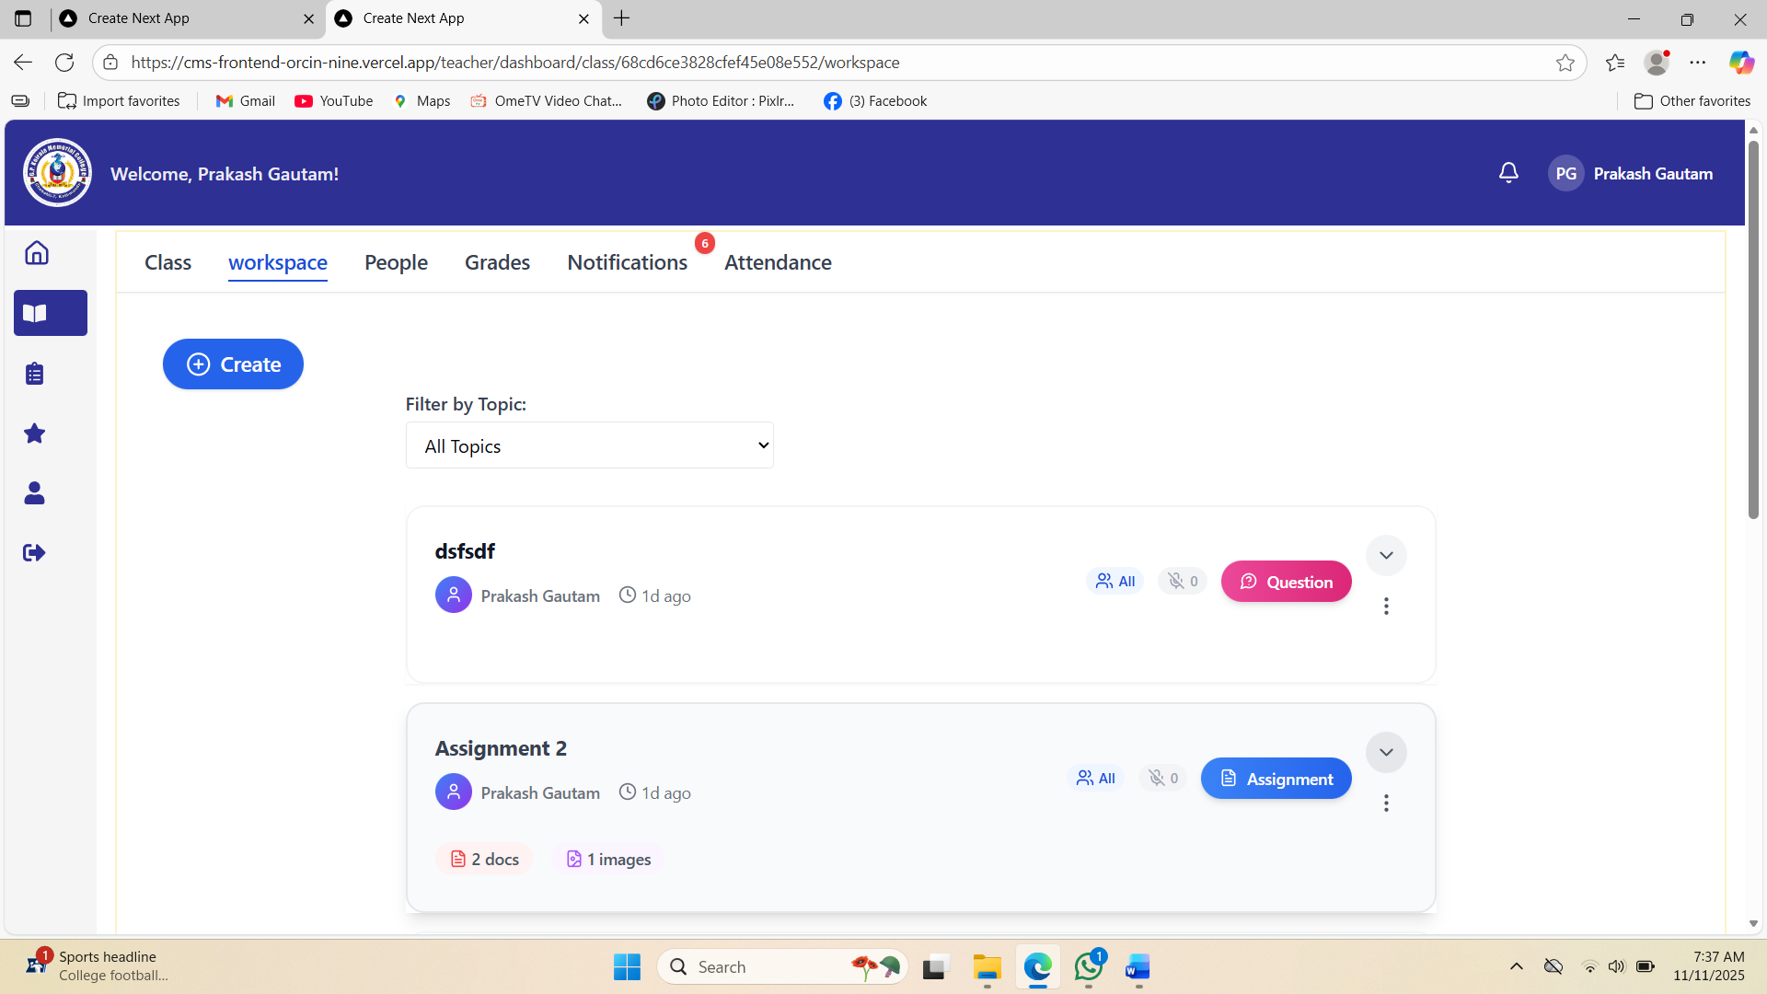
- Notification Page
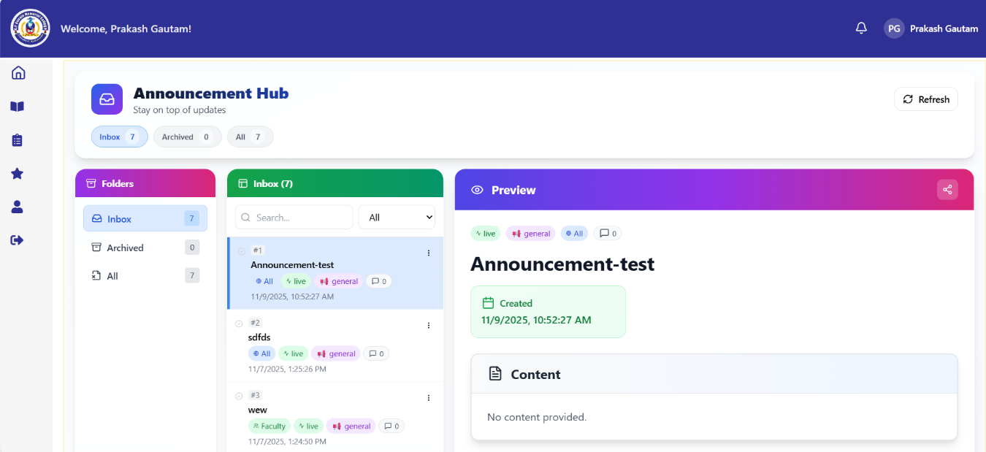
- Home page (Admin)
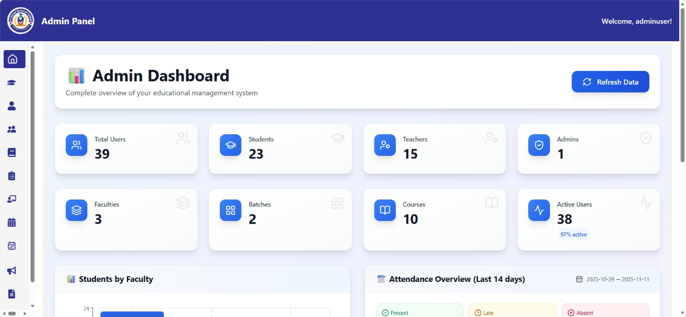
- Login page (Admin)
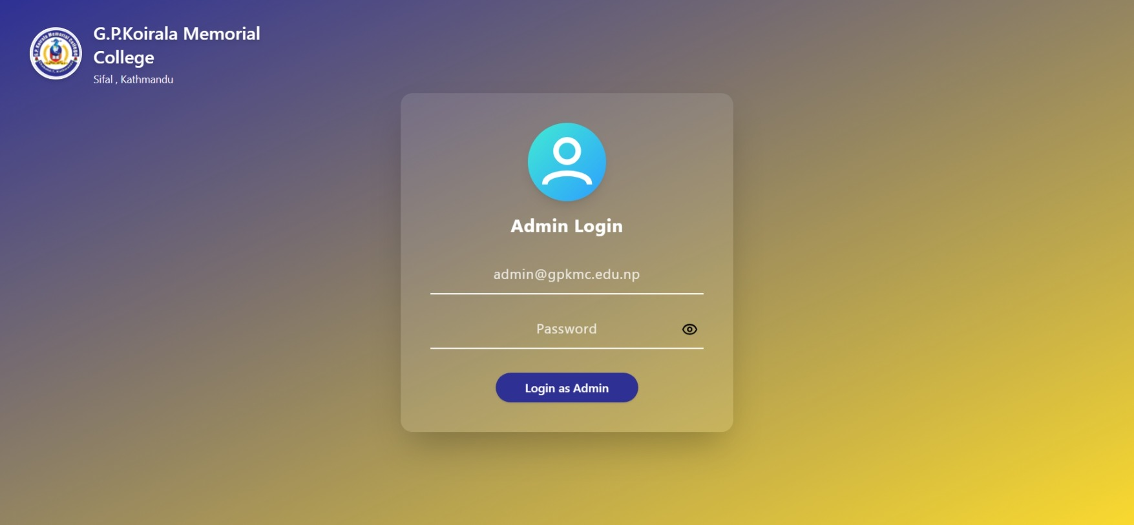
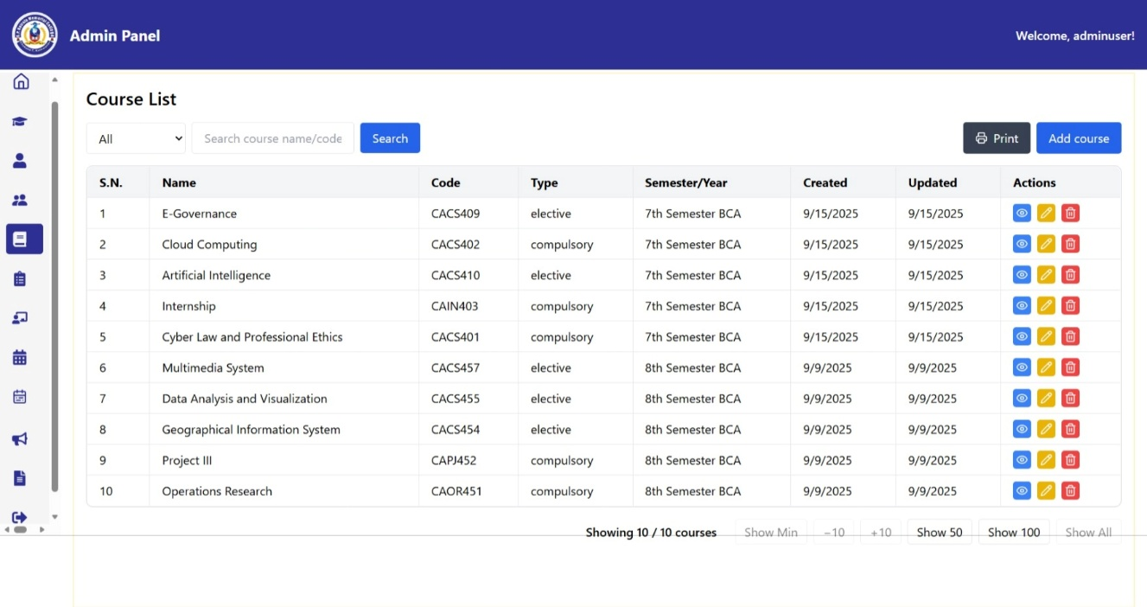
- Course Management Page
- Program Management
