
Tribhuvan University
Faculty of Humanities and Social Sciences
A PROJECT REPORT
On
LEARNING MANAGEMENT SYSTEM
Submitted to:
Department of Information Technology
G.P. Koirala Memorial College

In partial fulfillment of the requirement for the Bachelors in Computer Application
Submitted by:
Biplov Karki
6-2-703-6-2020
Prerana Koirala
6-2-703-13-2020

November, 2025

Under the supervision of
Mr. Sujan Koirala

Tribhuvan University
Faculty of Humanities and Social Sciences
G.P. Koirala Memorial College
Sifal, Kathmandu
Bachelor of Computer Applications (BCA)

SUPERVISOR’SRECOMMENDATION

I hereby recommend that this project prepared under my supervision by BIPLOV KARKI and PRERANA KOIRALA entitled “LEARNING MANAGEMENT SYSTEM” in the Partial Fulfillment of requirement for the degree of Bachelor’s in Computer Application is recommended for that final evaluation.

…………………………….
Mr. Sujan Shrestha
Supervisor/Co-Ordinator
Department of Information Technology
G.P. Koirala Memorial College


Tribhuvan University
Faculty of Humanities and Social Sciences
G.P. Koirala Memorial College

LETTER OF APPROVAL
This is to certify that this project prepared by BIPLOV KARKI and PRERANA KOIRALA entitled “LEARNING MANAGEMENT SYSTEM” in partial fulfillment of the requirements for the degree of Bachelor of Computer Application has been well studied. In our opinion it is satisfactory in scope and quality as a project for the required degree.

……………………………………  Sujan Shrestha  Supervisor  GPKMC | …………………………………………..  [External Examiner]  Academic Designation  FOHSS, Tribhuvan University
……………………………………  Sujan Shrestha  Program Coordinator  GPKMC | …………………………………………..  Shiva prasad Adhikari  Campus Chief  GPKMC

ABSTRACT
In response to the growing need for digitized academic processes in Nepalese educational institutions, this project proposes the development of a web-based Learning Management System (LMS) named GPKMC eCampus. Built using the MERN stack (MongoDB, Express.js, React.js, and Node.js) and styled with Tailwind CSS, the system aims to provide a unified platform for managing academic and administrative activities. It addresses the inefficiencies of traditional and scattered digital tools by offering centralized features such as attendance tracking, class scheduling, study material sharing, assignment submission with plagiarism detection, and real-time notifications.
The LMS is designed for three main user roles—admin, teacher, and student—each having access to a customized dashboard and feature set. Advanced features include Google OAuth login, dynamic timetable generation, content search via Elasticsearch, and intelligent algorithms for attendance analysis and course recommendations. The system prioritizes usability, security, scalability, and operational efficiency, making it ideal for institutions seeking an affordable, user-friendly, and locally relevant solution.
Through this platform, GPKMC eCampus seeks to improve academic integrity, enhance collaboration, and minimize manual workload, thereby fostering a smarter and more connected educational environment.
Keywords: LMS, eCampus, MERN Stack, Academic Management, Attendance, Assignments, Plagiarism Detection, Role-Based Access, Nepal, Google OAuth

ACKNOWLEDGEMENT
We would like to express our special thanks of gratitude to our supervisor and BCA Program Coordinator Mr. Sujan Shrestha who gave us the golden opportunity to do this wonderful project on the topic of Learning Management System (LMS), which also helped us in doing a lot of research and we came to know about so many new tools and technologies. We would like to express my special gratitude and thanks Mr. Sujan Shrestha for his support and help for our personnel development and mainly for the completion of this Project.
We wouldliketo express our special thanksof gratitude toour Campus Chief Mr.Shiva Prasad Adhikari who gaveus permission to dothisProject.
IamhighlyindebtedtoGP Koirala Memorial College fortheirguidanceandconstantsupervisionas well as for providing necessary information regarding the Project and support in thecompletion.
Wewouldalso liketoexpressmygratitude towardslibraryandmember ofGP Koirala Memorial College for their kind co-operation and encouragement which help me in completion ofthisProject.
We would also like to thank our parents and friends who helped us a lot in finalizing thisprojectwithin thelimited timeframe.
Intheend,wewouldalsoliketothankTribhuvanUniversityforgivingusthisopportunityviathecourseofComputerApplicationtohelpusunderstandtheprojectethicsatthisearlystage and helped us toevaluatemyknowledgeand expand it alittle more.

Prerana Koirala
Roll No: 70302014
Biplov Karki
Roll No: 70302005
Date: 2082/06/22

Table of content

List of abbreviations

CHAPTER 1: INTRODUCTION

Introduction
In the digital age, managing academic workflows through traditional paper-based or disjointed systems can lead to inefficiencies, miscommunication, and limited access to essential academic services. Students, teachers, and administrators often struggle with manual processes, scattered information, and lack of real-time updates — all of which hinder effective learning and campus management.
eCampus is a modern, web-based Learning Management System (LMS) designed to simplify and enhance the academic experience for educational institutions. Built using the MERN stack (MongoDB, Express.js, React.js, and Node.js) and styled with Tailwind CSS, the platform offers a responsive and intuitive interface accessible across devices.
The system centralizes core academic activities including user management, faculty and batch coordination, semester/year management, class schedules, notes, announcements, and assignment submissions. Students can track their academic progress, view resources, receive notifications, and submit assignments, while teachers can manage classes, share materials, mark attendance, and evaluate students. Secure Google login integration ensures seamless and safe access using institutional email accounts.
With features like real-time updates, plagiarism detection, and role-based access control, eCampus fosters a collaborative, transparent, and efficient academic environment. It bridges the gap between students, faculty, and administration — enabling smarter, faster, and more connected campus operations.

ProblemStatement
Educational institutions often rely on multiple disconnected systems or manual processes to manage academic activities such as student records, faculty assignments, course scheduling, and communication. This fragmentation leads to inefficiencies, delays, and errors that affect students, teachers, and administrators alike. Students may struggle to access timely information, submit assignments, or track academic progress, while faculty and staff face challenges in organizing courses, managing batches, and communicating effectively.
Additionally, the lack of a unified digital platform results in poor coordination, increased administrative overhead, and limited transparency in academic workflows. With the increasing demand for flexible and remote learning, these challenges become even more pronounced.
The project aims to address these issues by developing a comprehensive and user-friendly Learning Management System (LMS) that centralizes academic management. This system will streamline administrative tasks, facilitate communication, support real-time updates, and empower users with easy access to educational resources and tools, thus enhancing the overall learning experience and operational efficiency.

Objectives
The objective of this project is to
- To develop a unified digital platform for managing academic and administrative tasks.
- To enhance student learning through accessible course materials and real-time updates.
- To improve institutional efficiency and reduce operational costs with streamlined processes.

ScopeandLimitation

1.4.1Scope
This project focuses on building a web-based Learning Management System (LMS) called GPKMC eCampus, designed to improve the management of academic and administrative activities within educational institutions. The system targets three main user roles—Admin, Teacher, and Student—and offers role-based features to simplify daily tasks and improve communication. It will be developed using the MERN stack and styled with Tailwind CSS, ensuring scalability, usability, and relevance for institutions in Nepal.
The system will cover:
- Role-based dashboards for Admin, Teacher, and Student
- Attendance management (manual and QR-based)
- Class scheduling and timetable management
- Assignment upload, feedback, and plagiarism detection
- Study material sharing (PDFs, links, videos, etc.)
- Real-time notifications for announcements and updates
- Secure login using email/password and Google OAuth

1.4.2Limitations
- Financial management features (such as fee collection, payroll, or expense tracking) are not included in the current LMS
- Integration with external tools (e.g., Google OAuth, plagiarism detection) depends on third-party service availability and policies
- Initial data migration from existing manual records to the LMS can be time-consuming and prone to errors

ReportOrganization
Introduction
This chapter deals with the introduction of the system with its objectives and limitationsalongwith thereason whythe system is made.

BackgroundStudyandLiteratureReview
Thischaptersummarizestheworkthathasbeencarriedoutinthefieldofdataminingandalso describes the features about some existing applications related to the Learning Management System.

SystemAnalysisand Design
Thischapterfocusesonthedifferentrequirementofthesystem,whichdescribesaboutthefunctional,non-functional,feasibilityanalysis,EntityRelationaldiagram,DataFlowDiagram, design of the system with system architecture, database schema, and interfacedesign.

ImplementationandTesting
This chapter emphasizes tools used in system development, implementing details andresultof test performed.

ConclusionandFuture Recommendation
This chapter highlights brief summary oflesson learnt, outcome and conclusion of thewhole projectand explain what have been done and what further improvements could bedone.

CHAPTER 2: BACKGROUND STUDY AND LITERATURE REVIEW

BackgroundStudy
This project builds a web-based Learning Management System (LMS) for GPKMC to bring teaching and learning into one organized place. An LMS helps institutions deliver materials, run assessments, track progress, and communicate with students in a structured way that supports teaching quality and accountability [1], [2]. In Nepal, the shift toward online and blended learning highlighted both the promise of digital platforms and the persistent gaps in connectivity, devices, and user readiness, especially outside major cities [3], [4], [5].

The platform follows well-established LMS principles: clear organization of learning activities, reliable records of teaching/assessment, and timely feedback to students [1], [2]. To support fair evaluation, the system can check text submissions for similarity using modern sentence-embedding approaches (e.g., Sentence-BERT) that compare texts with cosine similarity and surface likely overlaps for teacher review rather than making automatic judgments [6]. For scanned or image-based work, Optical Character Recognition (OCR) is used to extract text so it can be searched and compared; OCR quality and evaluation metrics are important to ensure usable results [7]. The interface aims to be readable and navigable across devices by drawing on widely used web accessibility guidance (e.g., WCAG 2.x) so more learners can participate effectively [8], [9].

A course is the subject (e.g., Operations Research), while a course instance is the actual offering tied to a batch, teacher, and time window. Batch and semester/year reflect the local academic structure used for enrollment and scheduling. Teachers post materials (files/links) and create assignments and quizzes; students submit work that appears in the gradebook after marking. Timetables are modeled as recurring events (for example, weekly lectures at fixed times). Attendance tokens are short-lived QR codes shown in class so students can check in quickly while reducing sharing. For integrity checks, similarity analysis highlights matched passages and sources for teacher review, and OCR refers to converting scanned pages or images into searchable text [6], [7].
Overall, the LMS focuses on clear organization (courses vs. course instances), dependable scheduling and attendance, fair and reviewable evaluation, and an interface that works on common devices. Evidence from LMS research and from Nepal’s recent experience with online learning suggests that these foundations can improve access and day-to-day teaching, provided institutions continue to invest in connectivity, user support, and practical design choices that keep the system simple and reliable [8], [9].

LiteratureReview
Digital transformation in education has encouraged institutions worldwide to adopt Learning Management Systems (LMS) and campus/college automation tools to streamline both teaching and administrative work [1]. In their most common form, these platforms centralize course materials, announcements, assignments, grades, and records so that teachers and students interact in a shared digital space with clearer expectations and faster feedback cycles. Meta-reviews report consistent gains in course organization, communication efficiency, and learner satisfaction when teaching activities are coordinated through an LMS rather than fragmented channels [1], [7]. Yet, this global momentum contrasts with the situation in Nepal, where many colleges still depend on manual procedures or scattered digital tools. The result is duplicated effort, slower decision-making, and weak data visibility across offices and departments, especially when attendance, timetables, and assessments are tracked independently rather than in one place [5]. Understanding the current landscape—both locally and internationally—helps identify which features matter most, where existing systems fall short, and how a practical, affordable solution can be designed for institutions like ours.

A scan of representative systems illustrates clear trade-offs. TU’s Exam Portal provides an essential public service—exam notices and results—but it is not intended to manage daily teaching or student engagement; it offers no real-time interaction, notifications, or resource management, reflecting the minimal digital infrastructure most Nepali colleges currently rely on. Google Classroom became widespread during and after the COVID-19 period for its simplicity and rapid onboarding: teachers can distribute materials, collect submissions, and post announcements with minimal training [2]. However, it lacks built-in attendance tracking, structured scheduling, exam handling, or deeper back-office controls (for example, department-level views or multi-program coordination), and it depends heavily on Google accounts and stable internet—constraints repeatedly noted in developing contexts [2], [5]. In contrast, Moodle is a full-featured open-source LMS with quizzes, gradebooks, forums, and even attendance plugins, backed by a large plugin ecosystem and strong community documentation [3]. Its power, though, comes with overhead: installation, customization, hosting, and maintenance require technical capacity, and the interface can feel complex for smaller, resource-constrained colleges in Nepal [3], [5]. Beyond these, Student Lifecycle Management (SLCM) platforms used by universities in India and enterprise suites such as Ellucian myCampus deliver robust, centralized administration—admissions, records, fees, and academic planning—but are costly, require significant customization, and are typically sized for large institutions rather than public or semi-public colleges operating under tighter budgets and localized academic structures. Closer to home, C4mpus4.0 is widely used in Nepal and excels at administrative workflows such as enrollment, attendance, timetables, examinations, fee processing, and multi-role access via web and mobile [4]. While effective for digitizing operations, it emphasizes administration over pedagogy: interactive learning features, flexible assessment workflows, and analytics that support day-to-day teaching are comparatively limited, and customization options are narrower than in open platforms [4].

The Nepal-specific literature emphasizes constraints that shape adoption and real-world outcomes. Studies consistently point to bandwidth variability, device access, and uneven digital skills among faculty and students as primary barriers to sustained LMS use, particularly outside major urban centers [5]. In such settings, lightweight, mobile-friendly interfaces and clear, simple workflows are repeatedly recommended over heavyweight feature sets, because reliability and ease of use determine whether teachers actually move beyond messaging apps and shared drives to structured, trackable teaching workflows [5], [7]. International reviews add that usability alone is not enough: the platforms that improve learning outcomes integrate assessment and feedback tightly (e.g., clear due dates, rubric-based grading, timely notifications) and provide basic analytics that help instructors identify disengagement early rather than merely digitizing paperwork [1], [7]. At the same time, several functions important to academic integrity and fairness—such as text similarity checking for plagiarism support and OCR for scanned submissions—are most effective when presented as decision support for educators rather than as automated verdicts, aligning with good assessment practice and avoiding false positives that can erode trust [7]. Affordability, institutional capacity for setup/maintenance, and the need to align tooling to local academic structures (batch/semester flows, internal/practical marks, departmental oversight) remain decisive factors for Nepali colleges [5].

Synthesizing across these strands reveals a practical gap: institutions in Nepal are often forced to choose between easy-to-start teaching tools that remain shallow on administration and analytics, feature-rich open-source LMSs that are powerful but difficult to host and customize, and enterprise suites that are robust yet financially and operationally out of reach. Few options combine everyday administration (attendance, schedules, notices) with lightweight learning workflows (notes, assignments, quizzes, basic similarity checks) in a single, locally adapted, affordable system that works reliably on typical devices and networks. The GPKMC eCampus is designed to address this gap by unifying core academic and administrative functions—attendance management, scheduling, notifications, study notes, assignments, and plagiarism-similarity support—behind a simple interface that prioritizes clarity, cost-effectiveness, and local relevance. By aligning with features the literature associates with impact in resource-constrained contexts—clean organization, timely feedback, minimal friction, and actionable analytics—the system aims to elevate day-to-day teaching quality and reduce administrative workload while remaining feasible for Nepali colleges to adopt and sustain [1], [5]–[7].

CHAPTER 3: SYSTEM ANALYSIS AND DESIGN
The Learning Management System was developed using the Agile methodology, ensuring iterative and flexible progress. The process began with requirement analysis, where functional and non-functional requirements were identified. Based on these requirements, the system design was created, followed by development in iterative cycles (sprints), focusing on implementing key features step by step.
Each sprint included testing to identify and resolve issues early, ensuring the functionality of the system. After implementing all the core features, the system underwent integration and final testing. Any issues found were resolved, ensuring the system was fully functional and ready for deployment.
il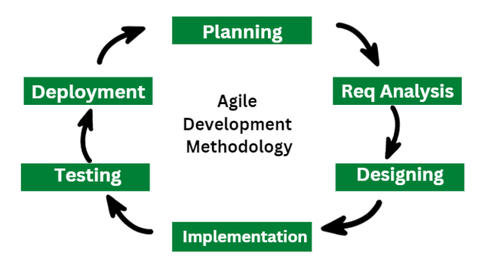

3.1.1 Requirement Analysis
The requirements of the system were collected before starting the development life cycle. Both functional and non-functional requirements were studied to design and develop the LearningManagement System.
- Functional Requirement
Different functional requirement of the system has been identified and are listed as below:
For Administration:
- The system allows the admin to log in to the admin dashboard using valid credentials.
- The system allows the admin to manage users (create, delete and update) expect password.
- The system allows the admin to manage Batches, Courses, Faculty, Course Instance, Batch Periods and Semesters.
- The system allows the admin to manage announcements.
- The system allows the admin to manage exam results.
- The system allows the admin to manage class schedules, view timetables, and track schedule changes
- The system allows admin to view leave requests and manage it.
For Teacher:
- The system allows the teacher to log in to the teacher dashboard using valid credentials.
- The system allows the teacher to create, edit, publish/unpublish, and delete assignments and study materials.
- The system allows the teacher to take attendance and generate attendance reports for selected courses.
- The system allows the teacher to view submissions and assign/edit grades with feedback.
- The system allows the teacher to record internal/practical marks and generate exportable exam result sheets.
- The system allows the teacher to securely change their own password after verifying the current password.
- The system allows the teacher to send leave requests.

For student:
- The system allows the student to log in to the student dashboard using valid credentials.
- The system allows the student to securely change their own password after verifying the current password.
- The system allows the student to view study materials and make comments.
- The system allows the student to submit assignments and view it’ s grades.
- The system allows the student to view class schedules.
- The system allows the teacher to send leave requests.

USECASE DIAGRAM
The Learning Management System is divided into three primary sectors: Admin, Teachers and students, each with distinct roles and functionalities:
- Admin: The admin logs in to a simple dashboard and sets up the whole system. They add and manage users and roles; create faculties, batches, semesters (with batch periods), and course instances (linking courses to batches/semesters and assigning teachers). They build and update timetables, manage teacher schedules, and resolve clashes. They post announcements, review leave requests (approve/reject), and handle exam results (enter, update, publish). The admin can also set basic rules (grading, content limits), send announcements, and view/export key reports like attendance and grades.
- Teacher: The teacher logs in to their dashboard and manages each course: they post study materials, announcements, assignments, and quizzes; take attendance and view attendance summaries; review submissions, give feedback, and grade; enter internal/practical marks and help prepare result sheets; view their timetable, request or reschedule classes within availability, and track changes; manage their own leave requests; and export reports such as gradebooks, submission lists, and attendance summaries. This clearly separates admin duties from teacher functions and keeps day-to-day teaching tasks efficient and accessible.
- Student: The student logs in to a personal dashboard and manages their learning: they access course pages with modules, study materials, and announcements; submit assignments and take quizzes; see scores, feedback, and overall progress; mark attendance during class, view weekly timetables, rooms, exam dates, and schedule changes; request leave with reasons and track approval; receive notifications for new materials, grades, and updates;

- Non-Functional Requirement
Different non-functional requirement has been studied and identified and are listed as below:
- Security: The system ensures data security by securely storing user information and employing encryption techniques for passwords.
- Usability and User Experience: The system offers an intuitive and user-friendly interface, ensuring ease of use for both registered users and administrators.
- Performance: The system delivers fast and accurate performance due to the use of a normalized database structure, ensuring quick data retrieval and efficient operations.
- Response Time: The system provides quick response times for all user interactions, ensuring a seamless experience when searching routes, viewing stops, or calculating fares.
- Scalability: The system is designed to scale effectively, accommodating future growth in terms of users, routes, bus stops, and fare structures without compromising performance.

3.1.2Feasibility Analysis
The feasibility study concluded that the project is able to be implemented to success as it wascarefullyplanned.
      - TechnicalFeasibilityStudy
For this project, all the required hardware and software resources were available and capable of handling the project’s needs. The development was done using Visual Studio Code as the primary IDE, with MongoDB for data storage, and Postman for testing and interacting with the API. These tools were sufficient for building and testing the system, allowing for smooth development throughout the process. Given the simplicity of the project, it was easily completed with the limited number of technical resources available.

      - OperationalFeasibilityStudy
Our system is designed with operational feasibility at its core, ensuring a smooth user experience. The interface is intuitive and user-friendly, allowing users with basic computer and internet skills to easily navigate the system. This minimizes the need for extensive training. By incorporating essential features that cater to the needs of our target users, we ensure that the system is both practical and useful. The focus on usability and accessibility guarantees that the system will integrate seamlessly into the users' workflow, providing a functional solution for everyday use.

      - EconomicFeasibilityStudy
From an economic standpoint, our system demonstrates high feasibility. By strategically utilizing open-source resources and tools, we have significantly minimized costs while ensuring optimal performance. The project’s cost-effectiveness continues beyond development, as the system's deployment does not require additional hardware or software investments. Leveraging existing assets allows us to achieve our objectives without straining financial resources. This approach aligns with our commitment to delivering value while maintaining economic sustainability, ensuring that the system remains affordable and efficient throughout its lifecycle.
      - ScheduleFeasibilityStudy
The system is completed within scheduled time and do not exceed the scheduled time.
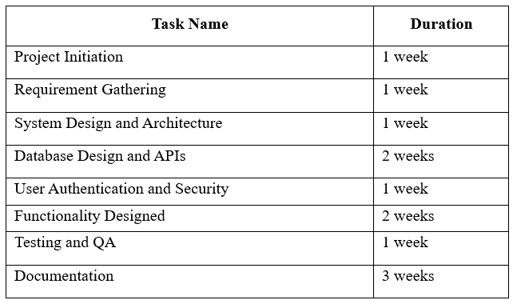
Table 3.1: Gantt chart Table for Learning Management System

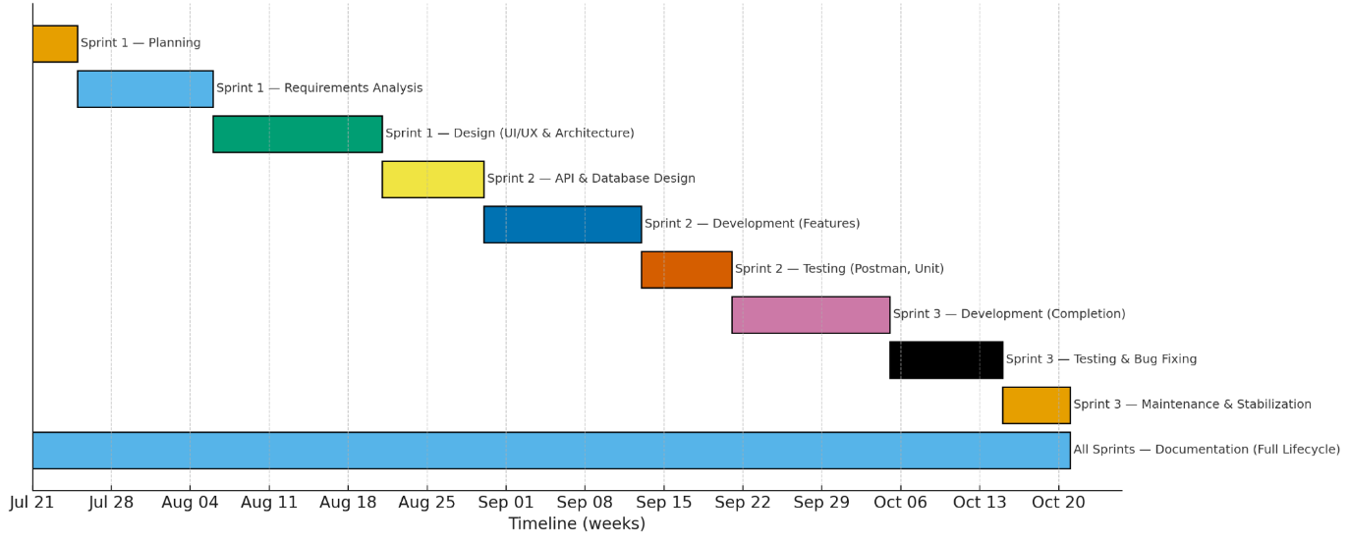

3.1.3 Object Modelling using Class and Object Diagrams
Object modelling is used to represent real-world entities and their relationships in a software system. It helps visualize how data and operations are grouped into classes and how these classes interact.
- Class Diagram

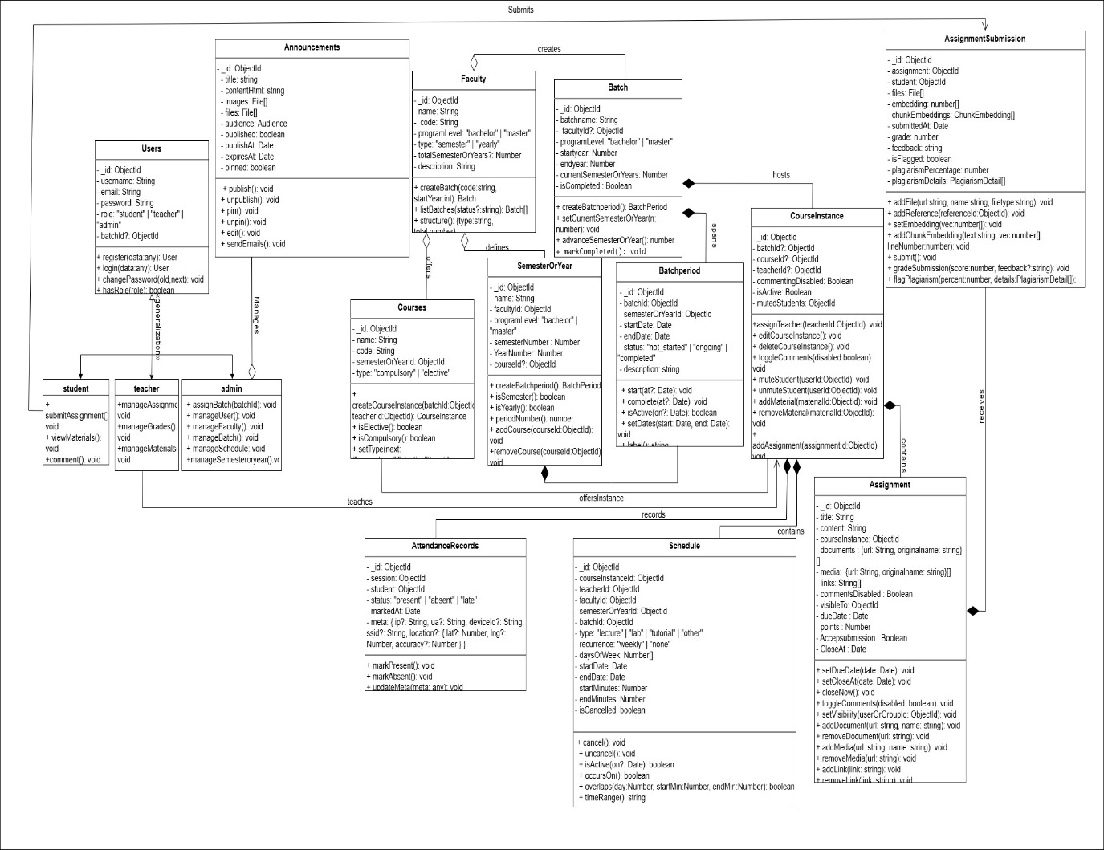
- Object Diagram
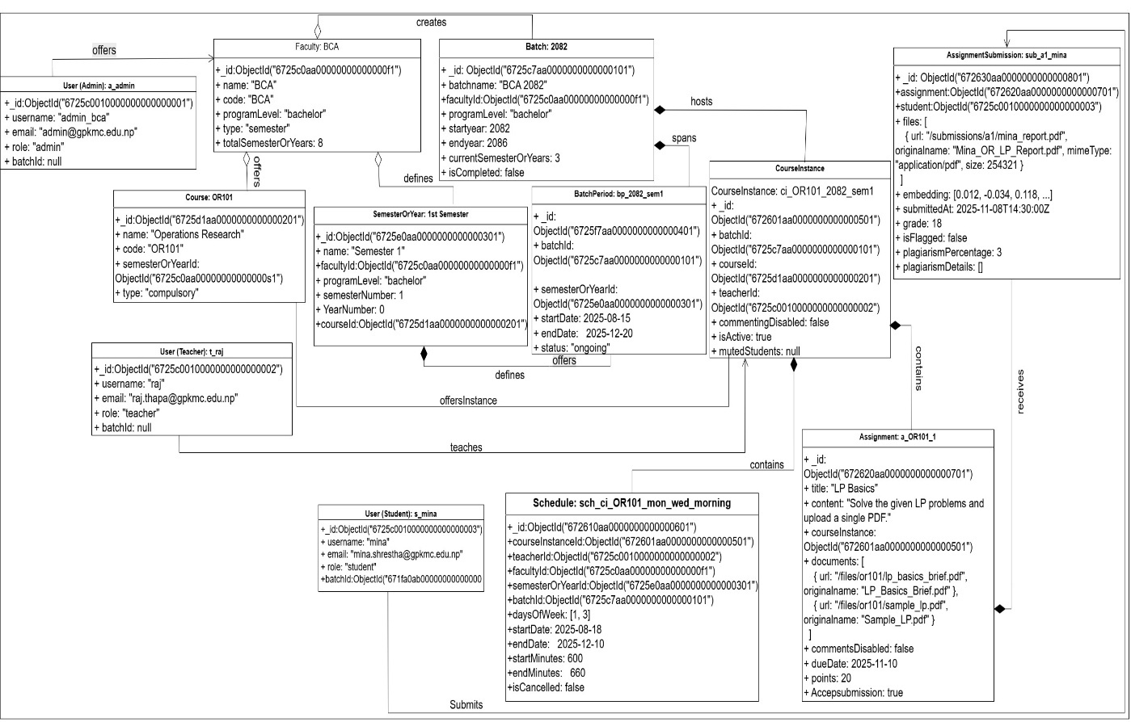
Figure 5: Object Diagram of Care Sync System

3.1.4 Dynamic Modelling using State and Sequence Diagrams
Dynamic modelling describes how the system behaves over time and how various components interact during specific operations. It helps to understand the flow of activities, changes in system states, and object communication. Two key tools used for dynamic modelling are the State Diagram and Sequence Diagram.
- State Diagram

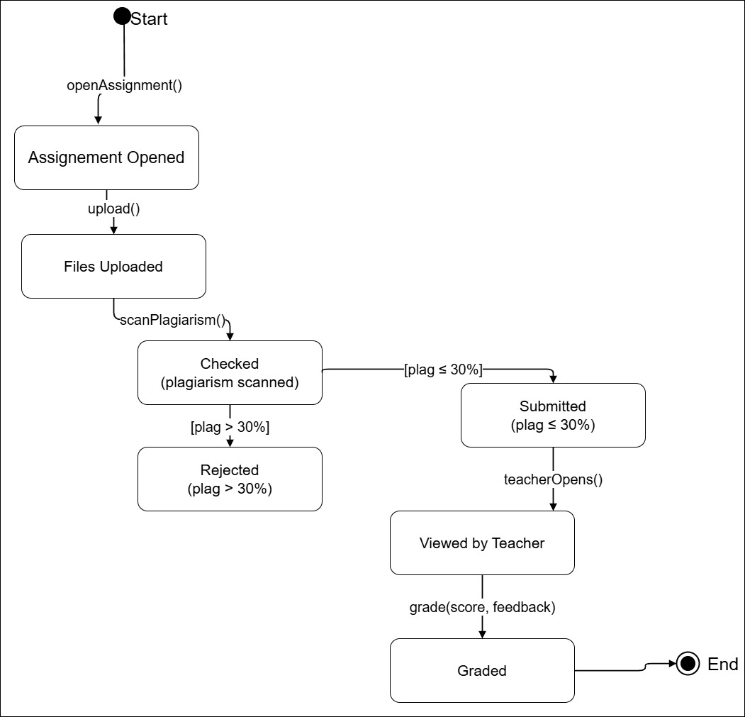
- Sequence Diagram
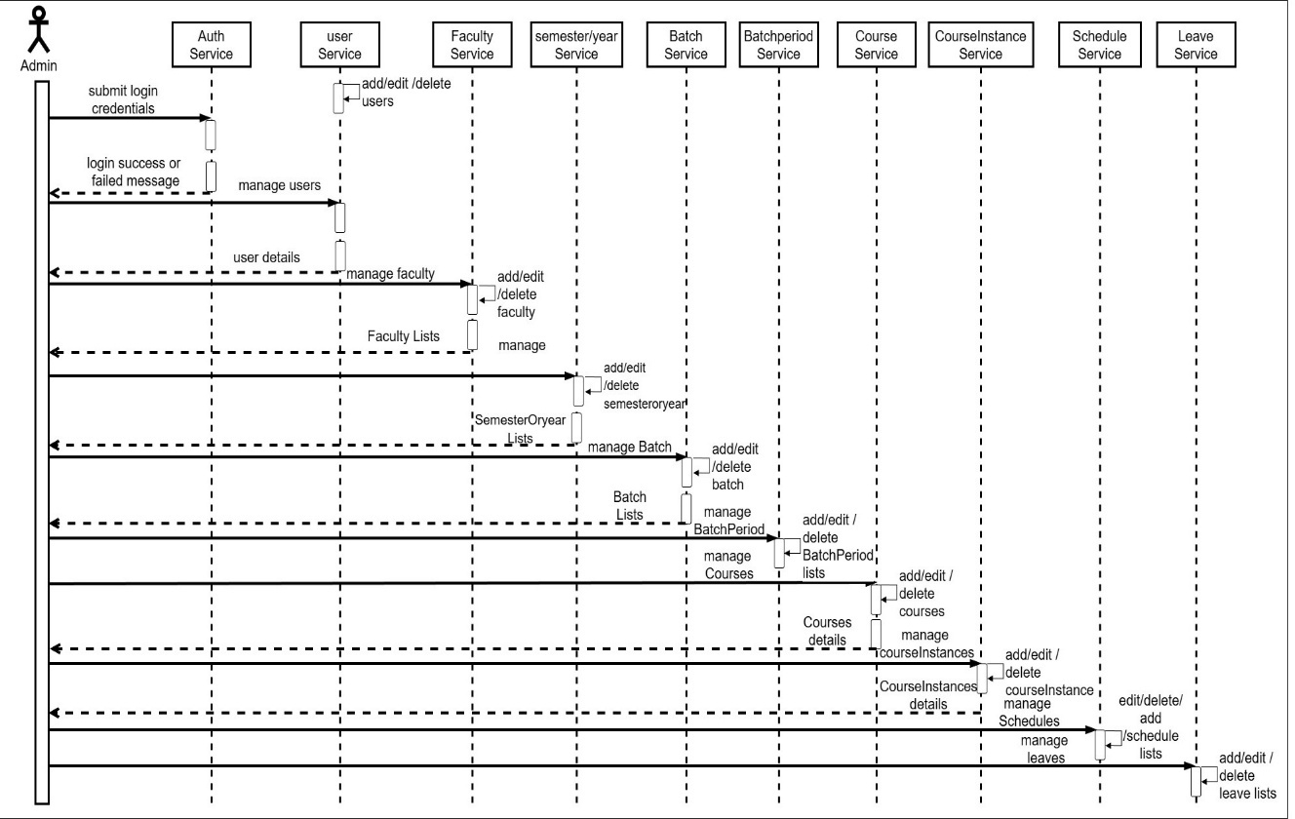

3.1.5 Process Modelling using Activity Diagrams
Process modelling helps in visualizing how different tasks are carried out step-by-step in the system. It shows the flow of control and decision points involved in a particular use case or process. For this project, the following models are used:
- Activity Diagram

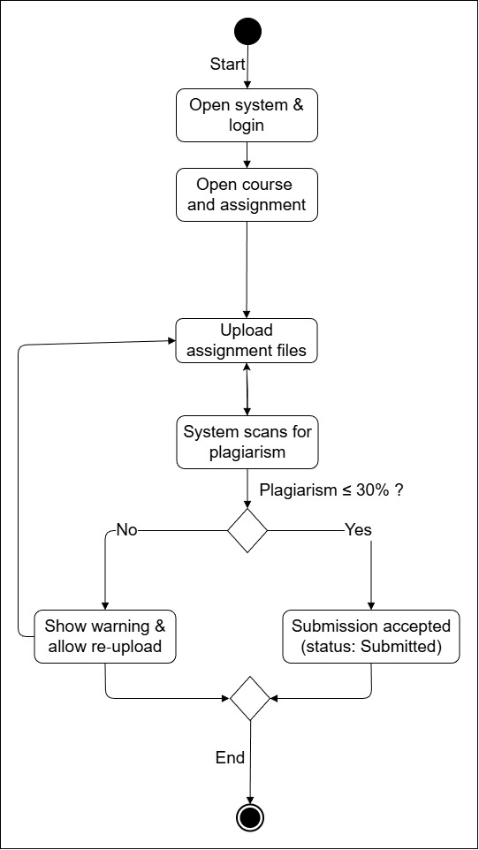
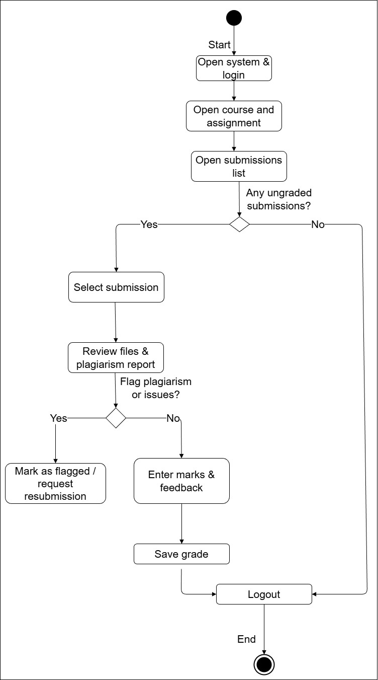
- Flowchart
A Flowchart is used to show a broader logical sequence of actions in the system. For Care Sync, you can create three flowcharts — one for each module:

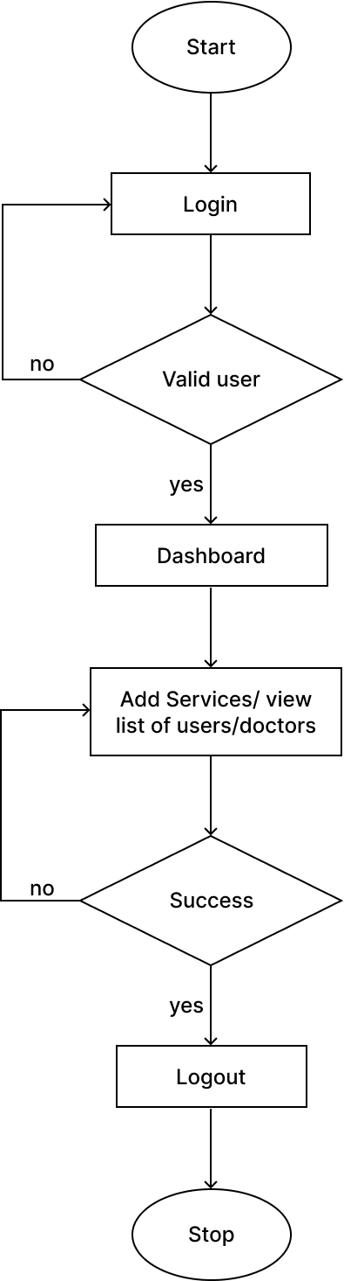
Admin Module

Figure 9: Admin Flowchart of Care Sync System
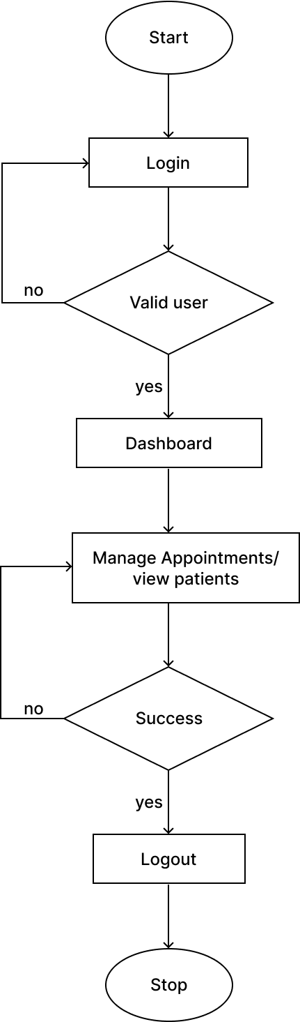
Doctor Module

Figure 10: Doctor Flowchart of Care Sync System

Patients Module
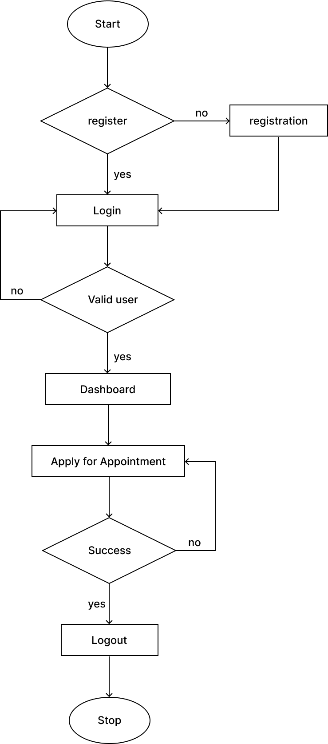

Figure 11: Patients Flowchart of Care Sync System

- DFD (Data Flow Diagram)
DFD Level 0 (Context Diagram)

DFD Level 1

3.2 System Design
To realize the different functional requirement of the system in graphical form, different design diagram of the system has been prepared which are as follows:
- ER Diagram
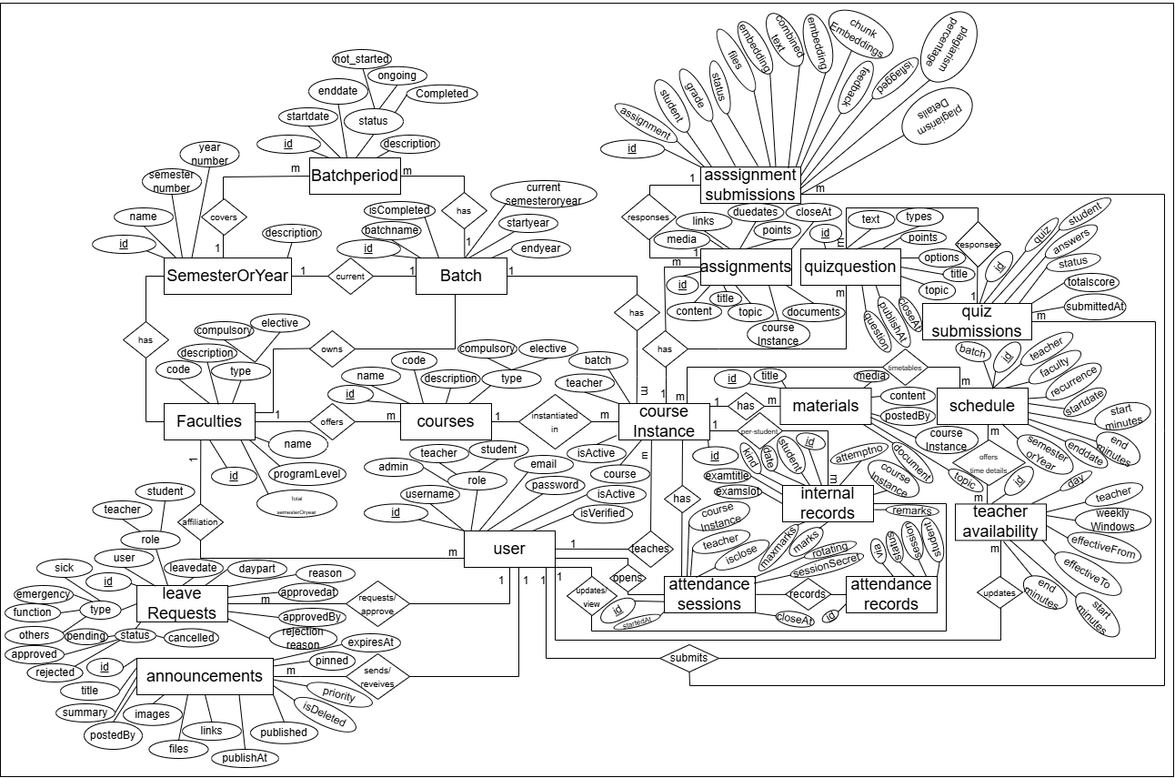
- Architectural Design

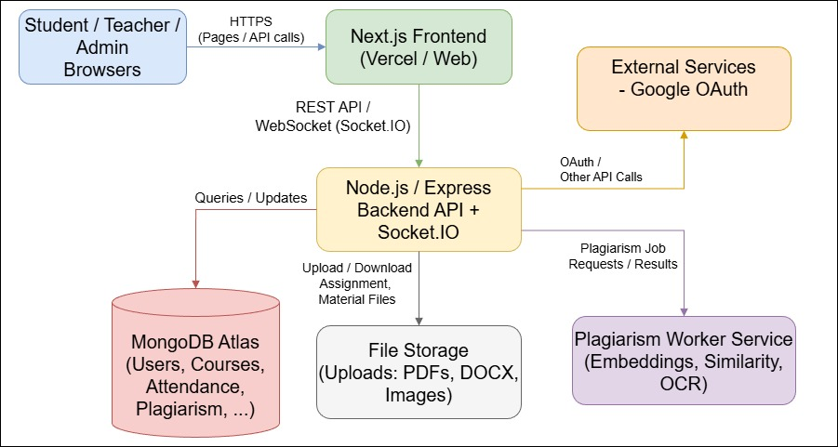

3.2.1 Refinement of Class, Object, State, Sequence and Activity Diagrams

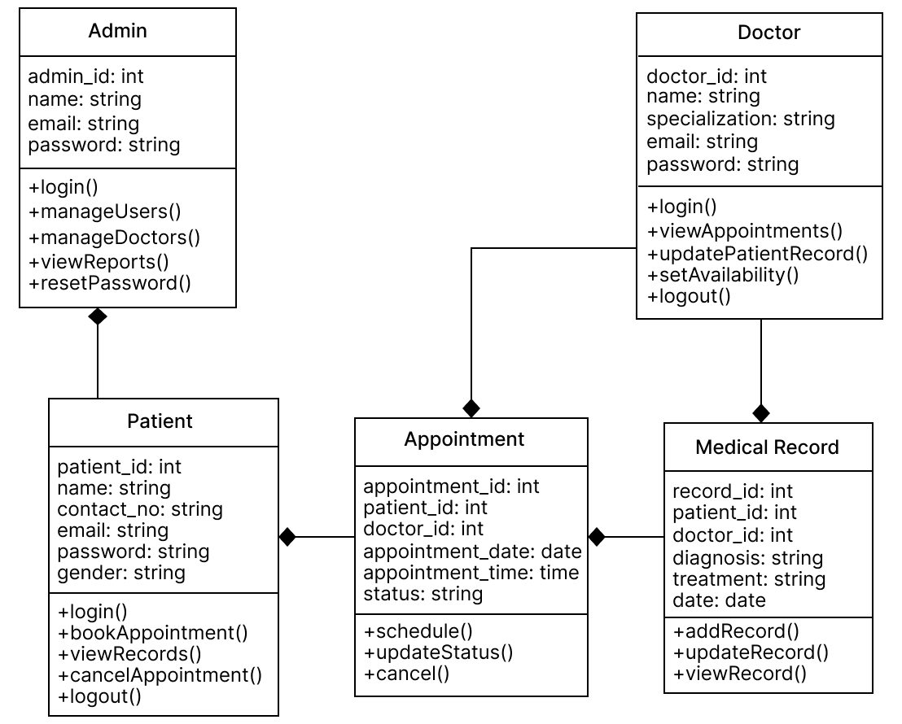

Figure 16: Refined Class Diagram (UML) of Care Sync System

3.2.2 Component Diagrams
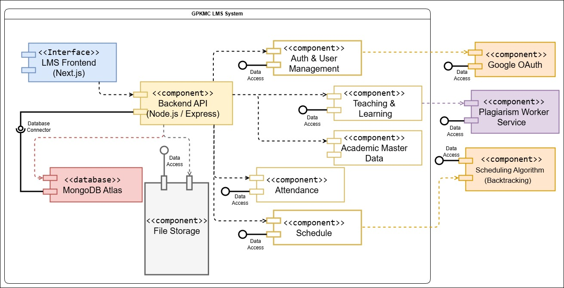

3.2.3 Deployment Diagrams
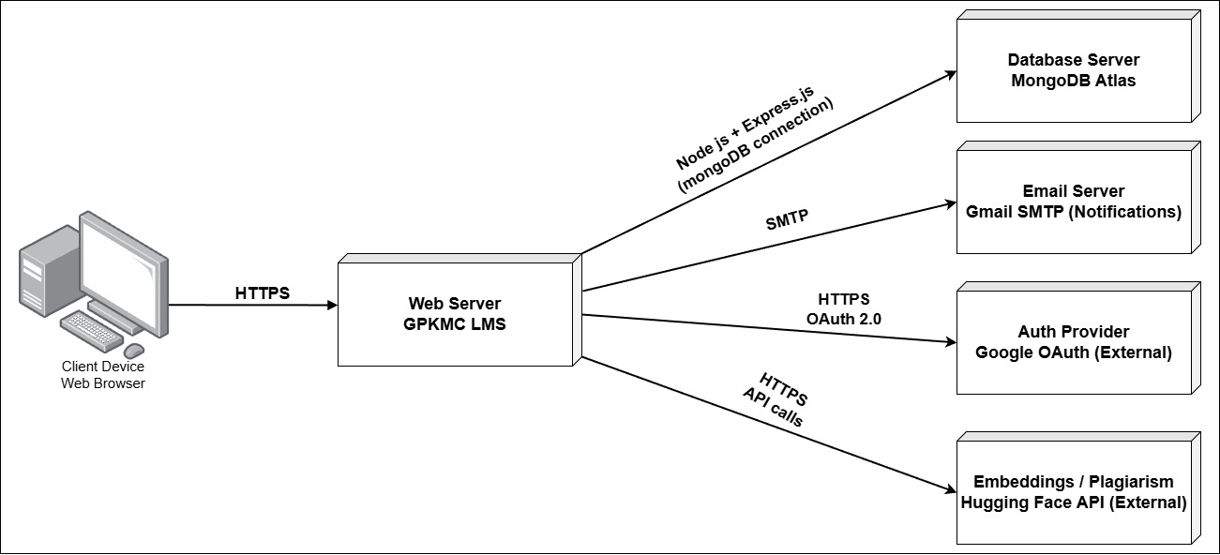

3.3 Algorithm Details

3.3.1 Recommendations Algorithm (User Based)

CHAPTER 4: IMPLEMENTATION AND TESTING

Implementation
In this phase, theoretical design is turned into practice i.e., working system. The most crucial stage in achieving a new successful system and in giving confidence on the new system for the users that it will work efficiently and effectively.
The system can be implemented only after thorough testing is done and if it is found to work according to the specification

4.1.1 Tools Used

The development of the LearningManagement System (LMS) was enabled through the use of modern tools and technologies, which were selected for their efficiency and compatibility with the MERN stack.
Front-End Tools:
- React.js: Used for building dynamic, responsive user interfaces with fast rendering and state management.
- CSS (Tailwind CSS): Utilized for styling and creating responsive, visually appealing designs.
- JavaScript (ES6): Enabled interactivity and dynamic behavior across the system’s UI, enhancing user experience.
Back-End Tools:
- Node.js: The server-side runtime environment responsible for handling requests and managing asynchronous operations.
- Express.js: Simplified the creation of RESTful APIs, handling requests related to system functions and features.
Database:
- MongoDB: A NoSQL database used to store flexible, dynamic data such as bus schedules, user profiles, and routes.
- Mongoose: A library to define and manage the data structure within MongoDB, ensuring efficient CRUD operations.
Server:
- Node.js with Express Server: Served as the backbone of the server-side application, handling HTTP requests and interacting with the database.
Documentation Tools:
- MS Office: Used for creating documentation such as system specifications and user manuals.
- Draw.io: Helped in creating system architecture diagrams and flowcharts for better planning and communication.
Development Tools:
- Git and GitHub: Utilized for version control, collaborative development, and tracking changes.
- Postman: Used for testing API endpoints to ensure proper functionality before integration.
- VS Code: The primary code editor, offering debugging and version control features to streamline development.
The MERN stack (MongoDB, Express.js, React.js, and Node.js) formed the core of the Learning Management System, supported by tools like Tailwind CSS for styling, Postman for API testing, and GitHub for version control. These technologies enabled the creation of a responsive, dynamic, and scalable application that meets the needs of modern urban Learning Management Systems.

4.1.2 ImplementationDetailsofModules
The implementation of various modules in the Learning Management System is carried outmeticulously to ensure the system's effectiveness and seamless functionality. The description of the procedures/functions within different modules is outlined as follows:
AdminModule
The Admin Module of the Learning Management System empowers administrators with comprehensive control and oversight, enabling efficient management and seamless operation of the platform. The following subsections highlight the key functionalities embedded within the Admin Module:
Admin Login:
The admin login lets authorized administrators sign in securely and land on the admin home dashboard, so they can immediately manage users, academics, schedules, and results.
Admin Authentication:
Authentication safeguards all admin pages and APIs—verifying identity at sign-in, keeping the session secure, supporting logout and password change/reset, and blocking non-admins from sensitive controls.

Admin Dashboard (home):
The dashboard is the control center: it summarizes totals (users by role, faculties/batches/semesters), active course instances and today’s classes, attendance trends, pending leave requests, announcements, and result-publishing status, with quick links to common admin actions.
Users (/admin/users):
Central place to create, update, activate/deactivate, and delete user accounts, assign roles, and handle bulk onboarding—keeping the community clean and up to date.
Faculty, Batch, Semester/Year & Batch Periods:
Tools to set up the academic structure: define faculties and batches, configure semesters/years, and map per-batch batch periods so each term’s dates are correct for scheduling and results.
Courses & Subjects (/admin/course, /admin/subjects):
Define catalog courses and subjects, maintain titles/codes/credits, and prepare them for offering across different batches and terms.
Schedule / Timetable (/admin/schedule):
Build and adjust weekly timetables with rooms/labs and teacher availability, detect clashes, and publish changes so teachers and students see an accurate schedule.
Announcements (/admin/announcement):
Create, edit, publish/unpublish, and target announcements to roles, batches, or specific courses—ensuring timely updates for the campus.
Results (/admin/result):
Oversee result workflows: import or enter marks, validate, publish to students, or retract when needed—keeping an audit of changes for transparency.
Leave Management (/admin/leave):
Review teacher/student leave requests, approve or reject with remarks, and notify applicants, helping maintain orderly attendance and coverage.

Student Module
Student Login:
The Student Login lets enrolled students securely access the platform with their credentials and then routes them straight to the student dashboard so they can continue with classes, materials, submissions, and alerts without extra steps.
Student Authentication:
Authentication keeps the student area protected during use—verifying identity on sign-in, maintaining a secure session, handling logout and password change/reset, and blocking access to any teacher/admin features or private APIs.
Student Dashboard:
The dashboard is the student’s home screen, highlighting today’s classes, upcoming assignment/quiz deadlines, recent grades and feedback, attendance status, announcements, and a quick timetable—so students can see priorities at a glance and jump directly to the right course or task.
Course Instance (Student View):
Each course instance is the live classroom space for a specific batch/semester/section where students read materials, submit assignments, take quizzes, mark attendance during class windows, follow announcements, and view grades and progress—all organized per course.
Student Profile:
The profile page lets students review and update permitted personal details, manage notification preferences, and access password change options, providing a simple place to keep their account up to date.
Student Notifications & Announcements:
This module delivers timely course and system updates—new materials, grade releases, schedule changes, and reminders—grouped in an inbox-style view with read/unread states and deep links to the relevant course pages.

Teacher Module
Teacher Login:
The Teacher Login lets authorized instructors sign in securely and takes them straight to the teacher dashboard so they can begin managing classes, materials, grading, and announcements without extra steps.
Teacher Authentication:
Authentication protects the teacher area throughout a session—verifying identity on sign-in, maintaining a secure session, handling logout and password change/reset, and preventing access to admin-only settings or student-only pages.
Teacher Dashboard:
The dashboard is the instructor’s daily workspace, highlighting today’s classes with rooms, items awaiting grading, recent submissions, attendance snapshots, unread messages, and a mini-timetable—so teachers can prioritize quickly and jump to the right course.
Class / Course Instance (Teacher View):
Each course instance is the active classroom space for a specific batch/semester/section where teachers post materials and announcements, schedule sessions, take attendance (QR/token or manual), manage discussions, and monitor student progress for that course.
Assignments & Grading (Assignments):
This module lets teachers create and publish assignments (and group work), set instructions and due dates, review submissions, give feedback with rubrics, and record or revise grades with an audit trail—streamlining the full assignment lifecycle.
Exams & Marks (Exam):
The exam area supports recording internal/practical marks, preparing result sheets, validating entries, and exporting summaries for review or publishing per policy—keeping assessment data accurate and organized across terms.
Notifications & Announcements (Notification):
Teachers can send and manage course-specific announcements and see read/unread status, ensuring students receive timely updates about materials, deadlines, schedule changes, and results.
Teacher Profile (myProfile):
The profile page allows instructors to review and update permitted personal details, manage notification preferences, and access secure password change options, providing a single place to keep their account current.

Database Models and Routes (Backend)
Authentication & Users:
Handles secure login/logout, session/refresh flow, password change/reset, and role-based access. Exposes basic profile endpoints so each account (admin/teacher/student) can use the system safely.
Admin:
Provides the admin dashboard and controls for user management, academic setup, schedule oversight, announcements, result publishing, and high-level reports—tying together actions that span multiple modules.
Academic Structure (Faculty, Batch, Semester/Year, BatchPeriod):
Defines the academic backbone—faculties/programs, batches/cohorts, terms, and per-batch term windows—so timetables, enrollments, and results align to the correct dates.
Courses & Course Instances:
Stores the course catalog and creates live offerings (instances) for a specific batch/semester/section with assigned teacher(s). All classroom features, materials, assignments, attendance, grades—hang off each instance.
Assignments & Submissions (incl. Grading):
Lets teachers create assignments (and group work), students submit, and instructors grade with feedback. Feeds the course gradebook and student progress views.
Quizzes & Questions:
Delivers timed quizzes from question banks, records attempts, and returns results to gradebook summaries where enabled.
Attendance:
Creates attendance sessions per class meeting, supports QR/token or manual marking, and generates summaries for teachers, admins, and students.
Scheduling / Timetable:
Builds and updates weekly class schedules with rooms and availability, detects clashes, and serves role-specific timetable views (admin, teacher, student).
Announcements & Notifications:
Publishes targeted messages (system, batch, course) and sends in-app/email notifications for critical events like new materials, deadlines, schedule changes, and grade releases.

This detailed structure ensures that all components of the Learning Management System are well-integrated and functional, providing a seamless experience for both administrators and users.

Testing
Testing is an essential phase of software development that ensures the developed system functions correctly, efficiently, and reliably. The main objective of testing is to identify errors, verify that the system meets the specified requirements, and validate that it performs as expected under various conditions. In this project, testing was carried out for the Learning Management System (LMS), which involves three main users: Admin, Teacher, and Student.

Testing Objectives
The objectives of testing this system are:
- To verify that all modules perform according to functional requirements.
- To identify and correct defects before deployment.
- To ensure that integrated components work together seamlessly.
- To validate that user interactions (Admin, Teacher, Student) produce the expected results

Unit Testing
Unit testing focuses on verifying the correctness of individual modules or components of the system. Each unit (e.g., login, course management, assignment submission) was tested independently to ensure correct functionality.

Integration Testing
After unit testing, modules were combined, and interactions among them were tested. For instance, when a teacher uploads a file, the student module should correctly display it, and the database should store the record appropriately.

System Testing
System testing was performed to validate the overall behavior of the LMS. It ensures that all modules work together as an integrated system according to the specified requirements.

Test Case Design

Each test case was designed to include the following components:
Component | Description
Test Case ID | Unique identifier for tracking
Test Description | Functionality to be tested
Preconditions | Requirements before executing the test
Test Steps | Step-by-step process to execute
Expected Output | Anticipated system behavior
Actual Output | Actual system behavior during test
Status | Pass or Fail result
Remarks | Notes or observations

Table 4.1: Unit Test Cases
Test Case ID | Module | Test Description | Input | Expected Output | Actual Output | Status
UT-01 | Login | Verify valid login | Email: Adminuser@gpkmc.np | Redirect to Dashboard | Redirects successfully | Pass
UT-02 | Login | Verify invalid login | Email: admin@gpkmc.np | Show error message | Error displayed | Pass
UT-03 | Student | Add new student record | Name: Biplov | Record saved | Record created | Pass
UT-04 | Course | Create new course | Course: Web Dev | Course added | Course created | Pass
UT-05 | Quiz | Evaluate quiz score | 3/5 correct | Score 60% | Score correct | Pass
Table 4.2: System Test Cases
Test Case ID | Test Description | Preconditions | Steps | Expected Output | Actual Output | Status
ST-01 | Student submits assignment | Student logged in | Upload file | Success message | Displayed | Pass
ST-02 | Teacher grades work | Teacher logged in | Enter grade | Grade updated | Updated | Pass
ST-03 | Admin views report | Admin logged in | Select student | Show summary | Displayed | Pass
ST-04 | Quiz submit | Student logged in | Select Options | submit | Result | Pass
ST-05 | Notification check | Assignment graded | Notify student | Notification visible | Visible | Pass

Testing Tools
- Postman – for API and backend testing
- MongoDB Compass – for database validation
- Browser Developer Tools – for frontend debugging

Testing has confirmed that the Learning Management System performs its intended operations efficiently. Minor issues found during the initial phase were corrected before final deployment. The system is now reliable for real-time use by students, teachers, and administrators.

CHAPTER 5: CONCLUSION AND FUTURE RECOMMENDATIONS

LessonLearnt/Outcome
The Learning Management System project has been a great learning experience, helping me develop both technical and soft skills.
Problem-Solving Skills
This project improved my problem-solving skills. I faced several technical challenges and errors, which taught me how to diagnose issues, find their root causes, and implement solutions. These skills will help me approach real-world problems more logically and systematically.
Writing Skills
I also improved my writing and communication skills. Writing technical documentation and proposals helped me articulate my ideas clearly. Using tools like use case diagrams, schema diagrams, and data flow diagrams also helped me present complex conceLMS more effectively.
Time Management
Time management was crucial for this project. Juggling coding, testing, and documentation taught me how to prioritize tasks and manage deadlines efficiently. This experience will help me better allocate time in future projects.
Teamwork and Collaboration
Although I mostly worked on the project individually, I collaborated with peers during the initial stages and received feedback on the system. This taught me how important collaboration and teamwork are in gathering diverse perspectives and improving the final output.
Adaptability and Learning
I had to learn new tools, technologies, and frameworks throughout the development process, including Node.js, MongoDB, and React. This experience taught me how to quickly adapt to new tools and expand my technical knowledge, which will be valuable in future projects.

Conclusion
The Learning Management System (LMS) has been successfully developed to achieve its primary objectives, providing a user-friendly platform for individuals to access critical public transportation services. Registered users can effortlessly explore available routes, bus stops, schedules, and fare information, ensuring convenience and accessibility. The system also empowers users with additional functionalities, such as making bookings and viewing specific route details, fostering a comprehensive and tailored experience.

With a focus on intuitive design, the LMS caters to a diverse range of users, enhancing engagement and usability. Transportation data is meticulously structured to ensure clarity, while the platform streamlines operational management and optimizes user interaction.

Overall, the LMS offers an all-encompassing solution that bridges the gap between users and public transportation services, enhancing accessibility, improving user satisfaction, and enabling efficient management of transportation information.

FutureRecommendations
Some of the future recommendations for this system are:
• Introduce a digital payment system for seamless and secure ticket purchases.
• Enable offline access to route maps, schedules, and fare details for better accessibility.
• Use AI to suggest personalized routes based on user preferences and traffic conditions.
• Include multi-language support to cater to a diverse user base, including tourists.
• Implement OTP-based authentication for secure login and booking confirmations.
• Add a feedback and rating system to gather user input and improve service quality.
• Display environmental benefits of using public transportation to promote eco-friendly commuting.
• Provide push notifications for route changes, delays, and schedule updates.
• Develop a dedicated mobile app for enhanced user convenience and accessibility.

REFERENCES

[1] | A. Paudyal, S. Shrestha and R. Karki, "Challenges in Urban Transportation in Kathmandu Valley," Nepal Transport Journal, Kathmandu, 2022.
[2] | M. Thapa and P. Dahal, "Infrastructure Limitations in Public Transport Systems of Nepal," Journal of Transport Development, Kathmandu, 2020.
[3] | S. Adhikari, "Urban Growth and Public Transport: Analyzing the Gaps in Kathmandu," International Journal of Urban Studies, Kathmandu, 2021.
[4] | B. R. Gurung, "Environmental Impacts of Fossil Fuel-based Public Transport in Kathmandu," Nepal Journal of Environmental Science, Kathmandu, 2019.
[5] | Asian Development Bank., "Kathmandu Sustainable Urban Transport Project," Asian Development Bank, Manila, 2019.
[6] | R. Singh and A. Manandhar, "Centralized Management for Public Transportation: A Case Study of Kathmandu Valley," Journal of Urban Transport, Kathmandu, 2023.
[7] | S. Lamsal, "he Role of Electric Buses in Sustainable Urban Transport," Renewable Energy Journal of Nepal, Kathmandu, 2020.
[8] | G. Bista, "Policy Frameworks for Green Public Transportation in Nepal," Environmental Policy Review, Kathmandu, 2021.
[9] | R. Mishra, "Lessons from Bus Rapid Transit Systems in South Asia," Asian Transport Journal, New Delhi, 2021.
[10] | S. Pradhan, "Urban Mobility and Infrastructure Development in Kathmandu Valley," Nepal Infrastructure Journal, Kathmandu, 2020.
[11] | R. Subedi, "Challenges in Implementing the Kathmandu Sustainable Urban Transport Project," Urban Planning Review, Kathmandu, 2021.
[12] | D. Sharma, "Integration of GPS Tracking in Urban Transport Systems," Nepal Tech Review, Kathmandu, 2022.

