
Tribhuvan University
Faculty of Humanities and Social Science
Project Report
on
Product Recommendation system

Submitted To:
Department of Computer Application
Padmashree International College
Tinkune, Kathmandu
In partial fulfillment of the requirements for the Bachelors in Computer Application
Submitted by:
Sanju Chapagain
BCA Eight Semester
University Registration No: -
6-2-622-49-2020
Date: 2081/08/11


Tribhuvan University
Faculty of Humanities and Social Science
Padmashree International College

Subidhanagar, Tinkune
Bachelor in Computer Application (B.C.A)
Subject: Approval of project proposal

The project entitled “Product Recommendation System” proposed by Sanju Chapagain for the partial fulfillment of the requirement for a Bachelor in Computer Application (BCA), six semesters has been approved for further development.
……………………………  Mr. Basanta Chapagain  Project Supervisor  Department of Computer Application  Padmashree International College | ……………………………….  Mr. Ramesh Kumar Pudasaini  BCA Coordinator  Department of Computer Application  Padmashree International College
……………………………  Mr. Basanta Chapagain  Internal Examiner | ………………………………  Mr.  External Examiner

ABSTRACT

This project presents the development of a Product Recommendation System Website designed to assist users in discovering products that align with their interests and preferences. The website integrates machine learning algorithms such as collaborative filtering, content-based filtering, and hybrid methods to analyze user behavior, product attributes, and interaction history. By collecting and processing user inputs like ratings, search queries, and browsing activity, the system dynamically generates personalized product suggestions. The user-friendly interface allows seamless navigation, real-time recommendations, and an engaging shopping experience. The primary objective of this website is to enhance user satisfaction, reduce decision fatigue, and increase business conversion rates by delivering relevant product options. This project highlights the importance of intelligent recommendation systems in modern e-commerce and demonstrates how web technologies and AI can work together to personalize user experience.
Keywords:
Product Recommendation System, Collaborative Filtering, Content-Based Filtering, Machine Learning, E-commerce, Thrift Store, Python, Firebase, User Preferences, Sustainable Fashion.

ACKNOWLEDGEMENT
We would like to take this opportunity to express our sincere thanks to Department of Computer Application, Tribhuvan University for providing us this opportunity to explore our interest and ideas in the field of computer software though the “Project-III”. It gives pleasure to express our deepest sense of gratitude and sincere thanks to our highly respected and esteemed guide Mr. Basanta Chapagain, Supervisor of Padmashree International College, for his valuable guidance, encouragement and help for completing this work.
We would also like to thank Mr. Ramesh Kumar Pudasaini, Coordinator, Department of Computer Application, Padmashree International College for whole hearted support.
Equally, we are grateful to our all-dear friends for their frequent and everlasting support in the completion of this report. Similarly, we extend our sincere thanks to all other seen and unseen personalities involved in the preparation of the project work.

Table of Contents
1 Introduction 1
2 Problem Statement 1
3 Objectives: 1
4 Scope 2
5 Methodology 2
5.1.1 Study of Existing System 3
5.2.2 Literature Review 4
5.1.3 Requirement Analysis 5
5.2 Feasibility Study 7
5.3 High Level Design of System 9
5.4 Algorithm 9
5.5 System development tools 10
6. Expected outcome……………………………………………………….…………….11
Reference…………………………………………………………………………………11

LIST OF FIGURES
Figure 1.1: Waterfall Model for product recommendation system……………………….2
Figure 3.1: Gantt Chart 8
Figure 3: User Data Flow………………………………………………………………….9

1. introduction
In today’s fast-paced digital landscape, users are often overwhelmed by the vast number of product choices available online. A Product Recommendation System addresses this challenge by intelligently filtering and presenting items tailored to individual user preferences. This system leverages machine learning algorithms such as collaborative filtering, content-based filtering, or hybrid methods to analyze user behavior, past interactions, and product characteristics. The result is a personalized shopping experience that not only improves customer satisfaction and engagement but also boosts conversion rates and revenue for businesses. Widely used in platforms like Amazon, Netflix, and Spotify, recommendation systems have become a critical component of modern digital services. This project focuses on building an efficient and user-friendly recommendation system integrated into a web platform, aimed at delivering relevant product suggestions in real time.

2. Problem Statement
Users often struggle to find relevant products due to the vast options available on digital platforms. Traditional search lacks personalization, leading to poor user experience and low engagement. This project aims to build a web-based recommendation system that uses machine learning to provide personalized product suggestions, enhancing user satisfaction and business outcomes.

3. Objectives:
- To build a web-based product recommendation system using machine learning techniques.
- To analyze user behavior and product data for generating personalized suggestions.
- To enhance user experience and increase business engagement through improved conversions.

4. Scope
The scope of product recommendation system is listed below:
- The system will be developed as a web-based platform accessible to users via browsers.
- It will recommend products based on user preferences, browsing history, and interaction data.
- Machine learning algorithms like collaborative and content-based filtering will be implemented.
- The system will support dynamic, real-time recommendations for improved user experience.

5. Development Methodology
The proposed system will be built using the Waterfall methodology. It was selected for the proposed system because of the fact that the requirements are well-defined and will not change over time.
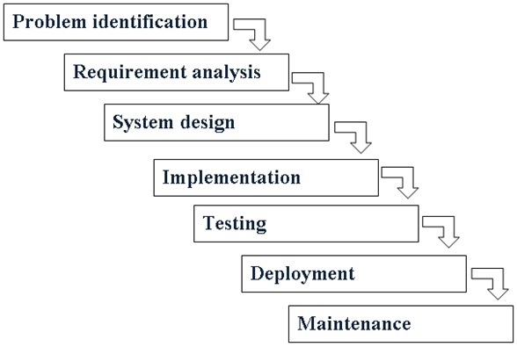
Figure 1.1: Waterfall Model for Product Recommendation System

5.1 Requirement identification
5.1.1 Study of Existing System
Many leading digital platforms have effectively adopted product recommendation systems to personalize user experiences and boost their overall sales. These systems are typically built using collaborative filtering, content-based methods, or a combination of both (hybrid approach). Below is a summary of some notable systems currently in use:
Amazon
Amazon employs a hybrid recommendation model that merges item-based collaborative filtering with deep learning algorithms and user browsing data. It delivers personalized product suggestions based on users’ previous purchases, viewed items, and the behavior of similar users.
Netflix
Netflix’s recommendation engine utilizes collaborative filtering and matrix factorization to analyze users' watch history, ratings, and preferences. This allows the platform to offer personalized suggestions, leading to increased user engagement and retention.
Spotify
Spotify integrates collaborative filtering with Natural Language Processing (NLP) to generate music recommendations. It evaluates listening patterns and metadata such as genre, artist relations, and playlists to tailor suggestions to individual users.
YouTube
YouTube leverages deep learning techniques alongside collaborative filtering to recommend videos. Its system considers user watch history, likes, and engagement trends to present relevant content in real time.

5.1.2 Literature Review
Product recommendation systems have become essential in enhancing user experience and driving engagement across various digital platforms. These systems analyze user preferences and behaviors to provide personalized suggestions, thereby increasing customer satisfaction and platform efficiency.
Ricci, Rokach, and Shapira (2011) classify recommendation systems into three main categories: collaborative filtering, content-based filtering, and hybrid approaches. Collaborative filtering recommends items based on user-user or item-item similarities using past behavior (Sarwar et al., 2001). However, it often struggles with issues like the cold start problem and data sparsity.
In contrast, content-based filtering recommends items similar to those previously liked by the user, using item features and user profiles (Lops, De Gemmis, & Semeraro, 2011). While effective for new users, it may lead to limited diversity in suggestions.
To address these limitations, hybrid systems combine both approaches for more accurate and diverse recommendations (Burke, 2002) [1]. Major platforms such as Amazon and Netflix have successfully implemented hybrid models, improving user retention and satisfaction (Gómez-Uribe & Hunt, 2016). [2]
Recent advancements include the use of matrix factorization, deep learning, and context-aware models, which have significantly enhanced the performance of recommendation engines (Koren, Bell, & Volinsky, 2009). Open-source tools like Scikit-learn and TensorFlow have made these techniques more accessible for developers and researchers.
This project draws on these existing methodologies to build a web-based recommendation system that delivers real-time, personalized product suggestions using machine learning algorithms.

5.1.3 Requirement Analysis
For this system requirements are basically identified through functional and non-functional requirements.
5.1.3.1 Functional Requirements
For Users:
- Registration & Login:
Users can create an account, log in securely, and maintain a personal session.
- Product Browsing:
Users can explore various products listed on the platform with details such as price, category, and description.
- Personalized Recommendations:
Users receive product suggestions based on their browsing history, preferences, and interaction patterns.
- Search & Filter:
Users can search for specific products or apply filters to find items of interest.
- Rating & Feedback:
Users can rate products or give feedback, which helps the system improve future recommendations.
- User Profile Management:
Users can update their personal information and view past activity or preferences.
For Admin:
- Admin Login Panel:
Admins access the system through a secure login interface.
- Product Management:
Admins can add, update, or delete product listings, including details like name, price, category, and images.
- User Management:
Admins can view and manage user accounts and activity records

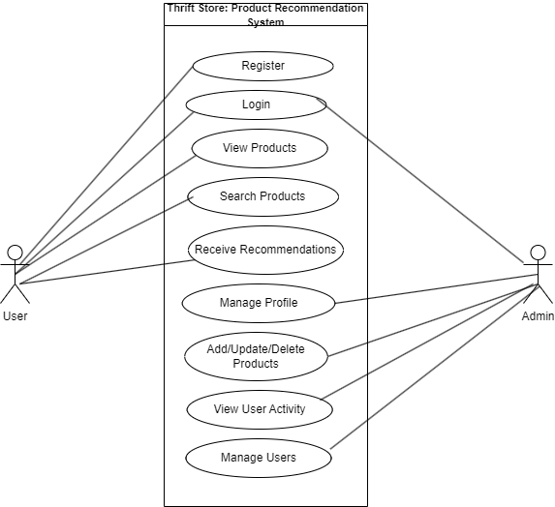
Figure 1: Use case diagram for Product Recommendation System
5.1.3.2 Non-functional Requirements
Non-functional requirements define the overall qualities and constraints of the system that enhance performance, usability, and reliability:
- Performance:
The system should provide real-time product recommendations without noticeable delay, even with a large number of users and products.
- Scalability:
The system must be scalable to handle increased user traffic, product data, and activity logs over time.
- Security:
User data (login credentials, preferences, etc.) must be stored securely with proper authentication and encryption methods.
- Usability:
The interface should be user-friendly, intuitive, and accessible to both technical and non-technical users.
- Maintainability:
The codebase and system architecture should be well-structured and documented to allow easy updates and maintenance.
- Compatibility:
The web application should be compatible across different browsers and responsive to various screen sizes (desktop, tablet, mobile).
- Data Accuracy:
The recommendations provided should be relevant and accurate based on the processed user behavior and product data.
5.2 Feasibility Study
- Technical Feasibility:
The system can be developed using widely available technologies like Python, Django, and machine learning libraries such as Scikit-learn, ensuring smooth implementation.
- Economic Feasibility:
Development costs are minimal, relying on open-source tools, making it cost-effective for a student or prototype project.
- Operational Feasibility:
The system is designed to be user-friendly and meets essential requirements like product browsing, personalized recommendations, and user interaction.
- Legal Feasibility:
The project complies with data privacy norms and uses only open-source software, ensuring no legal constraints.
- Schedule Feasibility:
The project can be completed within the academic timeline, with clear phases for design, development, and testing.

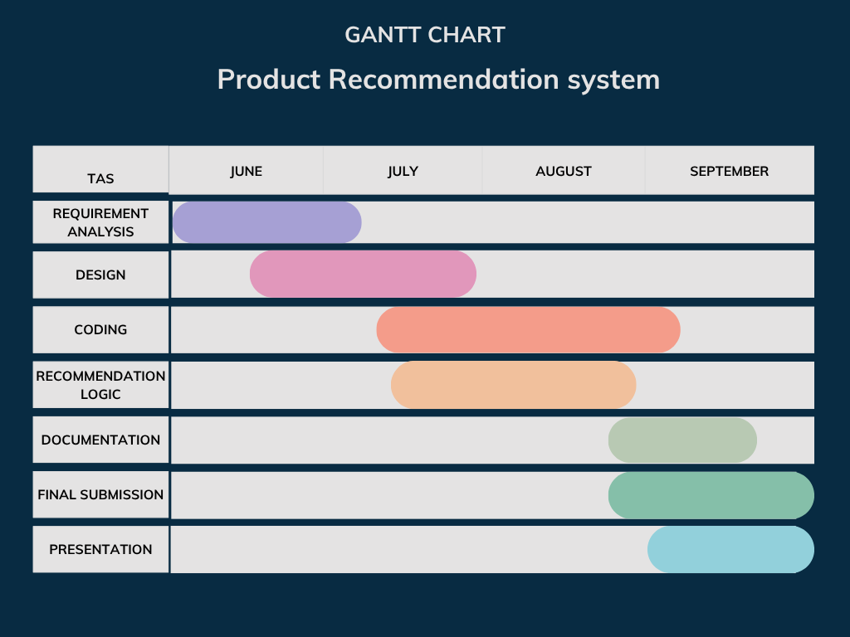

Figure 2: Gantt Chart for Thrift Store

High Level Design of System
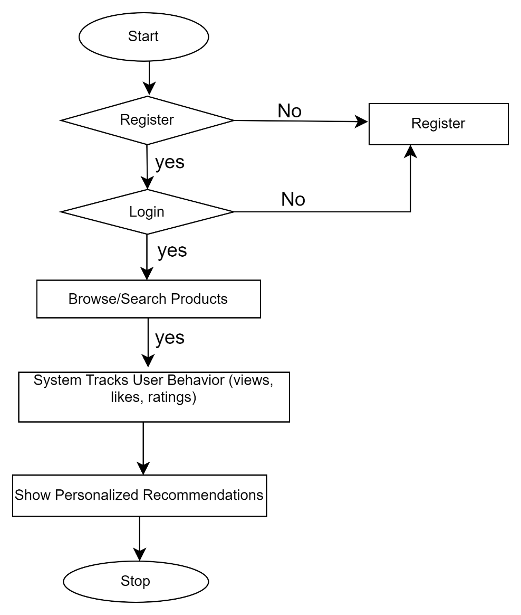

Figure 3: User Flow Chart

Algorithm to be used:
The core functionality of the recommendation system will rely on the following algorithms:
- Collaborative Filtering:
This algorithm recommends products by analyzing the preferences and behavior of users with similar interests. It identifies patterns based on user-item interactions (e.g., ratings, clicks, or purchases).
- Content-Based Filtering:
This approach recommends products similar to those the user has shown interest in, by comparing product attributes (e.g., category, price, description).
- Hybrid Filtering (Optional):
A combination of collaborative and content-based filtering is used to improve accuracy and handle limitations such as the cold start problem.
- Cosine Similarity / Euclidean Distance (for content comparison):
These similarity metrics are used to measure how closely related products or users are in the feature space.
- Matrix Factorization (Optional - for advanced systems):
Techniques like Singular Value Decomposition (SVD) may be used to reduce dimensionality and improve recommendation performance.

System developments tools
The development of the Product Recommendation System involves various tools and technologies to support both frontend and backend functionality, machine learning integration, and data handling:
- Python
Used as the primary programming language for implementing machine learning algorithms and backend logic due to its simplicity and strong library support.
- Django
Python-based web frameworks used to develop the backend of the web application, manage user interactions, and connect to databases.
- HTML, CSS, JavaScript
Core technologies for designing the frontend interface, ensuring responsive and interactive user experience.
- Pandas / NumPy
Python libraries used for building and training the recommendation model, handling data preprocessing, and performing numerical computations.
- SQLite
Relational database systems used to store user data, product information, and user interaction history for generating recommendations.

6. Expected Outcome
The system will provide personalized product recommendations based on user behavior and preferences. Users can browse, search, and interact with products, while admins can manage data through a simple interface. The project aims to enhance user experience and demonstrate the practical use of recommendation algorithms in a web-based platform.

7. References

[1] | "R. Burke," Hybrid recommender systems, 01 Dec 2002. [Online]. Available: https://link.springer.com/article/10.1023/A:1021240730564. [Accessed 19 Jun 2025].
[2] | "C. A. Gómez-Uribe and N. Hunt," The Netflix recommender system, Dec 2016. [Online]. Available: https://dl.acm.org/doi/10.1145/2843948.
[3] | "scrbid," scrbid, [Online]. Available: https://www.scribd.com/presentation/451556415/ONLINE-NOTES-SHARING-PROJECT-ppt-finale.
[4] | "Django Documentation," [Online]. Available: https://docs.djangoproject.com/.

