FutureInSites Brand Guidelines
Version 1.0 draft for review | June 5, 2026 | Source of truth: futureinsites.com
Sync rule: the website and all collateral (decks, docs, graphics) stay in sync. The website defines the brand; these guidelines codify what is already live. Any proposal that goes beyond the live site is flagged [WEBSITE CHANGE] because adopting it means updating the site to match. Nothing in sections 1 through 5 requires website changes; everything is documented as built.

1. Logo and wordmark
White version (the primary logo): full lockup as used on dark surfaces:
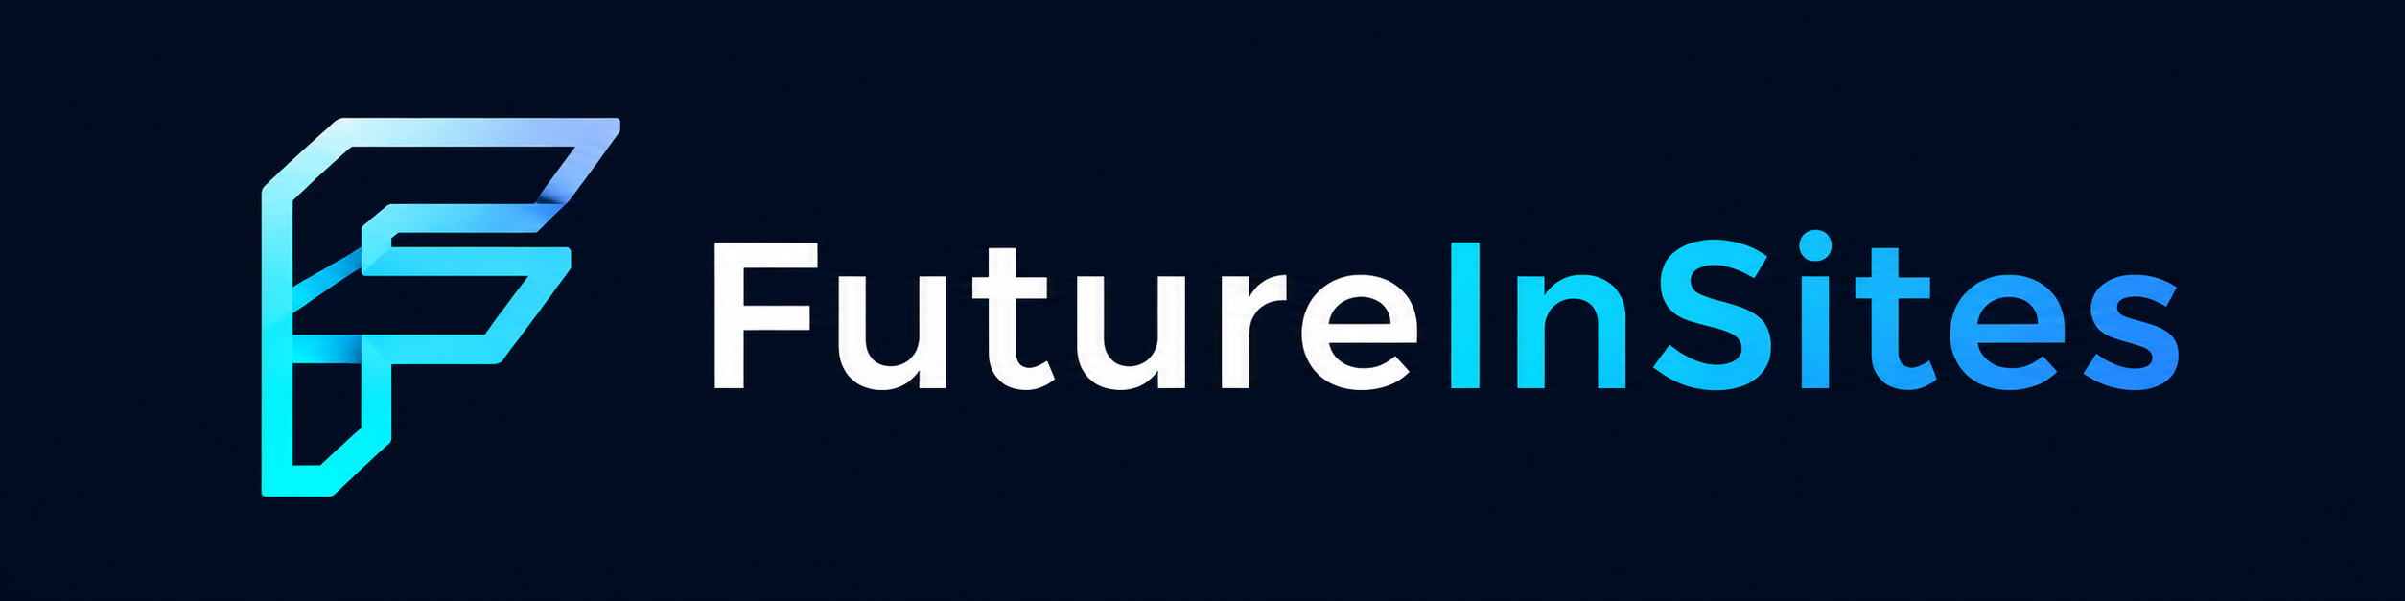
Wordmark alone on dark:

Standalone mark (nav, avatars, favicons):

- Two versions: the white version (white “Future”) lives on dark surfaces and is the primary logo; the black version (“Future” in #0B0C10) lives on white and light surfaces. In both, “InSites” carries the brand gradient, left to right, Cyan to Blue (90°). Manrope ExtraBold 800, letter-spacing -0.025em, no space between the parts.
- The gradient belongs to “InSites” only. Never apply it to headlines, icons, bars, or any other text.
- No riffs: where gradient text is impossible (plain text contexts, email), render the full wordmark in one solid color instead.
- Tagline lockup: “AI Strategy & Engineering” in regular weight, white or near-black depending on background.
- Which version where: the logo picks itself based on the surface. Dark surface = white version, exactly as the site does today. White or light surface = black version. The white version must never sit directly on a light background.
The black version
New asset to create: “Future” in near-black #0B0C10, “InSites” keeps the exact same Cyan to Blue gradient, mark unchanged since it already reads on white. Standard for all white surfaces: slides, docs, print. Mock below is set in a stand-in font; the production asset uses Manrope ExtraBold:

Small-size rule: the cyan end of the gradient is low contrast on white, so below roughly 1 inch of logo width “InSites” goes solid Blue #2563EB, or drop to the standalone mark. Until the black version exists, the interim treatment is the white version on its own dark band with rounded corners:
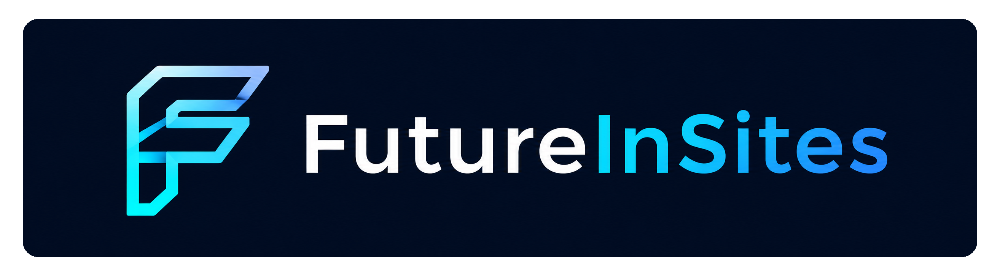
After the black version exists, the band treatment stays available as an occasional brand moment (covers, footers), not the default. Where nothing fits (tight corners, tiny footers), light surfaces carry the standalone mark only.
The brand gradient:

#2DD4FF → #2563EB, 90° (left to right)

2. Color palette
Core
Name / role | Swatch | Hex | Usage
Near-black (primary dark) | #0B0C10 | #0B0C10 | Dark section backgrounds; body text on light
Near-black 2 (raised dark) | #12141A | #12141A | Cards and panels on dark backgrounds
Blue (accent) | #2563EB | #2563EB | Buttons, links, emphasis; gradient end
Cyan (highlight) | #2DD4FF | #2DD4FF | Eyebrow labels, accent bars, glows; gradient start
White (base) | #FFFFFF | #FFFFFF | Light section backgrounds

Supporting
Name / role | Swatch | Hex | Usage
Alt background | #F8F9FB | #F8F9FB | Alternating light sections, table fills
Accent tint | #EFF6FF | #EFF6FF | Soft blue fill behind accent content
Border | #E4E7EE | #E4E7EE | Card and divider lines on light surfaces
Muted text | #64748B | #64748B | Secondary text on light surfaces

Dark-surface conventions: on dark backgrounds, use white at reduced opacity rather than gray hexes: 75% for lead paragraphs, 65% for card body text, 50% for subtitles. Card surfaces are white at 4% with a 1px white 8% border.
Weighting: roughly 60-70% neutral (near-black or White), 20-30% supporting tones, Cyan and Blue as sharp accents. Cyan is a highlighter, not a background: small doses only (labels, 4px bars, glows), never large fills.

3. Typography
Element | Font | Weight | Case and tracking
Wordmark, display headlines | Manrope | 800 | Tight tracking (-0.02 to -0.04em); hero lines may be ALL CAPS
Section titles | Manrope | 800 | Sentence case, -0.02em
Eyebrow labels | Inter / system | 600 | ALL CAPS, wide tracking (0.12-0.18em), Cyan
Card titles | Inter / system | 700 | Sentence case
Body | Inter / system | 400 | Line-height 1.7; #64748B for secondary text

Decided June 5, 2026: the brand pair is Manrope (display) + Inter (body). The site currently declares Inter without loading it, so the website gets fixed to match: add the Inter Google Fonts link to each HTML page, with the CSS stack set to 'Inter', -apple-system, BlinkMacSystemFont, 'Segoe UI', sans-serif. Where Inter is unavailable (desktop Office files on machines without it installed), the fallback is the system sans; in Google Slides and Docs, Inter is available natively.

4. Signature motifs
- Eyebrow labels: small cyan ALL CAPS label above titles, with either a 24px cyan dash to its left or a rounded pill outline (cyan 8% fill, 20% border).
- Pill buttons: fully rounded (100px radius), Blue fill, white 600-weight text.
- Cards: 8px corner radius, 1px subtle border, generous padding. No heavy drop shadows.
- Cyan accent bar: 4px vertical Cyan bar on the left edge of featured panels.
- Dark texture: subtle 60px grid lines (white at 2.5%) plus a soft radial glow blending Cyan into Blue. Hero and cover surfaces only.
- Sandwich structure: dark for opening and closing moments; White and #F8F9FB alternating between.

5. Slide translation (for the template step)
Element | Spec
Format | 16:9 widescreen
Cover / closing slides | Near-black background, subtle grid + cyan glow, wordmark, white display title
Content slides | White background, near-black titles, cyan eyebrow label above the title
Section dividers | Near-black background variant
Slide titles | Manrope 800 (Arial fallback), 26-30pt
Eyebrow labels | 10-11pt, ALL CAPS, Cyan, wide tracking
Body | 12-14pt near-black; #64748B for secondary lines
Cards | White or #F8F9FB fill, 1px #E4E7EE border, 8px corner radius
Page numbers | Small, muted, consistent corner

6. Decisions (June 5, 2026)
- Body font: Inter adopted. Website fix queued: load Inter on every page and set the fallback stack per section 3.
- Per-case palettes: confirmed out of scope. Case-study pages keep their own palettes.
- Black version of the logo: approved per section 1 (“Future” in #0B0C10, gradient “InSites” unchanged, small-size rule included). Asset creation queued; it joins the site repo so web and collateral share one set. The dark band is the interim treatment until it exists.
Editorial conventions already in force: no em dashes, no “ship/shipping” jargon, no “AI” prefix on role or section names, audience labels plural, Build-Operate-Transfer framed as build + co-operate + transition.

