GPMDNA Program User Manual

Table of Contents
1 Introduction 2
2 Glossary 3
3 Running the program 4
4 The GPMDNA Input Language 6
5 Viewing, Entering and Editing Profiles 7
5.1 Select Profiles 7
5.2 New 7
5.3 Edit 7
5.4 Delete 8
5.5 Clear 8
5.6 Save 8
5.7 Dataset 8
5.8 Metadata 8
6 Import/Export 9
7 Database Management 10
8 Searching for matching profiles 11
8.1 Selecting Crime and Reference Datasets 11
8.2 Match parameters 11
8.2.1 Frequency database 12
8.2.2 Deltas 12
8.2.3 Relationships to match 12
8.2.4 LR threshold 12
8.3 Processors 13
8.4 Database 13
9 Results 16
9.1 Save Results 16
9.2 Clear Results 16
10 Message window 17

Introduction
The GPMDNA Program looks for matches between forensic DNA profiles.

DNA profiles may be imported or entered manually, and are stored in a database. The software supports probabilistic data entry. I.e. when the identity of an allele can not be determined with certainty, a probability distribution may be entered. This is useful when interpreting poor quality EPGs (partial or low-template samples), and mixtures.

Probabilistic interpretation of EPGs should be performed by an SO.

The user selects two sets of profiles from the database (The “crime” set and the “reference” set) for comparison. One-to-one, one-to-many and many-to-many comparisons are supported.

The software is able to detect a possible identity match between two profiles (i.e. the samples may have come from the same person), or a possible familial match (i.e. the samples may have come from people with a particular familial relationship, e.g. siblings, or parent-child).

The strength of a match is reported as a Likelihood Ratio (LR). LRs are calculated relative to the null hypothesis that the profiles come from unrelated people.
When the software is run on a computer with one or more NVIDIA CUDA-capable graphics cards, the software can make use of hardware acceleration to perform one-to-many and many-to-many comparisons many times faster than is possible on the CPU.
WARNING! The LR is a statistical measure of the strength of the genetic evidence in favour of the tested hypothesis, compared to the null hypothesis. THE LR DOES NOT HAVE A SIMPLE INTERPRETATION AS THE PROBABILITY OR THE ODDS THAT THE TESTED HYPOTHESIS IS TRUE. The interpretation of LRs should be undertaken by trained individuals.

Glossary

DNA | Deoxyribonucleic acid
EPG | Electropherogram
Identifiler | AmpFlSTR® Identifiler® PCR Amplification Kit (Applied Biosystems)
LR | Likelihood Ratio
MRGS | Military Grid Reference System
PCR | Polymerase Chain Reaction
PMF | Probability Mass Function
Powerplex 16 | PowerPlex® 16 System (Promega)
SGM | Second Generation Multiplex PCR Amplification Kit (Applied Biosystems)
SGM+ | AmpFlSTR® SGM Plus® PCR Amplification Kit (Applied Biosystems)
SO | Scientific Officer
STR | Short Tandem Repeat

Running the program
The GPMDNA software runs on desktop and laptop computers under the CentOS Linux operating system. To make use of hardware acceleration an NVIDIA CUDA graphics card is required. For the greatest processing power a workstation with multiple GPGPUs is used. However all functionality is available on low-powered laptops.
The GPMDNA GUI is started by running a script named gmatch.sh at the command prompt.
> gmatch.sh
A number of defaults and options are controlled by environment variables set within this script.
Environment variable | Values | Notes
POPDATA | Path to default frequency database | May be set within the Match Parameters tab of the GUI
CRIME_DELTA | Default value of C-Set delta (error) value | May be set within the Match Parameters tab of the GUI
REF_DELTA | Default value of R-Set delta (error) value | May be set within the Match Parameters tab of the GUI
UNKNOWN_ALLELES | IGNORE | Ignore alleles not in the frequency database
UNKNOWN_ALLELES | ADD_AS_RARE | Add allele at an appropriate low frequency (for this match only)
PROC | CPU | Default choice of processor. May be set within the Processors tab of the GUI
PROC | GPU
PRINT_PROFS | true | Whether to print profile details in the message are of the GUI
PRINT_PROFS | false
Table 1: GPMDNA environment variables
The appearance of the GUI at start-up is illustrated in Figure 1.

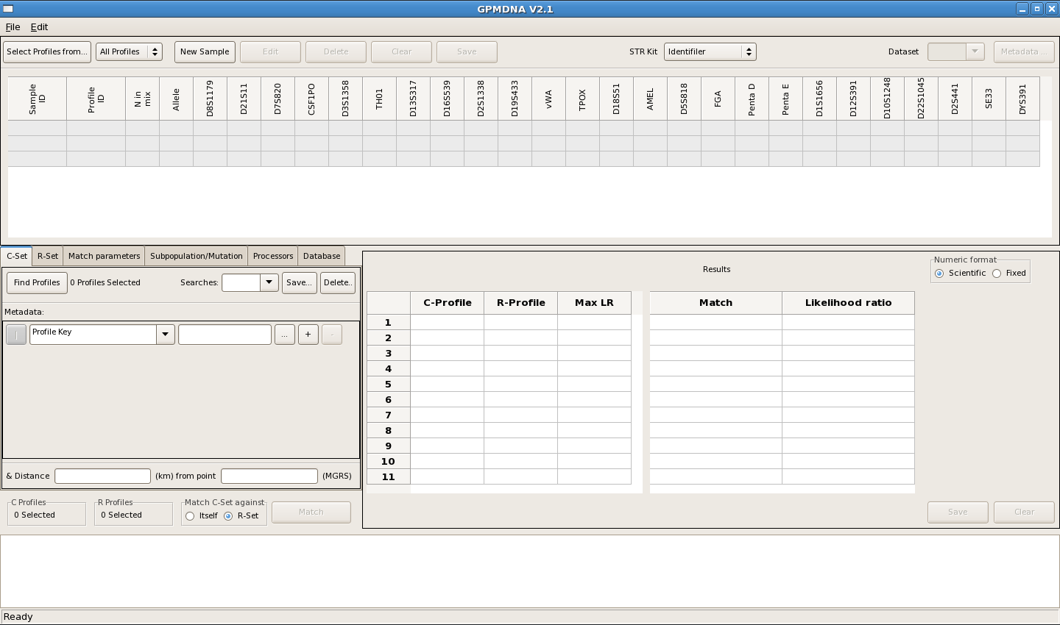Figure 1: GPMDNA GUI

The GPMDNA Input Language
When entering data the user is required to enter a value for each allele at each locus in the sample. This is illustrated in Figure 2.
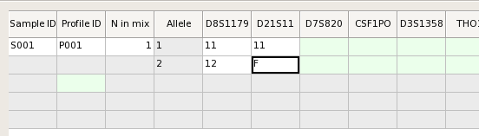Figure 2: Data entry area
A column is provided for every locus in all the commonly used forensic genetics STR PCR amplification kits, including Identifiler, Powerplex 16, Powerplex ESI 17, NGM Select, GlobalFiler.
In accordance with convention, an allele is represent in the format repeats.variant, and an unknown allele (ie for which there is no evidence) is represented as 'F'.
In addition the GPMDNA program provides an extended notation the GPMDNA input language, in which probabilistic statements may be made. This is summarised in Table 2.

Example | Comment
12.3 | Allele name in the format repeats.variant
F | Unknown (not measured). The background distribution is used.
12.3@0.6 | Allele with associated certainty: allele@p-value.  If p-value<1 background is added to normalize, so 12.3@0.6 is equivalent to 12.3@0.6/F@0.4.
12.3@0.6/13@0.3 | A list of alleles separated by ‘/’ (OR).  In this case F @ 0.1 would be added automatically in order to normalise the PMF.
(11/12/12.3)@B | The listed alleles at relative background frequencies, normalised to 1.
(11/12/12.3)@B@0.6 | The listed alleles at relative background frequencies, normalised to the indicated p-value.  In this case F @ 0.4 would be added automatically.
D | Indicates all the alleles observed in the sample at this locus {S}, at background frequencies, i.e. {S}@B.
D@0.8 | Equivalent to {S}@B@p-value  In this case F @ 0.2 would be added automatically.
Table 2: GPMDNA input language

Viewing, Entering and Editing Profiles
Profiles are viewed, entered and edited in the input area at the top of the GUI main window.

Select Profiles
The Select Profiles From... button in the input area pops up the Select Profiles dialog (Figure 3), which allows one or more profiles to be selected by key for display in the input area. The select profiles dialog is populated with either all the profiles in the database, or the profiles selected in the C-Set or R-Set tabs (see Section 8.1 ). This is controlled by the selector to the right of the button.

New
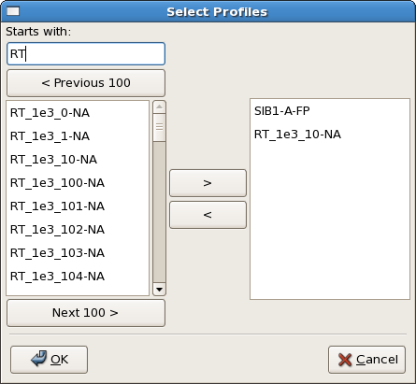Figure 3: Select Profiles dialog
The New sample option in the Edit menu, and the New Sample button in the input area, initialize the input area for entry of a new sample.
The user must enter a Sample ID and a Profile ID, which must together be unique in the profile database.
A sample may consist of several profiles, and a profile may have one or more components. (A profile with more then one component is a mixture).
The number of alleles to be entered (at each locus) is equal to twice the number of components.

Edit
When the input area is being used to view a single profile, the Edit profile option in the Edit menu and the Edit button in the input area put the input area into edit mode, in which the profile (and its metadata) may be edited. When viewing multiple profiles the edit function is not available.

Delete
The Delete profile option in the Edit menu, and the Delete button in the input area, delete the currently displayed profile from the database.

Clear
The Clear profile option in the Edit menu, and the Clear button in the input area, clear the current entry in the input area. (The profile stored in the database is not affected).

Save
The Save profile option in the Edit menu, and the Save button in the input area, allow an edited profile, (or the profiles of a newly entered sample) to be saved to the database.
NB: When a new sample is saved, each profile is saved separately in the database. Each profile can be recalled and edited independently, but they can not again be edited as a single sample.

Dataset
Each profile is assigned a dataset when it is first saved to the database. The dataset serves as a means of grouping profiles, and its meaning is a matter for the user. The dataset of the currently viewed profile is displayed at the top right of the input area. When in edit mode, the dataset may be edited.

Metadata
Each profile may have values assigned to a number of metadata fields. The metadata for the current profile in the input area may be viewed or edited via the Metadata dialog, which is displayed by the Metadata button at the top right of the input area.

Import/Export
The Import option in the File menu pops up the Import Profiles dialog (Figure 4). This dialog allows profiles to be imported in a number of common formats.

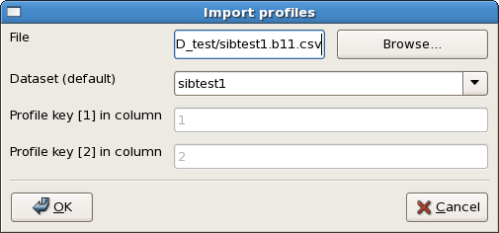Figure 4: Import profiles dialog

Database Management
The bulk editor option in the Edit menu pops up the Bulk Profile Editor dialog (Figure 5). In the top part of this dialog is a Select Profiles Panel allowing a set of profiles to be selected based on dataset, profile key, metadata fields and within a given radius of a fixed location. Locations are specified in MRGS.
The Find Profiles button searches the database for profiles matching the specified criteria and displays the number of profiles found. The selected profiles may be either moved to a different dataset, or deleted.
Search parameters may be saved and recalled by name using the controls at the top right of the panel.

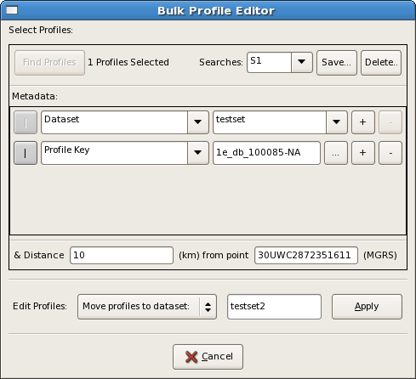Figure 5: Bulk Profile Editor

Searching for matching profiles
A profile match is performed between two sets of profiles selected from the database: notionally a “Crime set” denoted by C-Set, and a “Reference set” denoted by R-Set.

Typically, the C-Set consists of profiles recovered from one or more crime scenes, and the R-Set consists of the profiles of known individuals. However arbitrary sets of profiles may be matched and it does not matter which name is assigned to which set of profiles.

Each profile in the C-Set is matched against each profile in the R-Set. If there are N profiles in the C-Set and M profiles in the R-Set thenpairs of profiles must be matched. If both sets are large then clearly a very large number of individual matches must be performed, and the calculation may take a long time. In such cases the use of hardware acceleration is advantageous (see Section 3 ).

A set of profiles (nominally the C-Set) may be matched against itself. Each profile is matched against every other profile, requiringmatches, i.e. approximatelymatches for large N.

Selecting Crime and Reference Datasets
The crime and reference datasets are selected using the C-Set and R-Set tabs in the tabbed pane at the left of the GUI (Figure 1). Each of these tabs holds a Select Profiles panel as described in Section 7 for the Bulk Profile Editor (Figure 5).

Note that all three Select Profiles panels in the application (C-Set, R-Set, Bulk Profile Editor) use the same set of named searches, that may be defined or edited in any one of them.

Match parameters
The Match parameters tab (Figure 6) allows selection of the frequency database for use in LR calculations, setting delta factors, choosing relationships to match, and setting the LR threshold.

Frequency database
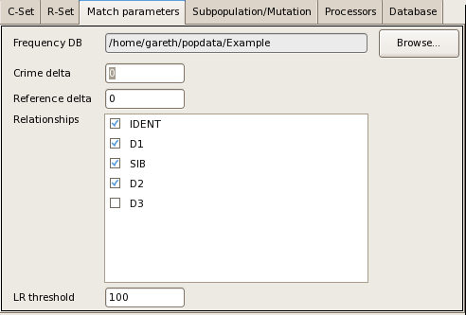Figure 6: Match parameters tab
Frequency databases are provided as text files in external directories. A number of frequency databases are provided with the GPMDNA program. A frequency database is selected using the Browse button in the top right of the tab.

Deltas
The crime and reference delta values provide a crude model or errors and mutations. Delta represents the probability that an allele has changed because of an error in the analysis (eg a 'typo') or because of a mutation. See (1) Section 8 and (2) for more details.

Relationships to match
Version 1.0 of the software offers the relationships shown in Table 3.
Name | Relationships
IDENT | Identity
D1 | Child, Parent.
SIB | Full sibling.
D2 | Grandchild, Grandparent, Uncle, Aunt, Nephew, Niece, half-sibling.
D3 | Great-grandchild, Great-grandparent, first cousin, (and others ...)
Table 3: GPMDNA relationships

NB: Unless a familial relationship can be excluded, at least the closest familial relationships (D1 and SIB) should always be run alongside IDENT. See (2) for further explanation.

LR threshold
Matches are reported in order of descending LR. The LR threshold provides a bound below which matches are not reported. This is useful when matching familial relationships with large databases, since a large number of low-LR matches will be generated by chance.
WARNING! When using hardware acceleration, there is a limit on the number of matches than can be reported back to the CPU. If the LR threshold is set too low, this limit may be exceeded, and further matches (even at higher LRs) will be missed. Look out for warnings of this condition reported in the message window, and increase the LR threshold accordingly.

Processors
On platforms with NVIDIA CUDA-capable GPUs, the choice of processors to use is controlled from the Processors tab (Figure 7).

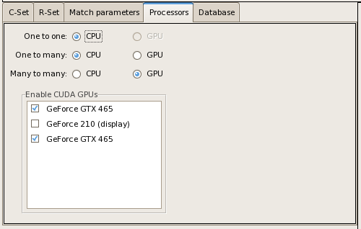Figure 7: Processors tab
The default behavior is to use the CPU for one-to-one and one-to-many matches, and to use GPUs for many-to-many matches. By default all available GPUs are used except any that are used to drive a display, unless there is only one CUDA-capable GPU, when this is used in any case. However this is not always appropriate and the user may determine which processors to use.

Note that if a GPU is used for a display, any other process (such as GPMDNA) that occupies the GPU for more then five seconds may be terminated by the system. This limits the use of hardware acceleration on single-GPU machines.

Database
By default the GUI attempts to connect to a local MySQL database. However it is possible to connect to a database over the network, provided appropriate users and permissions have been set up on the server. (Figure 8)

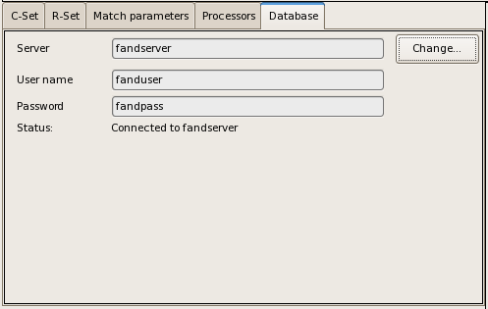Figure 8: Database tab

Results
During the LR calculation the GUI will “freeze”. When the calculation is complete the results are displayed in the lower right pane of the GUI as shown in Figure 9.

Matches are displayed in descending order of LR in the left of the pane. On selecting a result this is displayed in the right of the pane, showing the LR for each relationship tested for these two profiles. The two profiles are displayed in the input/viewing area for ease of comparison.

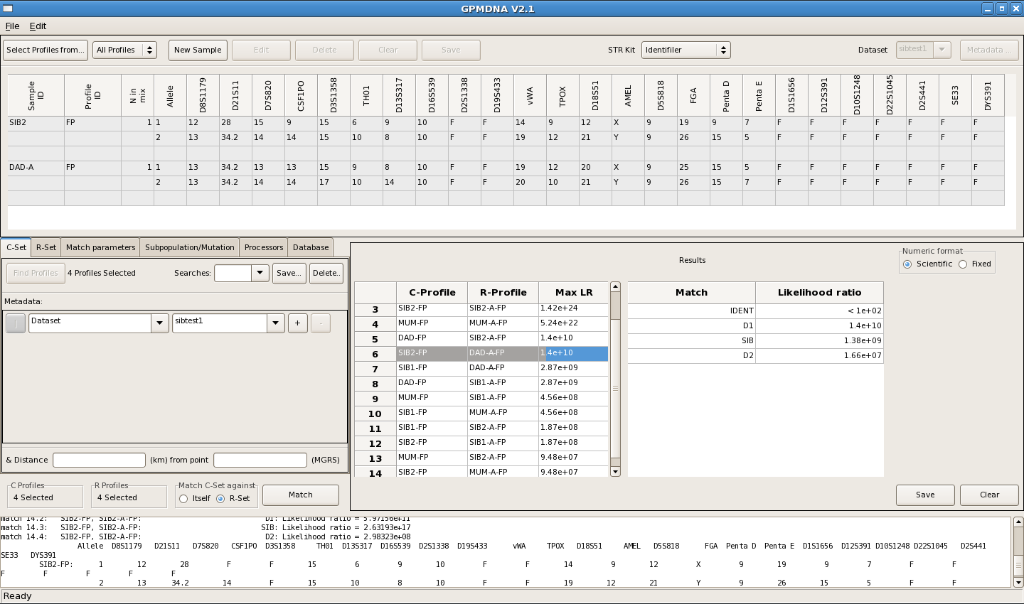Figure 9: Example of GPMDNA results

Save Results
The Save button at the bottom right of the results pane allows a results set to be exported in CSV format.

Clear Results
The Clear button at the bottom right of the results pane clears the results pane.

Message window
Messages including errors and warnings are displayed in the messages window at the bottom of the GUI.

