**Step-By-Step Guide for Multi-User Anaconda Installation on Windows**

The official guide can be found at <https://docs.anaconda.com/anaconda/install/multi-user/>.

This is an unofficial guide with pictures for a Multi-User Anaconda3 Installation.

*Step 1: Download Anaconda3*

The Anaconda3 Installer can be found at <https://www.anaconda.com/products/individual#windows>.

*Step 2: Execute Anaconda3 Installer*

Double-click the Installer in your Downloads folder to begin:

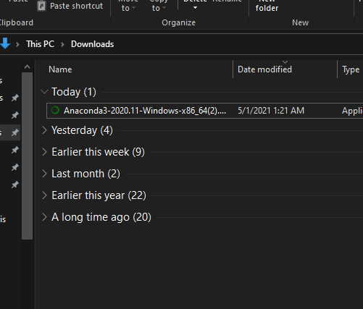

*Step 3: Install for All Users*

To install Anaconda3 for all users on the system, the below option must be selected:

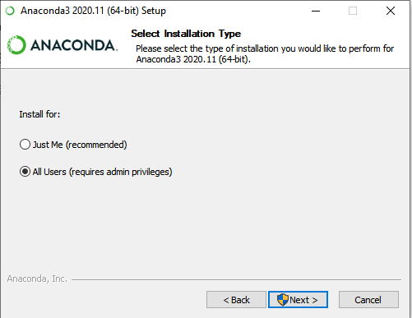

*Step 4: Choose Default Destination Folder*

Allow Anaconda3 to install to the default folder location as seen below:

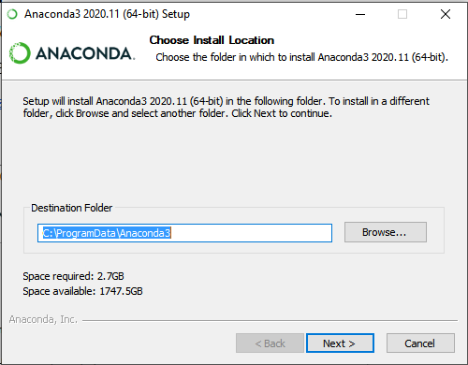

*Step 4.5: Finish Installation*

Anaconda3 can be installed with default settings for least difficulty of use.

The following Options are selected by default when installing. Users may decide whether to use either option depending on what suits their needs best.

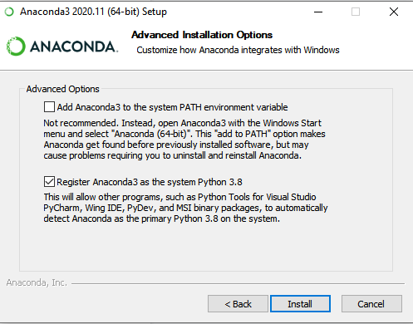

Users that are unsure should deselect both options so as to not conflict with other software on their system:

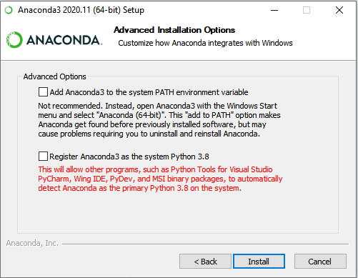

From here, users can select all default options and Click “Next” until the installation is complete.

*Step 5: Establish User Group*

Type “Computer Management” into the Windows Search Bar and select the first result.

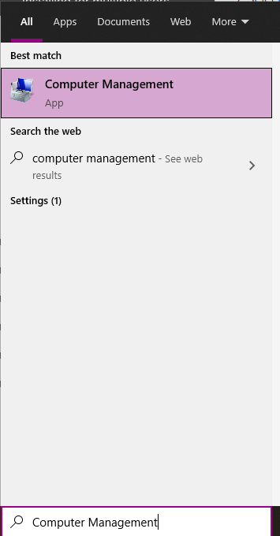

*Optional Step: Establish User Group and Add Users*

***\**This feature is not available on the Windows 10 Home Edition operating system\***

The process for creating a user group and adding users can be seen in the following guide:

<https://www.digitalcitizen.life/geeks-way-managing-user-accounts-and-groups/>.

The created User Group should be named “Anaconda-Users” and the user should add all User Accounts on which they plan to use Anaconda3.

*Step 6: Make Hidden Folder Visible*

If not done previously, adjust the File Explorer to display Hidden Folders by selecting the “Hidden Items” feature under the “View” tab:

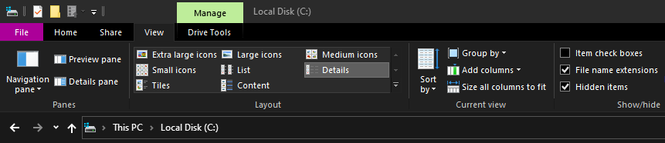

This will begin displaying the hidden folder “C:\ProgramData”

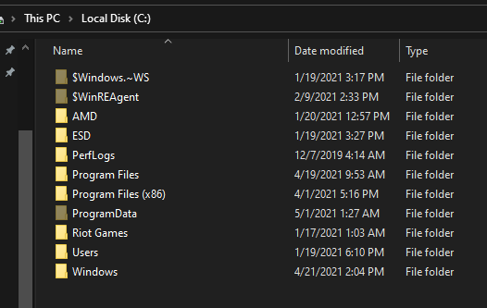

*Step 7: Navigate to Anaconda3 Properties*

In the File Explorer, navigate to the file location of the multi-user Anaconda3 installation:

“C:\ProgramData”

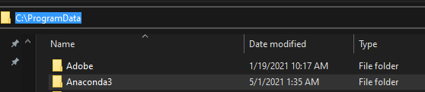

Right-click the Anaconda3 folder and select “Properties” from the list:

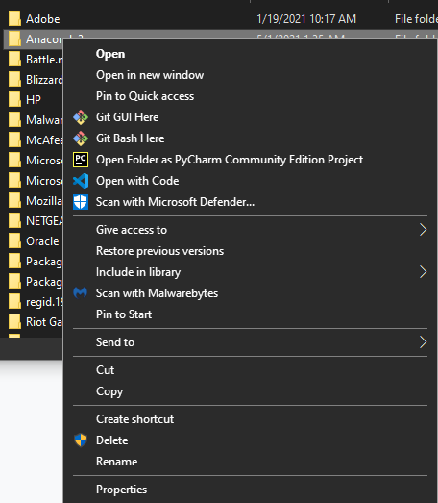

*Step 8: Adjust Anaconda3 Properties*

In Anaconda3 Properties, deselect “Read-only” and click **Apply** to launch this dialog:

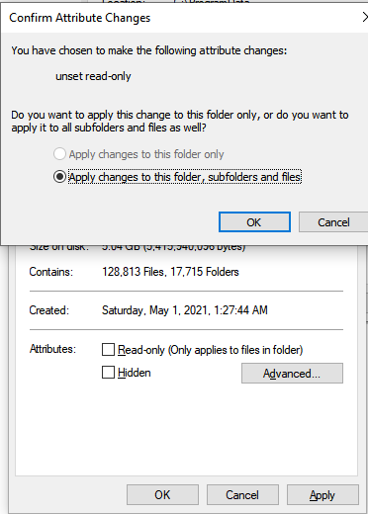

Press **OK** and **Continue** with administrator Permission.

This will take some time:

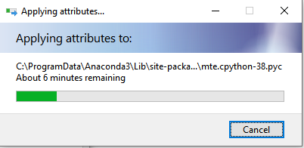

*Step 9: Adjust Anaconda3 User Permissions*

Switch to the “Security” tab and select **Edit**:

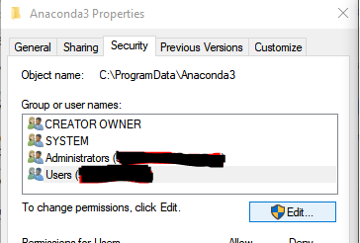

Add Users (or User Group if created) using the **Add** button and select the box under “Allow” to give them write permissions. Afterwards, click **Apply**

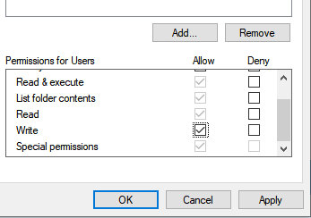

This process will again take a while.

Once complete, select **OK** on the Permissions Window and the Properties Window.

You have now successfully installed Anaconda3 for Multiple Users!