Semester 1
Self-Driven Activity report
Quarter 1

Theme | Entrepreneurship
Activity Name | EUREKA – Idea Pitching
Mode of Conduct | Offline
Level of Activity | Level 1 *
Participants | Students: 8 students from 3rd year Faculty: 03
Online Resource | https://youtu.be/hIR9xjCxuRg
Brochure | 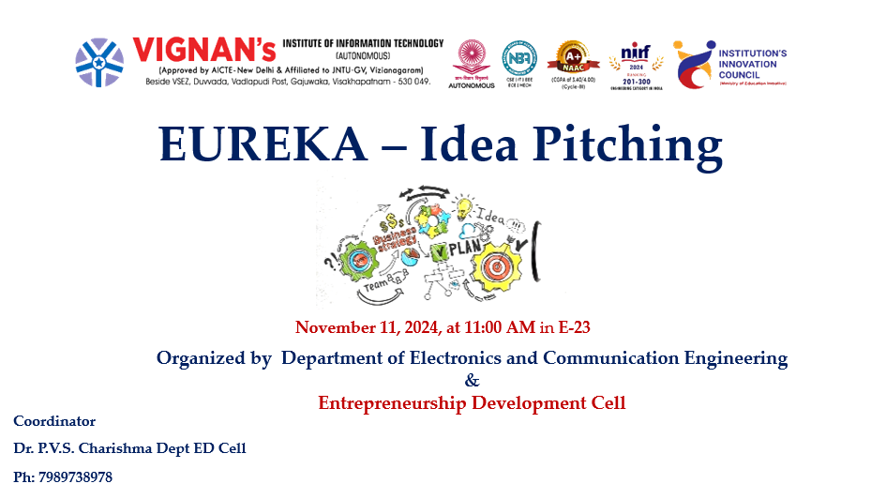
Description | Department of Electronics and Communication Engineering On November 11, 2024, the IIC ambassador and ED Cell at E-23 room in Vignan's Institute of Information Technology (A) organized a idea presenting event designated "EUREKA – Idea Pitching" that was tailored for third-year ECE students. During this activity, students presented innovative startup concepts that tackled industrial and social demands. The objective was to foster business acumen and creativity in students at an early stage. Many domains, such as sustainability, transportation, textile innovation, and health, were addressed in the concepts. Each student presented their proposal, which encompassed an issue description, a proposed solution, market viability, and the anticipated outcome. Dr. P.V.S. Charishma serves as the coordinator for this initiative. The students were motivated and encouraged by Dr A.S.Dakshina Murthy, the Head of VCIS, to submit their ideas to the call for proposals from STPI 2024 under a variety of initiatives.
Objectives | - To foster entrepreneurial mindset and creativity among ECE students.  - To enhance students’ skills in idea articulation and business presentation.  - To provide a platform for early-stage startup ideation.
Outcomes | - Over 8 innovative startup ideas were pitched by students.  - Students gained practical exposure to the entrepreneurial ecosystem.  - 3 student teams were encouraged to refine and submit their proposals.
Photos | 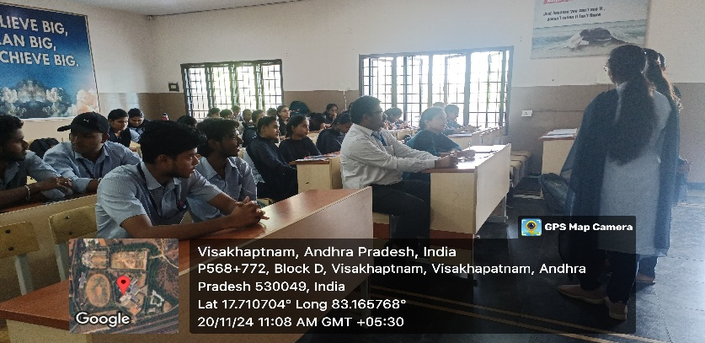  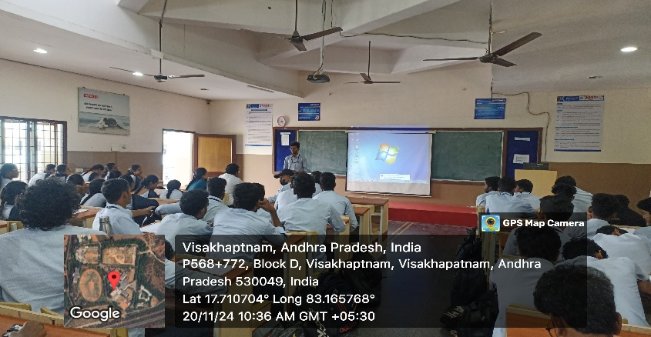  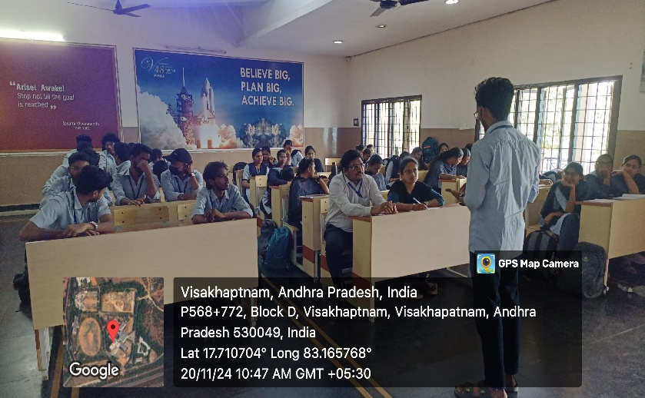  Students participated in the session

Feedback:
Students expressed enthusiasm and found the session engaging. Many appreciated the constructive feedback provided by the faculty mentors. They requested more such events that allow them to test their ideas in a safe and supportive environment.

Budget:
No external budget was required.

List of Students
S. No | Year | Name | Start up- Idea | Team Members | Signatures
1 | III-I | A S Theerdhankar | EcoFetch, Vahana Patra Darshi | 2
2 | III-I | B.Jahnavi | Empower Tailor | 3
3 | III-I | A.Kushal | Mortgage-Friendly Bike Rental Service | 2
4 | III-I | T. Kintan Varma | IllumniSense | 3
5 | III-I | K.S.S.S. Vardhan | GreenMiles Solutions | 2
6 | III-I | S. Sai Kiran | Eco Fibers | 3
7 | II-I | K.S Chaitanya | BMI Bites | 2
8 | II-I | Gopal Krishna | Vistora | 2

Faculty Ambassadors and Coordinators

S.No | Name of the Coordinators | Role
 | Dr. P.V.S. Charishma | ED cell Coordinator
 | Dr A. Sampath Dakshina Murthy | Head VCIS, IIC Ambassador
 | Mrs M Karuna | IIC Ambassador

Dr. P.V.S. Charishma Dr. A. S. Dakshina Murthy
ED - CELL Activity Coordinator Head VCIS, IIC Ambassador

Dr. J. Sudhakar Dr. V. Madhusudhana Rao
Convener VIIT-IIC President, VIIT-IIC

