Semester 1
Thrust area: Inspiration, Motivation & Ideation
Quarter 1

Theme | Entrepreneurship
Activity Name | Workshop on “Entrepreneurship and Innovation as Career Opportunity”
Mode of Conduct | Offline
Level of Activity | Level 2 *
Participants | - Students: 229 students from the Institute.  - Faculty: 06
Online Resource | https://youtu.be/WROBEjM0q4g
Brochure | 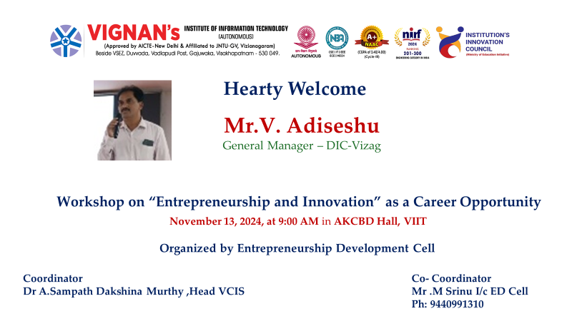
Description | The Institute Innovation Council (IIC) and ED Cell of Vignan's Institute of Information Technology (A) organized an inspiring session, " Workshop on “Entrepreneurship and Innovation as Career Opportunity” on November 13, 2024, at 09:00 AM in AKCNB Hall. Over 229 students and 06 faculty innovation ambassadors actively participated in the session.  The speaker, Mr. V.Adiseshu, General Manager-DIC, Visakhapatnam, shared his remarkable on Entrepreneurship and Innovation as Career Opportunity. Workshop is an exciting event designed to explore the dynamic world of starting and growing businesses, and how innovation plays a crucial role in shaping successful ventures. Participants will hear from industry experts, seasoned entrepreneurs, and innovators who will share their personal experiences and insights on navigating challenges and seizing opportunities in today’s fast-paced market. Additionally, the event will provide hands-on activities, case studies, and networking opportunities to foster collaboration and inspire entrepreneurial thinking. This workshop offers a unique opportunity for attendees to gain practical knowledge, build valuable connections, and explore entrepreneurship and innovation as viable and rewarding career paths.
Photos | 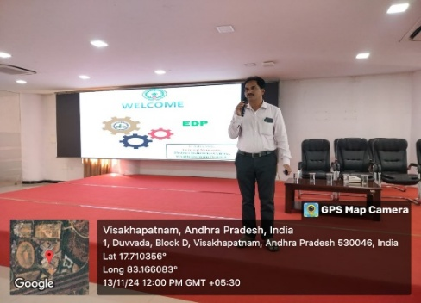  Speaker V.Adiseshu, General Manager-DIC, Visakhapatnam  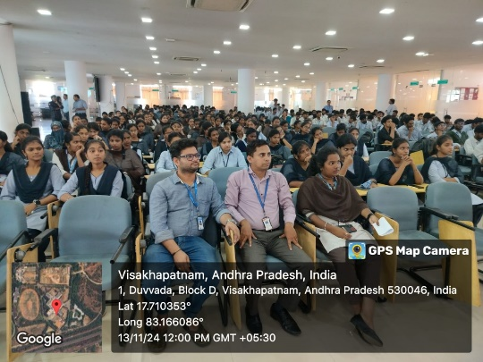  Students participated in the session

Feedback:

V.Adiseshu expressed his gratitude to Vignan for the warm welcome and inspiring atmosphere. He emphasized the significance of entrepreneurship, learning from failure, and recognizing individual potential. Sharing his experiences from marketing various schemes of innovation as career opportunities, and he was delighted to inspire the next generation of innovators.

The workshop on Entrepreneurship and Innovation as a Career Opportunity was highly informative, providing valuable insights into MSME schemes for startup funding. It enhanced our understanding of innovation and entrepreneurship. We sincerely thank the coordinators for organizing such sessions and look forward to more initiatives promoting innovation, startups, and entrepreneurship development.

Event Coordinator Dr. A. S. Dakshina Murthy IIC Activity Coordinator
Head VCIS

Dr. J. Sudhakar Dr. V. Madhusudhana Rao
Convener VIIT-IIC President, VIIT-IIC

List of Students
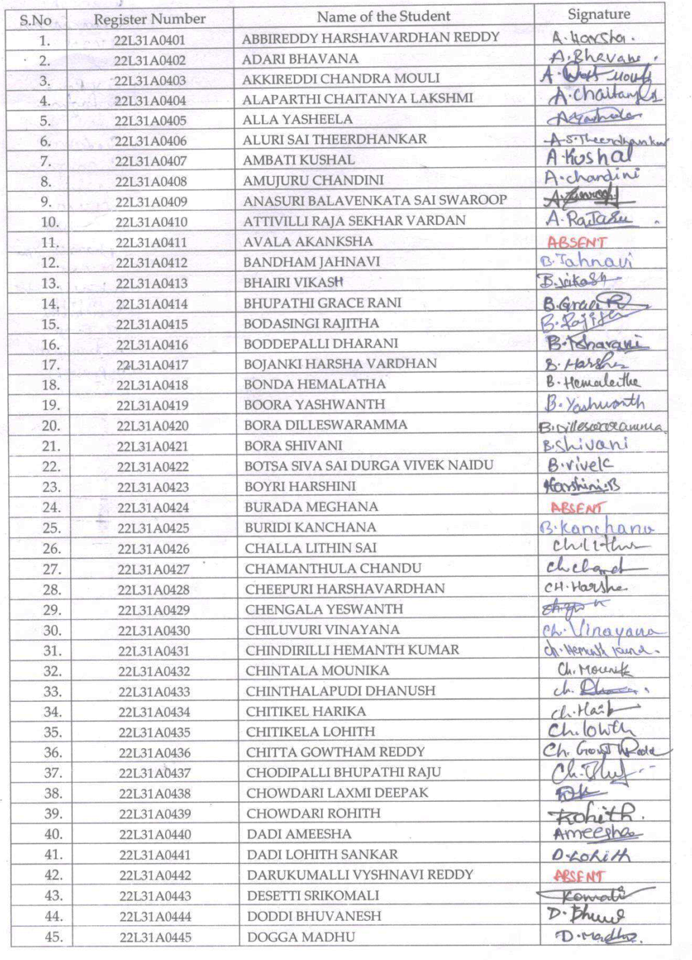

Faculty Ambassadors and Coordinators

S.No | Name of the Ambassadors and Coordinators
 | Dr A. Sampath Dakshina Murthy
 | Mr. N. Venkata Rao
 | Ms. K. Mounika
 | Dr Ch Bharat
 | Mr M. Srinu
 | Dr. S. Murali Krishana

Feedback:

V.Adiseshu expressed his gratitude to Vignan for the warm welcome and inspiring atmosphere. He emphasized the significance of entrepreneurship, learning from failure, and recognizing individual potential. Sharing his experiences from marketing various schemes of innovation as career opportunities, and he was delighted to inspire the next generation of innovators.

Students found the session highly inspiring and insightful. The workshop on Entrepreneurship and Innovation as a Career Opportunity was highly informative, providing valuable insights into MSME schemes for startup funding. It enhanced our understanding of innovation and entrepreneurship. We sincerely thank the coordinators for organizing such sessions and look forward to more initiatives promoting innovation, startups, and entrepreneurship development.

Event Coordinator Dr. A. S. Dakshina Murthy IIC Activity Coordinator
Head VCIS

Dr. J. Sudhakar Dr. V. Madhusudhana Rao
Convener VIIT-IIC President, VIIT-IIC

