

- Event Summary
a. | Date and Time | 13-11-2024, 10.00 AM to 4.00 PM
b. | Name of the Event | Technical Extension Activity - 2K24
c. | Venue | World One School Thimmapuram
d. | No. of Students Participated | More than 500 students
e. | Name of the Event Coordinator | Dr. Girish Bhiogade
f. | Organized By | Department of Mechanical Engineering

Event Coordinator

VIIT/ME/TEA/2024-25/13/11 Date: 11-11-2024

CIRCULAR

To

The Students and Staff

This is to inform all the students and staff members that the Technical Extension Activity is going to organize on the occasion of “Childrens Day Celebrations-2K24” by Mechanical Engineering Department on Wednusday 13.11.2024 from 10:00 AM onwards at World One School Thimmapuram. On behalf of this event we are going to conduct Project Exhibitions for the students, staffs and local people. Kindly take part in the above event.
Venue : World One School Thimmapuram
Timings : 10:00 AM -04:00 PM

For any query, you may please contact,
Faculty Co-ordinator: Dr.Girish Bhiogade, Asso. Professor, Mechanical Engineering Dept.

Event Coordinator HOD- ME

Copy to:
- CEO office
- Rector office
- Principal office
- Admin office
- All Deans
- All HODs

Technical Extension Activity-2K24
On
13th November 2024
Venue: World One School, Thimmapuram

Organized by

Department of Mechanical Engineering
Vignan’s Institute of Information Technology (Autonomous)

In association with

ATAL World One School Thimmapuram
Technical Extension Activity-2K24

About the event:
The III-year Mechanical Engineering students of Vignan’s institute of Information technology Visakhapatnam fabricated an eco-friendly and cost-effective Pedal operated grinding machine designed primarily for small-scale flour production in rural and remote areasat a cost less than Rs 5000. The Pedal operated grinding machine harnesses human power to grind grains like wheat, maize, ragi, rice, and other cereals into flour without the need for electricity or fuel. The project was demonstrated to the students of world one school, staffs and people of Thimmapuram village. The students were interested to know about working of pedal operated grinding machine. People in Thimmapuram village showed their interest in purchasing the machine. The event was conducted in world one school on November 13, 2024 at Thimmapuram, Visakhapatnam (A.P)
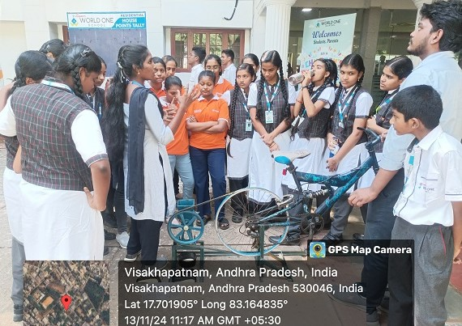

Event Coordinator Principal

Childrens Day Celebrations-2K24
On 13th November 2024
Organised by
Mechanical Engineering Department, VIIT (A)

Venue: World One School Thimmapuram
Image Gallery:

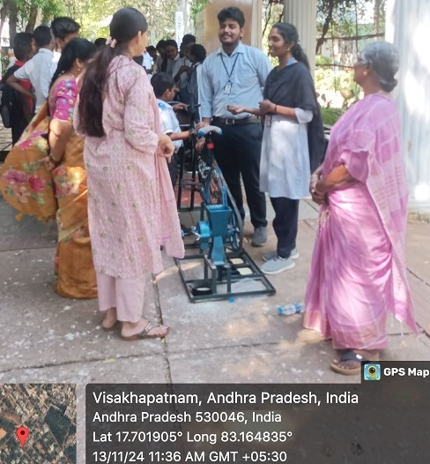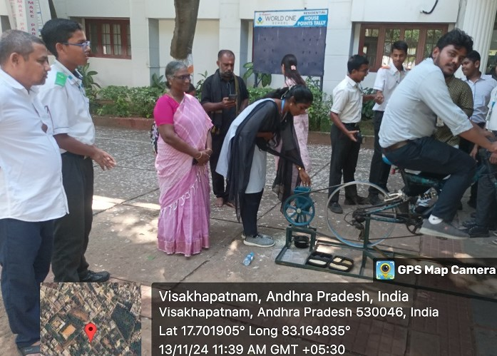

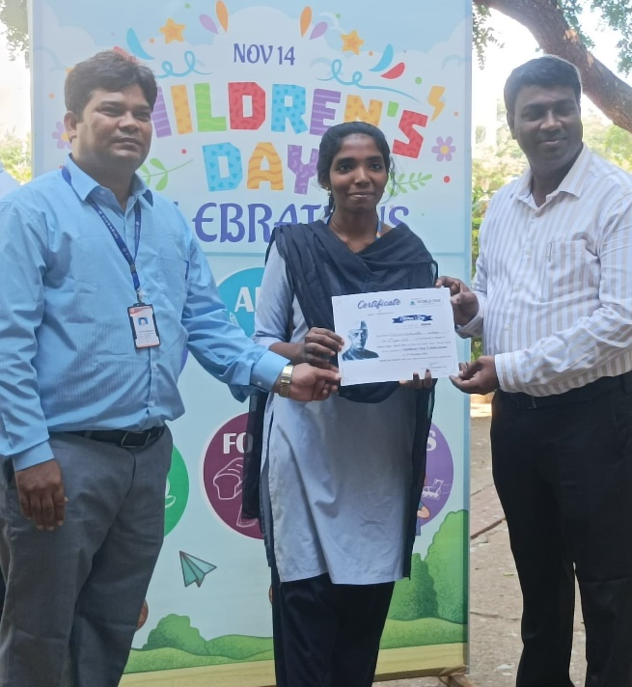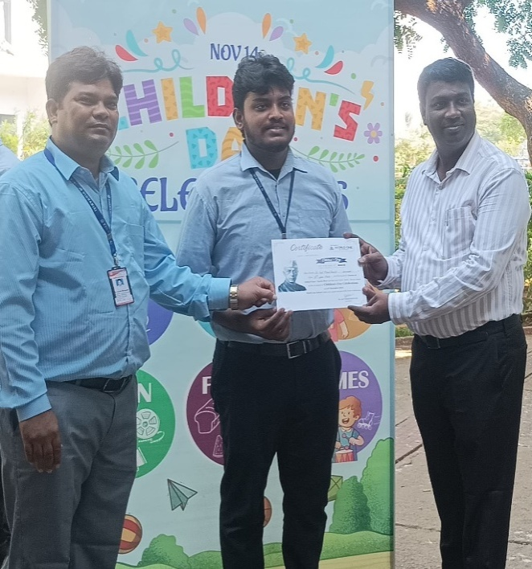

Event Coordinator Principal
Children’s Day Celebrations-2K24
On 13th November 2024
Organised by
Mechanical Engineering Department, VIIT (A)

List of students participated

S.No. | Regd. No. | Name of the students | Branch/sec | Signature
1 | 22L31A0336 | D.M.S.M. Madhumitha | Mech - C
2 | 22L31A0346 | G.Santhosh Kumar | Mech - C
3 | 22L31A0329 | Ch.Sai Manikanta | Mech - C
4 | 22L31A0351 | G. Deepika | Mech - C
5 | 22L31A0368 | K.Aneesh | Mech - D
6 | 22L31A0393 | N.Manikanta | Mech - D

Event coordinator Convener

