Semester 1 Celebrations Activity

Quarter 1
Activity Name | National Education Day
Date of the Activity | 22.11.2024
Mode of Conduct | Offline
Time | One Day
Mandatory/  Elective | Mandatory
Participants | Students: 40; Faculty: 10
Online Resource | https://www.youtube.com/watch?v=KYiWbpC5TfU
Brochure | 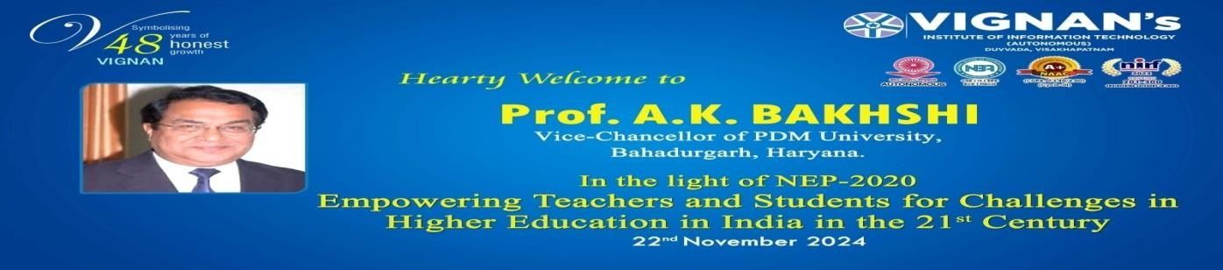
Description | On the eve of National Education Day, the Centre for Innovations and Startups, Vignan’s Institute of Information Technology (Autonomous), organized a seminar on “NEP-2020 & Its Practices through Curriculum” on 22nd November 2024. The seminar was delivered by Prof. A.K. Bakhshi, Vice Chancellor, PDM University, who shared valuable insights on the transformative aspects of the National Education Policy and its integration into higher education curricula.
Objectives | - To create awareness among students and faculty about the key features and implementation strategies of NEP-2020.  - To highlight the role of curriculum design in fostering innovation, multidisciplinary learning, and skill development.
Outcomes | - Participants gained a clear understanding of the role of NEP-2020 in shaping future-ready education.  - Faculty and students identified actionable practices to implement outcome-based and multidisciplinary learning in their respective domains.
Photos | 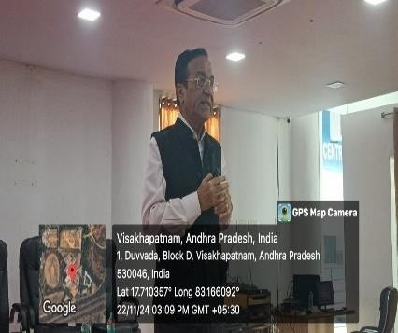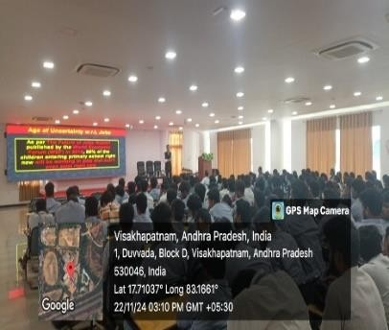  Glimpses of the event

Feedback:
Students expressed that the seminar was highly informative and inspiring. They appreciated the speaker’s practical examples on curriculum design and felt motivated to embrace the new learning approaches recommended by NEP-2020.

IIC Activity Coordinator Dr. A. S. Dakshina Murthy Head VCIS

Dr. J. Sudhakar Dr. V. Madhusudhana Rao
Convener VIIT-IIC President, VIIT-IIC

