Semester 1 Celebrations Activity

Quarter 1
Activity Name | National Entrepreneur's Day
Date of the Activity | 19.11.2024
Mode of Conduct | Offline
Time | One Day
Mandatory/  Elective | Mandatory
Participants | Students: 54; Faculty: 02
Online Resource | https://youtu.be/NR_PxPkvgi8
Brochure | 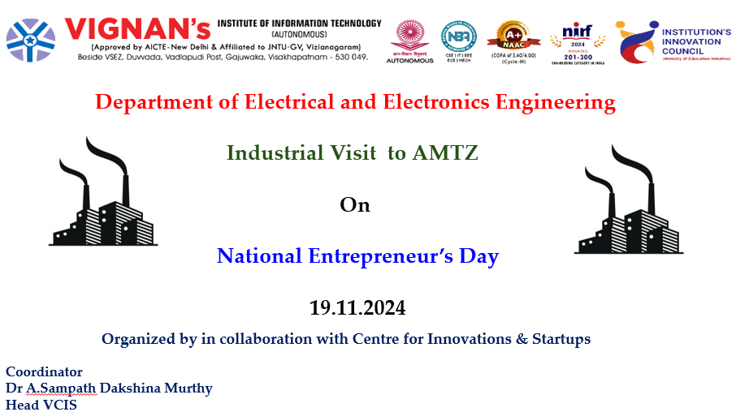
Description | On the eve of National Entrepreneur’s Day, 19th November ,2024 the Centre for Innovations and Startups in association with the Department of Electrical and Electronics Engineering, Vignan’s Institute of Information Technology (Autonomous) organized an Industrial Visit to AMTZ. A total of 54 students from 3rd Year EEE visited the Convention Centre and the Artificial Limb Centre to observe the manufacturing and demonstration of various prosthetic and orthotic devices. Students also explored assistive technology devices and visited the Advanced Medical Technology Lab to understand the design, manufacturing, operation, and control of various electrical, mechanical, and life-supporting medical devices.
Objectives | - To expose students to real-time applications of electrical and electronic engineering in the field of medical technology.  - To help students understand the role of innovation and entrepreneurship in developing advanced assistive and life-supporting devices.
Outcomes | - Students gained practical knowledge of prosthetics, orthotics, and assistive technologies, linking theory to practice.  - The visit enhanced students’ awareness of industrial processes, interdisciplinary applications, and entrepreneurial opportunities in medical technology.
Photos | 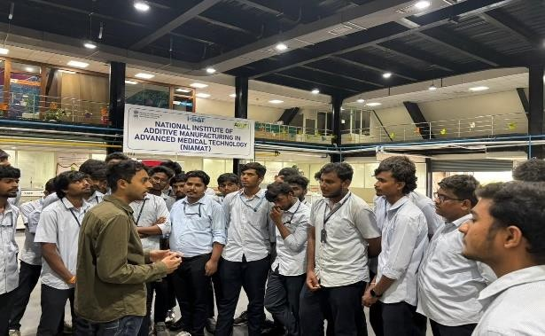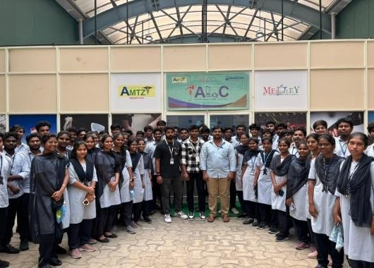  Glimpses of the event

Feedback:
Students expressed that the seminar was highly informative and inspiring. They appreciated the speaker’s practical examples on curriculum design and felt motivated to embrace the new learning approaches recommended by NEP-2020.

IIC Activity Coordinator Dr. A. S. Dakshina Murthy Head VCIS

Dr. J. Sudhakar Dr. V. Madhusudhana Rao
Convener VIIT-IIC President, VIIT-IIC

