Event Summary
Date and Time | 4th July 2025, 9:30 AM to 12:30 PM
Name of the event | Technical Extension Activity on  “ EPL-IGNITE-2K25”
Venue | Prathibha Vidyalayam, Visakhapatnam
No. of students/Faculty participated | 60 Students & Two Faculty Members
Name of the event Coordinator | Dr. M.Karuna, Associate Professor
Organized by | Department of Electronics and Communication Engineering

HoD Principal

VIIT/ECE/EXT/2025-26/07/01 Date: 02/07/2025

CIRCULAR

To

All the students of III Year
***
This is to inform to all the III Year students VIIT in association with ECE Department is going to conduct a Technical Extension Activity on “EPL-IGNITE-2K25” on 4th July 2024. Hence, all the interested students are hereby informed to participate in the session.

Venue: Prathibha Vidyalayam, Visakhapatnam

Time: 9:30 AM to 12:30 PM

For any query, you may please contact,
Event Coordinator: Dr.M.Karuna, Associate Professor, Mobile No: 9014744333
Student Coordinators: T T N V V S K Rohith (23L31A04I0), Mobile No: 9985824746

HoD Principal

Copy to:
    - CEO Office
    - Rector Office
    - Principal Office
    - Admin Office
    - All Deans
    - All HoDs

“Technical Extension Activity :: EPL-IGNITE-2K25”
by
Dr.M.Karuna
Associate Professor, VIIT, Duvvada, Visakhapatnam
Mrs.B.Bharani
Assistant Professor, VIIT, Duvvada, Visakhapatnam
On
4th July 2025
Venue: Prathibha Vidyalayam, Sabhavaram, Visakhapatnam
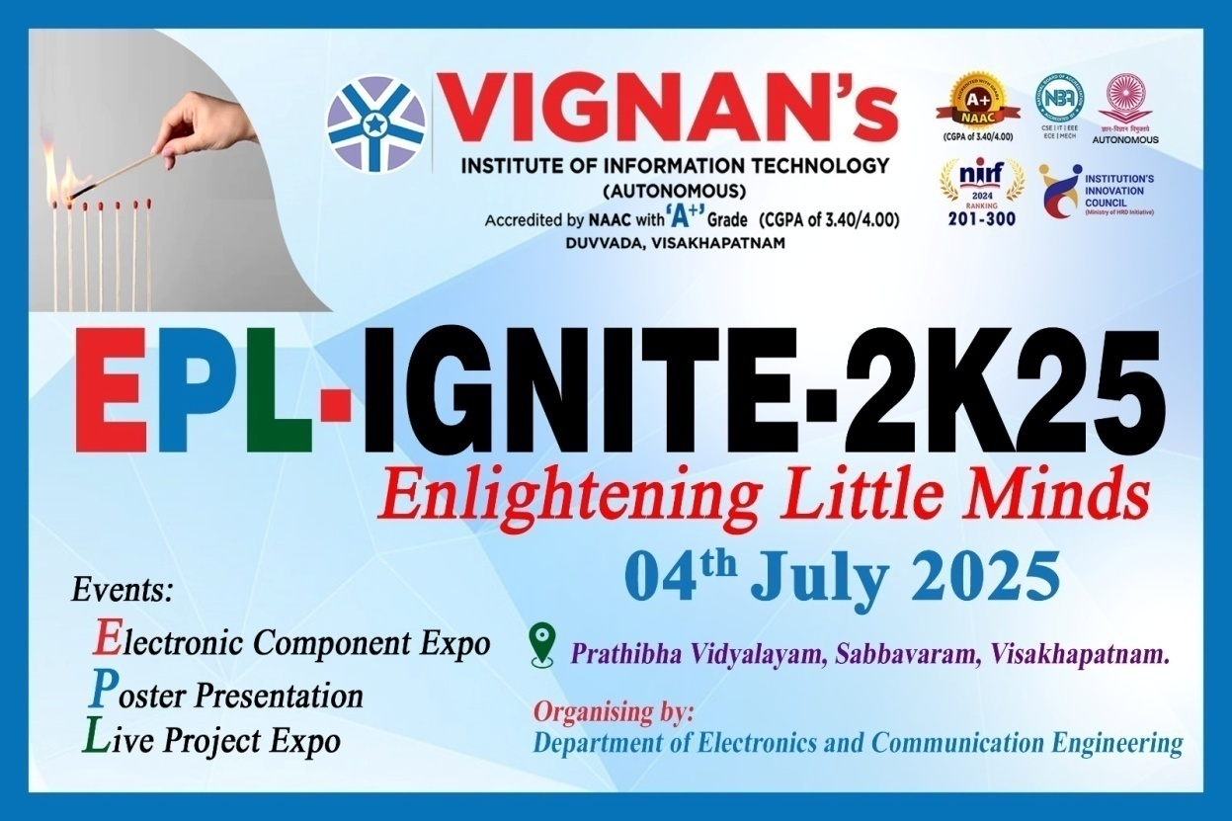
Organized by

Department of Electronics and Communication Engineering
Vignan’s Institute of Information Technology (A)

“Technical Extension Activity :: EPL-IGNITE-2K25”
On
4th July 2025
Organized by
Department of Electronics and Communication Engineering

Venue: Prathibha Vidyalayam, Visakhapatnam
About the event:
The Department of Electronics and Communication Engineering (ECE) organized a Technical Extension Activity titled EPL-IGNITE-2K25 on 4th July 2025 at Prathibha Vidyalayam, Sabhavaram, Visakhapatnam – 530035. The event included an Electronic Component Expo, Poster Presentations, and a Live Project Exhibition, aimed at igniting curiosity and interest in electronics among school students. Creative and socially relevant ideas were presented by III B.Tech ECE students, showcasing prototype projects such as an Energy-Efficient Escalator using Arduino, a Smart Water Quality Monitoring System, an Automatic Plant Watering System, Robotics and Automation models, and various electronic measuring instruments. These low-cost, efficient innovations addressed current societal issues and demonstrated the practical relevance of engineering concepts.
The activity served as a platform to transfer technical knowledge and research experiences in the field of Electronics and Communication Engineering to students of grades 7 to 10. The event witnessed active participation from 60 B.Tech students, 240 school children, faculty members from the engineering college, and school teachers, making it a successful outreach and learning initiative.

HoD Principal

“Technical Extension Activity :: EPL-IGNITE-2K25”
On
4th July 2025
Organized by
Department of Electronics and Communication Engineering

Venue: Prathibha Vidyalayam, Visakhapatnam
Geo-Tagged Photos:

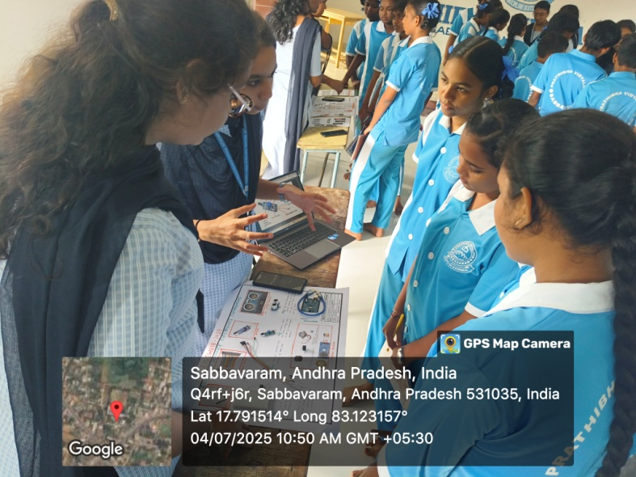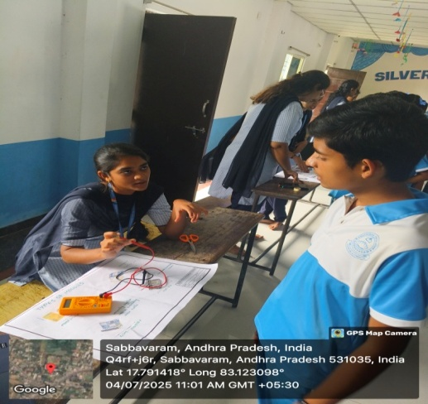
Electronic Component Display
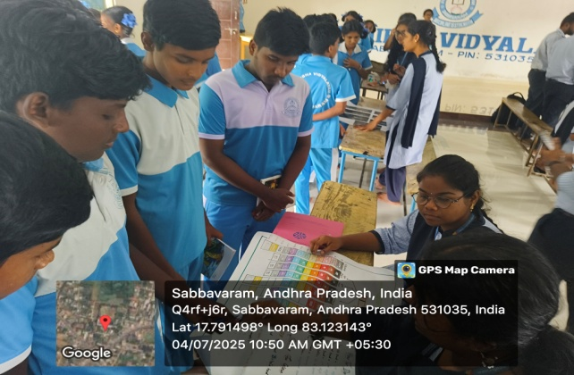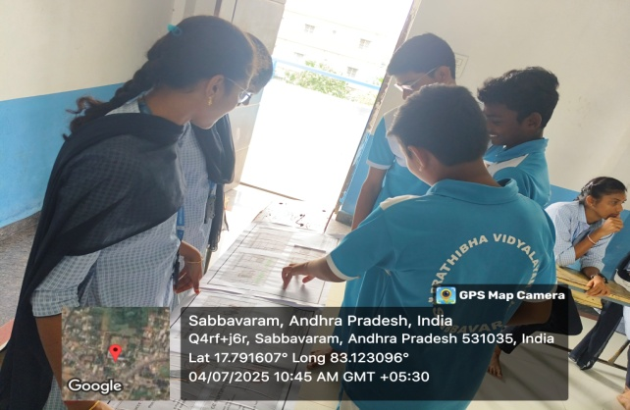
Poster Presentation

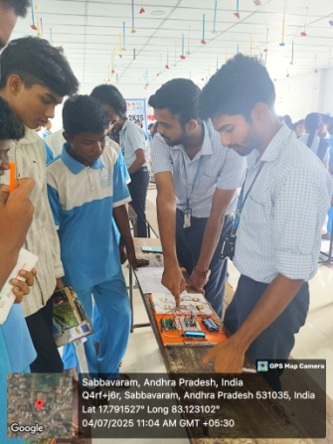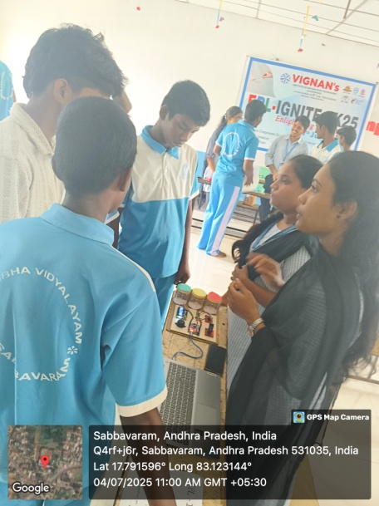
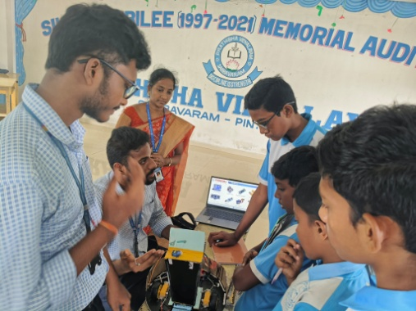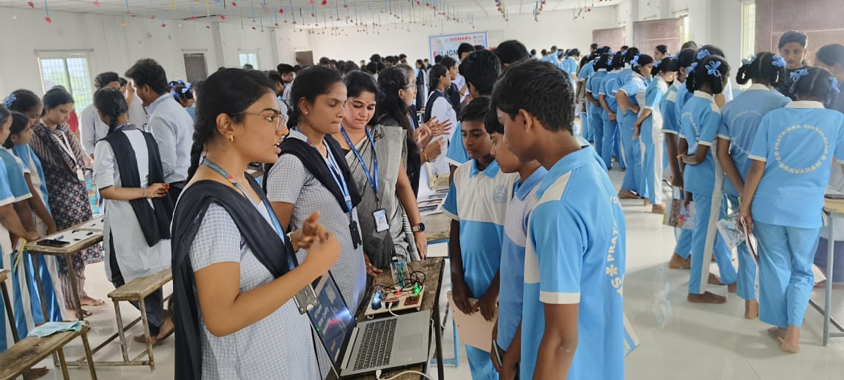
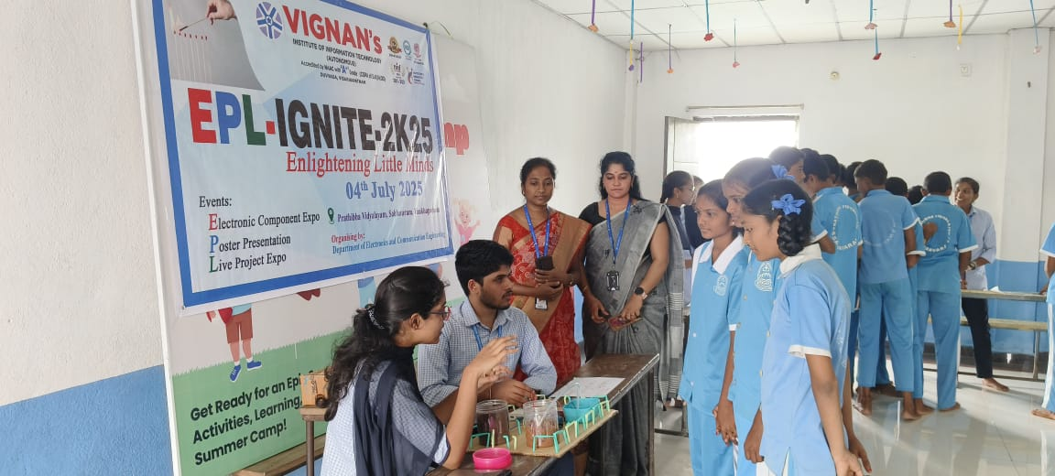
Live Project Expo

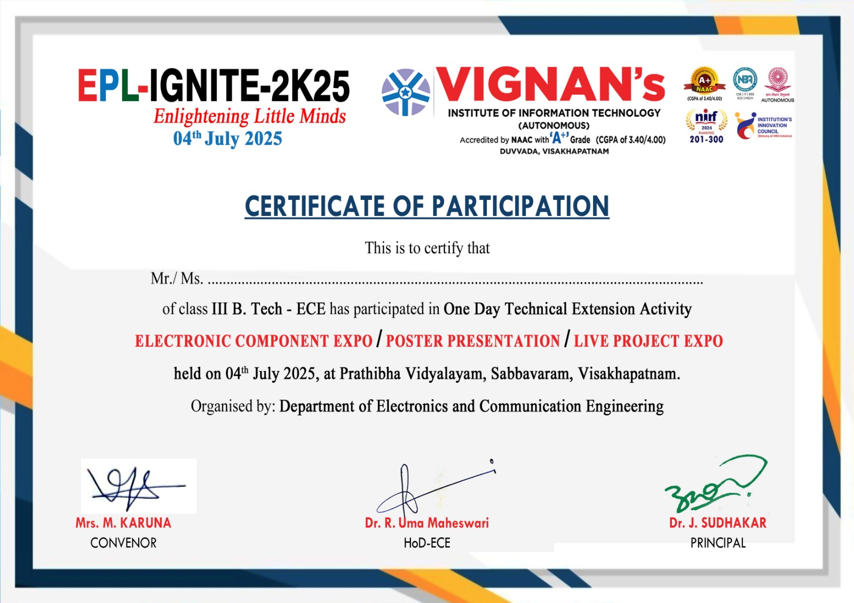
Certificate issued to the student
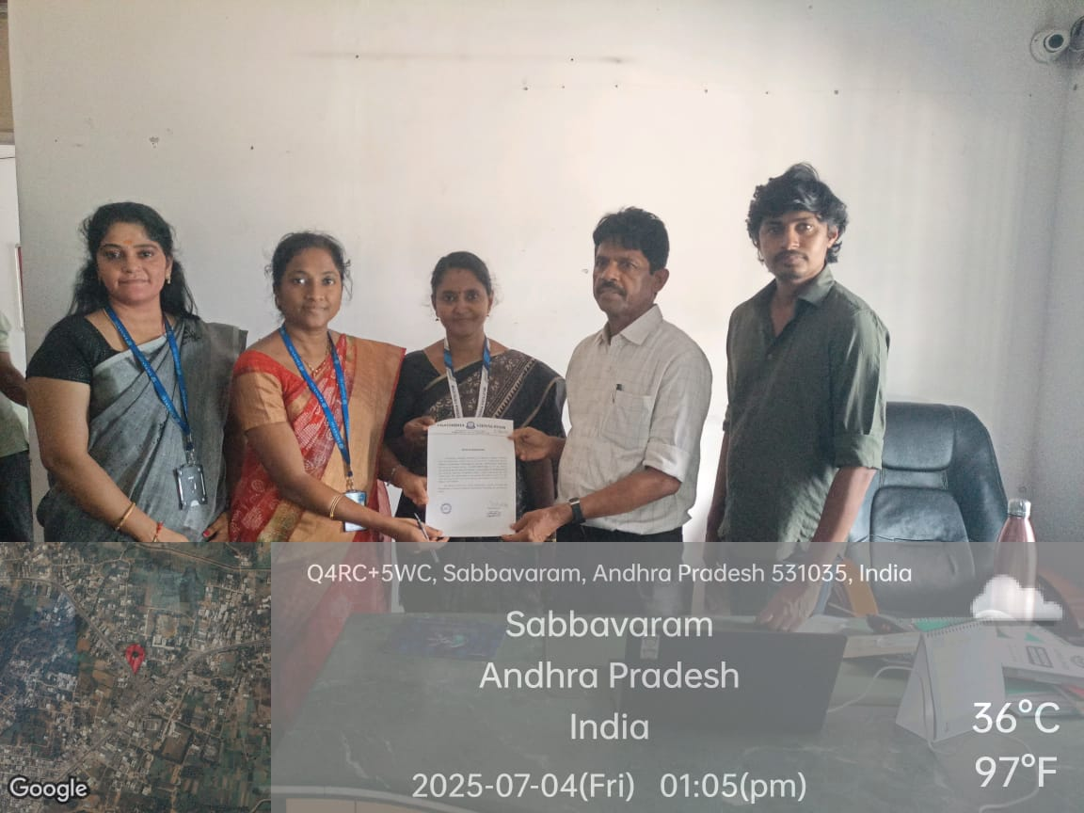
Appreciation Letter Issued by the School Correspondent

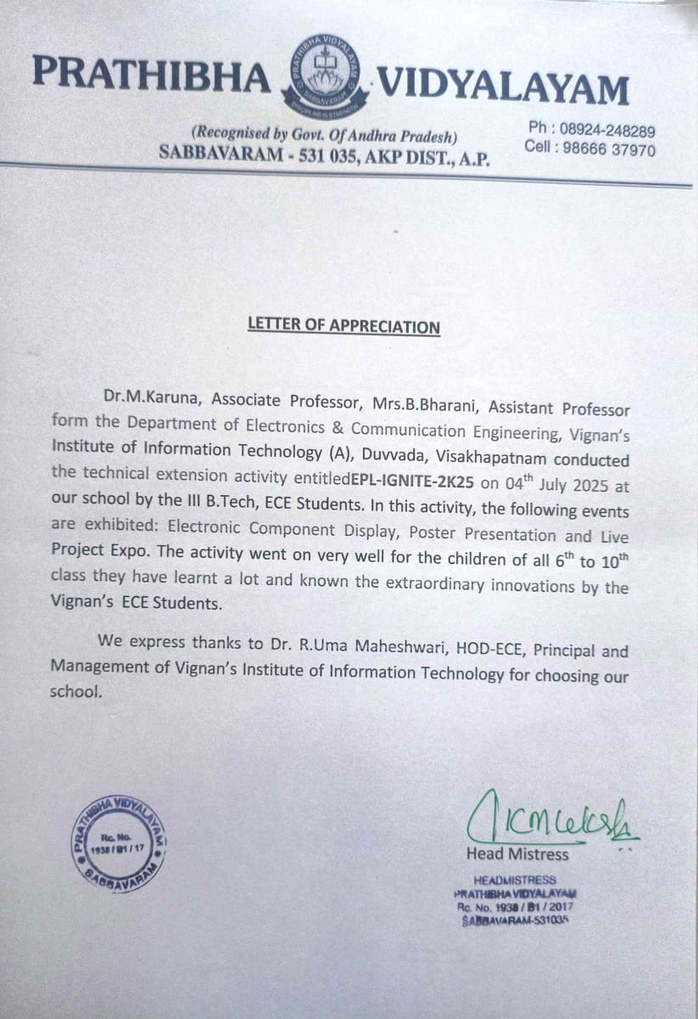
Appreciation letter issued by the ZPH Principal
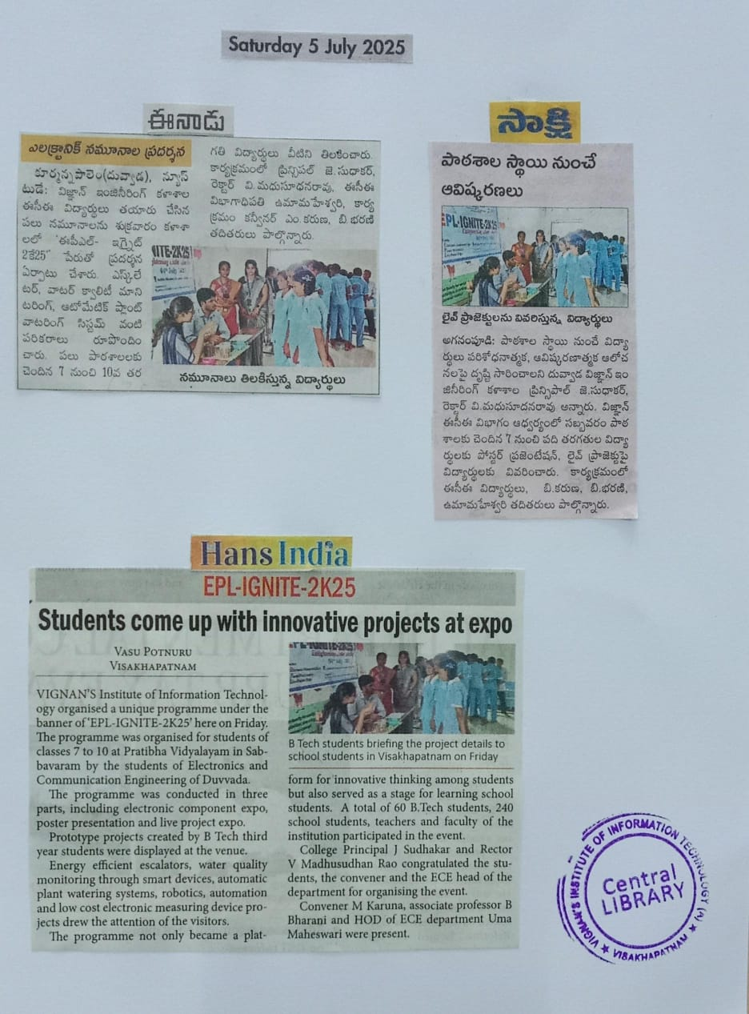
News Paper Clipping
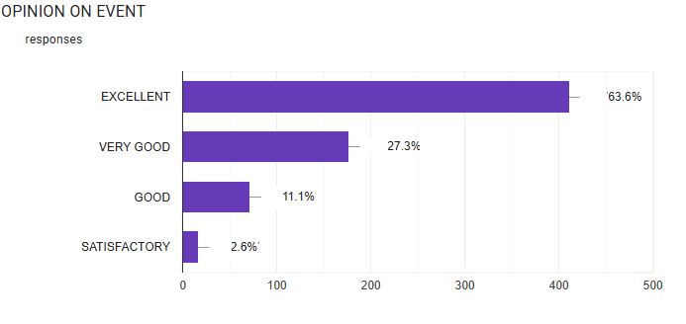
Feedback from School Students
HoD Principal

“Technical Extension Activity :: EPL-IGNITE-2K25”
On
4th July 2025
Organized by
Department of Electronics and Communication Engineering

Venue: Prathibha Vidyalayam, Visakhapatnam

List of Participants:
S.No | Reg.No. | Name of the Student | Name of the Presentation | Department | Signature
1 | 21L31A04E0 | Ponnada Saiswetha | Ai In Mobile Chips | ECE
2 | 22L31A0459 | Gorjana Anuradha | Anti-Sleep Alarm Spects For Drivers | ECE
3 | 23L31A0407 | Anakapalli Lokesh | Smart Spectacles For Ocular Health And Stress Relief | ECE
4 | 23L31A0409 | Anga Deepthi | Basic To Advanced Electronic Components | ECE
5 | 23L31A0414 | Ganireddy Pujeetha | Smart Glasses For Users With Combined Visual And Hearing Impairments | ECE
6 | 23L31A0416 | Betapudi Samuel Prasad | Smart Glasses For Users With Combined Visual And Hearing Impairments | ECE
7 | 23L31A0420 | B.Pratap | Movable Dustbin | ECE
8 | 23L31A0421 | Bongu Chandu Varma | Smart Movable Dustbin | ECE
9 | 23L31A0430 | D N L Sowmya | Organizer | ECE
10 | 23L31A0438 | Dharmala Preethi Reddy | About Capacitor,Types Of Capacitor,And Breadboard | ECE
11 | 23L31A0439 | Dharmireddy Jyostna | Types Of Modules, Multimeter Display | ECE
12 | 23L31A0447 | Gauda Likhithakumari | About Capacitor,Types Of Capacitors And Breadboard | ECE
13 | 23L31A0450 | G.V.S.Haswanth | Electric Mosquito Repellent Mesh | ECE
14 | 23L31A0460 | J L V V Chaithrika | Basic To Advance Electronic Components | ECE
15 | 23L31A0463 | Kaki Buvana | Ai Chips Using Vlsi | ECE
16 | 23L31A0465 | Kalavala Jhanshi | Types Of Modules( Display) | ECE
17 | 23L31A0471 | K.L.R.Chandrika | Light Fedility | ECE
18 | 23L31A0474 | Karri Bharatarsha Sai Ram | Voice Controlled Home Automation | ECE
19 | 23L31A0476 | K Sravani | Voice Controlled Home Automation | ECE
20 | 23L31A0481 | Kenguva Pujitha | Multimeter | ECE
21 | 23L31A0482 | Kesireddi Devi | Energy Efficient Escalator Using Arduino | ECE
22 | 23L31A0485 | Kodela Kalyani | Automatic Plant Watering System Using Arduino | ECE
23 | 23L31A0487 | Kompella Kiranmayi | Generating Electricity Through Garbage Reduction | ECE
24 | 23L31A0491 | Kotana Raviteja | Emergency Safety Pendent System | ECE
25 | 23L31A0499 | Lanki Praveen Kumar | Generate Electricity Through Garbage Reduction | ECE
26 | 23L31A04A0 | Lekkala Uday Teja | Emergency Safety Pendent System | ECE
27 | 23L31A04A1 | Lotla Keerthi | Energy Efficient Escalator Using Aurdino | ECE
28 | 23L31A04A4 | M.Parimala | Advancement Im Mobile Network | ECE
29 | 23L31A04A6 | Mahammad Rahamath Nisha | Basic Electronic Components | ECE
30 | 23L31A04B0 | Mamidi. Swathi | Automatic Street Light | ECE
31 | 23L31A04B3 | Saranya | Automatic Plant Watering System Using Arduino | ECE
32 | 23L31A04B4 | Maturi Anilkumar | Arduino Base Automatic Solar Tracker | ECE
33 | 23L31A04B6 | Metta Harisha | Poster Presentation On Multimeter | ECE
34 | 23L31A04B8 | Mondeti Kavya | Robotics | ECE
35 | 23L31A04B9 | Moturi Vineela | Basic Components Of Electronics | ECE
36 | 23L31A04C1 | Mula Mohit | Smart Irrigation System | ECE
37 | 23L31A04C2 | Mutchi Renusri | Automatic Solar Tracker | ECE
38 | 23L31A04C4 | Nagula Sri Harsha | Robotics | ECE
39 | 23L31A04D0 | Pala Yamini | Light Fedility | ECE
40 | 23L31A04D3 | Panchadarla Venkata Sai Kavya Sri | Smart Irrigation System | ECE
41 | 23L31A04D7 | Pentakota Hema Sree | Water Quality Monitoring System Using Smart Device | ECE
42 | 23L31A04E1 | Katumala Hemanth | Piezoelectric Foot Energy Generator | ECE
43 | 23L31A04E2 | P. Arya Vardhan | Transformer | ECE
44 | 23L31A04E5 | Prakriti Uriti | Resistor Colour Coding | ECE
45 | 23L31A04E8 | Puttupakala Madhavi | Iot Based Water Quality Monitoring System By Using Esp32 | ECE
46 | 23L31A04F2 | Reddi Sri Venkat Vardhan | Peizo Eletric Foot Step Power Generator | ECE
47 | 23L31A04G1 | Samayamanthula Iswarya | Resistor Colour Coding | ECE
48 | 23L31A04G2 | S.Yaswanth Kumar | Resistors | ECE
49 | 23L31A04H0 | Sigireddi Venkata Mohan Surya | Organizer | ECE
50 | 23L31A04H2 | Singampalli Tejash Vardhan | Transformer | ECE
51 | 23L31A04H6 | Surisetty Aman Krish | Basic Electronic Components | ECE
52 | 23L31A04H7 | Surisetty Epshitha | Automatic Medicine Remainder For Elder People | ECE
53 | 23L31A04I0 | Tatikonda T N V V Sai Krishna Rohith | Organizer | ECE
54 | 23L31A04I5 | Vanjarapu Teja Vardhan | Logic Gates | ECE
55 | 23L31A04J4 | Yelamanchili Naga Devi Prasanna Kumar | Basic Electronic Components | ECE
56 | 24L35A0402 | Sai Vignesh Dayana | Electric Mosquito Repellent Mesh | ECE
57 | 24L35A0409 | Lingam Sree Keerthi | Advancement In Mobile Networks | ECE
58 | 24L35A0410 | Margana Krishna Priya | Automatic Street Light | ECE
59 | 24L35A0416 | Raparthi Kavya | Anti-Sleep Alarm Spects For Drivers | ECE
60 | 24L35A0420 | Vaddadi Jyothsna Sri | Medicine Reminder For Elder People | ECE

HoD Principal

“Technical Extension Activity :: EPL-IGNITE-2K25”
On
4th July 2025
Organized by
Department of Electronics and Communication Engineering

Venue: Prathibha Vidyalayam, Visakhapatnam

List of Faculty Participated:

S.No | Emp. ID | Name of the Faculty | Department | Signature
1 | 10040 | Dr.M.Karuna | ECE
2 | 11238 | Mrs.B.Bharani | ECE

HoD Principal

