MIC Driven Activity

Semester 2 Quarter 4
Theme | Innovation & Entrepreneurship
Activity Name | Podcast Series on “Rashtra Pratham” and “Celebrating Failures”
Date of the Activity | 04-07-2025
Mode of Conduct | Hybrid/Online
Level of Activity | Level 1
Time | 11:30 AM to 01:00 PM
Mandatory/  Elective | Mandatory
Participants | Students: 40; Faculty: 10
Online Resource | https://www.youtube.com/watch?si=S8LL95vOdIpTGOkO&v=9LZ7t9kHZlw&feature=youtu.be  https://www.youtube.com/watch?v=qgEoO8tx7Ps
Brochure | 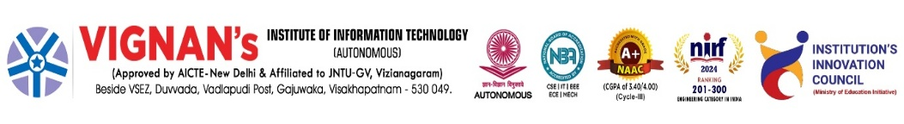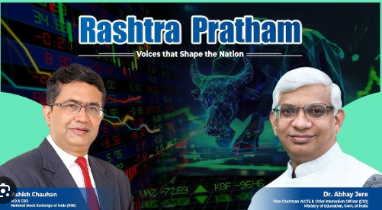
Description | The Ministry of Education’s Innovation Cell is going to organise series of sessions with Indian Leaders and Start-up founders in form of podcasts named “Rashtra Pratham” and “Celebrating Failures” to inspire young minds by seeing challenges as opportunities.
Objectives | - To instil patriotism and national-first mindset among students.  - To encourage resilience by learning from failures as stepping stones.
Outcomes | - Students developed leadership and problem-solving skills.  - Enhanced confidence in embracing challenges with positivity.
Photos | 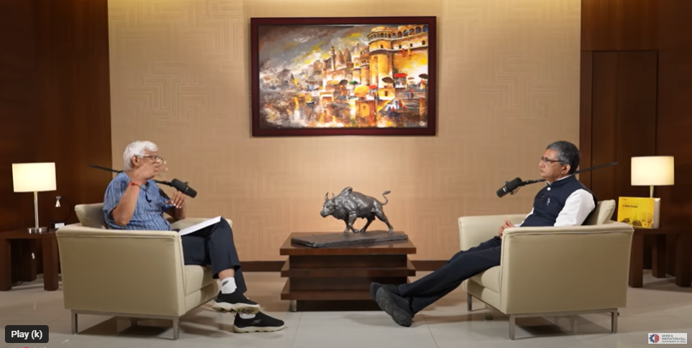  Glimpses of the event

Feedback:
The participants expressed to present their innovative ideas. Sessions inspired us to prioritize nation and view failures as opportunities for growth and success.

IIC Activity Coordinator Dr. A. S. Dakshina Murthy Head VCIS

Dr. J. Sudhakar
Convener VIIT-IIC

