Report on MIC-Driven Activities for the Quarter I

MIC-Driven Activities for the Quarter I of IIC 7.0 (2024-2025) for IIC Institutions was carried out by delivery of a YouTube session of one hour. It was attended by 05 faculty members of Institution’s' Innovation Council, Committee on 20-09-2024 on the topic of “Session on MIC Programmes & Schemes” by Dr. Abhay Jere of Ministry of education. The main objective of this program was to make the colleges aware about startup, entrepreneurship programs for their self-employment. Objectives: Accelerating R &D, Innovation and Entrepreneurship in the country Benefits: Forwarding information on the role and functioning of ATLs and SIC
No. of Participating Students: 54
No. of Faculty Participants: 05
You tube Link after the event: https://youtu.be/liN44c98emg

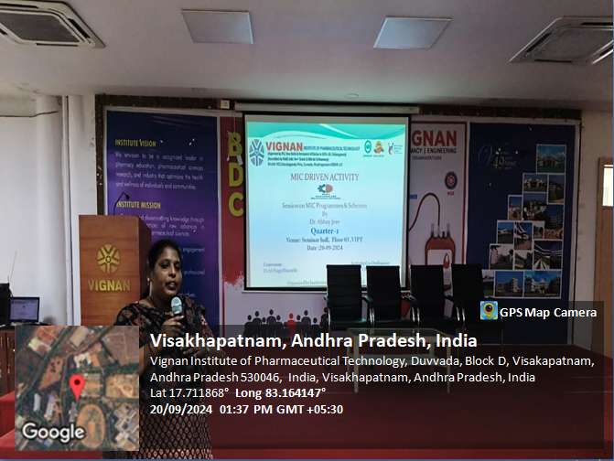
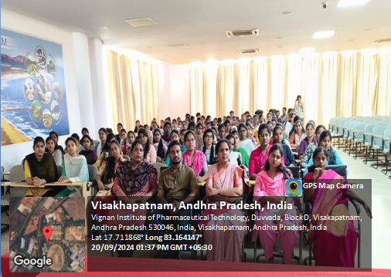
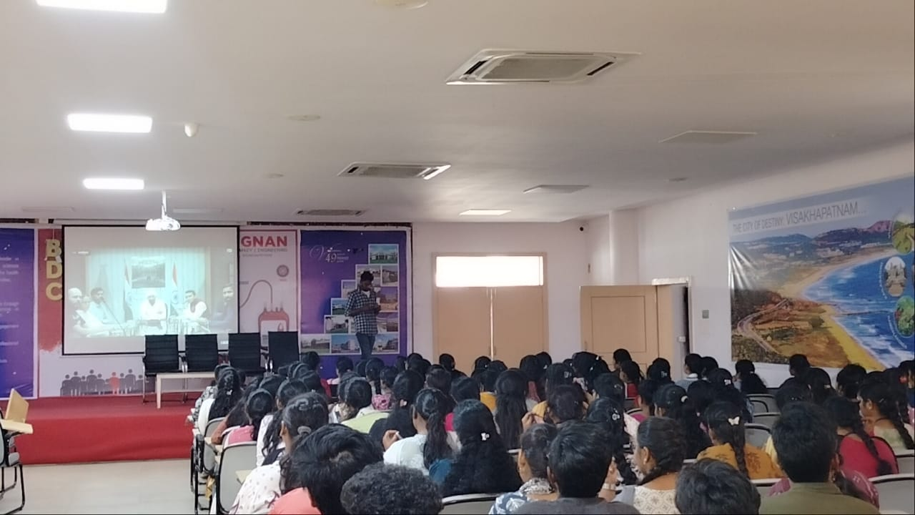

IIC Activity Coordinator President, VIPT-IIC Vice-PresidentVIPT-IIC

