Semester 1 Self Driven

Quarter 1
Activity Name | National Innovation and Startup Policy (NISP): Guiding Framework for HEIs
Session Theme | Start-up Planning and Development
Speaker Details | Mr. Dipan Sahu, Asst. Innovation Director, Dr. Pooja Rawat, Innovation Officer  MoE Innovation Cell
Date of the Activity | 22.11.2024
Mode of Conduct | Online
Time | One Day
Mandatory/  Elective | Mandatory
Participants | Students: 40; Faculty: 10
Online Resource | https://www.youtube.com/watch?v=HkRqVccC8B0
Brochure | 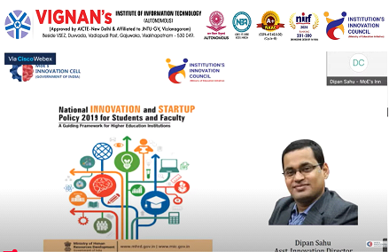
Description | The Vignan’s Institute of Information Technology organized an event on National Innovation and Startup Policy (NISP): Guiding Framework for HEIs on 22.11.2024 through Virtual mode .
Objectives
Outcomes
Photos | 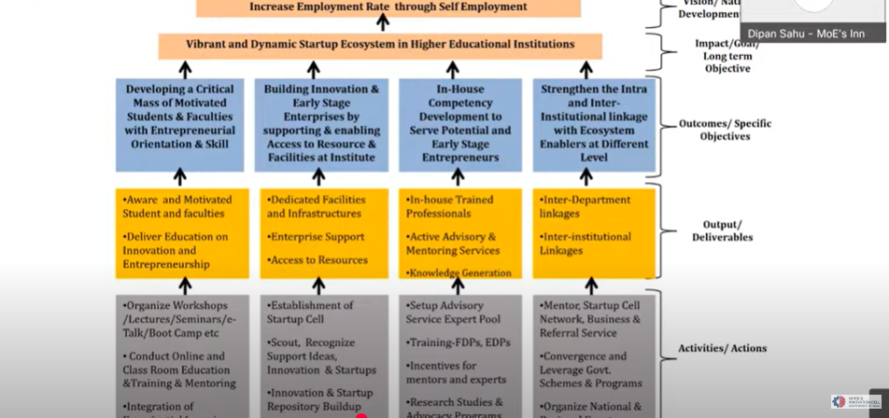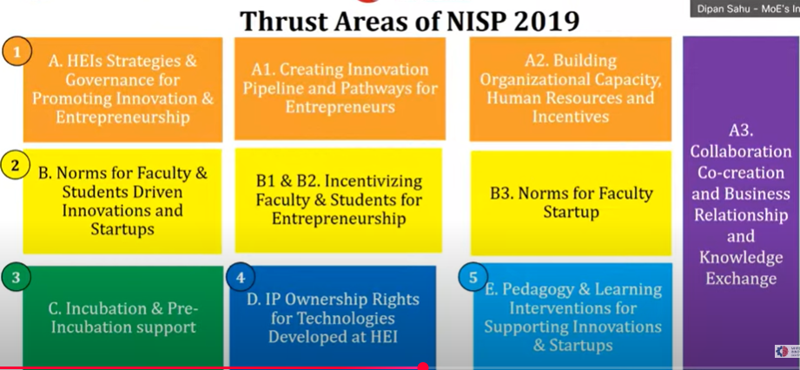  Glimpses of the event

Feedback:

IIC Activity Coordinator Dr. A. S. Dakshina Murthy Head VCIS

Dr. J. Sudhakar
Convener VIIT-IIC

